6.2.3: Implementation of e-governance in areas of operation.
1. Administration
2. Finance and Accounts
3. Student Admission and Support
4. Examination
1) Provide Institutional expenditure statements for the heads of E- governance implementation reflected in the audited statement.
2) Provide Screen shots of user interfaces of Examination module reflecting the name of the HEI.
3) Provide Annual e-governance report approved by Governing Council.
4) Provide ERP Document.
Response:
All above documents are attached herewith on the page number as given in index.
INDEX
Sr. No. | Description | Pg. No.
 | Institutional expenditure statements for the heads of E – governance implementation reflected in the audited statement | 2
 | Screen Shots of Examination module | 3
 | Annual e-governance report approved by Governing Council | 9
 | ERP Document | 11
.

- Institutional expenditure statements for the heads of E – governance implementation reflected in the audited statement.

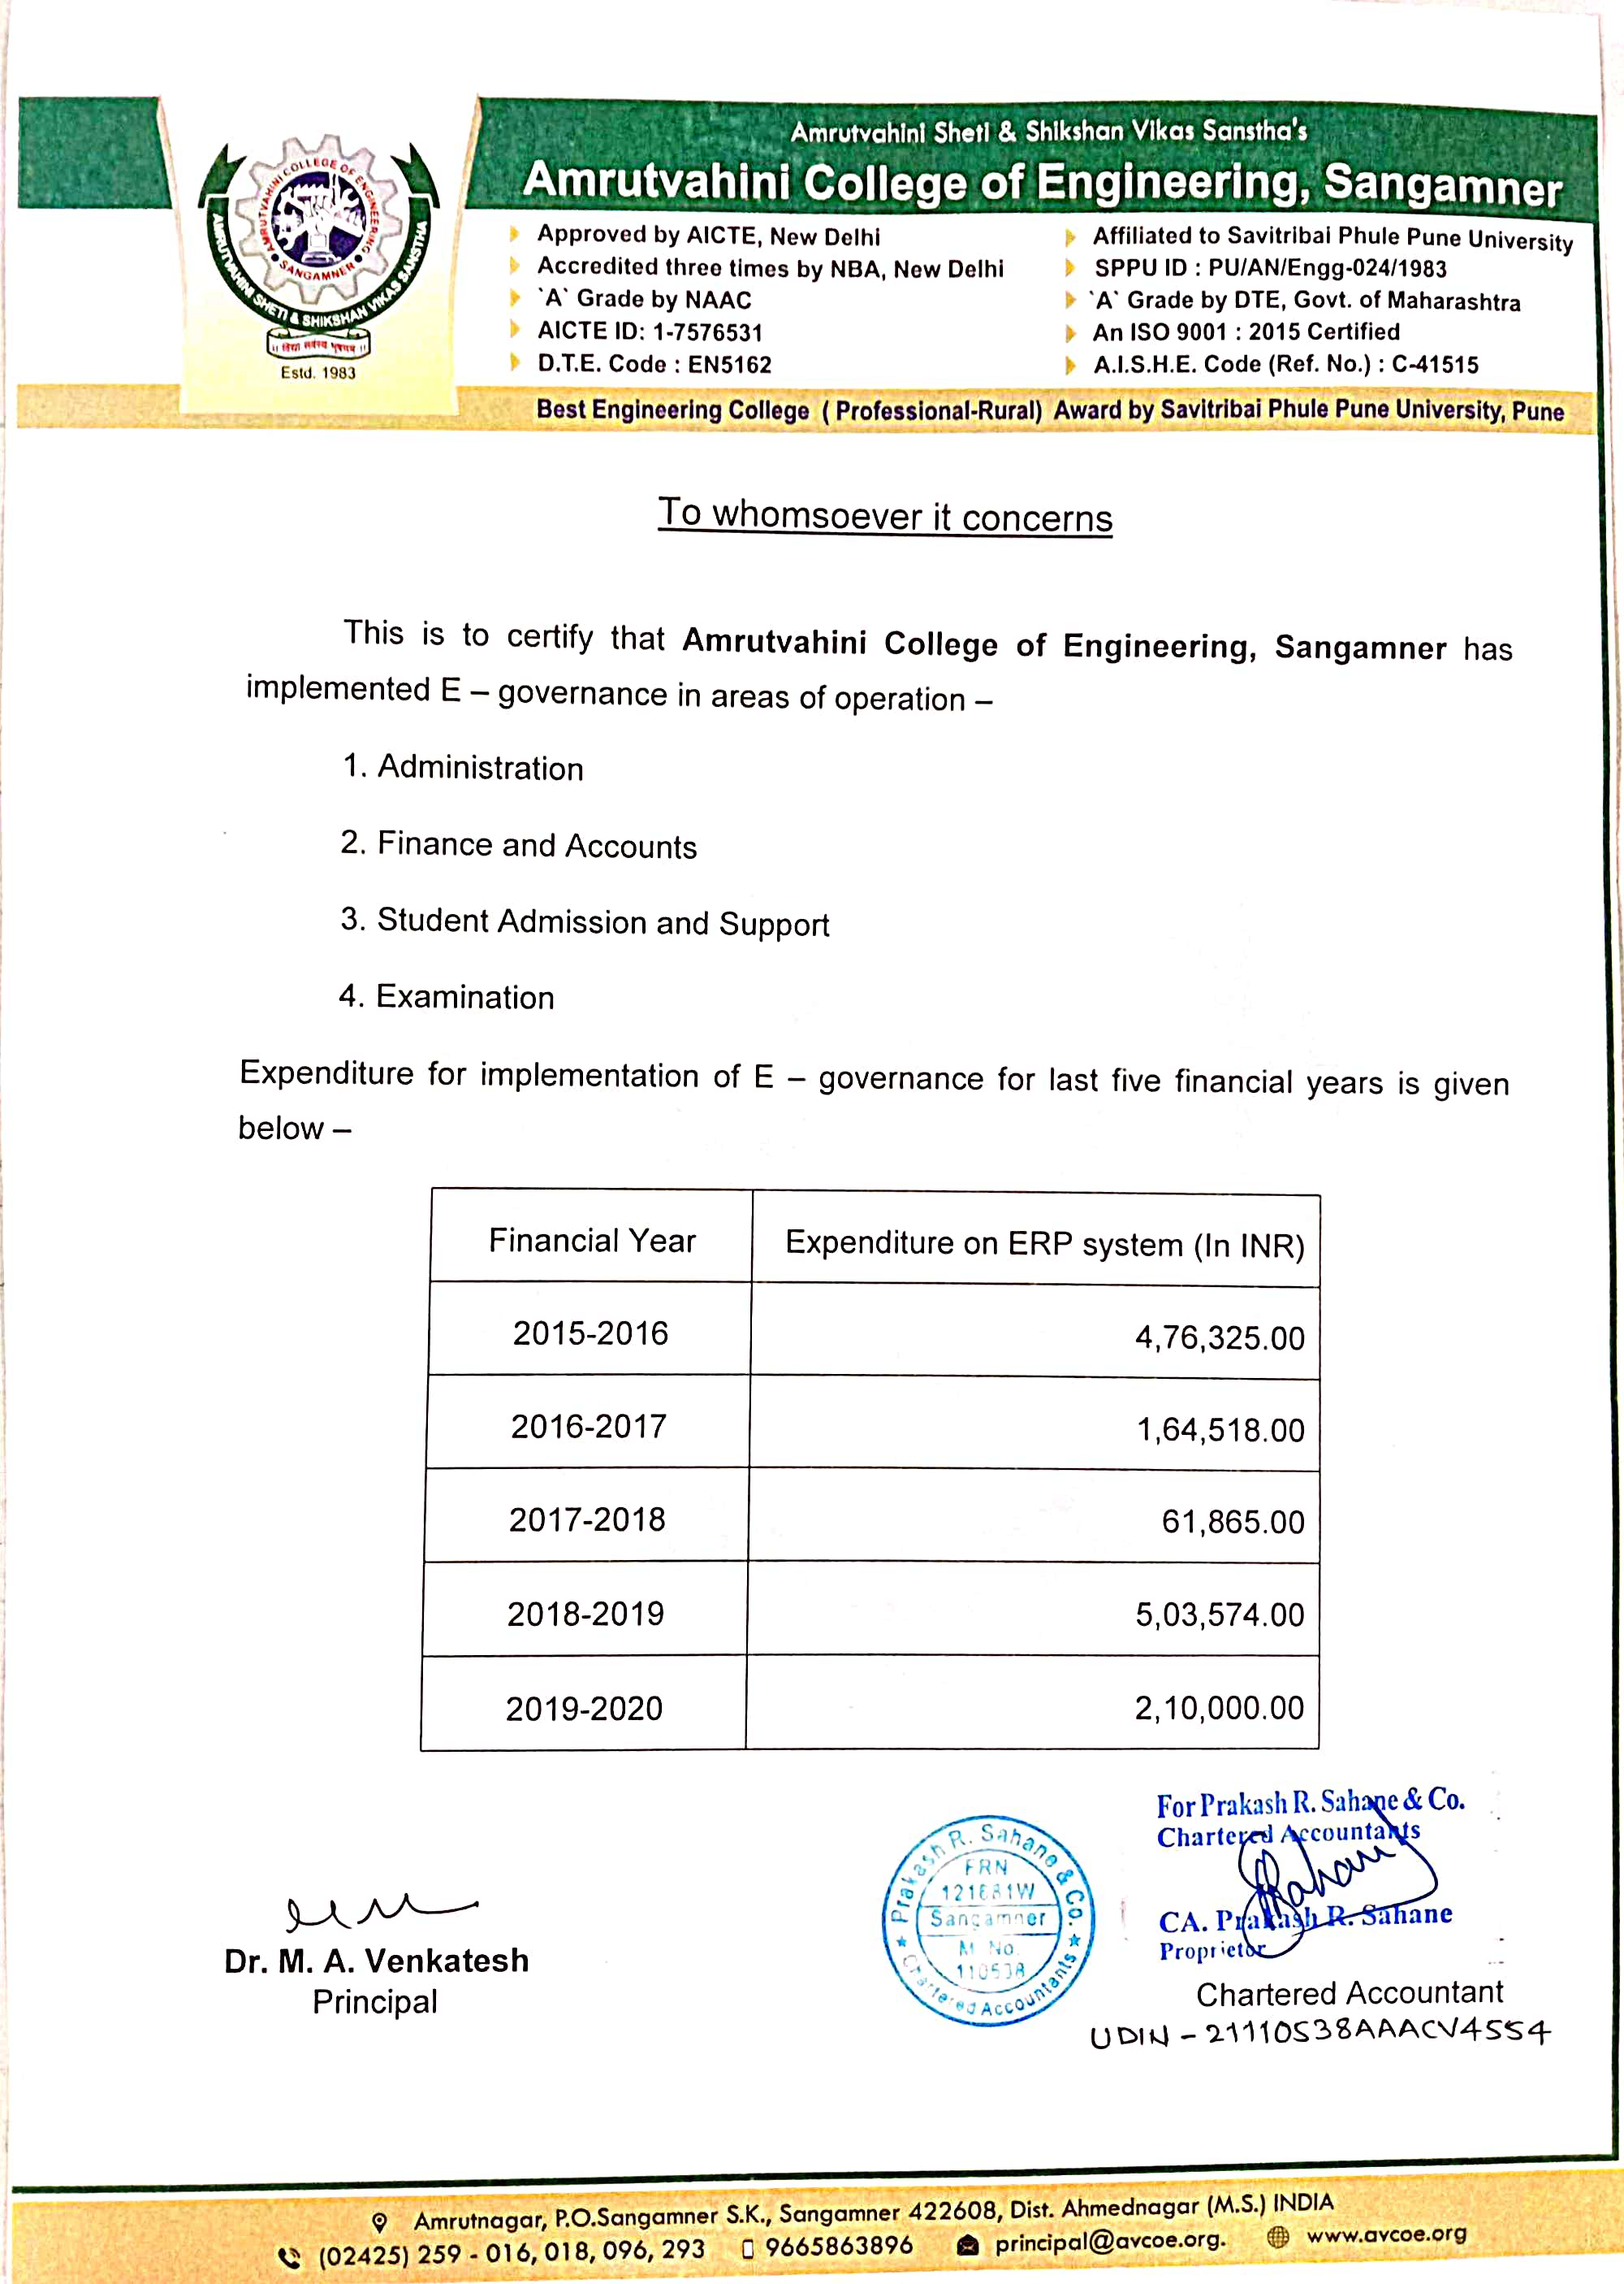
2. Screen Shots of Examination module
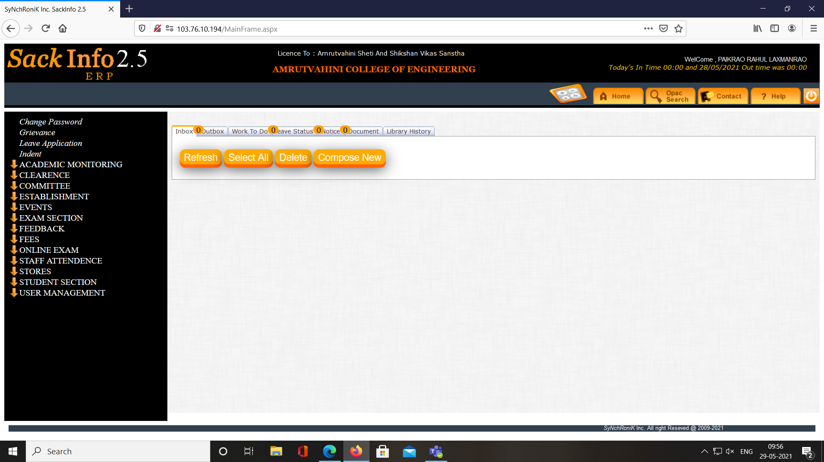
Screen Shot 1. General window of Software showing all options including Exam Section, Online Exam
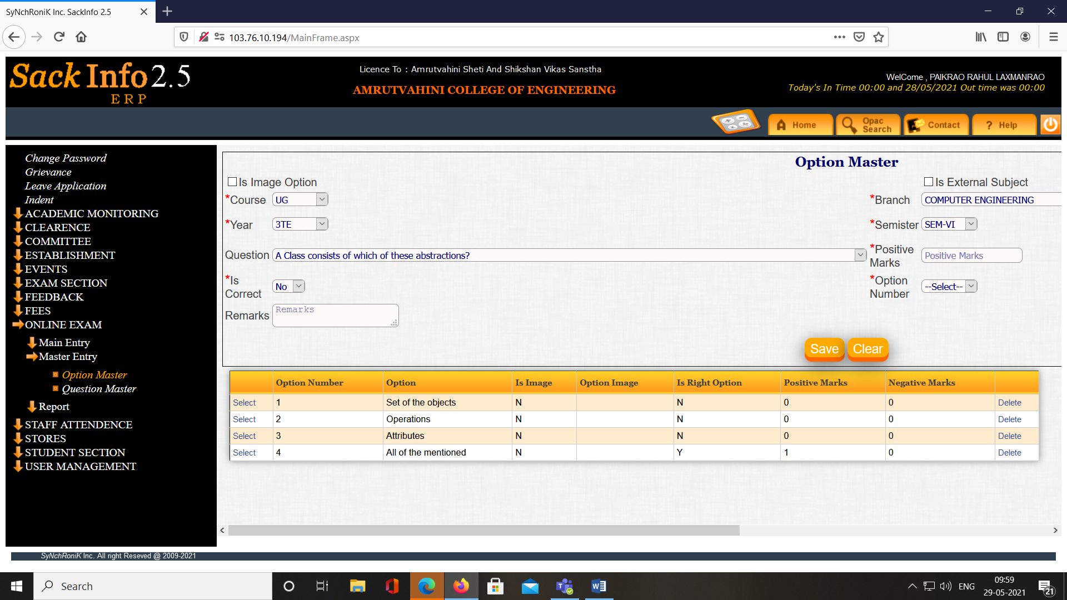
Screen Shot 2. Online Exam MCQ question paper setting
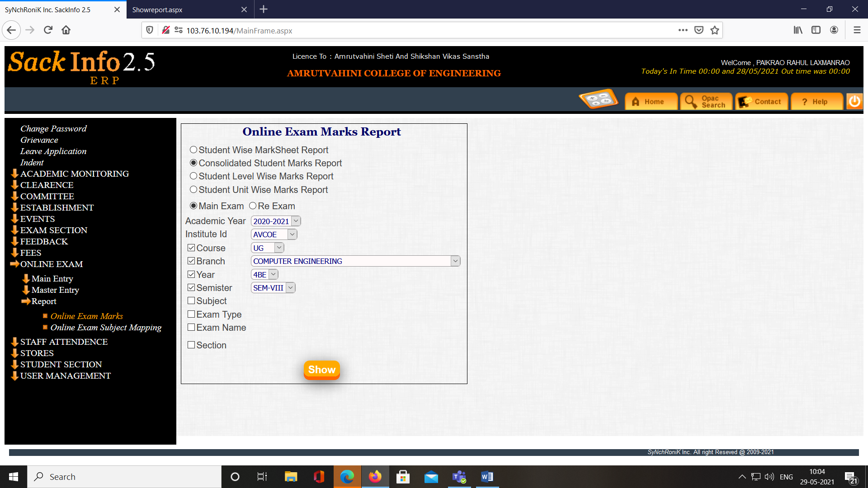
Screen Shot 3. Online Exam MCQ Report generation
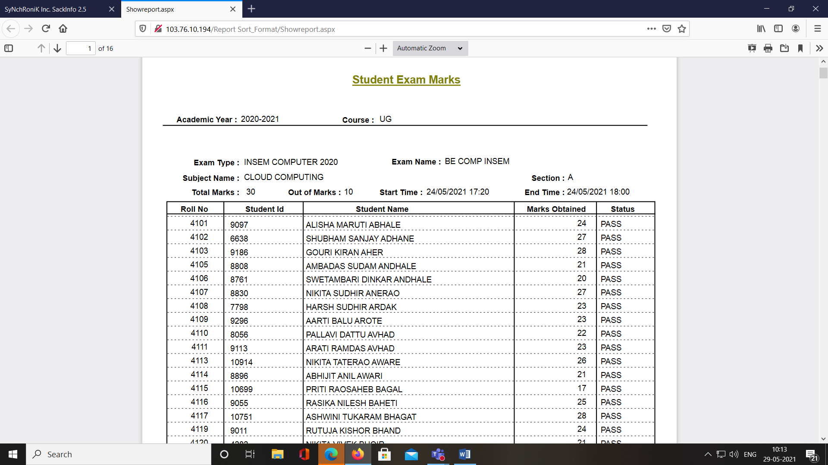
Screen Shot 4. Result report generation
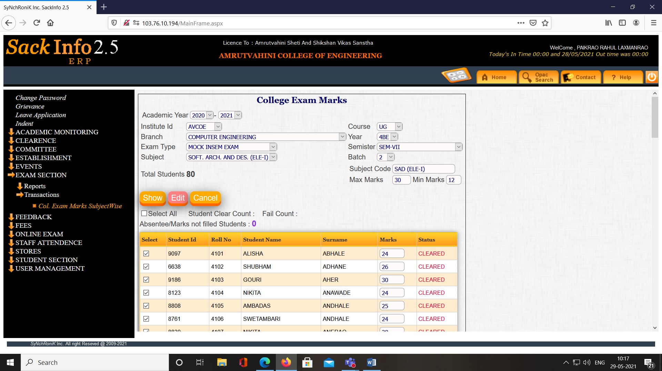
Screen Shot 5. Insem/ Prelim marks filling Marks Filling in Exam Module
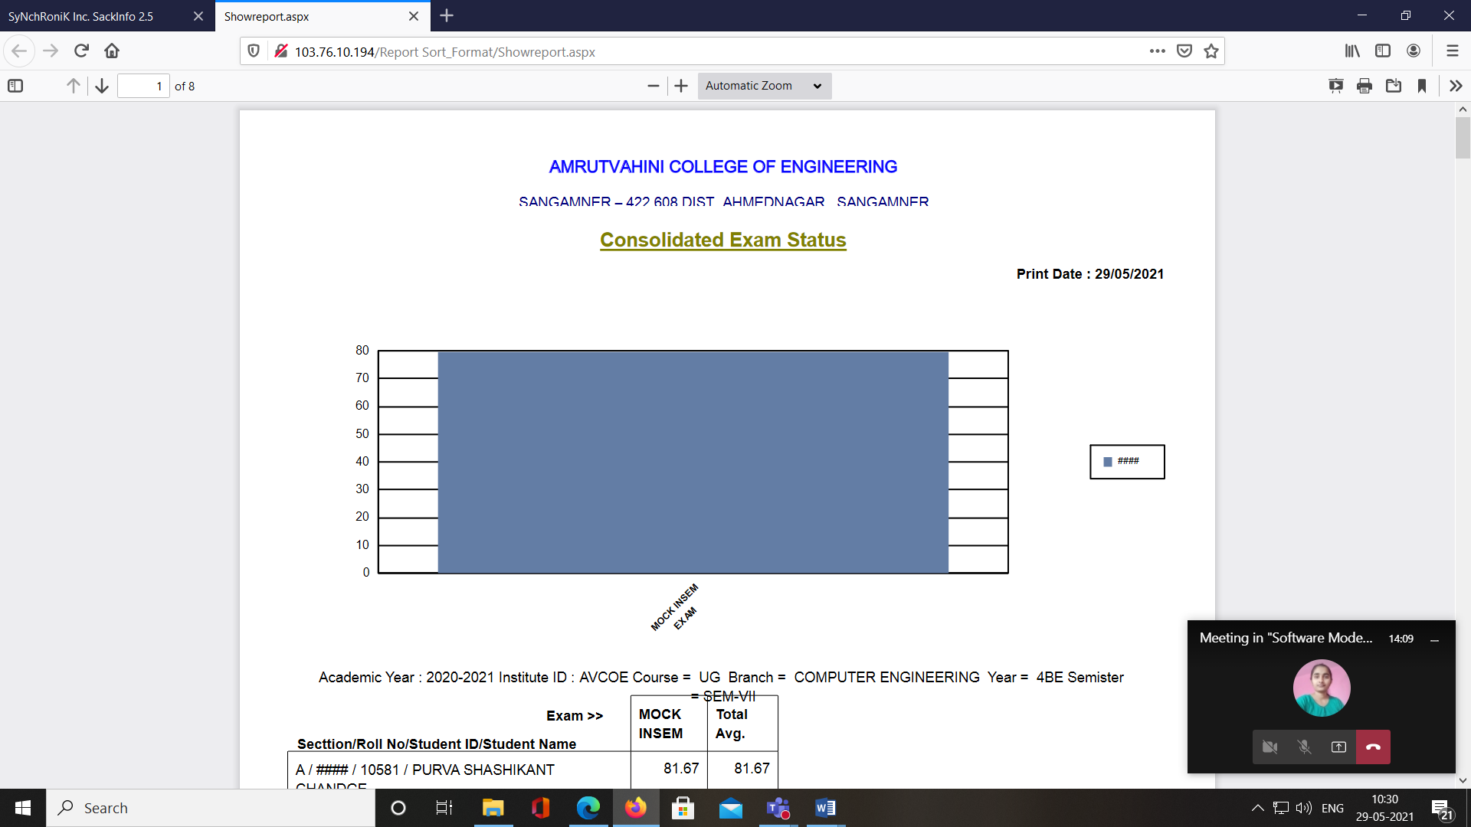

Screen Shot 6. Consolidated exam status report

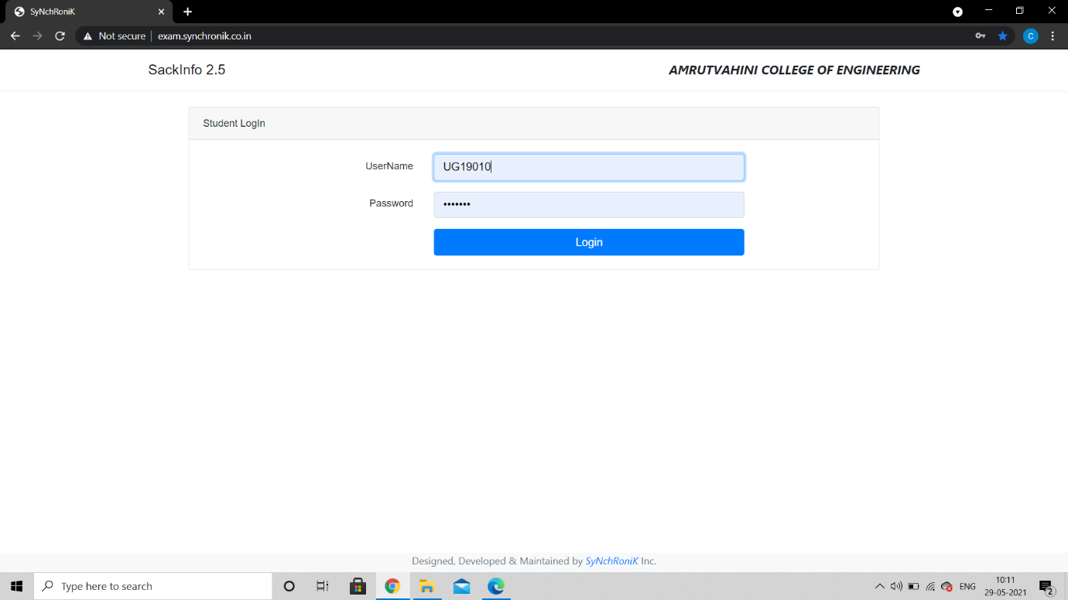
Screen Shot 7. Online exam module at Student side

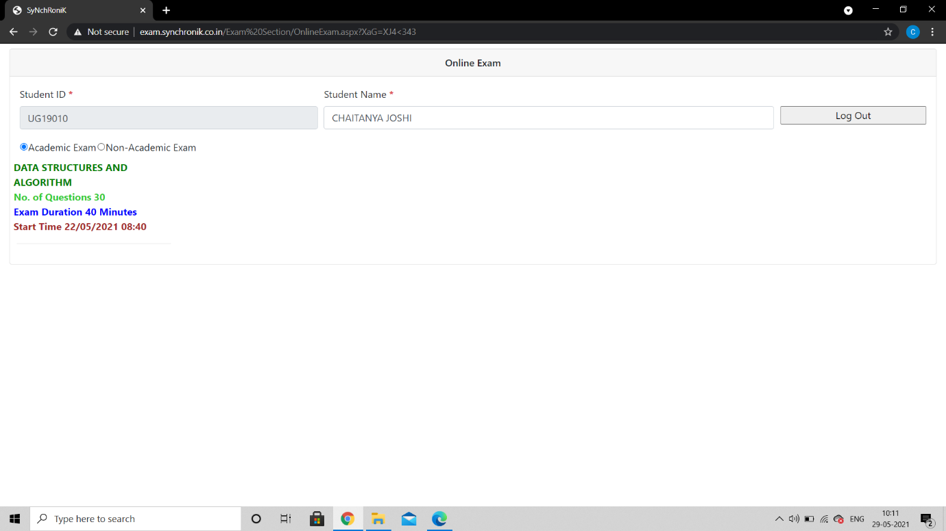
Screen Shot 8. Subject display
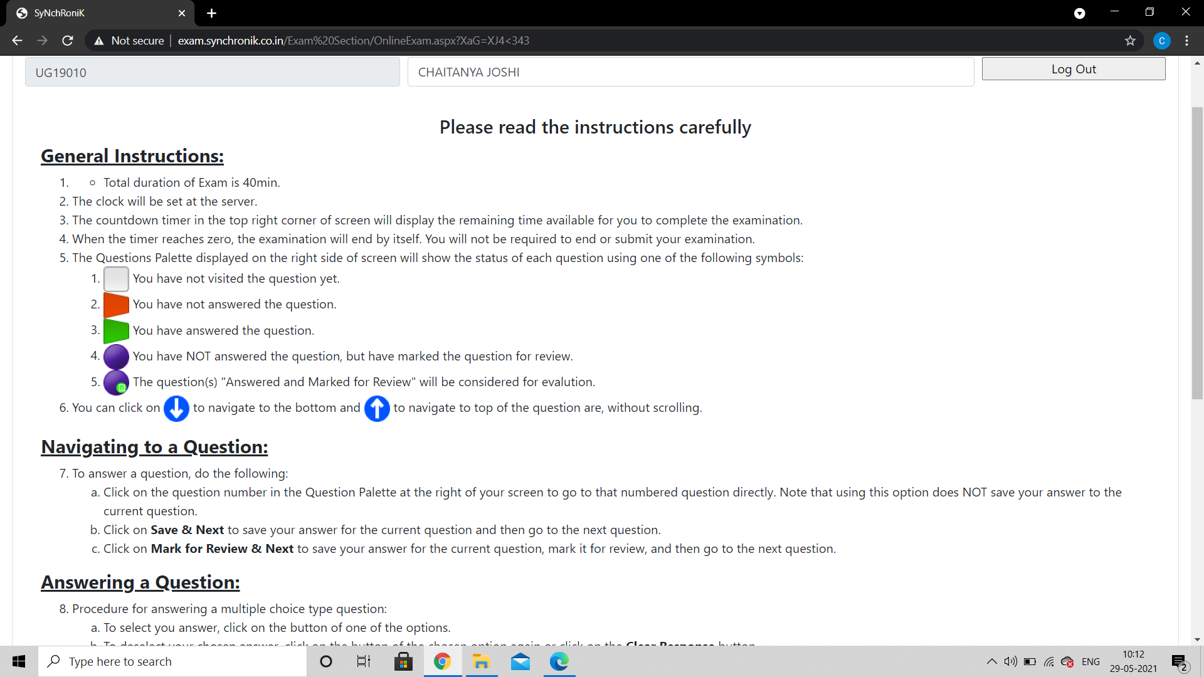
Screen Shot 9. Instructions for students
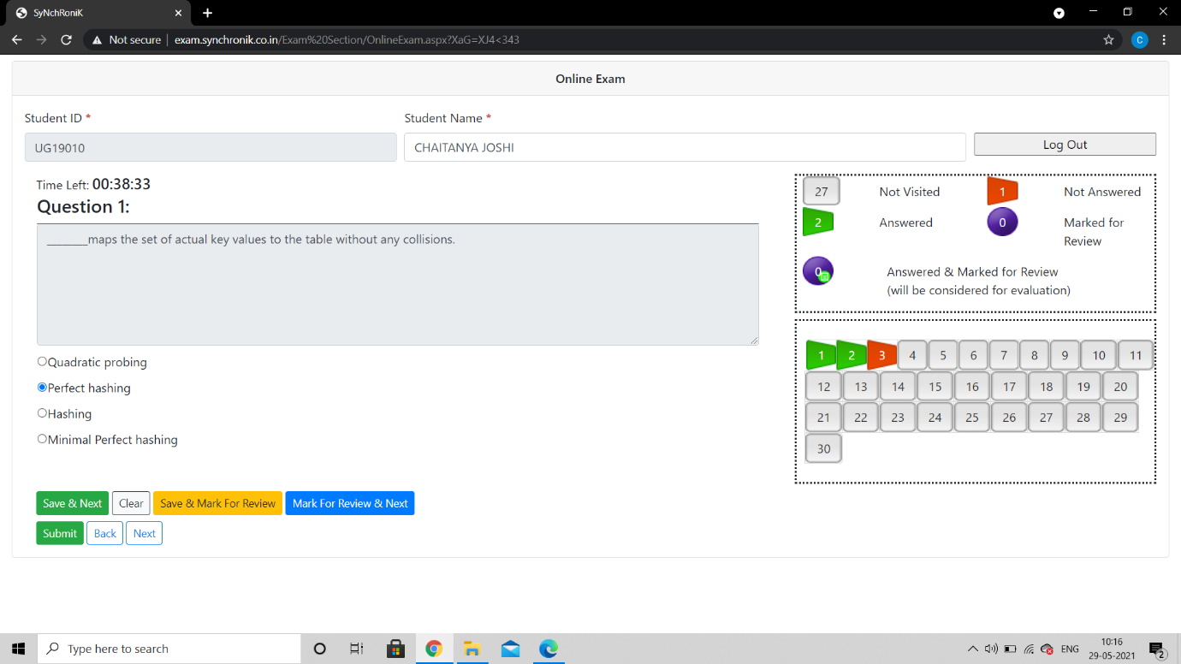
Screen Shot 10. Exam window
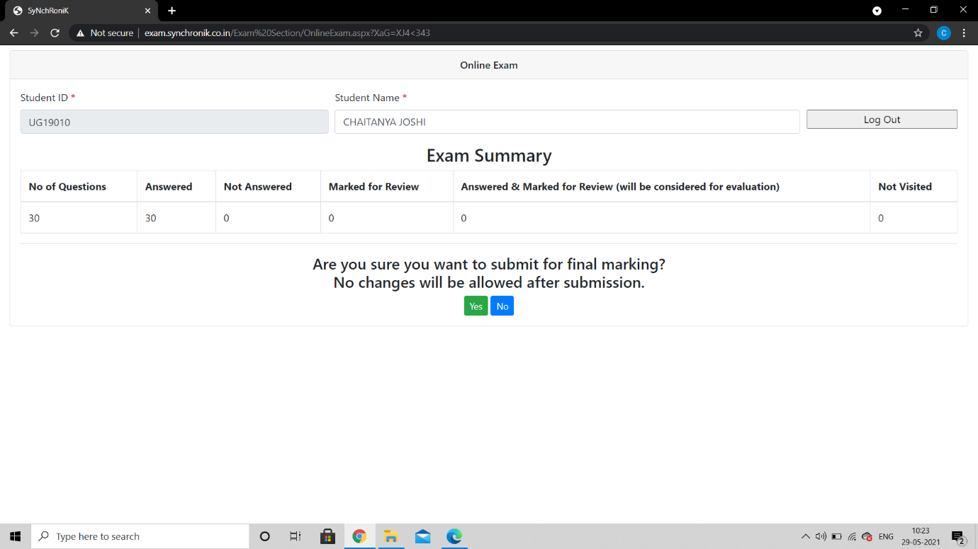

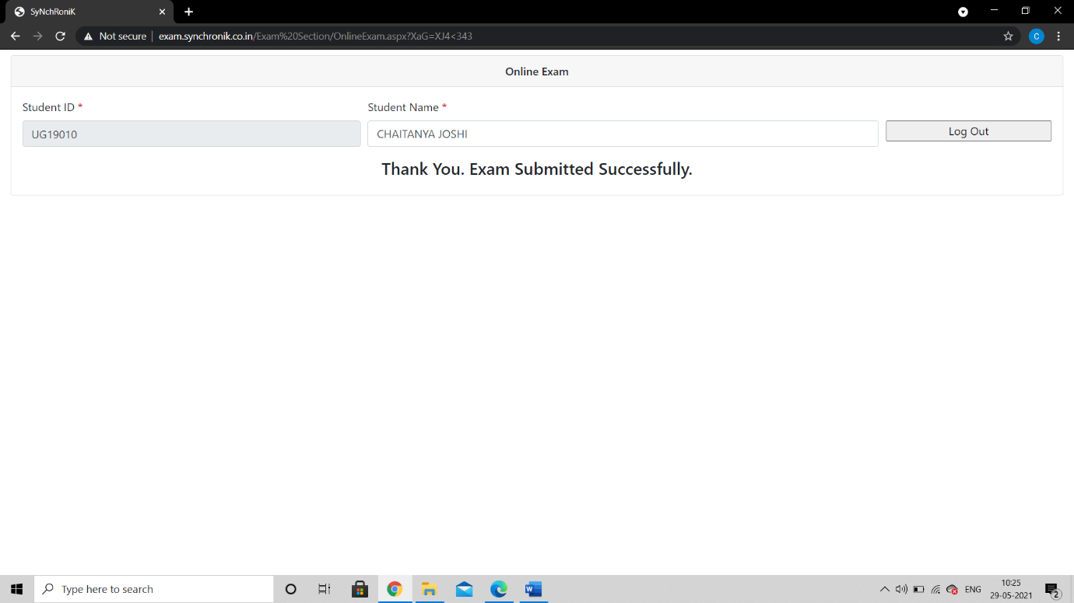
Screen Shot 11. Exam Submission
- Annual e-governance report approved by Governing Council
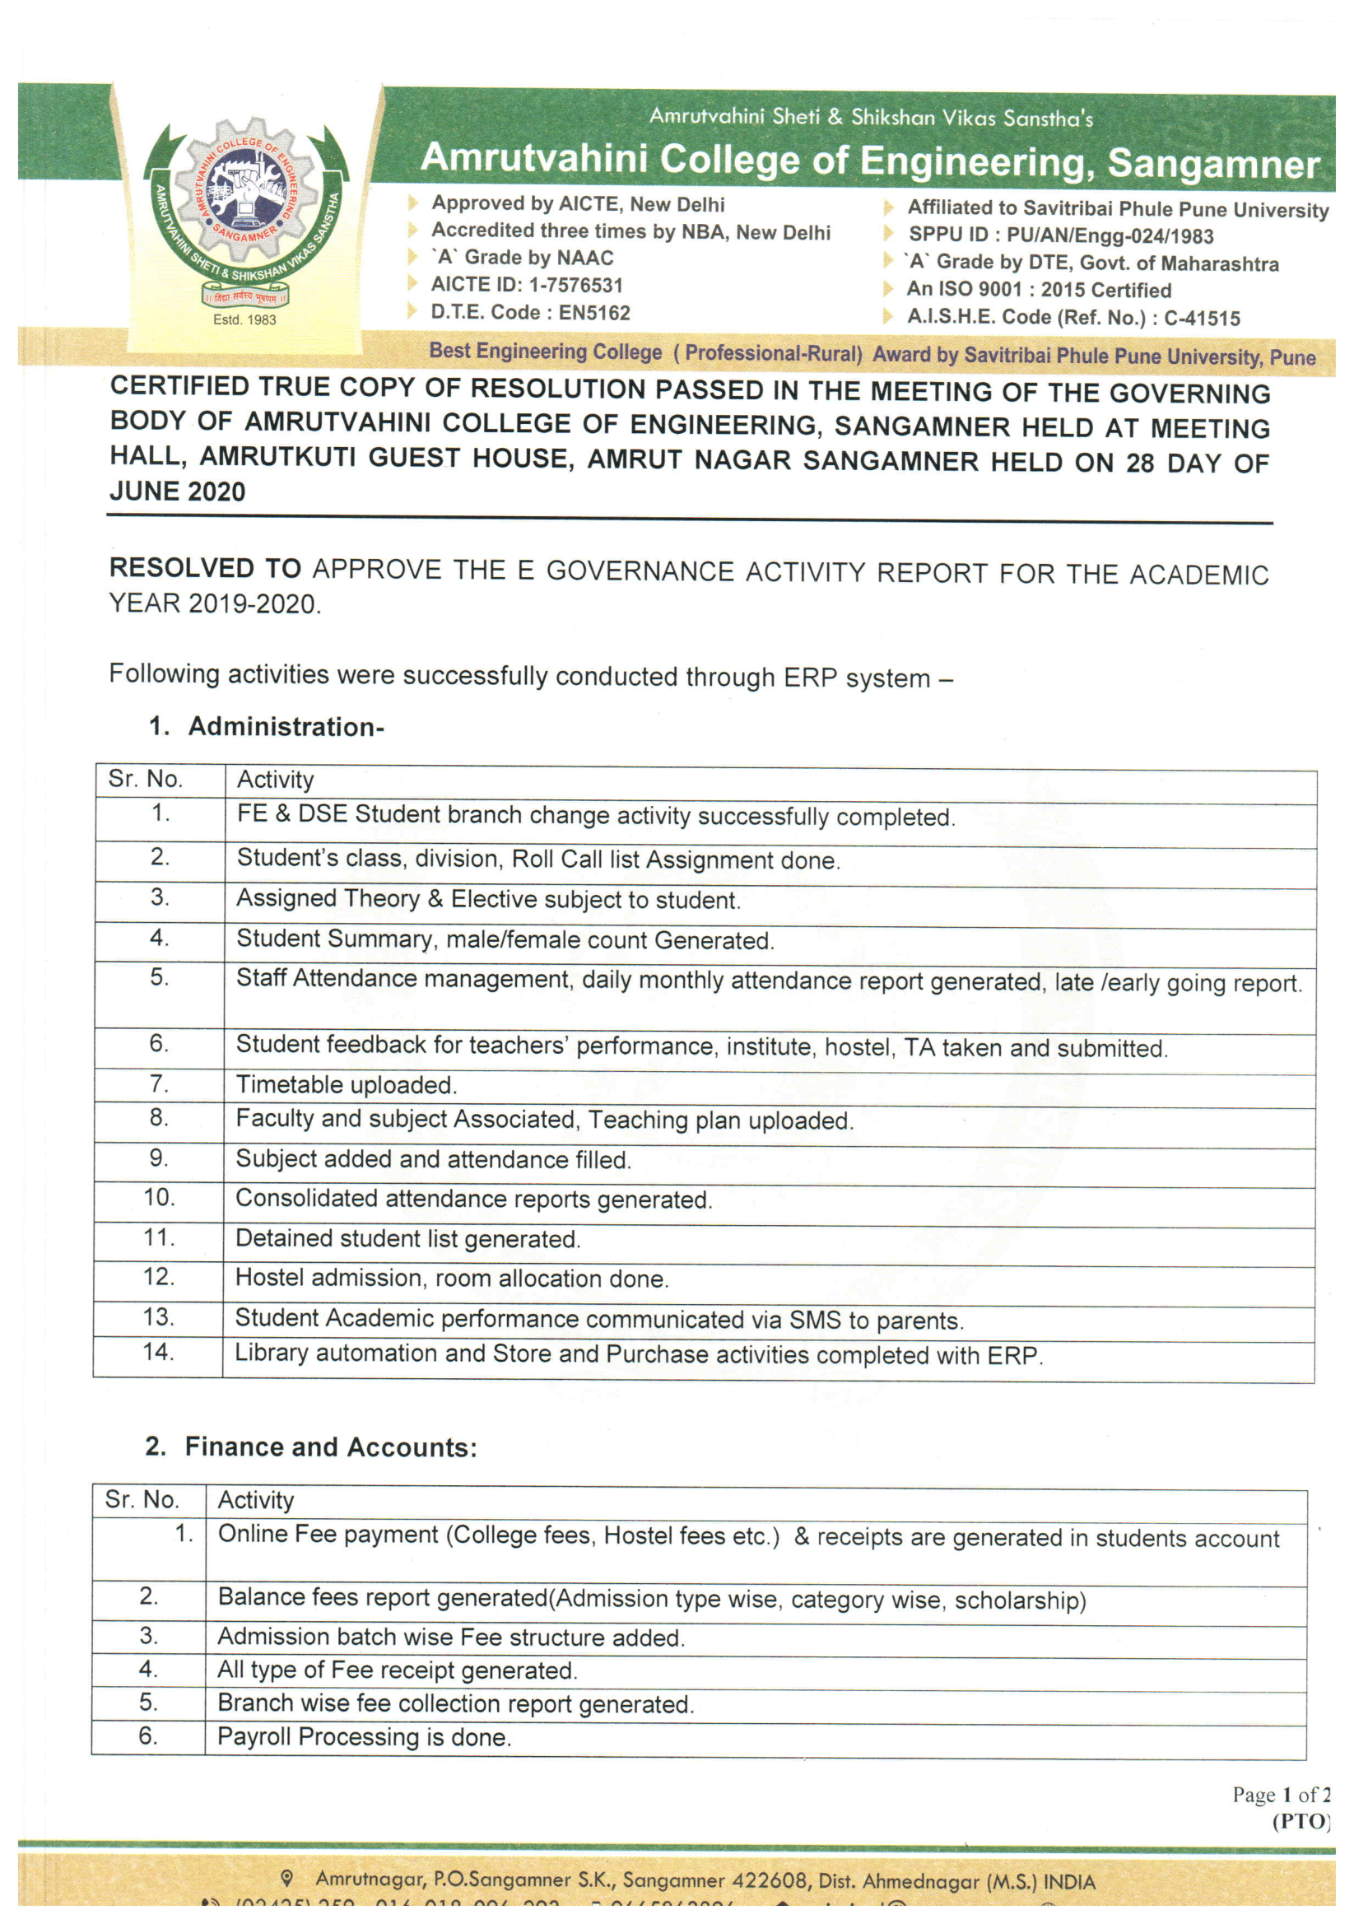
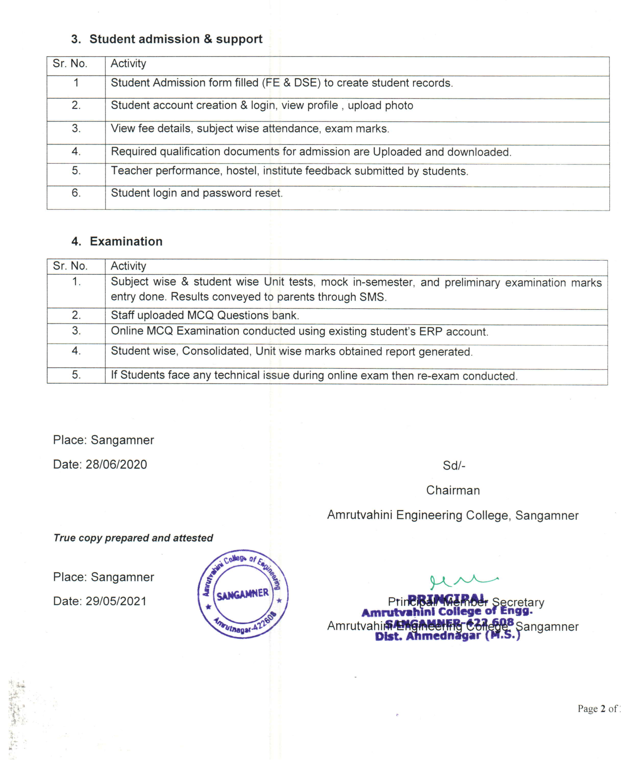
4. ERP Document


Ref. No. : SNRK/ / Date :

To,
The Principal,
Amrutvahini College of Engineering, Sangamner

Sub: - Details of Web & SMS based Customized College Automation software SackInfo (ERP). Dear Sir/Mam,
We at SyNchRoniK Inc, have developed the versatile software for the variety of needs of Educational Institutes for their day to day & other Management related activities with all most all important reports & information frequently asked by various prevailing committees like AICTE, DTE, NBA etc. & Management Bodies.
As we are aware that a MIS (Management Information System) plays a vital role in an Educational Institute. With continuous increase in number of students, material & other data in various categories, the management of institution becomes tedious and cannot provide required quality service to the users.
The Customized College Automation software developed by SyNchRoniK Inc. ensures very fast, prompt and well-managed services to everyone concerned. The software is so user friendly that, not only the working staff but also the users feel themselves very comfortable & at ease.
Beside, various routine features mentioned in the enclosed brochure, the advanced features like Web enabled, automated & manual sending of SMS to concern person, Response to SMS, Cash Collection, associating Digital media, Photo ID cards, Bar-coding and Web_OPAC, Graphical presentation, link with Bio-Matrix (finger print) machine, RF ID cards or face detection etc... are also incorporated in this software.
Company not only provides the suitable software for your esteemed institution but also commits the long-term healthy relationship by way of an excellent after sales support.
The SyNchRoniK & its services are not new, as our Library Automation software which is running successfully in more than 150 institutions from past 18 years.
The technology used for this is .Net (using C# & VB.Net) as front end & Oracle 10g as backend, which is very reliable for handling very high end data & web application with full security.
It will be our pleasure to provide you any information pertaining to the software.

Thank you,
For SyNchRoniK Inc. Encl: Module description in short, Client List

Rupesh Bhattad Director

Are you facing these challenges??

- Each time when Accreditation assessment process to execute or committee comes, you have to work preparing documents related to academics.
- How many students come for admission counseling & get converted into admission & counselor’s conversion ratio. Intimating important dates or availability of seats to students.
- Faculty does not know his/her syllabus coverage
- Don’t know about faculty’s academics, paper/seminar/project/workshop etc. details.
- Parents/Students does not know his/her attendance
- Parents/Students does not know his/her ward’s marks & progress
- Preparing mark sheet manually & unable to find faculty wise exam performance.
- Parents are not aware about his/her ward’s performance.
- You have to prepare student performance letter (letter to parents)
- Every time you have to spend 2-3 days in collection, preparation & calculation for monthly attendance of students subject wise.
- You are not aware of faculty on leave & their arrangement.
- You don’t know about teaching load as per time table & weekly, monthly coverage on time.
- You are not aware about the total fee balance from student & from govt. (Scholarship)
- You are not aware about the students not deposited single rupee & attending classes.
- You have to manually post the daily receipt entry in accounting software.
- Your library, exam, academic department have to maintain each student’s data separately which is not in sync with student section or to each other.
- Manually preparing Bonafied, Leaving, Character certificates for which you have to again look in to the student register & some time even you need to check forms.
- Circulating paper Notice & checking how many faculties have signed it? (E-Notice with read log).
- You are not able to send daily SMS regarding student full day/total absentee/presentee to their parents.
- Bulk mailing to students/faculty (selected/branch/year wise) for greetings or other important information.
- Unable to know department wise No. of books, titles & cost. Where to invest in books & most frequently require title & title wise demand.
- Not able to watch late comer/early going staff Unable to know leave sanctioned, leave balance (SMS alerts).
- Not able to know Department wise/Lab wise investment, stock available for consumable, furniture, equipments etc.
- Each time manually calculating salary, maintaining separate DA & other allowance & their deduction, preparing bank letter for crediting staff salary amounts, PF challan etc. Difficult handling multiple pay commission wise salary, providing pay slip & various salary certificates, deduction of loans & advances.
- Creating committees, maintaining meetings held & agenda, minutes of meeting & outcome
- Students don’t know future events, photos & details of past events.
- Benefits of training (its details) to students & its relation with placements. How many students are placed with average & max/min salary?
- How many students are using hostel, its room wise allocation & vacant bed & rooms, student balance fee etc.
- Important NOC related to land, fire & other gets lapsed & to renew you need to pay extra amount or fines.
- Don’t know about students travelling in bus, their boarding points, payments & balance, along with maintenance expenditure on bus & route. Driver’s details & his bus expenses etc.

- Management doesn’t know student’s feedback on various issues with corrective action taken. Faculty wise feedback & average rating of staff on various aspects.
- Loss important/confidential correspondences (inward & outward documents).
Many more such types of issues you are facing right now the only solution for this is to get an integrated management information system, which can manage your resources & provide right information at right time with very less efforts, easy to handle & cost effective too.
List of Modules we cover in ERP software are:

Sr No. | Module | Category
1 | System Administration | Compulsory
2 | User Management | Compulsory
3 | Establishment | Compulsory
4 | Admission | Compulsory
5 | Front Office | Compulsory
6 | Student Section | Compulsory
7 | Maintenance | Compulsory
8 | Fee Collection | Optional
9 | Accounts | Optional
10 | Central Clearance | Optional (Compulsory with Library)
11 | Payroll | Optional
12 | Purchase | Optional (Compulsory with Stores)
13 | Store | Optional (Compulsory with Purchase)
14 | Leave Management | Optional (Compulsory with staff Attendance)
15 | Staff Attendance | Optional (Compulsory with Leave management)
16 | Academic Monitoring | Optional
17 | Exam Section | Optional
18 | #Library | Optional
19 | SMS | Optional
20 | *Committee & Meeting | Optional (Compulsory with Events)
21 | *Training & Placement | Optional
22 | *Events | Optional (Compulsory with Committee & Meeting)
23 | *Feedback | Optional
24 | *Inward Outward Document | Optional
25 | Hostel | Optional
26 | Estate Management | Optional
27 | Transport | Optional
28 | Skill Development | Optional
29 | *Grievance redressal | Optional
30 | *Andriod App (For Students/Faculty) | Optional
31 | #Student Attendance automation | Optional
32 | Online classroom (Teaching- Learning Integration  with third party software) | Optional(Compulsory with Academic monitoring)
33 | Online admission ( with Payment gateway  integration) | Optional

* Marked additional modules are helpful in NBA/NACC (MIS and DSS facility also available) # Module depend on level of automation and technology feasibility.

Flow diagram of SackInfo 2.5 (ERP) software

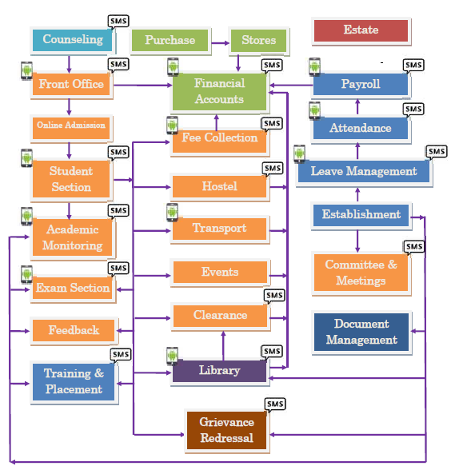

*Integrated with Android App Integrated with SMS

  - Modules Over view

    - System Administration

There should be a user as an Administrator who should be able to set the Parameters and Masters. Role based access rights will be provided. There is one level down to Administrator called as Module Admin who will further decide the role & access level of users.

    - Admission

      - Form collection from students.
      - Prospectus selling & course wise rate fixing.
      - Admission confirmation & Student ID with password send through SMS
      - Seat availability position Branch/Quota wise

    - Student Section

      - General Information of students admitted Detailed Information of students admitted Last school/college details
      - Documents submitted by student at the time of admission & receipt printing Permanent Register
      - Photo ID card with barcode
      - Category wise, Male/Female wise, Branch wise, Year/Sem wise, Section wise list Address labels
      - Automatic Roll No. assigning & batch allocation
      - Bulk transfer of students to next year with facility of balance fee carried forward.
      - Student seminar/paper presentation & other details.
      - University/AICTE/DTE related student list.
      - Blood group wise student’s list Other reports …

    - Front Office

      - College Leaving Certificate (T.C.) (One time printable for a student & next time duplicate is written on the certificate)
      - List of student taken T.C. University Form “A” & “B”
      - Bonafied Certificate (With purpose selection & issue details) Character Certificate
      - Notice for Digital notice board
      - Notice bin for Department with list of staff who seen the notice
      - Student Counseling with back remarks
      - Image for front page display, thought for the day

    - Fee Collection

      - Fee structure making (Academic Year/ Batch/ Course/ Year/ Category)
      - Automatic fee collection (Depending on fee structure & priority)
      - Fee Installment
      - List of Fully paid students
      - List of non-paid students
      - List of some paid students (not fully paid & fully paid)
      - Payment details of students (Student ledger)
      - Daily Collection report (Head wise/cash/cheque wise)
      - Fee collection collecting person wise
      - Fee collection for non-registered students
      - Fee Collection under college & sanstha head
      - Head wise fee receipt automatic transfer to Accounts module (Bank selection facility for chq/DD case)
      - Consolidate fee applicable/paid/balance with no. of students
      - Receipt cancellation/ fee refund & other related facility
      - Branch/Year wise graphical comparison

    - Academic Monitoring

      - Daily monitoring (Topic completion, work assignment etc.)
      - List of Period not engage
      - Letter/SMS to Parents about attendance & college exam marks.
      - Student Roll List section wise.
      - Student Attendance (Date of Admission / day college open)
      - Subject wise student Attendance (from date to date) Faculty lag & lead as per teaching plan
      - Department wise period details Subject wise period engage
      - Subject wise student list for (Elective subject) Subject Description
      - Time Table (Consolidate, Faculty wise, Year/sem wise etc.)
      - Elective subject handling & its attendance.
      - Theory/Practical/Tutorial/Studio etc. wise attendance

    - Leave Management
      - Leave management (C.L./M.L./Half Pay etc.)
      - Leave application & sanction
      - Leave credited, availed & available (balance)
      - Online application for leave
      - Leave Approval & sanction by sanctioning authority (2 level process)
    - Staff Attendance

      - Attendance (time in time out) using bio-matrix(thumb)/barcode/RF ID / Face detection / contact less card etc.
      - Monthly muster with time in/out & total no. of punches
      - Monthly leave processing
      - Consolidated attendance sheet

    - Exam Section
      - Subject wise Marks entry for internal exam/test
      - List of appeared/non appeared students
      - Topers list
      - University Exam marks & result sheet
      - University Exam fee collection & fine implementation.

    - Establishment

      - Employee master information
      - Employee detail information
      - Employee Experience details
      - Employee Academic details
      - Employee Paper presentation, seminar, Projects, funded, sponsored projects, publication etc.
      - Employee work specialization
      - One page bio-data of teaching staff.

1.2.11 Payroll Processing
- Monthly salary processing of employees.
- Monthly processing of various loans.
- Monthly processing of various advances.
- Monthly processing of various deductions
- Salary Slip.
- Consolidated department/Employee Type wise salary sheet

    - Financial Accounting

- Complete Book Keeping.
- Register and Statement of Accounts. General Ledgers.
- All types of Vouchers i.e. Payment, Receipt, Journal, Contra, Purchase. All linked with respective modules like Purchase Voucher with Central Purchase, Payment against GRN, and Receipt with Fee Collection etc.
- Flexible Voucher Numbering.

    - Central Purchase

      - Indent (Requirement & if not present purchase) New item/material
      - Purchase requisition Approval (Direct & from requisition slip)
      - Purchase Order
      - Material received on Delivery challan
      - Approval of material from concern department & GRN (goods receipt note)
      - Payment request generation for accounts department
      - Material returned/not received reminders with reminder number (1st, 2nd)

    - Central Stores

      - GRN number generation for stock entry
      - GRN number wise/Department wise/Financial Year/Academic year wise stock book Central Stock Book
      - Party Ledger
      - Lab wise stock report
      - Material Movement
      - Provision to Writoff
      - Consumable material handling
    - Maintenance

      - Compliant regarding Computer Hardware/Civil Works/Electrical works/Carpentry works etc. can be lodge on line & call attended with remarks.
      - Daily/Weakly/Monthly report of work done & work load on each department
    - Digital Library

Acquisition
- Budget Allocation.
- *Budget deduction at each level.
- Generating and placing Purchase Order
- Receiving items, keeping record of no of copies of items ordered and received & balance.
- Reminders.
- Master record (Accessioning) keeping.
- *Suggestion at each level with online help.
- Generation of new arrival Bulletin (on line)
- Graphical analysis of Material wise Inventory.
- Automatic keyword feeding (Just by scanning content list)
- Automatic class no. from subject class no. Database.
- *Accompanying material handling.

Catalogue
- This module does technical processing of books received from Acquisition Section
- Catalogue search through OPAC
- User services
- Authority file maintenance.
- Title/Sub-title/Author/Publisher/Subject/ISBN/keywords wise search facility
- Report Generation.
- Automatic catalogue in exact AACR2 format
- Adds Copy, use of authority files, single database for different material, material type creation, editing any record, Class No. help depending on subject.
- *Fully Bar-Code Enabled with bar-coded Spine label printing, Unified Acc. No. for bar-coding can be printed using normal laser printer (Barcode printer not require) on simpler & sticker paper.

Web Online Public Access Catalogue (Web-OPAC)
- Searching an item available in the library, by author, title, subject descriptors, Keywords, *ISBN etc.
- Single search screen for Books, Journals, Newspaper & Magazine with digital media presentation & keyword wise searching.
- Fresh arrivals list.
- Catalogue card view with Availability status for each accession number.
- Access through Internet Browser on each machine in network.
- *Advance OPAC includes AND, OR & combination of Search (i.e. Boolean Search).
- Online Reservation of non-available title.
- Facility of updating records on net through s/w.

Circulation
- Membership management with *Photographs.
- *Generation of Bar-coded Membership Cards.
- Maintains Status of various items.
- Circulation transactions viz. issue, return, re-issue with *Bar code & manual.
- Fine management for each category of user and Material category-wise & Member category- wise.
- Reading room & night issue of Material
- Cumulative fine.
- Fine account history with amount forgiven entry with remarks
- Generation of No Dues Certificate.
- Overdue & other Reminders.
- Related statistical & detailed reports.
- Automatic Holiday management for return date
- Single point Issue-Return capability.
- Customizable Member-Material transaction rules.
- Non-moving material list.
- Material in demand with multiple choice options
- Material History (Complete transaction history)
- Member History (Complete transaction history)
- Issued on basis of amount deposited with or without % rules
- Clearance list of student
- Penalty implementation
- Stock Verification, adaptable with advanced *hand-held computers through Bar-code facility.
- Year wise stock availability & lost/cost paid etc. record
- Send to/Receiving material from Binder.

Serial Control
- Subscription (renewal and new subscription)
- Checks the issues including prediction of arrival of issues & issue monitoring with *accompanying material handling.
- Search for every item.
- Master file Maintenance.
- Master database management.
- Various report generation.
- Reminders.
- Binding Management.
- *Bill Management (Monthly/Yearly)
- Integrated search from Web-OPAC/OPAC.

Article Indexing
- Accompanying Material Handling.
- Article saving with Title, Author/Editor, Pertaining Pages, Subject, ISSN, Publisher.
- Type of serial i.e. News Letter, Proceedings etc.
- Indian/Foreign list.
- Late arrival of issue.
- Not arrived Issue List.
- Amount deference between Performa-Invoice/Invoice amounts to calculate out-standings.

Administration
- Level based user access setting, by using this module Administrator can create the users and allot the work to users, He can also modify the user access & change passwords.
- Backup facility of full Database on single button click including Photograph etc.
- *Also in this module the Administrator can monitor the overall system.
- Total 3-tire security system is implemented.

Statistical Presentation
- The financial Year wise graphical representation of statistics data in Bar-Chart & Pie-Chart formats.
- Number of various members in various categories.
- Statistics in Pie/Bar chart of Amount invested in various financial/Academic years
- Dynamic selection of years as required.
- Department wise-financial year wise statistical presentation in Graphical view.

Other / Committee Reports
- Number of Titles & their copies.
- Indian/foreign Journals report.
- Requisition/Approval/Order/D.C./Accessioned/Payments etc. Reports & their Status.
- Transactions of circulation.
- Member/Material History and Stock Verification Reports
- Alphabetical Booklet of Title & Author with no. of Copies in dictionary type view for search.

    - SMS
- Marked modules are helpful for NBA

  - Attendance update of each student (for parent’s access) with subject wise details
  - Terminal/University marks update to parents
  - Automatic Due date reminder of library books by SMS
  - SMS of availability of reserved material.
  - Salary processed intimation with net salary update Fee pending/submitted update
  - Leave balance (With leave type details)
  - Daily attendance update to parents
  - Birthday greetings
  - Bulk SMS sending (course wise/branch wise/year wise)

    - User Management
      - Facility to Create of new user with level of access to various modules
      - Facility to restrict the user privileges with 5 level access controls.
      - User logs with working details.
1.2.19 Central Clearance
- Issue of materials to various departments
- Dues implementation
- Single window for clearing of dues on students for Department, Library & accounts (fees)

    - *Feedback
- Multiple feedback creation
- Feedback question creation & rating
- Assign feedback to group of students
- Feedback for parents, Industries etc. registered members
- Student wise feedback analysis
- Subject wise feedback analysis
- Feedback wise Student wise Average Rating
- Feedback wise Subject wise Average Rating
- Comparison of feedback subject wise
- Action/Reward to faculty feedback wise
- Corrective action taken record keeping

    - Event Management
      - Creation of academic & nonacademic events
      - Maintaining details of all events with photographs
      - Details of all events like chief guest/winner up/venue/sponsors/organizers
      - Search engine
      - Presentation of events on calendar with colors
      - Various reports & contact details

    - Estate Module
      - Multiple land creation & details of land like owners & their share etc.
      - Details of land
      - Document keeping & scan copy of each legal documents/maps
      - Various NOCs from deferent departments their renewals & reminders
      - List of all supporting documents their scan copy
      - Various construction works in land.
      - Floor wise construction details with area allocated to various amenities
      - Lots of reports with consolidation/details

    - *Inward/outward document management
      - Unique ID generation for Inward document maintaining record of subject, address, keywords, dates, sender etc. & mode of transport.
      - Maintaining different types (Confidential/Urgent/general/Quotation/AICTE/DTE etc.)
      - Document forwarding to different person associated & re-forwarding with remarks.
      - Scan copy uploading facility
      - Status updation at each level
      - Complete document life cycle with current status & person name.
      - Search engine
      - Unique ID for outward document capturing various details
      - Reply with reference to outward document link
      - Various reports

    - *Committees & Meetings
      - Create different levels & committee in that levels.
      - Add agenda of committee formation.
      - Add roles of committee
      - Add member to committee
      - Add roles to each member
      - Call meeting & send e-mail/SMS to all committee members on a click,
      - Enter venue/date/time etc. information for meetings
      - Add attendance of members of committee.
      - Add minutes of meeting.
      - Get various types of reports: list of committees, members, meetings, attendance, minutes of meeting etc.

    - *Training & Placement
      - Academic/nonacademic training program organized by our institution with participants, their presence, venue, schedule date & time, organizer details, guest etc.
      - Preparing database of companies on the basis of type of work & sector, with contact details of key persons, calling companies for campus.
      - Company wise selection criteria.
      - Preparing database of eligible students
      - Conducting interview
      - Final placement with package information
      - Package analysis on year on year & branch on branch basis.
      - Various list as desired by companies on various filters
      - Training to placement comparison.
      - Follow-ups with companies for placements
      - Auto Sending of greetings (SMS/e-mail) to contact persons of companies.

    - Hostel Module
      - Multi building creation
      - Creation of type/subtypes for rooms
      - Floor wise room details with area, bed & other amenities
      - Enrolment of students
      - Allocation of room & beds to students
      - Bed wise room rents collection monthly/yearly basis
      - Option to choose from amenities available & its charge allocation
      - Fee collection
      - Student wise monthly/yearly outstanding
      - Monitoring students in & out with bio matrix machine.
      - Night out/guest entry
      - Conserving various capital expenses & day to day basis.
      - Meal calendar
      - Alerts for various grocery items.

    - Skill Development Module
- Creation of multiple Skill Development Programs
- Student database with facility of in house student & out student enrollment facility
- Course wise fee structure (Compulsory & course wise fee head)
- External Faculty registration & remuneration (Fees & No. of students enrolled in program wise)
- ADHAR Card association for tracking of students
- Many reports for tracking activities.

    - Transport Module
      - Route wise bus allocation
      - Multiple buses on same route.
      - Student & bus allocation
      - Student bus fees as per location of boarding
      - Student fee reminder & student having outstanding fee list
      - Bus wise month wise maintenance & expenses details
      - Bus’ legal documents & renewal reminders/alerts If integrated with VTS (Vehicle tracking system)
        - Boarding & dropping SMS to parents
        - Real time tracking of particular bus.
        - Bus tracking from smart device using app or on web browser

    - *Grievance redressal Module
      - Complaint lodging by students/parents or by Staff with Anonymous naming but through proper authentication.
      - Ticket generation for all logged complaints.
      - Ticket wise tracking of actions taken & current status of the ticket.
      - Ticket open/closed status with complaining person’s remarks with the facility of re-opening of closed tickets.
      - Related reports.

    - Android Mobile App.
A closely integrated mobile app with instant auto update. Can be integrate with other modules as per requirements
- : For Students
  - Student Profile
  - Fee Details (Applicable, Paid, Balance)
  - Library Outstanding book list (Due to return)
  - Attendance (Subject wise attendance with Average)
  - Exam Marks (Exam wise Subject wise Marks)
  - Live Notice
  - Library Book Search (OPAC)
- : For Staff
  - Staff Profile
  - Student Attendance fill up
  - Leave Application
  - Library Book Search (OPAC)
  - Today’s Lecture Schedule (as per time table)
  - Departmental Notice (Specific to Department he/she belongs to)
  - General Notice

    - Student Attendance Automation
As per requirement student attendance can be fully automated with RFID/Portable or Standalone Biometric/face machine.

    - Online Classroom
Planning, facilitating & uploading the video lecture is available at faculty login. Schedule and filtered access of teaching material like eBook, video available at student login.
Depending on student response auto attendance marking can be integrated with academic monitoring module.

    - Online Admission
Online admission process right from inquiry to payment and digital confirmation of admission is available within this module.
Payment gateway integration can be done as per requirement.
Document upload and online verification process can be avail with student section.
*SMS alerts facility at admission stages available.

Terms & Conditions

      - You have to arrange Hardware & other requirements as mentioned by our Engineer.
      - We undertake installation of software at the defined location, training of concern staff with their respective modules in two phases & customizations in 25 reports & 15 new reports as require throughout the year.
      - Training in 2 phases at your site.
      - We won’t provide any third party software or hardware or any other accessories.
      - Cost mentioned in price list is for software only. You have to procure the hardware/software or any other package (SMS pack etc) as recommended by technical personals from company.
      - Any data entry/transfer requires, will be charged extra.
      - You have to properly maintain the backup of software & data.
      - Data lost due to virus attack or hardware failure will not be the responsibility of the company, the software & data is recovered from the latest backup available with you.
      - Data backup should also be taken on non-system drive and external drive (Pen drive or extern hard disk) and after backup it should be removed from the server.
      - Payment & other terms mutually decided.
      - The Software is License for 1 Institute & 1 Sanstha only, if you would like to add new Institute the License will 50% of the billing cost if installed on same server
      - VTS hardware & monthly recurring cost will be separate.
      - The software is copy right of SyNchRoniK Inc.
      - The data is property of the concern institution.
      - Provision for lodging & boarding of engineer who visit the college for training & other purpose will be your responsibility at you expenses.
      - Support will be provided online & if in any case require to visiting the college will charged.
      - The support will be free of cost for the 1st year from the date of installation.
      - After 1st year of service if you would like to continue the services just by opting AMC (Annual Maintenance Contract) which will be 17.5% of the total cost of the software.
Head Office | Regional Centre (North Maharashtra)
Place: Nagpur (Near R.T.O.) | Place : Nasik ( Near MIDC Satpur )
mail : info@synchronik.co.in | mail : info@synchronik.co.in
Sales : +91 7720074321 | Sales : +91 9920356768

