5.1.2.Average percentage of students benefitted by scholarships, freeships etc. provided by the institution / non- government agencies during the last five years
5.1.2.1. Total number of students benefited by scholarships, freeships, etc provided by the institution / non- government agencies year-wise during last five years
- Provide policy document of the HEI for award of scholarships and freeships.
- Provide Audited Statement showing the expenditure on scholarships / freeships.

Response:
  - Provided policy documents of Sahakar Maharshi Bhausaheb Thorat(SMBT)/Amrut Meritorious Scholarship(AMS) and Cummins Scholarship for award of scholarships and freeships
  - Provided Audited Statement showing the expenditure on scholarships / freeships.
INDEX
Sr. No. | Description | Pg. No.
 | Policy documents of Sahakar Maharshi Bhausaheb Thorat(SMBT) /Amrut Meritorious Scholarship(AMS) and Cummins Scholarship for award of scholarships and freeships | 2
 | Audited Statement showing the expenditure on scholarships / freeships. | 6

- Policy document of the HEI for award of scholarships and freeships
- Policy Document of Sahakar maharshi Bhausaheb Thorat(SMBT)/Amrut Meritorious Scholarship(AMS)
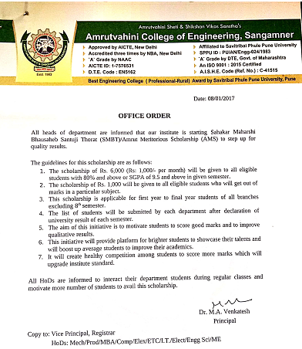
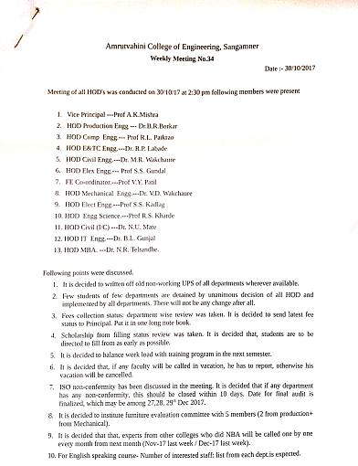
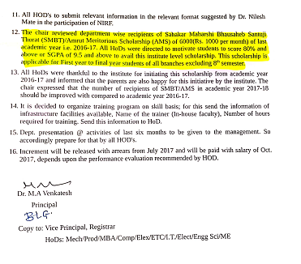

- Policy Document Cummins Scholarship
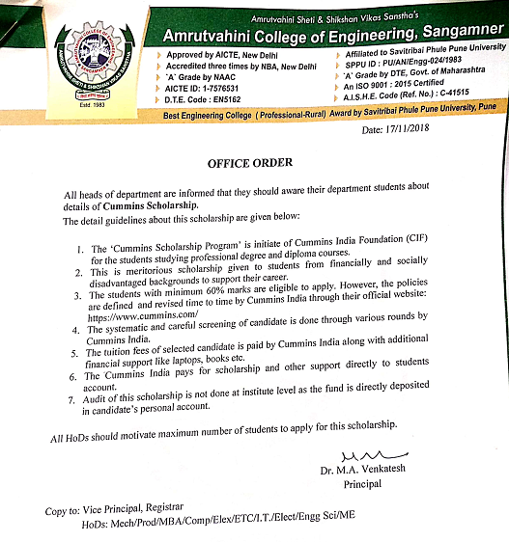

- Audited Statement showing the expenditure on scholarships / freeships
