5.1.1. Average percentage of students benefited by scholarships and freeships provided by the Government during last five years
5.1.1.1. Number of students benefited by scholarships and freeships provided by the Government year-wise during last five years
- Provide sanction letter of scholarship and freeships.
- Provide Year-wise list of students in each scheme.
Note:Link of Year-wise list of students is not opening.

Response:
  - Provided sanction letter of scholarship and freeships.
  - Provided abstract of Year-wise list of students for scholarships and freeships. For details, use the links given below for the Year-wise list of students in each scheme.
For detail click the following link
link
INDEX
Sr. No. | Description | Pg. No.
 | Document showing sanction letter of scholarship and freeships | 2
 | Abstract of Year-wise list of students for scholarships and freeships | 7

- Provide sanction letter of scholarship and freeships.
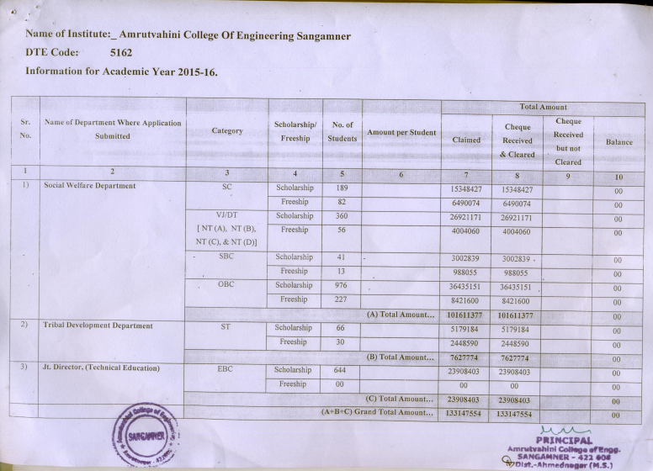
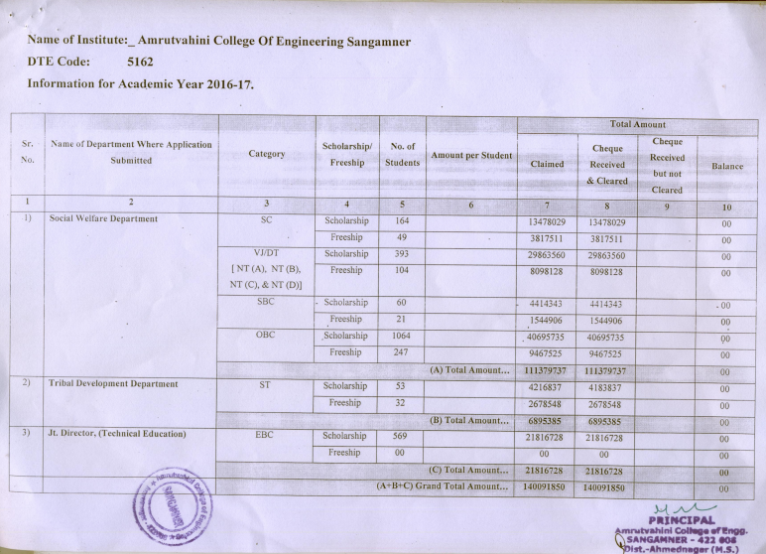

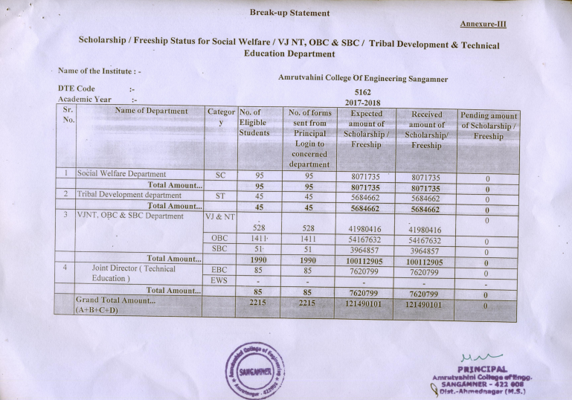
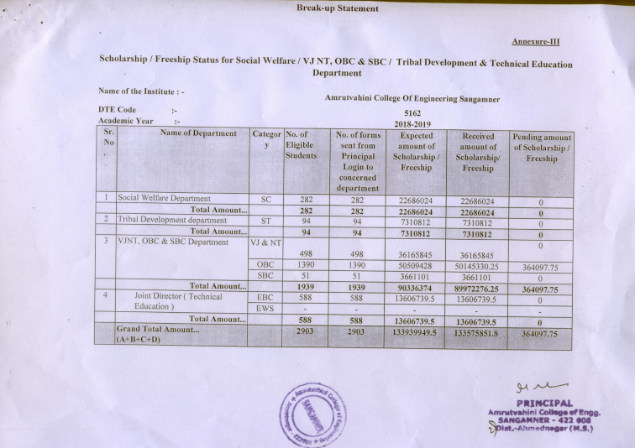
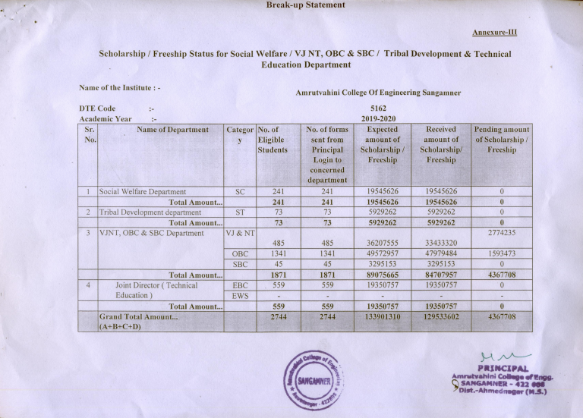

- Abstract of Year-wise list of students for scholarships and freeships.
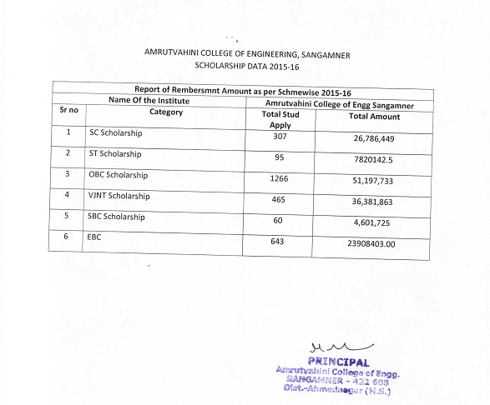
Kind request to use the links given below for the year-wise list of students in each scheme.
For detail click the following link

link

