4.3.3: Bandwidth of internet connection in the Institution
Options:
A. ≥50 MBPS
B. 30 MBPS – 50 MBPS
C. 10 MBPS – 30 MBPS
D. 10 MBPS – 05 MBPS
E. < 05 MBPS
1) Provide Bills for any one month/one quarter maximum three months old of the latest completed academic year indicating internet connection plan, speed and bandwidth and the HEI‟s name.
2) Provide E-copy of document of agreement with the service provider. Note: Snap shot of speed test for wifi/internet facility will not be considered. - Broadband connections will not be considered.
Response:
- Bills and E-copy of document of agreement are attached as mentioned in Index.

INDEX
Sr. No. | Description | Pg. No.
 | Bill copy and Purchase order of Internet | 2-3
 | BSNL-Internet Bills | 4-6
Bandwidth of internet connection in the Institution
Institution previously has 100MBPS internet bandwidth of BSNL which is now shifted to of Tatasky and detail of the proof is shown below.
- Bill copy of Internet Tata-sky (next pg.)

Bill copy of Internet Tata-sky
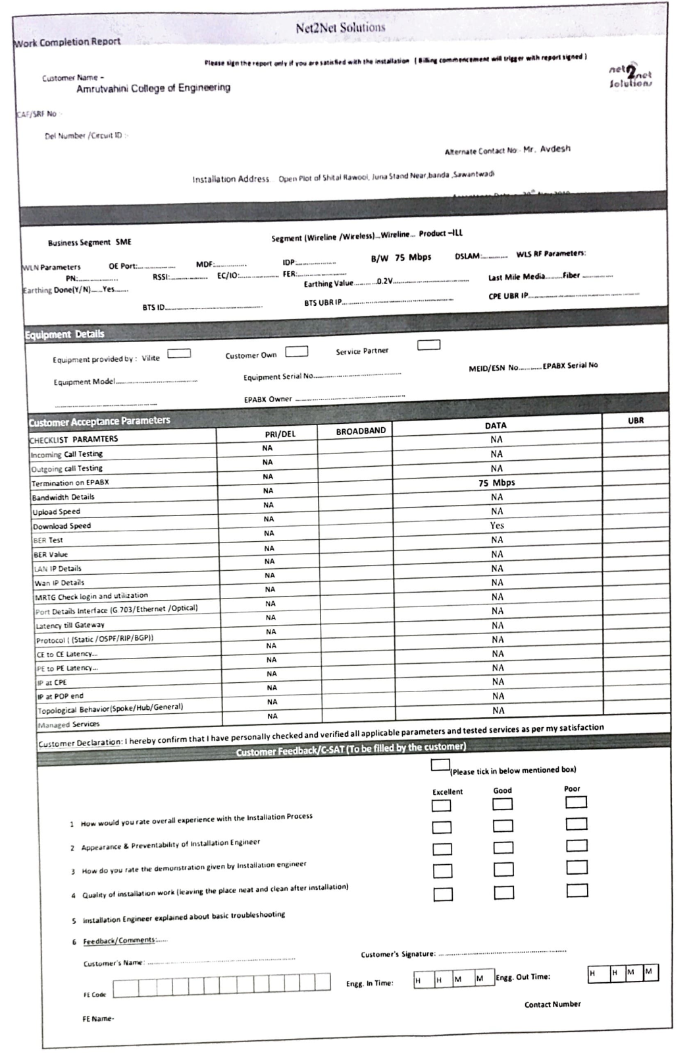
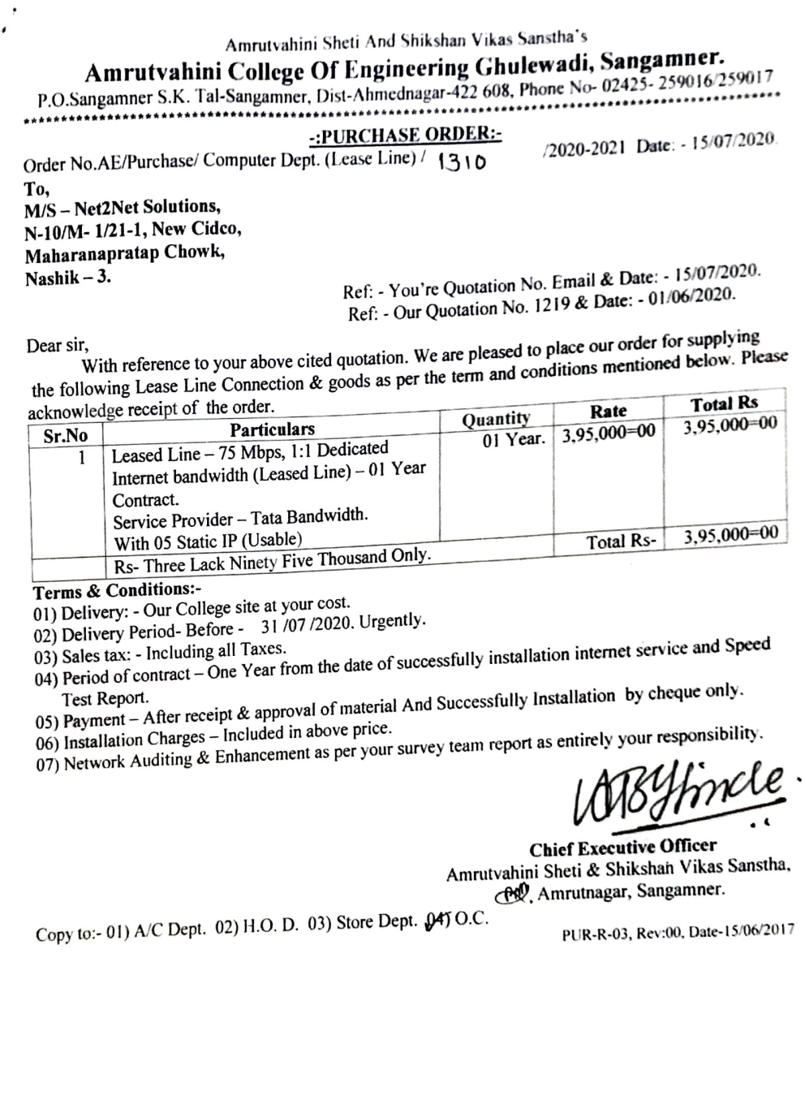

- BSNL-Internet Bills
