    - : Average pass percentage of Students during last five years
      - Total number of final year students who passed the university examination year wise during the last five years
      - Total number of final year students who appeared for the university examination year wise during the last five years
1) Provide consolidated document showing numbers of final year students who passed the university examination year-wise during the last five years signed by competent authority.
2) Provide Certified report from Controller Examination of the affiliating university indicating pass percentage of students of the final year (final semester) eligible for the degree program- wise / year-wise.
Response:
- Consolidated document showing numbers of final year students who passed the university examination year-wise during the last five years signed by competent authority.
- As per NAAC compliance, our college has applied to Savitribai Phule University, Pune for certified report from Controller Examination indicating pass percentage of students of the final year (final semester) eligible for the degree program- wise for last five years (2015-16 to 2019-20). It is still in process, we have only received the acknowledgement from University which is attached in this report.

INDEX

Sr. No. | Description | Pg. No.
1. | Consolidated document showing numbers of final year students who passed the university examination year-wise during the last five years  Numbers of final year students who passed the university examination in the academic year 2015-16 to 2019-20 | 2
2. | Certified report from Controller Examination of the affiliating university indicating pass percentage of students of the final year (final semester) eligible for the degree program- wise / year-wise.  Acknowledgement letter from affiliating university indicating pass percentage of students of the final year in the academic year 2015-16 to 2019-20 | 7
Note:

As per NAAC compliance, our college has applied to Savitribai Phule University, Pune for certified report from Controller Examination indicating pass percentage of students of the final year (final semester) eligible for the degree program- wise for last five years (2015-16 to 2019-20). It is still in process, we have only received the acknowledgement from University which is attached in this report.

- Consolidated document showing numbers of final year students who passed the university examination year-wise during the last five years
  - Numbers of final year students who passed the university examination in the academic year 2015-16

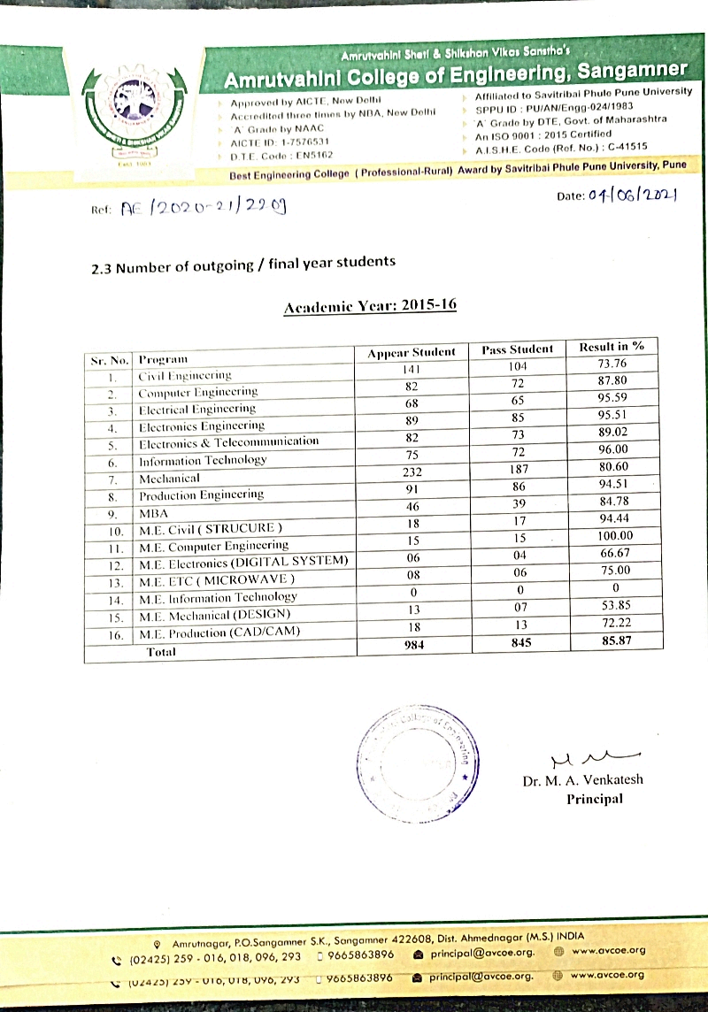

  - Numbers of final year students who passed the university examination in the academic year 2016-17

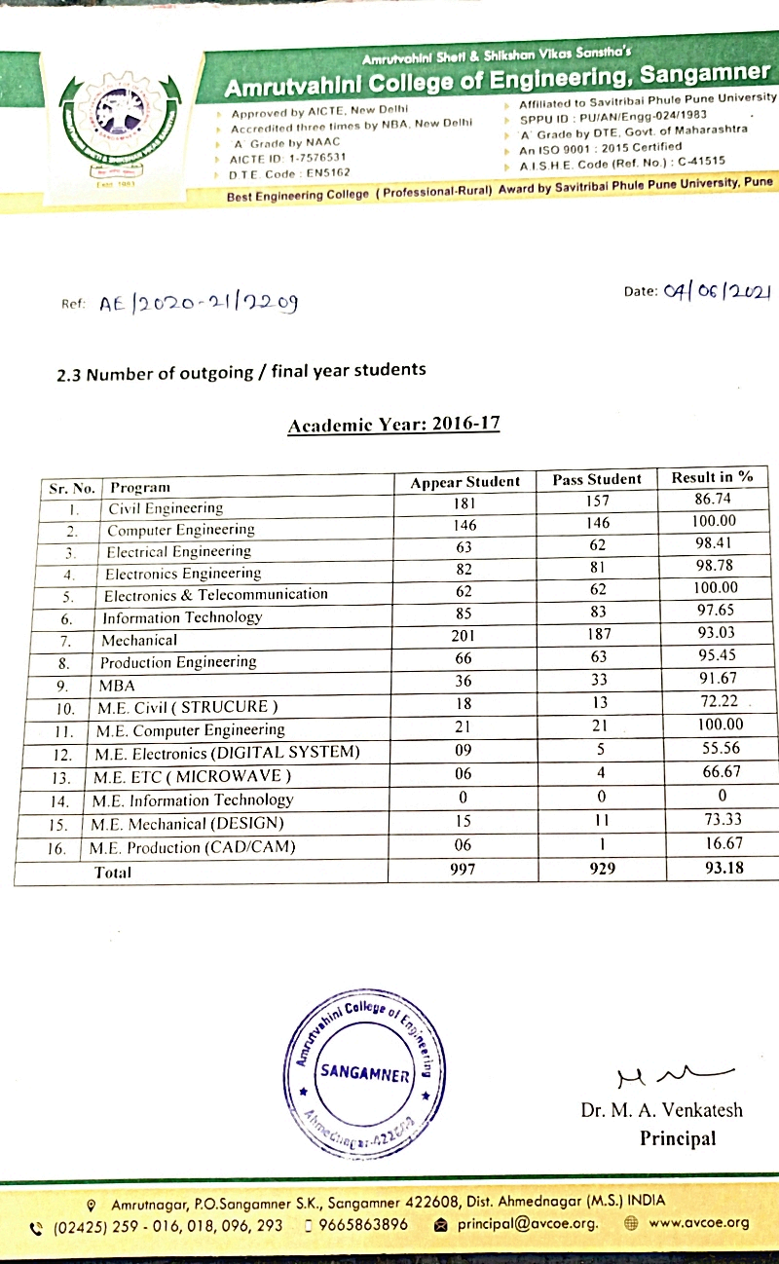

1.3 Numbers of final year students who passed the university examination in the academic year 2017-18

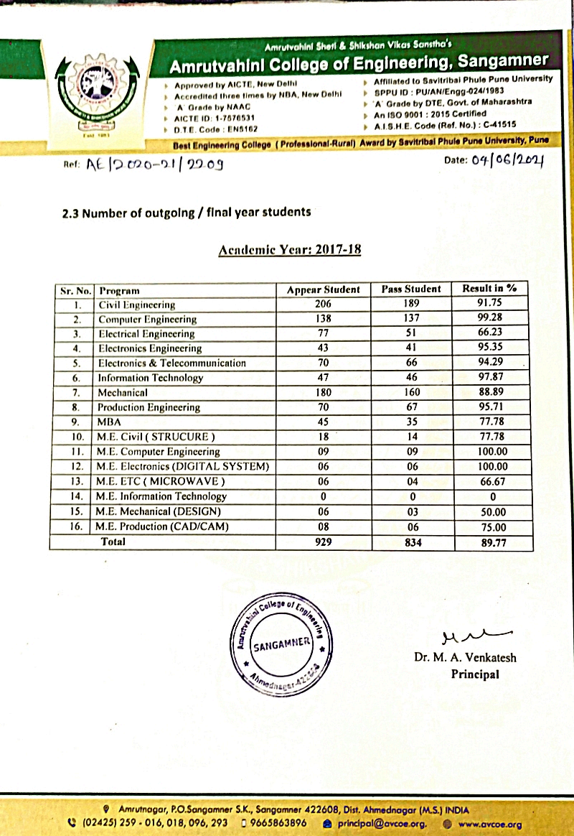

1.4 Numbers of final year students who passed the university examination in the academic year 2018-19

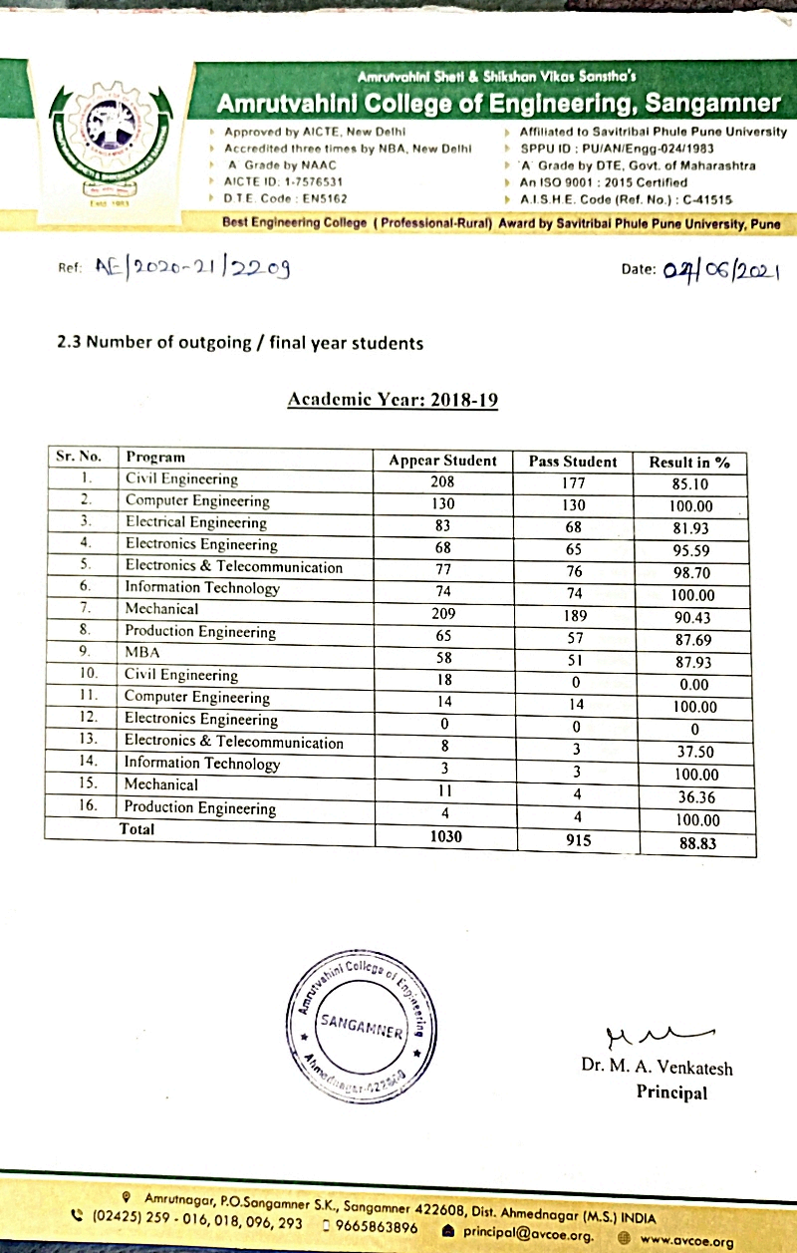

1.5 Numbers of final year students who passed the university examination in the academic year 2019-20

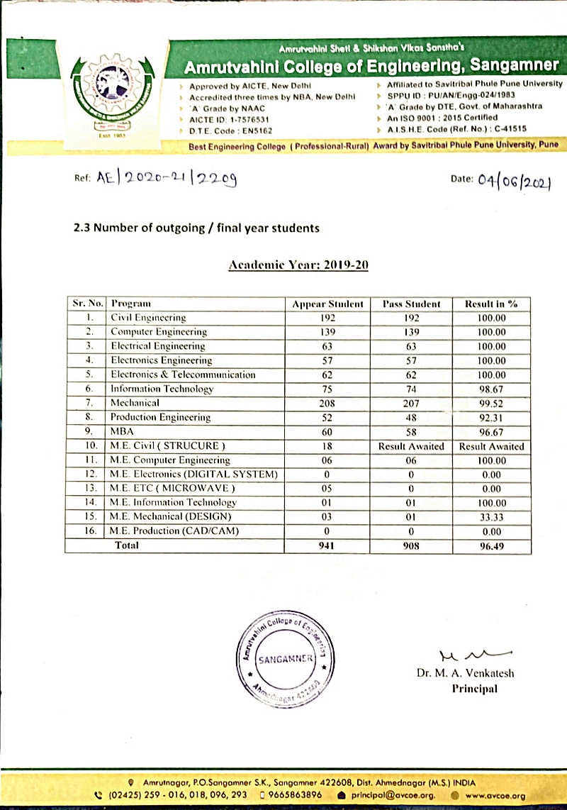

2. Certified report from Controller Examination of the affiliating university indicating pass percentage of students of the final year (final semester) eligible for the degree program- wise / year-wise.
2.1 Acknowledgement letter from affiliating university indicating pass percentage of students of the final year in the academic year 2015-16

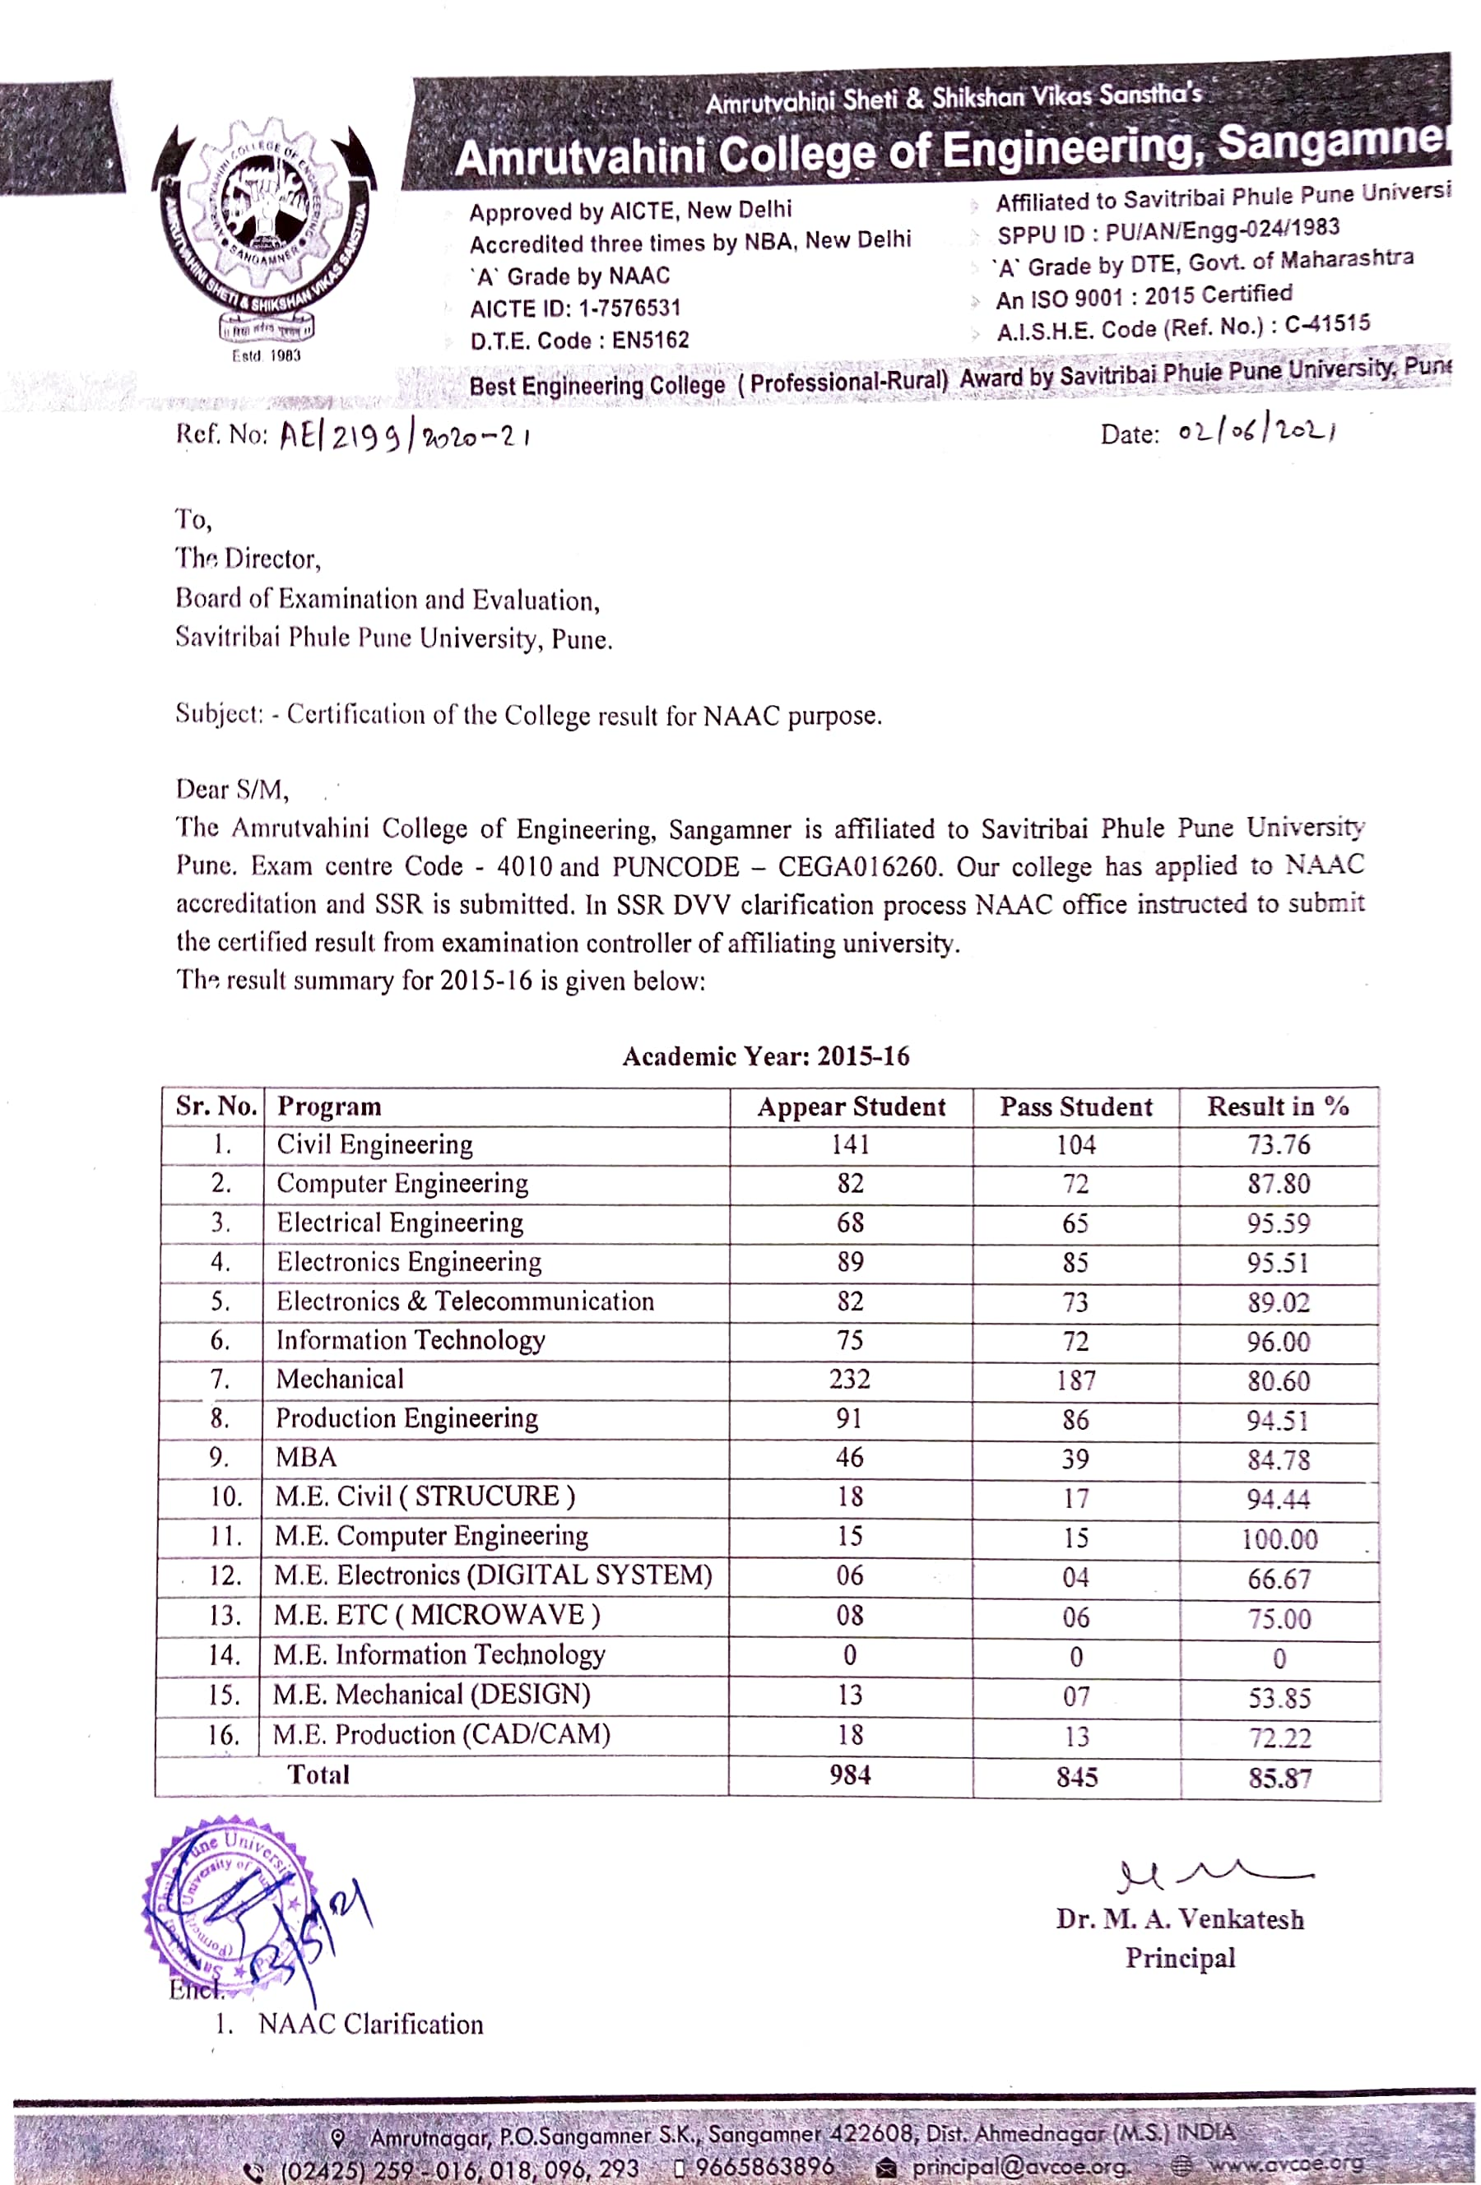

2.2 Acknowledgement letter from affiliating university indicating pass percentage of students of the final year in the academic year 2016-17

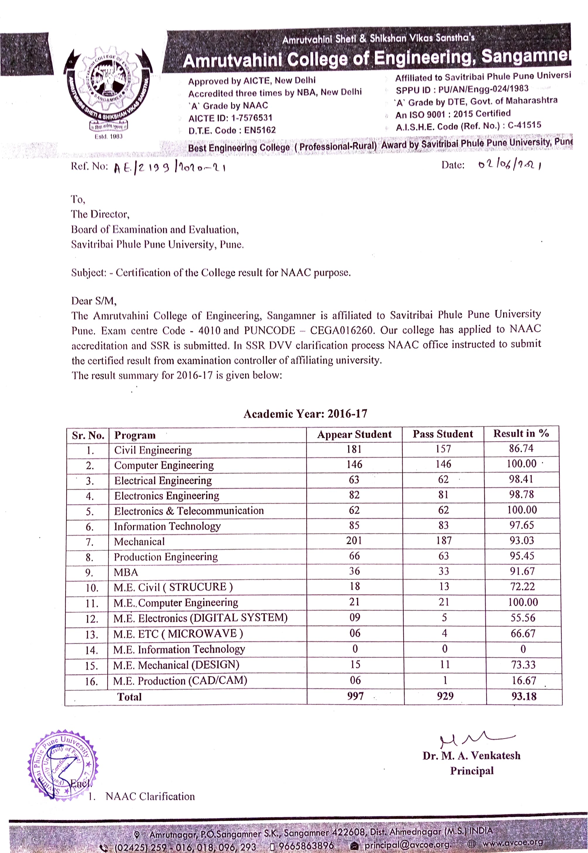
2.3 Acknowledgement letter from affiliating university indicating pass percentage of students of the final year in the academic year 2017-18

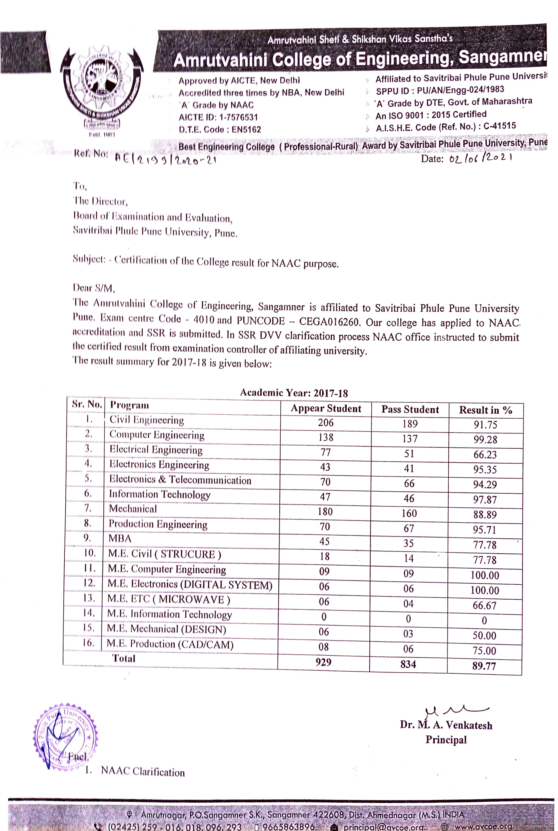
2.4 Acknowledgement letter from affiliating university indicating pass percentage of students of the final year in the academic year 2018-19

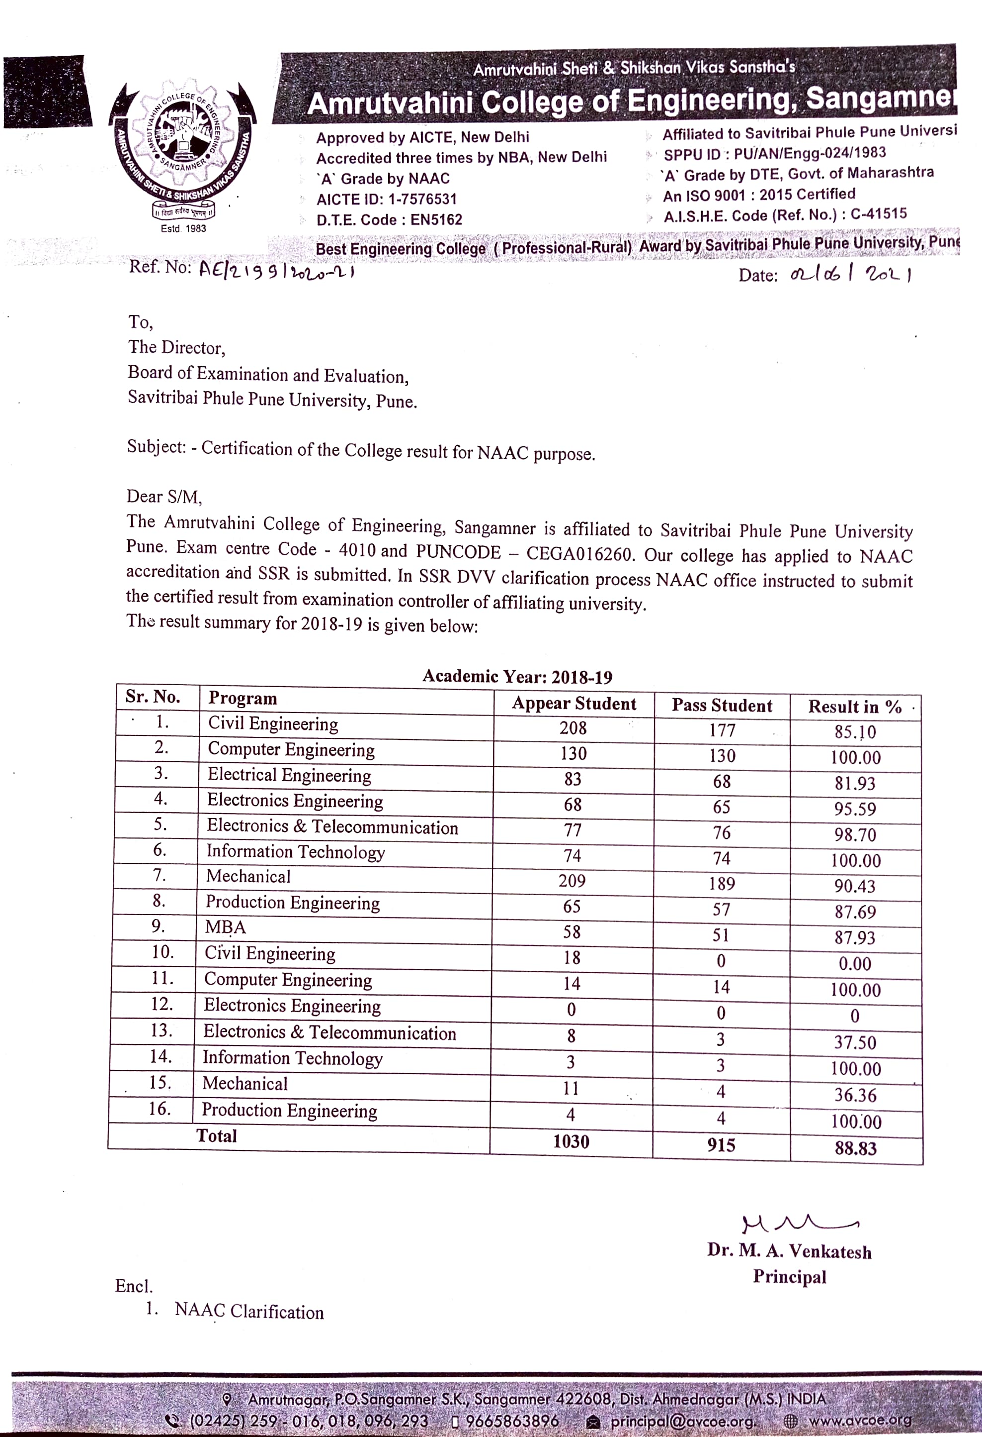
2.5 Acknowledgement letter from affiliating university indicating pass percentage of students of the final year in the academic year 2019-20

