Extended Profile
2.3: Number of outgoing / final year students year-wise during last five years

Provide authenticated document showing the number of outgoing/final year students in different programs during the assessment period duly signed by competent authority.

Response:
- Authenticated document showing number of outgoing/final year students in different programs during the assessment period duly signed by Head of the Institute is attached as mentioned in Index below.

INDEX

Sr. No. | Description | Pg. No.
1. | Authenticated document showing number of outgoing/final year students in different programs in the academic year 2015-16. | 2
2. | Authenticated document showing number of outgoing/final year students in different programs in the academic year 2016-17. | 3
3. | Authenticated document showing number of outgoing/final year students in different programs in the academic year 2017-18. | 4
4. | Authenticated document showing number of outgoing/final year students in different programs in the academic year 2018-19. | 5
5. | Authenticated document showing number of outgoing/final year students in different programs in the academic year 2019-20. | 6

Authenticated document showing number of outgoing/final year students in different programs in the academic year 2015-16.
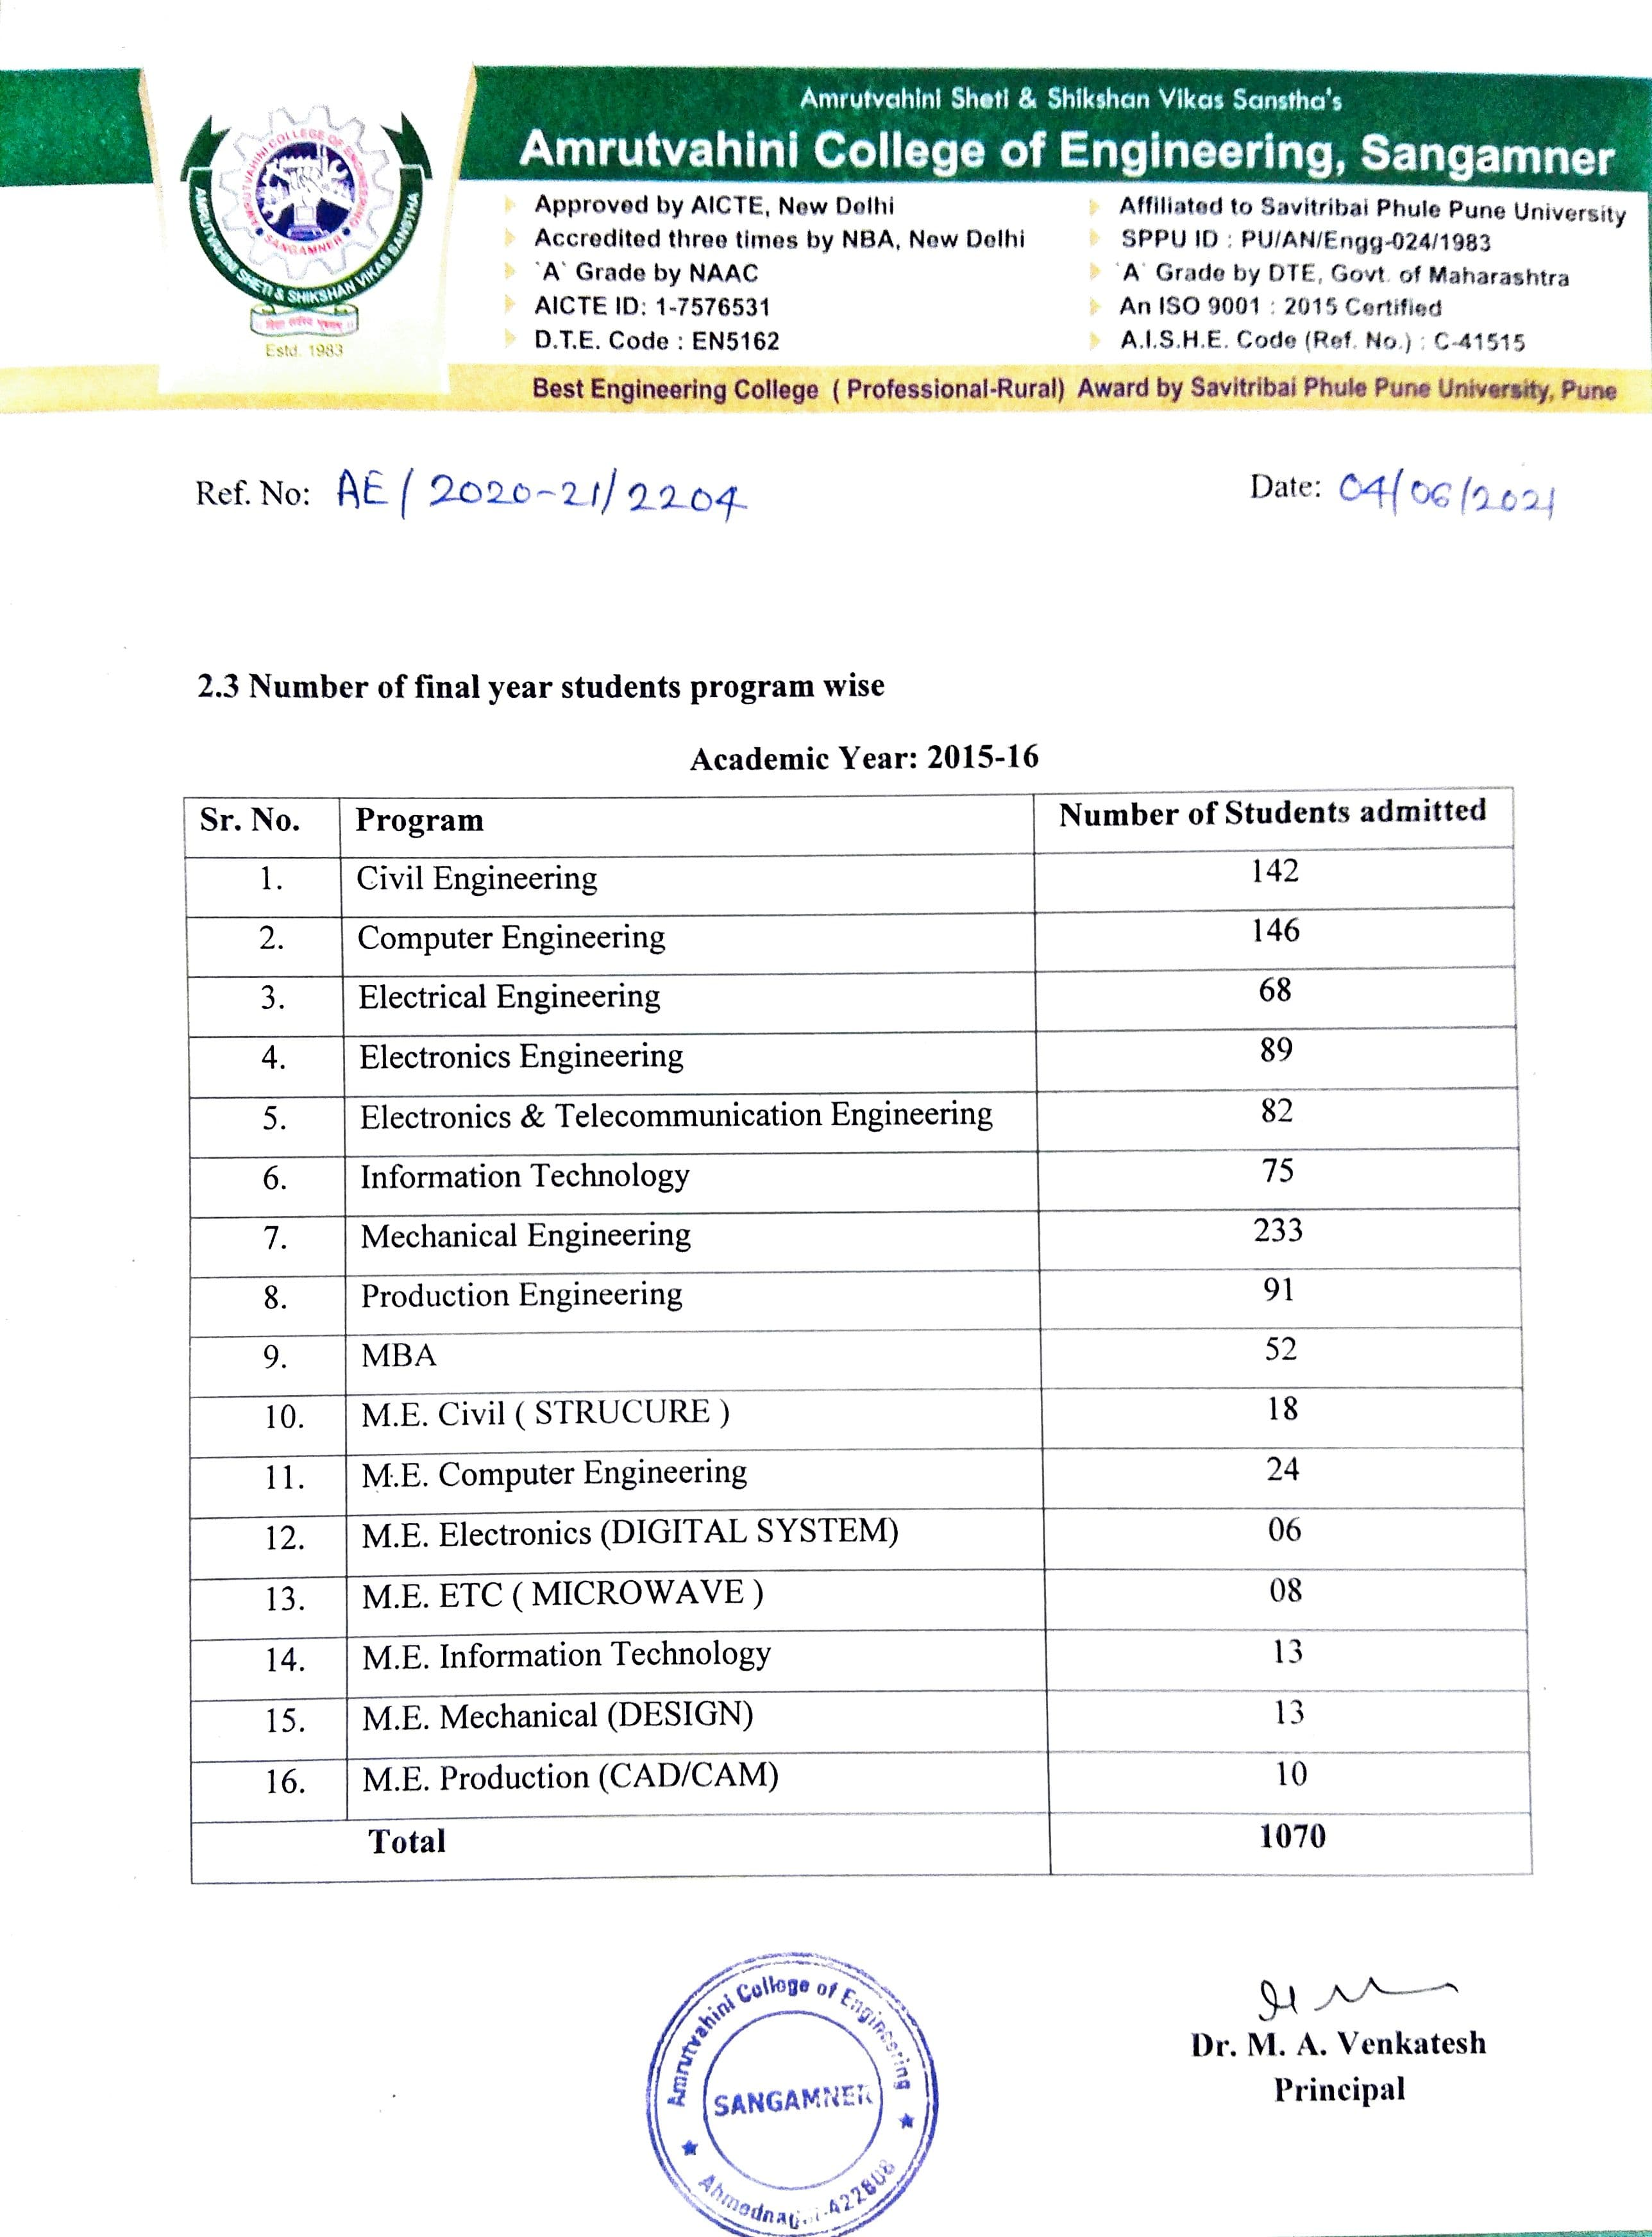

- Authenticated document showing number of outgoing/final year students in different programs in the academic year 2016-17.

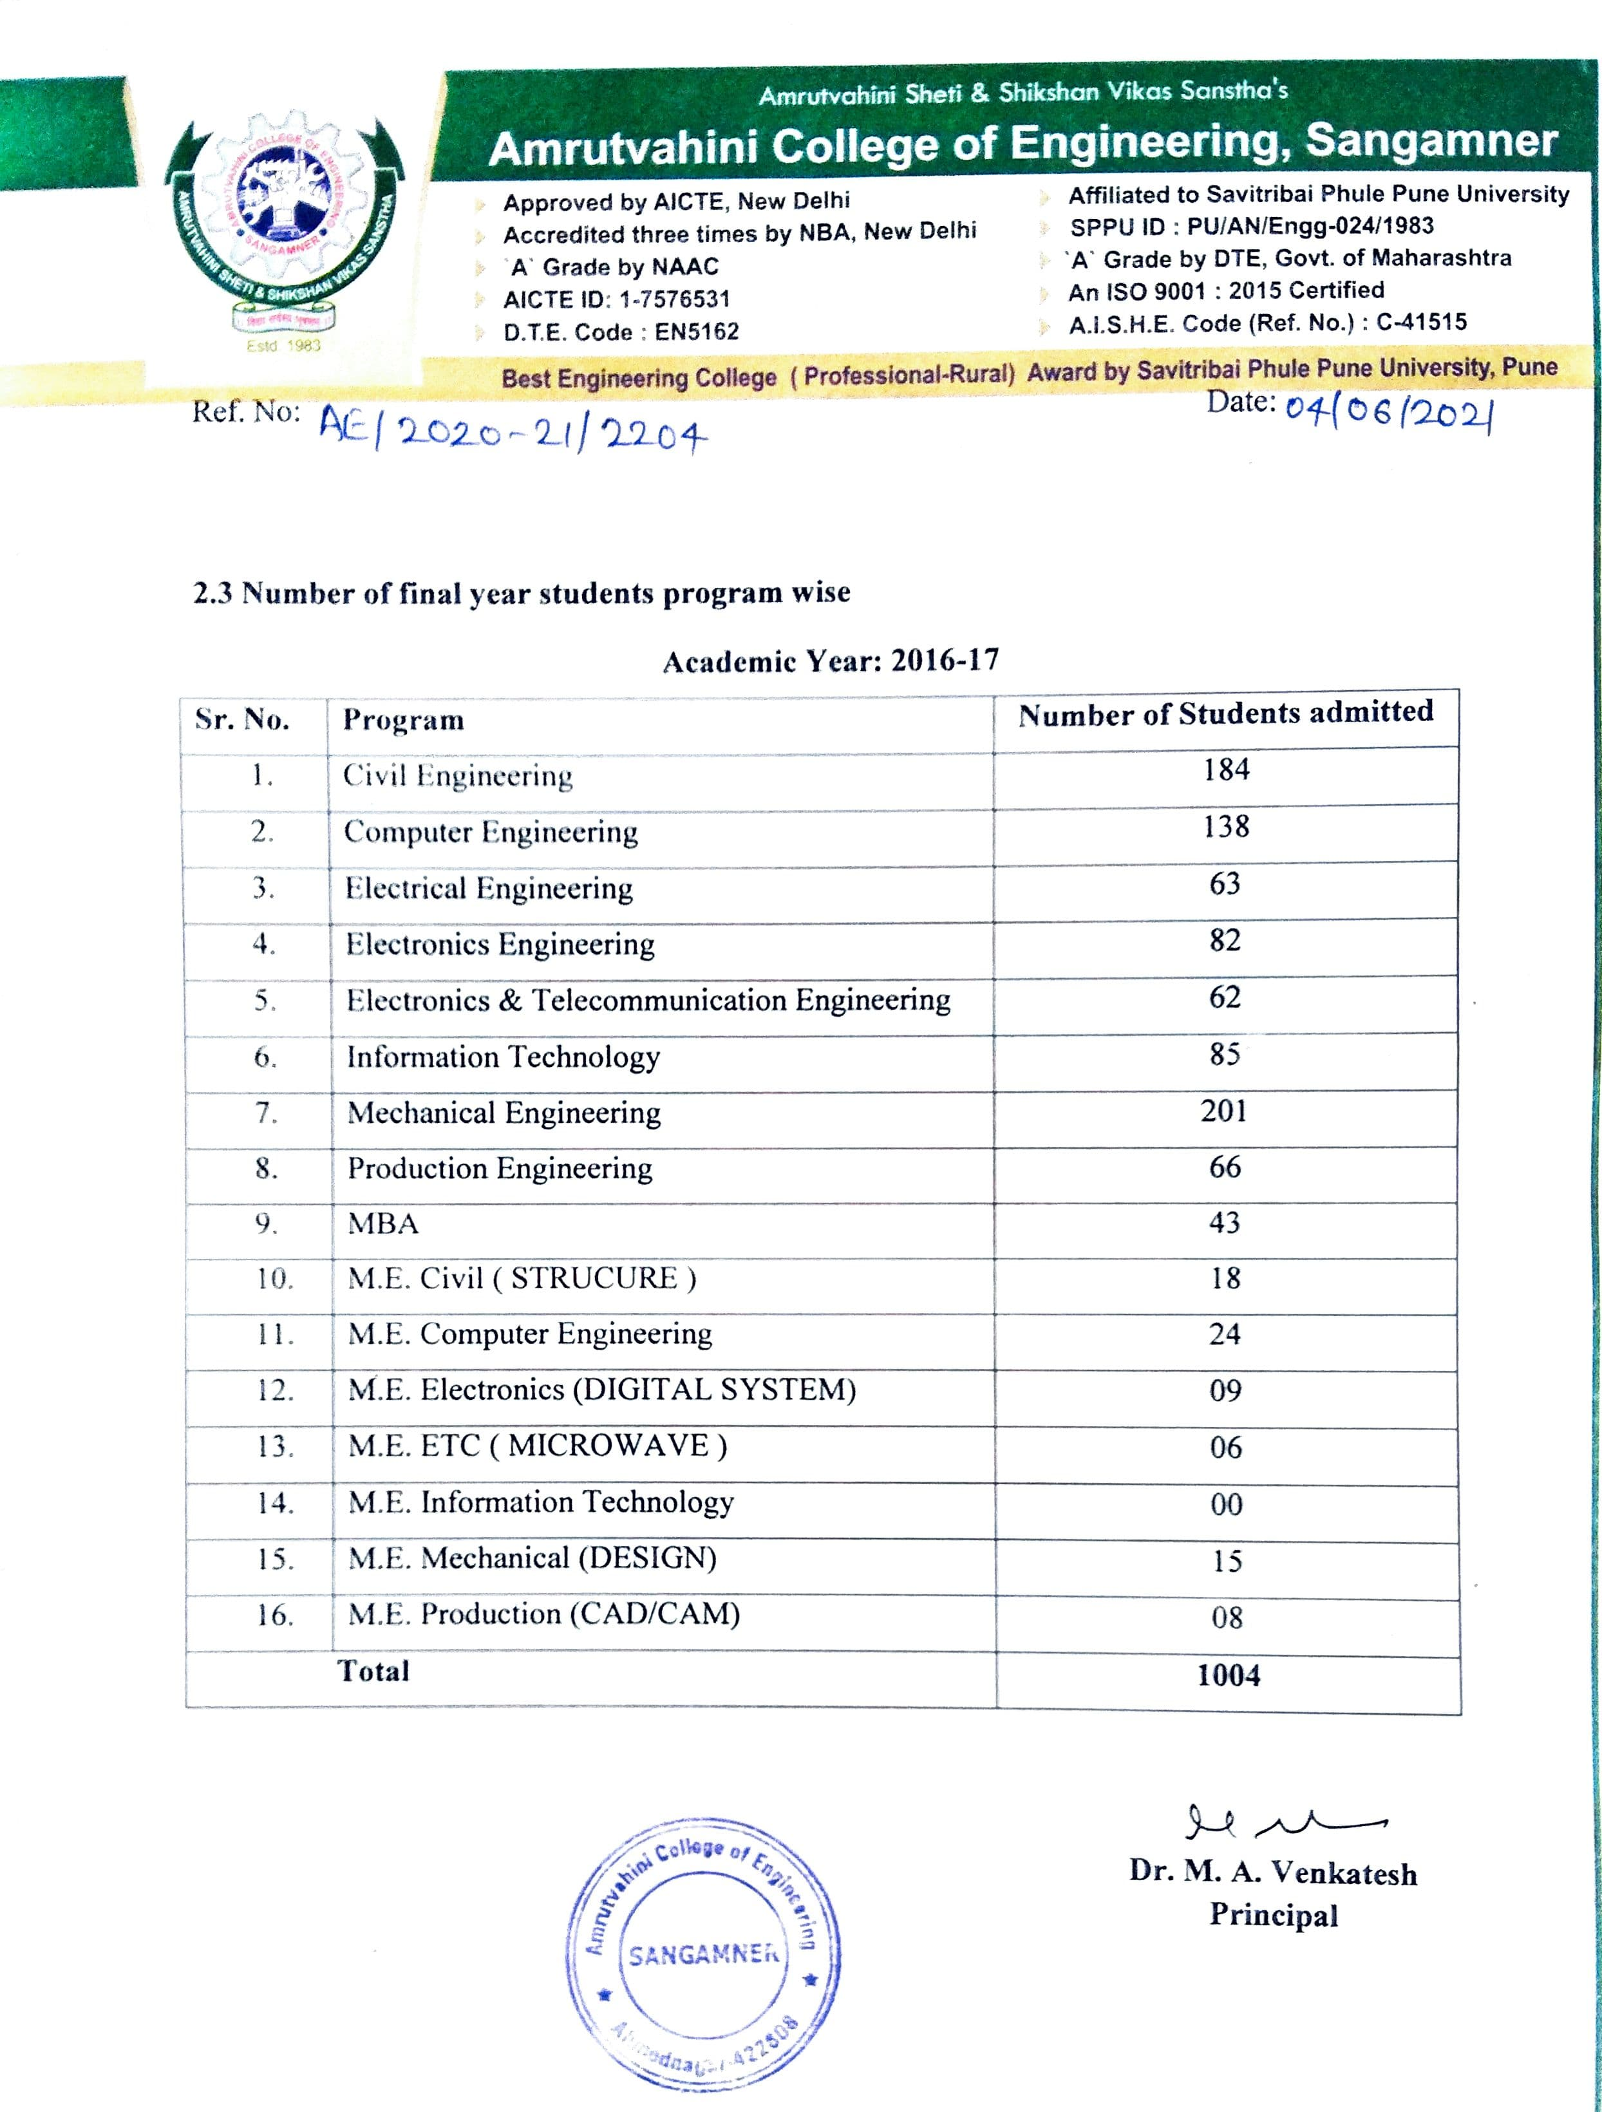

- Authenticated document showing number of outgoing/final year students in different programs in the academic year 2017-18.
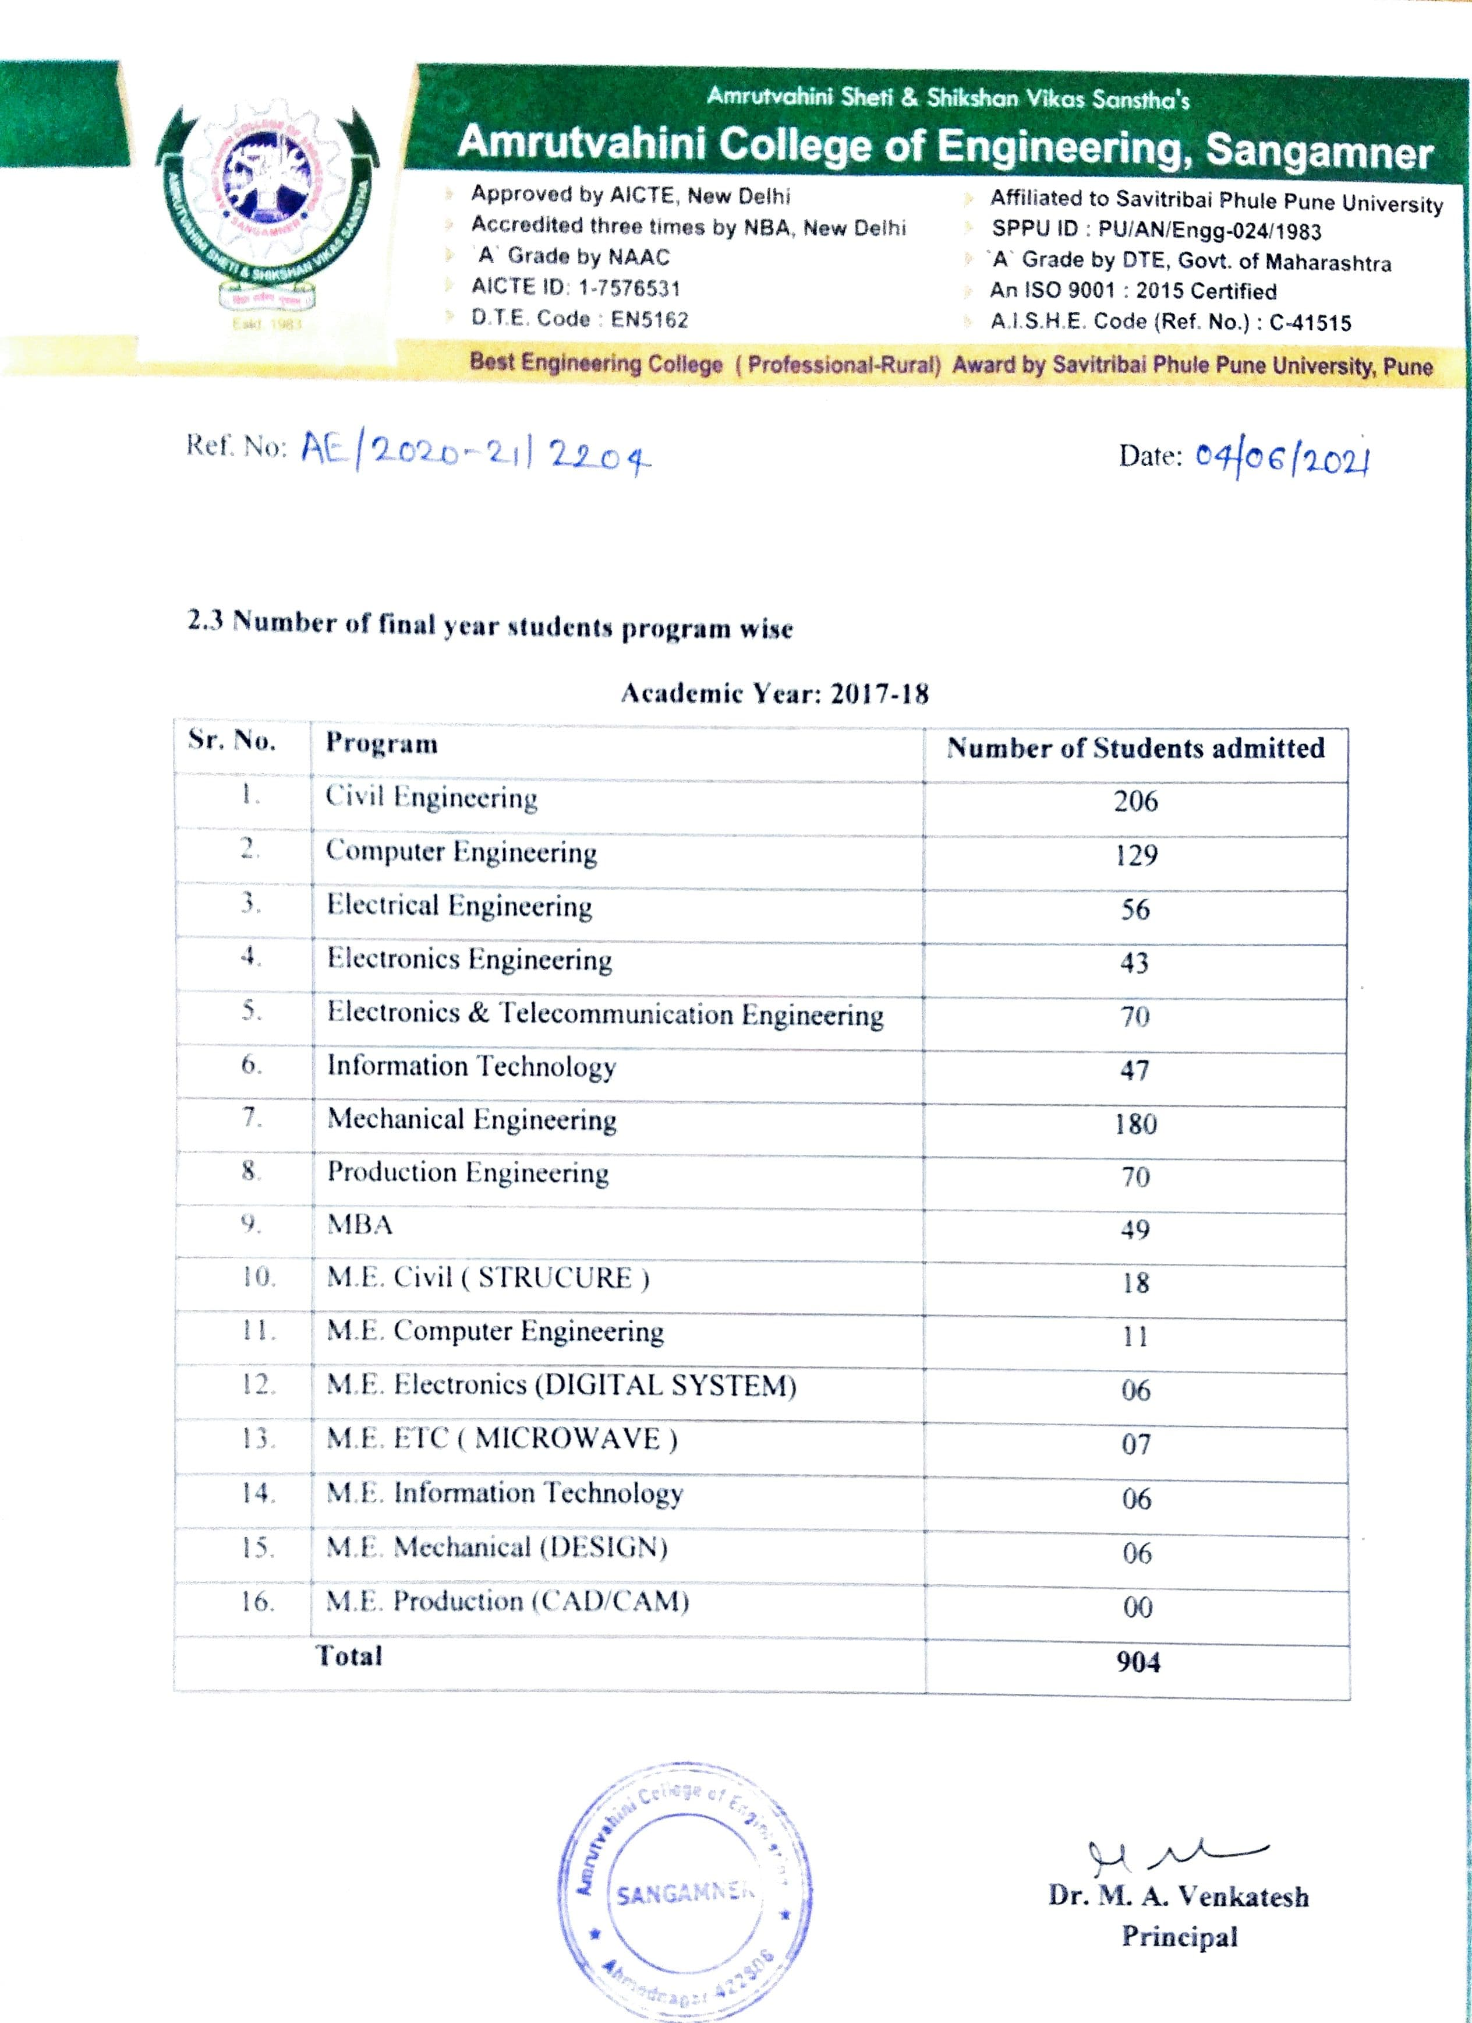

- Authenticated document showing number of outgoing/final year students in different programs in the academic year 2018-19.
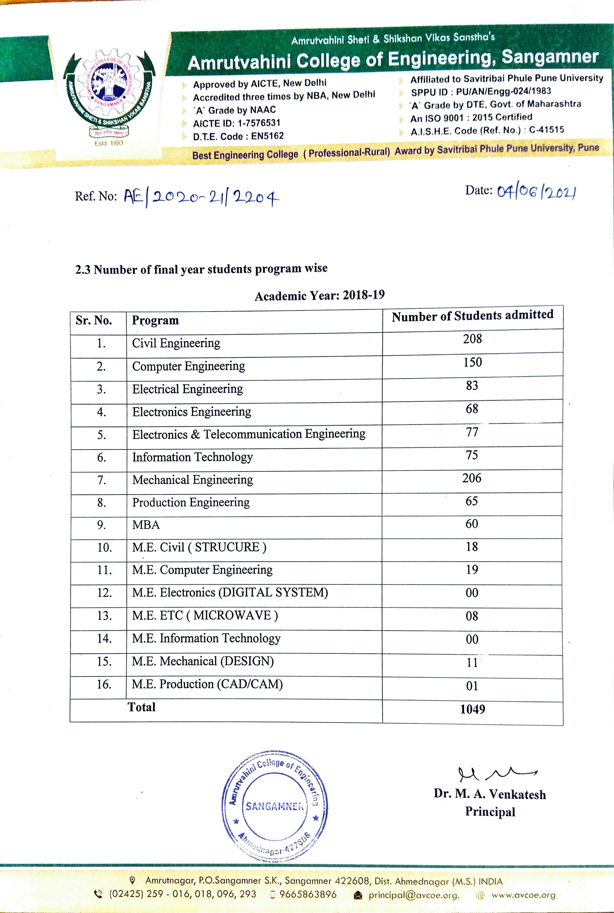

- Authenticated document showing number of outgoing/final year students in different programs in the academic year 2019-20.
