2.3.3: Ratio of mentor to students for academic and other related issues (Data for the latest completed academic year)
2.3.3.1 Number of mentors
The documents showing issues raised and resolved in the mentor system (Sample wise) are explained in sequence as mentioned in index below:

INDEX
Sr. No. | Description | Pg. No.
 | Ratio of mentor to students | 2
 | Case Study-1 | 3
 | Case Study -2 | 6

- Ratio of mentor to students

Ratio of mentor to students for the latest completed year (2019-20) is given below
Ratio of mentor to students for the latest completed academic year (2019-20)
Total No of Student | 3202
Total No of Mentors | 178
Ratio of Mentor to Students | 1:17.9 (15-20)

- Case Study-1
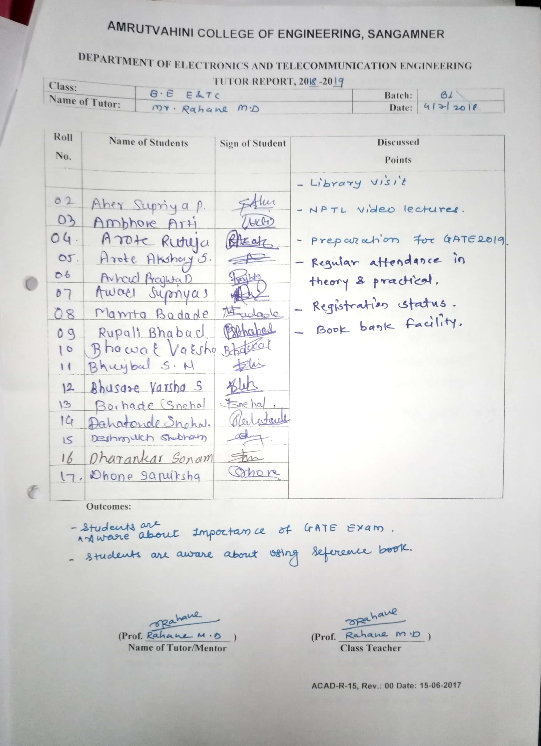

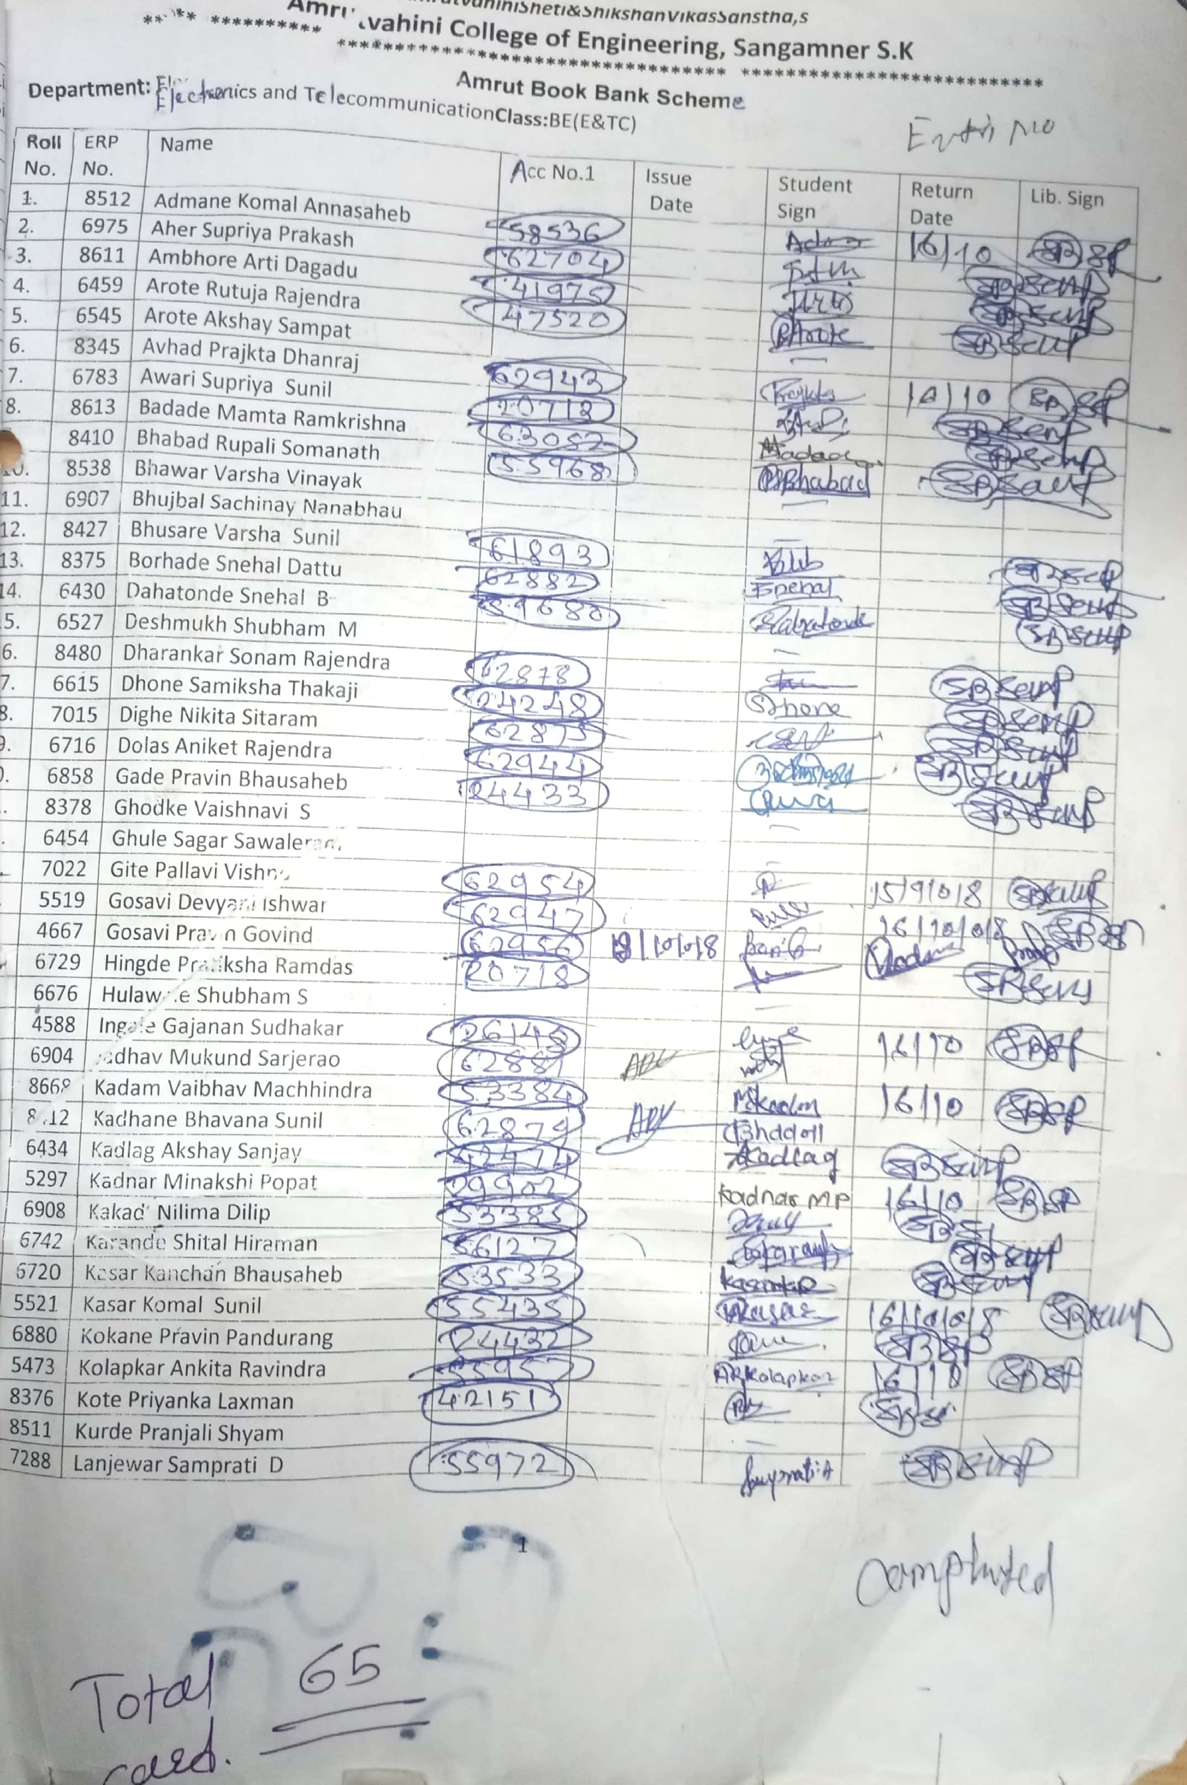
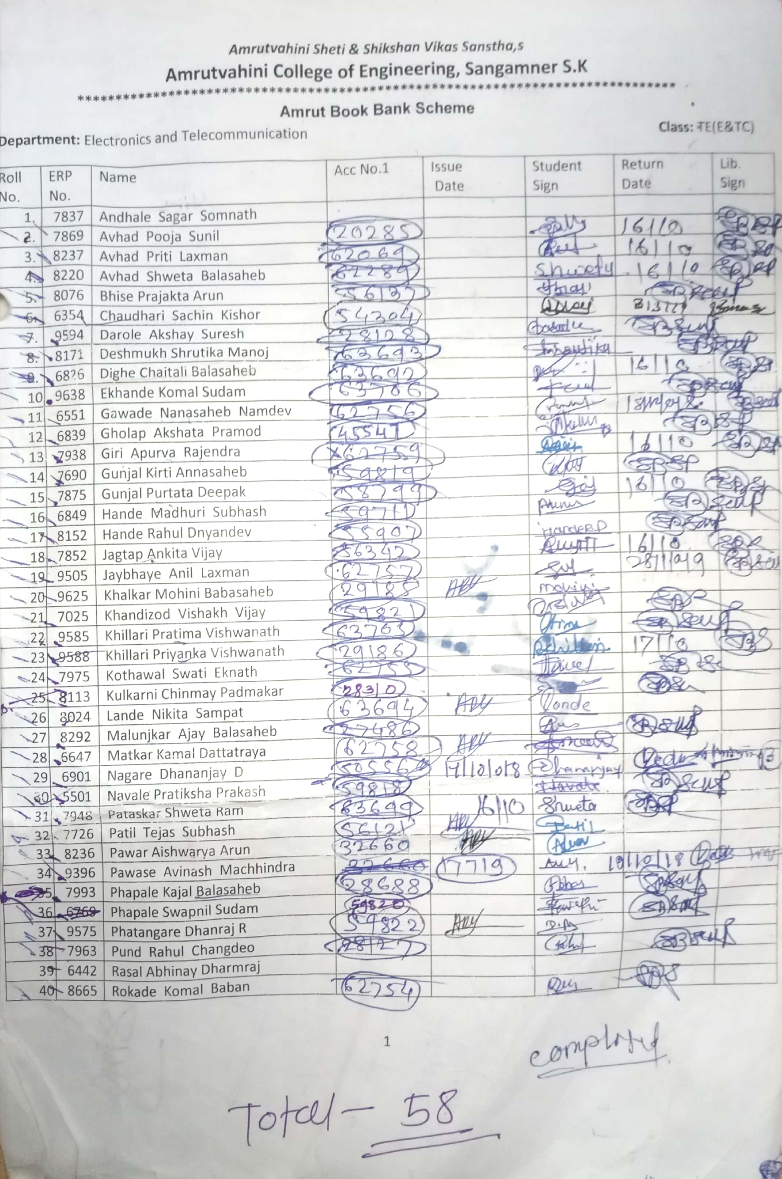

- Case Study-2:
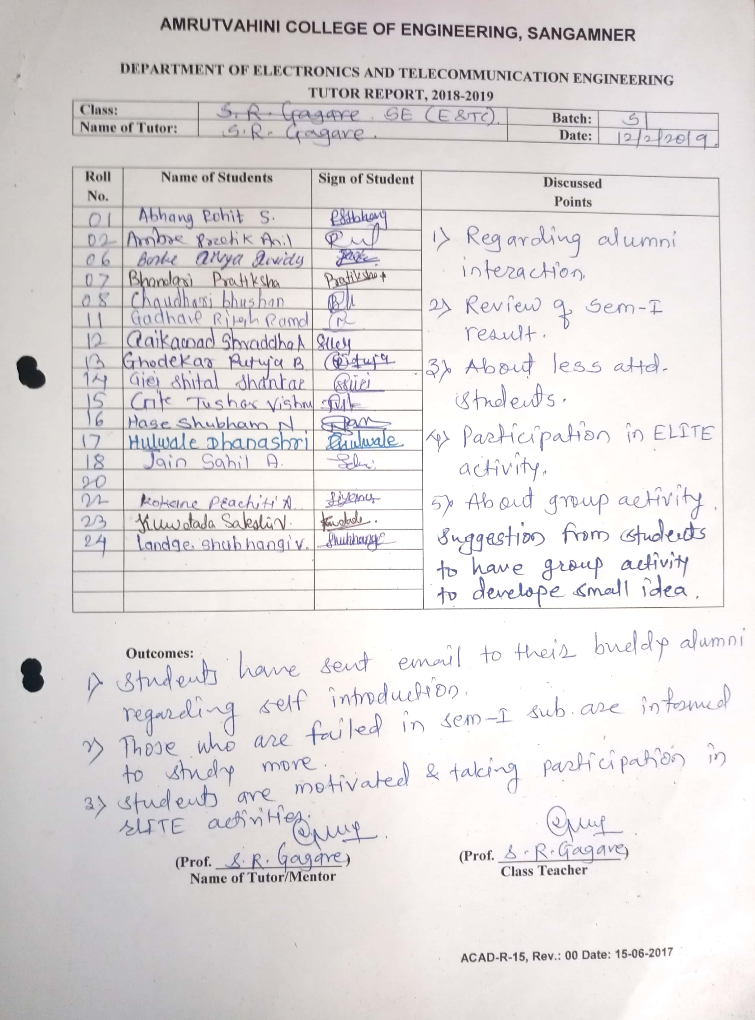

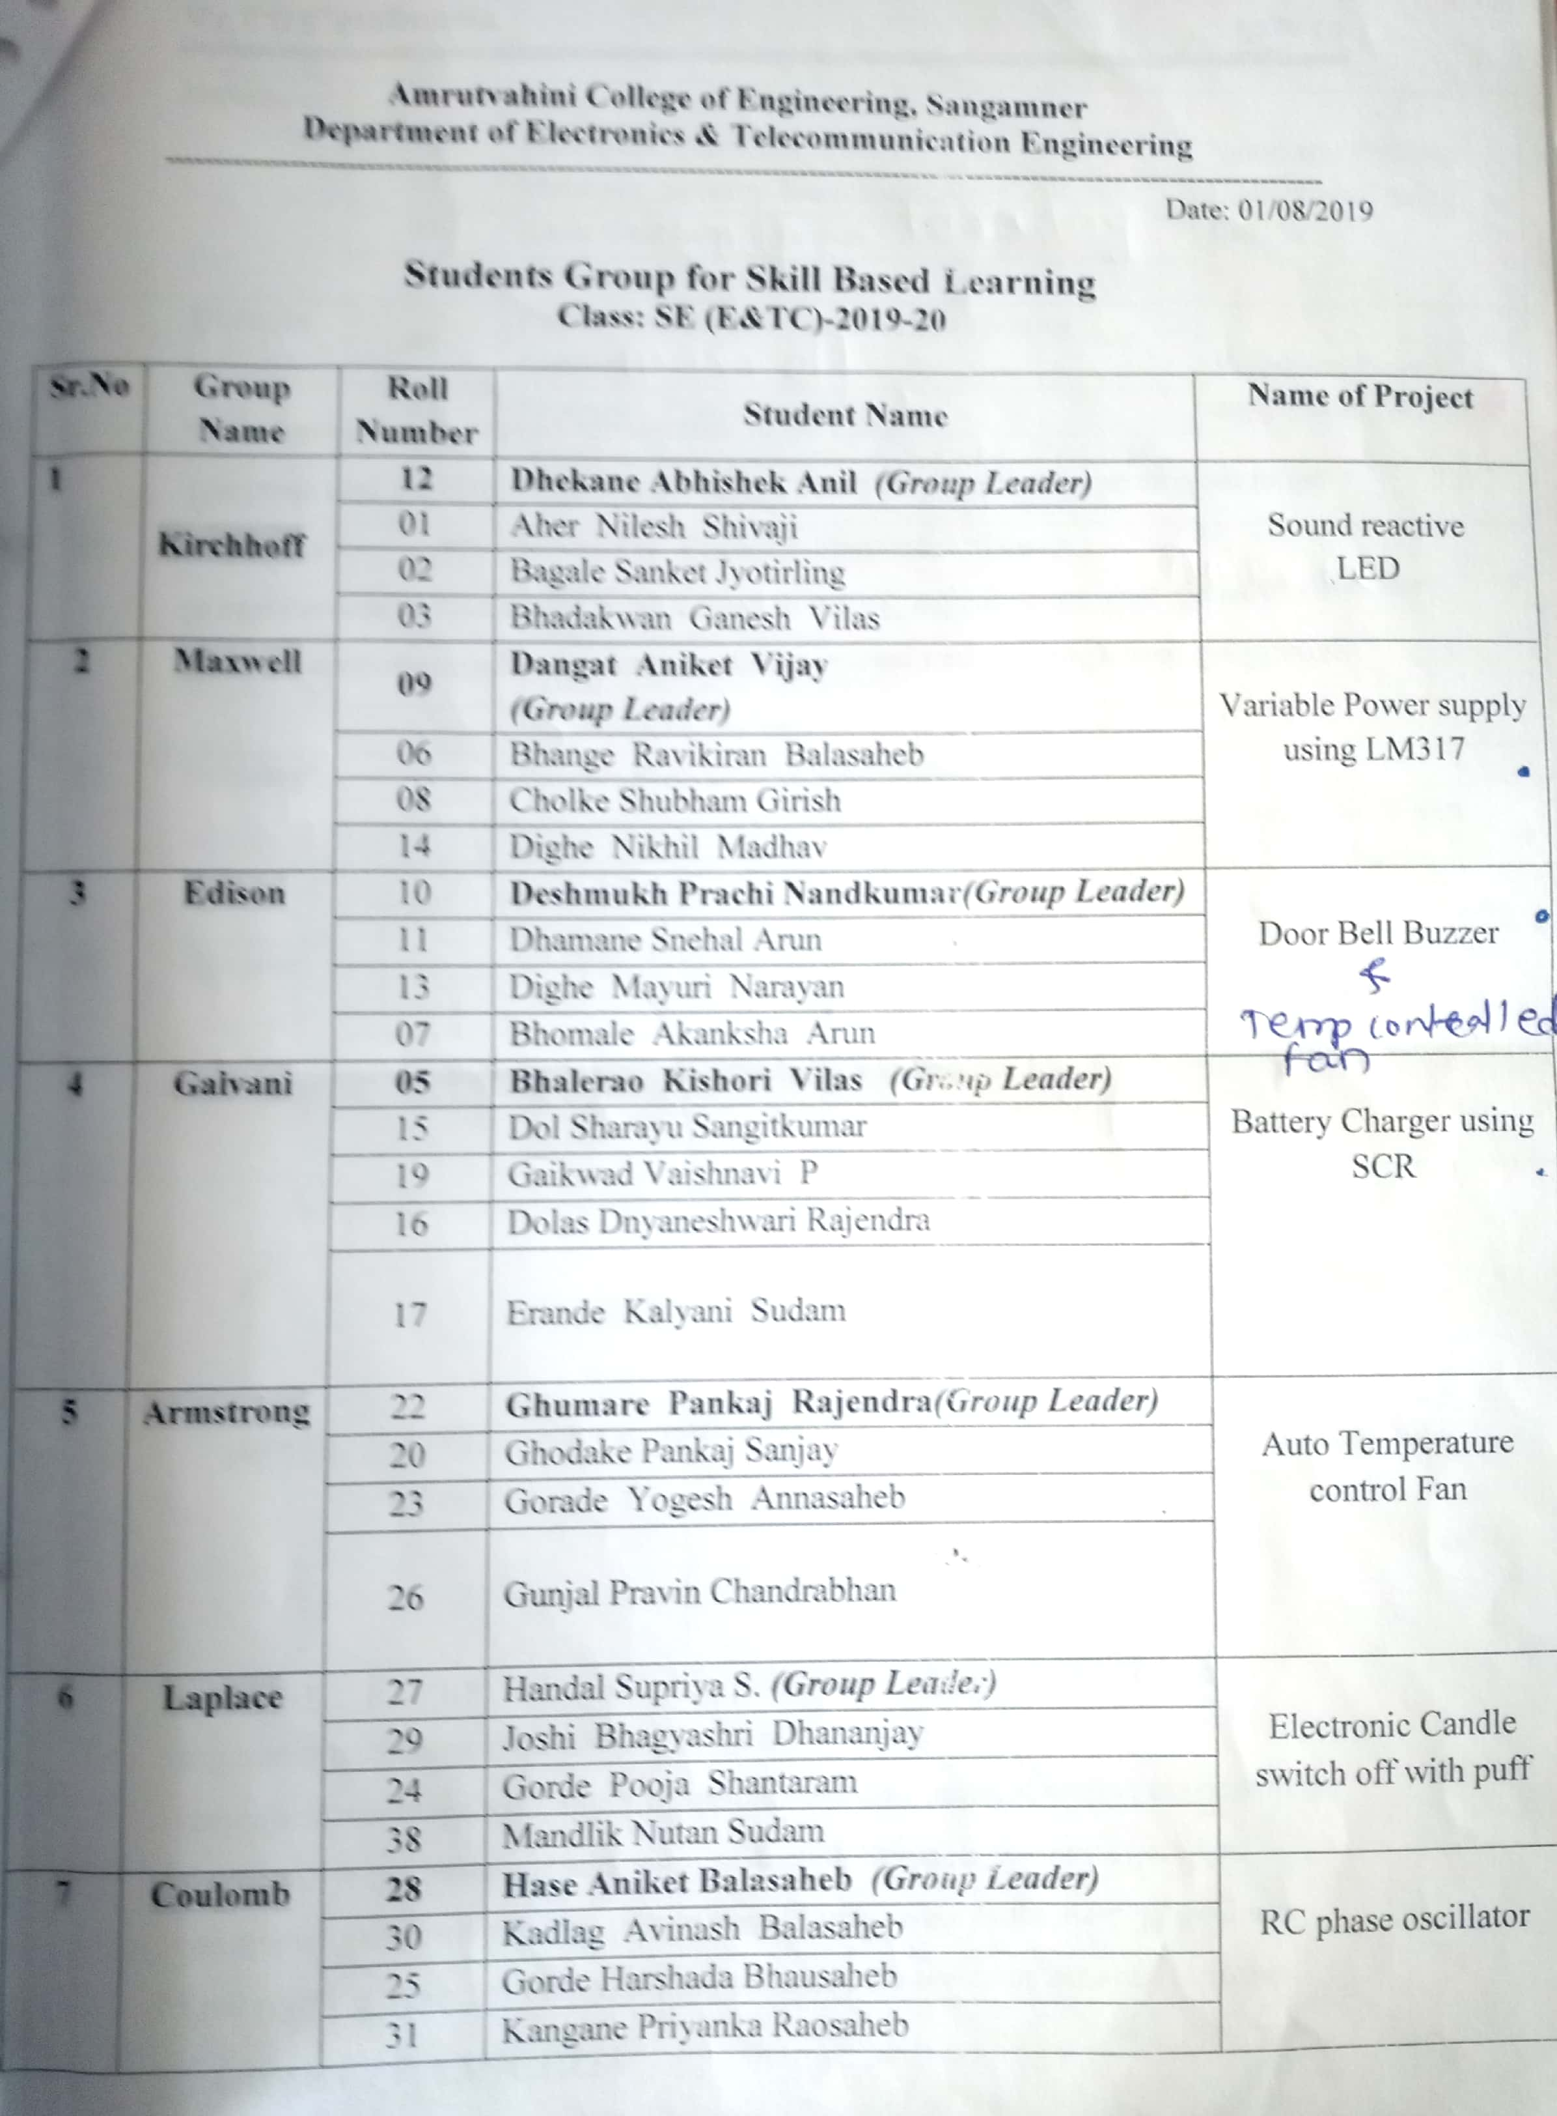

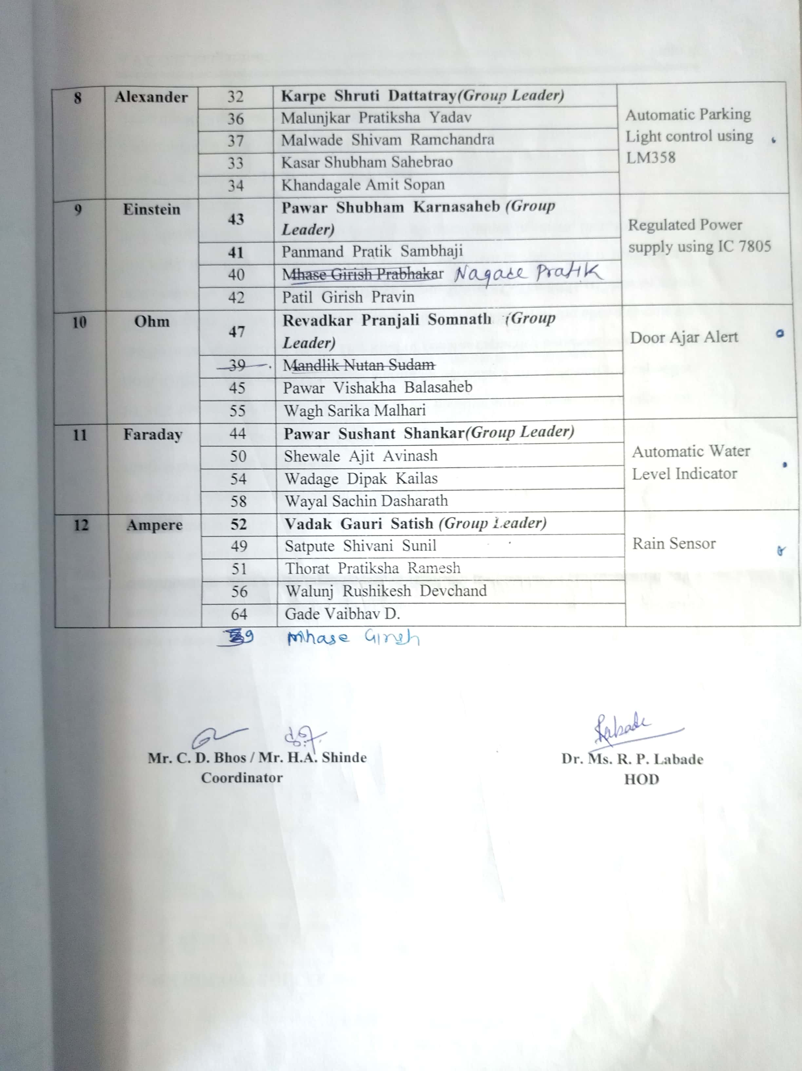

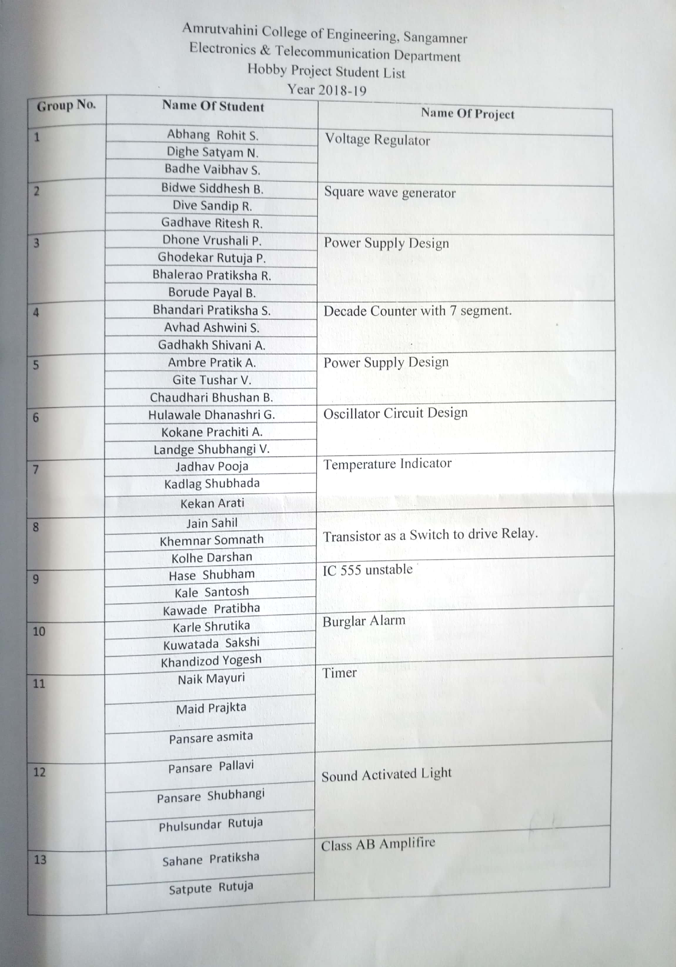
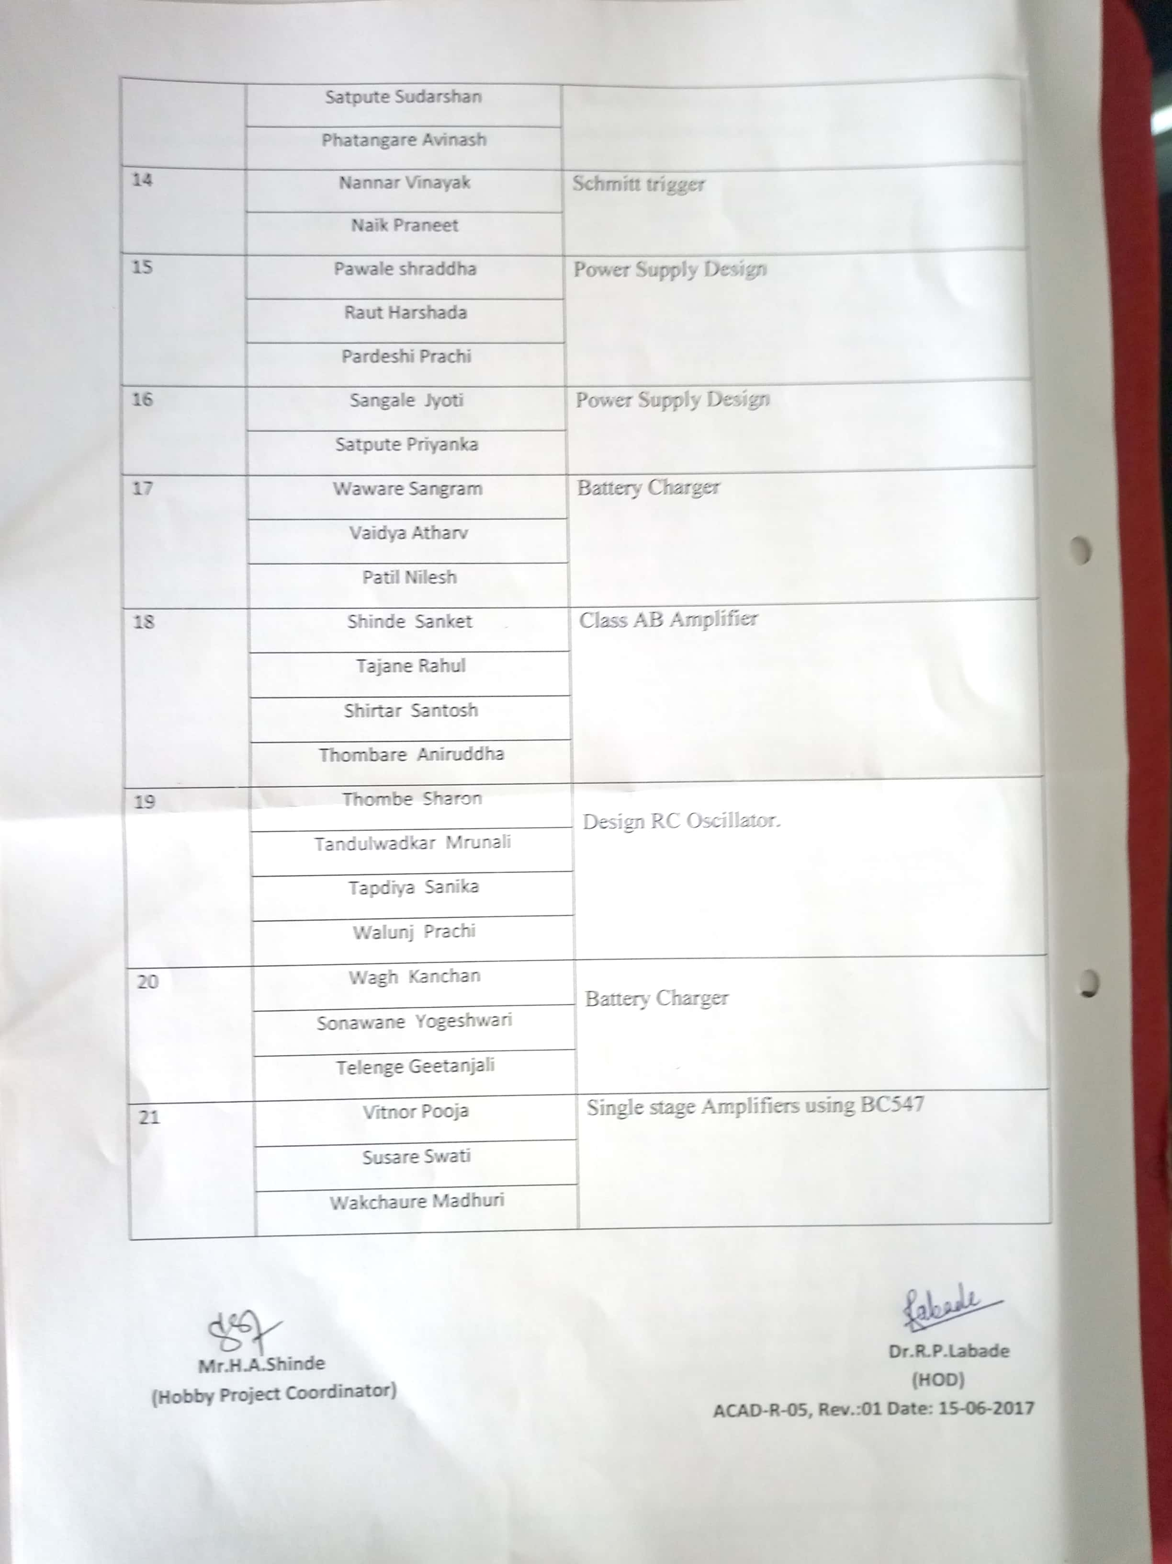

Group activity conducted for SE (E&TC) for skill based learning:
