Extended Profile
2.2: Number of seats earmarked for reserved category as per GOI/State Govt. rule year-wise during last five years.
1) Provide consolidated document showing the reserved category should be mentioned separately for each category as State government / Central Government reservation policy for admission to higher education.
2) Provide the number of seats reserved for each of the programmes and the program-wise total authenticated by the Registrar of the affiliating university/admission authority.
Response:
- Attested document showing the reserved category for each category as State government / Central Government reservation policy for admission to higher education is attached herewith.
- The document of number of seats reserved for each of the programmes and the program-wise total authenticated by the head of the institute is attached herewith.
INDEX
Sr. No. | Description | Page No.
 | Consolidated document showing the reserved category should be mentioned separately for each category as State government / Central Government reservation policy for admission to higher education.  1.1Maharashtra Government reservation policy (A.Y. 2015-16 to 2018-19)  1.2 Maharashtra Government reservation policy (A.Y. 2019-20) | 2
 | Number of seats reserved for each of the programmes and the program-wise total authenticated by the Registrar of the affiliating university/admission authority.  2.1 Number of seats reserved for each of the programmes and the program-wise total in the academic year 2015-16.  2.2 Number of seats reserved for each of the programmes and the program-wise total in the academic year 2016-17.  2.3 Number of seats reserved for each of the programmes and the program-wise total in the academic year 2017-18.  2.4 Number of seats reserved for each of the programmes and the program-wise total in the academic year 2018-19.  2.5 Number of seats reserved for each of the programmes and the program-wise total in the academic year 2019-20. | 9

- Consolidated document showing the reserved category should be mentioned separately for each category as State government / Central Government reservation policy for admission to higher education.
  - Maharashtra Government reservation policy (Academic Year 2015-16 to 2018-19)
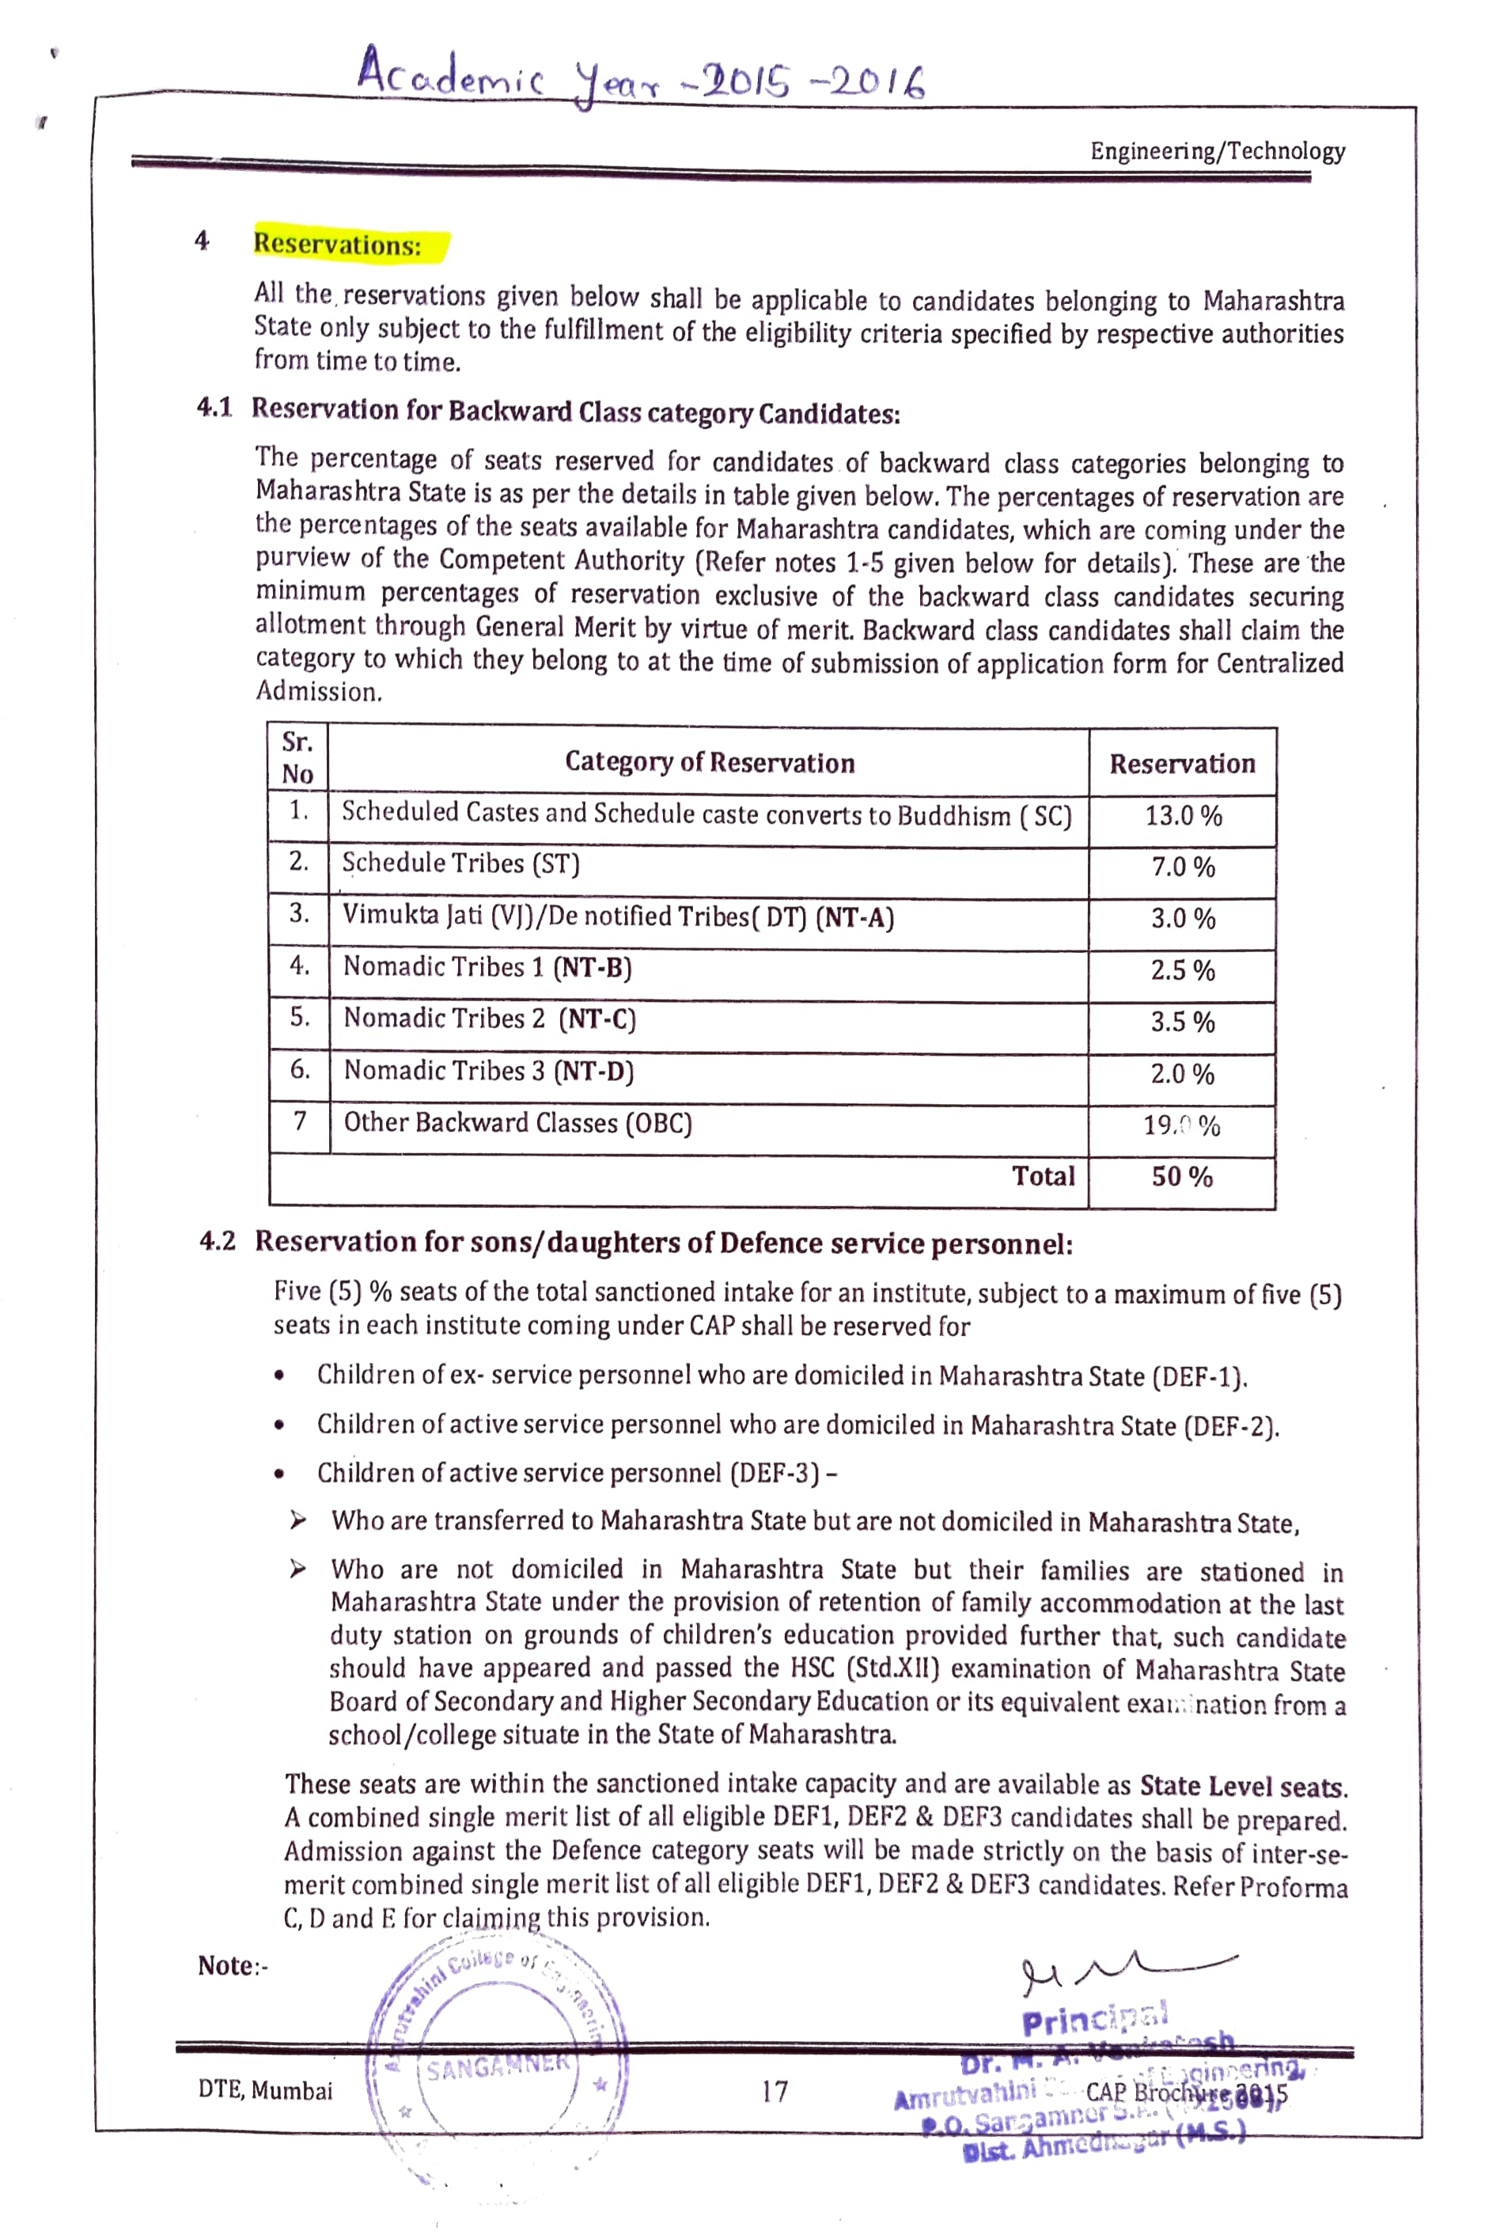
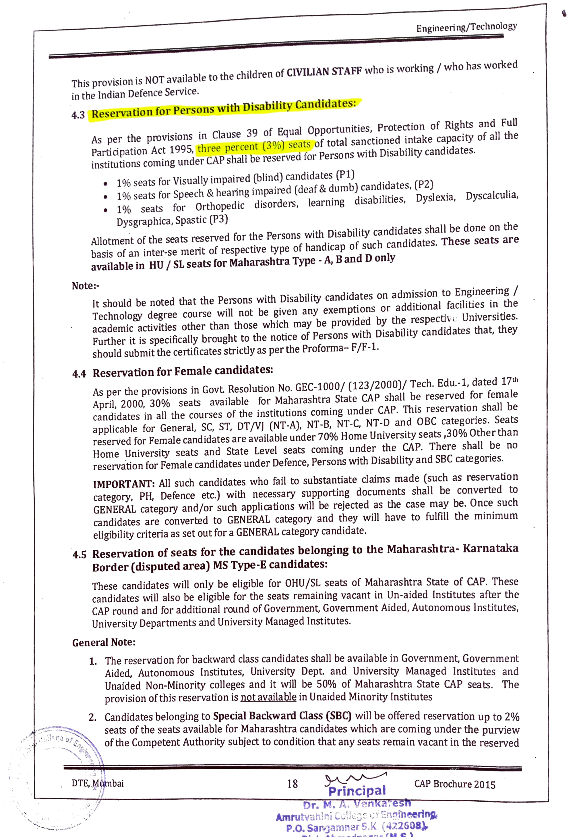
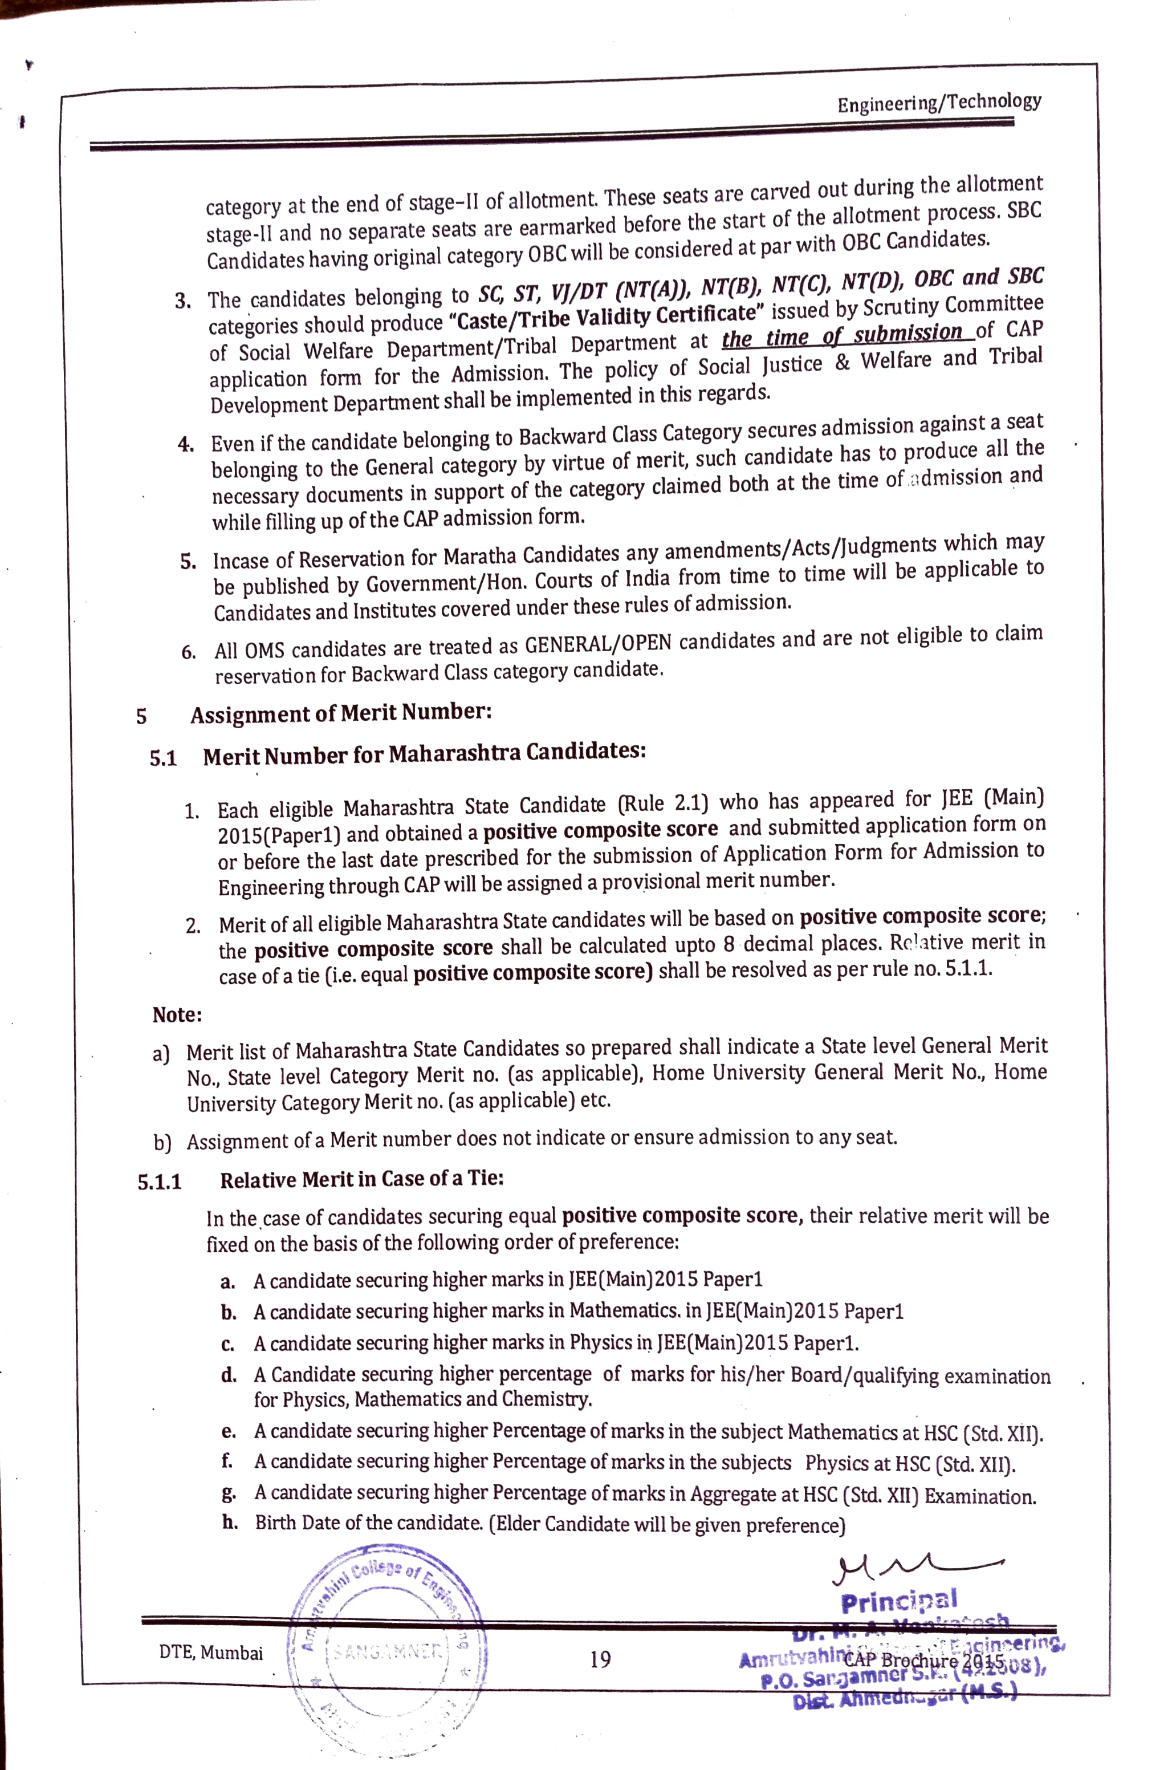
  - Maharashtra Government reservation policy (A.Y. 2019-20)
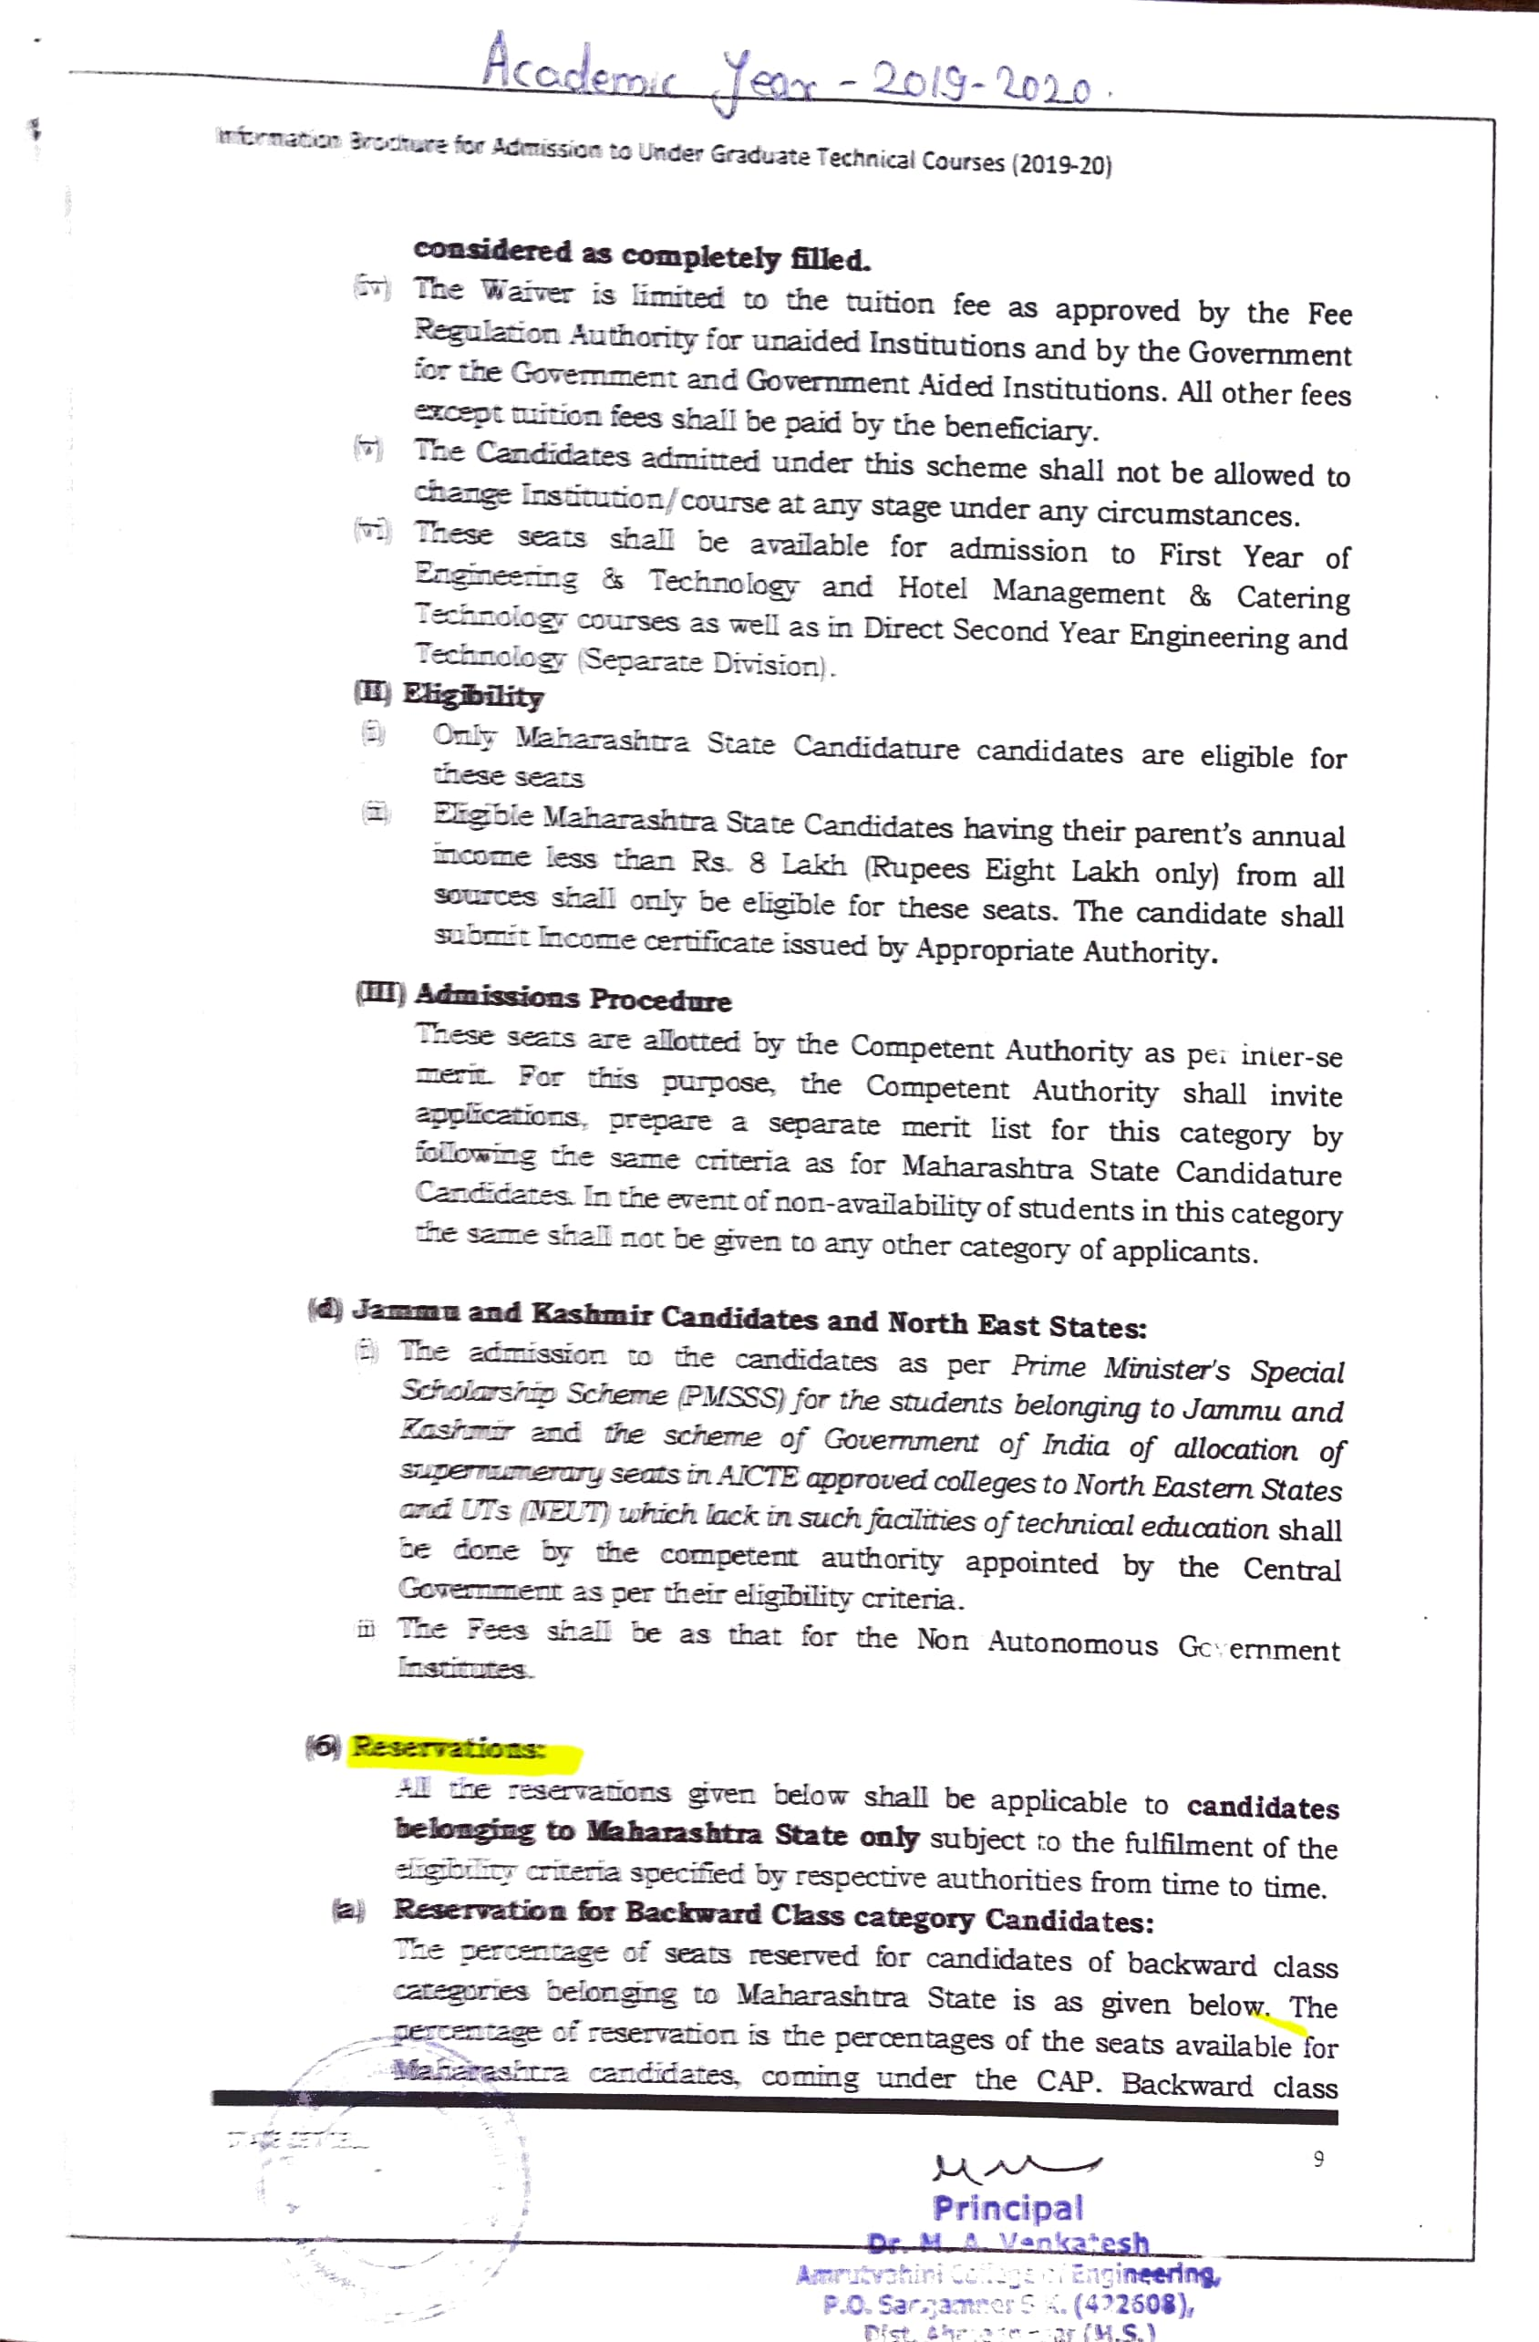
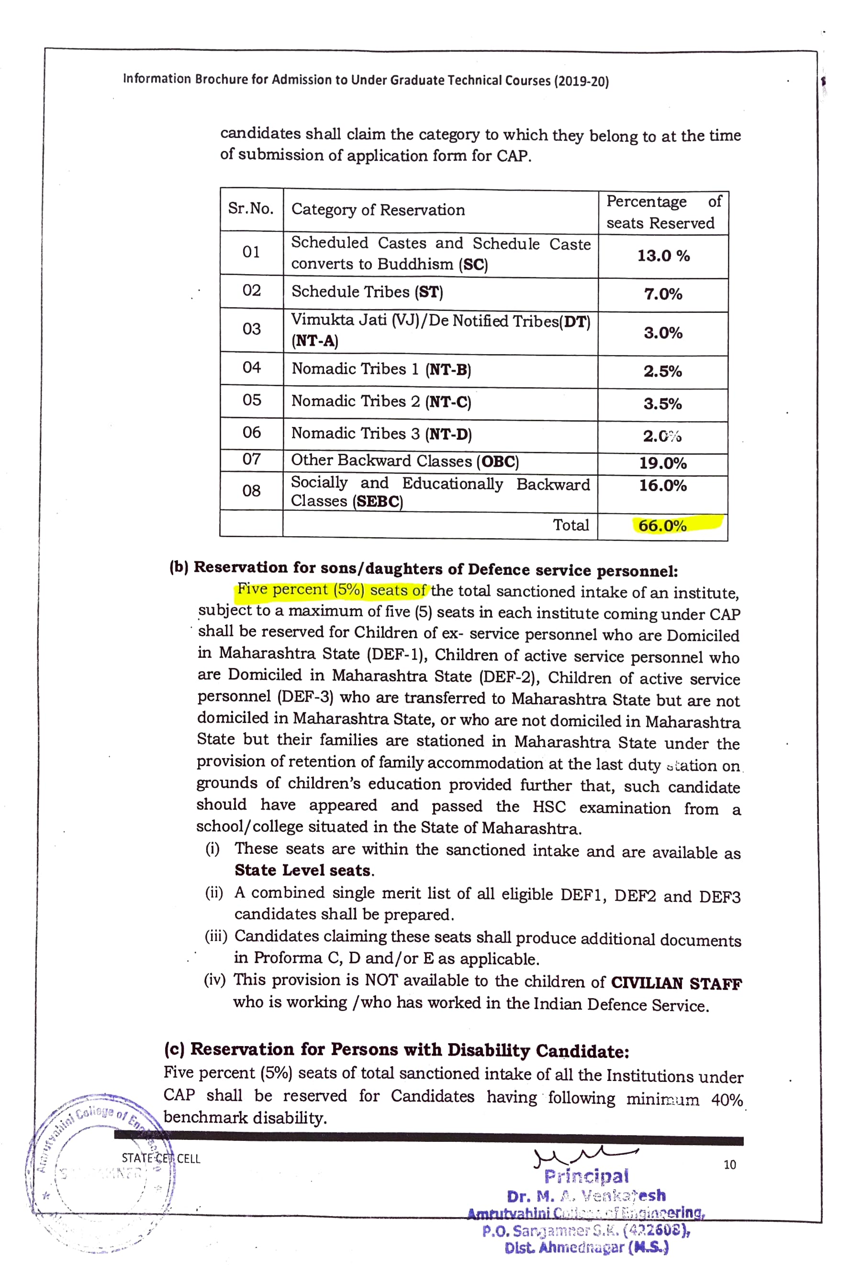
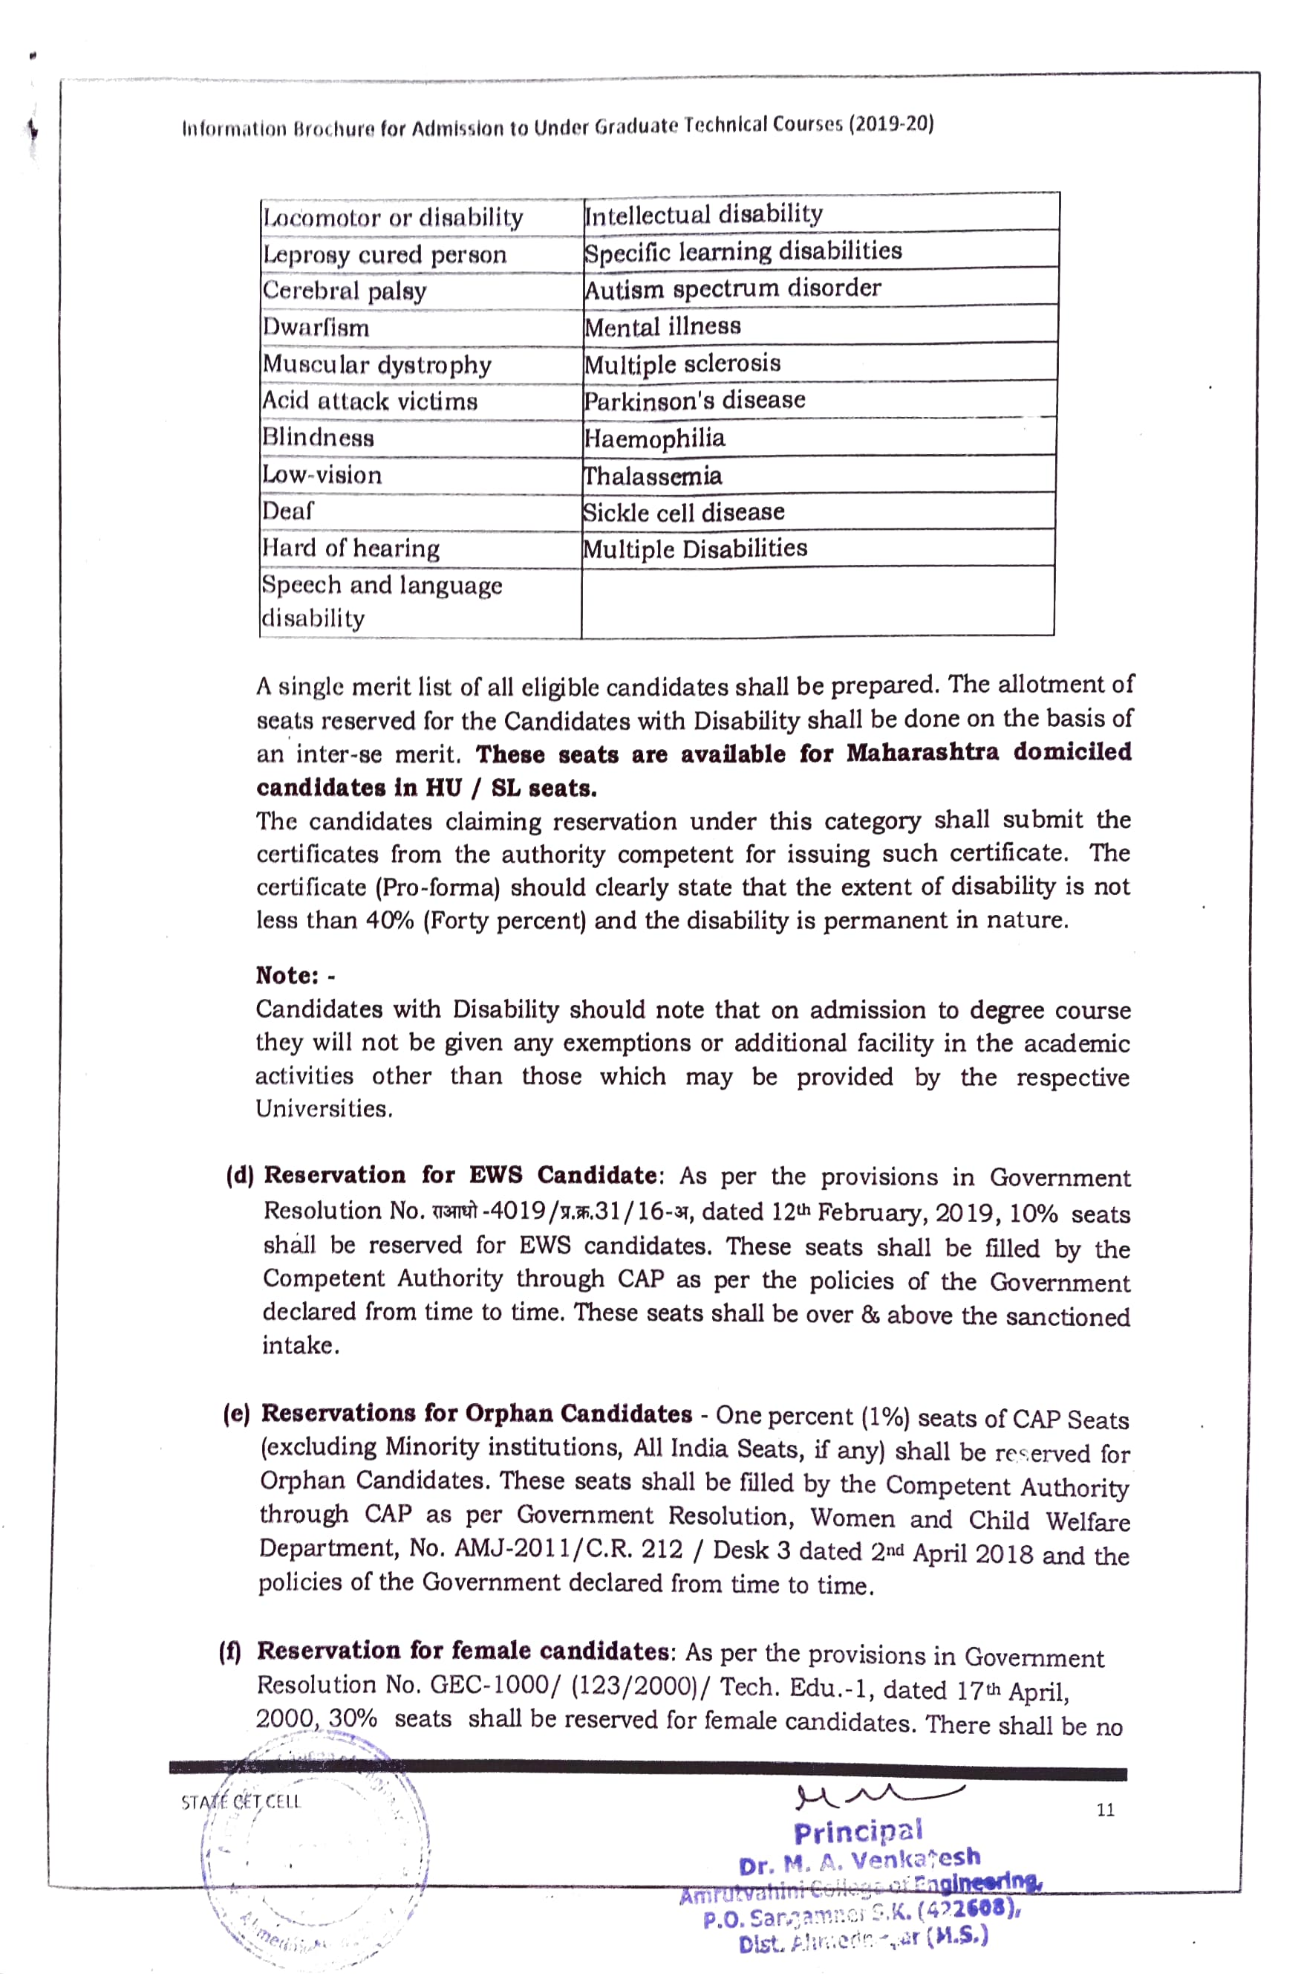
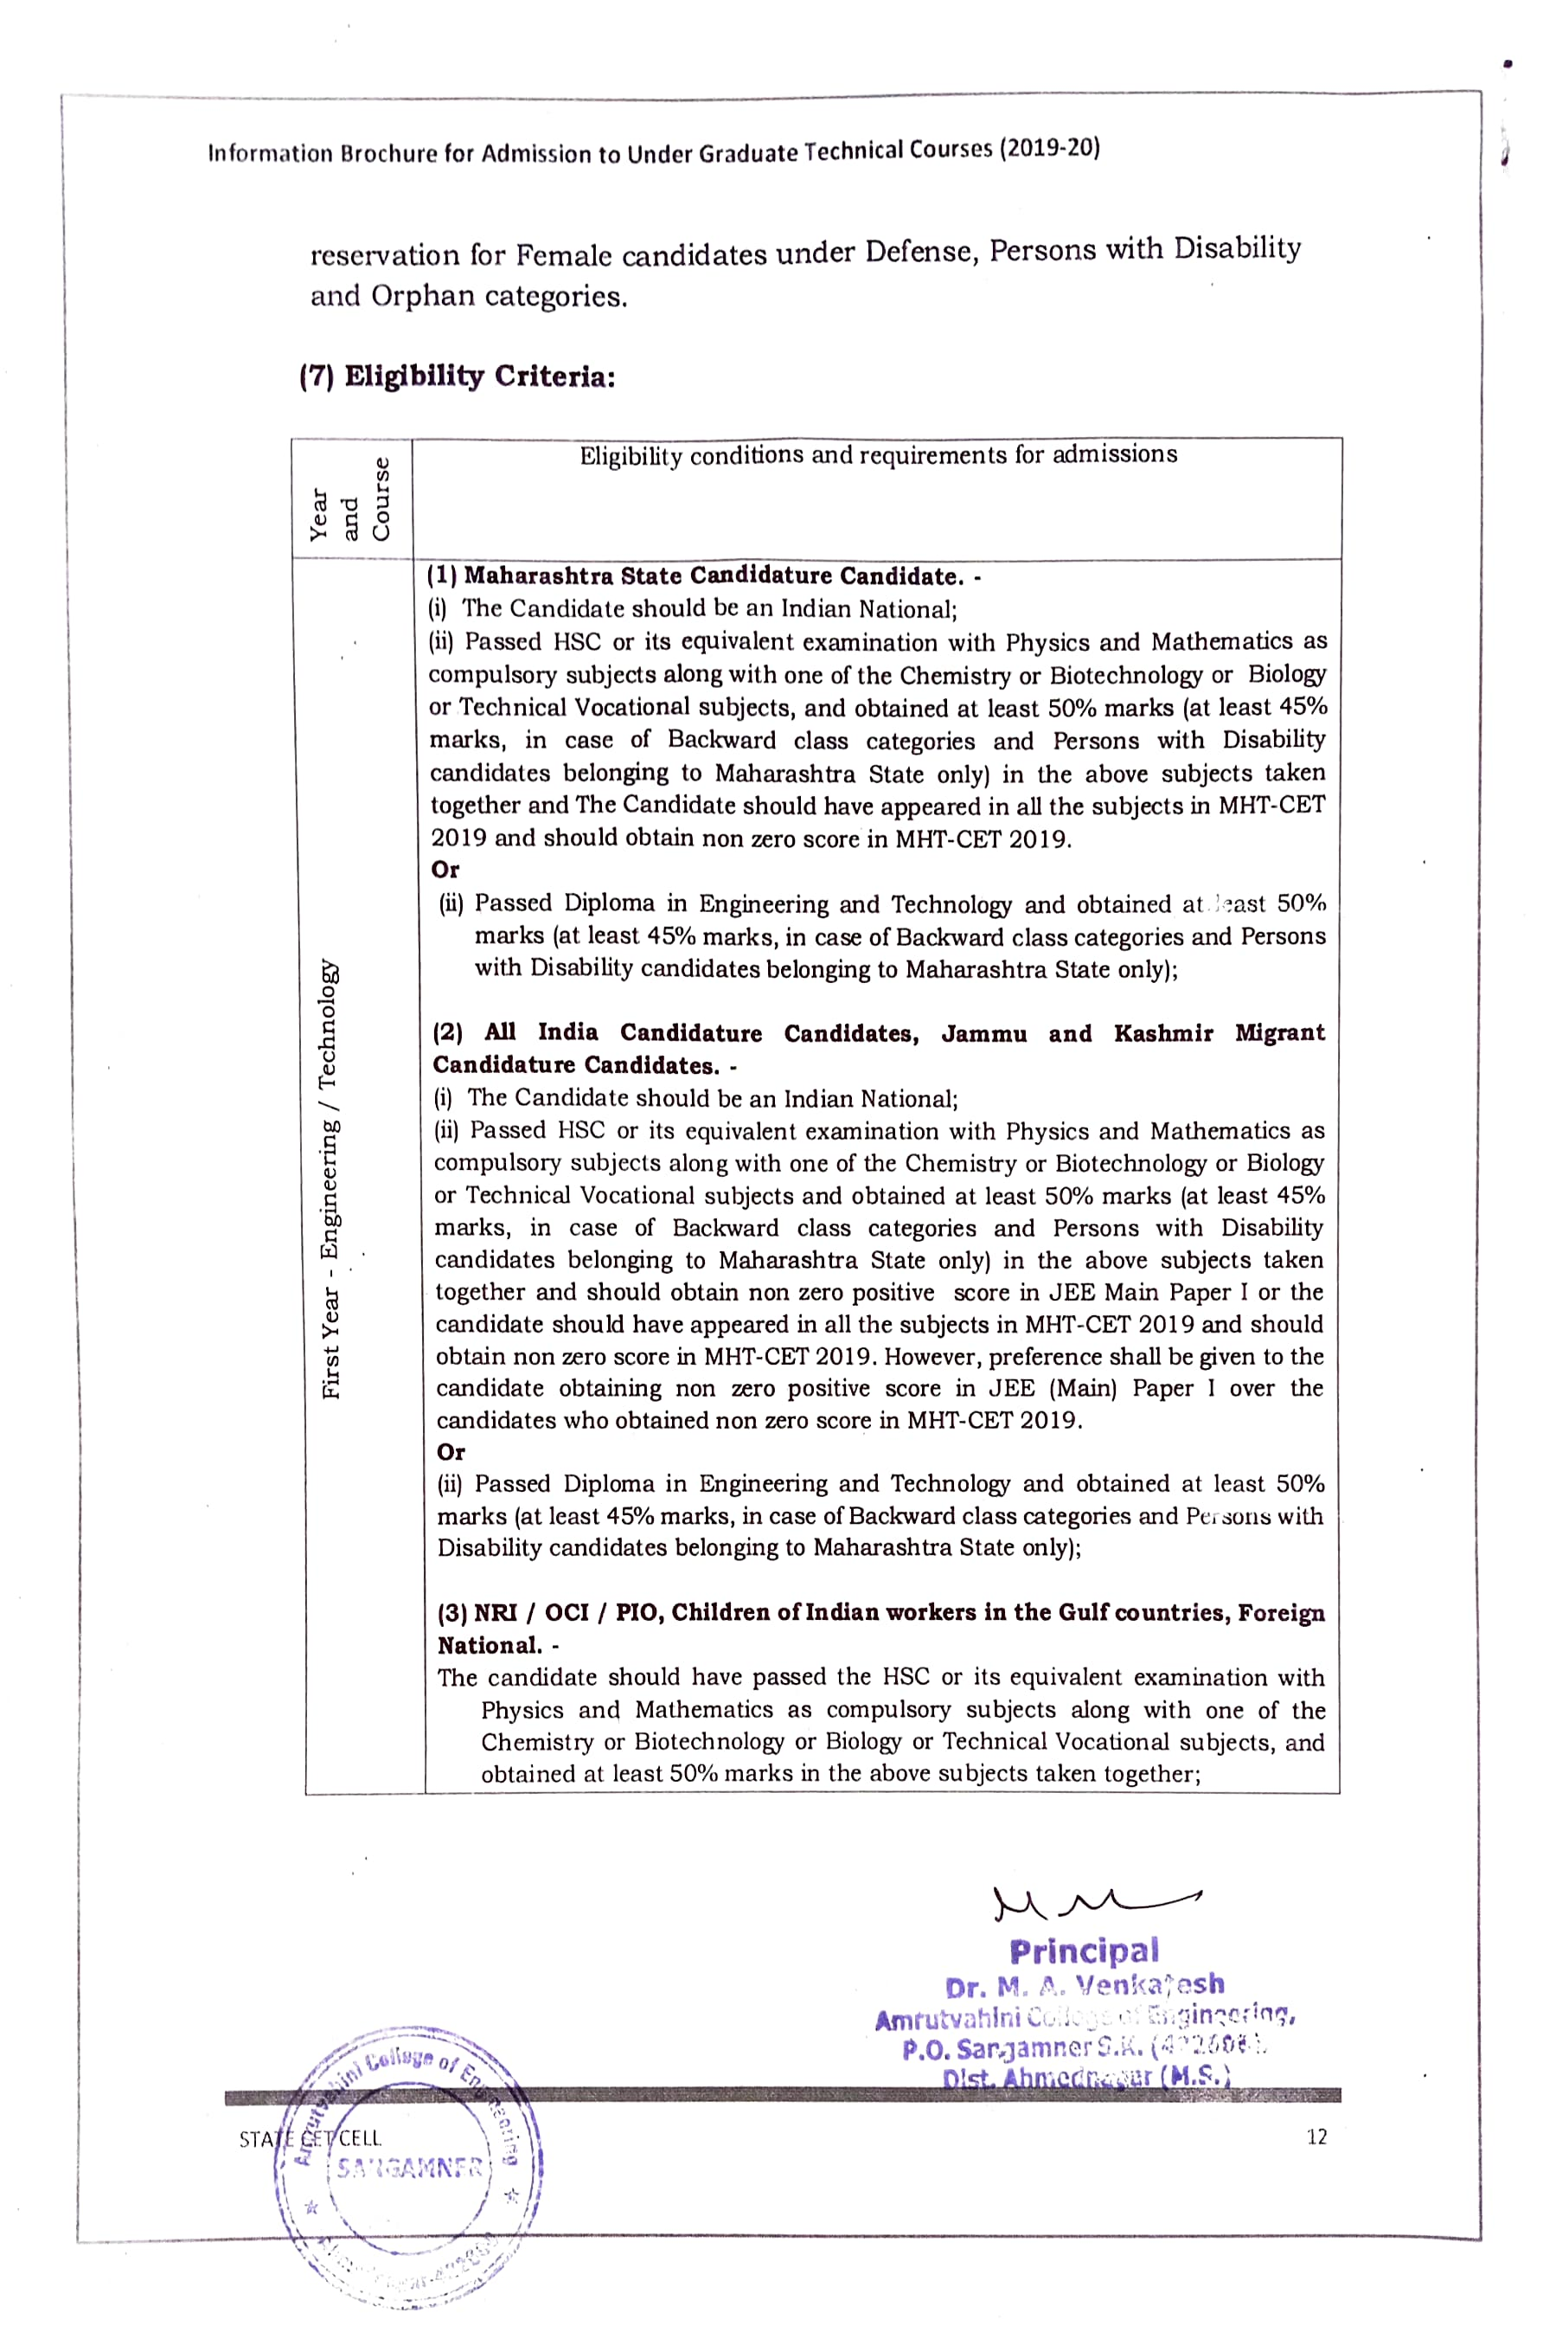

- Number of seats reserved for each of the programmes and the program-wise total authenticated by the Registrar of the affiliating university/admission authority.
2.1 Number of seats reserved for each of the programmes and the program-wise total in the academic year 2015-16.
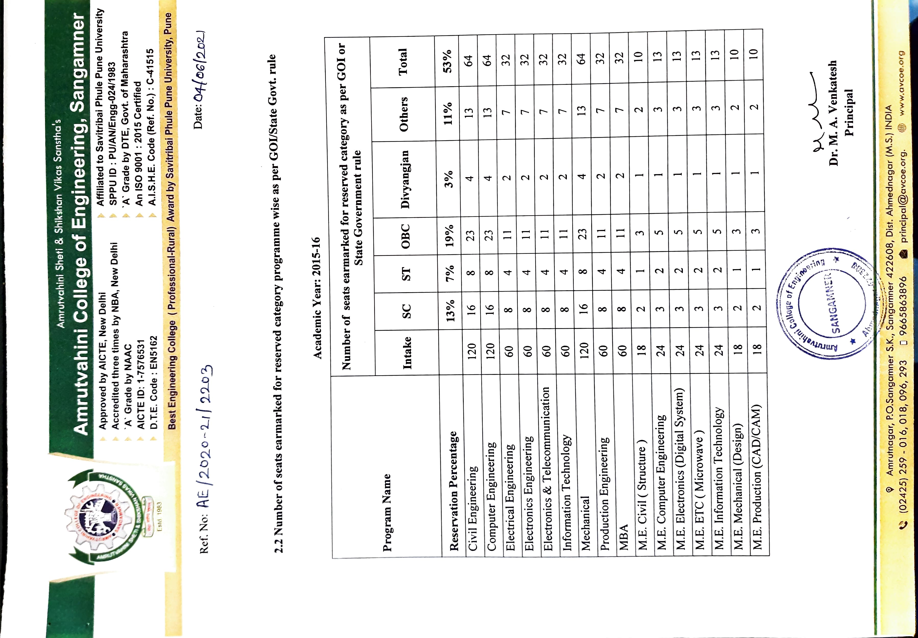
  - Number of seats reserved for each of the programmes and the program-wise total in the academic year 2016-17.
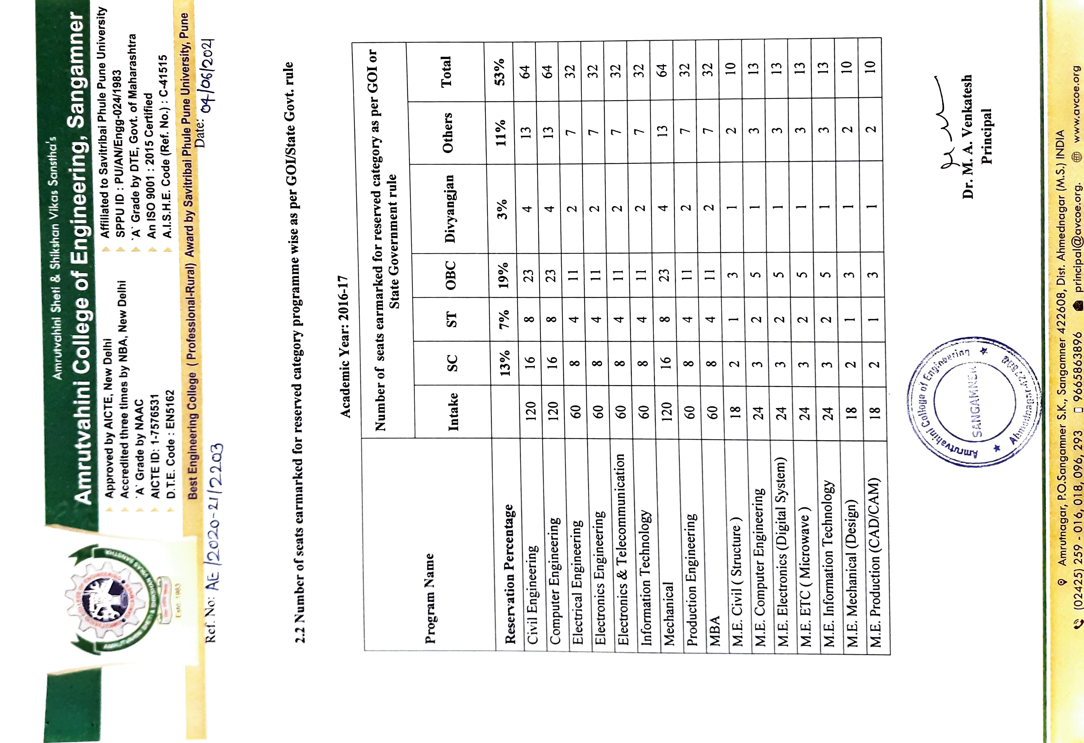

  - Number of seats reserved for each of the programmes and the program-wise total in the academic year 2017-18.
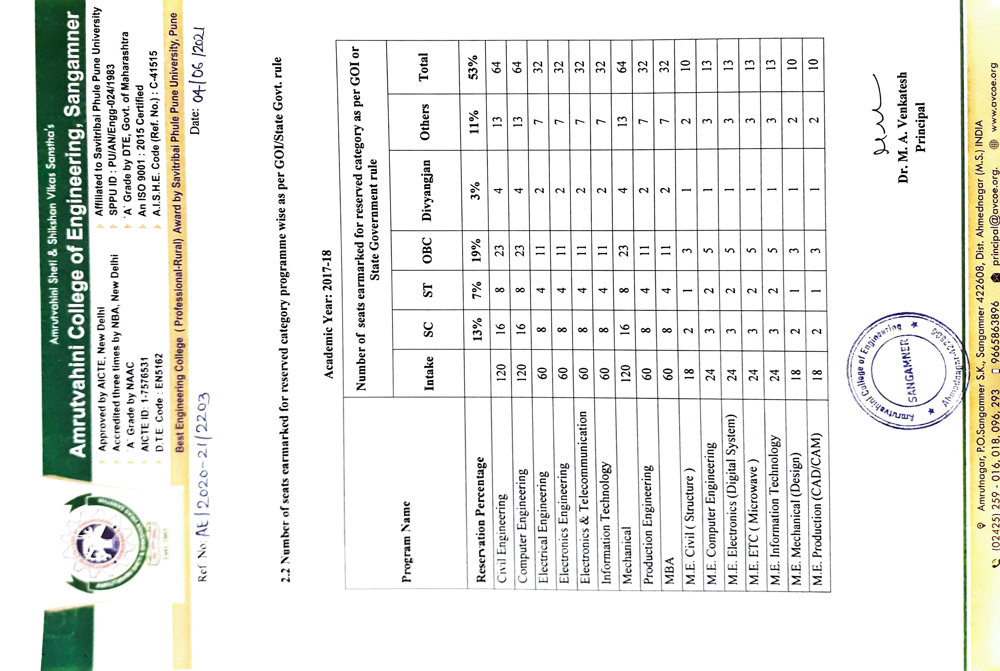

  - Number of seats reserved for each of the programmes and the program-wise total in the academic year 2018-19.
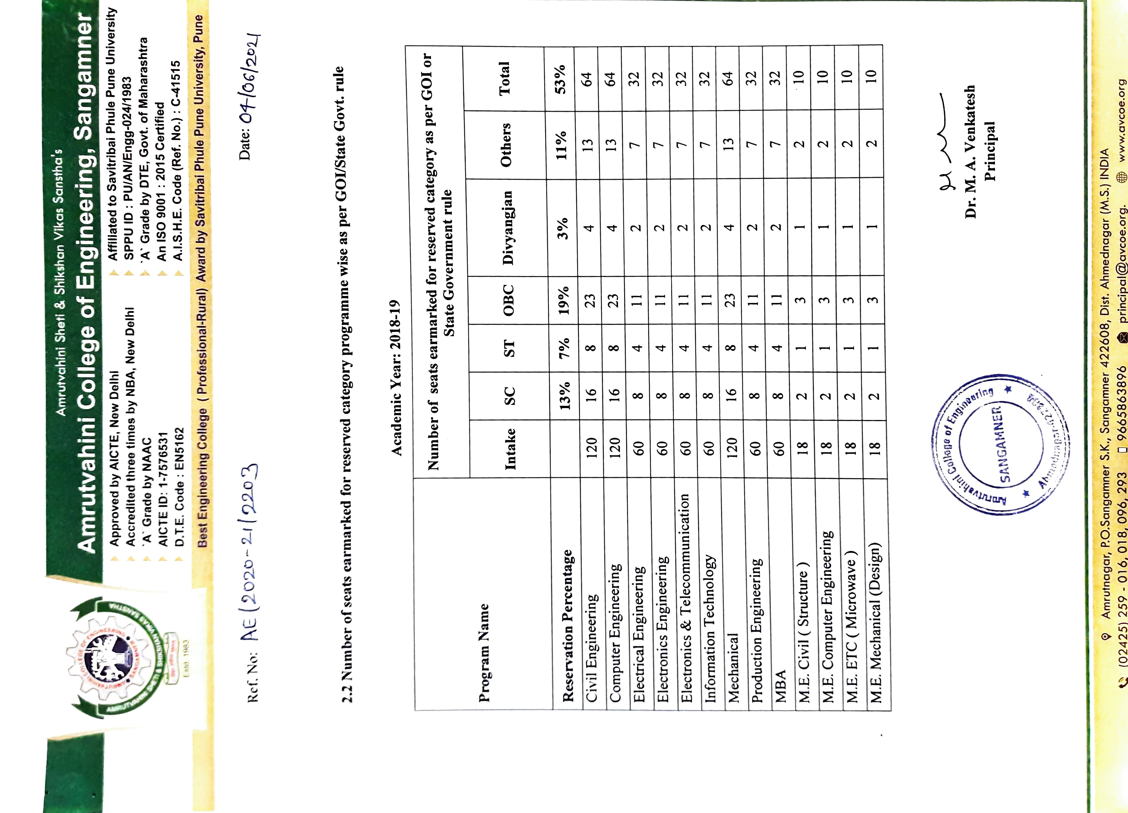
2.5 Number of seats reserved for each of the programmes and the program-wise total in the academic year 2019-20.
