Extended Profile
2.1 Number of students year-wise during last five years
HEI input is edited as per IIQA.
1) Provide appropriate document duly certified by competent authorities.
2) Provide Year wise list of students approved by the affiliating University.
Response:
- The number of student, 3361 edited in IIQA is for the current academic year (i.e. year 20-21). However the number of student for the year 19-20 is 3202.
- Document of consolidated number of student in each program and year wise signed by Head of the Institute is attached herewith
- As per NAAC compliance, our college has applied to Savitribai Phule University, Pune for certified list of students for the degree program- wise for last five years (2015-16 to 2019-20). It is still in process, we have only received the acknowledgement from University which is attached in this report.
INDEX
Sr. No. | Description | Pg. No.
 | Document of consolidated number of student in each program and year wise signed by Head of the Institute. | 2
 | Year wise list of students approved by the affiliating University. | 3
Note:

As per NAAC compliance, our college has applied to Savitribai Phule University, Pune for certified list of students for the degree program- wise for last five years (2015-16 to 2019-20). It is still in process, we have only received the acknowledgement from University which is attached in this report.

1. Number of students year-wise (FE, SE, TE and BE) during last five years duly certified by competent authorities
1.1 Total number of students admitted in the academic year 2015-16
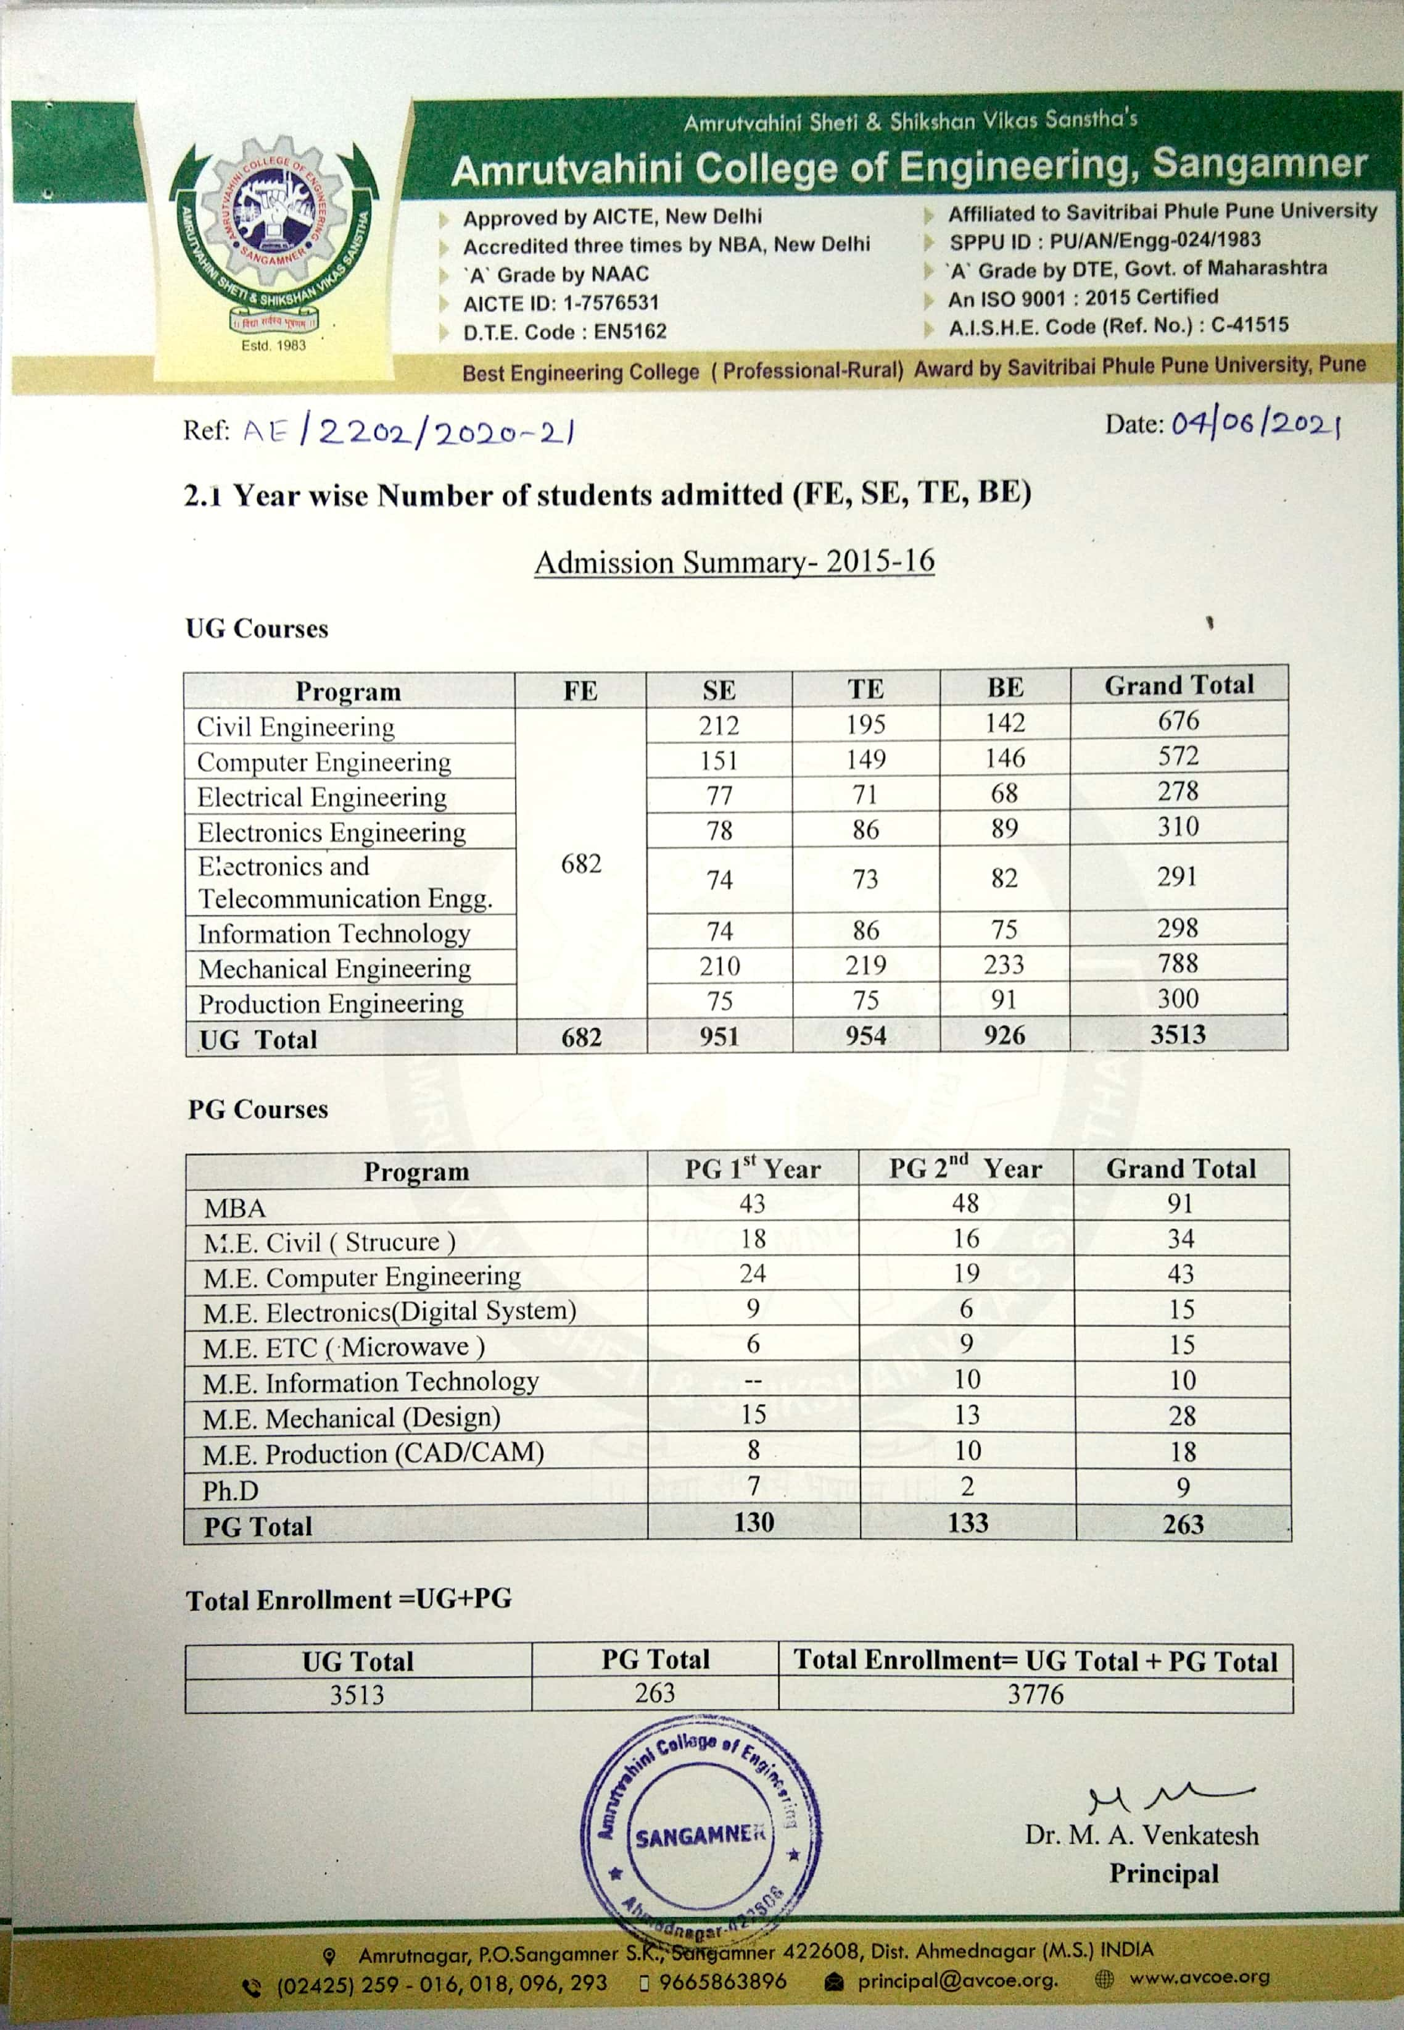
1.2 Total number of students admitted in the academic year 2016-17

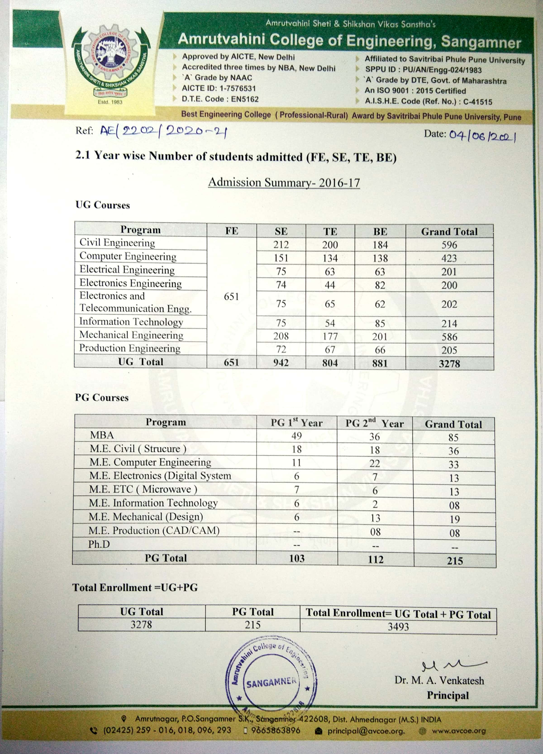
1.3 Total number of students admitted in the academic year 2017-18
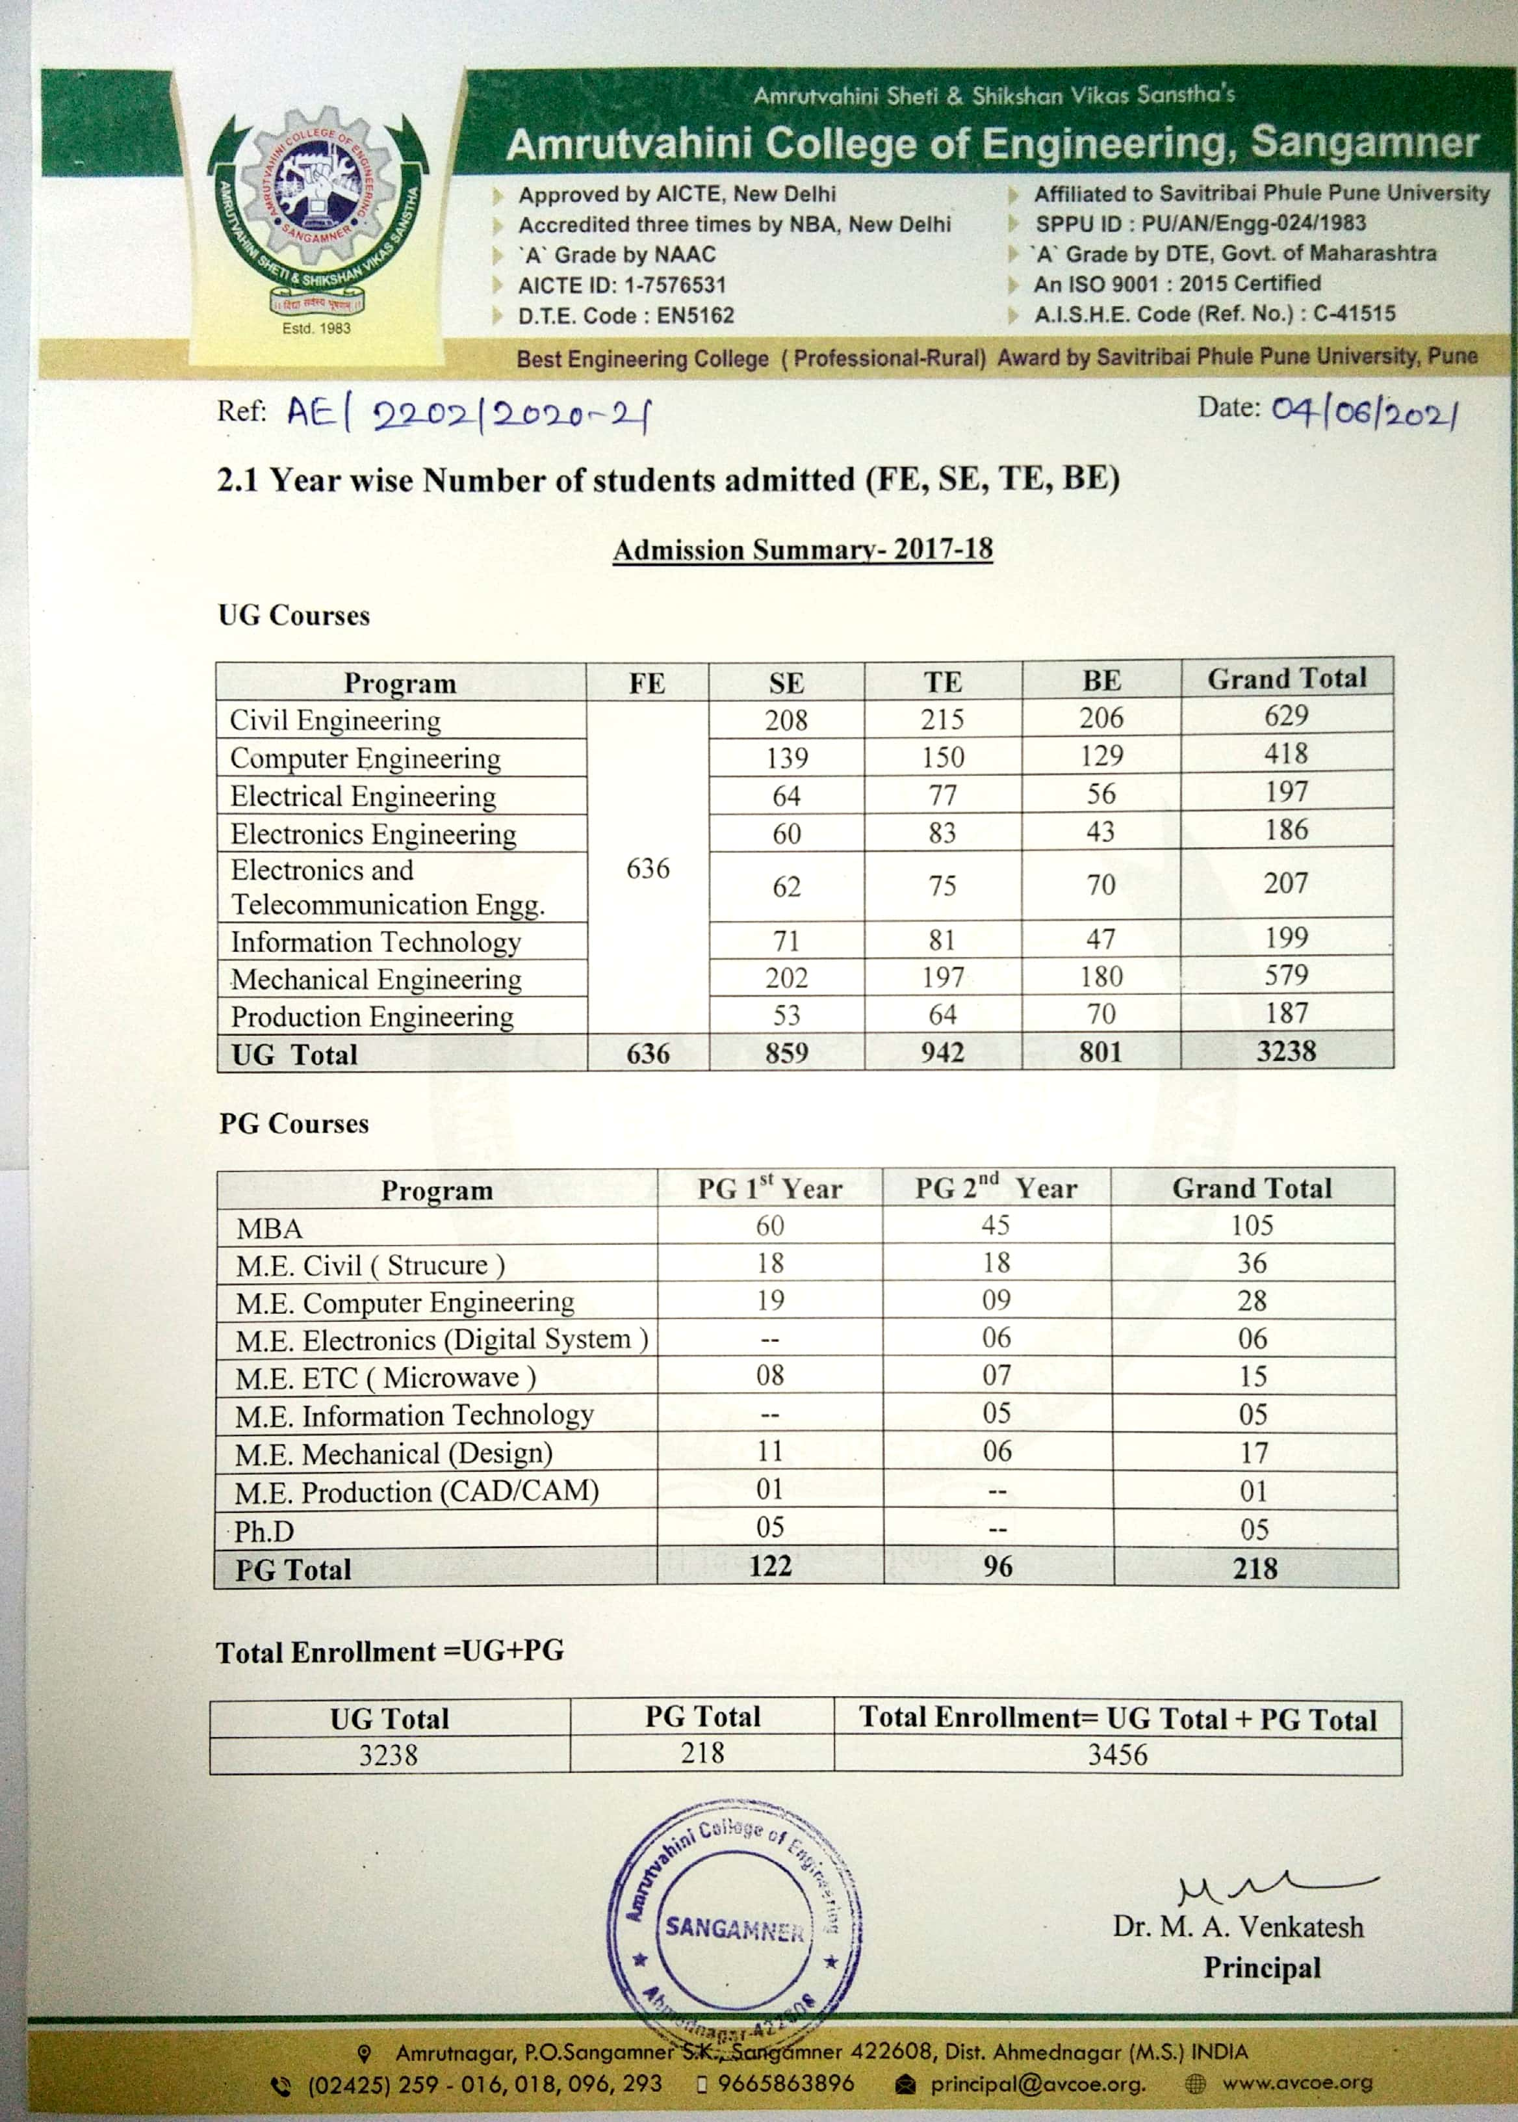
1.4 Total number of students admitted in the academic year 2018-19
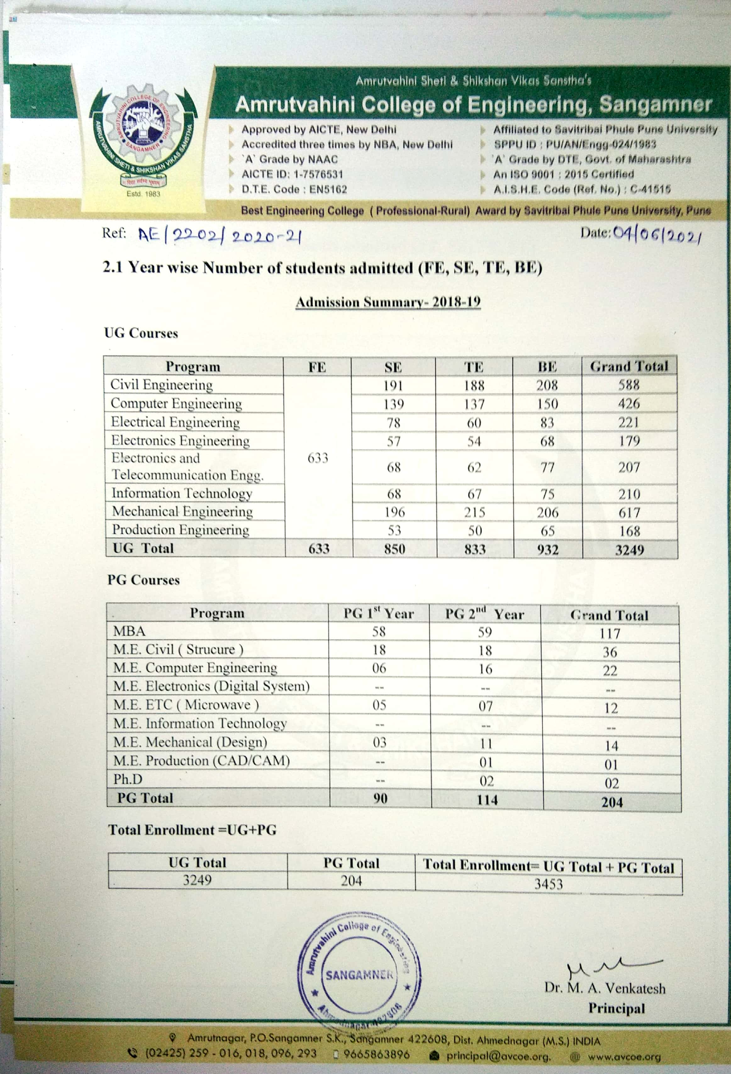
1.5 Total number of students admitted in the academic year 2019-20
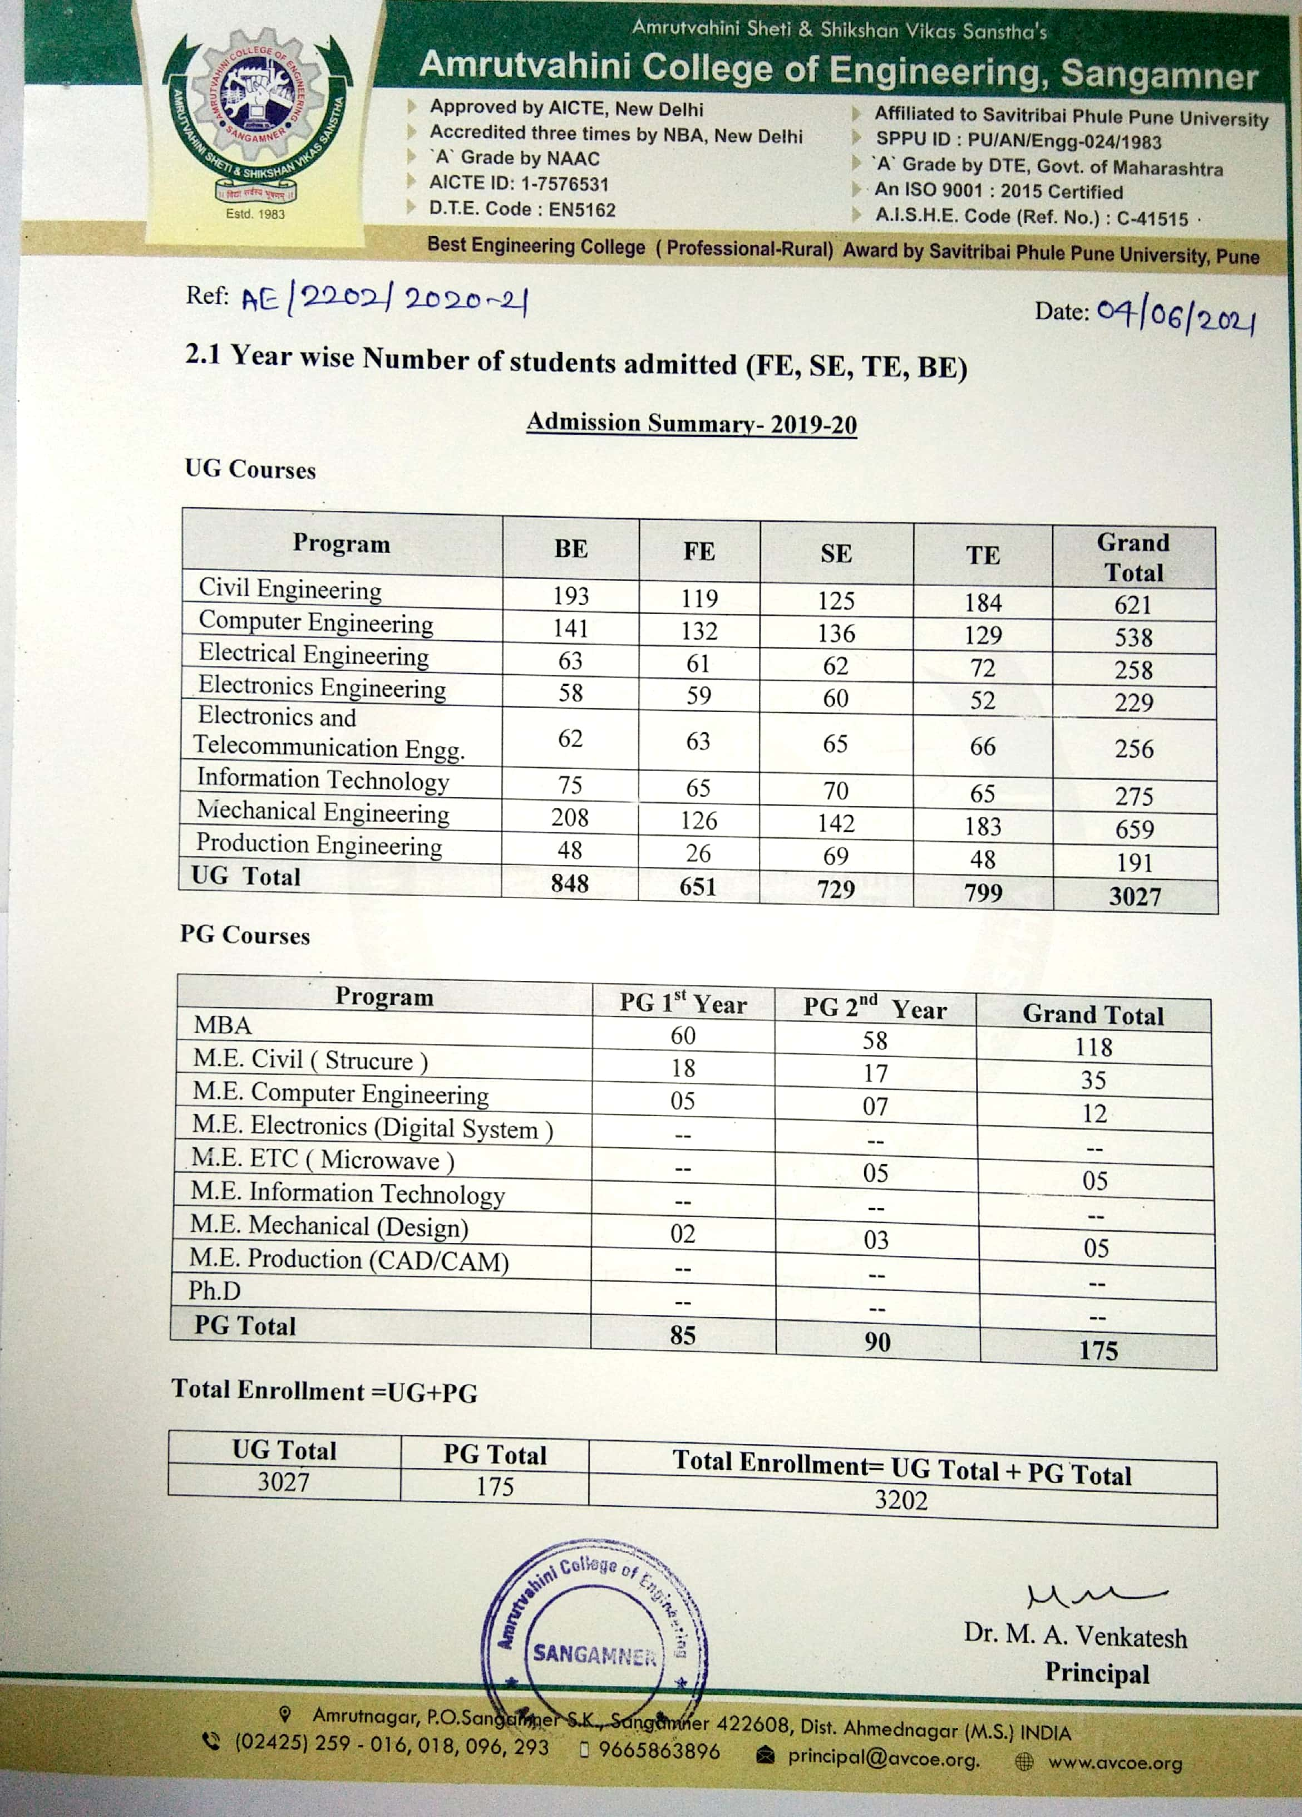
2. Year wise list of students approved by the affiliating University.
2.1 List of students admitted in the academic year 2015-16
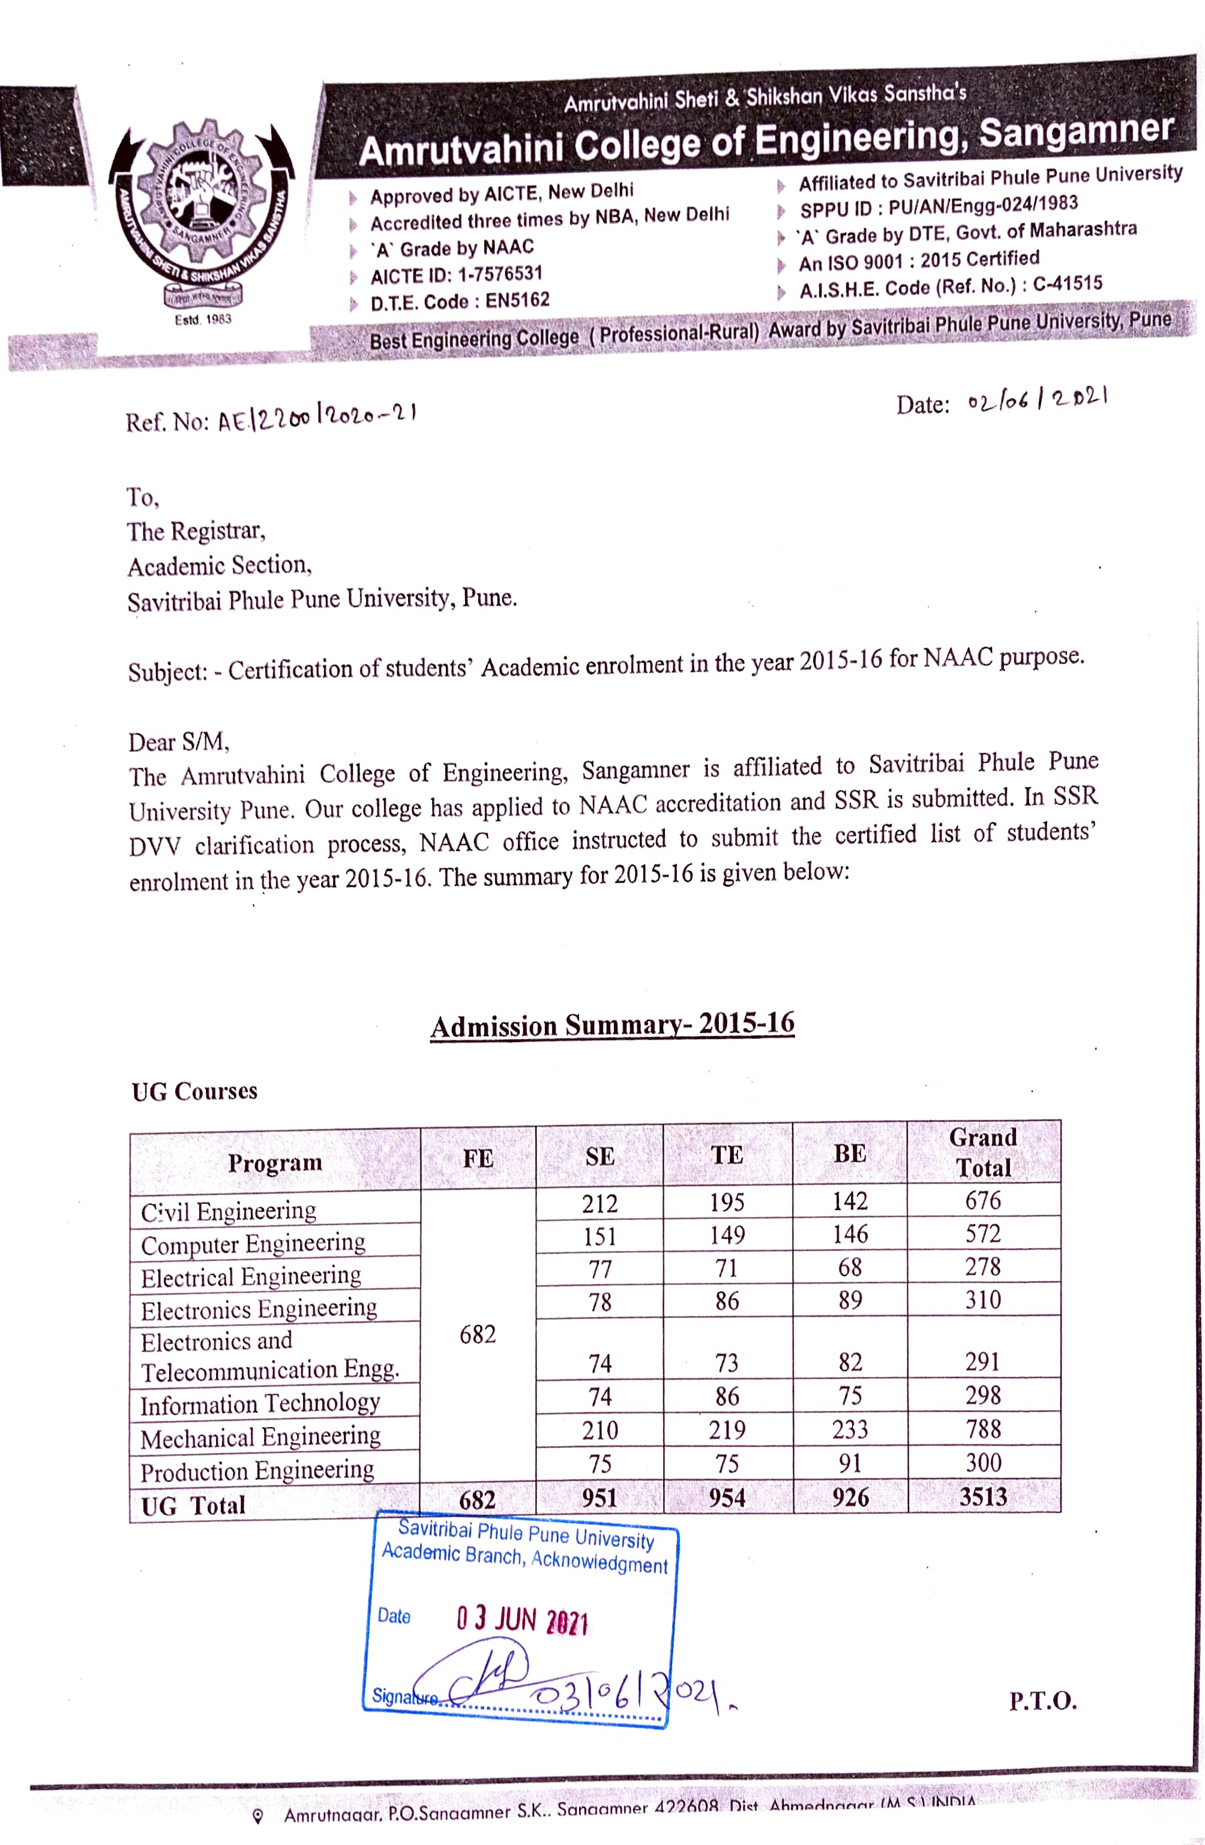
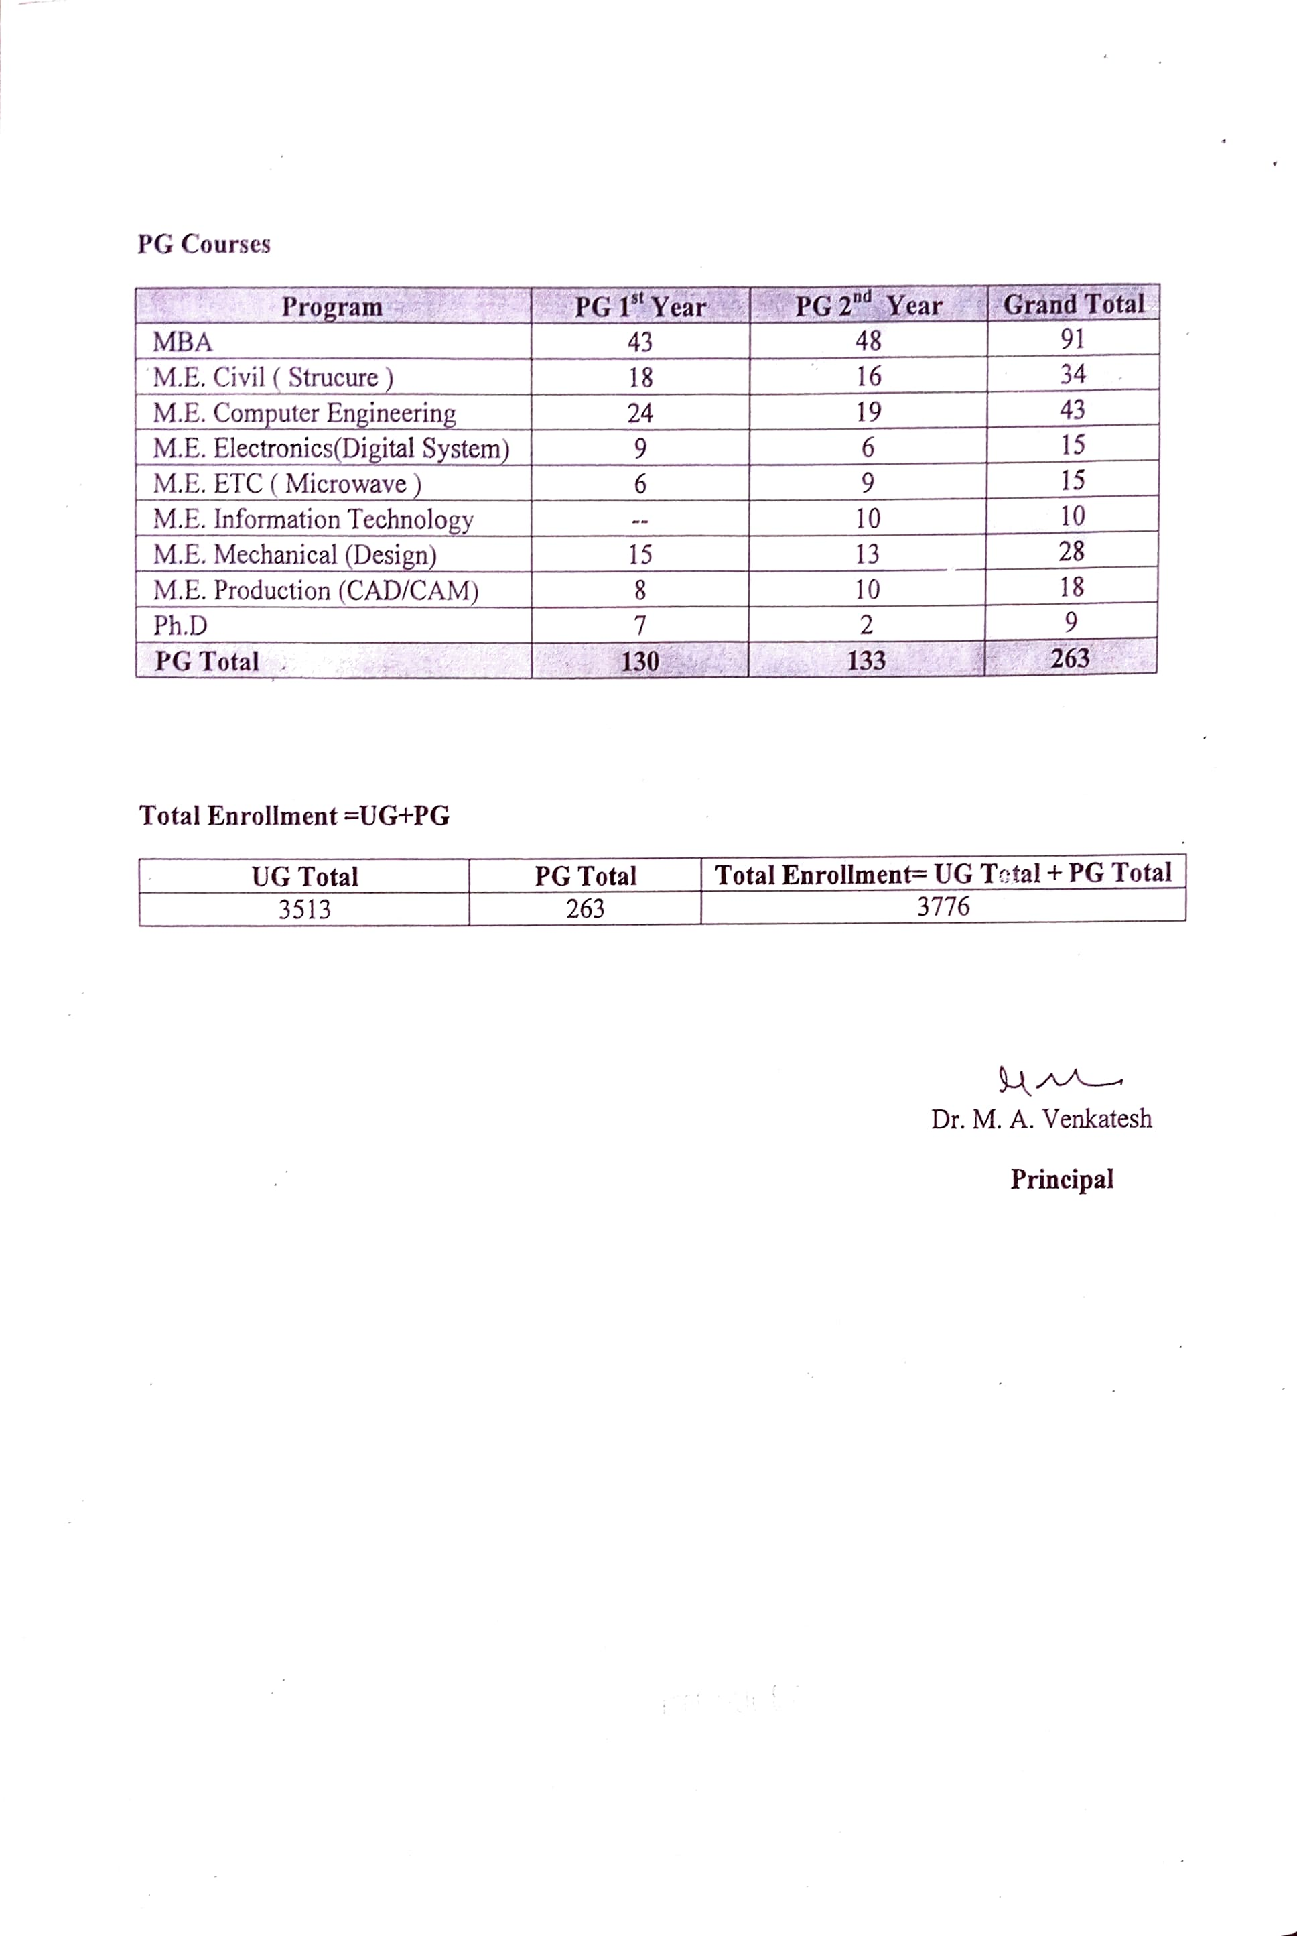
2.2 List of students admitted in the academic year 2016-17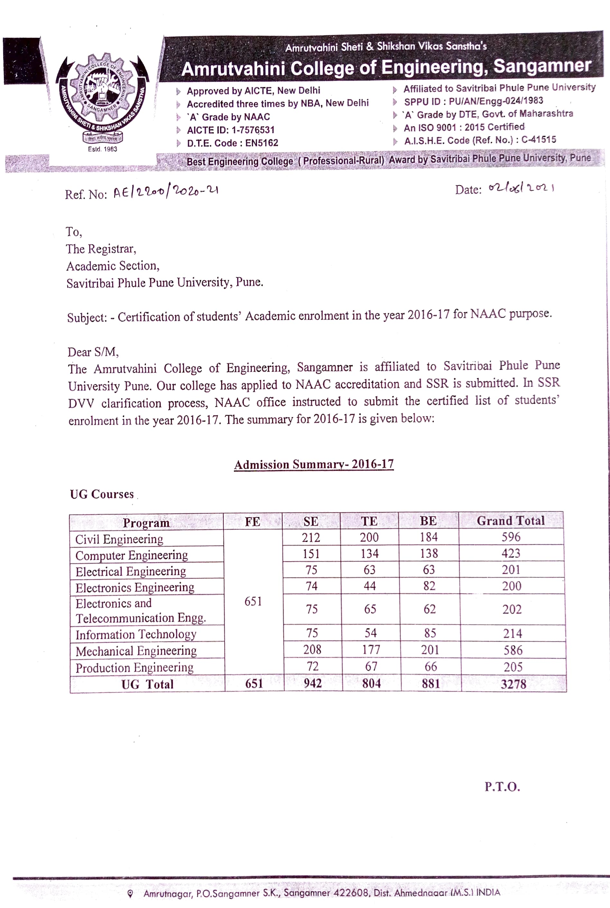
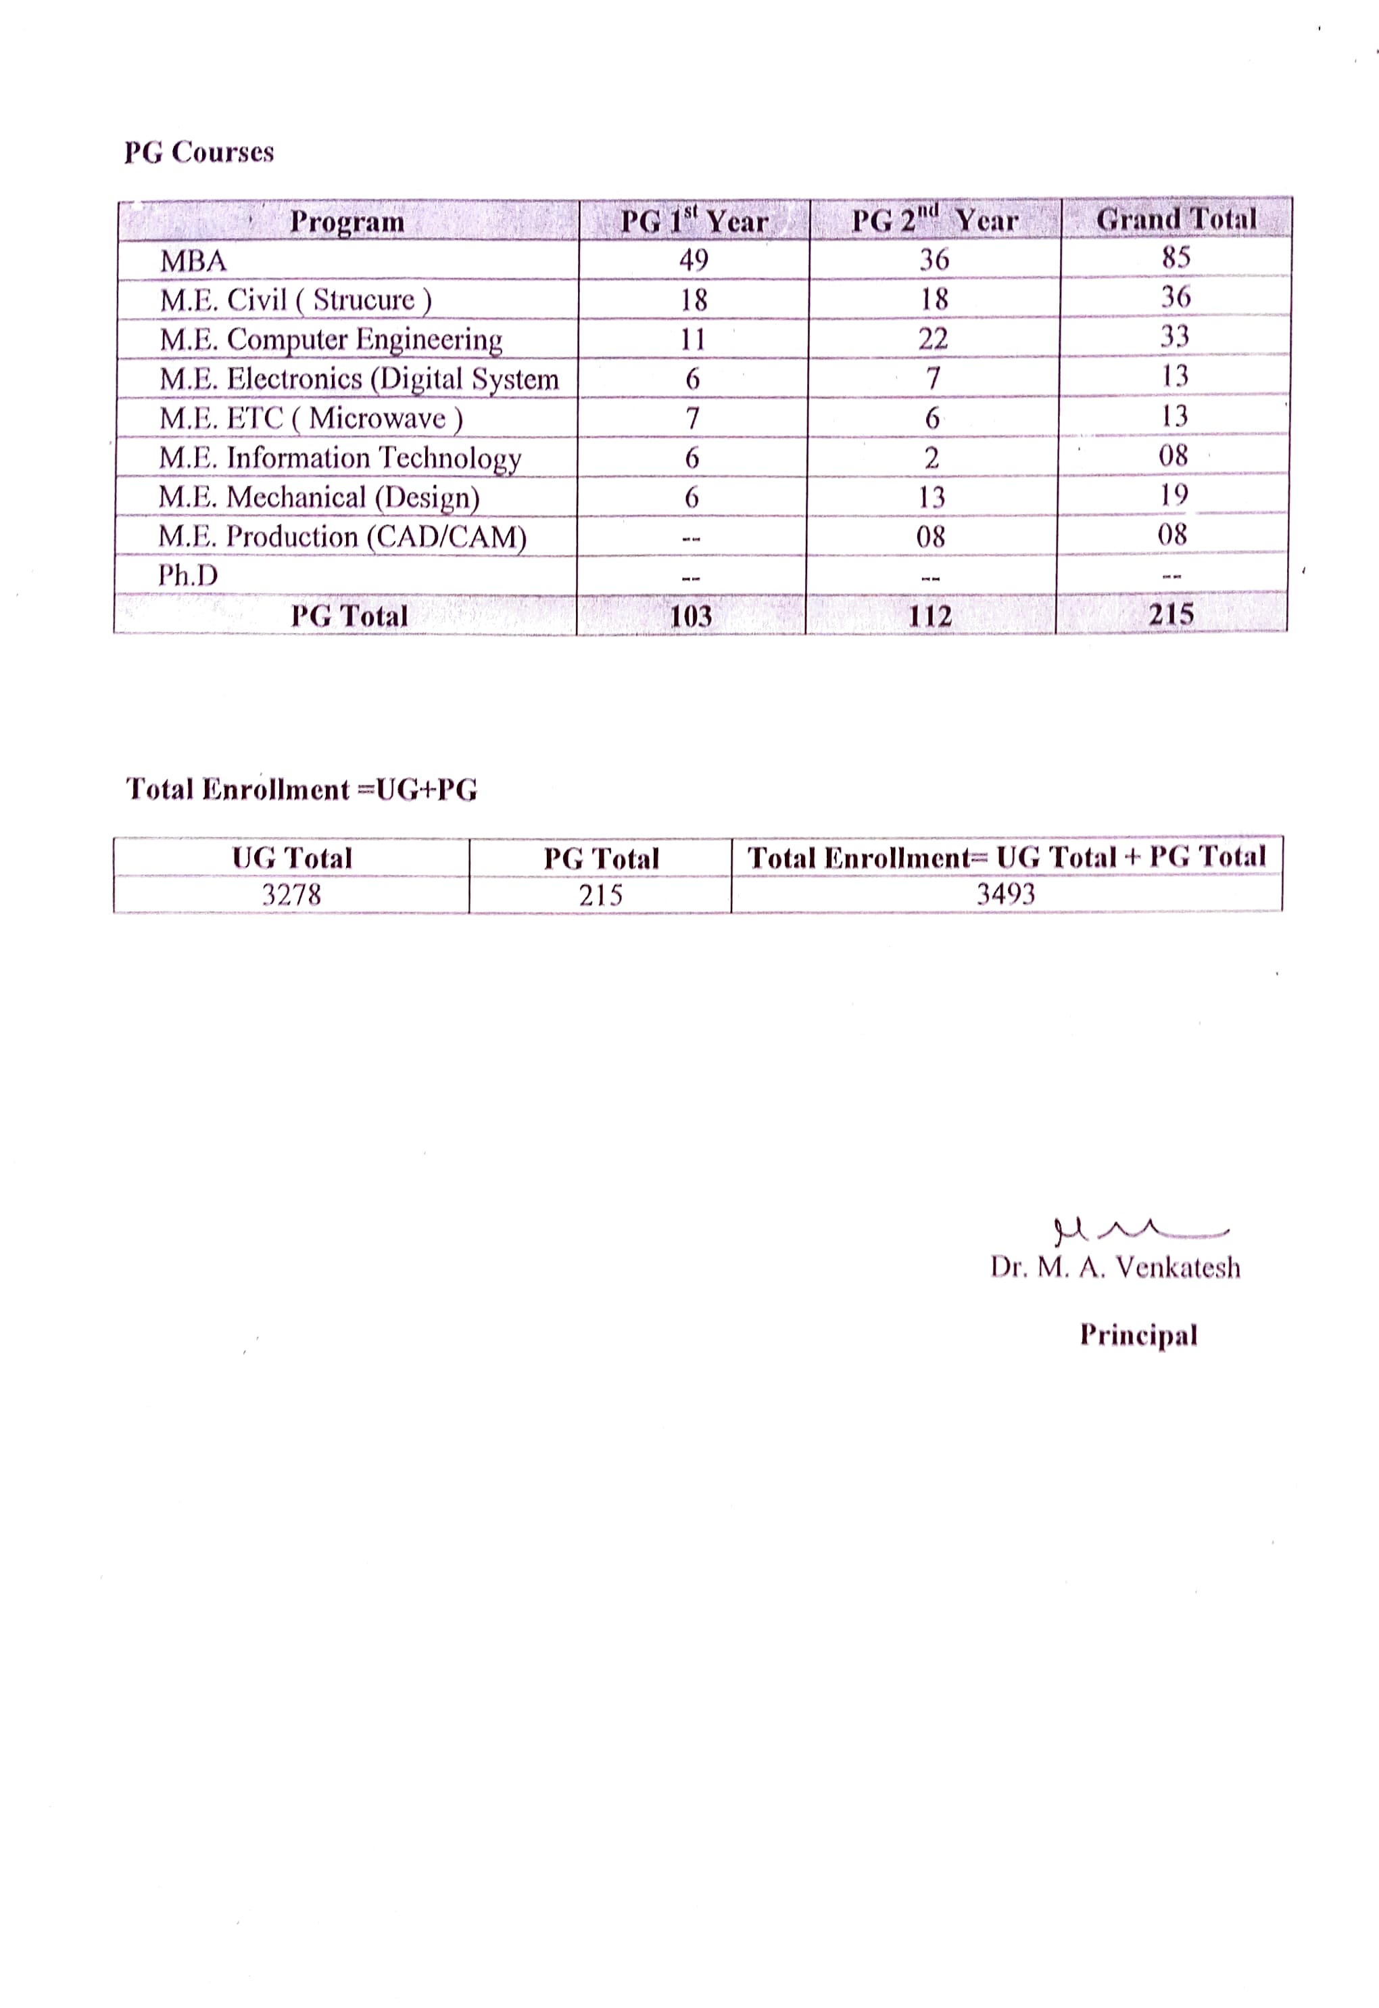
2.3 List of students admitted in the academic year 2017-18
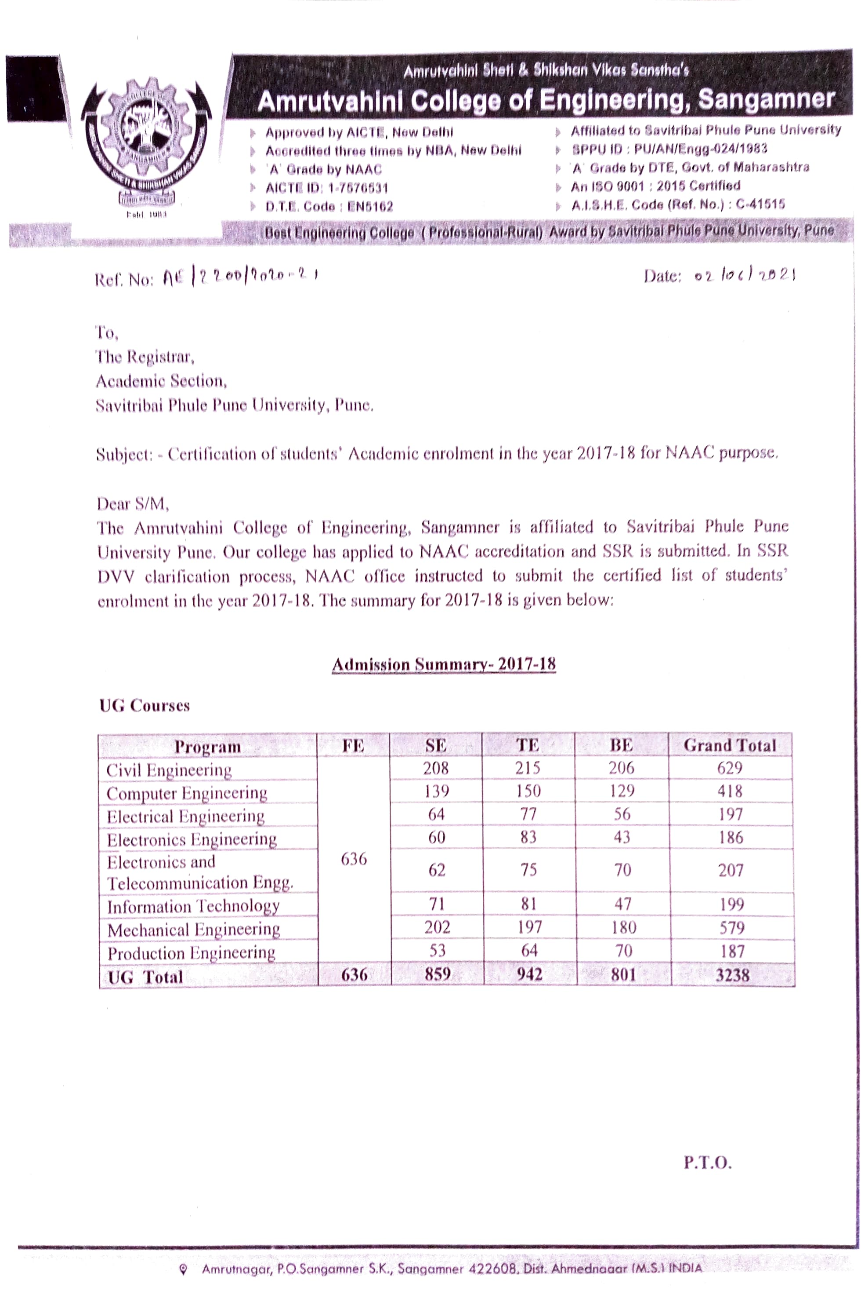
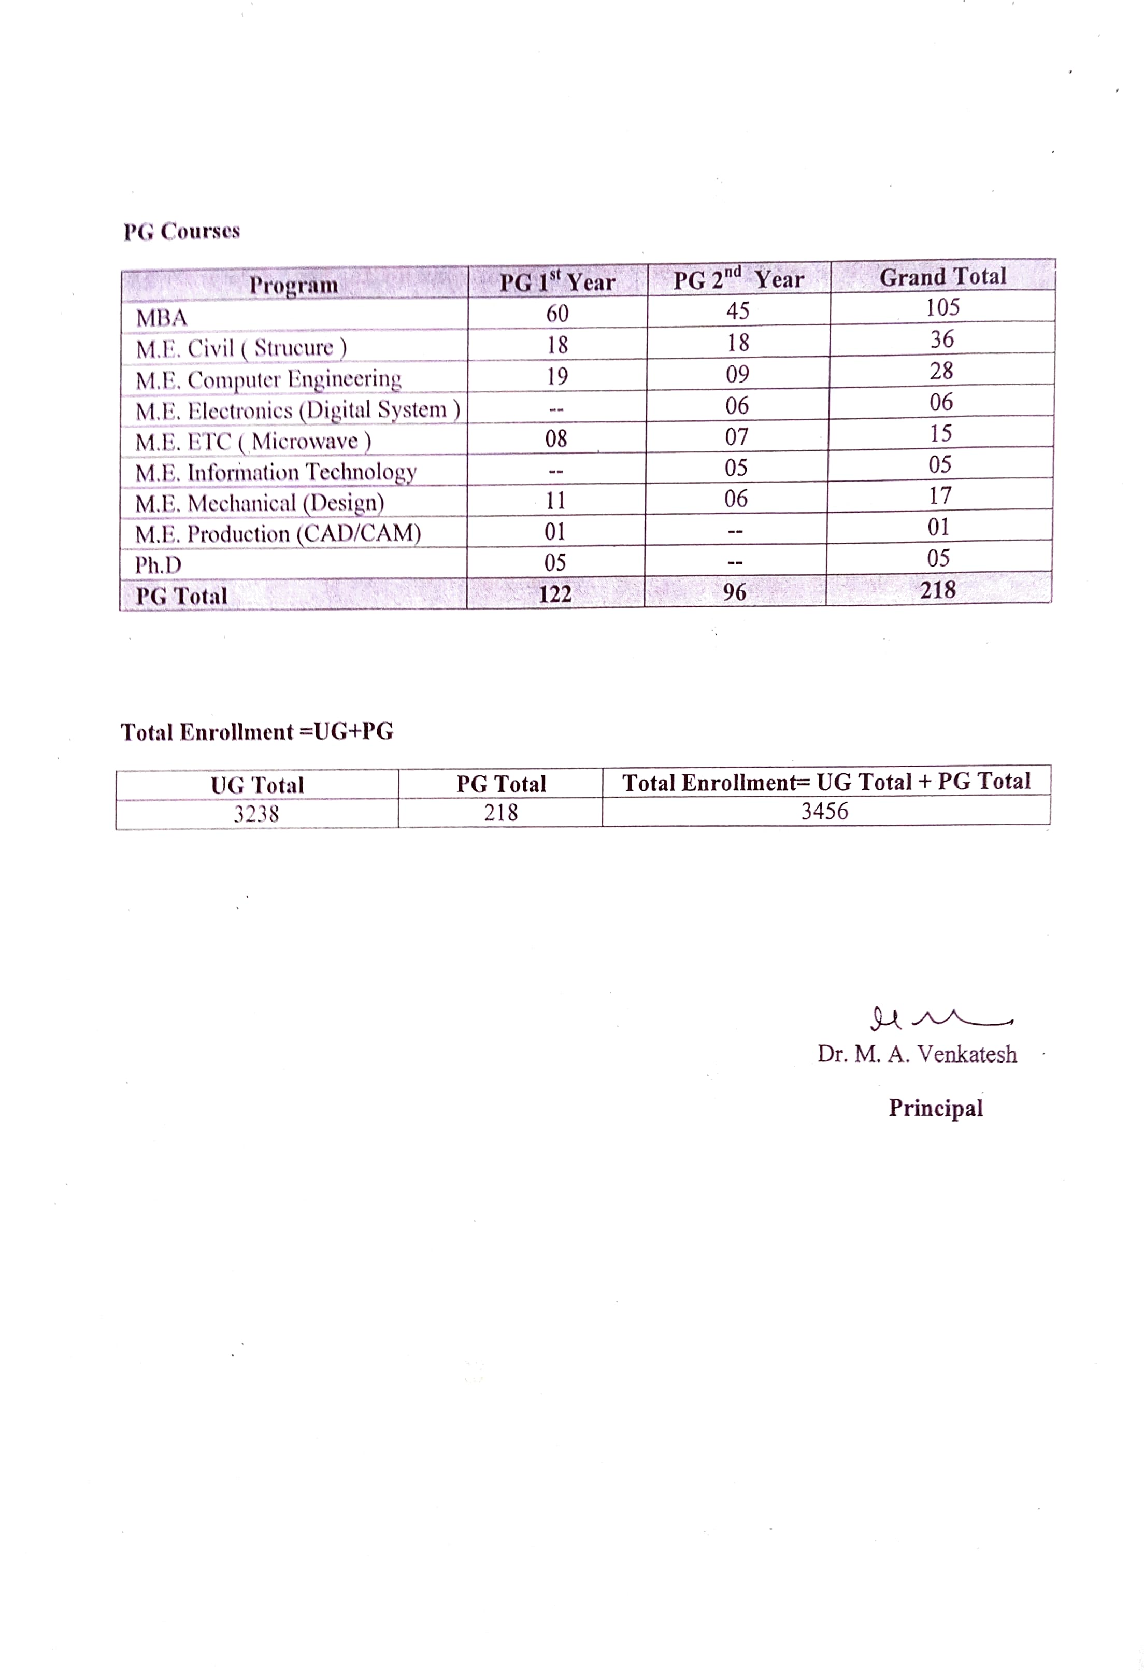
2.4 List of students admitted in the academic year 2018-19
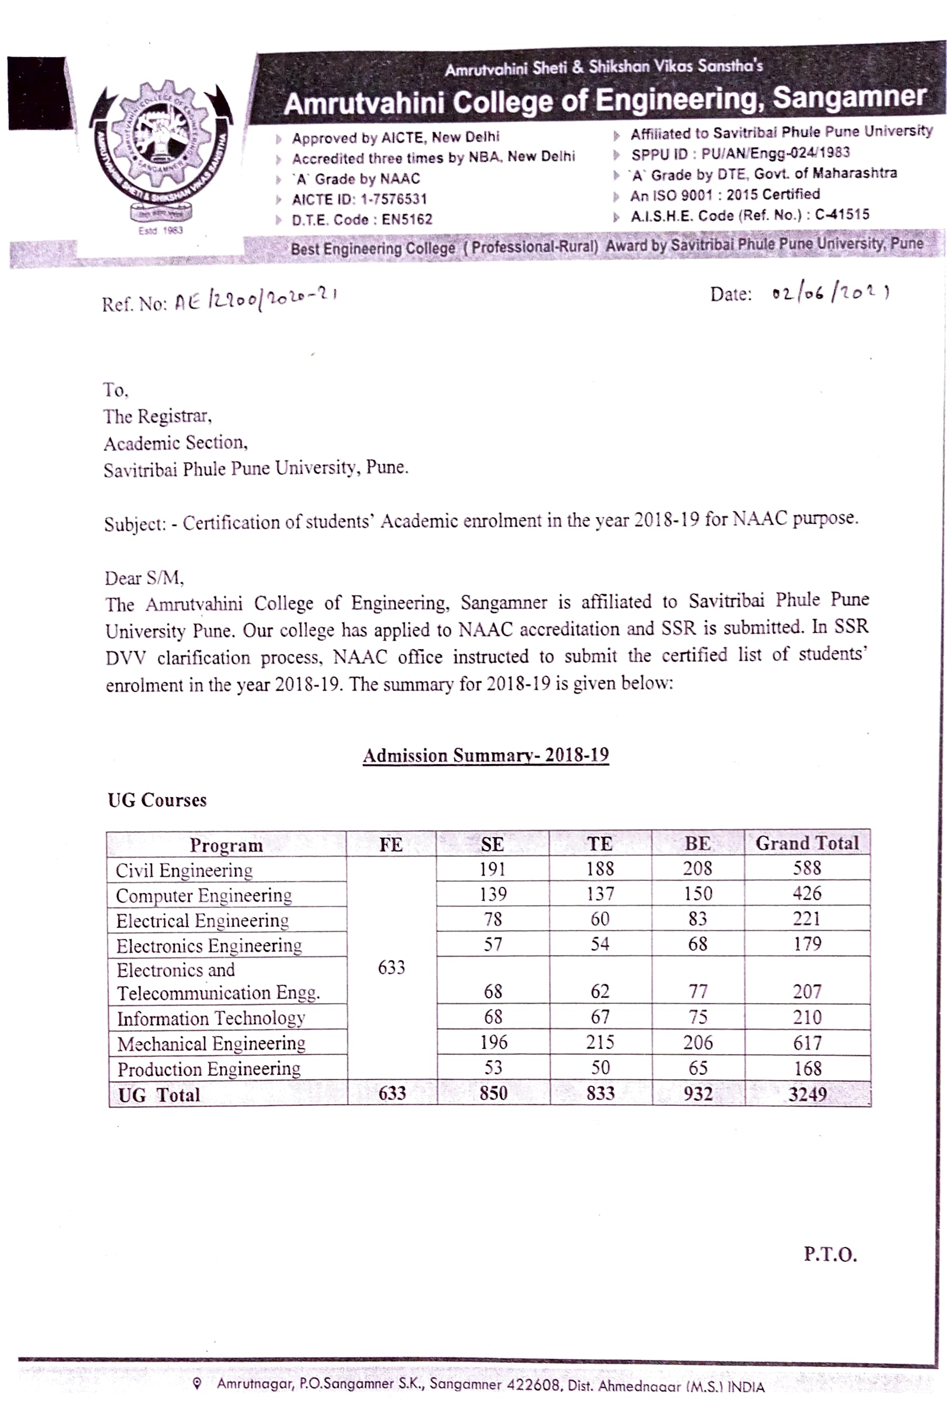
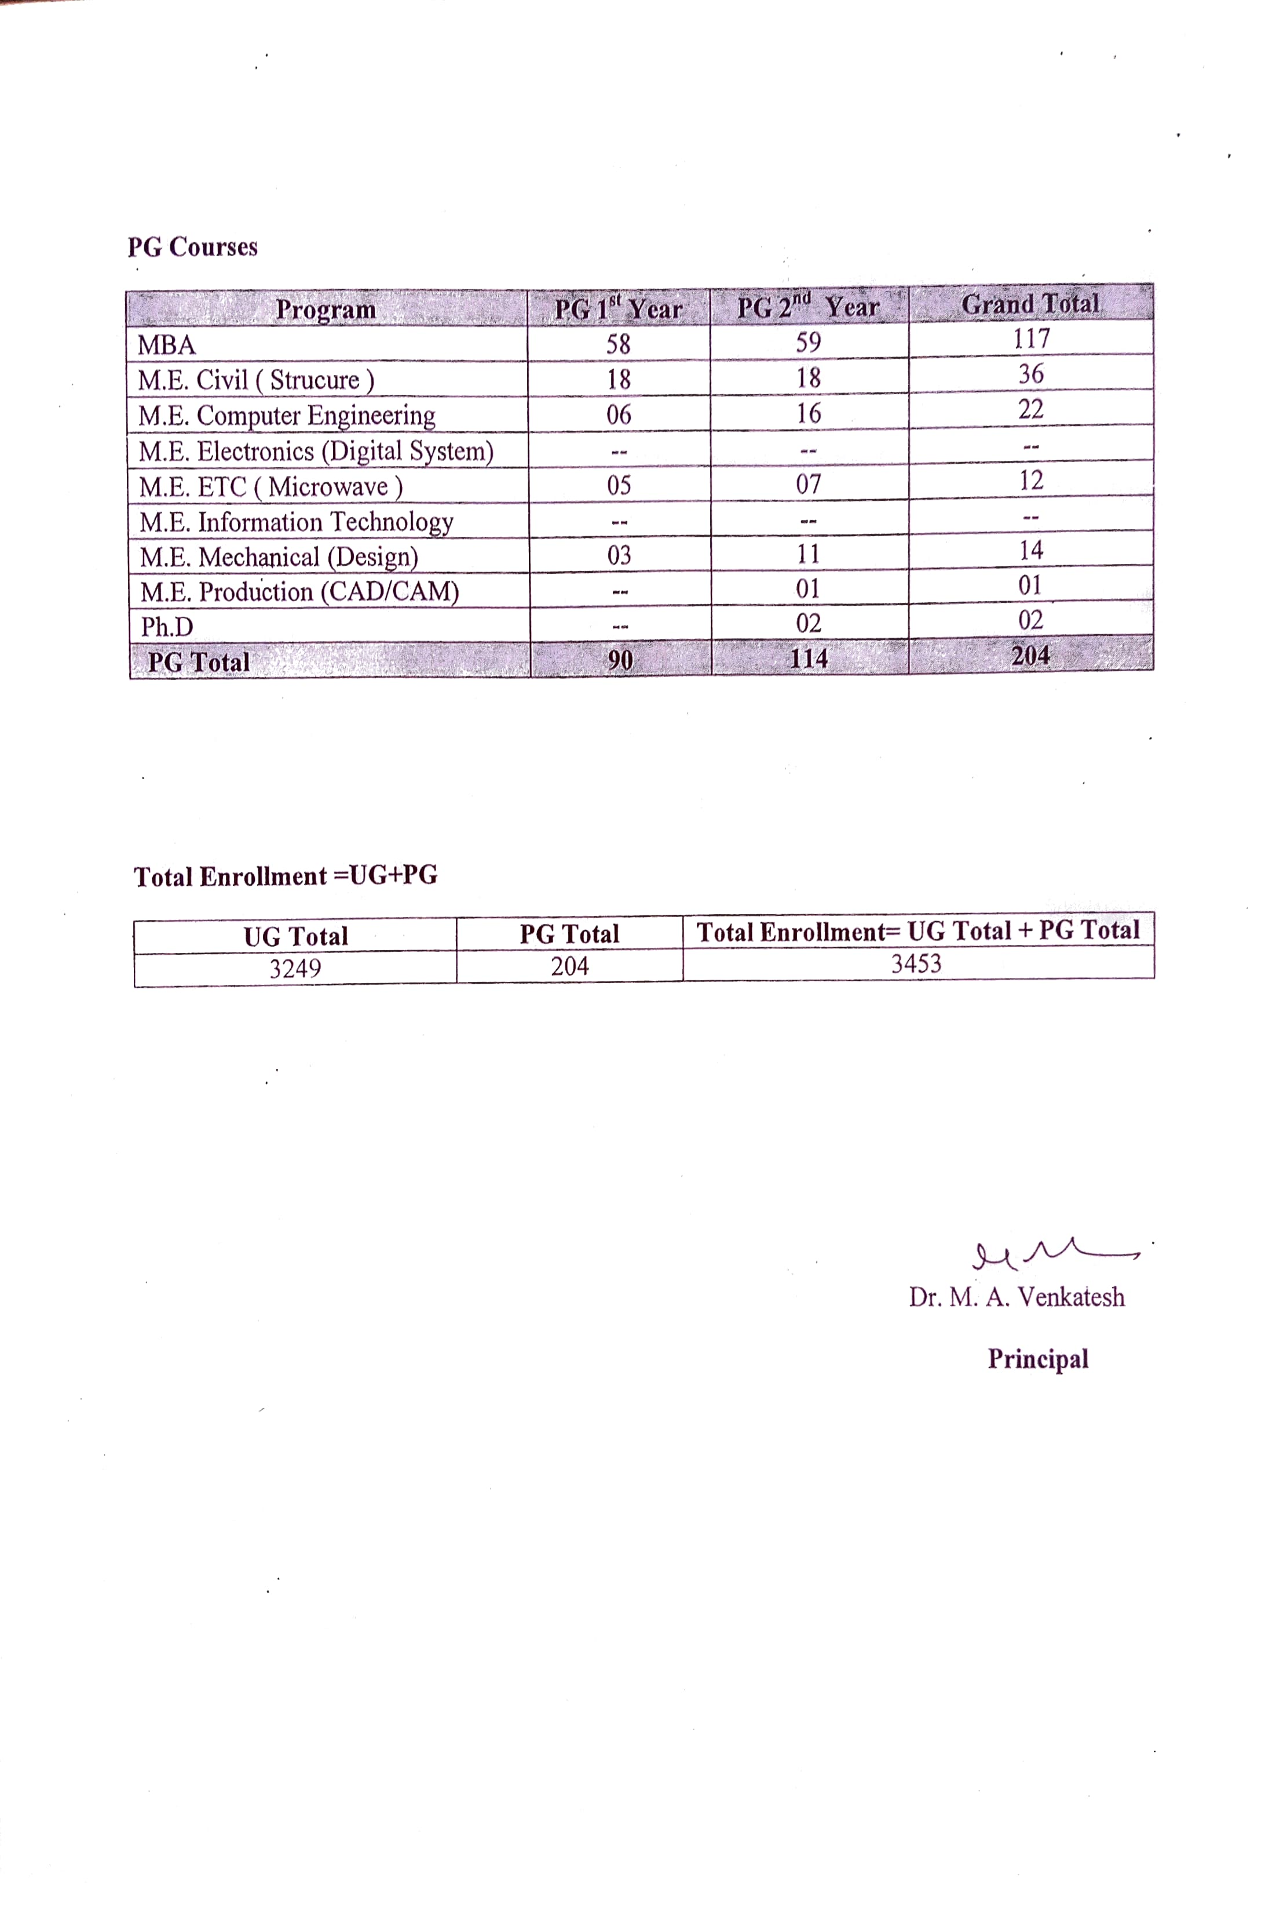
2.5 List of students admitted in the academic year 2019-20