2.1.1: Average Enrolment percentage (Average of last five years)
2.1.1.1. Number of students admitted year wise during last five years
2.1.1.2. Number of sanctioned seats year wise during last five years
Provide consolidated Document showing total number of students admitted year wise.
Response:
- Total number of Students admitted, total number of Students admitted including Supernumerary seats and total number of Sanctioned seats by affiliated university and Statutory Regulatory body (SRB - AICTE) for the last five year are attached in sequence as mentioned in Index below.
INDEX
Sr. No. | Description | Pg. No.
 | Consolidated document showing total number of students admitted in the academic year 2015-16 | 2
 | Consolidated document showing total number of students admitted in the academic year 2016-17 | 3
 | Consolidated document showing total number of students admitted in the academic year 2017-18 | 4
 | Consolidated document showing total number of students admitted in the academic year 2018-19 | 5
 | Consolidated document showing total number of students admitted in the academic year 2019-20 | 6

- Consolidated document showing total number of students admitted in the academic year 2015-16:

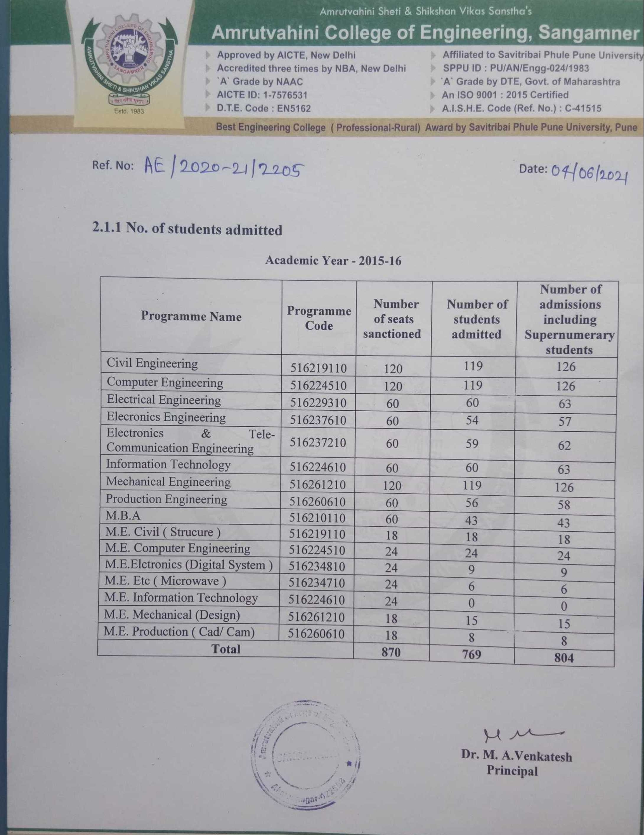
- Consolidated document showing total number of students admitted in the academic year 2016-17
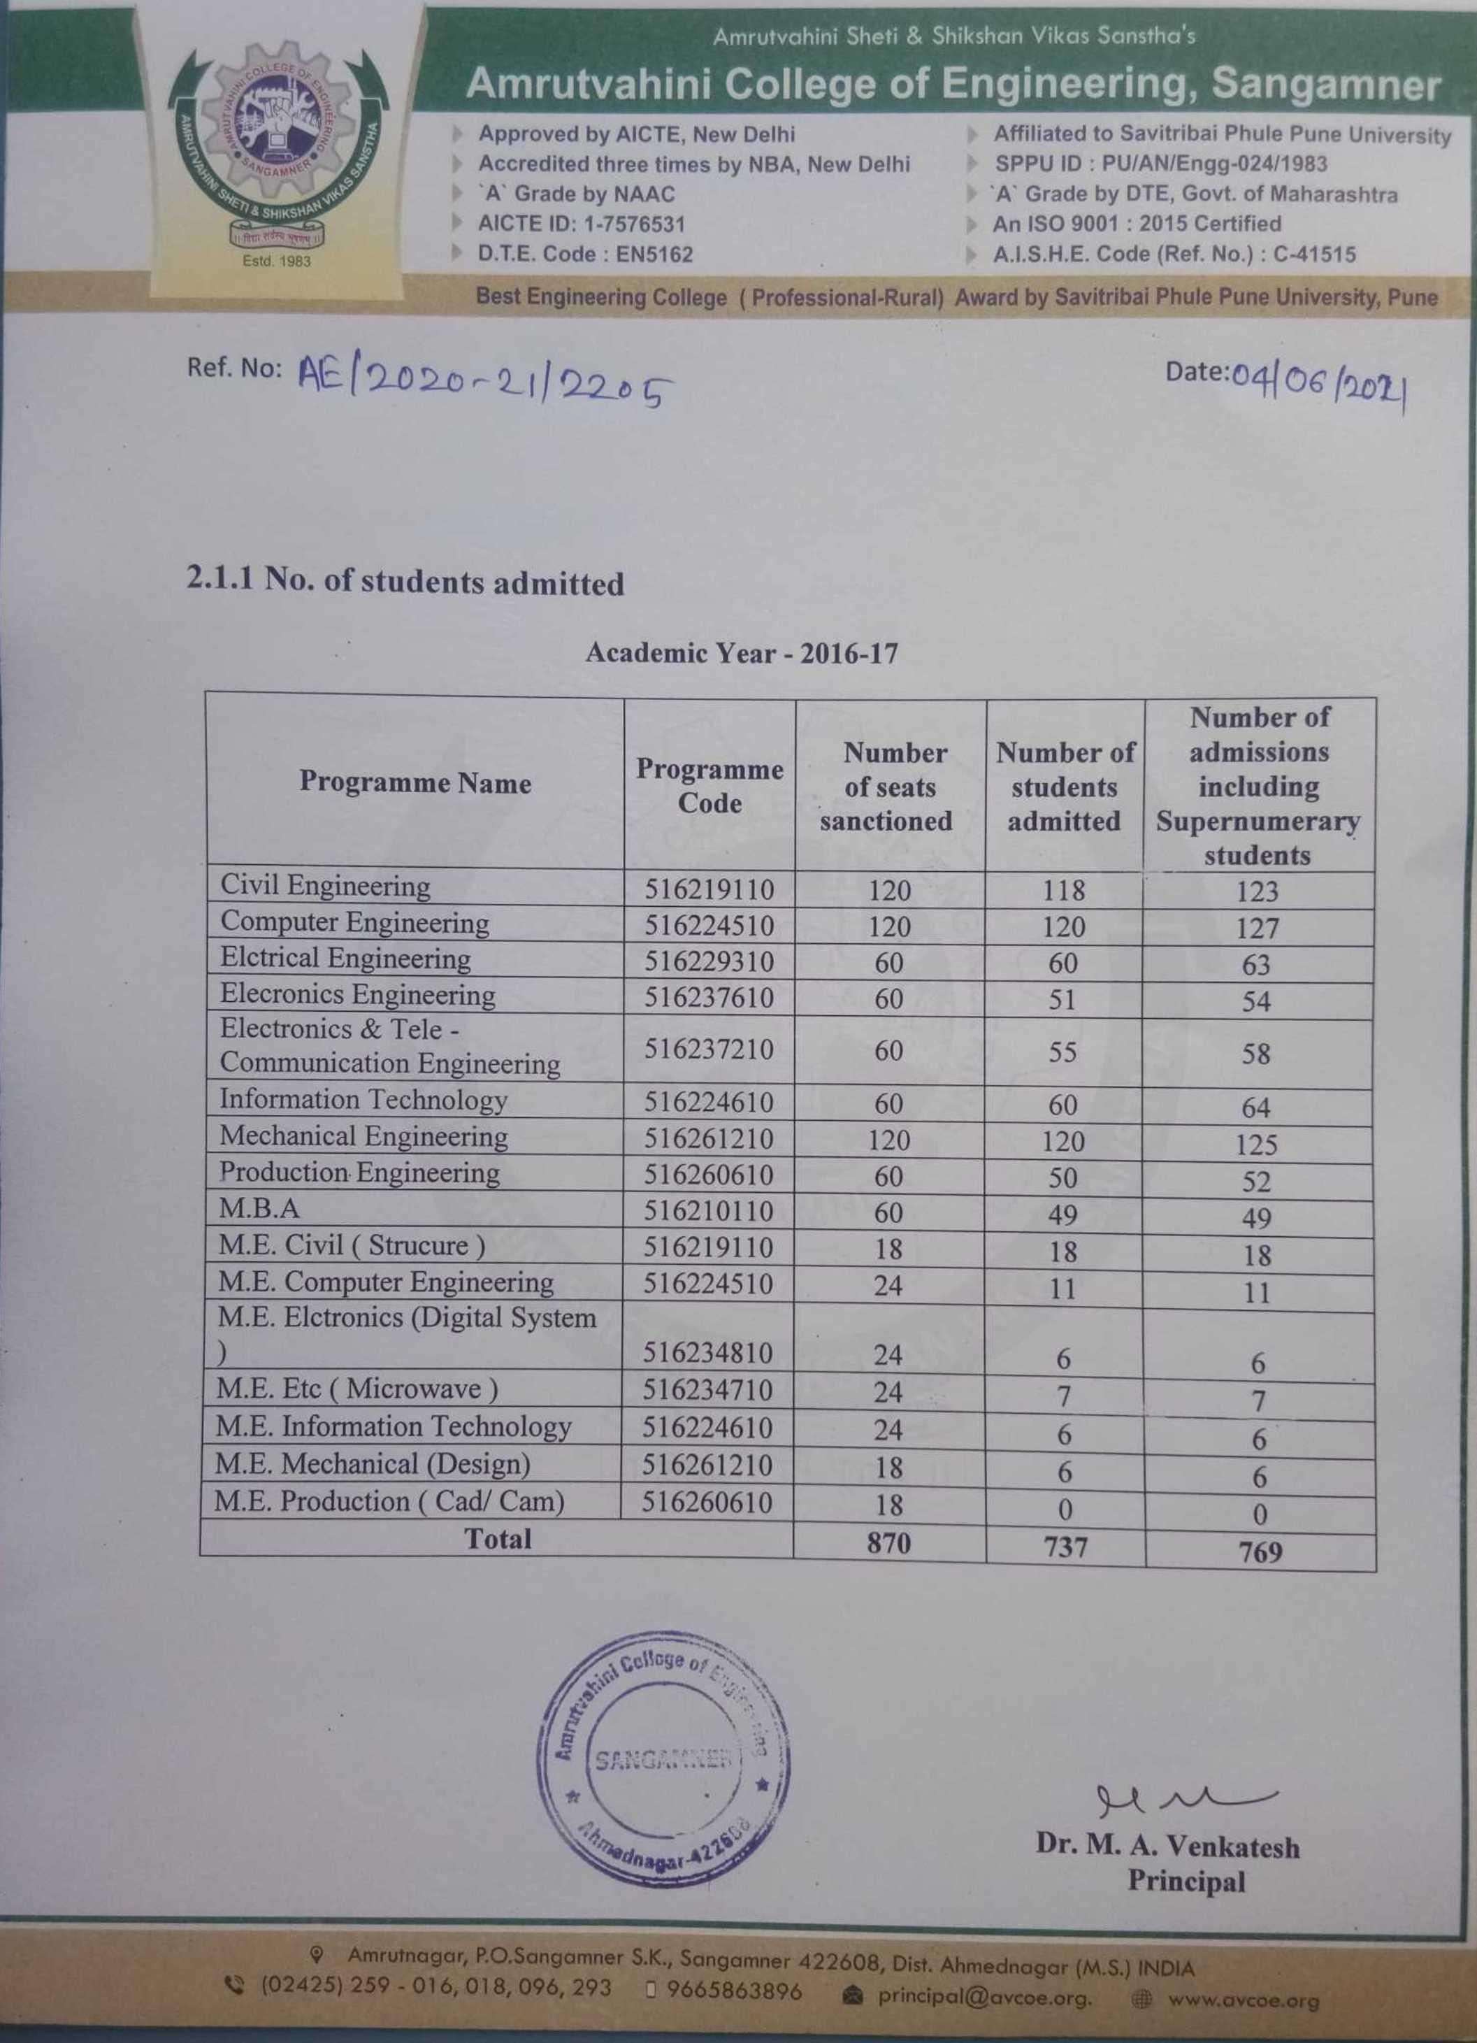
- Consolidated document showing total number of students admitted in the academic year 2017-18
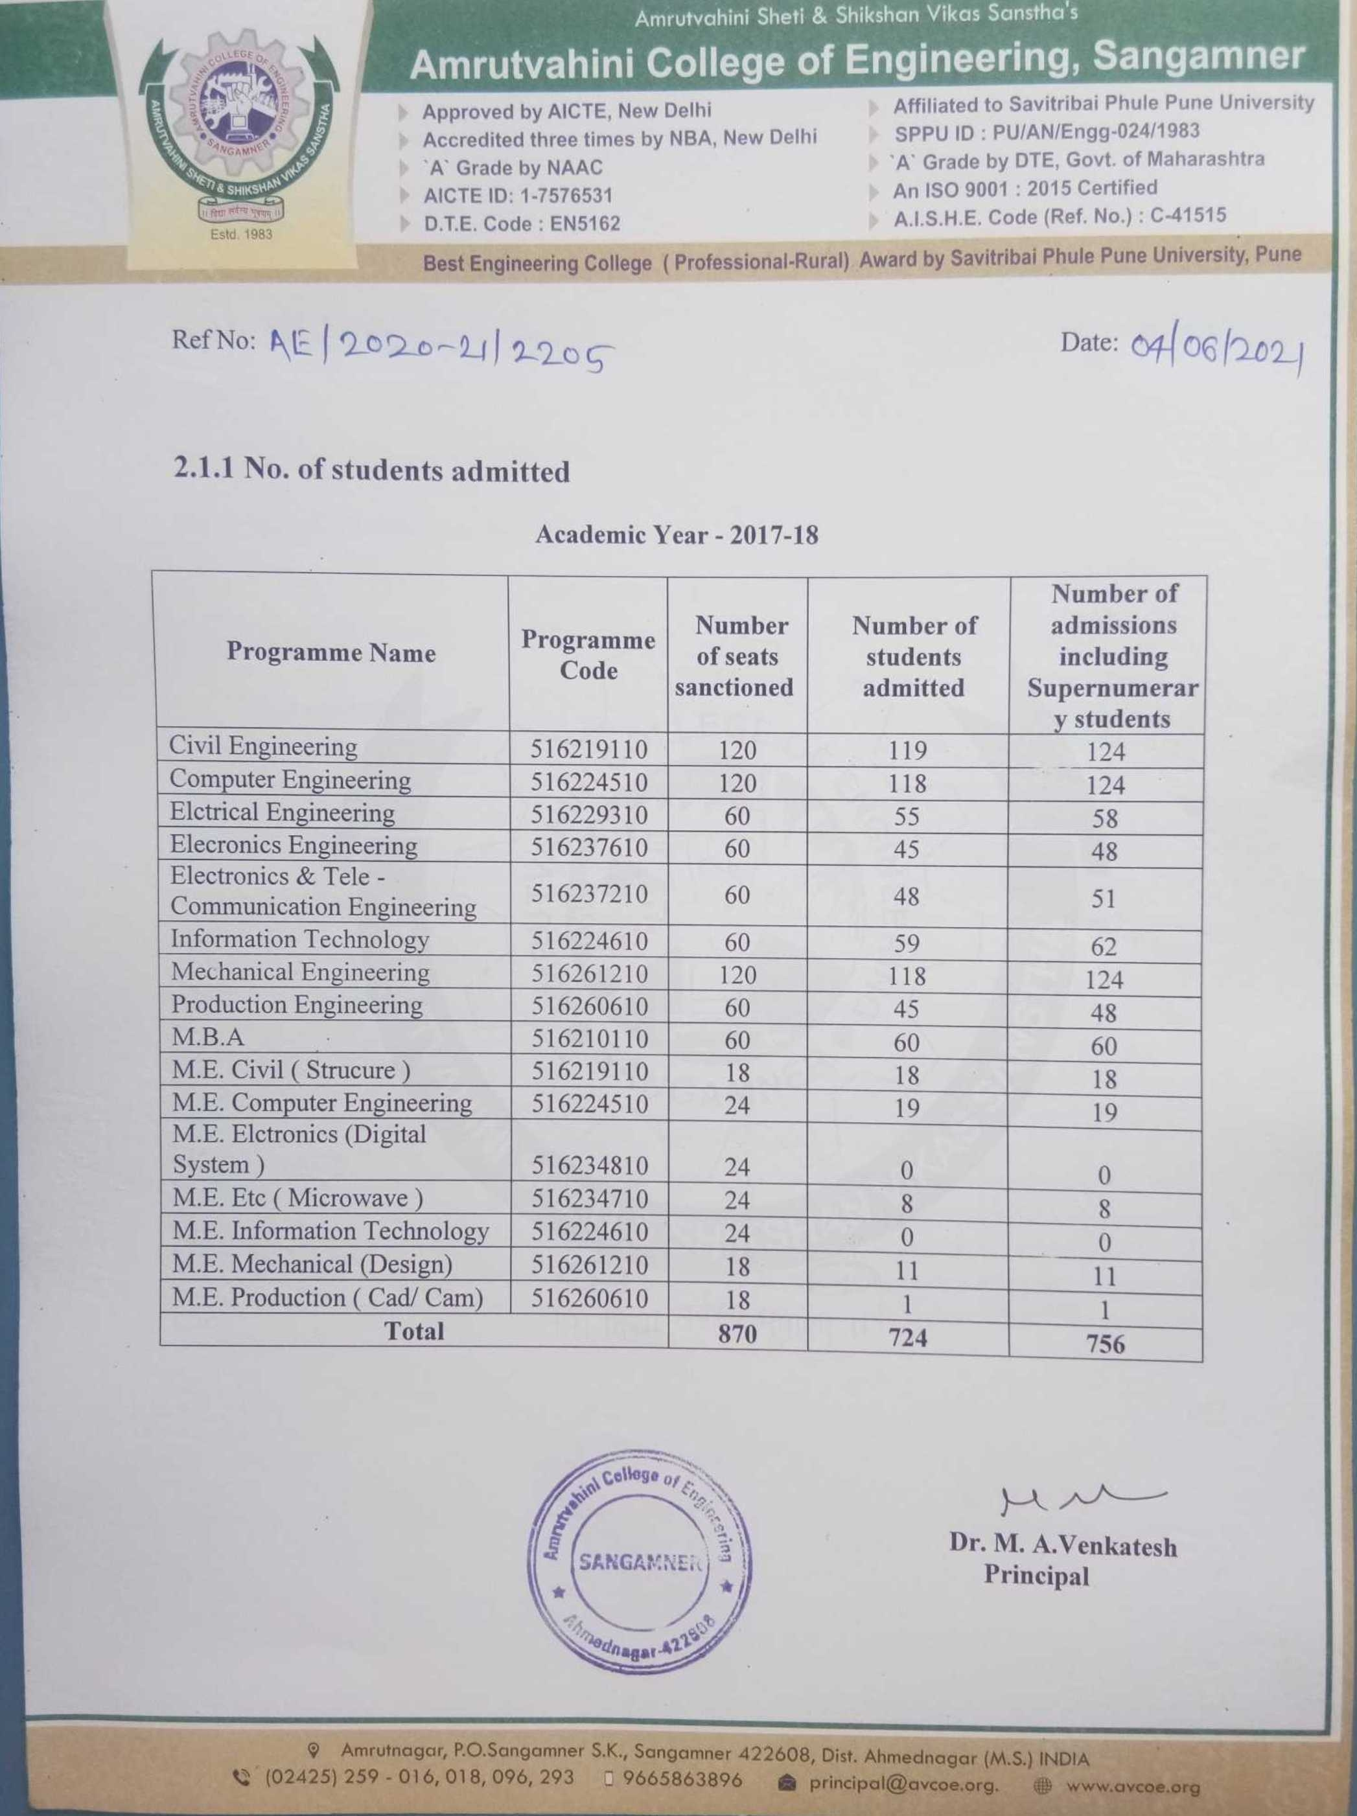
- Consolidated document showing total number of students admitted in the academic year 2018-19
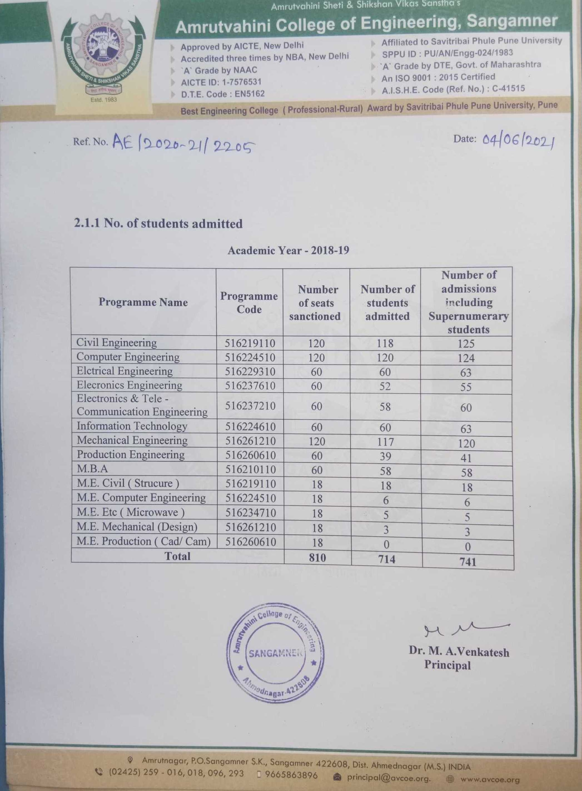
- Consolidated document showing total number of students admitted in the academic year 2019-20
