Amrutvahini Sheti & Shikshan Vikas Sanstha’s

AMRUTVAHINI COLLEGE OF ENGINEERING,

SANGAMNER – 422602

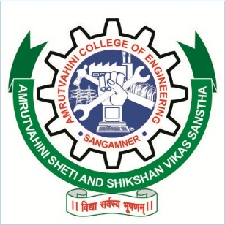

PERSPECTIVE PLAN

2019-2029
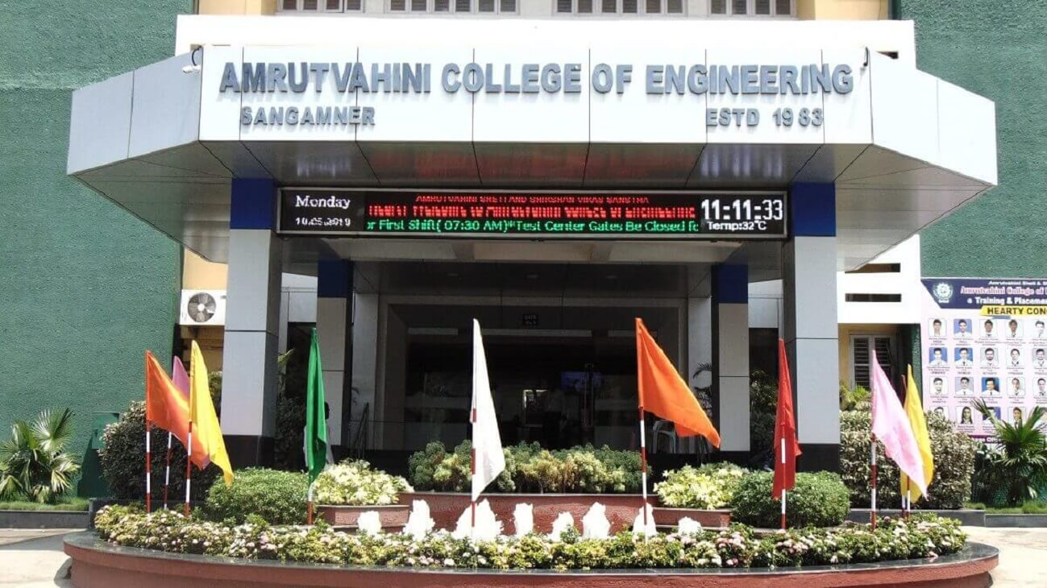

© 2019, Amrutvahini College of Engineering, Sangamner

OUR SOURCE OF STRENGTH & INSPIRATION
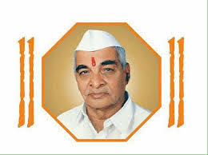

Hon Shri. Bhausaheb Santuji Thorat
Founder President
Amrutvahini Sheti and Shikshan Vikas Sanstha,
Amrutnagar, Sangamner.
The concept of non-aided engineering college was put forth by Padmashri Shri. Vasantdada Patil in 1983. The vision, untiring efforts , multidimensional thinking of a humble farmer, freedom fighter, social worker and the doyen of co-operative movement Sahakarmaharshi Shri. Bhausaheb Santuji Thorat alias Dada laid the foundation of "Amrutvahini Sheti & Shikshan Vikas Sanstha" in 1978 at Sangamner. An altruistic vision and aspiration of Dada was to start and propagate the higher technical education to the students of rural area and create long lasting imprints of Sangamner. Over the years, Amrutvahini Sheti and Shikshan Vikas Sanstha has become an integral part of each and every employee.
Dada used to say, "Since 1983 more than 15,000 students have completed their engineering and managerial education under the umbrella of Amrutvahini and have settled all over India right from Kanyakumari to Jammu-Kashmir and even abroad. Whenever they meet and tell me their success stories, my heart fills with joy along with tears in my eyes.”

OUR DYNAMIC LEADERSHIP
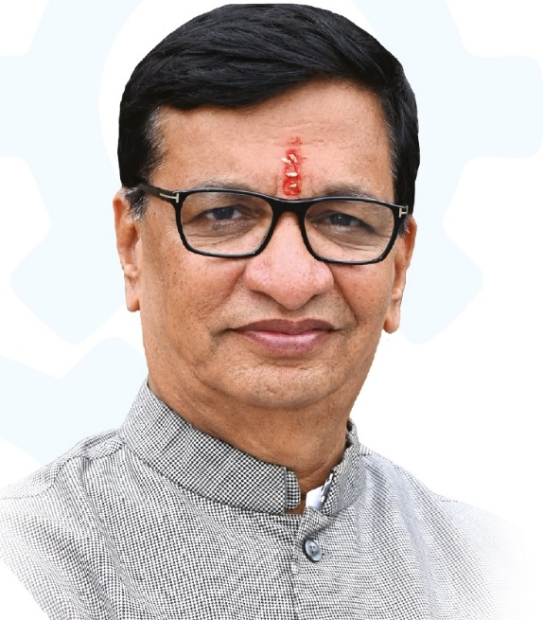

Hon’ble Shri. Balasaheb Thorat

President

Amrutvahini Sheti and Shikshan Vikas Sanstha,

Amrutnagar, Sangamner.

Minister for Revenue, Government of Maharashtra.

The Hon’ble President took upon himself the arduous task of translating the vision of Hon’ble Bhausaheb Thorat into concrete realities by imbibing the virtue of hard work and honesty to achieve excellence in the sphere of education through his dynamic and pragmatic leadership. It is under his able guidance that the college has expanded its horizons and achieved the distinction of being rated as the 'Best College' by the prestigious University of Pune along with other credentials.

OUR MORAL SUPPORT

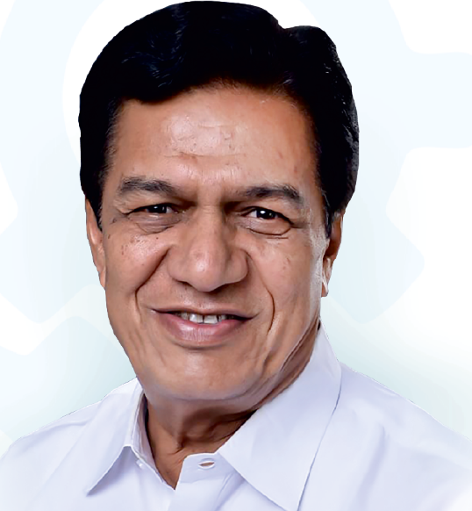

Hon. Dr. Sudhir Bhaskarrao Tambe

Trustee

Amrutvahini Sheti and Shikshan Vikas Sanstha,

Amrutnagar, Sangamner.

Member of Legislative Council, Maharashtra State.

M.S. (General Surgeon)

A doctor by profession, Dr. Sudhirji Tambe is a generous person with a flair for culture and art. With his dynamic and versatile personality, he has been a mentor to the poor and socially backward people. He has also been acting as a strong guiding force to this college. His vision is to provide quality education to the students and make them capable of facing the challenges of the globalized world.

THE CAPTAIN OF THE SHIP

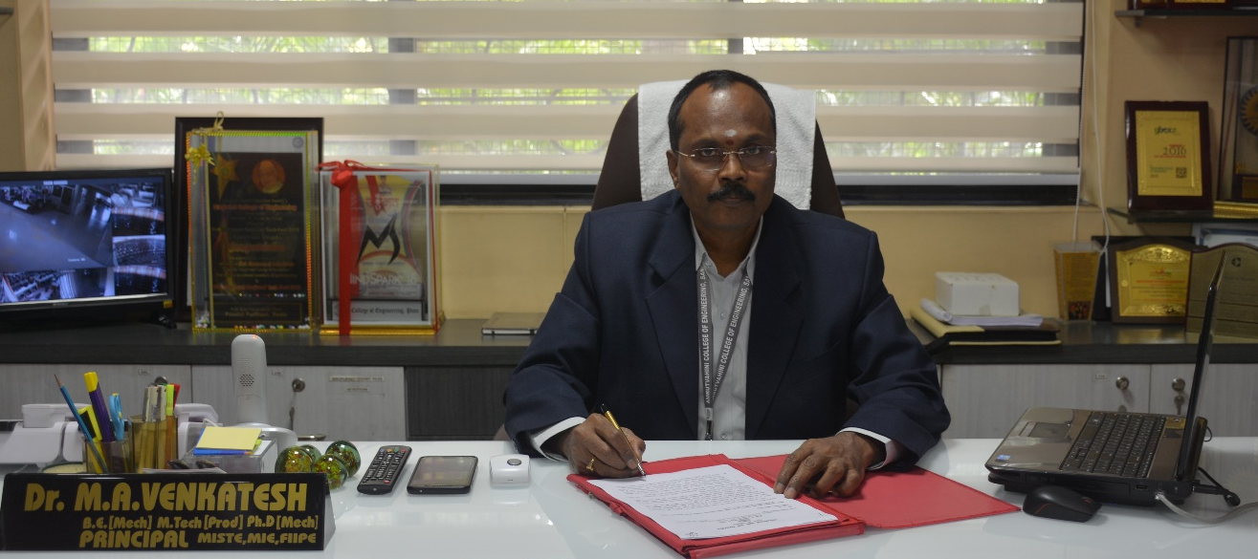

Dr. M. A. Venkatesh

Principal

Knowledge and hence the education is the openings for newer and newer horizons. After the 70 years of independence, India has won the overall championship in the various emerging educational fields like, science, engineering, technology, medical, industry, arts, commerce, farm etc. Looking at present scenario, India might be having a monarch-ship in quite very near future in 21st century compared to the rest of the world. This has the roots in the propagation of a quality, proficiency and very high degree of primary as well as advanced education at various levels to Indian societies. During the last few decades the knowledge traits have been cultivated to be at precise, rapid and innovative levels in Indian education system. Presently, this process rate has been increased enormously leading to highly professional dynamic, talented, skilled personalities. Looking at rapid cultivation of such personalities, we are also committed to very good quality of teaching-learning process with having maintained high grade discipline among the staff and students and to achieve sky-scraping point superiority in academic by maintaining a conductive atmosphere for studies, state-of art laboratories communication centre and digital library. In another view, we aim at development of our student at different levels by the proper encouragement, guidance, support and generation of in-house recourses by giving them a confidence to feel free at home. We further also committed to arrange scientific and/or technological based conferences, We are quite self-assured for the moulding and nurturing of our students as a young, bright, dynamic, talented & professional technocrats and a responsible gentle citizen by raising the our actions to at high quality technical education.

Board of Trustees

Board of Trustees of Amrutvahini College of Engineering, Sangamner is constituted under Amrutvahini sheti and Shikshan Vikas Sanstha vide Bombay public Trust Act. 1950 Registration Number -274(Ahmednagar) dated- 30/11/1978 Society Registration Act.No.MAH/317/Ahmednagar/78 dated – 08/08/1978.

This is the supreme authority to provide all the rules and regulations for running the institute smoothly. They provide us all the infrastructure and other privilege to conduct day to day affairs. The members of the Board of the Trustees discuss issues/matters at an interval of six months in the presence of Chairman .The member Secretary of the Board of Trustees place the points in front of the members.

1 | Hon. Shri. Balasaheb Bhausaheb Thorat | President
2 | Shri. K. H. alias Balasaheb Gunjal Patil | Vice-president
3 | Hon. Shri Dr. Sudhir Bhaskarrao Tambe | Trustee
4 | Shri. Adv. Ramnath Bhaurao Sonawane | Trustee
5 | Shri. Bajirao Khanduji Khemnar | Trustee
6 | Shri. Laxmanrao Balaji Kute | Trustee
7 | Shri. Tulashiram Prabhakar Bhor | Trustee
8 | Mrs. Sharyu Ranjeet Deshmukh | Trustee

Governing Council

The outcome of Board of Trustees is thoroughly discussed point to point in Governing Council Meeting. If they feel some corrections, they report the same things to Board of Trustees for discussion and get it confirmed by them.

1 | Hon. Shri Balasaheb Bhausaheb Thorat ,M.LA | Chairman
2 | Hon. Shri Dr. Sudhir Bhaskarrao Tambe, M.L.C. | Member
3 | Hon. Shri K.H. alias Balasaheb Gunjal Patil | Member
4 | Shri. Sanjay Shivajirao Dighe | Member
5 | Shri. Anil Baburao Shinde, Chief Executive | Member
6 | Nominee of central government nominated by AICTE  (Ex. Officer) | Member
7 | Joint Director, Technical Education Regional Office, Nashik (Nominee of State government D.T.E. Mumbai) (Ex. Officer) | Member
8 | Nominee of S. P. Pune University, Pune | Member
9 | Dr. Ms. Baisa Laxman Gunjal | Member
10 | Dr. Jyotiba Bhalchandra Gurav | Member
11 | Prof. Ashok Kumar Mishra | Member
12 | Dr. M.A. Venkatesh, Principal | Secretary member

College Development Committee

This committee prepare an overall comprehensive development plan of the college regarding academic, administrative and infrastructural growth, and Enable College to foster excellence in curricular, co-curricular and extra-curricular activities.

Sr. No. | Name of the Nominated Person | Designation
 | Shri. Balasaheb Bhausaheb Thorat | President
 | Dr. Sudhir Bhaskarrao Tambe | Local Member
 | Shri. Anil Baburao Shinde | Secretary of the Management
 | Dr. Madhukar Ramchandra Wakchuare | Head Of Civil Engg. Department
 | Prof. Ms. Swati Babasaheb Bhonde | Teacher
 | Prof. Dipak Shriramji Bajaj | Teacher
 | Prof. Vijay Pundlik Waghe | Teacher
 | Shri. Janardhan Jayram Gadakh | Non-Teaching
 | Shri. Sanjay Shivaji Dighe | Industry and Alumni
 | Dr. Arvind D. Shaligram | Research
 | Prof.(Dr.) Keshav N. Nandurkar | Education
 | Prof. Ravindra Somnath Tajane | IQAC Coordinator
 | Ms. Kalyani Ahire | President of College Students Council
 | Ms. Bharati Dake | Secretary of College Student Council
 | Dr. M. A. Venkatesh | Member Secretary

Academic Advisory Committee

The management, faculty and staff recognizes the need of effective advisory committee as it is critical to our mission in educating and preparing competent engineers capable of playing a meaningful and productive role in the global workforce of the future.
This policy establishes the basis for the formation of Academic Advisory Body, including their composition, membership, terms and recommendations.
Sr. No. | Name | Representative | Designation
 | Dr. M. A. Venkatesh | Principal | Chair Person
 | Shri. A. B. Shinde | Chief Executive Officer (CEO) | Member
 | Dr. Sriram Hegde  IIT Delhi | Distinguished academician | Member
 | Shri. P. S. Krishnan  Taparia Tools, Nashik | Experienced and well-versed industry person | Member
 | Shri. Vinit Adarkar Mercedes-Benz R&D India | Distinguished Alumni | Member
 | Shri. B. M. Pansare | Parent representative well-versed with technical education and industry requirements | Member
 | Dr. S. B. Rahane | Faculty representative | Member
 | Dr. M. R. Wakchaure | Dean Academic | Member Secretary

New National Education Policy: 2019 – 2020

Mr. Thomas Babington Macaulay (1800-1859) proposed the policy of introducing the English education system to British Colonies. After independence on 15th Aug, 1947, the need for a new education policy tabled, headed by Dr. D. S. Kothari. The Parliament passed first education policy in 1968. India has had three date as policy in the year 1968, 1986, and 1992. But it needed a holistic modification and took shape of “new national education policy”: 2020 issue of concurrent, under the pragmatic leadership of Hon’ble Shri Krishnaswamy Kasturirangan, former Indian Space Research Organization (ISRO) chief.
The vision of the National Education Policy is:
National Education Policy 2020 envisions an India-centric education system that contributes directly to transforming our nation sustainably into an equitable and vibrant knowledge society by providing high-quality education to all.
The zest of NEP 2019-2020 is abridged in-

    - Students should not only learn but also should learn how to learn.
    - Implementation of three language formula
    - Scientific temper
    - Communication
    - Ethical reasoning
    - Nurturing the culture of teaching
    - Propel the GER (Gross Enrolment Ratio)
    - Autonomy must mean the freedom to Innovate
    - College will take the lead in community service.
    - Curriculum, pedagogy, assessment and student support will be revamped.
    - Internationalisation of higher education
    - Research and Innovation across the country in all academic disciplines
    - Need of a born teacher, not like for the sake of teacher

PERSPECTIVE PLAN: 2019 – 2029

Established in 1983, under the leadership of Hon. Late Bhausaheb Thorat, the Institute has been providing a distinctive excellence driven engineering education that grooms the future generations of engineers and entrepreneurs. Currently the college offers undergraduate and postgraduate courses with annual intake of 660 and 132 respectively. The Institution has the coveted honor of accreditation in 2003 and 2007 from NBA, an AICTE wing for quality assurance, New Delhi. Continuing the trend of quality education, the institute has re-accredited by NBA for the third time to all the disciplines by maintaining their quality education and research in 2012. The Institute Is also accredited with A Grade by NAAC Bangalore in 2016.The institute has International Academic Accreditation lSO 9001:2015 by TUV SUD in 2017-18. The college has progressed in leaps and bounds and is continuously improving in all aspects of curricular and extracurricular activities.

1. Vision
To create opportunities for rural students to become able engineers and technocrats through continual excellence in engineering education.
2. Mission
Our mission is to create self-disciplined, physically fit, mentally robust and morally strong engineers and technocrats with high degree of integrity and sense of purpose who are capable to meet challenges of ever advancing technology for the benefit of mankind and nature.
We, the management, the faculty and staff, therefore promise to strive hard and commit ourselves to achieve this objective through a continuous process of learning and appreciation of needs of time.
3. Quality Policy
The College of Engineering is committed to develop in young minds the state-of-the art technology and high academic ambiance by synergistic spiritual values and technological competence continually, in a learning environment.
4. Quality Objectives
- To strive hard for academic excellence & synergizing spiritual & moral values.
- To improve overall development of student.
- To enhance industry-institute interaction.
- To provide assistance for placement & entrepreneurship development.
- To promote and encourage R&D activities.
Long Term Plans:
- To acquire status of renowned Deemed University.
- To have 100 % Ph.D. holder faculty members in all departments.
- Modernized Workshop infrastructure to be setup to facilitate revenue generation and skill development with new advanced machinery.
- To create an industrial complex in workshop.
- To create Software Park for software companies.
- More number of IPR for commercialization.
- Student and faculty exchange program with foreign universities.

Short term plans:
- To get all programs accreditation with good grades in NBA.
- To fetch A++ grade in NAAC.
- To establish new library block equipped with state of the art Technology.
- Improvement in Cadre ratio in all departments.
- Qualitative Academic improvement towards excellence.
- Research center in Computer Engineering, ETC Engineering and MBA department.
- Providing Manufacturing Services to nearby industries.
- As per National Education Policy: 2019 – 2020 to initiate academic autonomy.
- To start new programs in UG like Artificial Intelligence, Data Science, Mechatronics.
- To start Bachelor of Vocational (B. Voc.) Courses and certificate courses.
- To strengthen R & D cell through NISP.
- Proposed to start automation and robotics department instead of production engineering and Electronics and Computer Engineering instead of Electronics Engineering.
- To achieve NIRF ranking in top 100.
- To promote multidisciplinary Projects.
- To receive grants from various agencies like AICTE, CSIR, DST and other funding agencies.
- Strengthen infrastructure for R&D activities.
- Collaborative research with renowned industry.
- Offer skill based knowledge to all the students.
- TO initiate and strengthen Consultancy activity in all departments.

COLLEGE GROWTH PLAN 2019 – 2029

- Curricular Aspects
  - UG Education.
- Goal: To create conducive learning environment for Under Graduates with state of the art infrastructure so that they can be good technocrats and human citizens of this country adorned with diversity in its culture, creed, and beliefs.
- Strategies and Tasks :
Strategy 1: To attract high JEE/MHCET merit students and provide a campus environment for producing highly motivated and successful engineers cum entrepreneurs. Following measures have been planned and will be executed to implement the above strategy:
- Digital ICT classes.
- Supervised projects (mini and major) from Second year Engg. onwards.
- Guest lectures, technical seminars and workshops.
- Participation in national competitions and conferences.
- Continuous performance evaluation system at various levels.
- Industry interaction and internships to all students.
- Soft skills development, Starting Spanish and Mandarin languages from 2020, 2022 respectively.
- Motivational talks by eminent personalities to excel in varied fields.
- Student mentor system for overall development.
- Online Feedback mechanism for better governance.
Strategy 2: To achieve excellence in academics and teaching learning environment to ensure zero failures, 70% and 80 % First class and distinctions in 3rd and 4th years respectively and University rankers in each Department:
- Faculty Development Program (FDP) for Faculty members.
- 20% Faculty members should be PhD qualified by 2019. Enrollment at least 50% of the faculty strength to Ph. D. program by 2020-2021. To achieve 100 % Ph.D. qualified staff up to 2024.
- Awarding Amrut scholarships for high merit holders.
- Reward and Recognition Awards for excellence in teaching.
- Continuous evaluation of the effectiveness of the courses taught by faculty.
- Integration of written and oral communication skills throughout curricula.
- Adopting innovative ideas for teaching learning process.
Strategy 3: Ensure that all AVCOE students graduate with strong core engineering knowledge enriched by a broad education to ensure that 20% students obtain post-graduation, 100% registered students get placement, and 50% placements are in core engineering and consultancy firms with salary package of Rs 3.5 lakh and above.
- Prepare students with the ability to use the techniques, skills, and modern engineering tools necessary for modern engineering practice Value Addition Courses.
- Prepare students for ethical and professional leadership.
- Prepare students to communicate effectively among diverse audiences.
- Prepare students for lifelong learning and professional improvement.
- Strengthening of Entrepreneurship Development Cell (EDC), Industry Institute Partnership cell (IIP) and new National Innovation and Startup Policy (NISP).
Strategy 4: Introduce vocational course in Mechanical and Production Engineering by 2020
- Exploit the Technological boom and introduce new skill based courses.
- Prepare nearby youth force for MSME like initiatives (PMKVY and B. Voc.).
Strategy 5: Introduce core engineering courses:
- Automation and robotics department instead of production engineering under Mechanical BoS and Electronics and Computer Engineering instead of Electronics Engineering under Electronics BoS by 2021:
- Mechatronics under Mechanical BoS and AI & DS in Information Technology department under Comp. BoS by 2022 -2023.
Strategy 6: To Establish AVCOE as brand in the field of engineering education:
- NBA accreditation for all Departments by 2023 and NAAC with A++ grade by 2021.
- By achieving NBA status, introduce new courses of new technological domains in next 5 years.
- NIRF Ranking within first 100 private engineering colleges and other rankings by recognized rating agencies within first 10 private engineering colleges by 2022 in Savitribai Phule Pune University (SPPU), Pune/ Maharashtra state.
- Best College recognition by SPPU by 2020. Best Principal Award by SPPU by 2021.
- Implement faculty and students exchange programs with Foreign Universities by 2024.
1.2. PG Education
(a) Goal: To develop and sustain nationally recognized engineering research and PG Programs.
- Strategies and Tasks :
Strategy 1: Initiate New Programmes in PG and PhD:
- Introduce PG courses in a phased manner for Department of Electronics & Telecommunication in IoT and, in department of Electrical Engineering under Power systems in 2023-2024.
- To increase intake of MBA from 60 to 120 with specialization in International Trade by 2022-23.
- Introduce PhD course in ETC in 2022-23 and, Computer and Electrical Engineering by 2025.
- At the outset starting relevant PG courses and Research centers in all the departments.
Strategy 2: Advance the reputation of research programs in industry and outside:
- Accept rural need based projects.
- Accept MOUs with Industry establishments of Pune, Nasik and Ahmednagar.
- Aggressively market, at the state and national levels, the college’s research enterprise and PG programs.
- To strengthen Entrepreneurship Development Cell (EDC), Industry Institute Partnership cell (IIP).
- To fetch Seminar Grants (SG), Faculty Development Programs (SDP) with industry support and Visiting/ Adjunct Professors from industry.

- Research & Development
  - Research Projects
Strategy 1. Advance research and scholarly enterprise:
- To appoint Faculty with good research and scholarship potential.
- To identify and support programs and areas of emerging distinction (2019 target: 1 of 4 PG programs ranked in top 10 of private research colleges).
- To support Faculty members in pursuing new research programs.
- To have a Center of excellence in each emerging technology by 2025
- To establish of HPC center in collaboration with IIT by 2023.
- To provide opportunities for UG research experience by organizing National and International Technical Events.
Strategy 2. To improve research synergies with Industry:
- To stimulate long-term, mutually beneficial industrial collaborations (2022 target: 25% Faculty with at least one industry research / consulting contact per year).
- To increase appreciation of entrepreneurship among students and Faculty Members.
Strategy 3. To obtain research grants from various Government sources such as AICTE, DST, UGC, DRDO, SERB, ISRO, RGSTC, BCUD of SPPU, Pune etc.
- To fetch the grant up to INR 50 lakh under MODROBS (Modernization and Removal of Obsolescence of Lab Equipment/Machinery) scheme of AICTE by 2022.
- To motivate the faculty members to get the funding under the category of Research Promotion Scheme (RPS) for innovation in established and newer technologies.
  - Consultancy
Strategy 1. To provide consultancy services (such as material testing, planning and design, technical third party audit, structural and electrical audit) in the various of field of engineering such as Civil, Mechanical, Production, Electrical, Computer, Electronics and Electronic & Telecommunication Engineering to Ahmednagar, Nasik, Aurangabad and Pune’s infrastructure firms, auto industry and other surrounding areas.
- To have a tie up with Government College of Engineering, IIT, BATU for consultancy and R&D activities.

Strategy 2. To work Under Unnat Bharat Abhiyan (UBA) and Unnat Maharashtra Abhiyan (UMA) and provide expertise to nearby Talukas, and raise revenue for the institute.
- To get enrolled in the empaneled list of institutes recognized by Government of Maharashtra for consultancy and technical audit work.
  - IPR
Strategy 1. Encourage registration of IPR by providing financial support to students and faculty members through IPR policy of the institute.
- To establish Intellectual Property Right cell for smooth conduction of IPR activities.
- To have more number of patents filed (2022 target: two patents per Dept).
- To make commercialization of Patents according to the need.
- To get more number of registrations for various types of IPR such as Design Registration, Copy Right, Trade Mark, Patent and Geographical Indications (if any).
- To implement the guidelines given in National Innovation and Start Up Policy (NISP by AICTE).
- To establish Institutions Innovation Council (IIC) cell and conduct various activities related to it.
  - Internal Revenue Generation (IRG) Scheme.
Goal: Generate income for sustaining AVCOE growth plan on a No-Profit basis to the tune of Rs.10 Crore by 2029.
Strategy 1. Introduce 20 hour/semester value addition technical courses using AVCOE’s infrastructure in evening sessions after regular college hours:
- IT Courses on C, C++, Python, R programming, Data structures, Open Source C Programming, JAVA and .Net using current lab set-up and industry experts initially and own trained Faculty thereafter – Revenue generation Rs 2000/ semester /student.
- Electronics & Telecommunication Engineering Courses on VLSI embedded systems techniques, Visual instrumentation using Lab-view software.
- Fees Prescribed: - Rs 2,000 per semester per student.
- Mechanical, Production, Civil Engineering Courses on Auto-CAD, CAM, CAE, 6 SIGMA, CNC training, CATIA.
- Fees Prescribed: - Rs 2,000 to Rs 4,000 per semester per student.
- Android technology course with some additional set-up cost of Rs 1 lakh.
- Fees Prescribed: - Rs 2,000 per semester per student.
Strategy 2. Introduce GATE Coaching with Faculty members to achieve 20% number of students at NIT/IIT/Any other reputed engineering colleges for PG.
- Fees Prescribed: - Rs 2,000 per semester per student.
Strategy 3. Introduce Finishing School in conjunction with Seed InfoTech:20 hour per semester courses on Soft Skills development for all streams of graduation under TPO for Placement and revenue generation
- Fees Prescribed: - Rs 2,000 per semester per student.
Strategy 4. Offer Computer lab facilities, projects and product development for other institutes and industry: Cloud computing online courses and services
- Fees Prescribed: - Rs 2,000 per semester per student.
Generate revenue of Rs. 1 lakh and above on each product module developed for industry.

- Infrastructure Development
  - To create Inspiring environment at hostels by maintaining high degree of living standards and hygiene.
  - Starting separate library block by 2022-2023 to be completed by 2024- 2025.
  - Workshop Complex with G+2 structure to start by 2021-2022 and to be completed by 2023.
  - Separate single occupant hostel complex with de facto standards for the students in PIO category to start in 2023-2024 and to be completed by 2024-2025.
  - Good, Spacious mess building for boys
  - Alumni House in next two years.
  - Ultra-modern Gymkhana facility keeping large number of students’ strength in next two to three years.

- Academic Autonomy

  - With all credentials and Laurels achieved so far, apply for autonomy and achieve it. The process we will initiate in 2021-2022 and acquire it in 2022 – 2023 as the last but very important aspect of this perspective plan.

Sr No | Goal | Metric | 2019  - 2020 | 2020 - 2021 | 2021 - 2022 | 2022-2023 | 2023-2024 | 2024-2025 | 2025-2026 | 2026-2027 | 2027-2028 | 2028-2029
 | Curricular Aspects  UG Education. | Attract high JEE/MHCET merit students and provide a campus environment for producing highly motivated and successful engineers: | 70 % | 80% | 90% | 100% | 100% | 100% | 100% | 100% | 100% | 100%
 |  | Maintain excellent teaching, learning environment to achieve zero failures, 70% and 80 % First class and distinctions in 3rd and 4th years respectively and University rankers in each Department | 50 % | 60% | 70% | 80% | 90% | 100% | 100% | 100% | 100% | 100%
 |  | Ensure that all AVCOE students graduate with strong core engineering knowledge enriched by a broad education to ensure that 20% students obtain post-graduation, 100% registered students get placement, and 50% placements are in core engineering and consultancy firms with salary package of Rs 3.5 lakh and above. | 60% | 75% | 90% | 100% | 100% | 100% | 100% | 100% | 100% | 100%
 |  | Introduce vocational course in Mechanical and Production Engineering by 2020 | 50% | 75% | 100% | 100% | 100% | 100% | 100% | 100% | 100% | 100%
 |  | Introduce core engineering courses:  Automation and robotics department instead of production engineering under Mechanical BoS and Electronics and Computer Engineering instead of Electronics Engineering under Electronics BoS by 2021: | -- | -- | 25% | 50% | 75% | 100% | 100% | 100% | 100% | 100%
 |  | Mechatronics under Mechanical BoS and AI & DS in Information Technology department under Comp. BoS by 2022 -2023. | -- | -- | -- | 25% | 50% | 75% | 100% | 100% | 100% | 100%
 |  | Achieve good branding for AVCOE:  - NBA accreditation for all Departments by 2023 and NAAC with A++ grade by 2021. | 33% | 66% | 100% | 100% | 100% | 100% | 100% | 100% | 100% | 100%
 |  | - NIRF Ranking within first 100 private engineering colleges and other rankings by recognized rating agencies within first 10 private engineering colleges by 2022. | 25% | 50% | 100% | 100% | 100% | 100% | 100% | 100% | 100% | 100%
 |  | - Best College recognition by SP University of Pune by 2020. Best Principal Award by SP University of Pune by 2021. | 50% | 100% | -- | -- | -- | -- | -- | -- | -- | --
 |  | - Implement exchange programs with Foreign Universities by 2024. | 25% | 50% | 75% | 100% | 100% | 100% | 100% | 100% | 100% | 100%
 | Curricular Aspects  PG Education | Initiate New Programmes in PG and PhD:  Introduce PG courses in a phased manner for Department of Electronics & Telecommunication in IoT and, in department of Electrical Engineering under Power systems in 2023-2024. | -- | -- | -- | -- | 50% | 100% | 100% | 100% | 100% | 100%
 |  | To increase intake of MBA from 60 to 120 with specialization in International Trade by 2022-23. | -- | -- | -- | 50% | 100% | 100% | 100% | 100% | 100% | 100%
 |  | Introduce PhD course in ETC in 2022-23 and, Computer and Electrical Engineering by 2025. | -- | -- | -- | 33% | 33% | 33% | 100% | 100% | 100% | 100%
 |  | Advance the reputation of PG programs and research programs in industry and outside | 50% | 60% | 70% | 80% | 90% | 100% | 100% | 100% | 100% | 100%
 | Research & Development | Research Projects  Advance research and scholarly enterprise | 50% | 60% | 70% | 80% | 90% | 100% | 100% | 100% | 100% | 100%
 |  | Improve research synergies with Industry | 50% | 60% | 70% | 80% | 90% | 100% | 100% | 100% | 100% | 100%
 |  | Obtain research grants from various Government sources such as AICTE, DST, UGC, DRDO, SERB, ISRO, RGSTC, BCUD of SPPU, Pune etc. | 50% | 60% | 70% | 80% | 90% | 100% | 100% | 100% | 100% | 100%
 |  | Consultancy  Provide consultancy services (such as material testing, planning and design, technical third party audit, structural and electrical audit) in the various of field of engineering such as Civil, Mechanical, Production, Electrical, Computer, Electronics and Electronic & Telecommunication Engineering to Ahmednagar, Nasik, Aurangabad and Pune’s infrastructure firms, auto industry and other surrounding areas. | 50% | 60% | 70% | 80% | 90% | 100% | 100% | 100% | 100% | 100%
 |  | Work Under Unnat Bharat Abhiyan (UBA) and Unnat Maharashtra Abhiyan (UMA) and provide expertise to nearby Talukas, and raise revenue for the institute. | 70% | 80% | 90% | 100% | 100% | 100% | 100% | 100% | 100% | 100%
 |  | IPR  Encourage registration of IPR by providing financial support to students and faculty members through IPR policy of the institute. | 50% | 60% | 70% | 80% | 90% | 100% | 100% | 100% | 100% | 100%
 |  | Internal Revenue Generation (IRG) Scheme.  Goal: Generate income for sustaining AVCOE growth plan on a No-Profit basis to the tune of Rs. 10 Crore by 2029. | 50% | 60% | 70% | 80% | 90% | 100% | 100% | 100% | 100% | 100%
 |  | Introduce 20 hour/semester value addition technical courses (CEPs) using AVCOE’s infrastructure in evening sessions after regular college hours. | 50% | 60% | 70% | 80% | 90% | 100% | 100% | 100% | 100% | 100%
 |  | Introduce GATE Coaching with Faculty to achieve 20% number of students at NIT/IIT/Any other reputed engineering colleges for PG. | 50% | 60% | 70% | 80% | 90% | 100% | 100% | 100% | 100% | 100%
 |  | Introduce Finishing School in conjunction with Seed InfoTech: 20 hour per semester courses on Soft Skills development for all streams of graduation under TPO for Placement and revenue generation. | 50% | 60% | 70% | 80% | 90% | 100% | 100% | 100% | 100% | 100%
 |  | Offer Computer lab facilities, projects and product development for other institutes and industry: Cloud computing online courses and services. | 50% | 60% | 70% | 80% | 90% | 100% | 100% | 100% | 100% | 100%
 | Infrastructure Development | Workshop Complex with G+2 structure to start by 2021-2022 and to be sealed by 2023- 2024. | -- | -- | 33% | 66% | 100% | -- | -- | -- | -- | --
 |  | Starting separate library block by 2024-2025 to be completed by 2026- 2027. | -- | -- | -- | 33% | 66% | 100% | -- | -- | -- | --
 |  | Separate single occupant hostel complex with de facto standards for the students in PIO category to start in 2023-2024 and to be completed by 2024-2025. | -- | -- | -- | -- | 33% | 66% | 100% | -- | -- | --
 |  | Alumni House in next two years. | -- | 50% | 100% | -- | -- | -- | -- | -- | -- | --
 | To achieve Academic Autonomy | With all credentials and Laurels achieved so far, apply for autonomy and achieve. | -- | 33% | 66% | 100% | -- | -- | --

THANK YOU

