Criterion 6- Governance, Leadership and Management (100)

Key Indicator- 6.1 Institutional Vision and Leadership (10)

Metric  No. |  | Weightage
6.1.1  Q_{l}M | The governance of the institution is reflective of and in tune with the vision and mission of the institution  Describe the vision and mission statement of the institution on the nature of governance, perspective plans and participation of the teachers in the decision making bodies of the institution within a maximum of 500 words  File Description  - Paste link for additional information  - Upload any additional information | 5
The Vision and Mission statement of the institute were incarnated by the then Principal AVCOE, Sangamner along with all staff member in 1999.
Following things were considered while preparation of the Institute Vision and Mission Statement.
- Socioeconomical Condition and Low level of literacy rate/technical skill in the rural area.
- Need for upliftment to improve living standards in deprived rural panorama.
- Deliberation with board of trustees in presence of Academic and Industrial experts.
- Inputs from other stakeholders

- Vision of Institute
To create opportunities for rural students to become able engineers and technocrats through continual excellence in Engineering Education.
- Mission of institute
Our mission is to create self-disciplined, physically fit, mentally robust, and morally strong engineers and technocrats with high degree of integrity and sense of purpose who are capable to meet challenges of ever advancing technology for the benefit of mankind and nature.
We the management, the faculty, and staff therefore promise to strive hard and commit ourselves to achieve this objective through a continuous process of learning and appreciation of needs of time.
- Nature of Governance
The top management including Board of Trustees, Governing Council, College Development Committee, Academic Advisory Board, Chief Executive, and Manager of the Sanstha, Principal, Department Advisory Board, and faculty focus on institutional goals as follows -
- Top management directs Principal focusing on vision and mission of the institution.
- The Principal consistently follows top management policies to achieve the vision with the support of staff.
- Principal, Vice Principal, IQAC Director, Deans, Registrar and Head of Departments come together to form different committees to provide “decentralized administration” to achieve institution’s objectives and goals put forth.
- The institution is committed to follow quality framework defined by ISO 9001:2015 with the support of IQAC.
- Formulation of action plans for all operations and incorporation of the same into the institutional strategic plan:
The institution plans well in advance through all departments including:
Academic Planning: Semester wise academic calendar which includes all curricular, cocurricular, extracurricular activities by following University academic calendar.
Financial Planning: Budget required in academic year as per perspective plan.
It includes purchase of resources, software as per new syllabus or faculty recruitment in case of increase in intake. It includes fulfillment of resources (man, machine, software etc.) as per new syllabus and increase in intake.
File Description | Template | Documents
Upload any additional information |  | Upload
Paste link for additional information

6.1.2  Q_{l}M | The effective leadership is visible in various institutional practices such as decentralization and participative management  Describe a case study showing decentralization and participative management in the institution in practice within a maximum of 500 words  File Description  - Paste link for additional information  - Upload any additional information | 5
Decentralization- ISO, etc.
Participative Management:-Involvement of stakeholders (GC, CDC, AAB (Academic advisory board), IQAC, DAB (Department Advisory board), DMC (Department monitoring Committee), Department association, student council etc.)
College promotes culture of participative management. Therefore, the committees are set up to execute predefined strategies that emphasize active stakeholder involvement as mentioned below,
- Top Management Level
- Governing Council
- CDC
- AAB
- Principal’s Administration
- Vice Principal, Dean academics, Dean R&D
- IQAC
- HoDs Level/ In-charge / Coordinator Level
- Faculty Level
- Students Council
- Students Association
- Cultural and sport and other activities
Top Management Level:
- (Governing Council, Chief Executive and Manager of the Sanstha, CDC, Academic advisory board,) provide directions and guidelines focusing vision and mission of the institution.
Principal’s Administration:
This is the key node that provides effective administration by handling academic and all college level administration.
In-charge / Coordinator Level:
They can take necessary action for overall controlling and monitoring of their corresponding committee / cell.
Top Management
Principal’s Administration
In-charges / Committee Coordinators
H.O.D
Faculty
Students Associations
Vice Principal, IQAC, Dean, Registrar
Head of the department (HoD) Level:
HoDs have enough freedom to plan for overall progress of department. They can take necessary action for overall controlling and monitoring of department.
Faculty level:
The departmental advisory committees are formed in every department. Class teachers have sufficient authorities to suggest and implement variety of technical and non-technical programs, Workshops, seminars of student interest, Alumni Interactions, hands on practices, Industrial Projects, implant trainings, industrial trainings etc.. Faculty by their choice can take initiative and organize seminars, workshops.

File Description | Template | Documents
Upload any additional information |  | Upload
Paste link for additional information

Key Indicator- 6.2 Strategy Development and Deployment (10)

Metric  No. |  |  | Weightage
6.2.1  Q_{l}M | The institutional Strategic/ perspective plan is effectively deployed  Describe one activity successfully implemented based on the strategic plan within a maximum of 500 words  File Description  - Strategic Plan and deployment documents on the website  - Paste link for additional information  - Upload any additional information |  | 2
Perspective Plan 2009 -2019
- External Environment
- UG Environment
- PG Education and Research.
(a) Goal: To develop and sustain nationally recognized engineering research and PG Programs and PhD centre.
- Strategies and Tasks :
Strategy 1. Advance research and scholarly enterprise:
Strategy 2: Initiate research culture in AVCOE students:
- Introduce PhD course in Civil Engineering by 2019.
- Provide opportunities for research experience by organizing National and International Technical Events.
The department of Civil Engineering has started with UG Program with an intake of 60 in the year 1983, which helped to cater the need of technical education in the rural area. The department is having well qualified and experienced faculty members (05 PhD) and well trained supporting staff.
On the basis of successful execution of UG program, In the year 2010, the Savitribai Phule Pune University (SPPU) Pune and AICTE have granted the permission to start the PG Program in Civil Engineering with specialization of Structural Engineering.
With good and sound track record of Academics of UG and PG programs, the department was having the vision to start PhD Research Centre in Civil Engineering as part of Progressive Growth of the Department. The starting of new PhD Centre was included as part of PG Education and Research strategy in the Perspective Plan (2009-2019). Over the years the department is involved in consultancy services, third party inspections and providing solutions to rural problems. The department is actively participating in UMA and UBA initiatives. The agenda for the same was discussed and finalized in the meeting of Governing Council.
It was proposed to start the research center in academic year 2019-2020. In this regard, the proposal and detailed report was submitted to SPPU, Pune in the month of September 2019. Accordingly, to start new PhD Centre all the necessary provisions (infrastructure, laboratory and equipment and research facilities like Horizontal and Vertical Shake Table, etc.) were made available. Upholding our proposal, University appointed Local Inquiry Committee for this program (Ref: No, CA/LIC/19/AN/ENG/2 Dated:24/12/2019). The Committee visited to the institute on 21/01/2020 and after visit, submitted LIC report to University on 23/01/2020.
Based on the LIC recommendations, the University has granted the Permission to Start PhD Research Center (Civil Engineering) in the institute from Academic Year 2020-21 vide letter no, Ref: No, CA/236 Dated:05/03/2020. Two internal faculty members are associated with research centre as a PhD Supervisor (Guide). Two faculty members have completed their PhD and will be joining the research center in near future while two more faculty members are on the verge of PhD completion. This will further strengthen the research center activities. The admission process has completed in Month of Nov 2020 and 04 number of research scholars have joined research center as per SPPU PhD Admission Process Guidelines (admission process was delayed due to COVID-19 Pandemic).
Since 5 March 2020, the department is running PhD Research Centre successfully with the Aim of "In Pursuit of excellence in the field of research and development in civil engineering".
6.2.2  Q_{l}M |  | The functioning of the institutional bodies is effective and efficient as visible from policies, administrative setup, appointment and service rules, procedures, etc.  Describe the Organogram of the Institution within a maximum 500 words  File Description  - Paste link for additional information  - Link to Organogram of the Institution webpage  - Upload any additional information |  | 4
The organization has a well-structured administrative setup with Governing Council as the highest decision making body followed by CDC and AAB, 53 other functional bodies and committees.

Service rules, Procedures, Recruitment and Promotional Policies:

The Institute has a set of well-established rules, policies and regulations within the frame work of, AICTE, State Govt. and the affiliating university, which are approved by the Governing Council of, the Institute. The rules and regulations of the institute were first published in Nov 1997 and are, revised periodically. The following documents are published and are made available in the institute, library and in all departments to create awareness among the employees and students. The same is, also available in the college website – avcoe.org. The copies of the institute, Administrative Manual containing service rules, Procedures, Recruitment and Promotion Policies are circulated among all the staff (both Teaching and Non-teaching) for their information.
The following are the few manuals in which all the functional aspects of day to day activities are provided:
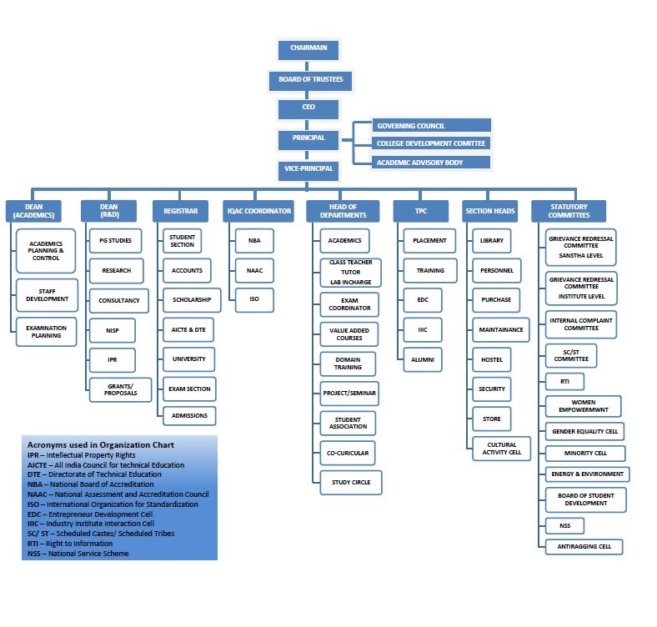
File Description | Template | Documents
Upload any additional information |  | Upload
Paste link for additional information
Link to Organogram of the Institution webpage

6.2.3.  Q_{n}M | Implementation of e-governance in areas of operation  - Administration  - Finance and Accounts  - Student Admission and Support  - Examination  Options:  - All of the above  - Any 3 of the above  - Any 2 of the above  - Any 1 of the above  - None of the above  Data Requirements: (As per Data Template)  - Areas of e-governance  Administration  Finance and Accounts  Student Admission and Support  Examination  - Name of the Vendor with contact details  - Year of implementation  File Description (Upload)  - ERP (Enterprise Resource Planning) Document  - Screen shots of user interfaces  - Any additional information  - Details of implementation of e-governance in areas of operation, Administration etc (Data Template) | 4
Options:
- All of the above
Have you collected
- ERP (Enterprise Resource Planning) Document
- Screen shots of user interfaces
- Any additional information
- Details of implementation of e-governance in areas of operation, Administration etc (Data Template)

Areas of e governance | Name of the Vendor with contact details | Year of implementation
Administration | Sack Info 2.5 | 2017-18
Finance and Accounts | Sack Info 2.5 | 2017-18
Student Admission and Support | Sack Info 2.5 | 2017-18
Examination | Ananosoft | 2012-13
Administration | Ananosoft | 2012-13
Finance and Accounts | Ananosoft | 2012-13
Student Admission and Support | Ananosoft | 2012-13
Examination | Ananosoft | 2012-13

File Description | Template | Documents
Screen shots of user interfaces |  | Upload
ERP (Enterprise Resource Planning) Document |  | Upload
Details of implementation of e-governance in areas of operation, Administration etc | Data Template | Upload
Any additional information |  | Upload

Key Indicator- 6.3 Faculty Empowerment Strategies (30)
Metric  No. |  | Weightage
6.3.1  Q_{l}M | The institution has effective welfare measures for teaching and non-teaching staff  Provide the list of existing welfare measures for teaching and non-teaching staff within a maximum of 500 words  File Description  - Paste link for additional information  - Upload any additional information | 05
The institution has effective welfare measures for teaching and non-teaching staff

All the staff that is eligible as per the Staffs' Provident Fund legislation shall be enrolled as members. The College contributes Rs. 1800 per person per month, towards the Employer's contribution to the EPF Scheme and Rs. 1800 is paid from the salary of the individual staff every month, towards his/her contribution to the Employer's contribution to the EPF Scheme. The College remits both the contributions stated above to the EPF Scheme authorities. Institute provides gratuity scheme. Group Medical Insurance is provided for teaching and non-teaching staff. All the benefits at superannuation are extended to all staff members.
The faculty members are eligible for availing Casual Leave of 12 days per year. Summer and Winter Vacations of 70 days are sanctioned for teaching and Non-teaching faculty as per university directives. Medical Leave is for 10 days per year for approved faculty and for adhoc faculty members 9 days of special leaves are sanctioned. Six months maternity leave is available to the women employees. The institute allows faculties to go for higher studies and short term courses. On duty facility and training and travel grants for attending workshops /conferences/seminars. For teaching staff, financial support is provided for attending conferences, workshops and seminars. For non-teaching staff, financial support is provided to pursue skill development. Also fees reimbursement policy is in place for Swayam, NPTEL and NITTT courses.
Institute provides residential facility for the staff members.
Institute constituted Amrut Madatnidhi for staff in case of medical emergency with maximum help amount extended upto Rs.50,000/-. In case of any emergency, personal loan is also provided to the staff through staff credit society. For other official purpose, institute provides vehicle facility to the staff concerned.
Tuition fees collected in Equal Monthly Installments (EMI) for wards of the staff. Institute provides uniforms to peons, class IV staff, drivers and workshop instructors. Uniform is being provided for security personals with all required accessories. Medical facility on campus, ambulance in case of emergency is also being provided for all staff.
File Description | Template | Documents
Upload any additional information |  | Upload
Paste link for additional information

6.3.2  Q_{n}M | Average percentage of teachers provided with financial support to attend conferences/workshops and towards membership fee of professional bodies during the last five years  6.3.2.1. Number of teachers provided with financial support to attend conferences/workshops and towards membership fee of professional bodies year wise during the last five years  Data Requirement for last five years: (As per Data Template)  - Name of the teacher  - Name of conference/ workshop attended for which financial support provided  - Name of the professional body for which membership fee is provided  Formula:  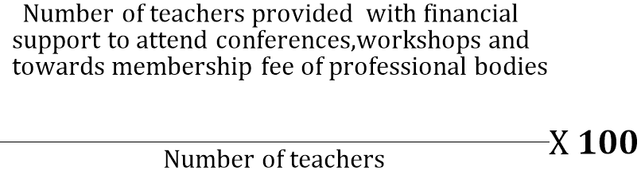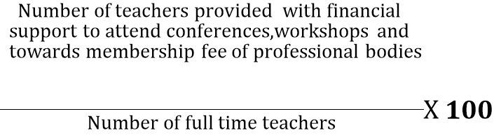 Percentage per year =  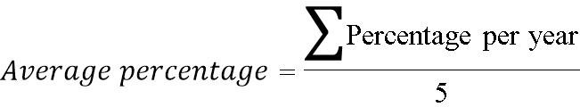  File Description:  - Upload any additional information  - Details of teachers provided with financial support to attend conference, workshops etc during the last five years (Data Template) | 10
  Year
  Number
File Description | Template | Documents
Upload any additional information |  | Upload
Details of teachers provided with financial support to attend conference, workshops etc during the last five years | Data Template | Upload

6.3.3  Q_{n}M | Average number of professional development /administrative training programs organized by the institution for teaching and non-teaching staff during the last five years  6.3.3.1. Total number of professional development /administrative training Programmes organized by the institution for teaching and non teaching staff year wise during the last five years  Data Requirement for last five years: (As per Data Template)  - Title of the professional development Programme organised for teaching staff  - Title of the administrative raining Programme organised for non-teaching staff  - Dates (From- to)  Formula:  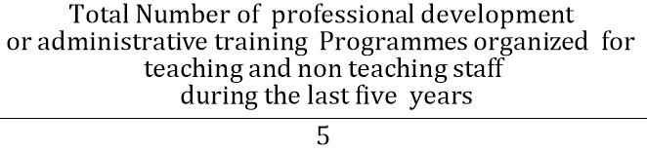  File Description (Upload):  - Reports of the Human Resource Development Centres (UGC ASC or other relevant centres).  - Reports of Academic Staff College or similar centers  - Upload any additional information  - Details of professional development / administrative training Programmes organized by the University for teaching and non teaching staff (Data Template) | 5
  Year
  Number
File Description | Template | Documents
Upload any additional information |  | Upload
Reports of the Human Resource Development Centres (UGC ASC or other relevant centres) |  | Upload
Reports of Academic Staff College or similar centers |  | Upload
Details of professional development / administrative training Programmes organized by the University for teaching and non-teaching staff | Data Template | Upload

6.3.4  Q_{n}M | Average percentage of teachers undergoing online/ face-to-face Faculty Development Programmes (FDP) during the last five years  (Professional Development Programmes, Orientation / Induction Programmes, Refresher Course, Short Term Course etc.)  6.3.4.1. Total number of teachers attending professional development Programmes viz., Orientation / Induction Programme, Refresher Course, Short Term Course year wise during the last five years  Data Requirement for last five years: (As per Data Template)  - Number of teachers  - Title of the Programme  - Duration (From –to)  Formula:  Percentage per year = 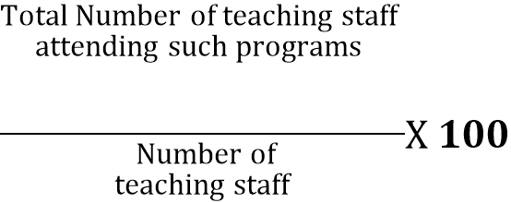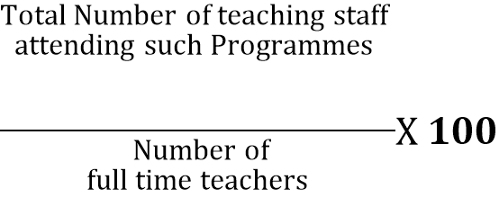  File Description  - IQAC report summary  - Reports of the Human Resource Development Centres (UGC ASC or other relevant centers).  - Upload any additional information  - Details of teachers attending professional development programmes during the last five years (Data Template) | 5
  Years
  Number
File Description | Template | Documents
Upload any additional information |  | Upload
Reports of the Human Resource Development Centres (UGC ASC or other relevant centers) |  | Upload
IQAC report summary |  | Upload
Details of teachers attending professional development programmes during the last five years | Data Template | Upload

6.3.5  Q_{l}M | Institutions Performance Appraisal System for teaching and non-teaching staff  Describe the functioning status of the Performance Appraisal System for teaching and non-teaching staff within a maximum of 500 words  File Description  - Paste link for additional information  - Upload any additional information | 5
The Institute follows a systematic Performance Appraisal System for teaching and non-teaching staff.
The institution / management evaluates teachers based on teaching, research and participation in development activities and due importance is given to all the activities.
The institution evaluates non-teaching staff based on performance in technical support and administration related activities, co-curricular, professional, development related activities, academic contributions, general conduct and qualities.
A structured “Self-Appraisal Form” is made use of by each faculty member for this purpose, wherein he/she gives the details of his/her performance and participation in all the activities assigned to him/her by the department /college.
The concerned HOD gives their remarks on the performance of the faculty member. The faculty performance appraisal system is evaluated in six categories namely teaching learning, co-curricular activities, research activities, academic performance- evaluated from the feedback from students, expert review feedback and management feedback.
Additionally Increment form based on API (Academic Performance Index) is introduced for awarding annual increments. The minimum requirement is 75% score. The management evaluates the faculty members and staff by merit rating based on their performance during the period of evaluation. They are recognized and awarded for academic performances, research proposals, consultancy, patents and publications, results, project guidance’s, peer reviewed publications, funded research, patents developed, recognition by professional bodies and contribution towards achieving institutional goals. In case of non – teaching staff, increment is released based on their performance in the department, their urge to learn new technologies, interpersonal behavior and punctuality towards the work done in department and institute. The above methodology of merit rating has helped the institution to identify and reward meritorious employees and to positively motivate them.

File Description | Template | Documents
Upload any additional information |  | Upload
Paste link for additional information

Key Indicator- 6.4 Financial Management and Resource Mobilization (20)
Metric  No. |  | Weightage
6.4.1  Q_{l}M | Institution conducts internal and external financial audits regularly  Enumerate the various internal and external financial audits carried out during the last five years with the mechanism for settling audit objections within a maximum of 500 words  File Description  - Paste link for additional information  - Upload any additional information | 6
Institution conducts internal and external financial audits regularly

At the beginning of every financial year, every department submits budget requirements to the institute. Department heads asks to laboratory in-charges for the modifications or procurement of new equipment. Head of the departments prepares budget reports, based on information provided by various lab in-charges and submit it to the institute.

Budget is proposed by Principal in Governing Council and College Development Committee, and is approved by them. Looking at the syllabus revisions and requirements thereof additional procurement is suggested if any. At the end of every financial year, it is observed, whether the allocated budget is properly utilized or not.

For above procedure, the institution is having qualified practicing Charted Accountant as internal and external auditors who audit the accounts annually. After the audit, the report is sent to the management for review. The auditors are appointed by the board of trustees in the trust board meeting.

In addition to this, the institution is having consultants to give opinion on taxation and legal issues. The college is filing income tax return every year within the stipulated time. The institution is ISO 9001 – 2015 certified, hence all framed procedures are externally audited regularly.
Internal Audit- It is conducted quarterly in a year by the audit department of the parent institution, Hase and Firm, Nasik
External Audit- In the second stage, the audit is carried out by M/S. Rajendra Gundecha & Company C.A., Ahmednagar.

Internal/External Audit | Last Audit date | Details of Compliance
Auditors:  Rajendra M. Gundecha & Company, Sangamner |  | There is no adverse remark on the accounts of the institution

File Description | Template | Documents
Upload any additional information |  | Upload
Paste link for additional information

6.4.2  Q_{n}M | Funds / Grants received from non-government bodies, individuals, philanthropist during the last five years (not covered in Criterion III)  6.4.2.1: Total Grants received from non-government bodies, individuals, Philanthropers year wise during the last five years (INR in Lakhs)  Data Requirement for last five years (As per Data Template)  - Name of the non-government bodies, individuals, Philanthropers  - Funds / Grants received  File Description  - Annual statements of accounts  - Any additional information  - Details of Funds / Grants received from of the non-government bodies, individuals, Philanthropies during the last five years (Data Template) | 8
  Year
  INR in Lakhs
File Description | Template | Documents
Details of Funds / Grants received from of the non-government bodies, individuals, Philanthropies during the last five years | Data Template | Upload
Any additional information |  | Upload
Annual statements of accounts |  | Upload

6.4.3  Q_{l}M | Institutional strategies for mobilization of funds and the optimal utilization of resources  Budget allocation is done as per following-  - 80% of total expected income is allocated for staff salary  - 20% of total expected income is budgeted in following proportion  - Library 5%  - Infrastructure built up -10%  - Laboratory equipment – 25%  - Laboratory Consumables – 5%  - Maintenance and Spares – 30%  - Research and Dev. – 3%  - Travel and Training – 2%  - Miscellaneous-10%  - Others – 10%  - Irrespective of the expenditure against each head for that financial year, the Institute allocates budgetary provisions as per the percentage decided. Unutilized funds may be used for other heads or can be forwarded to the next financial year.  - The funds are allocated for planned and unplanned activities, infrastructural and lab equipment to fulfill the requirements as per revised curriculum. Budgetary controls are exercised by Principal and accounts.  - Special considerations are made to accommodate unforeseen requirements. There has been no budget crunch that has affected the teaching learning process and effective functioning of the institute.  - Funds allocated are intimated to department heads and respective section in-charges. The major institute level work such as infrastructural development/ upgradation including civil and support infra, common utilities, housekeeping etc. are taken care by Sanstha Office.  - The procurement procedure for lab consumables, equipment, upgradation is initiated by purchase section in consultation with departments.  - Budget is prepared in March whereas the syllabus revision, Admissions and fees allocation is done in June/ July. So there may be some deviation in utilization and budgeted amount.  - It is ensured that the staff salary, upgradation and maintenance, infrastructure buildup and academic activities are upheld and improved for the benefit of all the stakeholders.  File Description  - Paste link for additional information  - Upload any additional information | 6
File Description | Template | Documents
Upload any additional information |  | Upload
Paste link for additional information

Key Indicator- 6.5 Internal Quality Assurance System (30)

Metric  No. |  | Weightage
6.5.1  Q_{l}M | Internal Quality Assurance Cell (IQAC) has contributed significantly for institutionalizing the quality assurance strategies and processes  Describe two practices institutionalized as a result of IQAC initiatives within a maximum of 500 words  File Description  - Paste link for additional information  - Upload any additional information | 10
Few Examples of two practices institutionalized as a result of IQAC :-
- Restructuring stakeholder feedback mechanism.
- Membership of e-ShodhSindhu and Shodhganga.
- Defining Core Values, Redefining Vision and Mission.
- ICT usage mechanism.
- ERP Implementation
Out of this any two
OR
Your suggestion
- Energy Conservation Initiatives
- Green Initiatives.
- Organization of Quality Enhancement Programs.
- Organizing events related to promotion of research culture.
- Defining/ Redefining of Maintenance Procedures.
- Registration of Alumni Association.

Internal Quality Assurance Committee
- There shall be an Internal Quality Assurance Committee in each college and recognized institution that shall be constituted and function as per the guidelines of the University Grants Commission and State Government issued, from time to time.
- The colleges and recognized institutions shall regularly submit their Annual Quality Assurance Reports to the affiliating university, State level quality assurance bodies and national accreditation bodies.
- The university shall monitor the functioning of Internal Quality Assurance Committees in the colleges and recognized institutions within its jurisdiction.
IQAC – Vision
To ensure quality culture as the prime concern for the Higher Education Institutions through institutionalizing and internalizing all the initiatives taken with internal and external support.
Objective
The primary aim of IQAC is
- To develop a system for conscious, consistent and catalytic action to improve the academic and administrative performance of the institution.
- To promote measures for institutional functioning towards quality enhancement through internalization of quality culture and institutionalization of best practices.
Strategies
IQAC shall evolve mechanisms and procedures for
a) Ensuring timely, efficient and progressive performance of academic, administrative and financial tasks;
b) Relevant and quality academic/ research programmes;
c) Equitable access to and affordability of academic programmes for various sections of society;
d) Optimization and integration of modern methods of teaching and learning;
e) The credibility of assessment and evaluation process;
f) Ensuring the adequacy, maintenance and proper allocation of support structure and services;
g) Sharing of research findings and networking with other institutions in India and abroad.
Functions
Some of the functions expected of the IQAC are:
- Development and application of quality benchmarks
- Parameters for various academic and administrative activities of the institution;
- Facilitating the creation of a learner-centric environment conducive to quality education and faculty maturation to adopt the required knowledge and technology for participatory teaching and learning process;
- Collection and analysis of feedback from all stakeholders on quality-related institutional processes;
d) Dissemination of information on various quality parameters to all stakeholders;
e) Organization of inter and intra institutional workshops, seminars on quality related themes and promotion of quality circles;
f) Documentation of the various programmes/activities leading to quality improvement;
g) Acting as a nodal agency of the Institution for coordinating quality-related activities, including adoption and dissemination of best practices;
h) Development and maintenance of institutional database through MIS for the purpose of maintaining /enhancing the institutional quality;
i) Periodical conduct of Academic and Administrative Audit and its follow-up
j) Preparation and submission of the Annual Quality Assurance Report (AQAR) as per guidelines and parameters of NAAC.
Benefits
IQAC will facilitate / contribute to
- Ensure clarity and focus in institutional functioning towards quality enhancement;
- Ensure internalization of the quality culture;
b) Ensure enhancement and coordination among various activities of the institution and institutionalize all good practices;
c) Provide a sound basis for decision-making to improve institutional functioning;
d) Act as a dynamic system for quality changes in HEIs;
e) Build an organized methodology of documentation and internal communication.
Composition of the IQAC
IQAC may be constituted in every institution under the Chairmanship of the Head of the institution with heads of important academic and administrative units and a few teachers and a few distinguished educationists and representatives of local management and stakeholders.

The composition of the IQAC is as follows:

- Chairperson: Head of the Institution
- Teachers to represent all level (Three to eight)
- One member from the Management
- Few Senior administrative officers
- One nominee each from local society, Students and Alumni
- One nominee each from Employers /Industrialists/Stakeholders
- One of the senior teachers as the coordinator/Director of the IQAC
As per the above requirements the college has a functioning Internal Quality Assurance Cell.

Sr. No. | Name of the Member | Role in IQAC | Designation
 | Dr. M. A. Venkatesh | Chairman | Principal
 | Prof. V. B. Dhumal | Management Representative | Manager, AVSSVS.
 | Prof. R. S. Tajane | Director, IQAC | Workshop Supdt.
 | Prof. A.K. Mishra | Senior Teachers | Vice Principal
 | Dr. M. R. Wakchaure | Senior Teachers | Dean Academics
 | Prof. V. P. Waghe | Administrative officers | Registrar
 | Dr. S. B. Rahane | Teachers | ISO Coordinator
 | Dr. M. H. Wagh | Teachers | Department of MBA
 | Prof. S. A. Thanekar | Teachers | Department of Computer
 | Prof. V. P. Kulkarni | Teachers | Department of Civil
 | Prof. A. Pathak | Teachers | Department of Electrical
 | Prof. S. K. Chaudhari | Teachers | Department of Electronic
 | Dr. R. S. Pawase | Teachers | Department of ETC
 | Prof. B. S. Borkar | Teachers | Department of IT
 | Dr. V. J. Gadakh | Teachers | Department of Mechanical
 | Prof. S. N. Patil | Teachers | Department of Production
 | Prof. Kalhapure | Teachers | Department of Applied Science
 | Dr. Mohan Waman | local society | Principal, Dr. D. Y. Patil College, Akurdi, Pune.
 | Mrs. Kalyani Ahire | Students | University Representative
 | Mr. Nikam Gokul | Alumni | Manager- Product Quality, M&M, Nashik
 | Mr. Shrikant Padhy | Industrialist | Engineer Entrepreneur
File Description | Template | Documents
Upload any additional information |  | Upload
Paste link for additional information

6.5.2  Q_{l}M | The institution reviews its teaching learning process, structures & methodologies of operations and learning outcomes at periodic intervals through IQAC set up as per norms and recorded the incremental improvement in various activities  ( For first cycle - Incremental improvements made for the preceding five years with regard to quality  For second and subsequent cycles - Incremental improvements made for the preceding five years with regard to quality and post accreditation quality initiatives )  Describe any two examples of institutional reviews and implementation of teaching learning reforms facilitated by the IQAC within a maximum of 500 words each  File Description  - Paste link for additional information  - Upload any additional information | 10
 | Details | Year
 | Details | 15-16 | 16-17 | 17-18 | 18-19 | 19-20
Infrastructure | Budget Utilization
Infrastructure | Internet
Library | Library budget
Library | Books
Library | Journals & Periodicals
Student | Intake
Student | Admissions
Student | Students benefited by scholarships & free ships by government schemes
Student | Certification Programs
Student | Students benefited by guidance for competitive examination & career counseling
Student | Placements
Student | Internship
Student | Higher Studies
Faculty | Faculty Number
Faculty | Faculty with Ph.D.
Faculty | Faculty with PG
Research and Development | Paper Publication, Book/ Conference
Result | Final Year Result
Extension Activities | Activities (Cultural +Sports)

File Description | Template | Documents
Upload any additional information |  | Upload
Paste link for additional information

6.5.3  Q_{n}M | Quality assurance initiatives of the institution include:  - Regular meeting of Internal Quality Assurance Cell (IQAC); Feedback collected, analysed and used for improvements  - Collaborative quality intitiatives with other institution(s)  - Participation in NIRF  - any other quality audit recognized by state, national or international agencies (ISO Certification, NBA)  Options:  - All of the above  - Any 3 of the above  - Any 2 of the above  - Any 1 of the above  - None of the above  Data Requirement for last five years: (As per Data Template  Quality initiatives  - AQARs prepared/ submitted  - Collaborative quality initiatives with other institution(s)  - Participation in NIRF  - Any other quality audit recognized by state, national or international agencies (ISO Certification, NBA)  File Description  - Paste web link of Annual reports of Institution  - Upload e-copies of the accreditations and certifications  - Upload any additional information  - Upload details of Quality assurance initiatives of the institution(Data Template) | 10
File Description | Template | Documents
Upload e-copies of the accreditations and certifications |  | Upload
Upload details of Quality assurance initiatives of the institution | Data Template | Upload
Upload any additional information |  | Upload
Paste web link of Annual reports of Institution

