Criterion 5- Student Support and Progression (130)
Key Indicator- 5.1 Student Support (50)

Metric  No. |  | Weightage
5.1.1  Q_{n}M | Average percentage of students benefited by scholarships and freeships provided by the Government during last five years  5.1.1.1. Number of students benefited by scholarships and freeships provided by the Government year wise during last five years  Data Requirement year wise: (As per Data Template)  - Name of the Scheme  - Number of students benefiting  Formula:  Percentage per year = 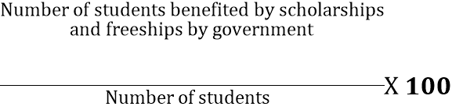  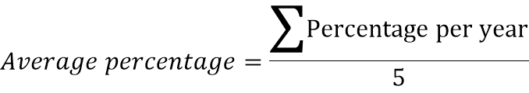  File Description:  - upload self attested letter with the list of students sanctioned scholarship  - Upload any additional information  Average percentage of students benefited by scholarships and freeships provided by the Government during the last five years (Data Template) | 20
  Year
  Number
Average percentage of students benefited by scholarships and freeships provided by the Government during last five years
Year | 15-16 | 16-17 | 17-18 | 18-19 | 19-20 | Av. For last 5 year
No. of Students benefited | 2836 | 2721 | 2749 | 2904 | 2749 | Av. For last 5 year
Total No. of student | 3776 | 3493 | 3456 | 3453 | 3202 | Av. For last 5 year
% of Students benefited | 75.11 | 77.90 | 79.54 | 84.10 | 85.85 | 80.50

students benefited by scholarships (in lacks of Rs.) provided by the Government during last five years
Year | 15-16 | 16-17 | 17-18 | 18-19 | 19-20
Students benefited in lacks of Rs. | 1506.963 | 1396.432 | 1456.762 | 1291.492 | 1457.160

File Description | Template | Documents
upload self attested letter with the list of students sanctioned scholarship |  | Upload
Upload any additional information Average percentage of students benefited by scholarships and freeships provided by the Government during the last five years (Data Template) | Data Template | Upload

5.1.2.  Q_{n}M | Average percentage of students benefitted by scholarships, freeships etc. provided by the institution / non- government agencies during the last five years  5.1.2.1 Total number of students benefited by scholarships, freeships, etc provided by the institution / non- government agencies year wise during last five years  Data Requirement for last five years: (As per Data Template)  - Name of the Scheme with contact information  - Number of students benefiting  Formula:  $$Percentage per year$$  $$=\frac{\begin{aligned}Total number of students benefited by scholarships and freeships \\ provided by the institution or non-government agencies \end{aligned}}{Total number of students}×100$$  $$Average percentage=\frac{Percentage per year }{5}$$  File Description:  - Upload any additional information  - Number of students benefited by scholarships and freeships institution / non- government agencies in last 5 years (Date Template) | 05
  Year
  Number
Average percentage of students benefitted by scholarships, freeships etc. provided by the institution / non- government agencies during the last five years
Year | 15-16 | 16-17 | 17-18 | 18-19 | 19-20 | Av. For last 5 year
Cummins | 0 | 0 | 0 | 1 | 3 | Av. For last 5 year
AMS | 0 | 34 | 52 | 20 | 108 | Av. For last 5 year
Total Students benefited | 0 | 34 | 52 | 21 | 111 | Av. For last 5 year
Total No. of student | 3776 | 3493 | 3456 | 3453 | 3202 | Av. For last 5 year
Percentage per year | 0.00 | 0.97 | 1.50 | 0.61 | 3.47 | 1.31

Students benefitted by scholarships ( in Lacks of Rs.) provided by the institution / non- government agencies during the last five years
 | 15-16 | 16-17 | 17-18 | 18-19 | 19-20
Cummins | 0.00 | 0.00 | 0.00 | 1.00 | 0.59
AMS | 0.00 | 1.56 | 3.12 | 1.33 | 6.48
TOTAL | 0.00 | 1.56 | 3.12 | 2.33 | 7.07

File Description | Template | Documents
Upload any additional information |  | Upload
Number of students benefited by scholarships and freeships institution / non- government agencies in last 5 years (Date Template) | Data Template | Upload

5.1.3.  Q_{n}M | Capacity building and skills enhancement initiatives taken by the institution include the following  - Soft skills  - Language and communication skills  - Life skills (Yoga, physical fitness, health and hygiene)  - ICT/computing skills  Options:  - All of the above  - Any 3 of the above  - Any 2 of the above  - Any 1 of the above  - None of the above  Data Requirement: (As per Data Template)  - Name of the capability building and skills enhancement initiatives  - Year of implementation  - Number of students enrolled  - Name of the agencies involved with contact details  File Description (Upload)  - Link to Institutional website  - Any additional information  - Details of capability building and skills enhancement initiatives (Data Template) | 10
ANS
- All of the above

File Description | Template | Documents
Link to Institutional website
Details of capability building and skills enhancement initiatives (Data Template) | Data Template | Upload
Any additional information |  | Upload

5.1.4.  Q_{n}M  Elabor-ate  DVV | Average percentage of students benefitted by guidance for competitive examinations and career counselling offered by the Institution during the last five years  5.1.4.1. Number of students benefitted by guidance for competitive examinations and career counselling offered by the institution year wise during last five years  Data Requirement for last five years:(As per Data Template)  - Name of the scheme  - Number of students who have passed in the competitive exam  - Number of students placed  Formula  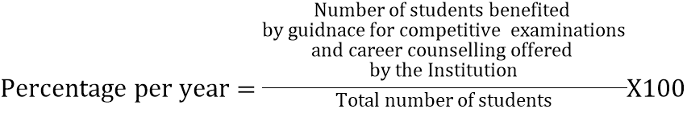 Percentage per year = 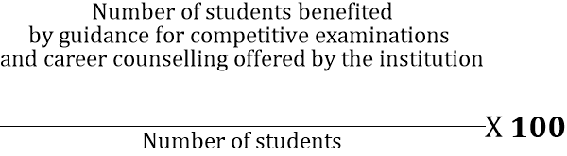  File Description (Upload)  - Any additional information  - Number of students benefited by guidance for competitive examinations and career counseling during the last five years (Data Template) | 10
  Year
  Number
Updated
Add TPO career counseling program and show the benefitted (placed)students

Average percentage of students benefitted by guidance for competitive examinations and career counselling
 | 15-16 | 16-17 | 17-18 | 18-19 | 19-20 | Av. For last 5 year
Civil | 0 | 0 | 0 | 0 | 0 | Av. For last 5 year
Computer | 72 | 0 | 0 | 0 | 0 | Av. For last 5 year
Electrical | 0 | 38 | 40 | 80 | 44 | Av. For last 5 year
Electronics | 0 | 0 | 6 | 21 | 0 | Av. For last 5 year
ETC | 8 | 32 | 0 | 46 | 49 | Av. For last 5 year
Engineering Sci. | 0 | 0 | 0 | 0 | 0 | Av. For last 5 year
IT | 0 | 0 | 0 | 0 | 0 | Av. For last 5 year
Mechanical | 0 | 0 | 0 | 0 | 0 | Av. For last 5 year
Production | 0 | 0 | 0 | 0 | 0 | Av. For last 5 year
MBA | 11 | 18 | 0 | 0 | 9 | Av. For last 5 year
Total | 91 | 88 | 46 | 147 | 102 | Av. For last 5 year
No of final year students | 1070 | 1004 | 904 | 1049 | 1003 | Av. For last 5 year
No of all students | 3776 | 3493 | 3456 | 3453 | 3202 | Av. For last 5 year
% per year with FS | 8.50 | 8.76 | 5.09 | 14.01 | 10.17 | 9.31
% per year with AS | 2.41 | 2.52 | 1.33 | 4.26 | 3.19 | 2.74

File Description | Template | Documents
Number of students benefited by guidance for competitive examinations and career counselling during the last five years | Data Template | Upload
Any additional information |  | Upload

5.1.5.  Q_{n}M | The Institution has a transparent mechanism for timely redressal of student grievances including sexual harassment and ragging cases  - Implementation of guidelines of statutory/regulatory bodies  - Organisation wide awareness and undertakings on policies with zero tolerance  - Mechanisms for submission of online/offline students’ grievances  - Timely redressal of the grievances through appropriate committees  Options:  - All of the above  - Any 3 of the above  - Any 2 of the above  - Any 1 of the above  - None of the above  Data Requirement:  Upload the grievance redressal policy document with reference to prevention of sexual harassment committee and anti ragging committee, constitution of various committees for addressing the issues, minutes of the meetings of the committees, number of cases received and redressed.  File Description (Upload)  - Minutes of the meetings of student redressal committee, prevention of sexual harassment committee and Anti Ragging committee  - Upload any additional information  - Details of student grievances including sexual harassment and ragging cases | 5
ANS
  - All of the above

File Description | Template | Documents
Upload any additional information |  | Upload
Minutes of the meetings of student redressal committee, prevention of sexual harassment committee and Anti Ragging committee |  | Upload
Details of student grievances including sexual harassment and ragging cases |  | Upload

Key Indicator- 5.2 Student Progression (25)

Metric  No. |  | Weightage
5.2.1  Q_{n}M | Average percentage of placement of outgoing students during the last five years  5.2.1.1: Number of outgoing students placed year wise during the last five years  Data requirement for last five years (As per Data Template)  - Name of the employer with contact details  - Number of students placed  Formula:  Percentage per year = 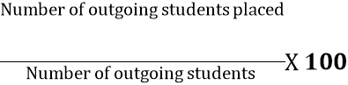 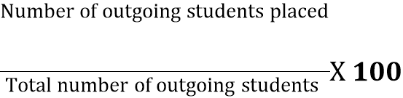  File Description (Upload)  - Self attested list of students placed  - Upload any additional information  - Details of student placement during the last five years (Data Template) | 10
  Year
  Number
Average percentage of placement of outgoing students
 | 15-16 | 16-17 | 17-18 | 18-19 | 19-20 | Av. For Last five year
Civil | 8 | 44 | 39 | 29 | 10 | Av. For Last five year
Computer | 72 | 85 | 95 | 143 | 83 | Av. For Last five year
Electrical | 6 | 38 | 40 | 81 | 52 | Av. For Last five year
Electronics | 26 | 22 | 20 | 37 | 36 | Av. For Last five year
ETC | 8 | 37 | 36 | 45 | 52 | Av. For Last five year
IT | 22 | 36 | 36 | 57 | 45 | Av. For Last five year
Mechanical | 32 | 60 | 91 | 105 | 122 | Av. For Last five year
Production | 19 | 14 | 43 | 52 | 47 | Av. For Last five year
MBA | 19 | 23 | 15 | 29 | 9 | Av. For Last five year
Total | 212 | 359 | 415 | 578 | 456 | Av. For Last five year
No of outgoing student | 1070 | 1004 | 904 | 1049 | 1003 | Av. For Last five year
Avg. % of placement of outgoing students | 19.81 | 35.76 | 45.91 | 55.10 | 45.46 | 40.41

File Description | Template | Documents
Upload any additional information |  | Upload
Self attested list of students placed |  | Upload
Details of student placement during the last five years (Data Template) | Data Template | Upload

5.2.2.  Q_{n}M | Average percentage of students progressing to higher education during the last five years  5.2.2.1. Number of outgoing student progression to higher education  Data Requirement: (As per Data Template)  Number of students proceeding from  - UG to PG:  - PG to MPhil:  - PG to PhD:  - MPhil to PhD:  - PhD to Post doctoral:  Formula:  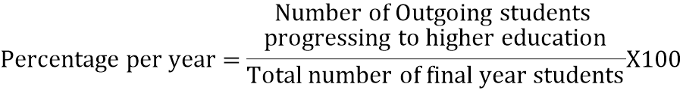  File Description (Upload)  - Upload supporting data for student/alumni  - Any additional information  - Details of student progression to higher education (Data Template) | 10
Average percentage of students progressing to higher education during the last five years
 | 15-16 | 16-17 | 17-18 | 18-19 | 19-20 | Avg. For Last five years
Civil | 6 | 29 | 16 | 9 | 4 | Avg. For Last five years
Computer | 11 | 6 | 3 | 0 | 0 | Avg. For Last five years
Electrical | 4 | 5 | 3 | 1 | 0 | Avg. For Last five years
Electronics | 4 | 0 | 1 | 2 | 0 | Avg. For Last five years
ETC | 2 | 1 | 0 | 0 | 1 | Avg. For Last five years
IT | 4 | 5 | 3 | 1 | 2 | Avg. For Last five years
Mechanical | 3 | 16 | 3 | 7 | 1 | Avg. For Last five years
Production | 0 | 8 | 3 | 5 | 0 | Avg. For Last five years
MBA | 0 | 0 | 0 | 0 | 0 | Avg. For Last five years
Total | 34 | 70 | 32 | 25 | 8 | Avg. For Last five years
No of outgoing student | 1070 | 1004 | 904 | 1049 | 1003 | Avg. For Last five years
Avg. % of students progressing to higher education | 3.18 | 6.97 | 3.54 | 2.38 | 0.80 | 3.37

File Description | Template | Documents
Upload supporting data for student/alumni |  | Upload
Details of student progression to higher education (Data Template) | Data Template | Upload
Any additional information |  | Upload

5.2.3.  Q_{n}M | Average percentage of students qualifying in state/national/ international level examinations during the last five years (eg: JAM/ NET/SLET/GATE/ GMAT/CAT/GRE/ TOEFL/ Civil Services/State government examinations, etc.)  5.2.3.1. Number of students qualifying in state/ national/ international level examinations (eg: JAM/ NET/ SLET/ GATE/ GMAT/CAT/GRE/ TOEFL/ Civil Services/ State government examinations, etc.)) year wise during last five years  5.2.3.2. Number of students appearing in state/ national/ international level examinations (eg: JAM/ NET / SLET/ GATE/ GMAT/CAT,GRE/ TOFEL/ Civil Services/ State government examinations) year wise during last five years  Data should collected from department  Data Requirement for last five years: (As per Data Template)  Number of students selected to  - JAM  - NET  - SLET  - GATE  - GMAT  - CAT  - GRE  - TOEFL  - Civil Services  - State government examinations  Formula:  Percentage per year = 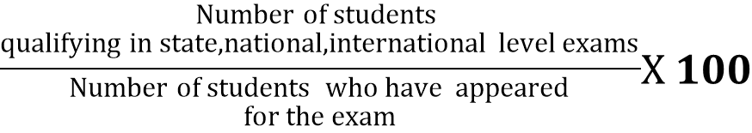 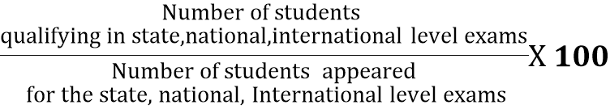 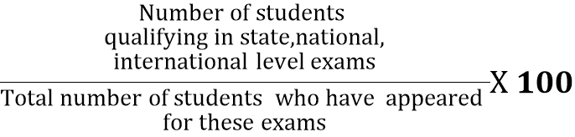  File Description (Upload)  - Upload supporting data for the same  - Any additional information  - Number of students qualifying in state/ national/ international level examinations during the last five years (Data Template) | 5
  Year
  Number
  Year
  Number
Students qualifying all type of examinations
 | 15-16 | 16-17 | 17-18 | 18-19 | 19-20 | Avg. Percentage for last five Year
Civil | 6 | 21 | 8 | 3 | 1 | Avg. Percentage for last five Year
Computer | 2 | 5 | 2 | 4 | 3 | Avg. Percentage for last five Year
Electrical | 0 | 2 | 1 | 2 | 1 | Avg. Percentage for last five Year
Electronics | 0 | 0 | 0 | 0 | 0 | Avg. Percentage for last five Year
ETC | 2 | 0 | 0 | 0 | 0 | Avg. Percentage for last five Year
IT | 1 | 1 | 0 | 1 | 1 | Avg. Percentage for last five Year
Mechanical | 0 | 7 | 20 | 7 | 8 | Avg. Percentage for last five Year
Production | 0 | 3 | 4 | 0 | 3 | Avg. Percentage for last five Year
MBA | 0 | 0 | 0 | 0 | 0 | Avg. Percentage for last five Year
Total Students qualified | 11 | 39 | 35 | 17 | 17 | Avg. Percentage for last five Year
Number of students appeared | 32 | 83 | 70 | 32 | 34 | Avg. Percentage for last five Year
Percentage per year | 34.4 | 47.0 | 50.0 | 53.1 | 50.0 | 46.9

File Description | Template | Documents
Upload supporting data for the same |  | Upload
Number of students qualifying in state/ national/ international level examinations during the last five years (Data Template) | Data Template | Upload
Any additional information |  | Upload

Key Indicator- 5.3 Student Participation and Activities (45)

Metric  No. |  | Weightage
5.3.1  Q_{n}M | Number of awards/medals for outstanding performance in sports/cultural activities at university/state/national / international level (award for a team event should be counted as one) during the last five years.  5.3.1.1: Number of awards/medals for outstanding performance in sports/cultural activities at university/state/national / international level (award for a team event should be counted as one) year wise during the last five years.  Data Requirement for last five years: (As per Data Template)  - Name of the award/ medal  - University/State/National/ International  - Sports/ Culture  File Description (Upload)  - e-copies of award letters and certificates  - Any additional information  - Number of awards/medals for outstanding performance in sports/cultural activities at university/state/ national/international level during the last five year (Data Template) | 20
  Year
  Number
Number of awards/medals for outstanding performance in sports/cultural activities at university/state/national / international level
Year | 15-16 | 16-17 | 17-18 | 18-19 | 19-20
Number of awards/medals | 43 | 74 | 19 | 29 | 17

File Description | Template | Documents
Number of awards/medals for outstanding performance in sports/cultural activities at university/state/ national/international level during the last five year | Data Template | Upload
e-copies of award letters and certificates |  | Upload
Any additional information |  | Upload

5.3.2  Q_{l}M | Institution facilitates students’ representation and engagement in various administrative, co-curricular and extracurricular activities following duly established processes and norms (student council, students representation on various bodies)  Describe the students’ representation and engagement in various administrative, co-curricular and extracurricular activities within a maximum of 500 words  File Description  - Paste link for additional information  - Upload any additional information | 05
The aim of promoting students representation and engagement in various administrative, co-curricular and extracurricular activities is to involve the students in policy making process as well as maintaining the transparency in the system. It helps in comprehensive development of the students. Various committees are formed at institute/department level and majority of them are given below.

1. Students’ Council: Under section 40(3) of Maharashtra Universities act, 1994, this council is established every year in the Institute and it performs its prescribed duties.

2. Student Grievance and Redressal: This committee addresses student grievances and maintains harmony and discipline among the students.

3. Gender Equality: The broad mandate of the cell is to provide an integrated and interdisciplinary approach to understanding social and cultural constructions of gender that shape the experiences of women and men in society.

4. Equal Opportunity : To oversee the effective implementation of policies and programmes for disadvantaged groups, to provide guidance and counselling with respect to academic, financial, social and other matters and to enhance the diversity within the campus.

5. Ant-Ragging: This committee ensures zero ragging incidents in the institute and also spreads awareness among students against any type of ragging activities.

6. Cultural Activities: This committee co-ordinates various cultural activities and events throughout the year. “MEDHA”, a, mega cultural event of our sanstha provides platform to the students to organise and participate activities through various event committees under Medha.

7. Sports Activities: This Committee organizes interdepartmental sports event. Our students actively participate in various sports in intercollegiate, interuniversity, state, national and International level.

8. Department/ College Magazine: ‘Medha’ is our annual magazine published by Magazine committee at college level. Students express their talent in the form of articles, poetry, interviews of eminent personalities etc. Each department publish their own magazine where student committees play active roles in magazine publishing process.

9. Extension Activities: The students are involved in all extension activities such as NSS, Blood donation Camp, Swachcha Bharat Abhiyan, Yoga day, Tree plantation camps, Marathi Bhasa Sanvardhan, Flood Donation, Jayanti Mohatsav.

10. Department Students Associations: In each department of the institute “students associations” are formed. They are “association of the students, by the students, for the students”. The curricular and extracurricular activities are carried out under students associations.

11. Internal Quality Assurance Cell (IQAC): The student representative is involved in IQAC. The student representative can present his/her ideas and put up suggestions in regular meeting of IQAC. Thus, he/she is also active member in policy making process of IQAC.

12. Department Advisory Committee (DAC):
In each department DAC plays important role in improving quality of overall teaching learning process. This committee involves student representative along with industry and academic experts. The student representative can present his/her ideas and expectations during regular meeting of DAC.

13. Professional Chapter Committee:
Professional chapters like IETE, CSI, IEI, IEEE, ISTE, ISHARE are established in each department. Students committees are formed to organize the chapter activities, throughout the year including planning and implementations.

File Description | Template | Documents
Upload any additional information |  | Upload
Paste link for additional information

5.3.3.  Q_{n}M | Average number of sports and cultural events/competitions in which students of the Institution participated during last five years (organised by the institution/other institutions)  5.3.3.1. Number of sports and cultural events/competitions in which students of the Institution participated year wise during last five years  Data Requirement for last five years: (As per Data Template)  - List of events/competitions  Formula:  $$\frac{\begin{aligned}Number of sports and cultural events/competitions \\ in which students of the Institution participated during \\ the last 5 years\end{aligned}}{5}$$  File Description  - Report of the event  - Upload any additional information  - Number of sports and cultural events/competitions in which students of the Institution participated during last five years (organised by the institution/other institutions (Data Template) | 20
  Year
  Number
Average number of sports and cultural events/competitions (like Amrutfest /Tech-uniq/project exhibition etc.) (organised by the institution/other institutions)

Average number of sports and cultural events/competitions in which students of the Institution participated
Year | 15-16 | 16-17 | 17-18 | 18-19 | 19-20
Number of student participated in sports and cultural events | 162 | 51 | 36 | 261 | 235

File Description | Template | Documents
Upload any additional information |  | Upload
Report of the event |  | Upload
Number of sports and cultural events/competitions in which students of the Institution participated during last five years (organised by the institution/other institutions (Data Template) | Data Template | Upload

Key Indicator- 5.4 Alumni Engagement (10)

Metric  No. |  | Weightage
5.4.1  Q_{l}M | There is a registered Alumni Association that contributes significantly to the development of the institution through financial and/or other support services  Describe contribution of alumni association to the institution within a maximum of 500 words  File Description:  - Paste link for additional information  - Upload any additional information | 5
- We are very proud to share that our alumini are occupied various positions like vice presidents, CEO’s, Entrepreneurs, plant heads at various MNC’s, Public sector and Government organizations at global, national level and state level.
- To strength the alumini network, the institute registered an Alumni Association during the year 1994 with registration number is MH/788/04/Ahmednagar. The purpose of the association is to bring together all the alumni in single platform, to share their experiences, to extend support and provide guidance to the institution.
- Apart of this, the alumni have formed group at various locations including USA, Delhi, and Pune etc. The special alma-shine portal is designed for alumni registrations. At present active alumni strength is 6333 out of more than 10000 graduates.
- The institute organize “MILAP” alumini meet every year. On an average of 400 to 500 alumini participate in the event. During the meet they interact with the students, faculties, management and share their ideas for improvement of overall progress of the institute.
- Apart of the regular event, the alumini visit the department to provide guidance through guest lectures, seminars, workshops and, supports for industry visits, internships, and placement drives etc. throughout the academic year.
- Alumni provide feedback on infrastructure development and other academic related matters of the college and suggest gaps in syllabus considering current demands of industry.
- The alumini of the institute supports the students for financial help during their project work, or any competitions. Also they provide infrastructure facilities at their own end wherever the technological need arises.
- Alumni voluntarily involve in mentorship for current first year and second year students of institute through Buddy scheme a unique feature. In this each alumini connect with the individual students. Alumini interact with students through phone, email, and social media. Alumini guide the students for academics, skill development, psychological development and career development.
- He inspires and motivates the student to infuse confidence level by quoting his journey, deep career to achieve the excellence. In this scheme the alumini supports till he graduates with career prospects.

File Description | Template | Documents
Upload any additional information |  | Upload
Paste link for additional information

5.4.2  Q_{n}M | Alumni contribution during the last five years (INR in Lakhs)  Options:  - ≥ 5 Lakhs  - 4 Lakhs - 5 Lakhs  - 3 Lakhs - 4 Lakhs Opt one  - 1 Lakhs - 3 Lakhs  - <1 Lakhs  Data Requirement for last five years (year wise):  - Alumni association / Name of the alumnus  - Quantum of contribution  - Audited Statement of account of the institution reflecting the receipts.  File Description  - Upload any additional information | 5
File Description | Template | Documents
Upload any additional information |  | Upload
Link for any additional information

