4.3.1: Institution frequently updates its IT facilities including Wi-Fi
Institution has adequate IT infrastructure which is updated and upgraded continuously as per the curriculum requirements and changing technology. Wi-Fi zones are provided at various locations such as reading halls, hostels, and department corridors which can be updated as per requirement. A case study of mechanical department is elaborated related to the above topic i.e. frequently updates its IT facilities including Wi-Fi
INDEX
Sr. No. | Description | Pg. No.
 | IT Facilities in Mechanical Engineering Department | 1
 | Updating IT facilities (Computers & Peripherals) | 2
 | Updating Software  - Syllabus  - Purchase/Updating of Software | 3  5  7
 | Lab Utilization | 8
 | Link for Supporting Documents | 8

- IT Facilities in Mechanical Engineering Department
The Mechanical Engineering Department started in the year 1992. The department has well equipped CAD CAM lab for under graduate (UG) and post graduate students (PG). The objective is to develop of designs of various mechanical components using both 2D and 3D Software’s, and manufacture the required part. All computers are interconnected by LAN. Internet facility is available on every computer in the laboratory. The lab is available to graduate the students in the fields of Computer Aided Design and Computer Aided Manufacturing. At Under graduation level aid is given for the students to model the complete part. The basic knowledge can be used for successful accomplishment of project works. At post-graduation level, the students can make use of advanced modules in the design software for their research work.
The software like AUTOCAD, CREO, FEATURECAM, ANSYS, MATLAB, MINITAB, WITNESS SIMULATION are available to UG and PG students.
Two separate CAD CAM labs are available for UG Students with 64 computers and 10 computers for PG students respectively.
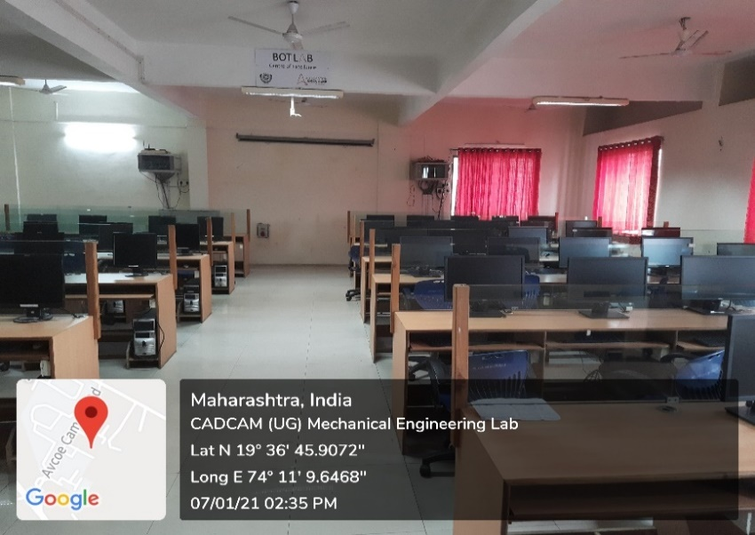
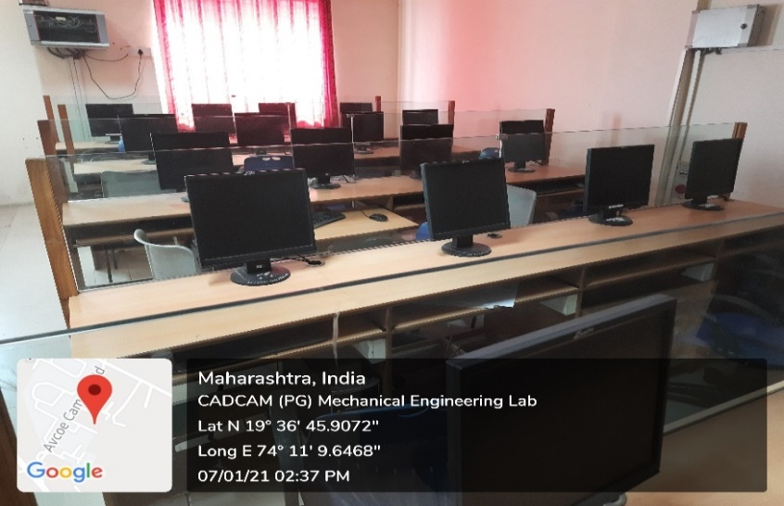
- Updating IT facilities (Computers & Peripherals)
Computers and other hardware are updated according to curriculum and research requirements.
For S.E Mechanical, Course Name: Computer Aided Machine Drawing (Course Code: 202042), computers with fast processors and latest graphics configurations were required as per curriculum for using CREO 5.0 (Required System configurations are mention below).
Accordingly, Dell make computers with 16 GB RAM and 4 GB graphics cards were purchased in year 2018.
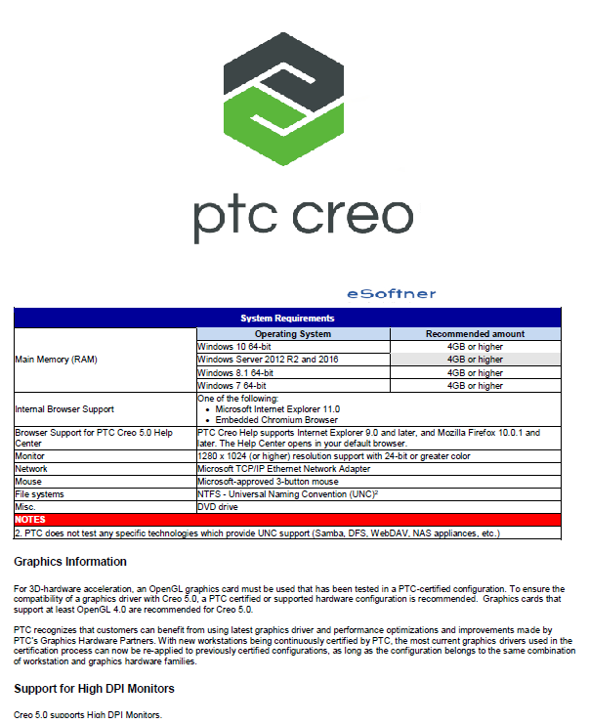
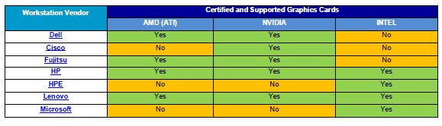

CAD CAM LAB- UG
Sr. No | IT Facilities | Quantity | Cost | Date of Purchase
1 | Dell make Computers  Specifications- Core IT 7700, Processor 16 GB, DDR- 4 RAM, AMD Radom R 7 450, 4 GB graphics card, 2 TB HDD, WIN 10 Pre-loaded, DVD RW, monitor 21.5 " | 40 | 39,41,200 | 15-03-2018
2 | Zenith Make Computers  P IV processor, C2D, 3 GB Ram upgraded, DVD writer,160GB HDD,17" SQ monitor TFT | 65 | 25,79,200 | 31-10-2008
3 | Server IBM make  Specifications: Intel Xenon processor, E 5405,2 GHz,12 MB RAM,Quadcore processor, | 1 | 67,600 | 15-05-209
4 | Laptop LENOVO make  Specification: Intel DCT 4300,2.1 GHz,2 GB RAM, 250 GB HDD, DVR RW | 1 | 35308 | 07-12-2009
5 | Laptop Dell make  Specifications: I3 processor, 3 GB RAM, 320 GB HDD, 15.6" monitor | 1 | 38500 | 15-07-2010
6 | Mini Laptop Samsung make  Mini Laptop, Model no-100, MA 011 10.1 | 2 | 311850 | 04-11-2011
7 | LCD Projector, SHARP, multimedia projector MODEL XR 105 | 1 | 62000 | 22-08-2006
8 | XEROX Machine | 1 | 120000 | 31-01-2011
9 | Printer -HP make LASER 1020 | 2 | 18795 | 17-02-2012
10 | Printer – HP make LASER 1022 | 1 | 17000 | 11-09-2005
11 | 3 KVA/72 VDC UPS-Single phase I/P & O/P  UPS Batteries | 1  2 set | 39015  190000 | 17-05-2017  07-02-2017
CAD CAM LAB- UG
Sr. No | IT Facilities | Quantity | Cost | Date of Purchase
1 | HP make Computers  Specifications- AMD 10 Processor, 7800 B 3.5 G, 500 GB HDD, 8 GB RAM,18.5" LED monitors | 10 | 418750.50 | 14-03-2013
- Updating Software
Softwares are updated according to curriculum and research requirements. For TE Mechanical, Course Name: Numerical Methods and Optimization (Course Code: 302047), required MATLAB, accordingly department purchased it in the year 2018. For this subject, department is also using open-source software SCILAB and OCTAVE. For BE Mechanical, Course Name: Industrial Engineering (Course Code: 402049 B) required practical assignments using simulation software, accordingly department purchased WITNESS simulation software in 2018.
3.1 Syllabus
TE Mechanical Syllabus of Course Numarical Methods and Optimization (302047
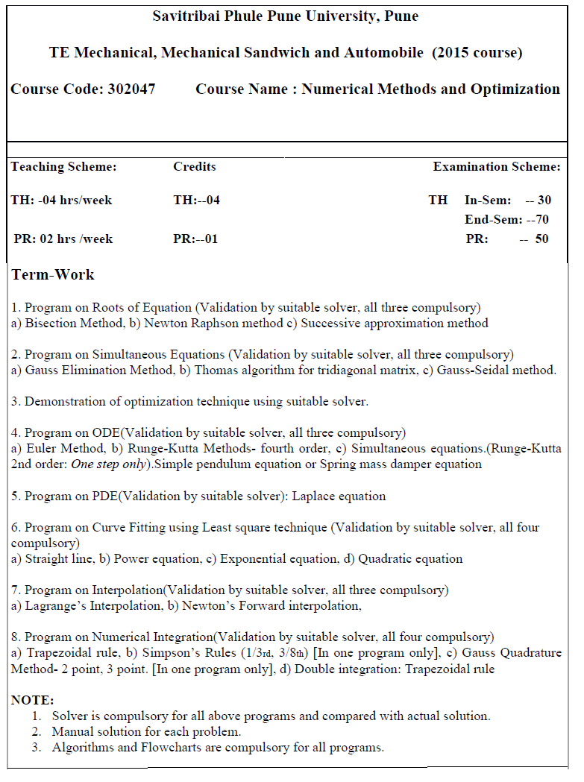
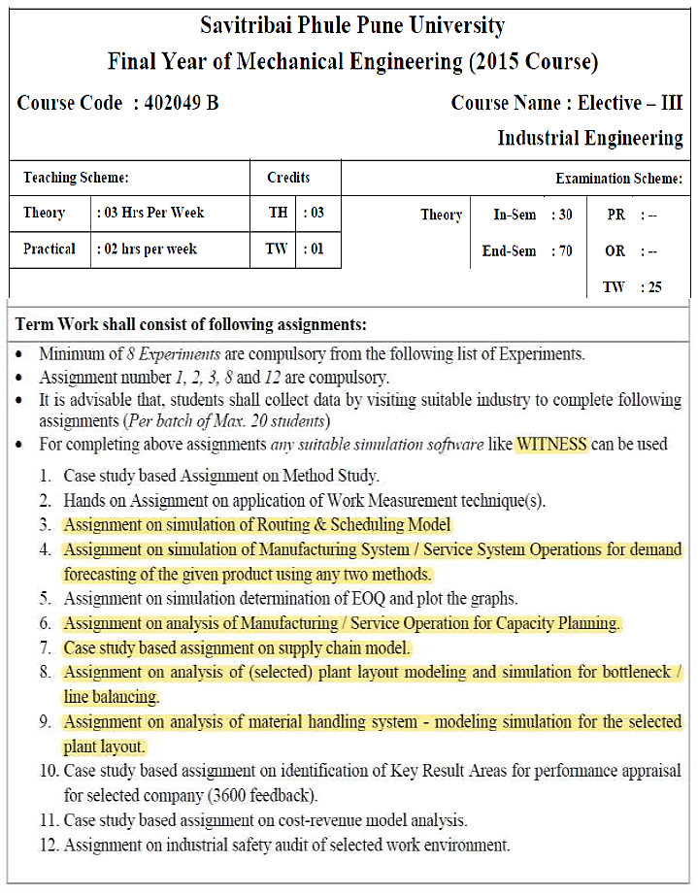

3.2 Purchase/Updating of Software
Software Used In Cad-Cam Lab- UG
Sr. No | Name of Software | Number of License users | Total Cost | Date of Purchase
1 | I-DEAS | 2 | 1,21,680 | 04-04-2001
2 | Auto CAD 2002 | 3 | 1,26,000 | 04-01-2001
3 | BORLAND TURBO C++ | 15 | 58,500 | 31-01-2001
4 | Auto CAD 2002 | 4 | 98,000 | 04-09-2002
5 | CATIA V5 | 20 | 4,50,000 | 26-07-2010
6 | Ansys 14.0 | 25 | 3,40,000 | 12-05-2012
7 | Feature CAM | 20 | 6,20,363 | 09-09-2015
8 | MATLAB 2018 | 5 | 1,00,684 | 03-08-2018
9 | Witness Simulation | 10 | 3,83,500 | 29-12-2018
10 | CREO 5.0 | 50 | 5,00,000 | 21-12-2019
For PG, to fulfil purpose of post experimental statistical analysis, MINTAB software was purchased in the year 2018.
Software Used In Cad-Cam Lab- PG
Sr. No | Name of Software | Number of License users | Total Cost | Date of Purchase
1 | ANSYS 16.2 with CFD | 5 | 2,40,000 | 06-10-2015
2 | MINITAB 18 | 3 | 41,300 | 23-10-2018
3 | MATLAB 2018 | 5 | 1,00,684 | 03-08-2018
4 | CREO 5.0 | 50 | 5,00,000 | 21-12-2019
For PG, to fulfill purpose of post experimental statistical analysis, MINTAB software was purchased in the year 2018.

- Lab Utilization
CAD CAM lab for UG and PG is engaged as per table given below
Sr. No | Course Name | Required Software | Year | Semester
1 | Computer Aided Machine Drawing | Creo 5.0 | SE Mechanical | III
2 | Numerical Methods and Optimization | MATLAB, SciLab | TE Mechanical | V
3 | CADCAM | Creo, Ansys, Featurecam | BE Mechanical | VII
4 | Finite Element Analysis | MATLAB, Ansys | BE Mechanical | VII
5 | Industrial Engineering | Witness Simulation | BE Mechanical | VIII
6 | Advanced Engineering Mathematics | MATLAB | ME Design Engg | I
7 | Advanced Machine Design | Ansys | ME Design Engg | II
- Supporting Documents
Use a following links for the proof of supporting documents.
Sr. No. | File Description | Link to open
 | Softwares CAD-CAM UG, PG Mech dead stock register | Click Here
 | Software screenshot | Click Here
 | Dead stock entries Computers & peripherals | Click Here
 | Utilization of IT Facilities | Click Here
 | Internet bills | Click Here  Click Here
 | Wifi Purchase Order (PO) | Click Here

