2.3.3: Ratio of mentor to students for academic and other related issues (Data for the latest completed academic year)
2.3.3.1 Number of mentors
2.3.3.2 Number of students assigned to each Mentor
Circulars Pertaining to Assigning Mentors to Mentees-
A well define procedure for mentor-mentee activity is given below. A mentor is allotted to each class at department level by Head of the Department. The list of mentor-mentee is submitted to principal through college level coordinator for approval. The list of mentor for latest completed year (2019-20) is attached below (pg. no. 2)
INDEX
Sr. No. | Description | Pg. No.
 | Tutor Meeting Process | 1
 | Mentor list for Semester-I | 2
 | Mentor list for Semester-I | 3
- Tutor Meeting Process
Conduct tutor meeting as per the frequency
Record the points raised and try to resolve it
Discuss unresolved points/issues in Head of Department meeting

Communicate actions initiated to the students
Discuss in Principal meeting and resolve
All issues resolved?
Yes
No
- Mentor list for Semester-I
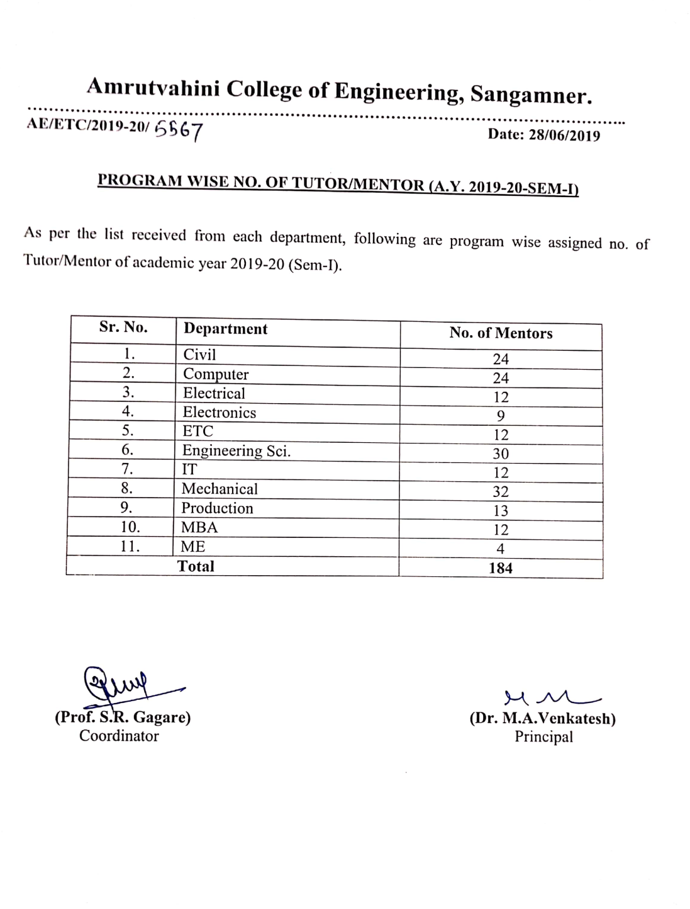

- Mentor list for Semester-II
