1.4.2: Feedback process of the Institution may be classified as follows:
Options:
- Feedback collected, analysed and action taken and feedback available on website
- Feedback collected, analysed and action has been taken
- Feedback collected and analysed
- Feedback collected
- Feedback not collected
Feedback process of the Institution
Feedbacks were collected from the stakeholder related to curriculum design and development. Even feedbacks from parent are also considered for this regard. Feedbacks were analyzed to prepare a consolidated report signed by head of the department (HOD) on up-gradation of syllabus. This report was communicated to university through the Principal to the affiliated university/BoS to be considered for up-gradation/revision of syllabus. Index below shows the feedback process of the Institution
INDEX
Sr. No. | Description | Pg. No.
 | Feedback taken | 2
 | Department wise Action taken Report on feedback signed by the Head of the Department | 6
 | Document showing the communication with the affiliating University for the Feedback provided through principal. | 7
 | Change in syllabus -Action taken by the affiliating university on the feedback | 8

Alumni Feedback

Employer Feedback

Teacher Feedback
Student Feedback
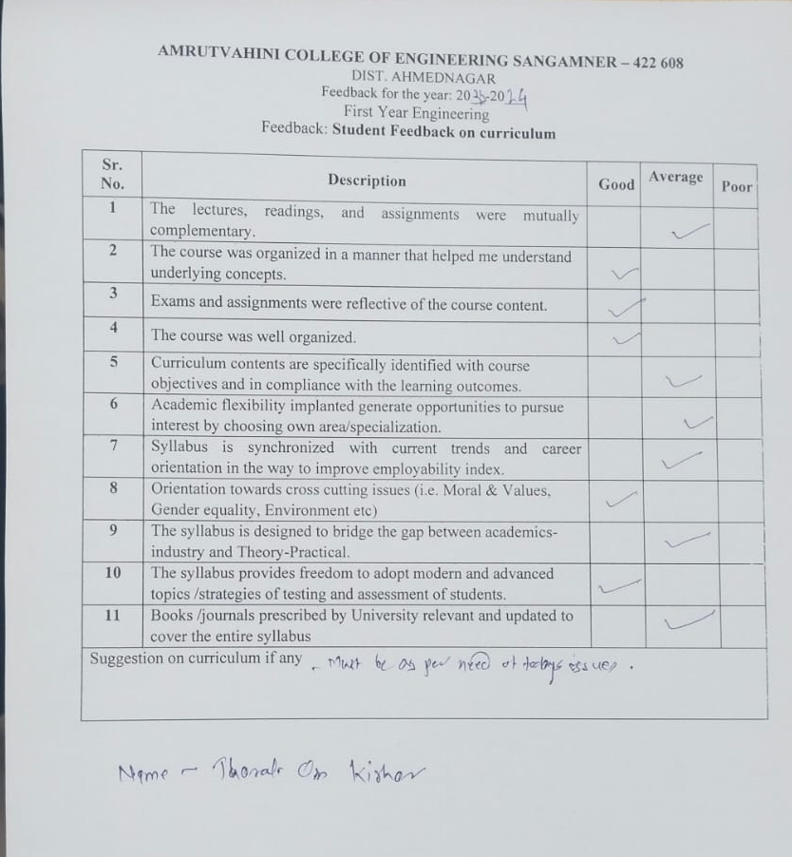

Summarized Feedback Report
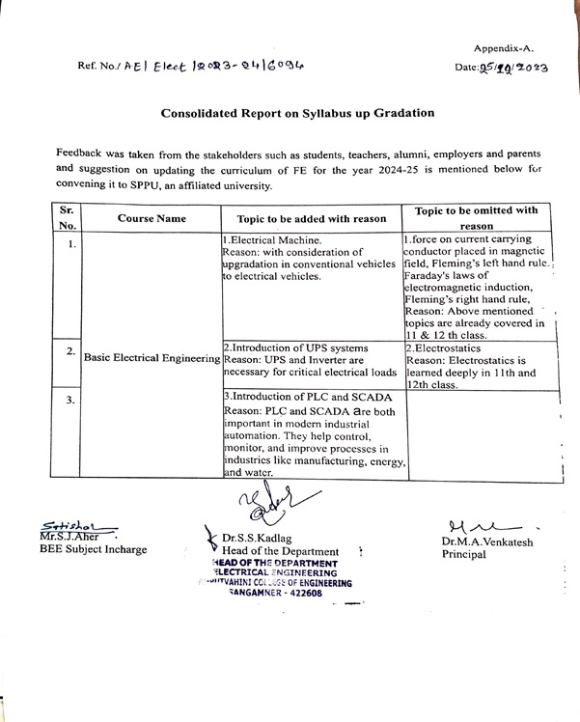

Action Taken Report
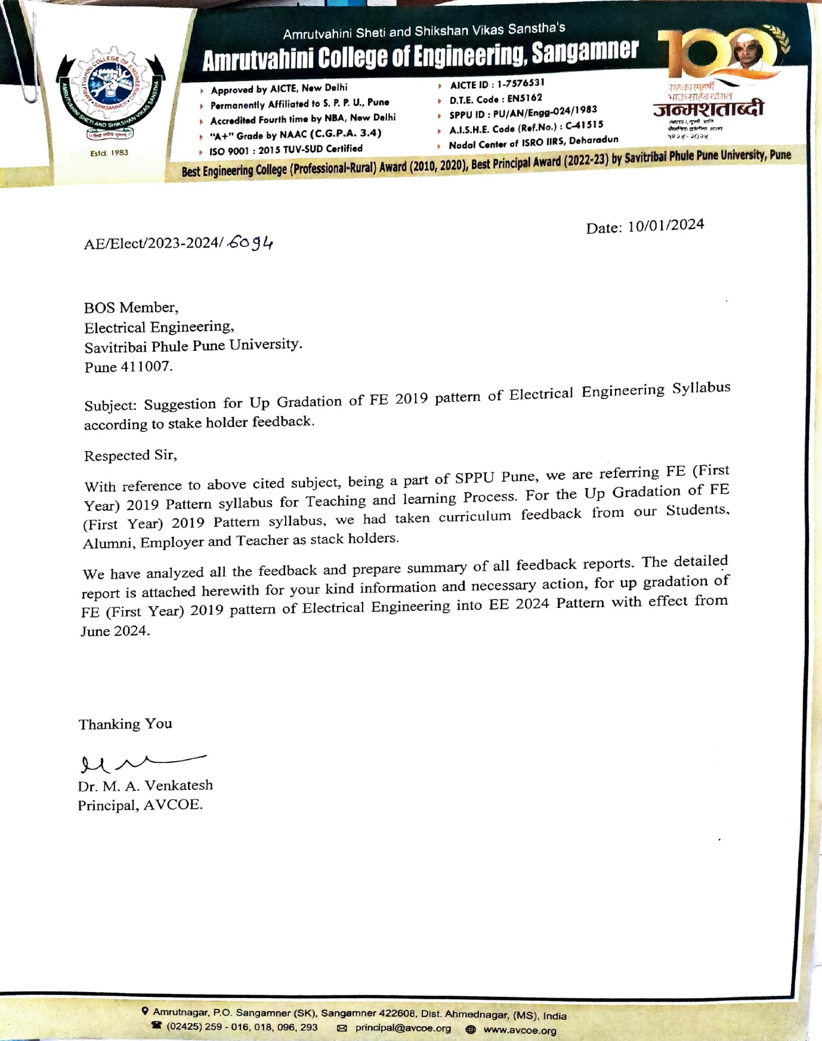

Change in syllabus highlighted by Red Box for the subject Basic Electrical Engineering.
