1.4.1: Institution obtains feedback on the syllabus and its transaction at the institution from the following stakeholders
- Students 2)Teachers 3)Employers 4)Alumni

INDEX
Sr. No. | Description | Pg. No.
 | Sample of Filled In Feedback Forms from the Stakeholders  - Student feedback on Curriculum  - Teacher feedback on Curriculum  - Alumni feedback on Curriculum  - Employer feedback on Curriculum | -  2  3  4  5
 | Stakeholder feedback analysis report | 6
 | Communication with the affiliating University Action taken | 7
 | List of Additional Feedback | -

Institute collects the feedback from the stakeholders not only on the curriculum but also on other activities of the teaching learning process for continual improvement. Feedbacks obtained from above stakeholder on the syllabus are analyzed and consolidated report is submitted to affiliated university for up gradation of curriculum. Even feedback of parent are also taken and considered for up gradation of curriculum. Various type of feedbacks on academic and admin other than Curriculum is mentioned in last page along with the link for the sample of these feedback.
- Sample- Filled Feedback Forms
Student feedback on Curriculum
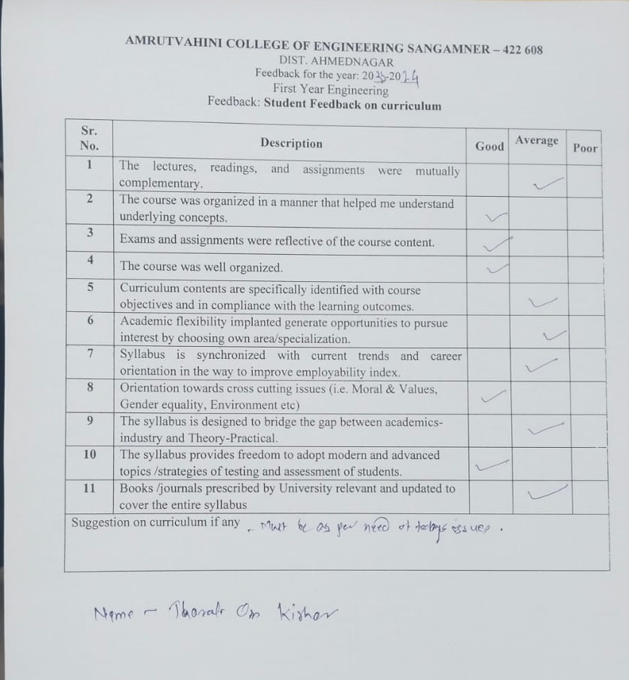

Teacher Feedback
Alumni Feedback

Employer Feedback

Stakeholder feedback analysis report
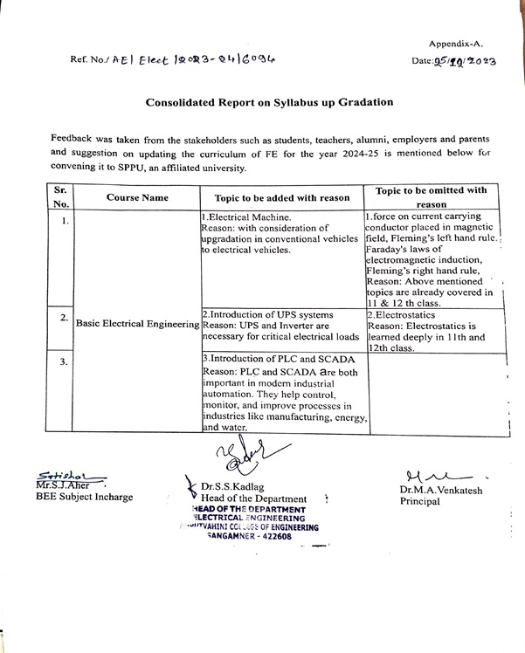

Action taken report
