1.1.2 The institution adheres to the academic calendar including for the conduct of CIE
Table below shows case study of value addition program conducted by Electrical Engineering and highlighted portion shows mapping of activity with calendar
INDEX
Sr.No. | Document Name | File No | Place
1 | University Academic Calendar | - | Principal Office
2 | Institute Academic Calendar | ISO - 01 | Respective Department
3 | Departmental Academic Calendar | ISO - 01 | Respective Department
4 | Mapping Document of planned and conducted activities with appropriate remark | - | Respective Department

University calendar-

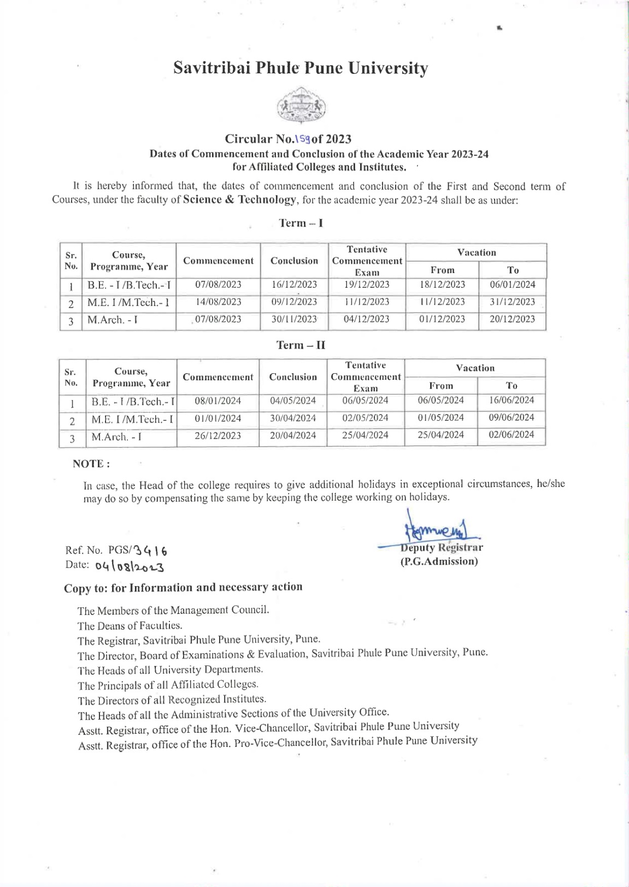

Institute Calendar-

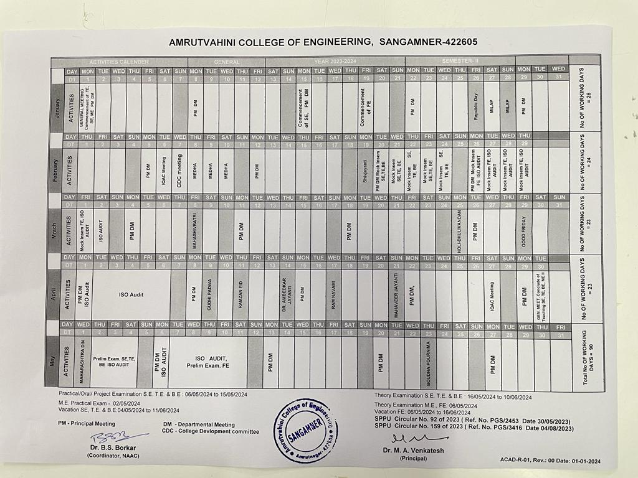

Department calendar

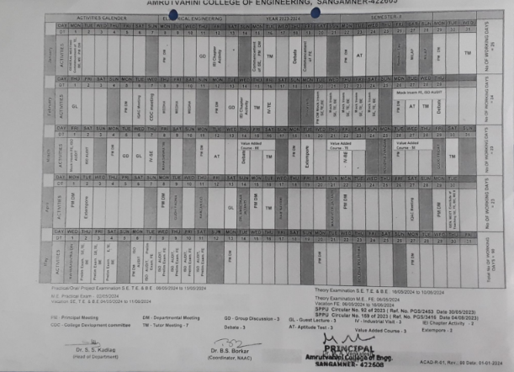

Case study of Electrical Department on Value addition course

