1.1.1: The Institution ensures effective curriculum delivery through a well-planned and documented process
Additional information
Flow chart shown in Fig 1.1.3, below represents processes to improve quality of Teaching & Learning which is the well planned and documented process to ensure the effective curriculum delivery. The index of documents along with the case study of department of Electrical Engineering is elaborated below.
Various document required for the effective implementation of curricular are prepared & preserved as listed below
Sr.No. | Documents | File No | Place
 | Vision-Mission - Quality Objectives | -
 | Dissemination of Vision-Mission | -
 | Affiliation Letter of SRA and University | - | Principal Office
 | Syllabus of All Program | - | Respective Department
 | Academic Calendar Institute/Department (If Available) | ISO - 01 | Principal Office
 | Principal-HOD-Faculty Meeting Record | - | Principal Office
 | Load Distribution Document | ISO - 01 | Respective Department
 | Time Table Record | ISO - 01 | Respective Department
 | Project Group and Guide Allocation Record | ISO - 10 | Respective Department
 | Continuous Internal Evaluation Scheme and its Components |  | Respective Department
 | External oral/Practical Oral Examination Record |  | Respective Department
 | University Exam Record |  | Exam Section
 | Result Gazette |  | Exam Section
 | Result Analysis Record | ISO - 06 | Respective Department
 | Next Semester Planning Meeting Minutes | - | Principal Office

Flow chart shown below represents awell-planned and documented process to ensure the effective curriculum delivery.
Subject distribution
Prior to Commencement of semester

Semester planning, Academic Calendar, Time Table

Preparation of Teaching Plans (Th./Pract.)
(Th./Pract.)

Satisfactory

Not Satisfactory
Check

Satisfactory

Student feedback

Academic monitoring
Analysis of result/data

Term work submission/conduct of University practical & theory exams

Bright students
Weak students
Amrut-meritorious” scholarship
Conduction of remedial class, extra class.
Monitoring of quality objectives & continual improvement

Check

Not Satisfactory
Gap identified & analyzed

In Process Corrective Action

Training, workshop, value addition courses

Practical conduction RCV & Project work
Lecture conduction, class test
Corrective Action in Next Semester
Fig. 1.1.3: Flowchart of effective curriculum delivery
VISION
To create opportunities for rural students to become able engineers and technocrats through continual excellence in engineering education.
MISSION
Our mission is to create self-disciplined, physically fit, mentally robust and morally strong engineers and technocrats with high degree of integrity and sense of purpose who are capable to meet challenges of ever advancing technology for the benefit of mankind and nature.
We, the management, the faculty and staff, therefore promise to strive hard and commit ourselves to achieve this objective through a continuous process of learning and appreciation of needs of time.
QUALITY OBJECTIVES
- To strive hard for academic excellence & synergizing spiritual & moral values.
- To improve overall development of student.
- To enhance industry-institute interaction.
- To provide assistance for placement & entrepreneurship development.
- To promote and encourage R&D activities.

Dissemination of Vision-Mission
- Principal's Office
- HOD’s Cabin
- Faculty cabin
- College Website
- Laboratory
- Class room
- Notice Board
- Library
- Course File
- Lab Manual
- Brochure
- Magazine/News letters

AICTE Approval Letter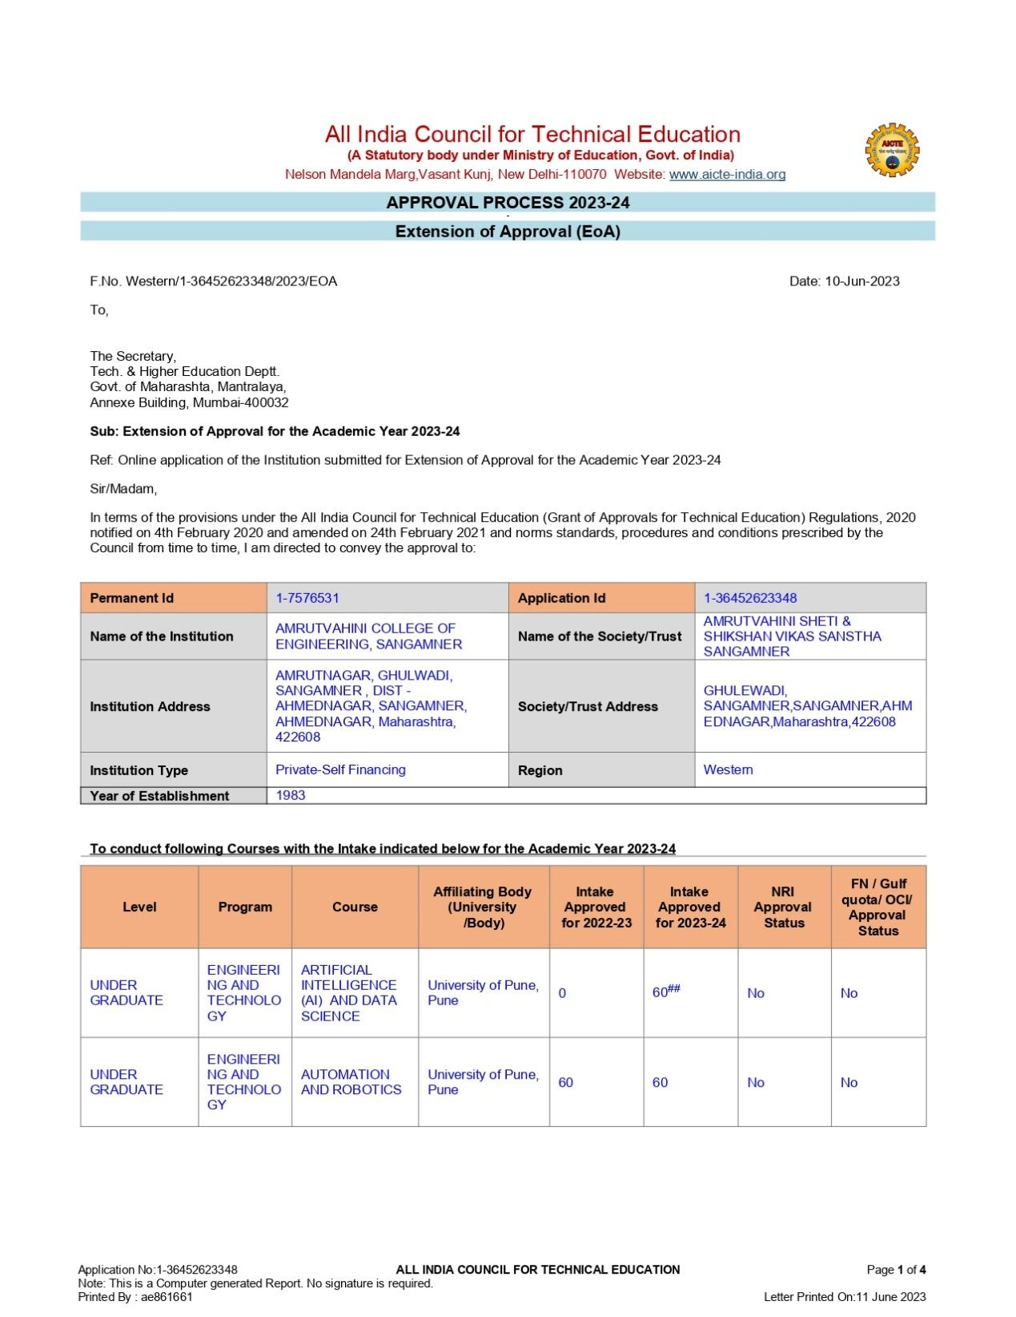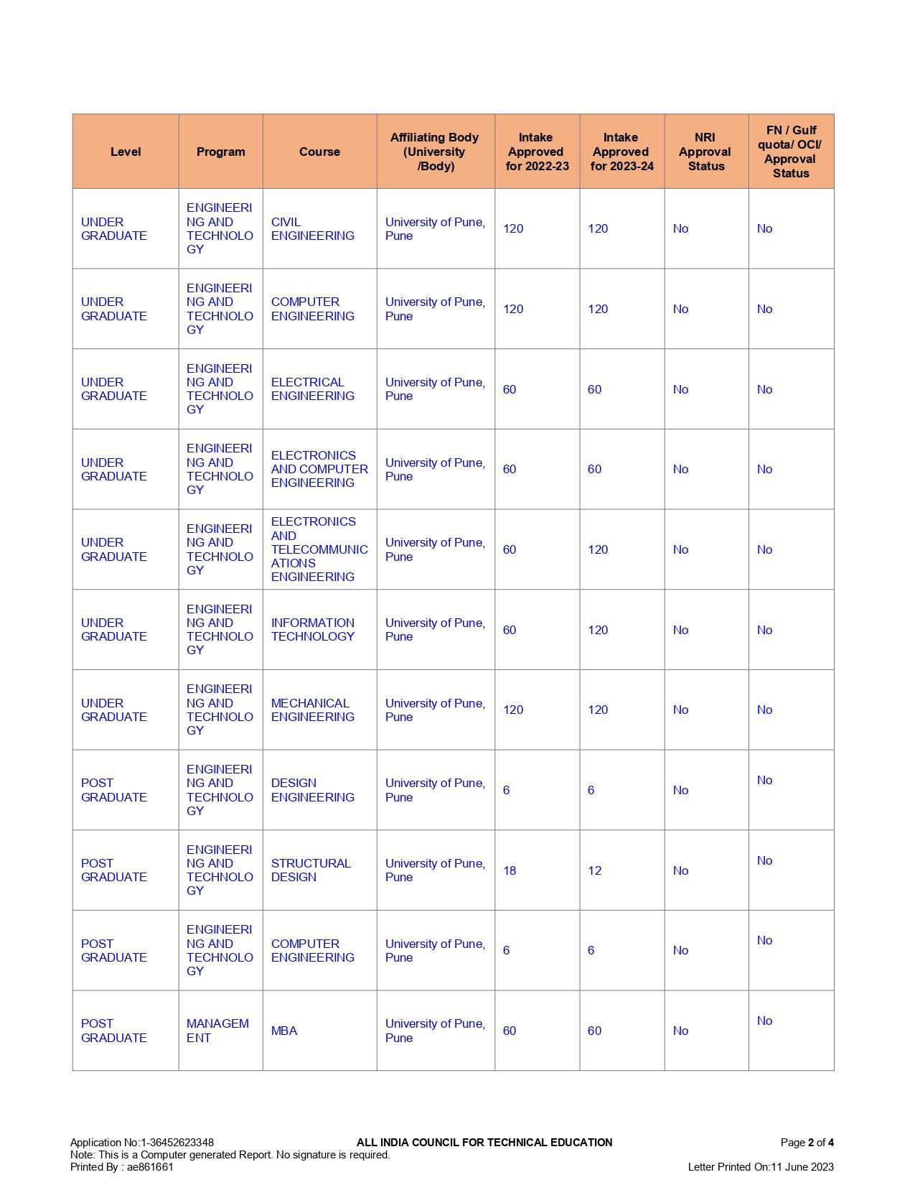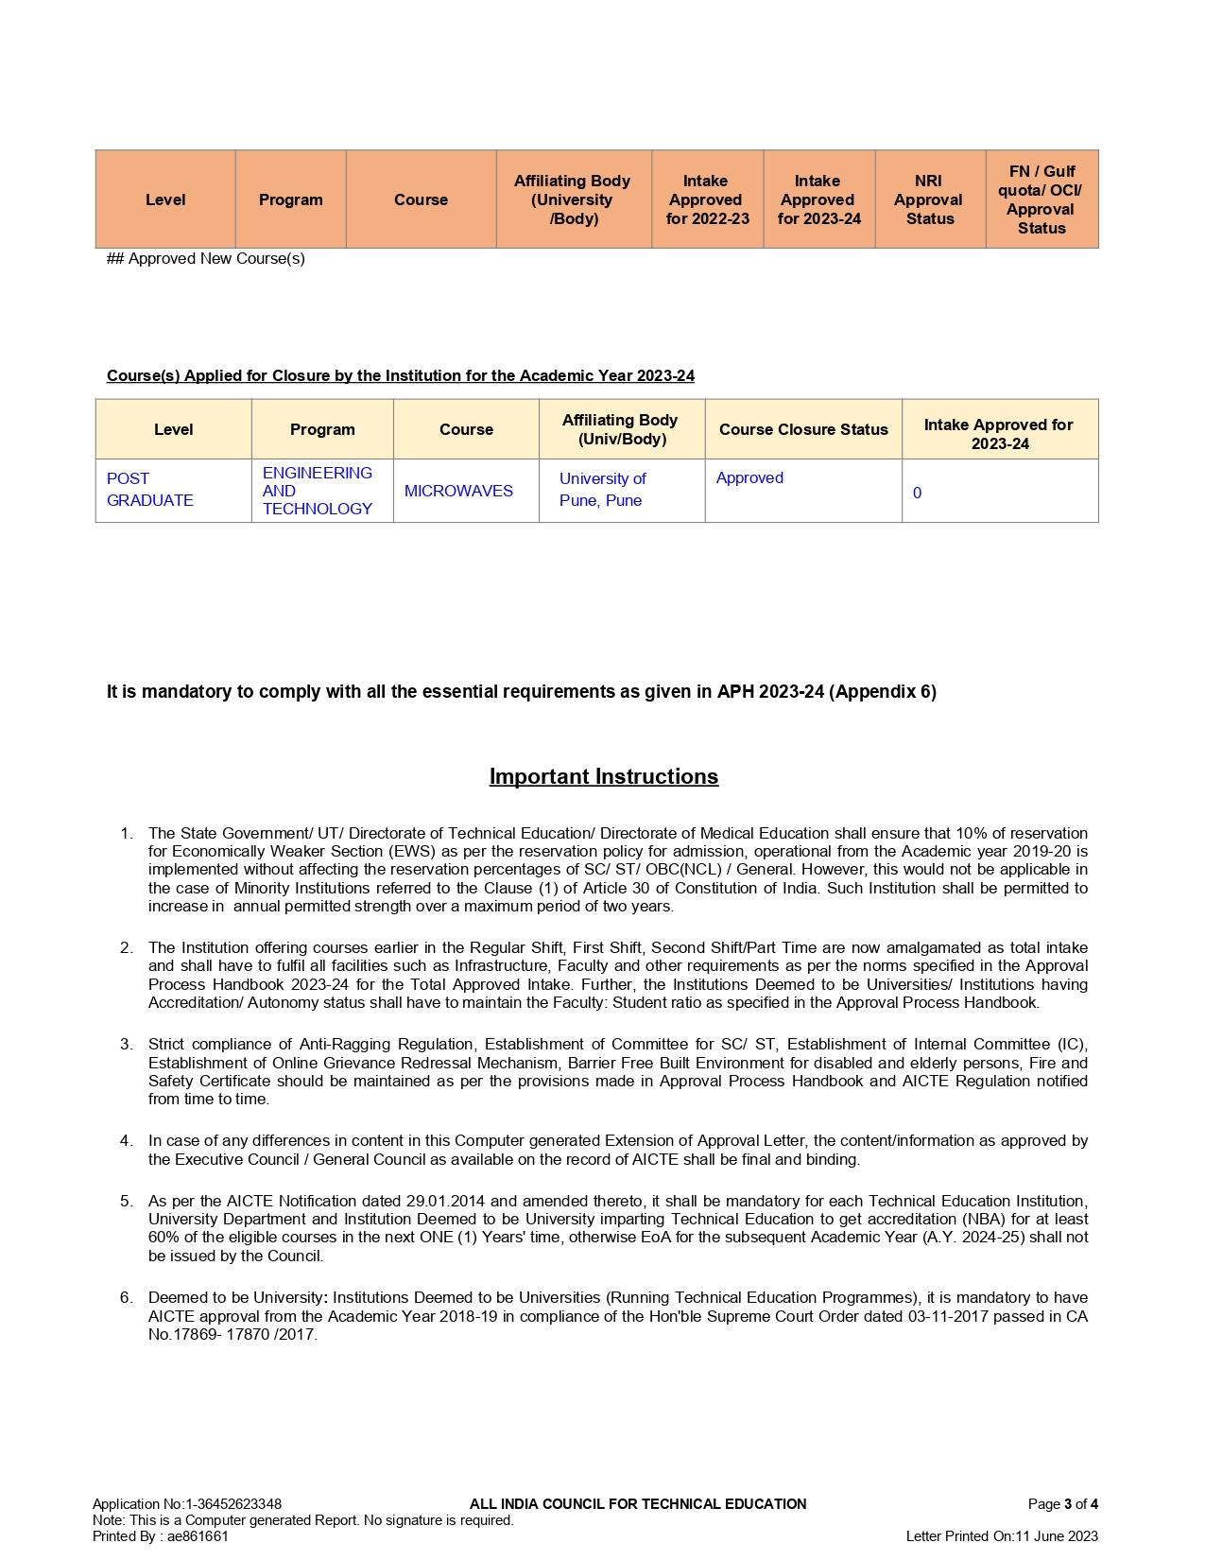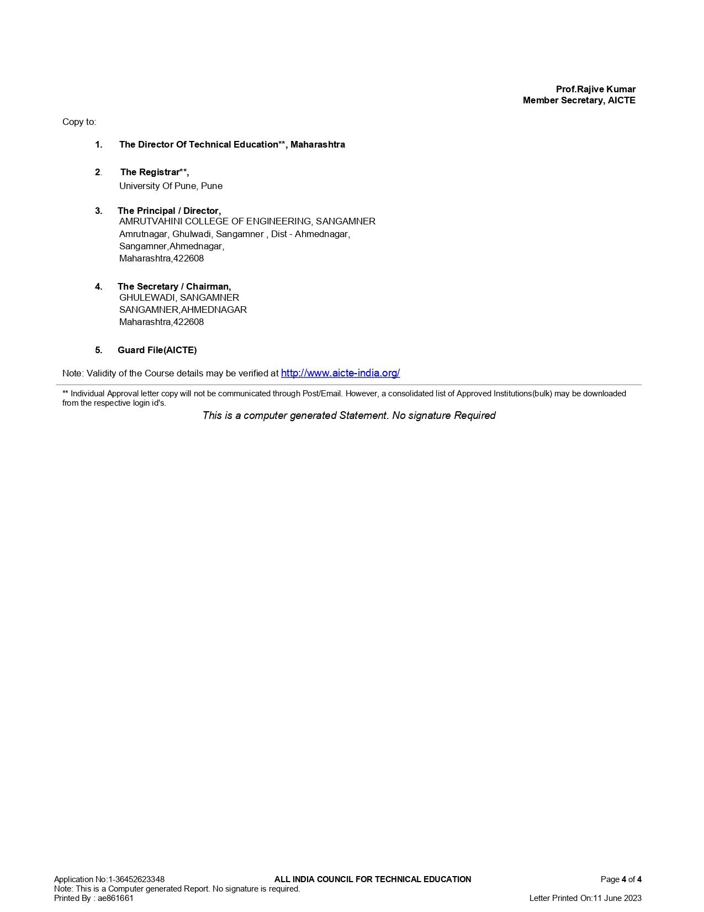

SPPU affiliation letter-
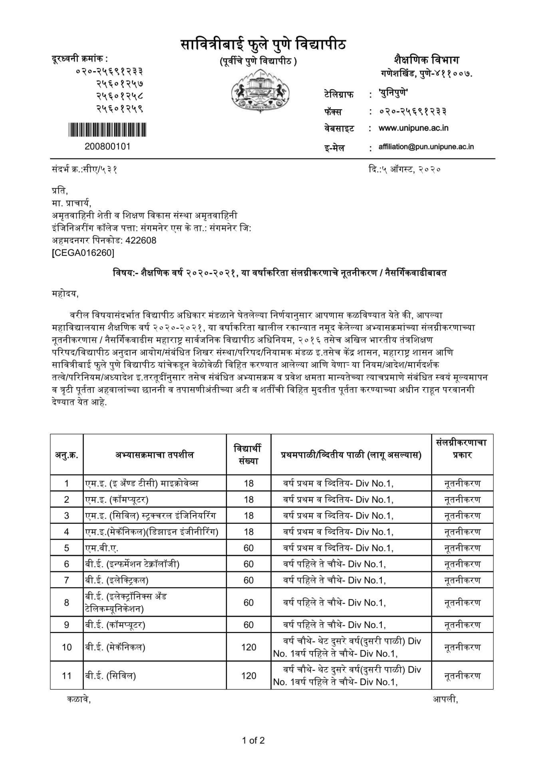


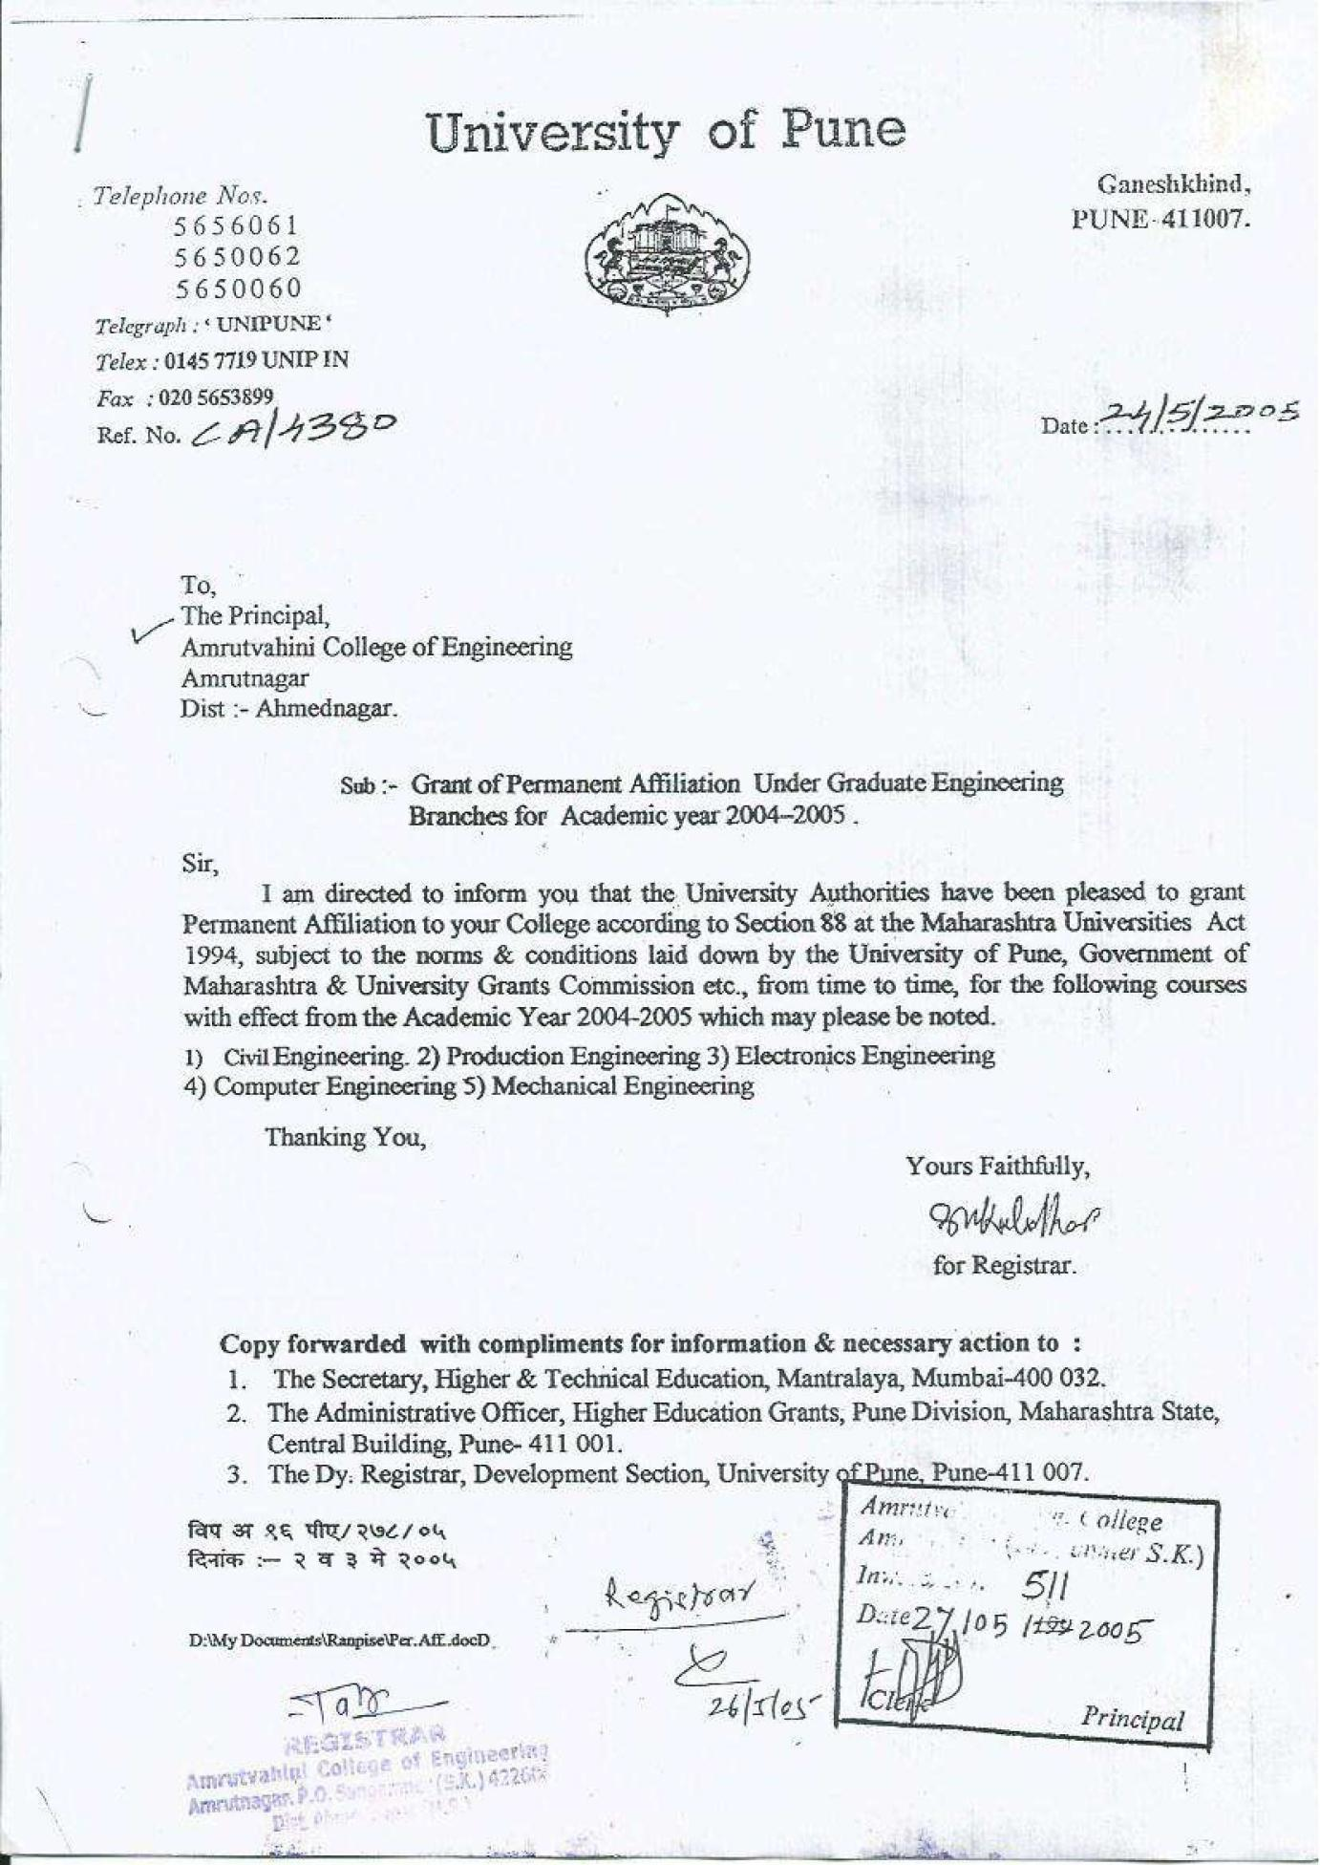

Load Distribution
Subject allocation to the faculty is done as per area of specialization and their choice by HOD based on result analysis. Subject distribution is planned well in advance for proper academic implementation.
Sample copy of Load/Subject distribution
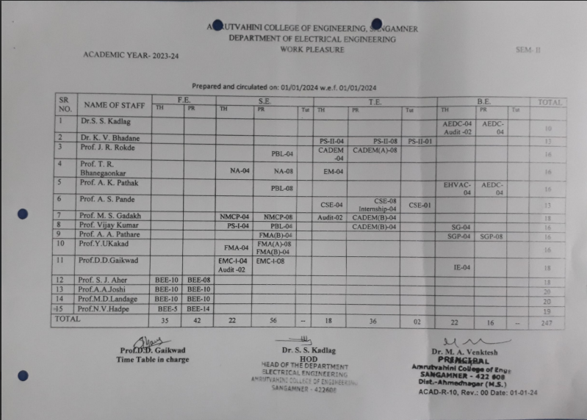

Academic calendar
Curriculum and academic calendar are designed and published by the Savitribai Phule Pune University (SPPU). And based on it Institute & departmental academic calendars are prepared.
University calendar-
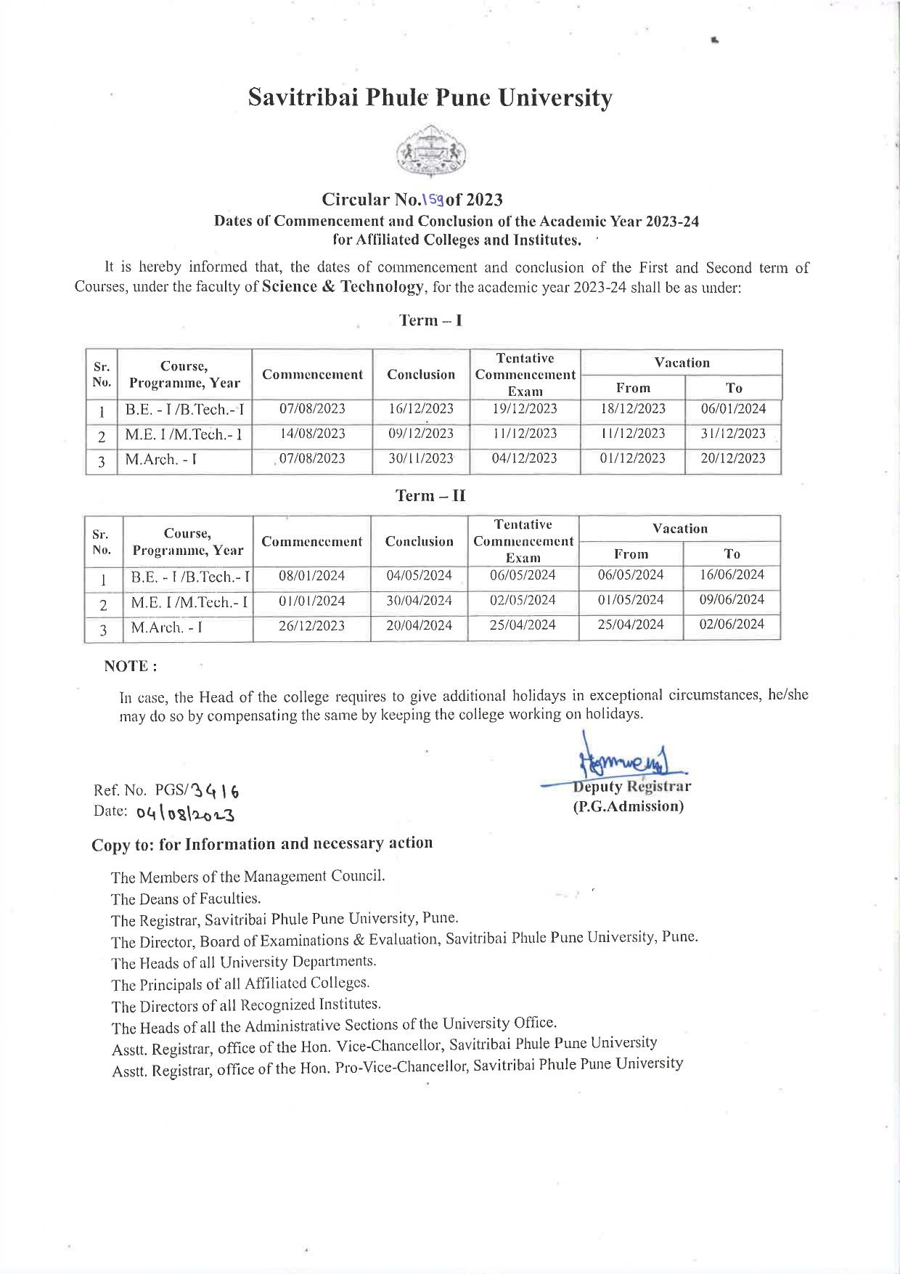
Institute Calendar-
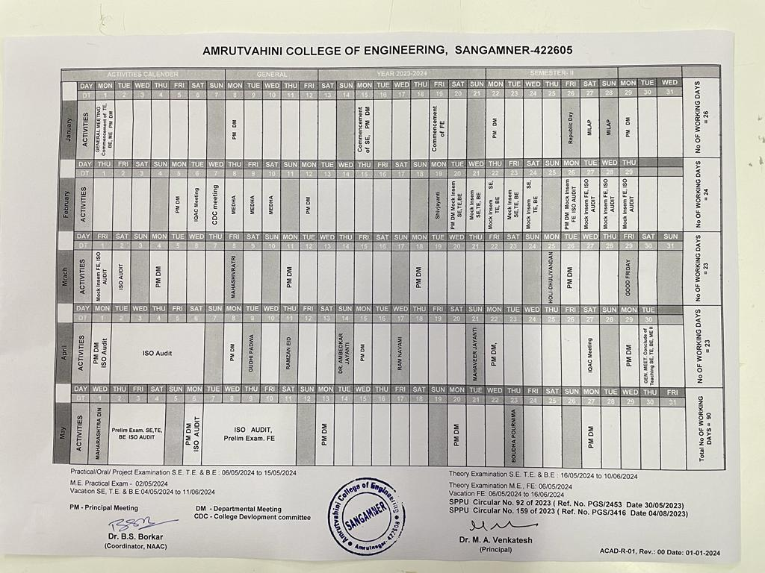
Department calendar-
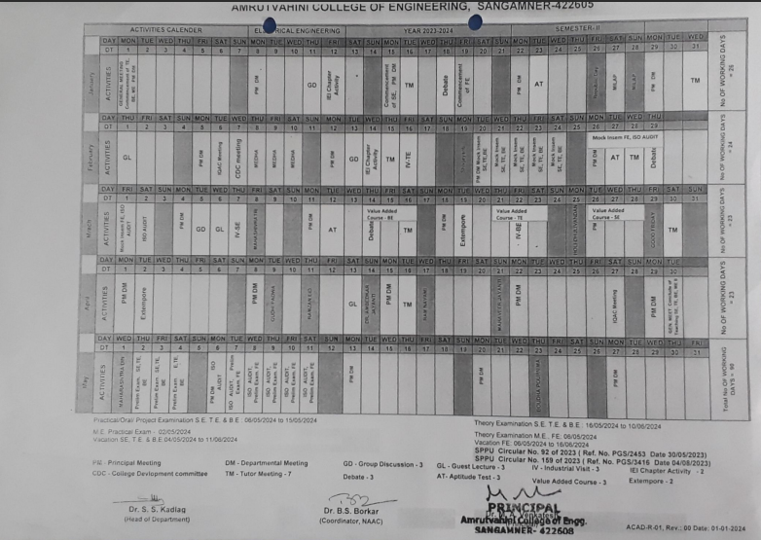
Teaching plan and practical plan
Teaching plan and practical plan are prepared by the individual faculty and adherence is continuously monitoring as per ISO procedures and standards.
Sample of Teaching Plan-
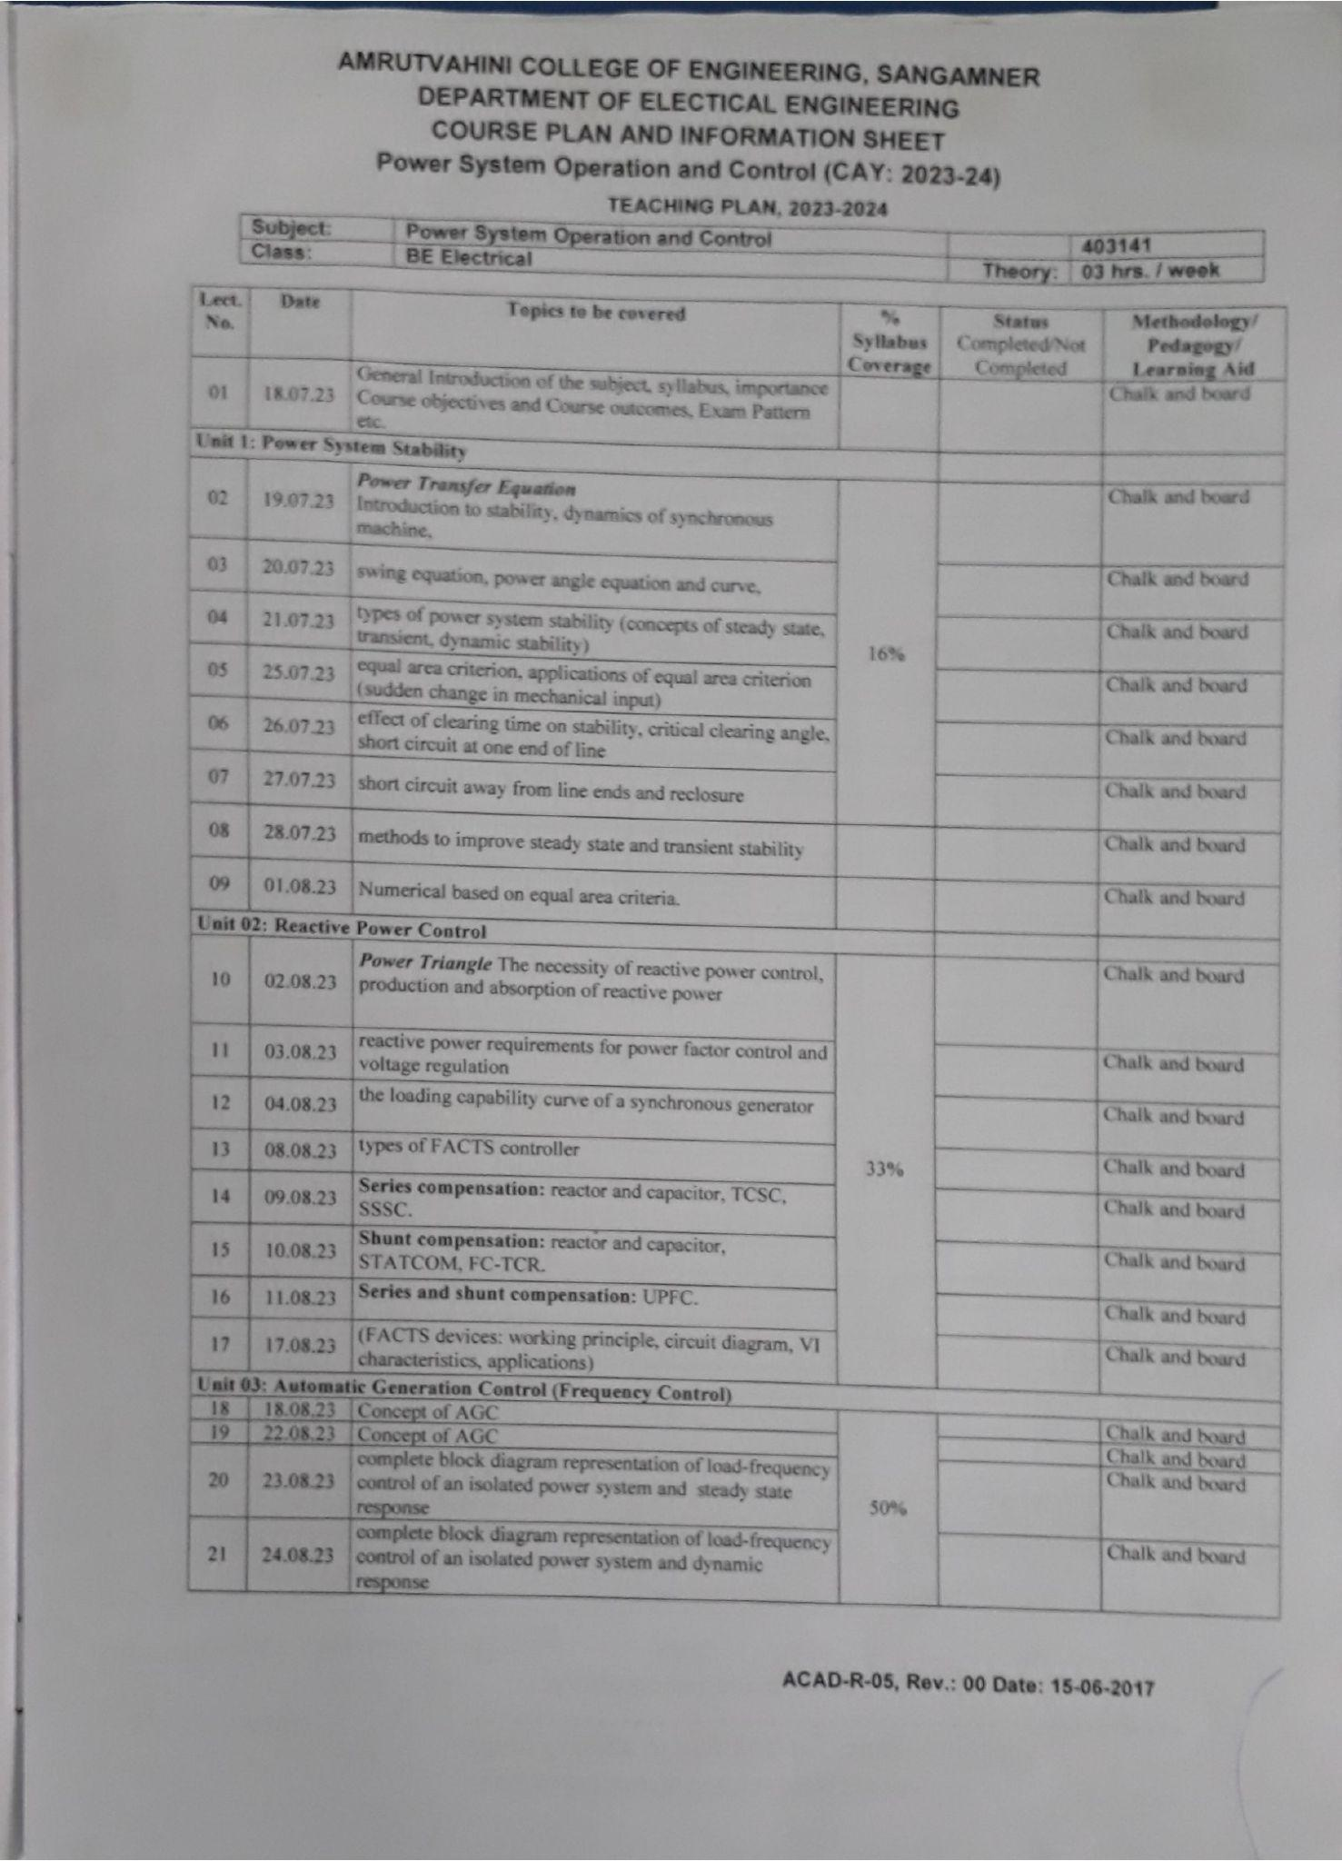
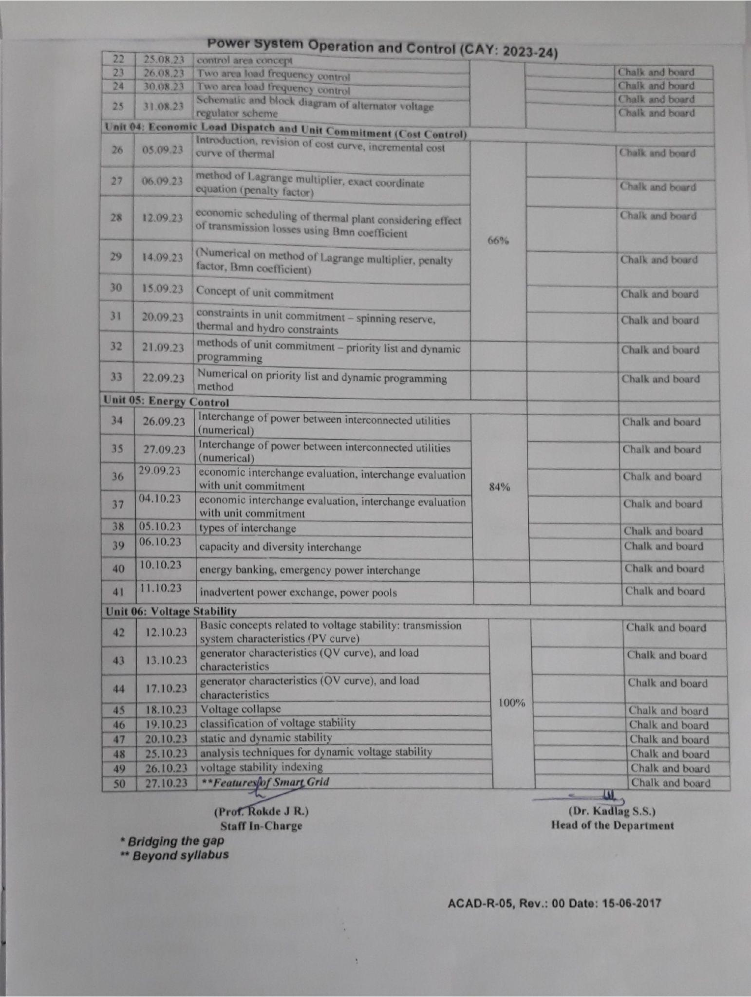

Sample of Practical Plan-
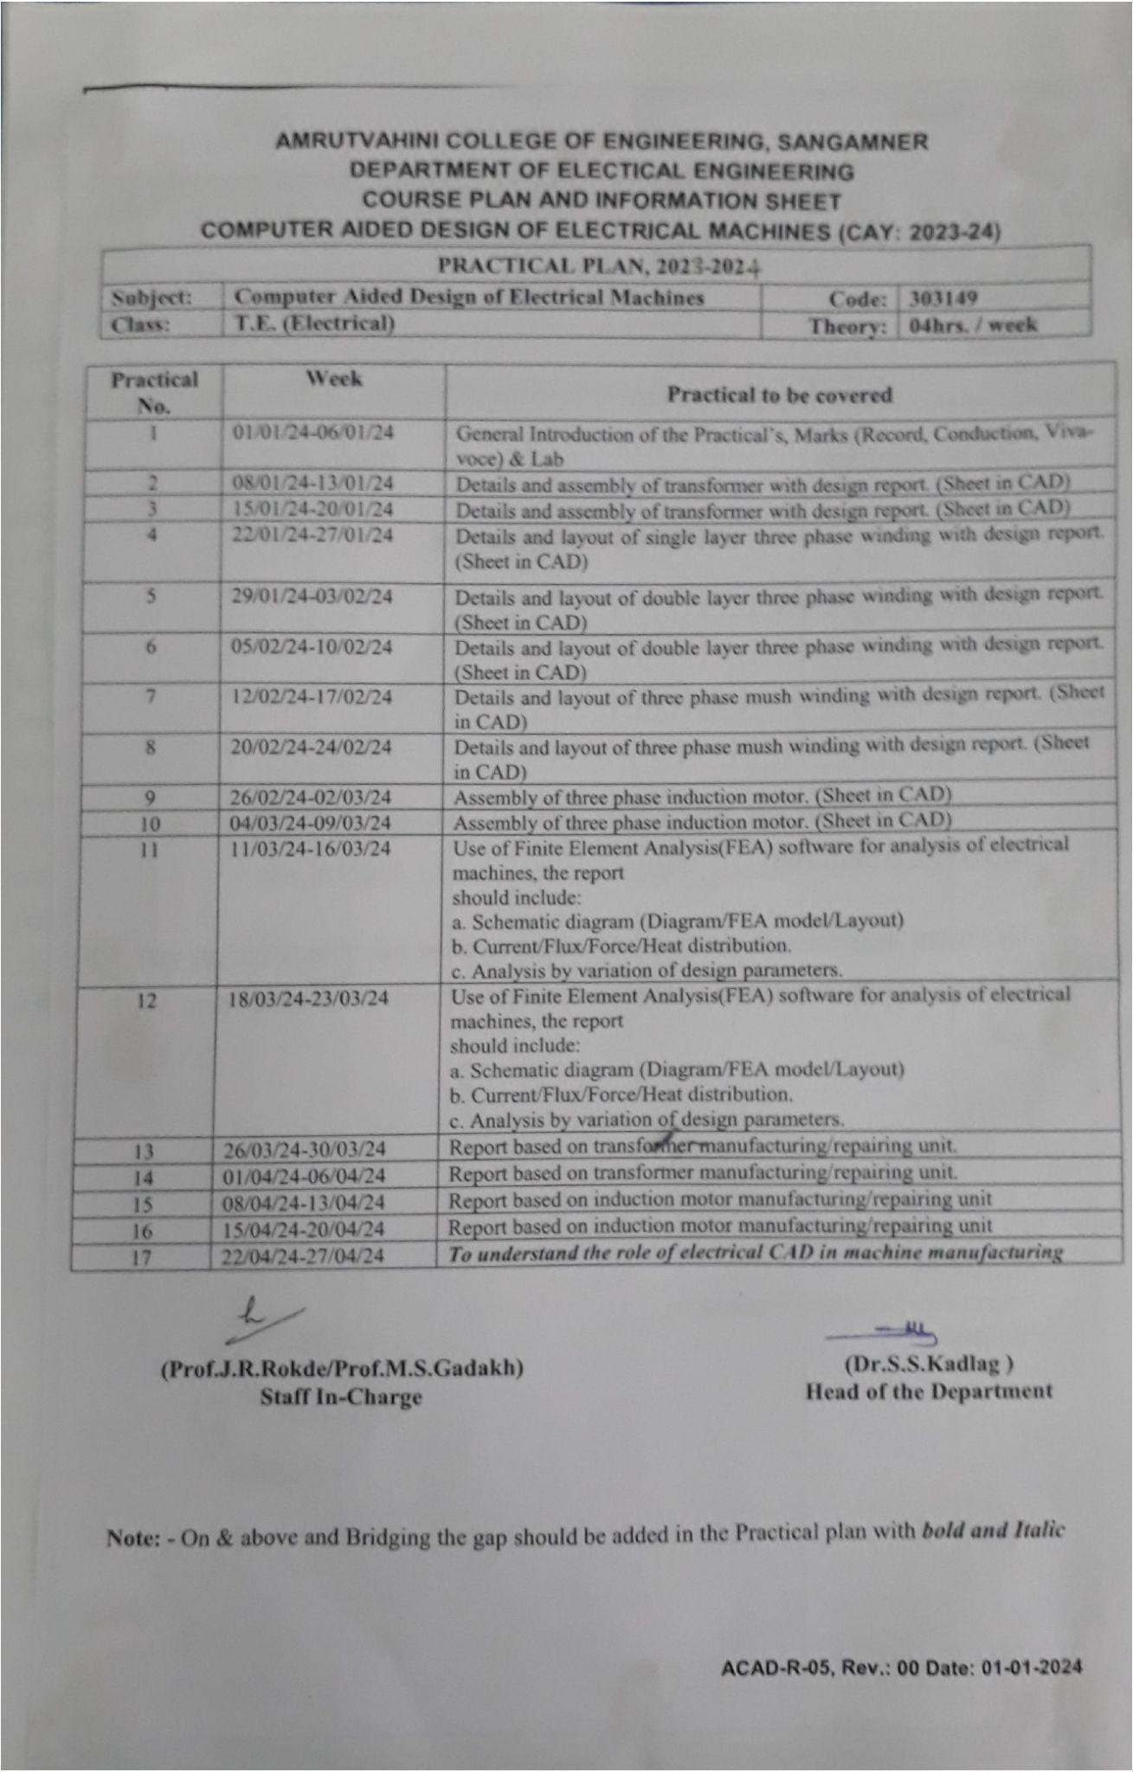

Time Table-
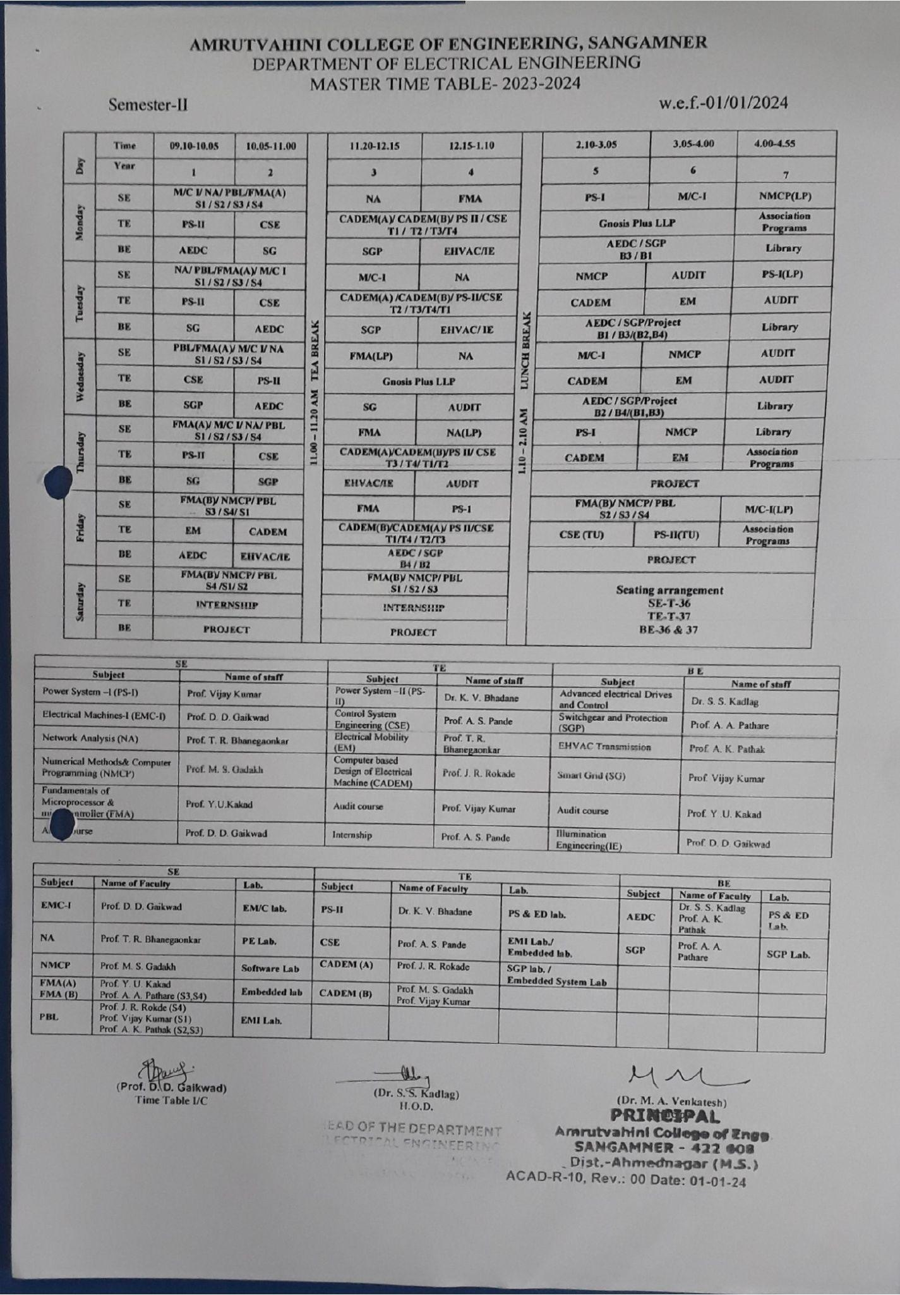

Class, laboratory and individual faculty time tables are prepared, preserved and displayed with prior approval of HOD, Principal.

Academic Audit
Academic audit and ISO audit is conducted to have continuous monitoring and corrective action in teaching learning process. Academic audit is conducted at the beginning of semester to check the course file, personal file. The discrepancies found will be corrected with in time by concern department. The course file and personal file audit report format is attached bellow that shows the various activities to be check.
Course file checking report
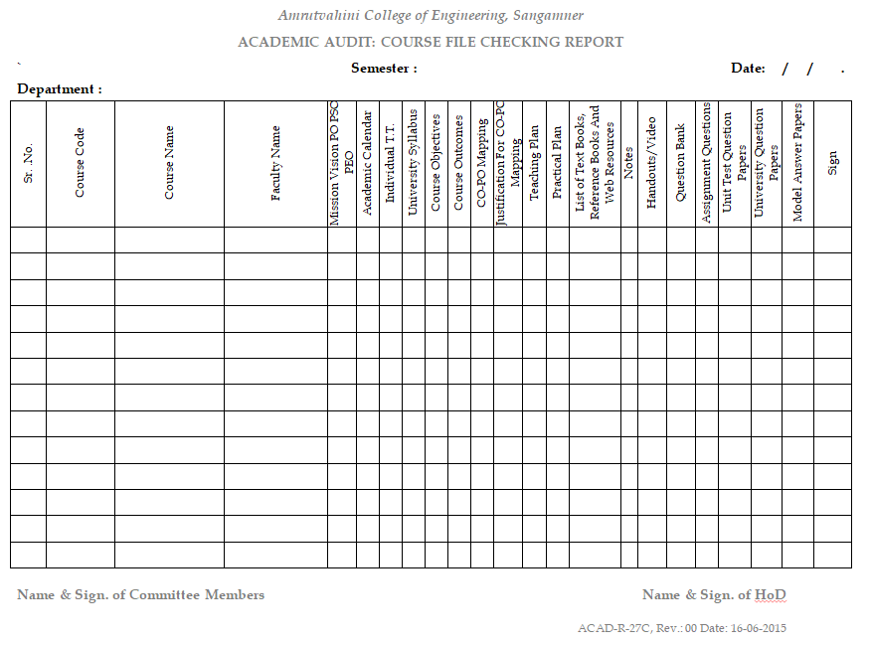

Personal file checking report
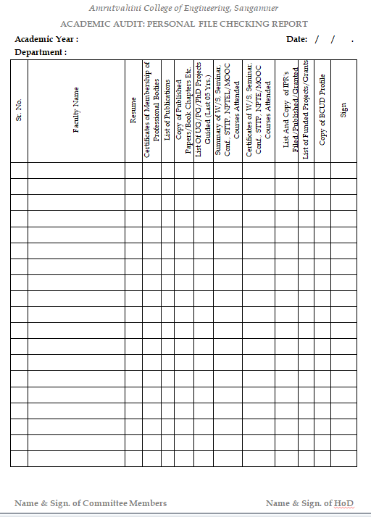
Faculty maintain course file.After preparation of course file, as per academic calendar and time table lectures & practicals are conducted by respective department. Along with this project allocation is also done.
Continuous Evaluation
Assignment/practical/term work is continuously checked by the concern faculty by conducting RCV (R-Record; C-Conduction, V- Viva) and in new format i.e. ACO(A- Attendance, C- Conduct, O- Oral). The sample of attendance sheet shown below indicates the continuous assessment.
Sample of practical Attendance sheet
Sample of practical evaluation on the basis of ACO (Attendance, Conduction, Oral)

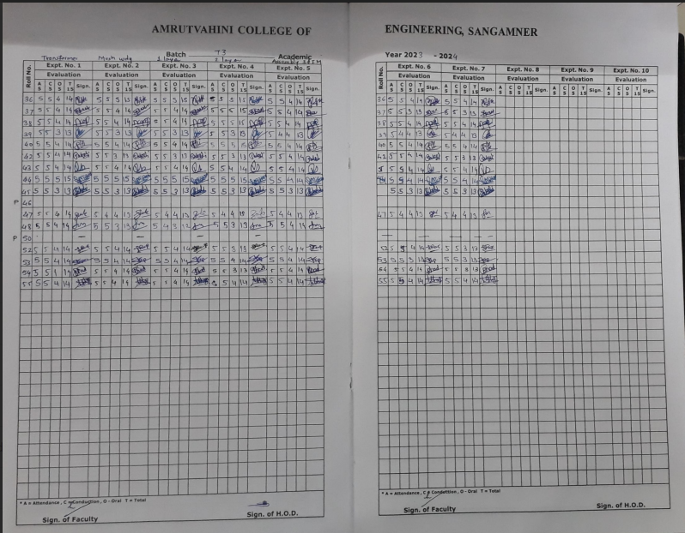

ACO

Sample of project allocation-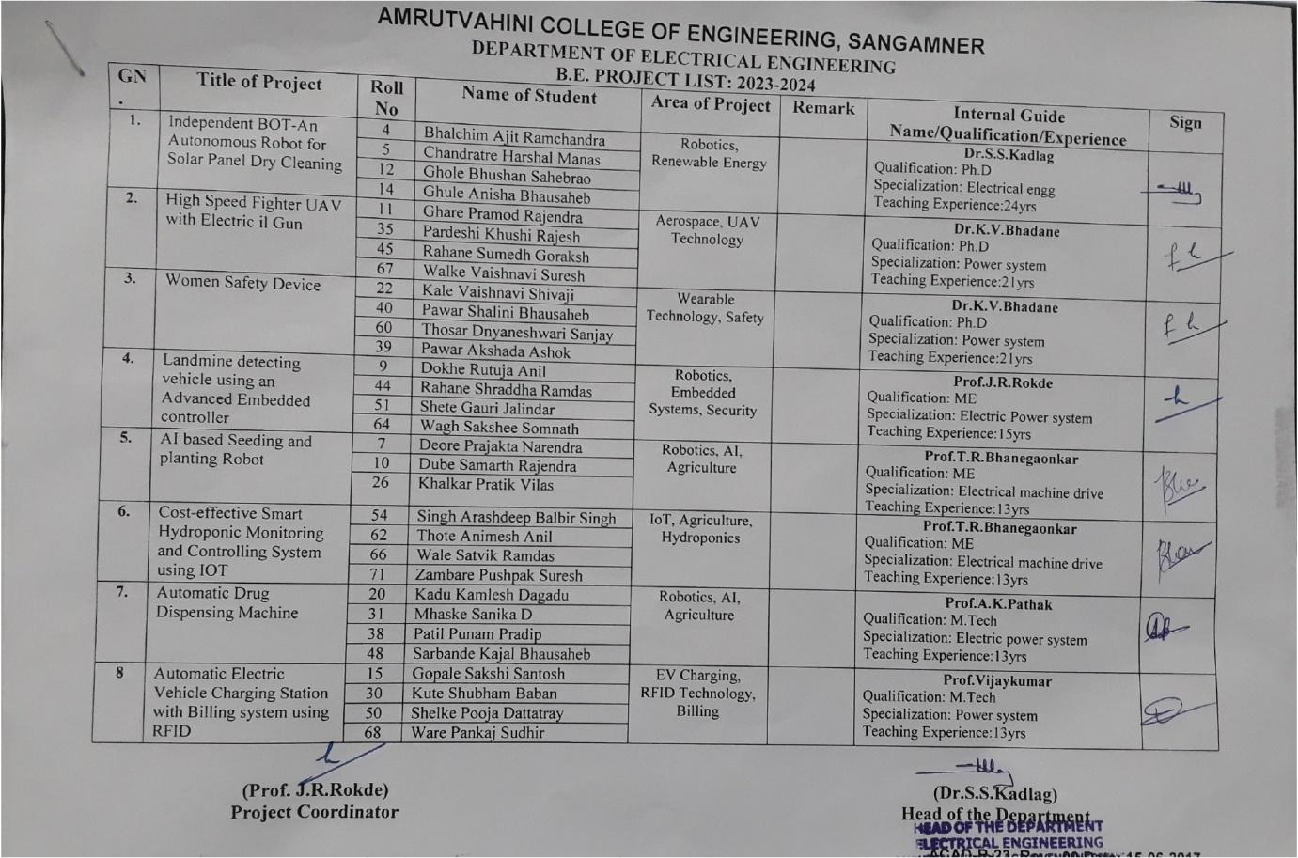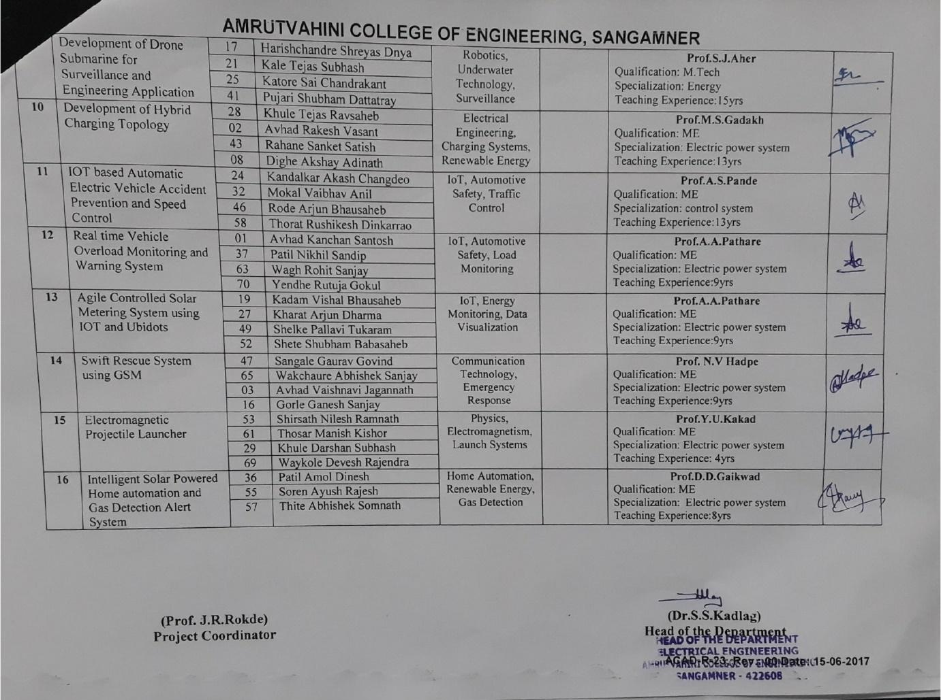
Monthly Report of syllabus coverage and class attendance
Report of syllabus coverage, monthly class attendance and test marks are submitted to Dean Academics and attendance and test marks are communicated to parents through post/massages.
Sample of monthly attendance and unit test report-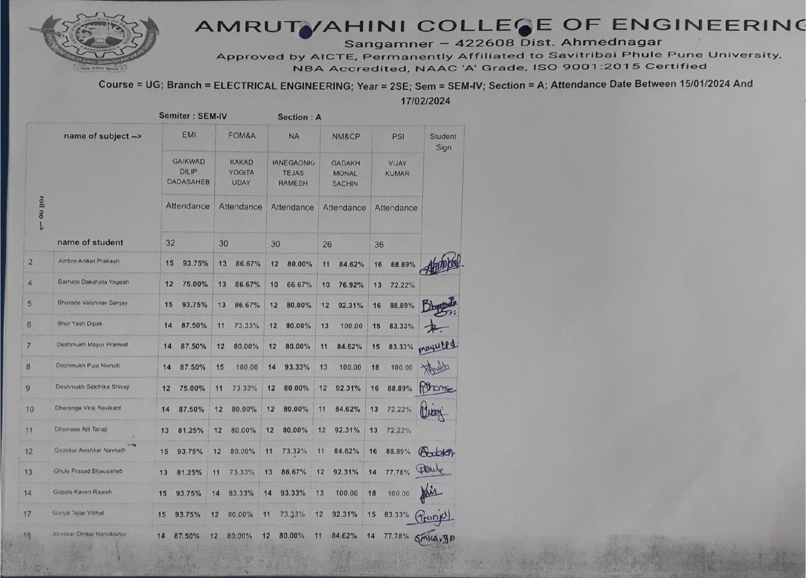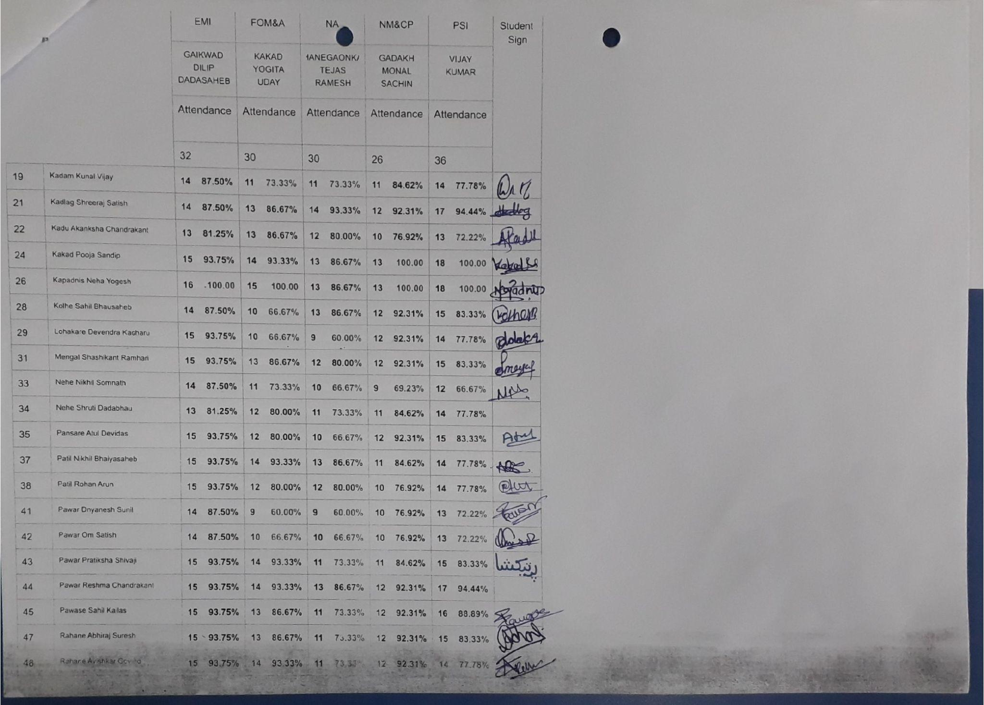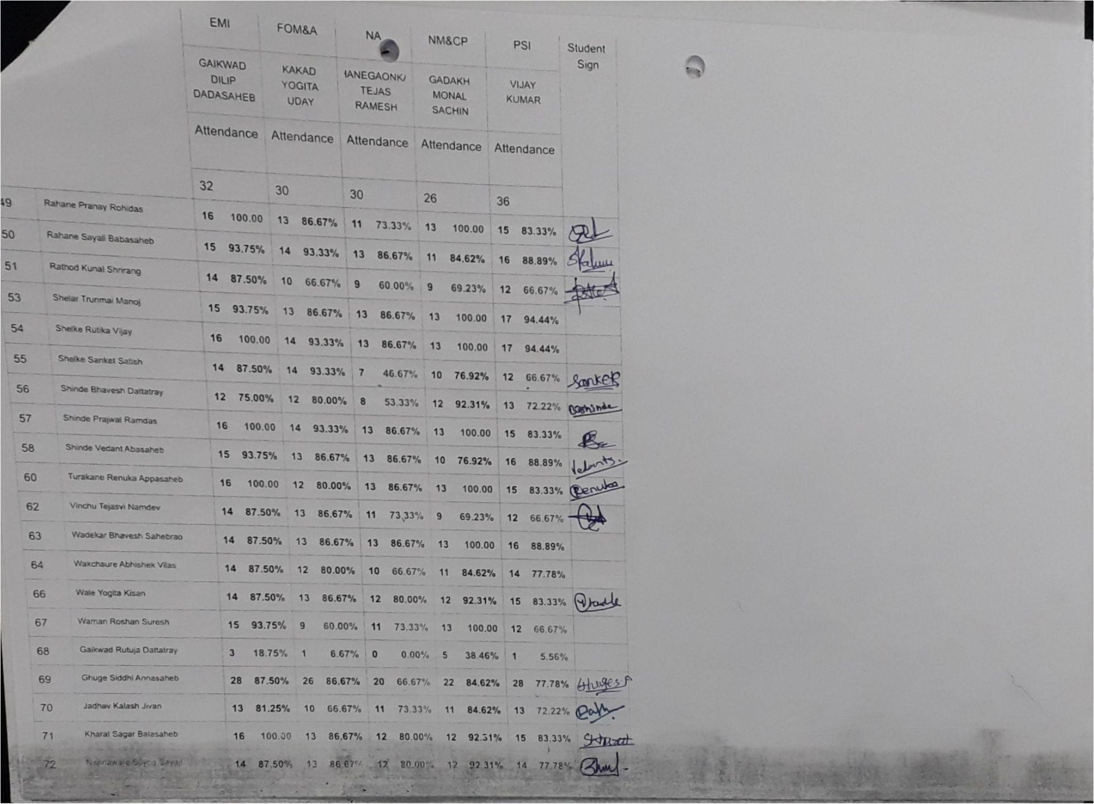
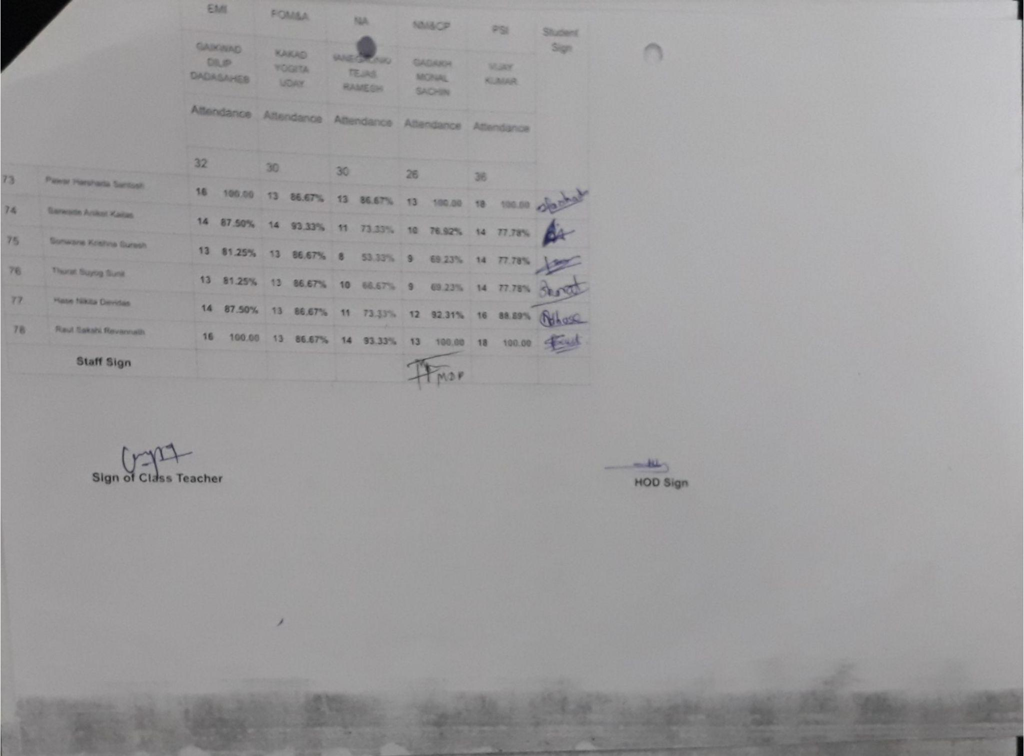

Sample of syllabus coverage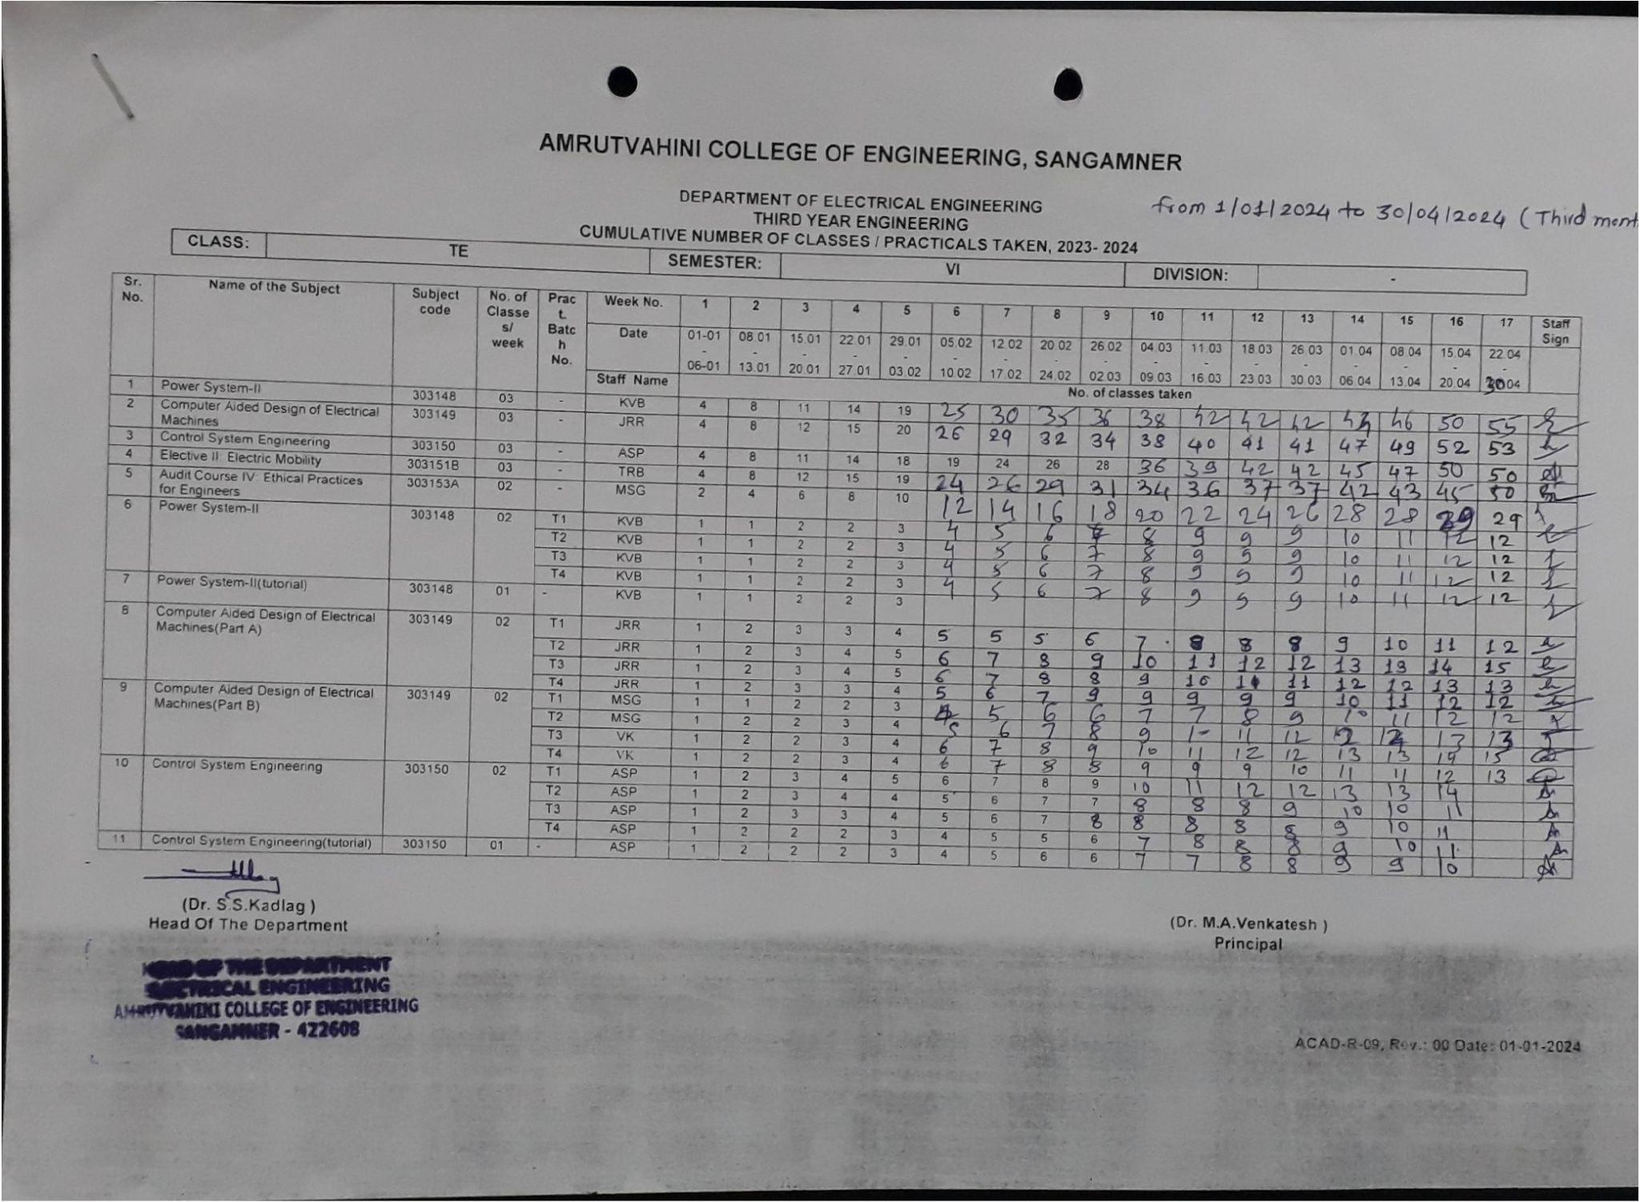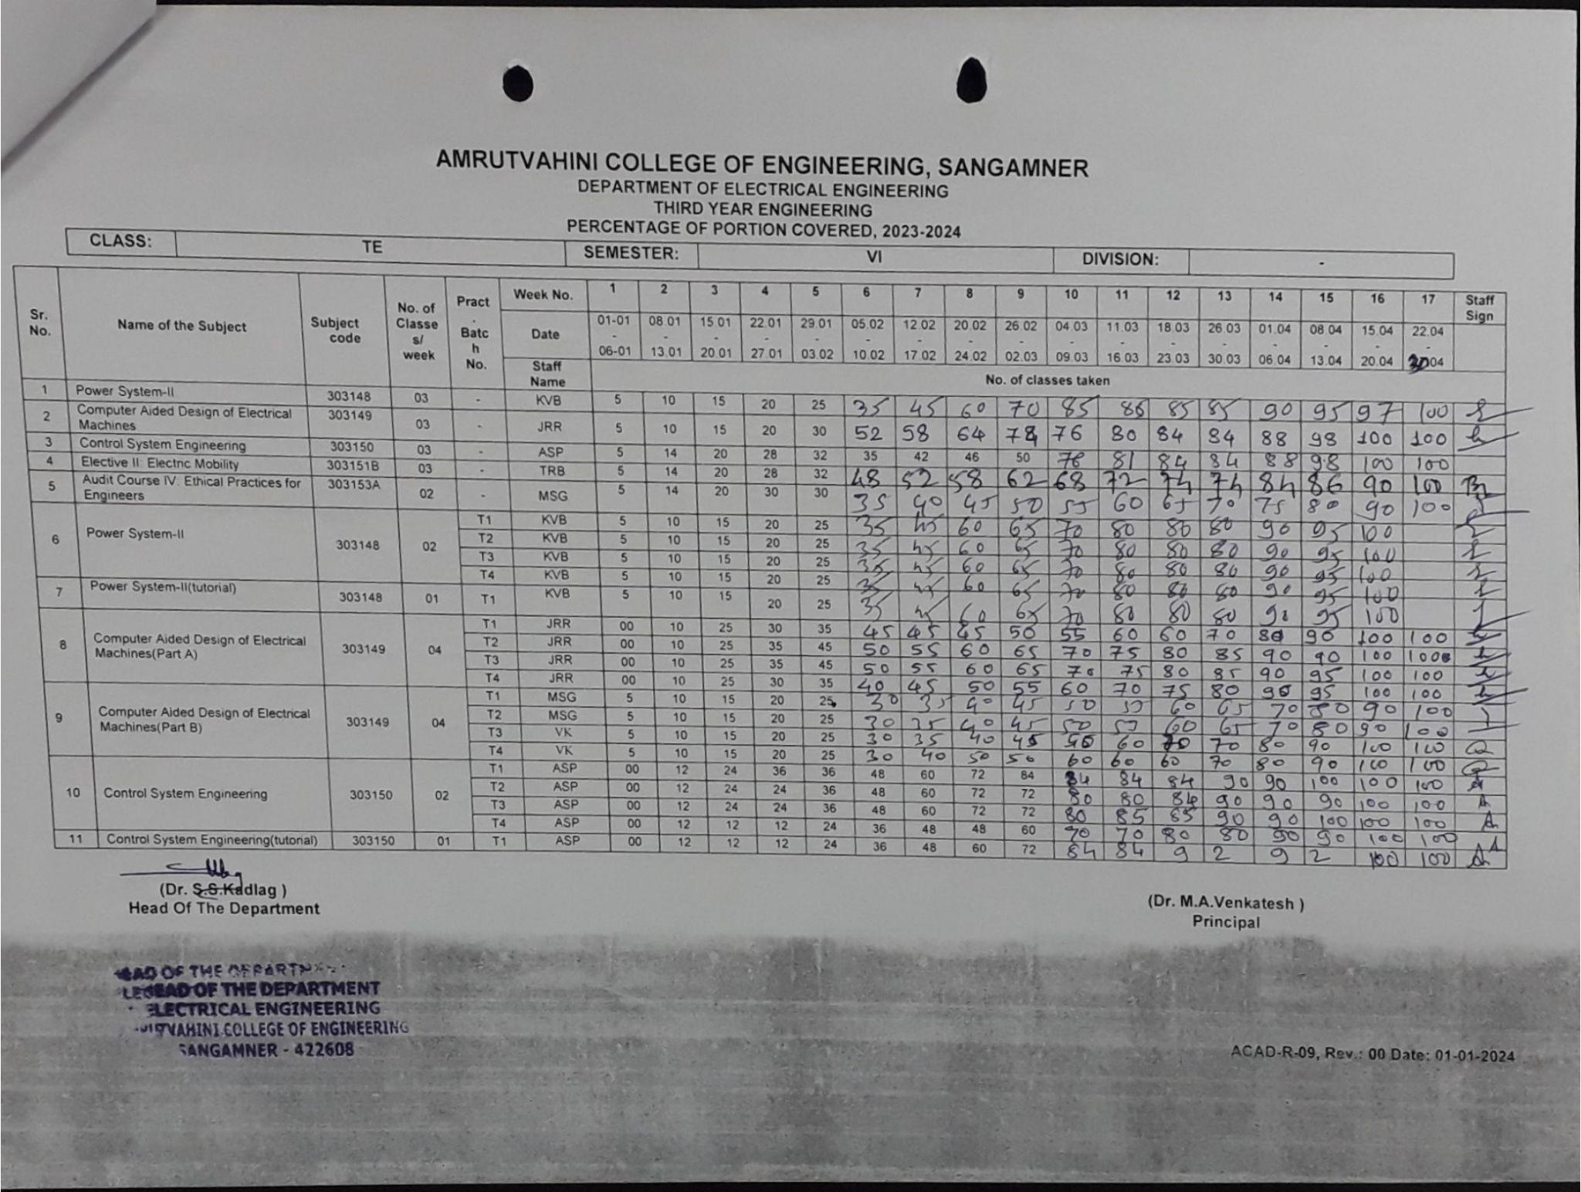

Add-on courses and workshops
Different Training/internship, workshops, value addition courses were conducted by the institute to improve the soft skill, personality skill etc. to make our student ready for corporate world
Workshop sample report:
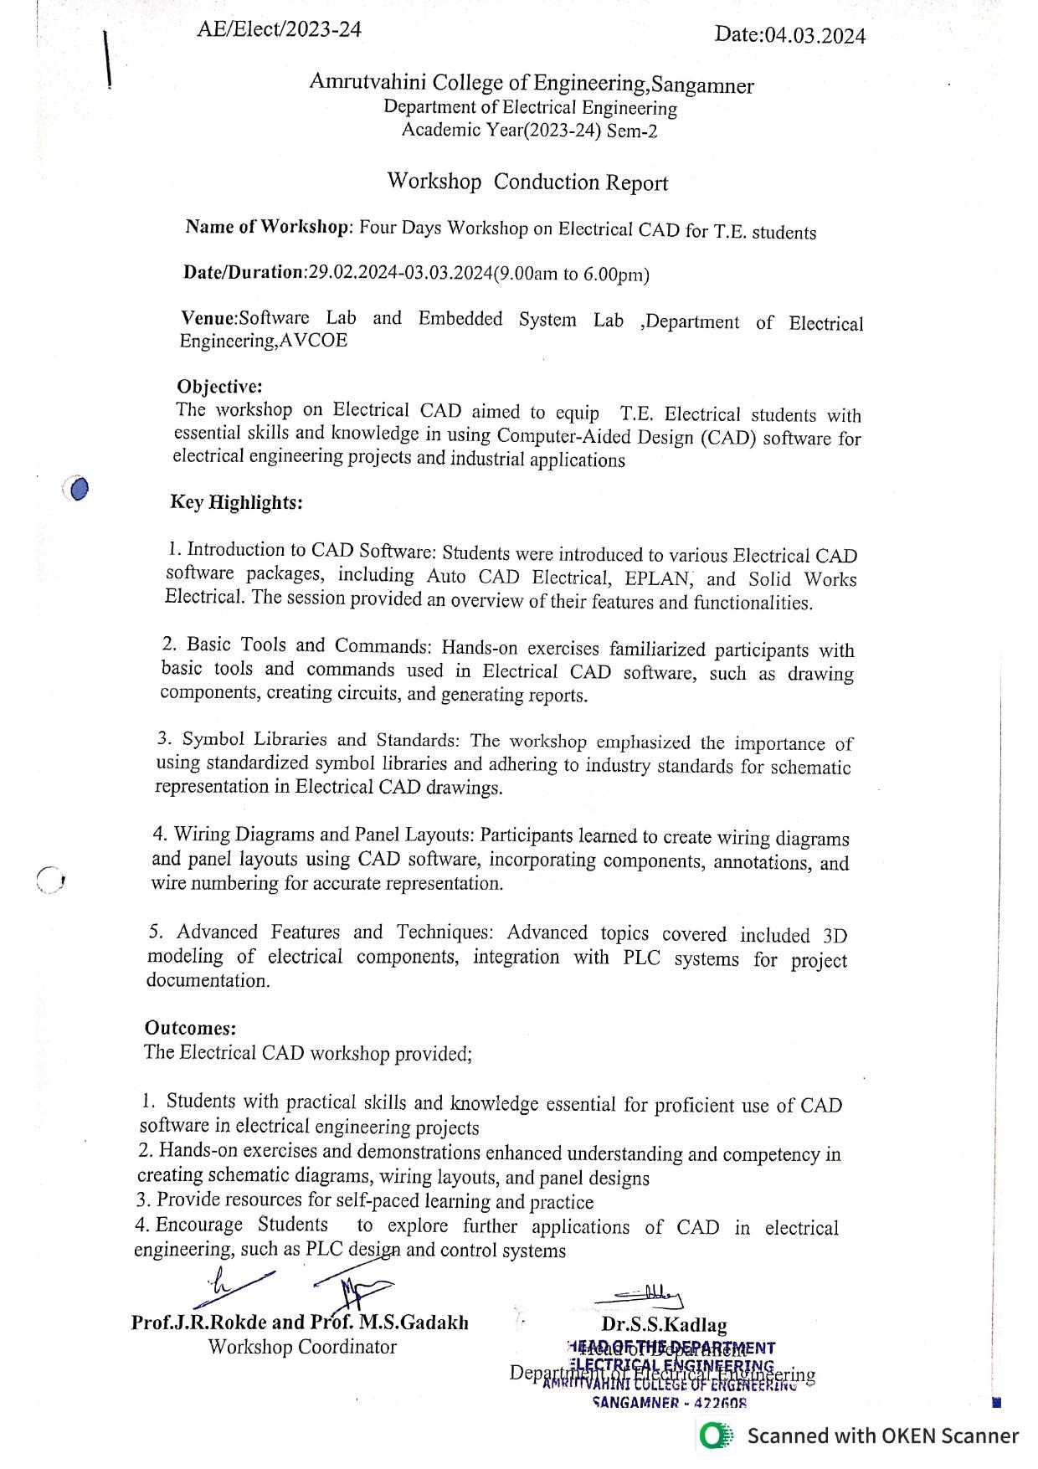

Attendance Report of workshop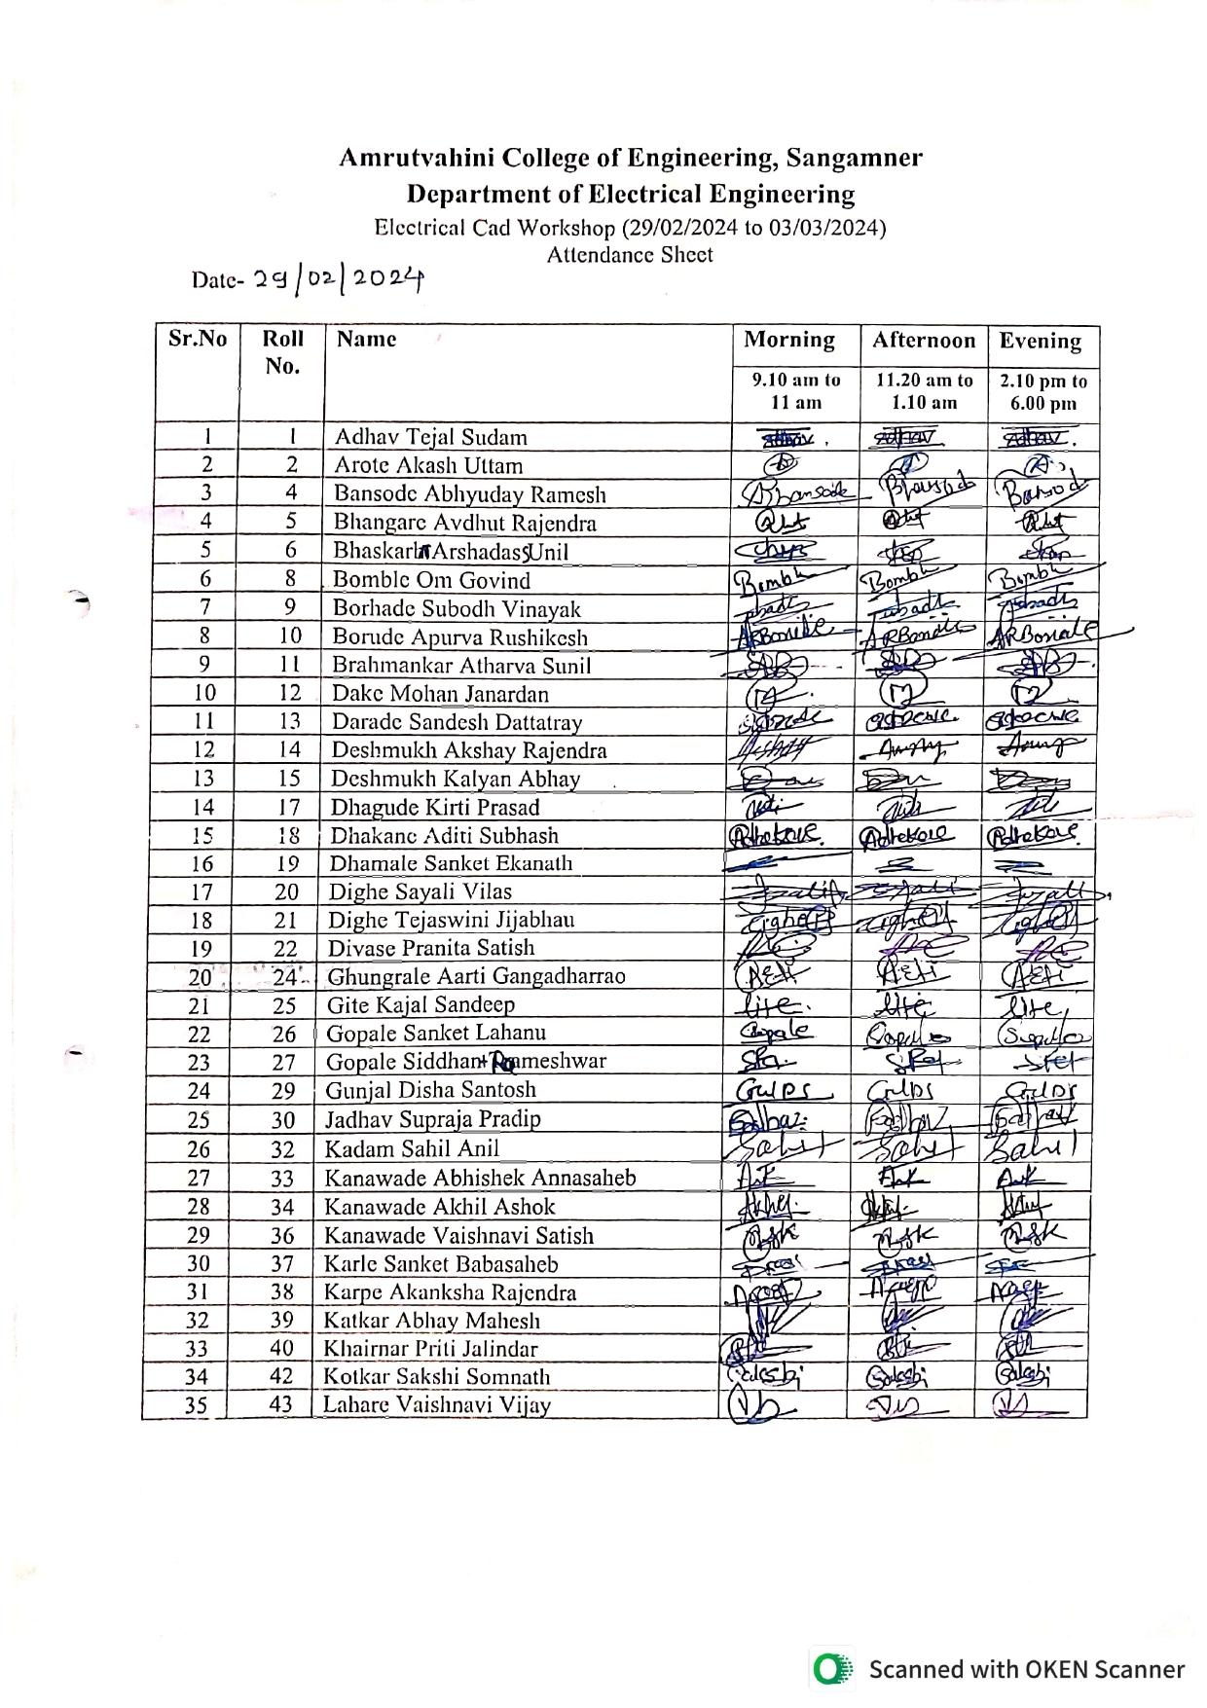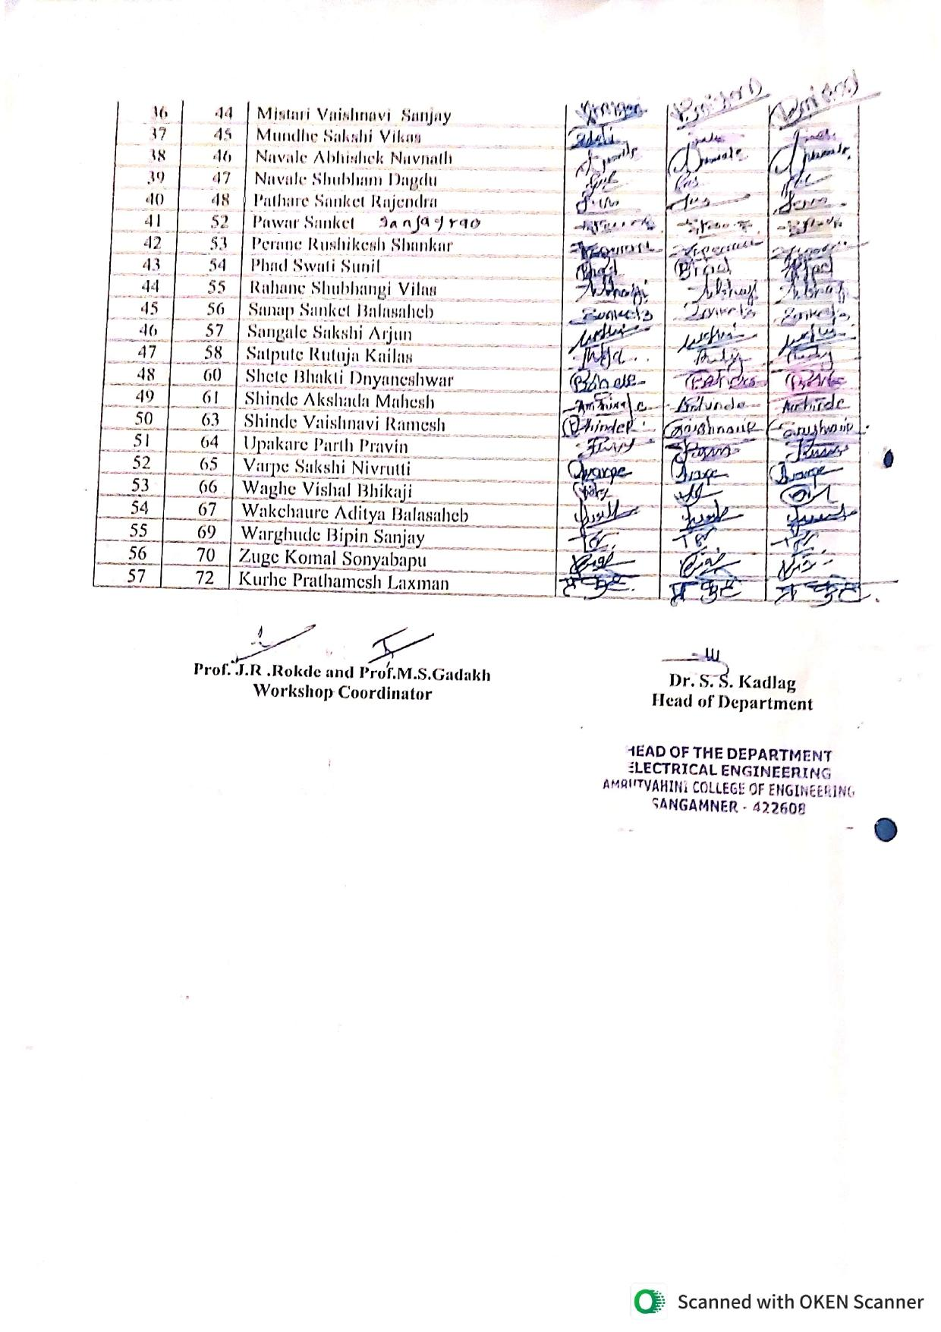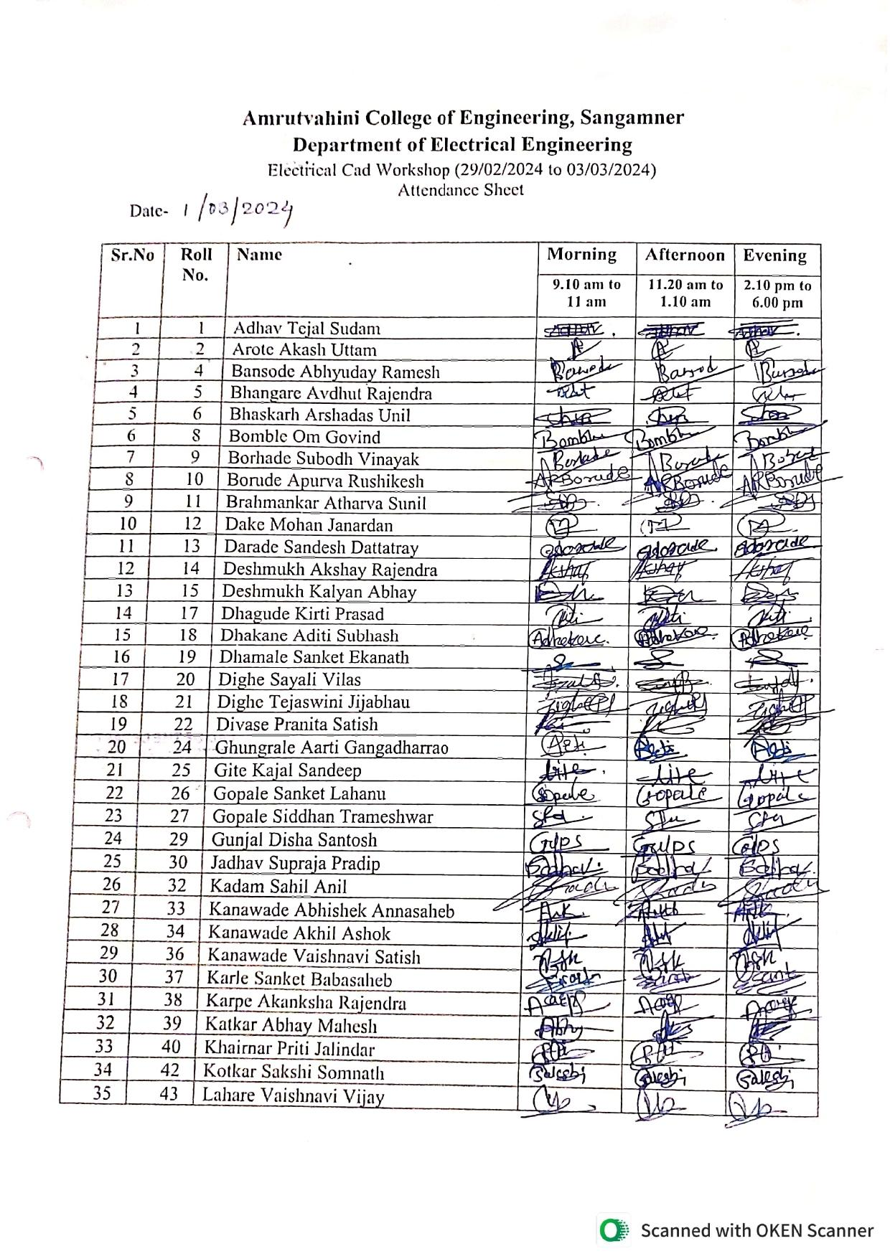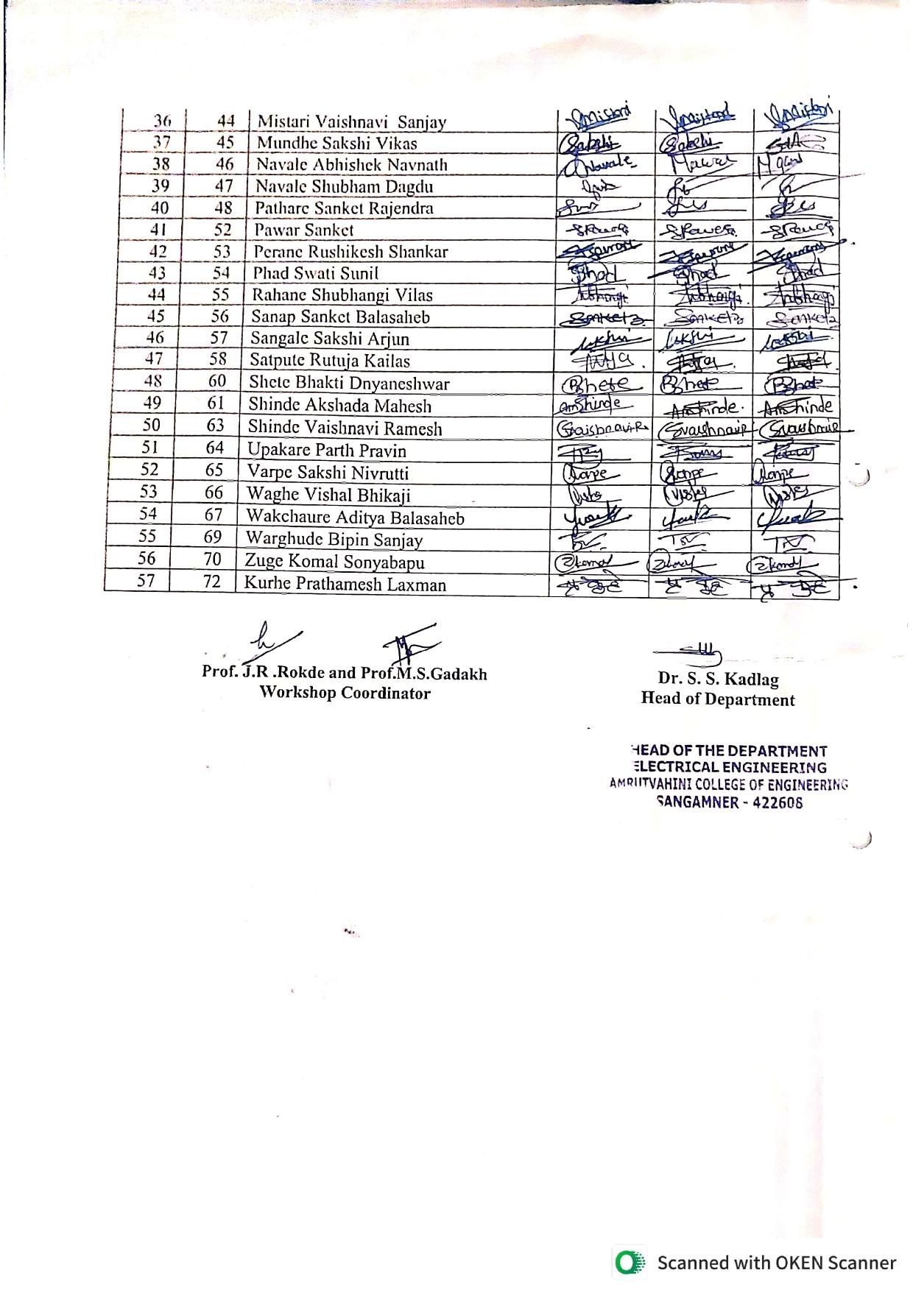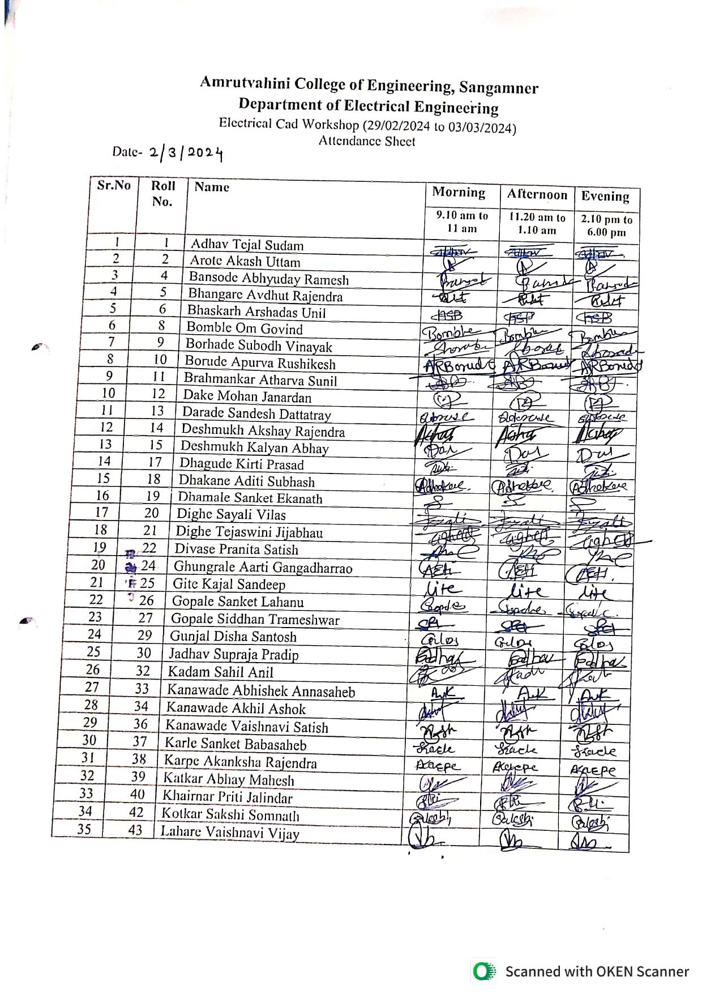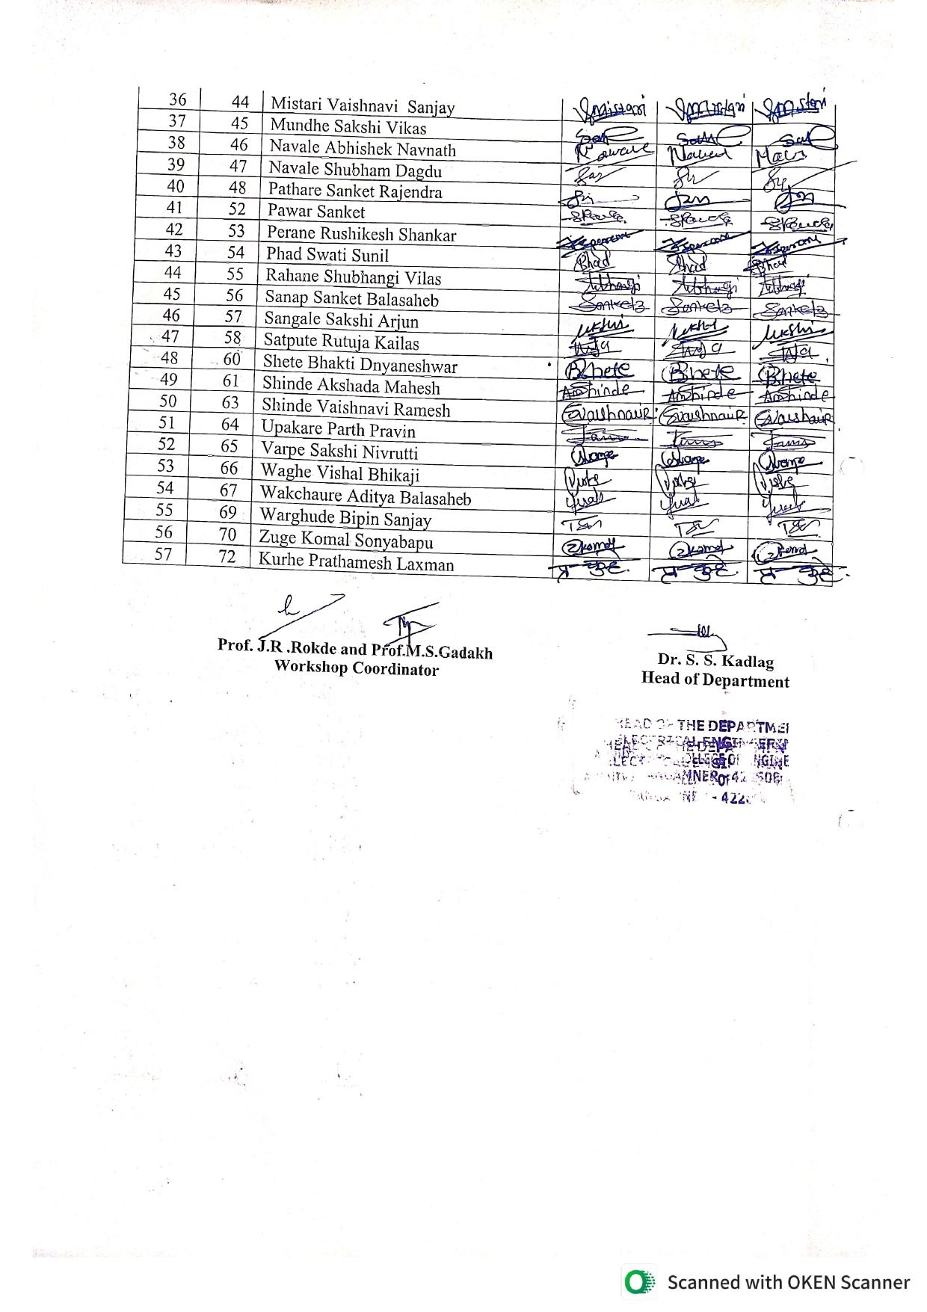

University Examination
At the end of the semester term work submission is taken and university exams are conducted. Term work by internal examiner based on lab index card, oral/practical are evaluated by internal and external examiner appointed by university. Grievances related to examination will be sort out by grievance committee and is explain in criteria 2.
Sample of practical, oral marks-

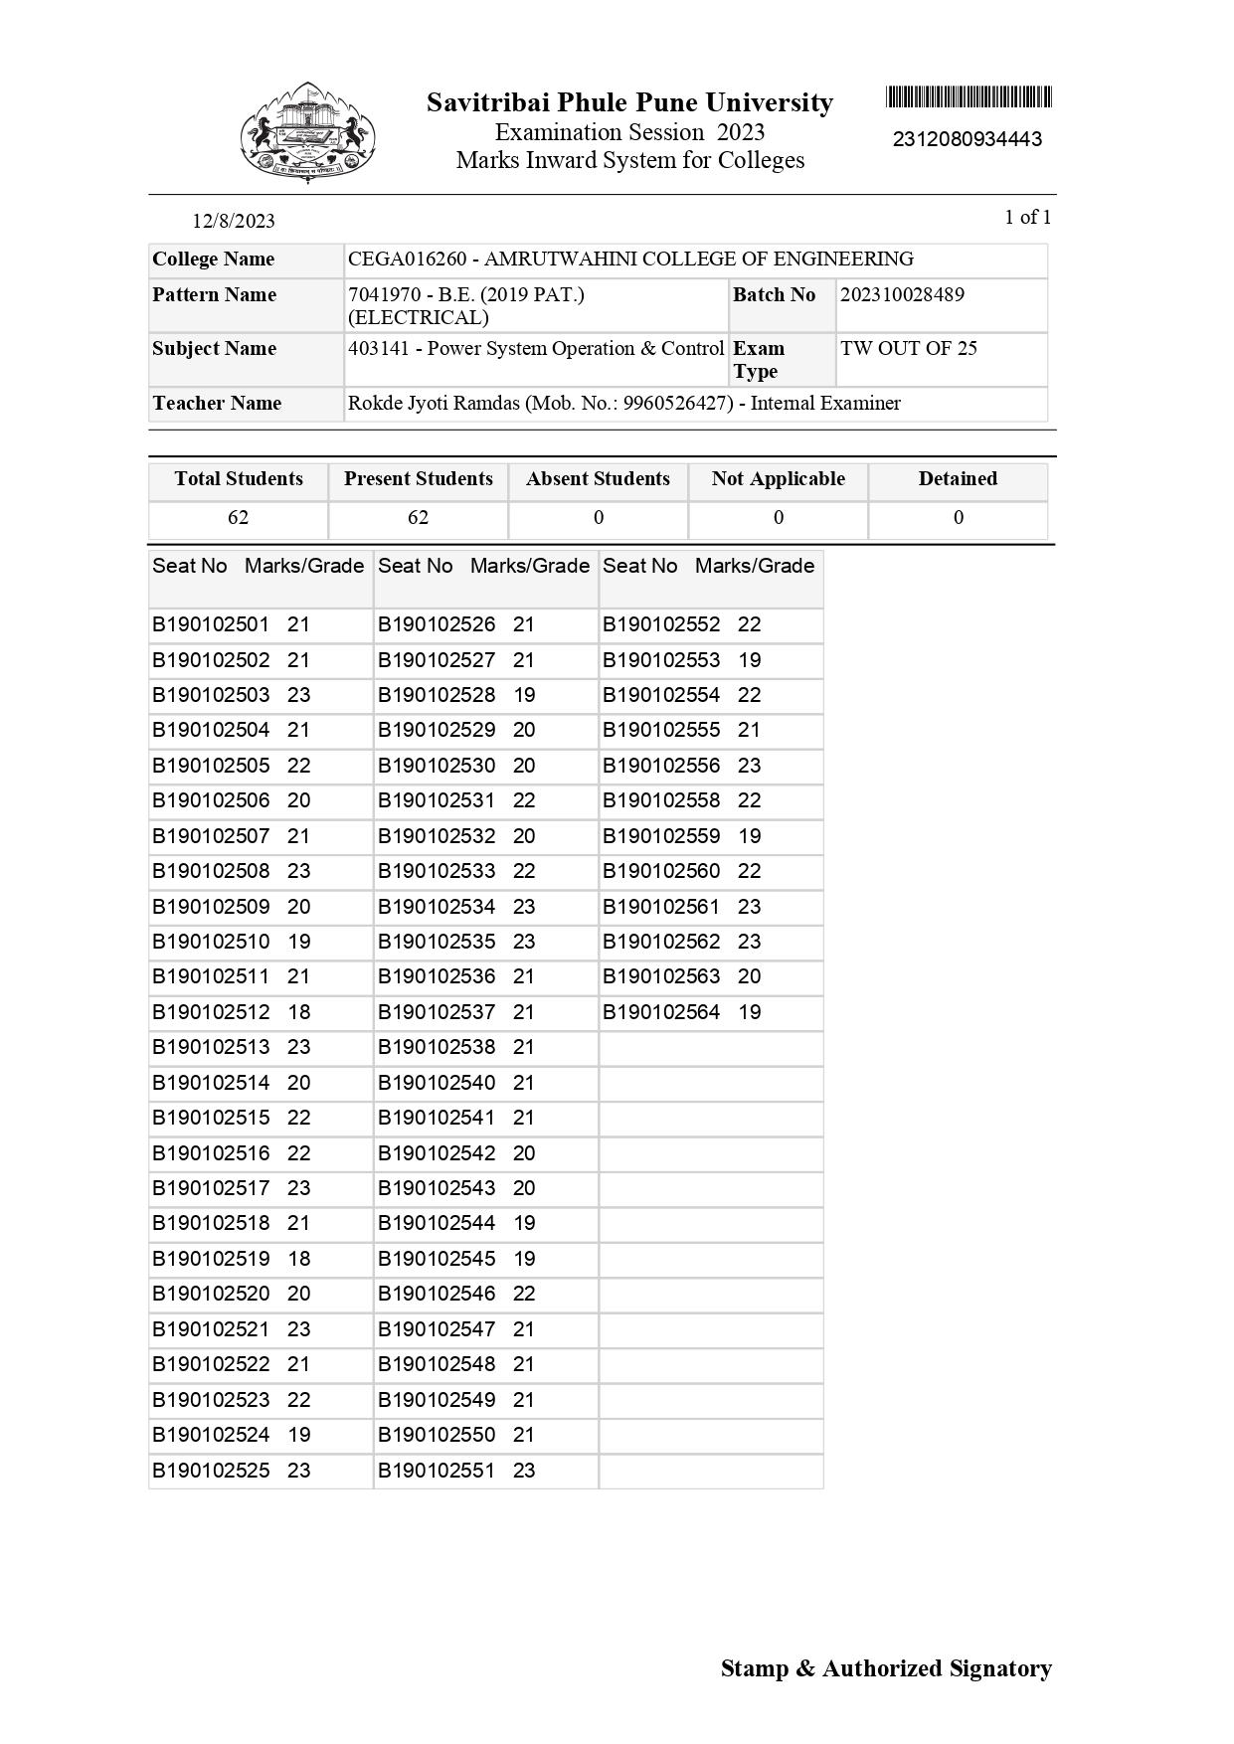
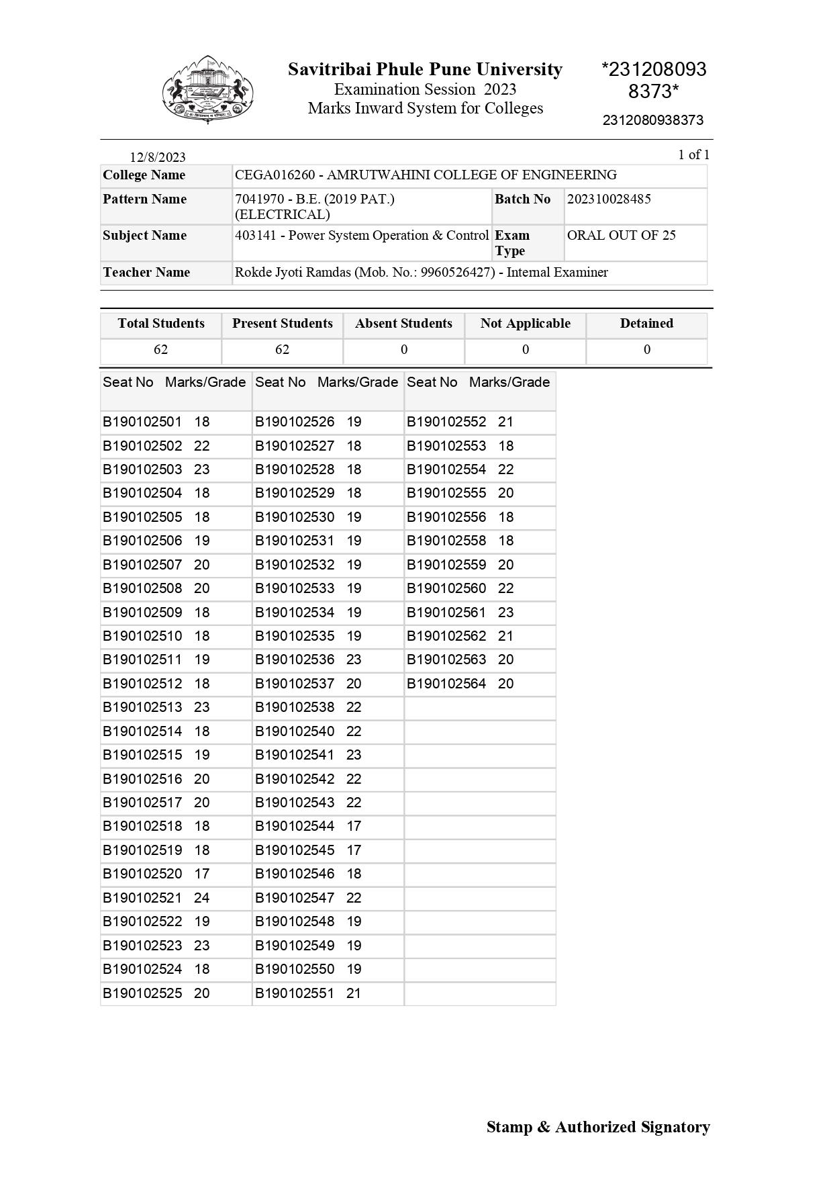

Result Analysis-
After exam analysis of result is done for further corrective action.
Sample of record- 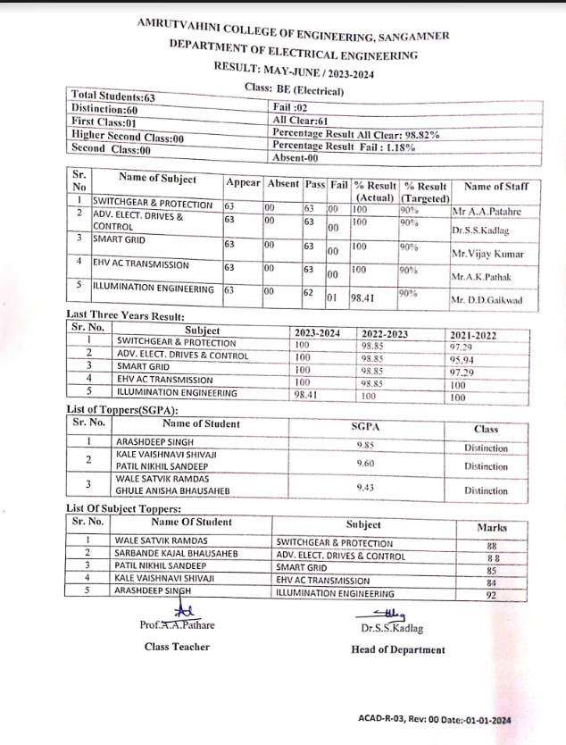

Next Semester Preparation
The maintenance of Laboratory equipment and other resources were carried out to make them in working condition. Material and consumables are purchased and all is set well for coming semester.
Workshop/ FDP/STTP were attended for update the knowledge to current scenario.
Subject/Load distribution.

