7.3 Institutional Distinctiveness

Best Principal Award: Dr. M. A. Venkatesh was honored with the Best Principal Award during the academic year 2021-22 by Savitribai Phule Pune University, Pune. Under his leadership, several innovative practices have been introduced at the institute, including Amrut-Expo, the Amrut Meritorious Scholarship, the Buddy Scheme, Learning Practice initiatives, the FE Conclave powered by senior alumni, Industrial Interaction by faculty, and access to the library and e-resources for all students.
Bhishmacharya Award: Principal Dr. M. A. Venkatesh was selected fod for Bharat Education Excellence Award under the Bhishmacharya Award during the academic year 2023-24 at Vishakhapatanam.
The faculty and staff, under the guidance of Dr. M.A Venkatesh, have achieved numerous milestones, contributing to the institute's growing reputation. Some key accomplishments are highlighted below:
- The institute holds permanent affiliation with Savitribai Phule Pune University, Pune.
- It has been accredited four times by the National Board of Accreditation (NBA), New Delhi, and has received an 'A+' grade from NAAC.
- The institute has earned ISO 9001:2015 International Academic Accreditation from TUV SUD.
- The 15.6-acre campus is enriched with lush greenery, with more being added each year.
- The institute provides 100% placement assistance to students through value-added courses, foreign language training (Japanese and German), and specialized coaching.
- It boasts a state-of-the-art IT center equipped with 500 Mbps Wi-Fi internet connectivity.
- Channakya Computer Lab with sate of the art Computers exclusively for First Year Engineering.
- The institute is committed to delivering excellence-driven engineering education, shaping future engineers and entrepreneurs.
- A total of 55 companies visited the institute for campus recruitment, In the academic year 2023-24, the institute achieved 676 campus placements.
- The Career Development Cell (CDC) offers various programs, including company-specific and general training, as well as guidance for competitive exams.
- Institution has state of art Japanees learning centre “Sakura” equipped with japanease language training materials like books, smart Tv with online platforms etc. The Japanese culture is created with Japanese materials.
- Uptil now 1200 students avail the benefit of Japanese training and 22 alumni are working in Japan.
- The institute has green campus with ecofriendly and clean environment.
- 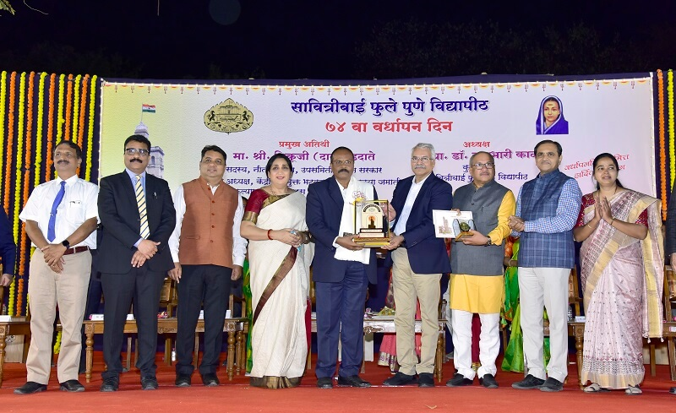
The Vice Chancellor awarding Dr.M.A.Venkatesh, Principal, Amrutvahini College of Engineering, Sangamner with Best Principal Award At SPPU, Pune.
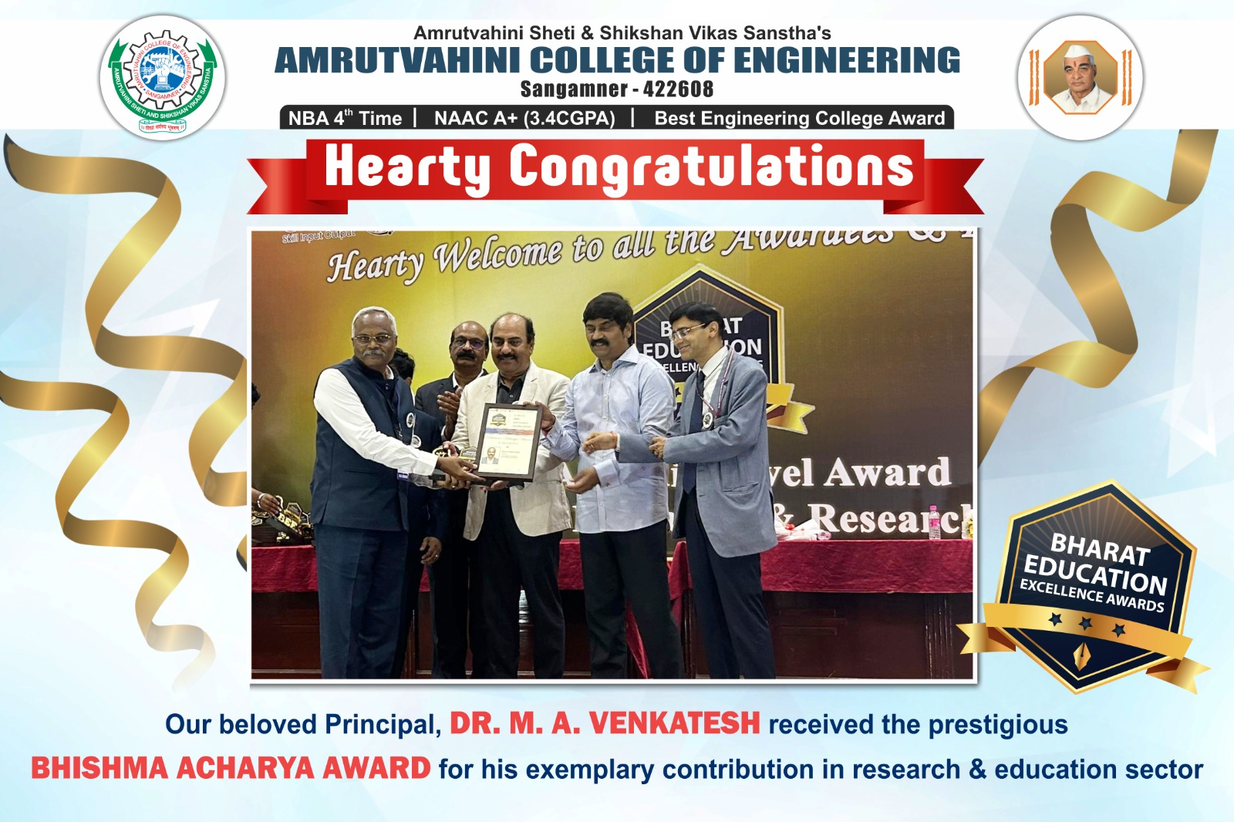
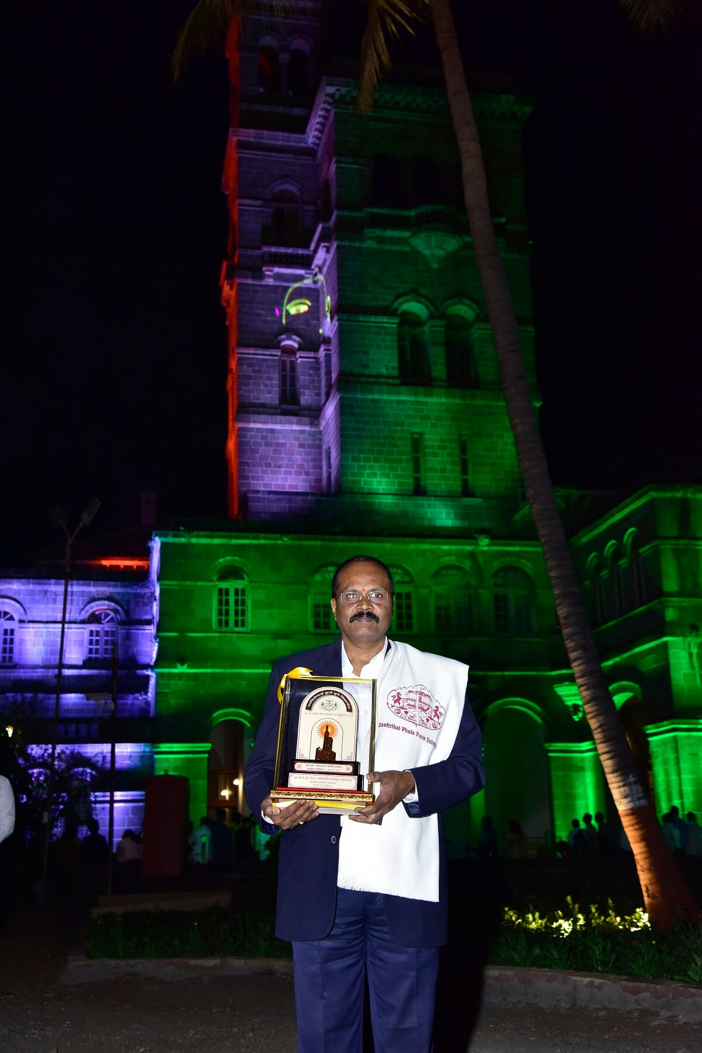
Dr.M.A.Venkatesh with Award at Main Building of Savitribai Phule Pune University, Pune

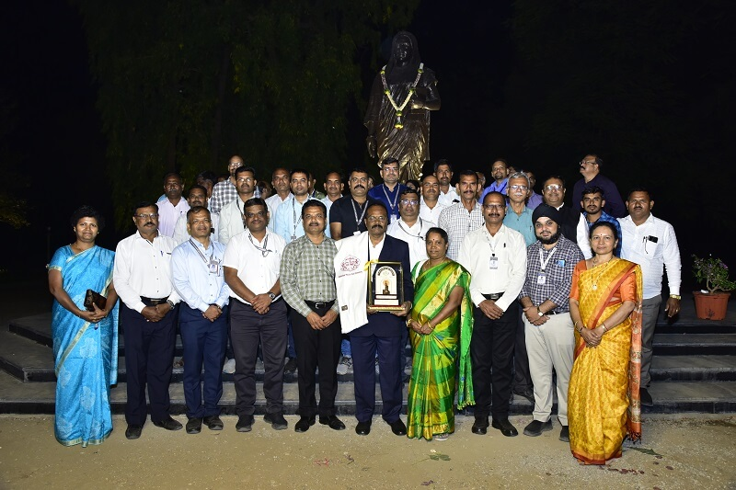
The Principal with all Heads of the Department, Section In charges and staff representatives.
