Best Practice 2 : Amrut-Expo: Providing platform to UG students to present their Project in front of industry persons and Junior college/School students

AmrutExpo-Project Exhibition held on 19/01/2024 and 20/01/2024. The exhibition provided platform for final year UG students to present their projects. The First Year to third year UG students along with 12th science students of nearby junior colleges were present in this exhibition. The projects evaluation done by industry experts of individual branch.
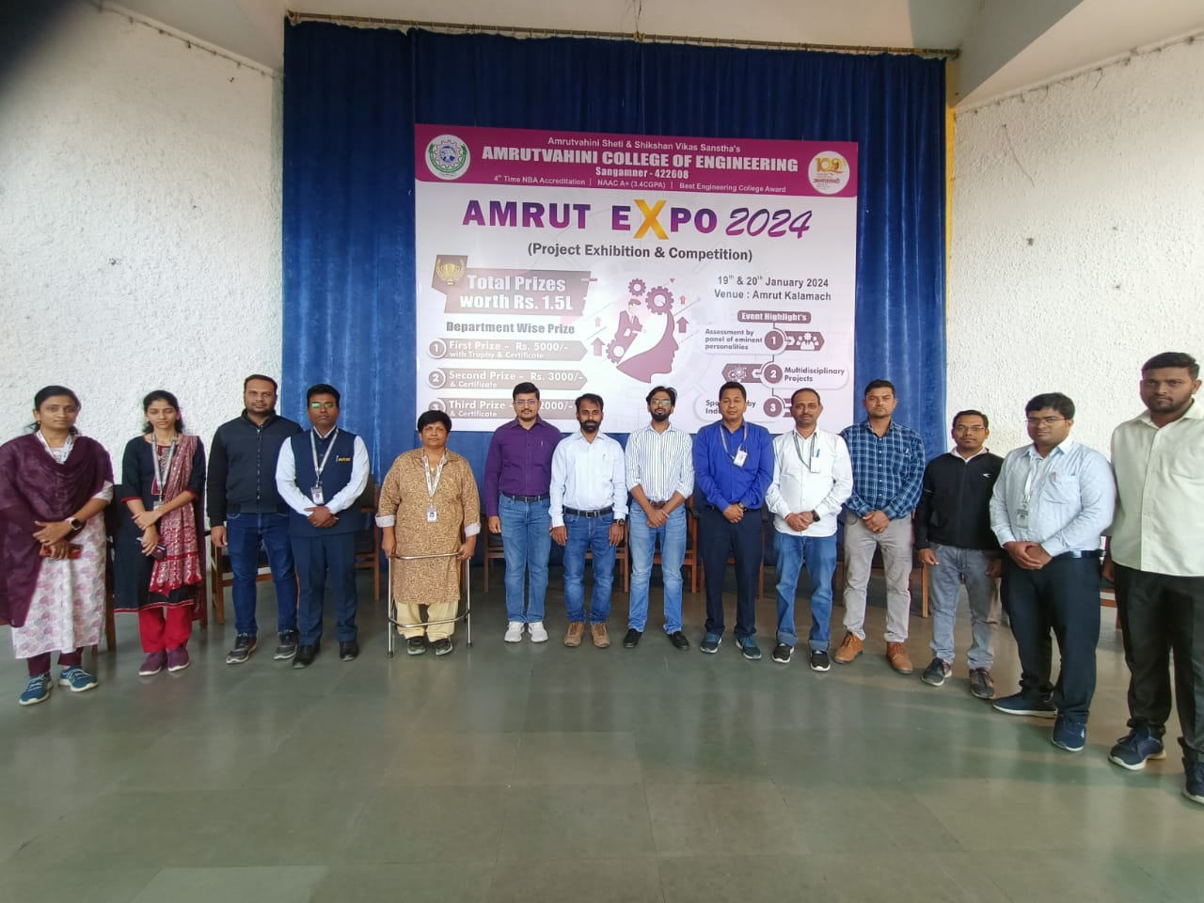
Amrut-Expo Inaugration
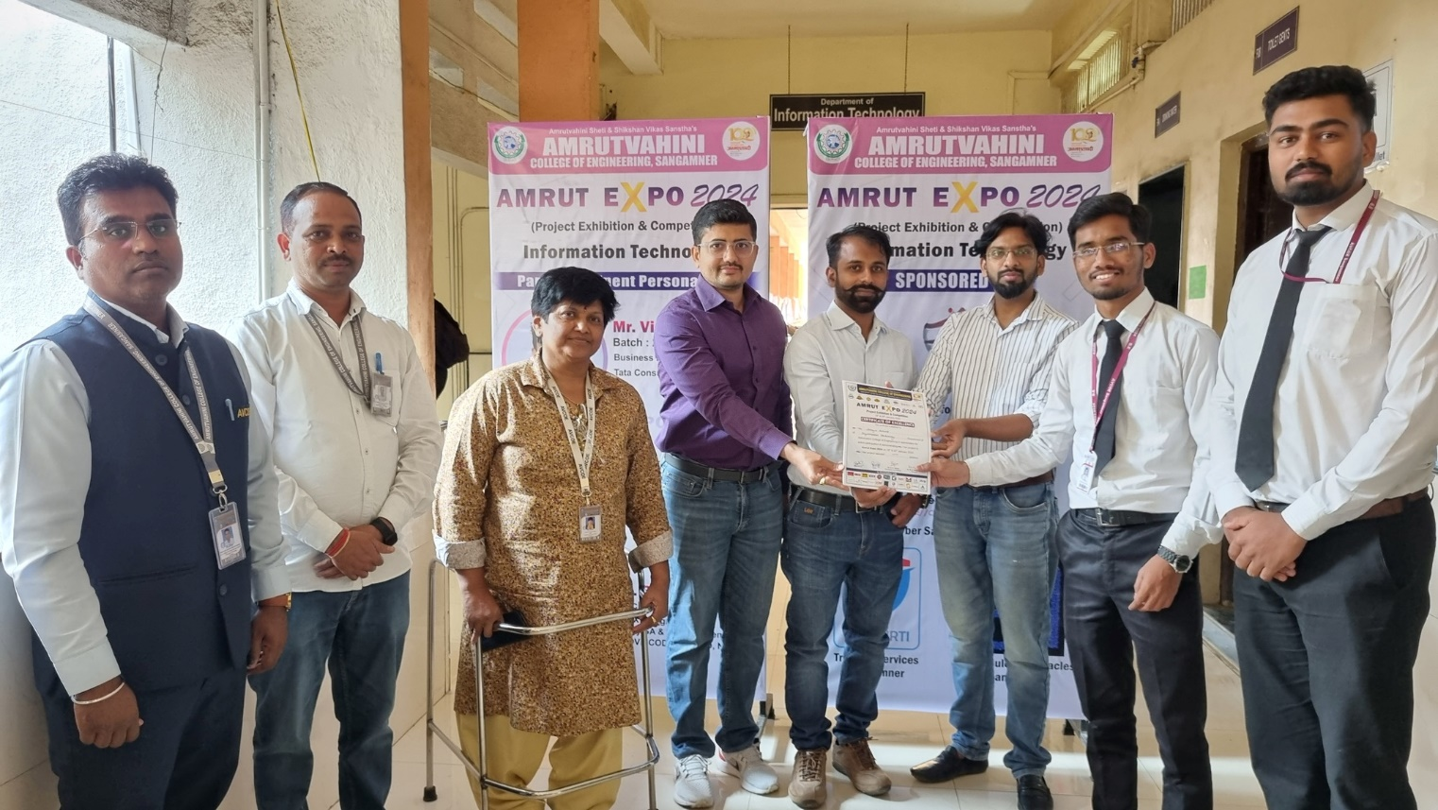
Dignities are visiting the project Expo.

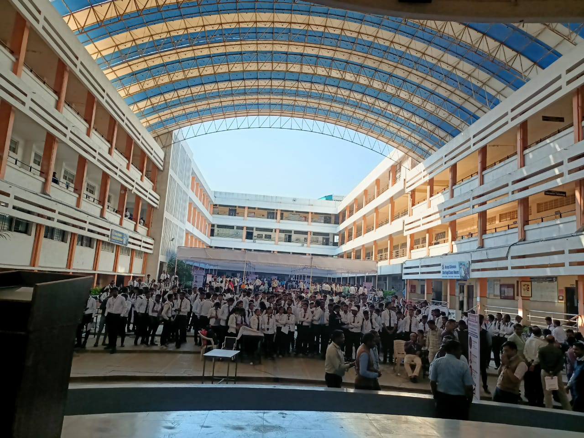
Students are visiting Project Expo.

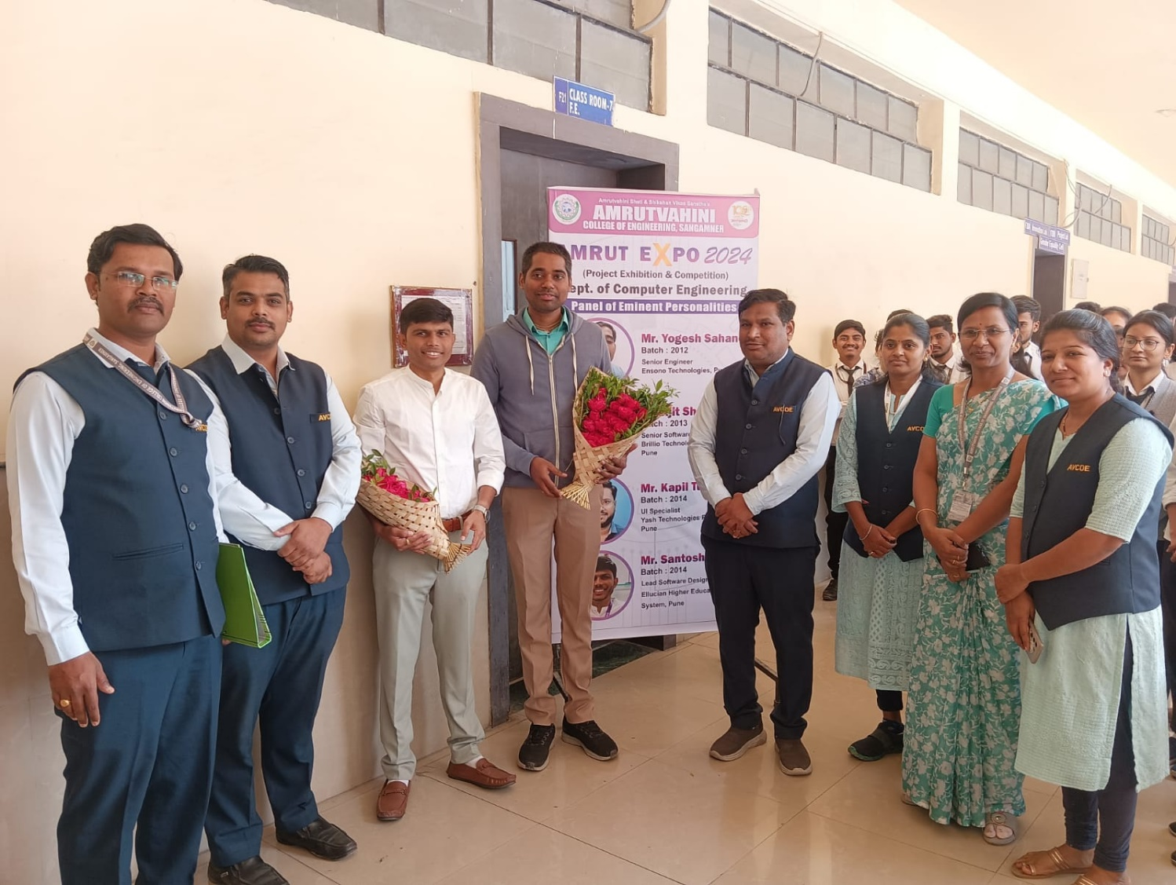
Amrut-Expo Inauguration at Department level.
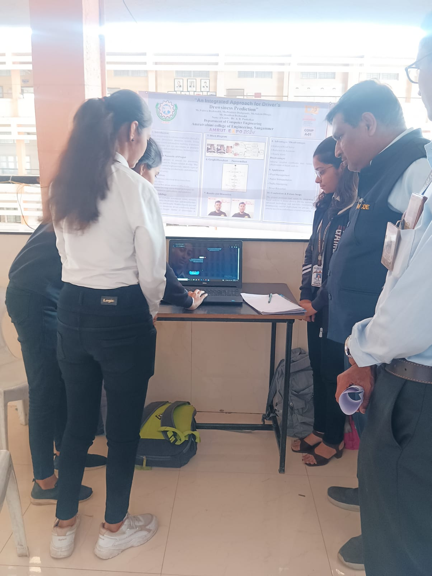
Dignities are visiting the project Expo.

