7.1.9 : Sensitization of students and employees of the Institution to the constitutional obligations: values, rights, duties and responsibilities of citizens
INDEX
Sr.No. | Perticulars | Page No.
1  1.1 | Activity for values:  Program on Ethics for Engineers | 2
1.2 | Program on Ethics and Values for Engineers by NSS Unit | 3
2  2.1 | Activity for duties and Responsibilty  Students Participated in IEEE COPE Donation program | 4
2.2 | Students participated in Azadi ka Amritmahotsav | 5

Activity for values:
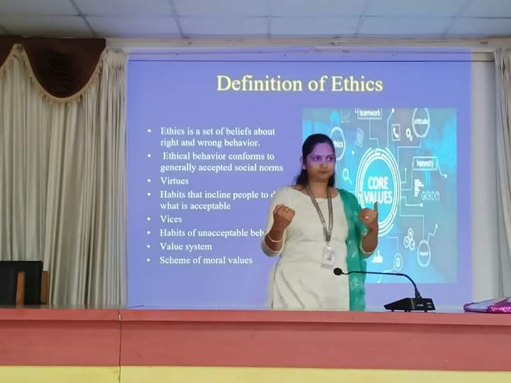

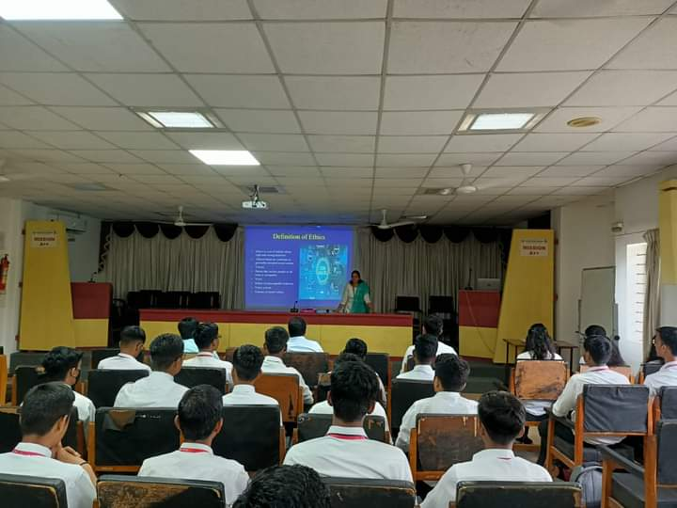Program on Ethics for Engineers
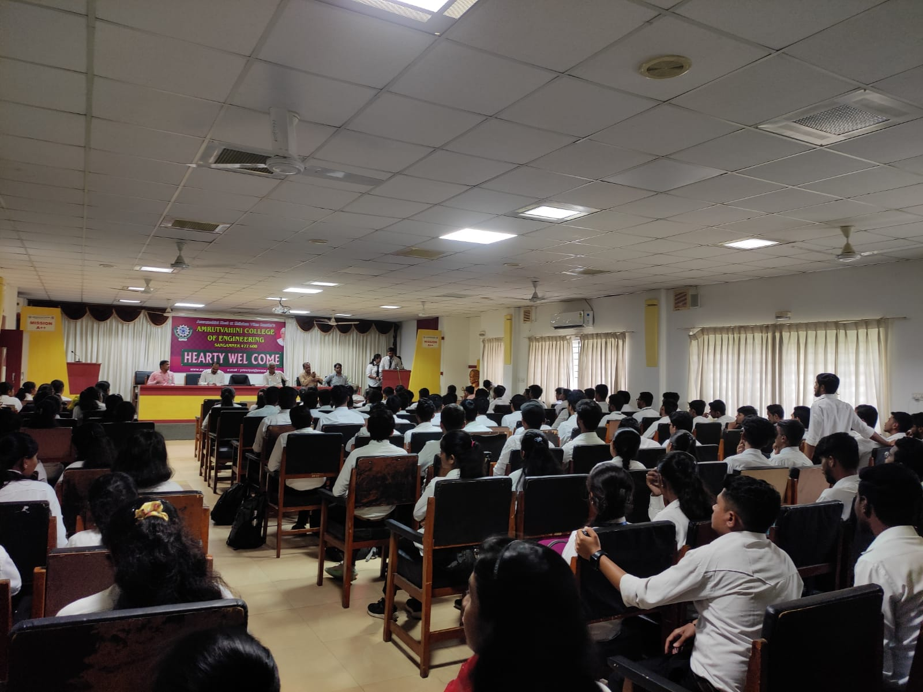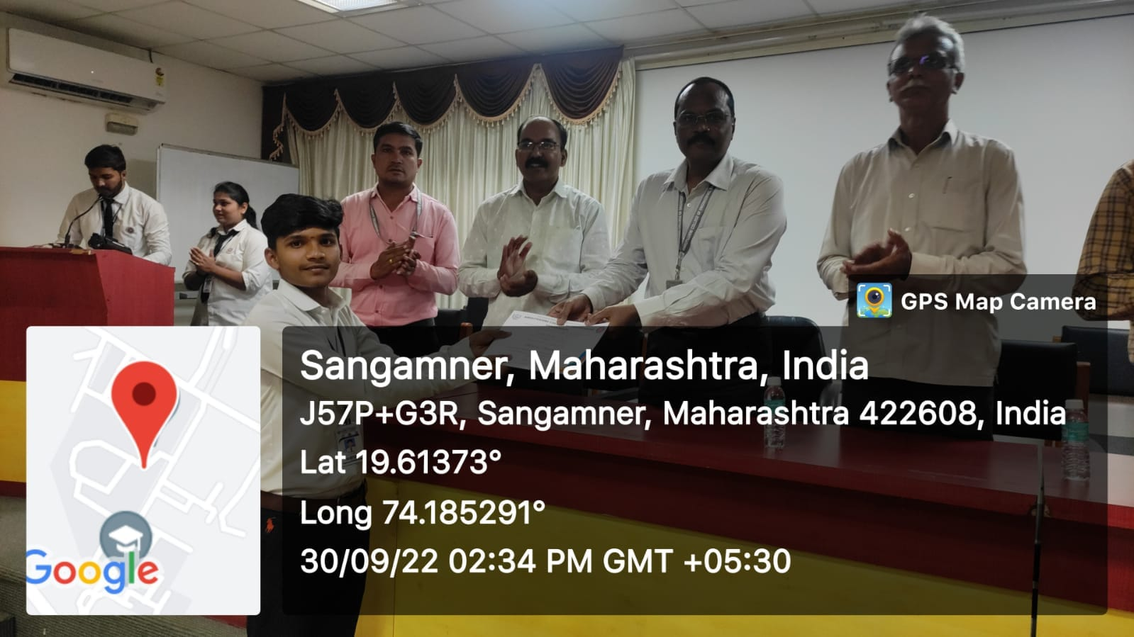
Program on Ethics and Values for Engineers by NSS AVCOE

Activities for and responsibilities of citizens:
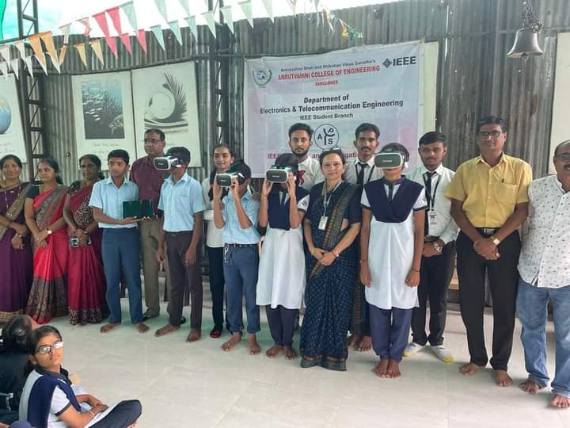
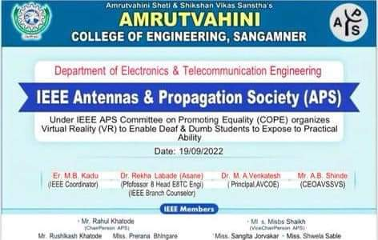
Students Participated in IEEE COPE Donation program

Azadi ka Amrut Mahotsav at 12 August 2022

