7.1.7 The Institution has disabled-friendly, barrier free environment
Assistive technology and facilities for persons with disabilities: Wheel Chair is provided near the door.
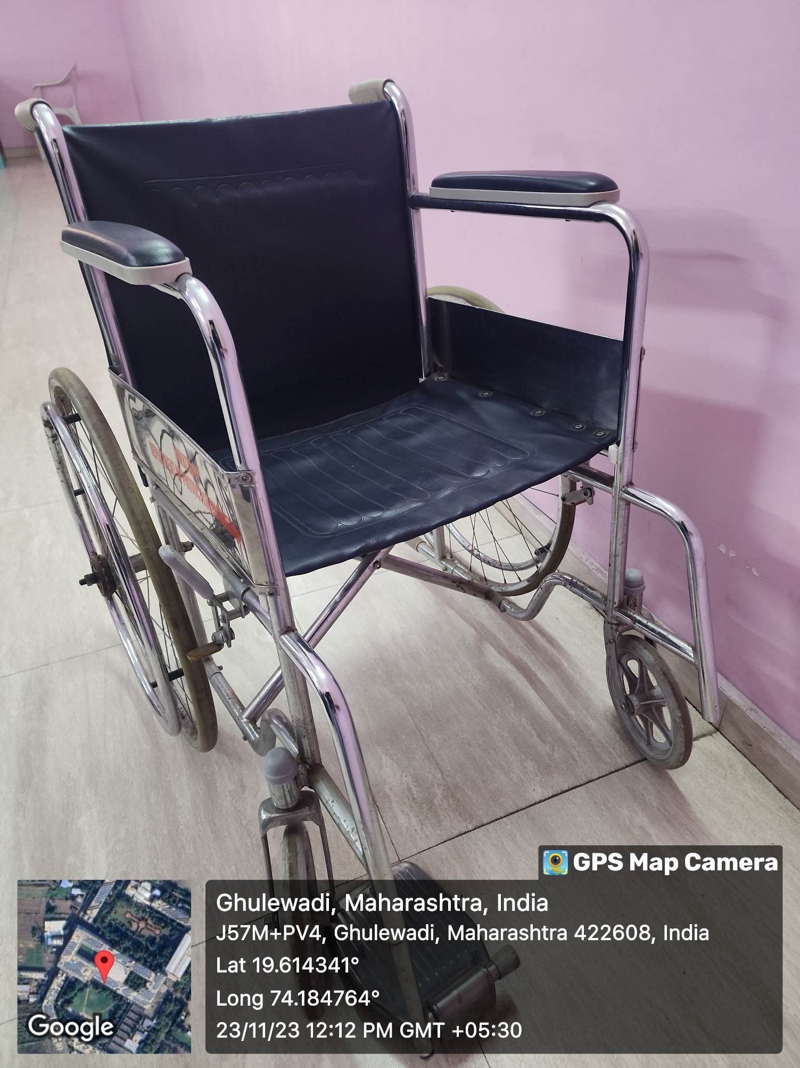

Physically disabled persons are allowd to park vehicles near main building.

