7.1.7 The Institution has disabled-friendly, barrier free environment
3. Signage including tactile path, lights, display boards and signposts.
The following facilities are available for physically disabled peoples.
Sr.No. | Facility | Remark
 | Lift | 1 no.
 | Ramp | 2 nos.
 | Railing | all strategic Location
 | Rest Rooms | 2 Nos.
 | Separate Seating arrangement. | Each class room.
 | Parking | Permission to park vehicles at Main academic building
 | Wash Rooms | Special arrangements / Aid in Wash rooms.
1. Signage
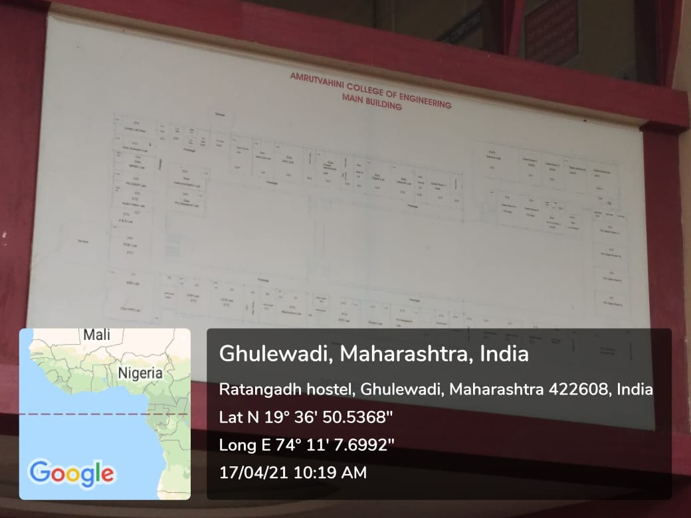
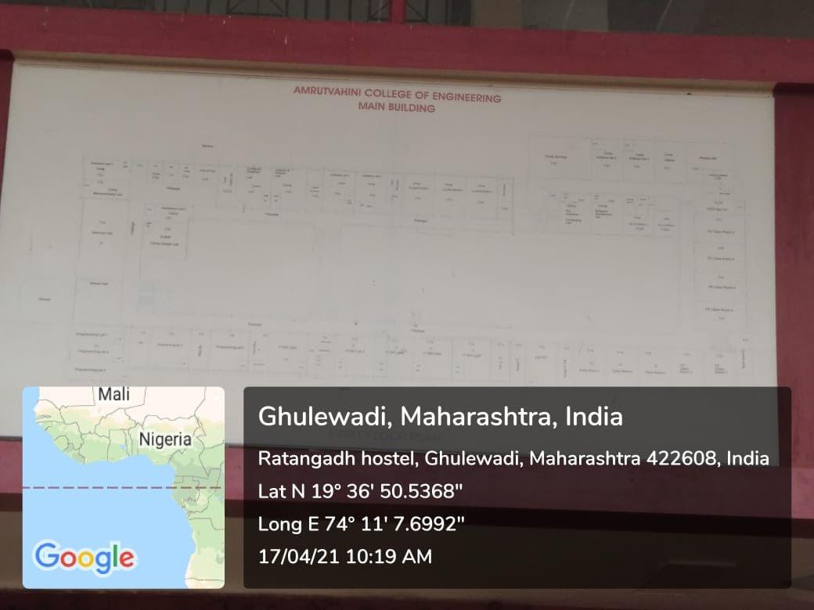
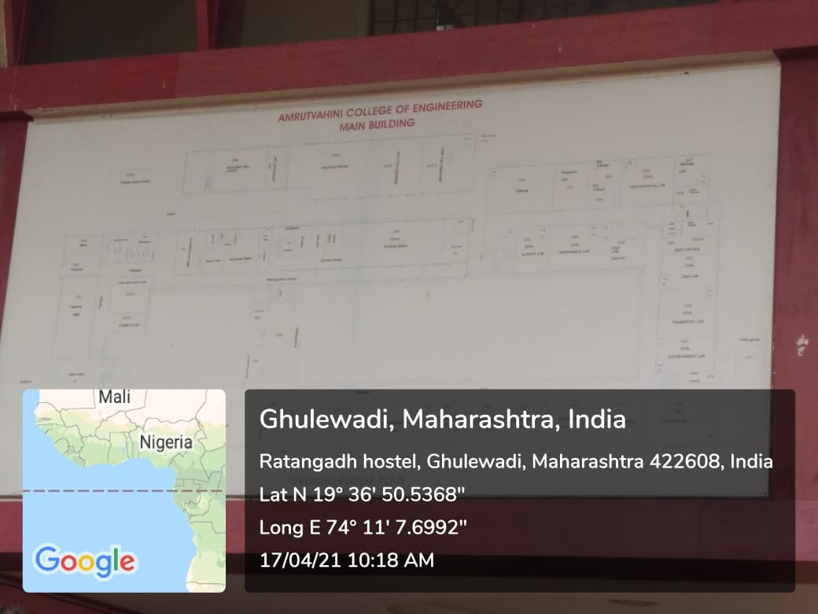
2. Tactile path:
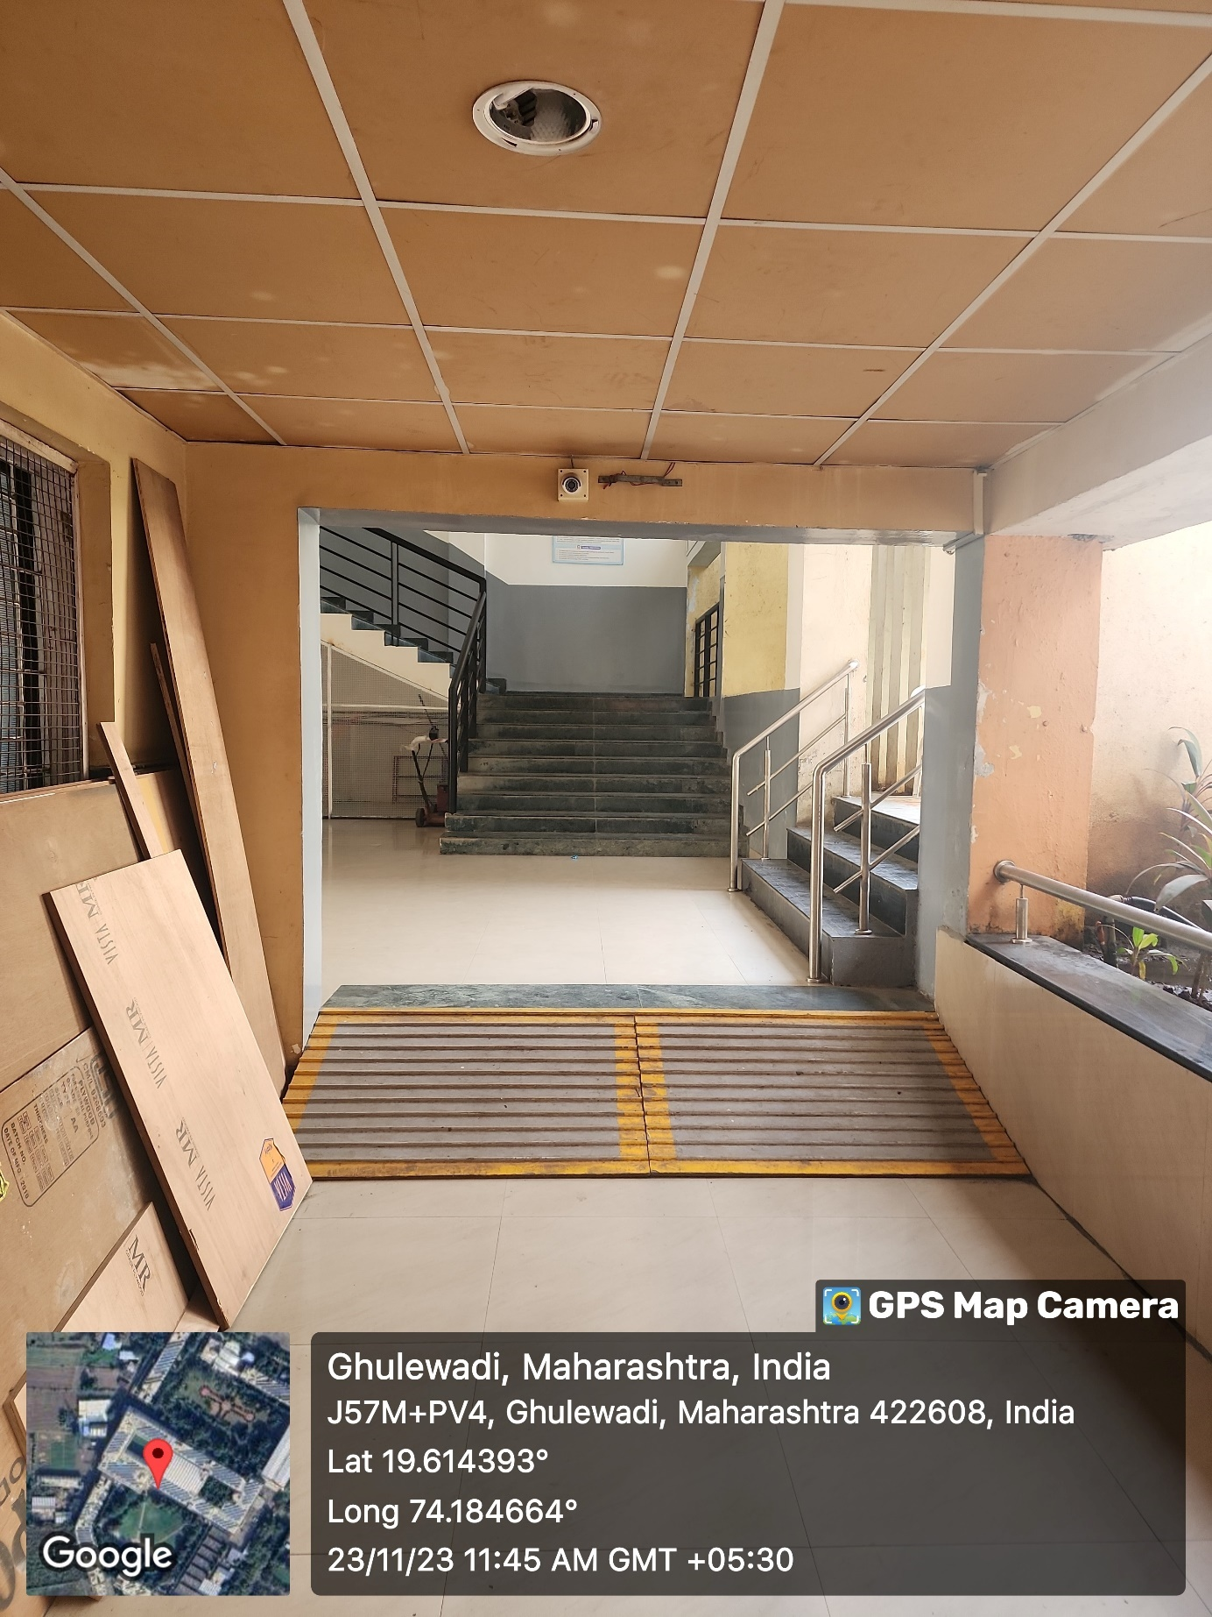

3. Display boards and signposts
