7.1.6: Quality audits on environment and energy are regularly undertaken by the institution

Clean and green campus recognitions/awards

INDEX

Sr.No. | Perticulars | Page No.
 | Clean Campus Award-2017 by AICTE, New Delhi held at COEP, Pune. | 2
 | National level Clean and Smart Campus Awards-2019 by AICTE, New Delhi. | 3
 | 12th State level award for excellence in energy conservation and management by MEDA 2018, Government of Maharashtra. | 4
 | Maharashtra Green Army certificate by Government of Maharashtra | 5
 | Energy Efficient Unit Award in 21st National Energy award for excellence in Energy Management 2020 by Confederation of Indian Industry (CII). | 6
 | Recognised as Swachhata Action Plan Institution by Mahatma Gandhi National Council of Rural Education Department of Higher Education, Ministry of Human Resource Development, and Government of India in 2020. | 7

Clean Campus Award-2017 by AICTE, New Delhi held at COEP, Pune.

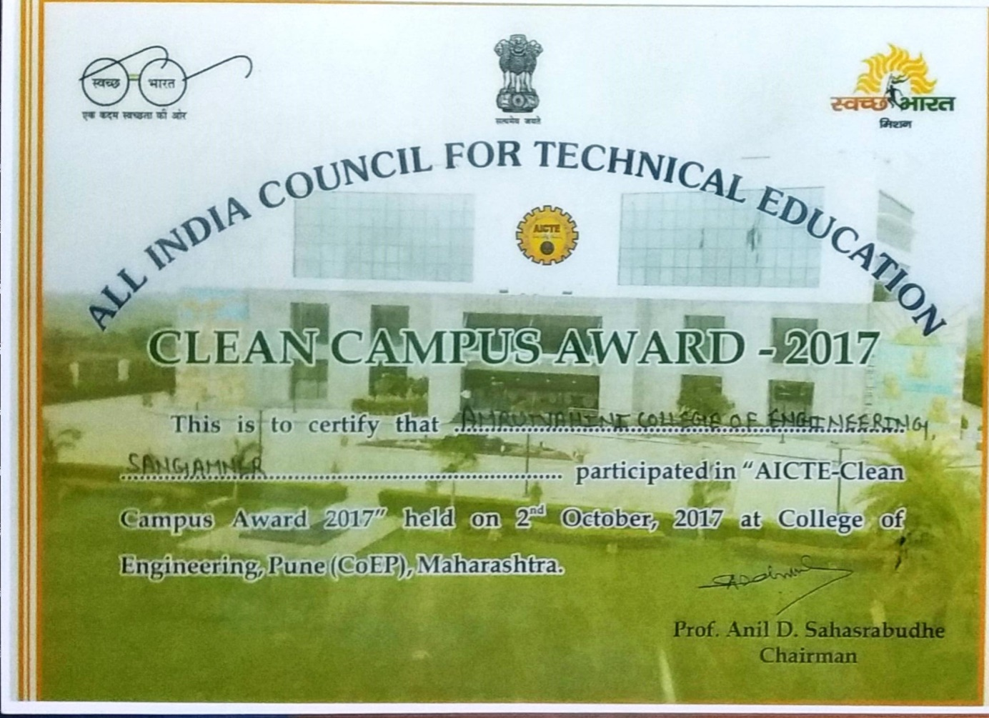

National level Clean and Smart Campus Awards-2019 by AICTE, New Delhi.

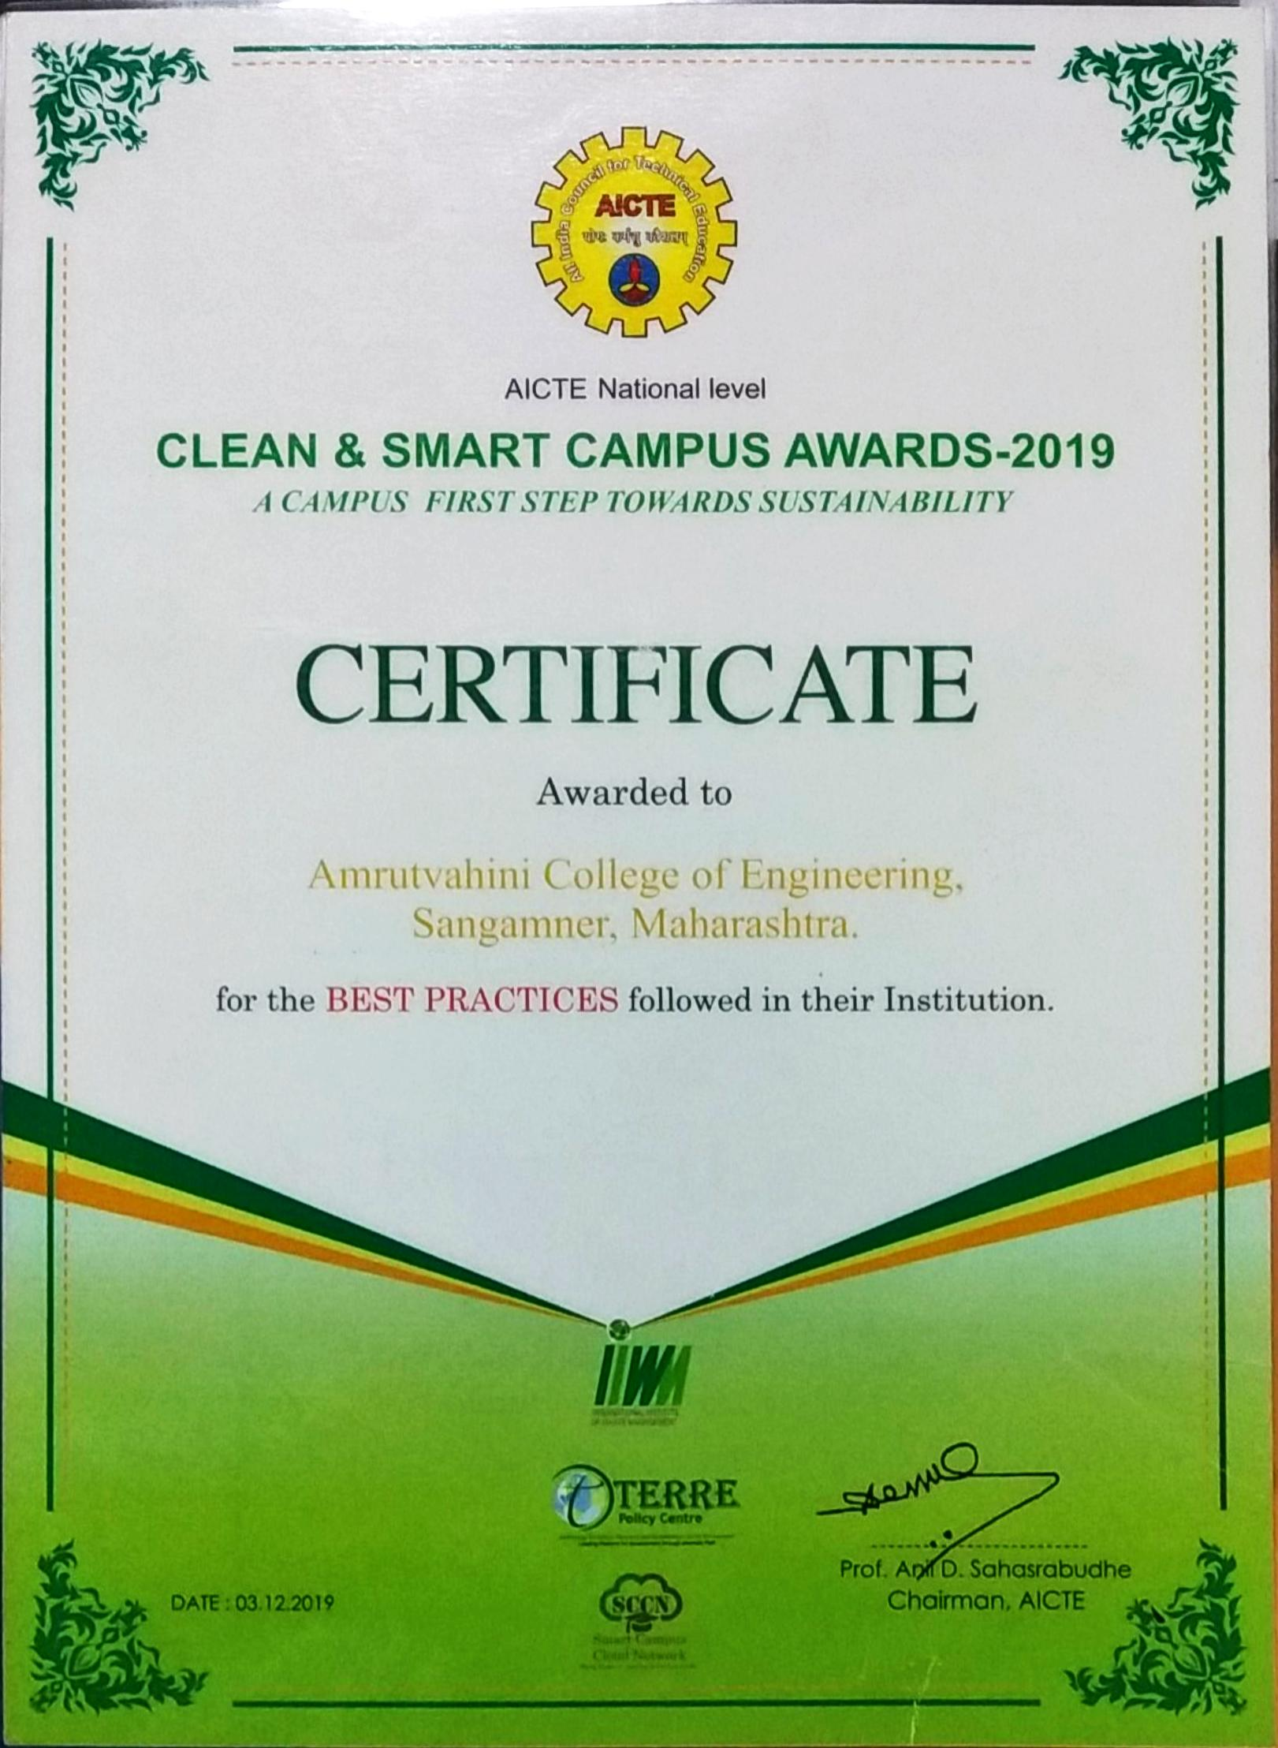
12th State level award for excellence in energy conservation and management by MEDA 2018, Government of Maharashtra.

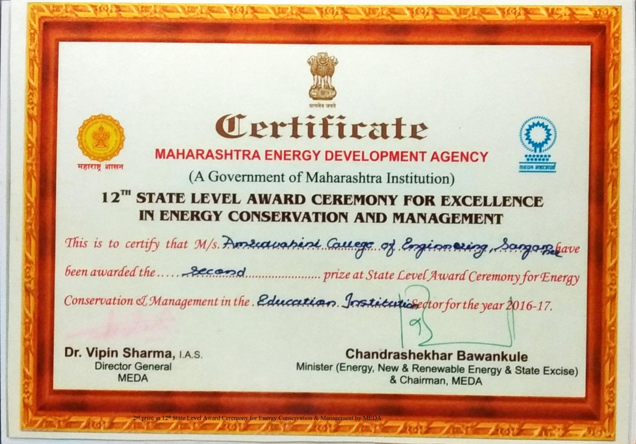

Maharashtra Green Army certificate by Government of Maharashtra
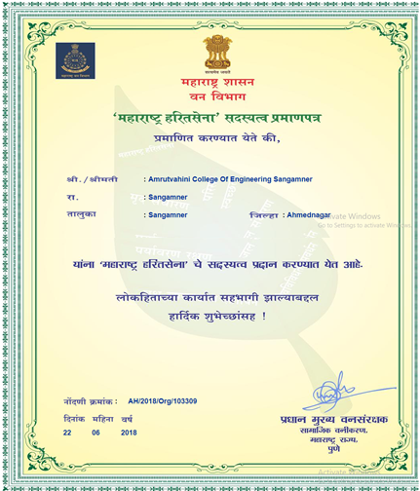

Energy Efficient Unit Award in 21st National Energy award for excellence in Energy Management 2020 by Confederation of Indian Industry (CII).
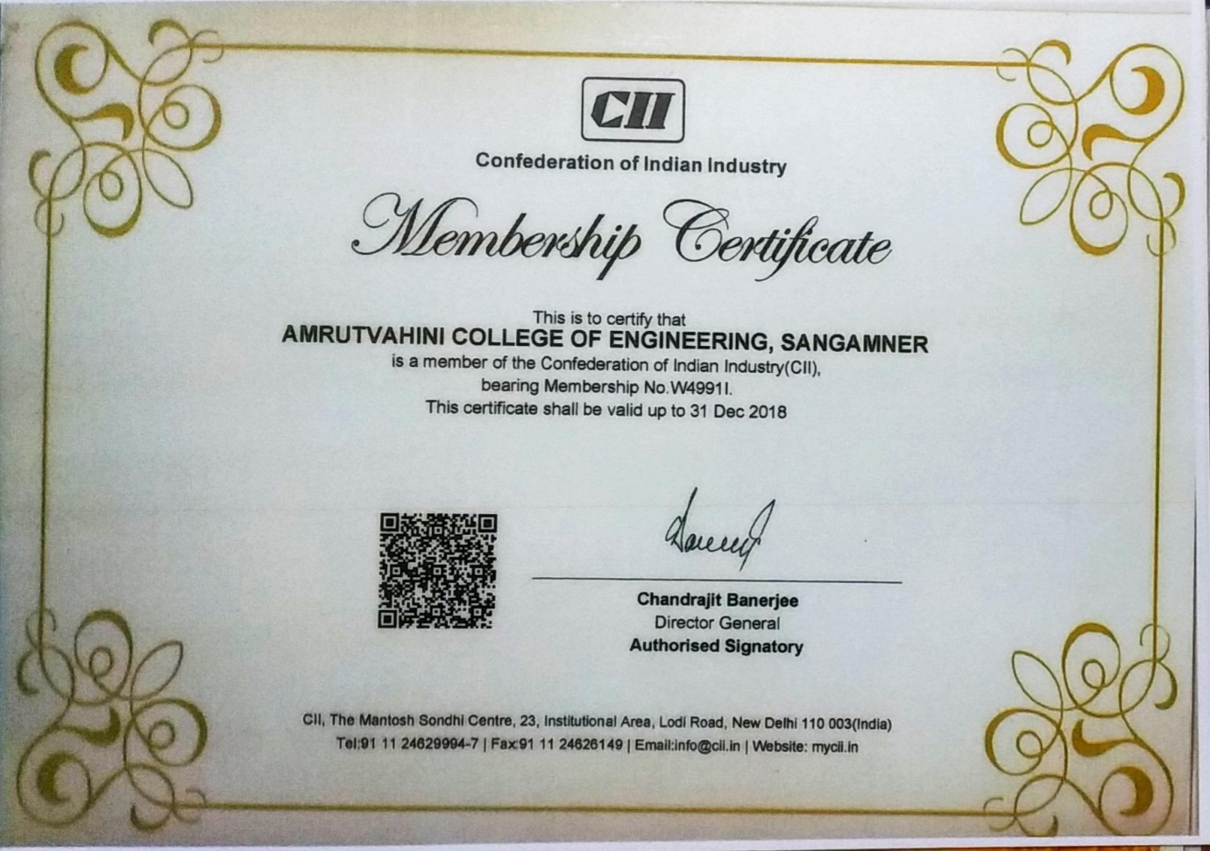

Recognised as Swachhata Action Plan Institution by Mahatma Gandhi National Council of Rural Education Department of Higher Education, Ministry of Human Resource Development, and Government of India in 2020.

