7.1.4 : Water conservation facilities available in the Institution:

Water Reservoir and Filtration unit for gravitational water circulation in campus
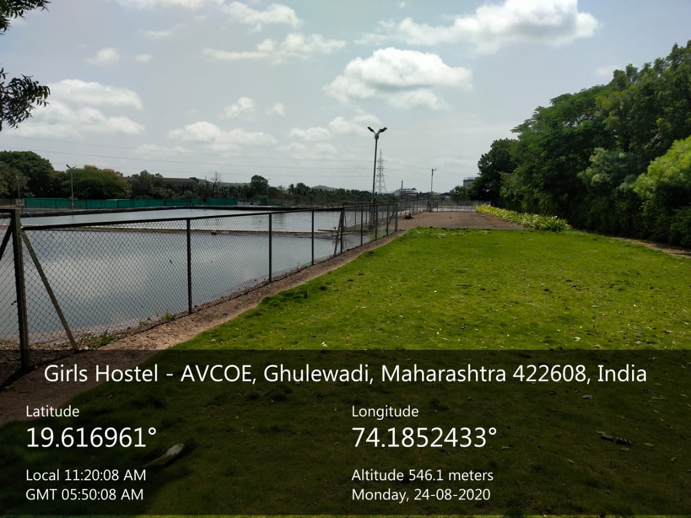
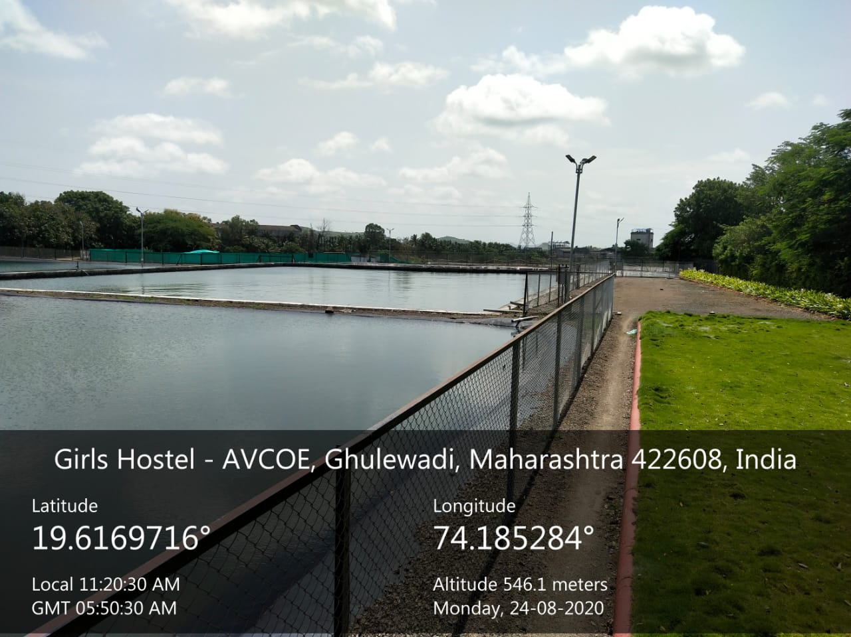

Filtration Plant at Roof Top:
