7.1.4: Water conservation facilities available in the Institution
Rain water harvesting: Information:
The scenario of the college itself reflects the importance given to the eco-friendly campus. Some of the relevant activities to save water are as follows:
- Constructed rain water harvesting set up.
- Monsoon run of roof top water is collected in a well and used for garden irrigation.
- For water harvesting survey have been carried out and underground storage tanks are constructed near hostels.
- The tress and lawns are maintained with water drips and sprinklers respectively.
- Reuse of waste water for gardening.
- Markers are installed at roof top water tanks to avoid overflows.
- We consider ourselves responsible stewards for water and teach our students continuously that communities are responsible for climate change and resultant scarcity of water supplies and cycles.
- We also contributed in “Sakal” (Leading news- paper in Maharashtra) group’s initiative “Sarv-Jal-Abhiyan” taking oath of minimum use of water and guidance to citizens.
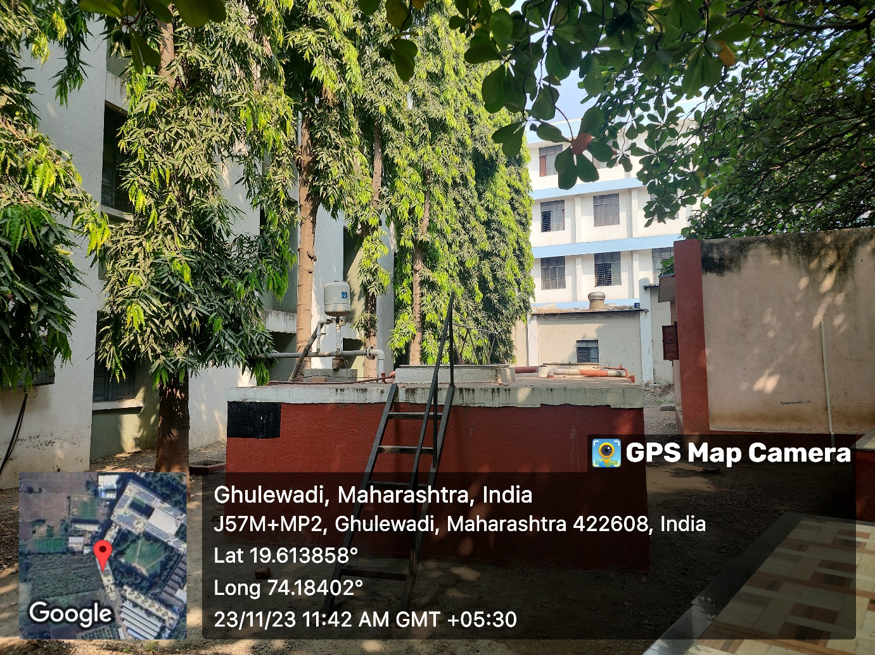

Sensor Based Motor start and Water Lifting System:

- 