7.1.3: Describe the facilities in the Institution for the management of the following types of degradable and non-degradable west:

Solid Waste Management:
Proper Cleanliness and Hygiene is maintained in the College Premises, Mess and Canteen. Generated compost using the canteen & mess waste food annually =3 tons of manure.

INDEX
Sr. No. | Process | Page No.
 | Solid Waste Management  - Biogas Plant: Information  - Biogas Plant: Photos  - Biogas Plant: Purchase Order  - Composting: Photos | 2  2  4  6  10
 | Liquid Waste Management  - Sewage Treatment Plant: Photo  - Sewage Treatment Plant: Information | 10  10  13
 | Biomedical waste management: Not Applicable | 18
 | E-waste management | 18
 | Waste recycling system: Sewage Treatment Plant | 10
 | Hazardous chemicals and radioactive waste management | 20

- Solid Waste Management
Proper Cleanliness and Hygiene is maintained in the College Premises, Mess and Canteen. Generated compost using the canteen & mess waste food annually =3 tons of manure.
  - Biogas Plant: Information
Generated compost using the canteen & mess waste food annually = 3 tons of manure.

  - Biogas Plant Photos:

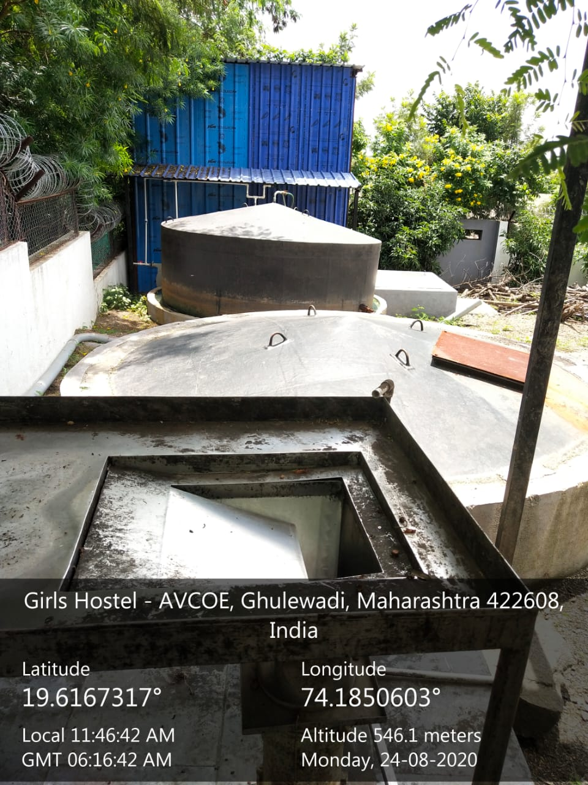

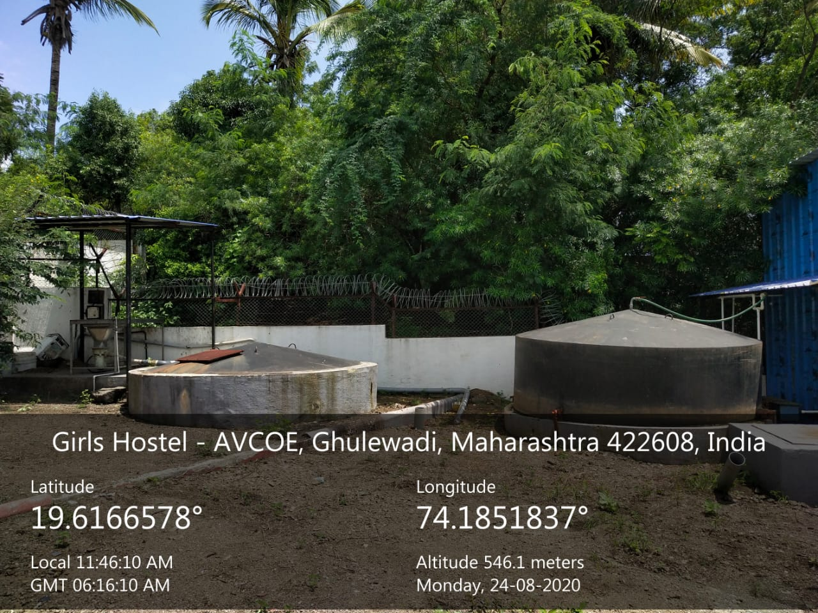

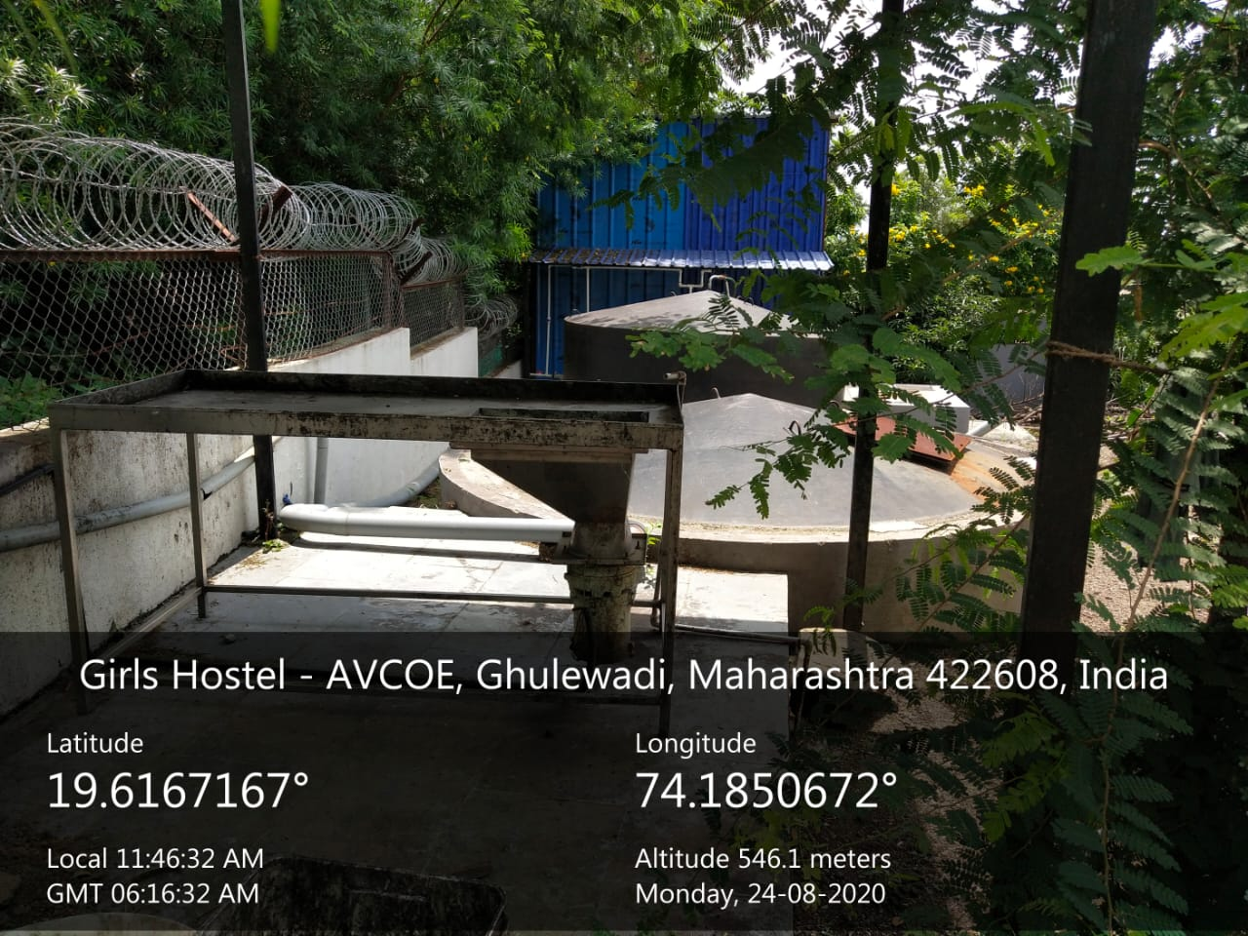

  - Biogas: Purchase Order

  - Composting -Photo
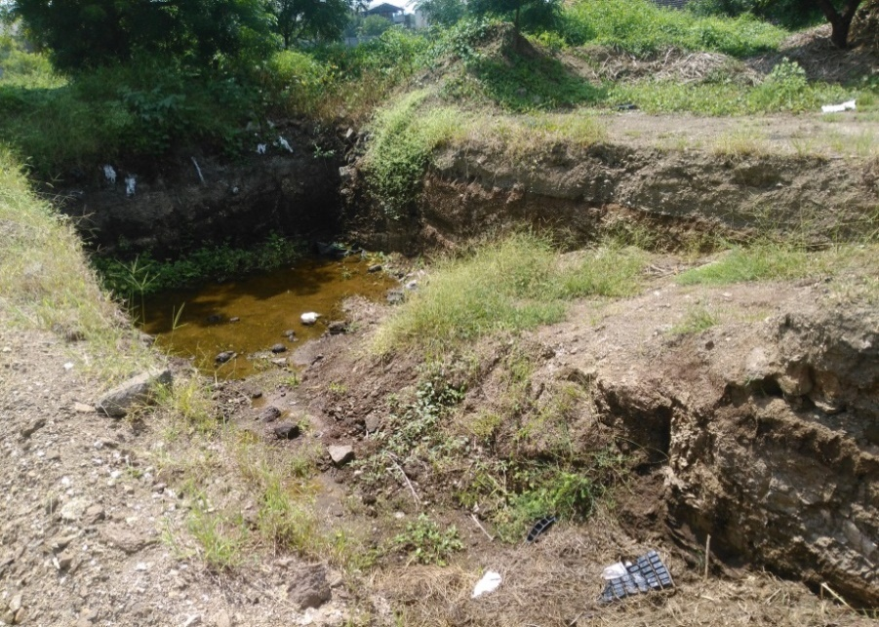

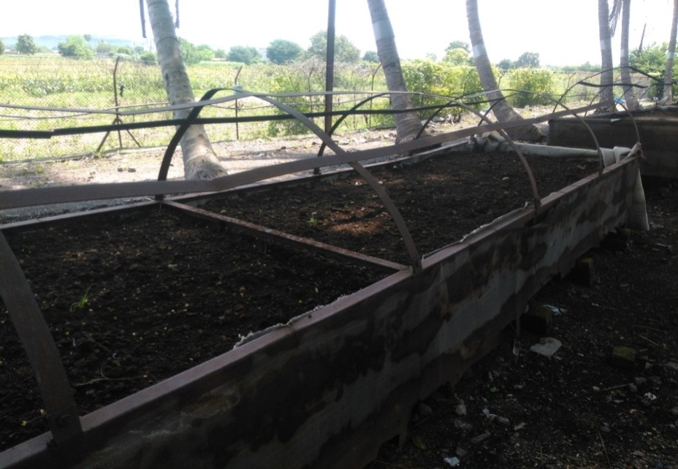

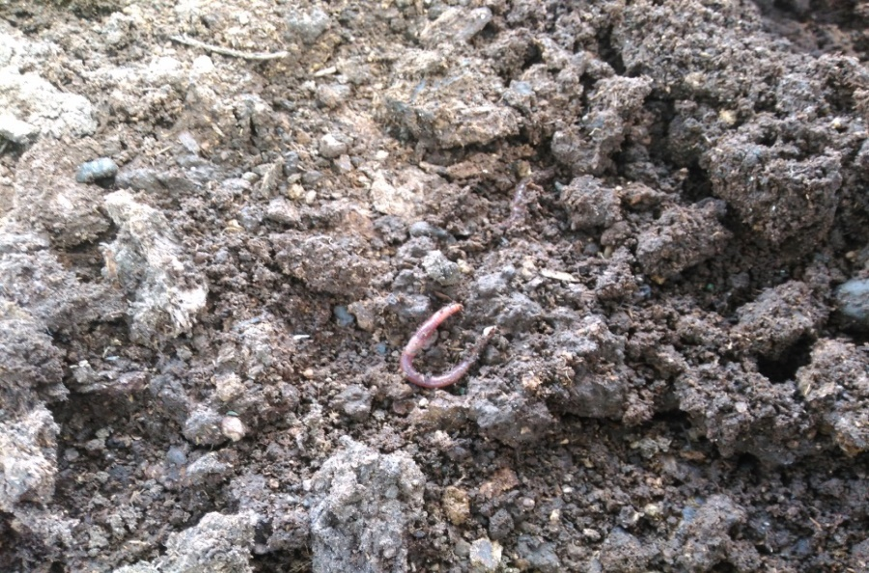

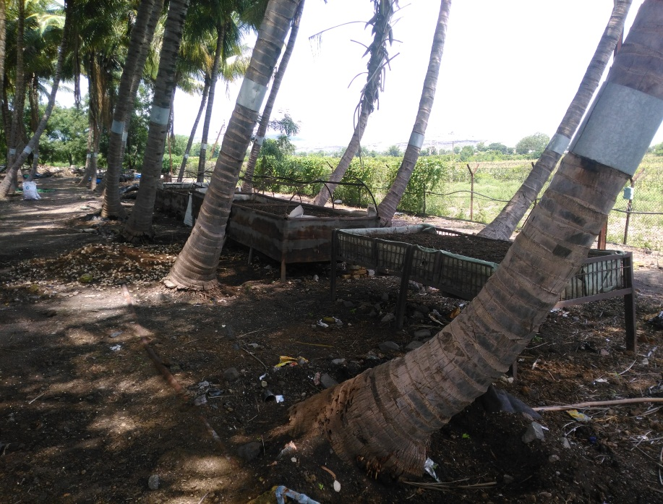

- Liquid Waste Management/ Waste Recycling System:
Waste water generated from Amrutvahini Campus includes sewage from the educational buildings, boy’s hostels, girl’s hostel and staff quarters etc. It needs treatment before discharging it as effluent into natural stream/river etc. and same treated waste water can be utilized for various purposes like gardening and irrigation. To treat waste water, innovative 3E (Eco-friendly, Economical, and Efficient) microbial technology has adopted by the institute. In 2019, Sewage Treatment Plant (STP) having capacity of 0.4MLD is started.
Sewage Treatment Plant Installation cost (INR In lakhs) = 35.5
  - Sewage Treatment Plant: Photos

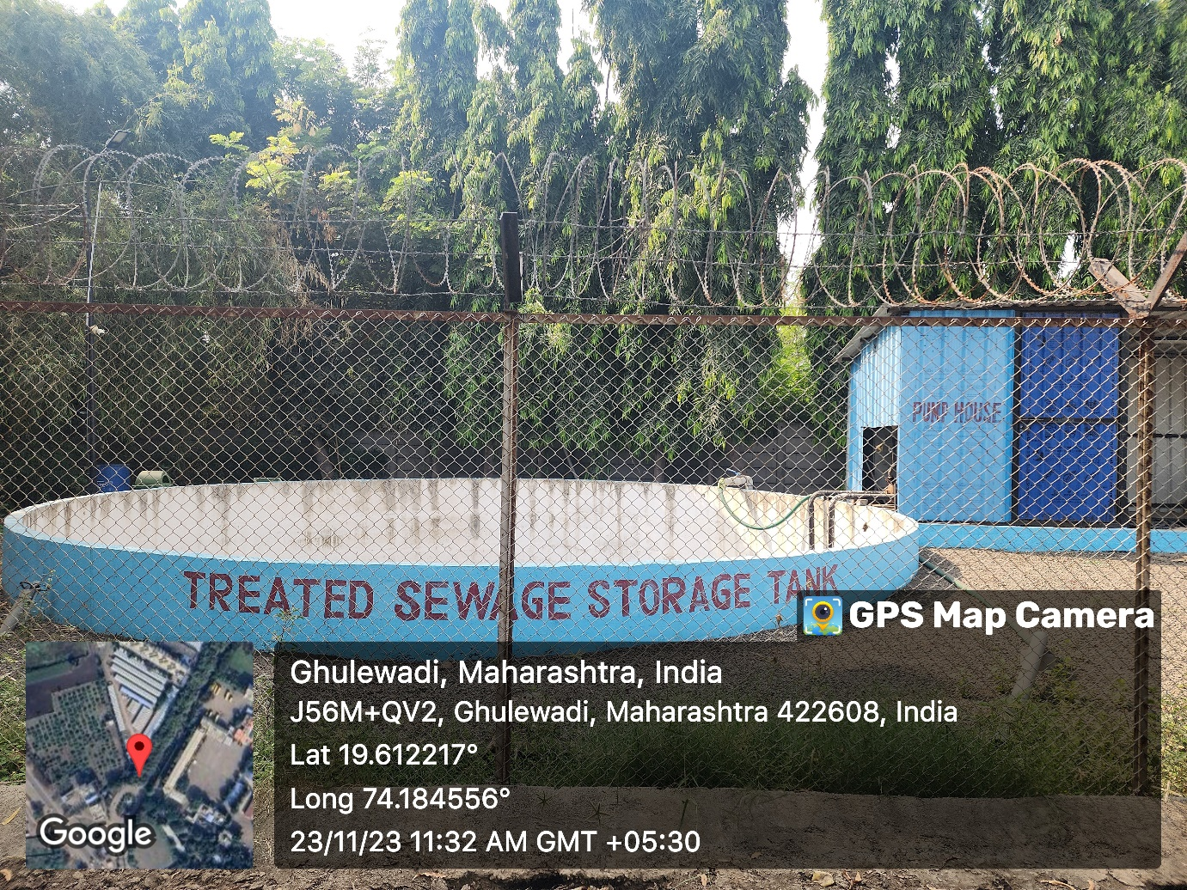
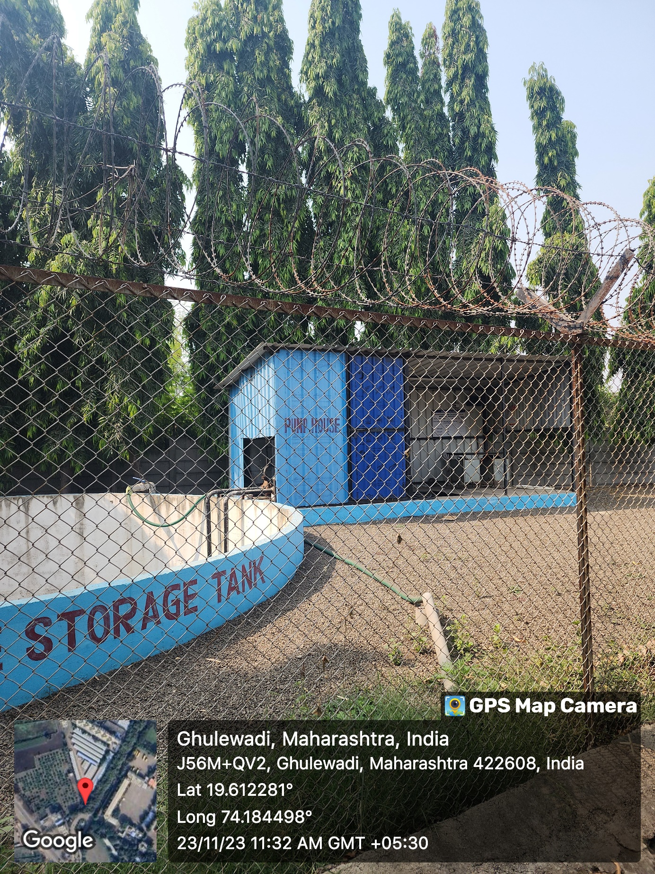

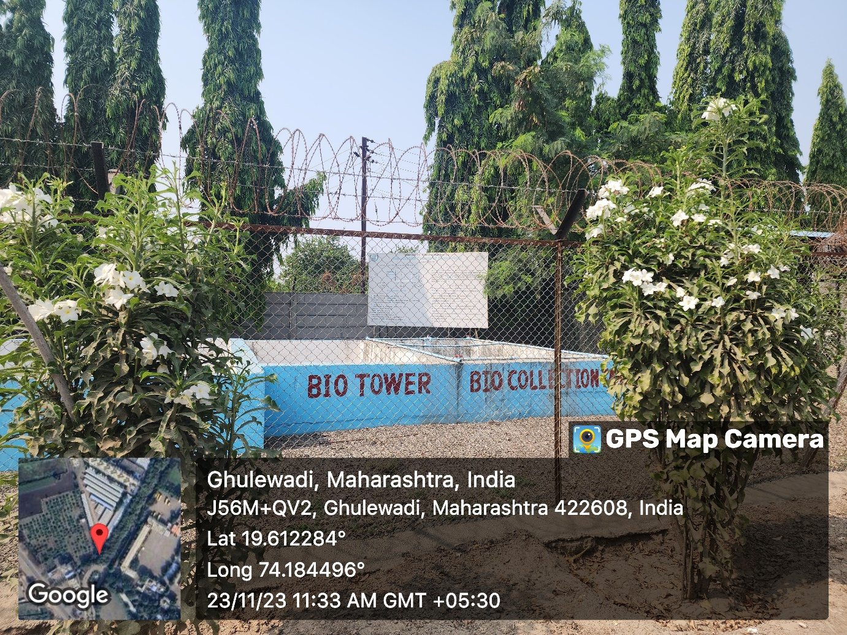

  - Sewage Treatment Plant: Information

- Biomedical waste management: Not Applicable
- E-waste management
- Out-dated and low-end e-components are being used for demonstration. e.g. CRO, Function Generator like these electronics equipments have been used as demonstration models in respective laboratories.
- The major e-waste such as out of use instruments / equipment, CRTs, Printers, Computers, Electronics gadgets, circuits, kits have been written off and then it is sold out to buyers by auctioning.
- All the miscellaneous e-waste such as CDs, batteries, fluorescent bulbs, PCBs and electronic items are collected from every department and office, and delivered to third party for safe disposal.
- Useful parts of electronic gadgets like resistors, capacitors, inductors, diodes, transistors, thyristors etc. have been removed from the gadgets for reuse purpose in students practical /projects
-Waste Management: Photos
Used for demonstration

Used as demonstration models in respective laboratories Used for demonstration

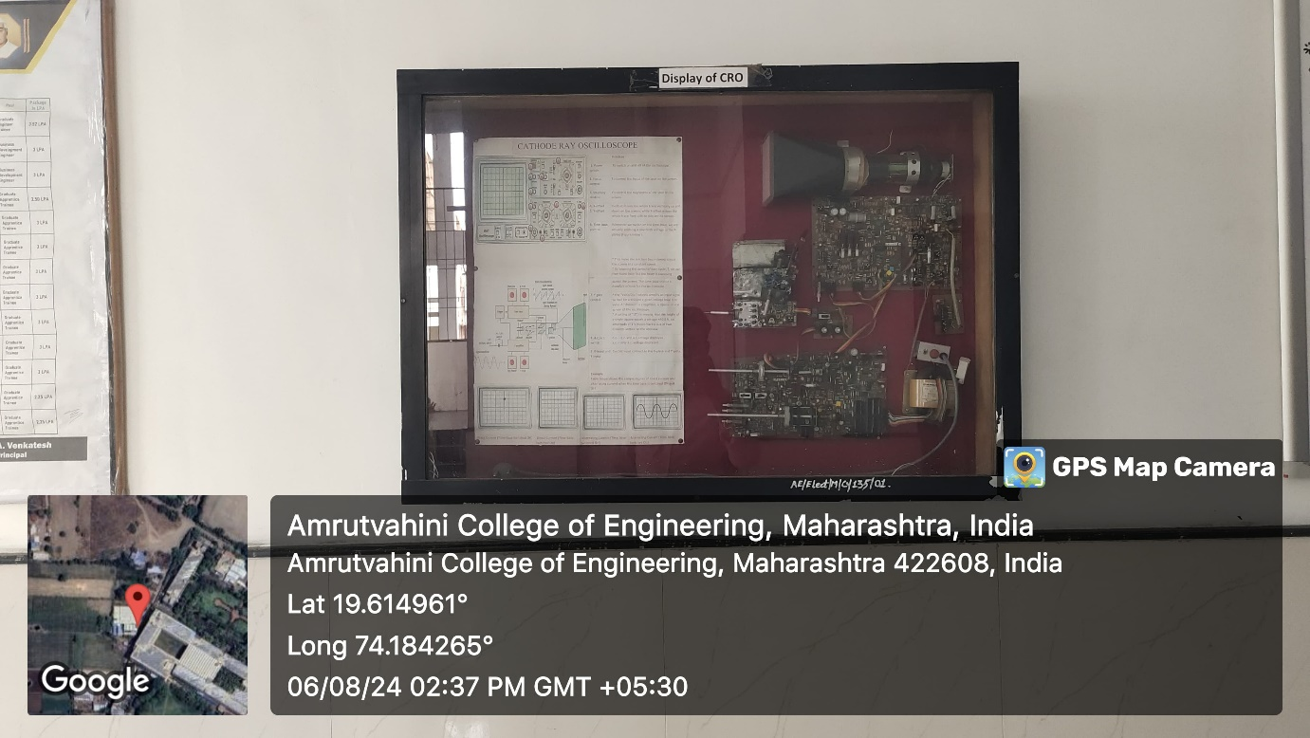
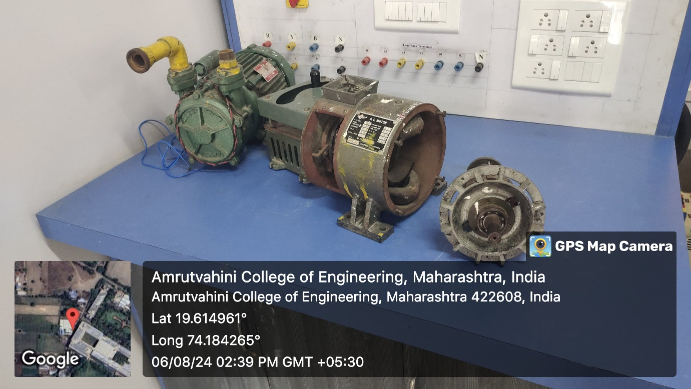

- Waste recycling system: Sewage Treatment Plant: (pg. No. 10)
- Hazardous chemicals and radioactive waste management
In chemistry lab much diluted chemicals are used for practicals and no hazardous waste is generated.

