7.1.2 : The Institution has facilities for alternate sources of energy and energy conservation measures
Use of LED bulbs/ power efficient equipment

INDEX
Sr. No. | Process | Page No.
 | Use of LED bulbs: Photos | 2
 | Use of LED bulbs: Purchase Order | 4
 | Power efficient equipment strategies: Microprocessor based APFC bank | 5
 | Power efficient equipment strategies: 500KVA online tap changing transformer | 6
 | Power efficient equipment strategies: Use of Star rating equipments | 7
 | Power efficient equipment strategies: Water supply through gravitational water flow | 8

- Solar street lamps are installed in campus.
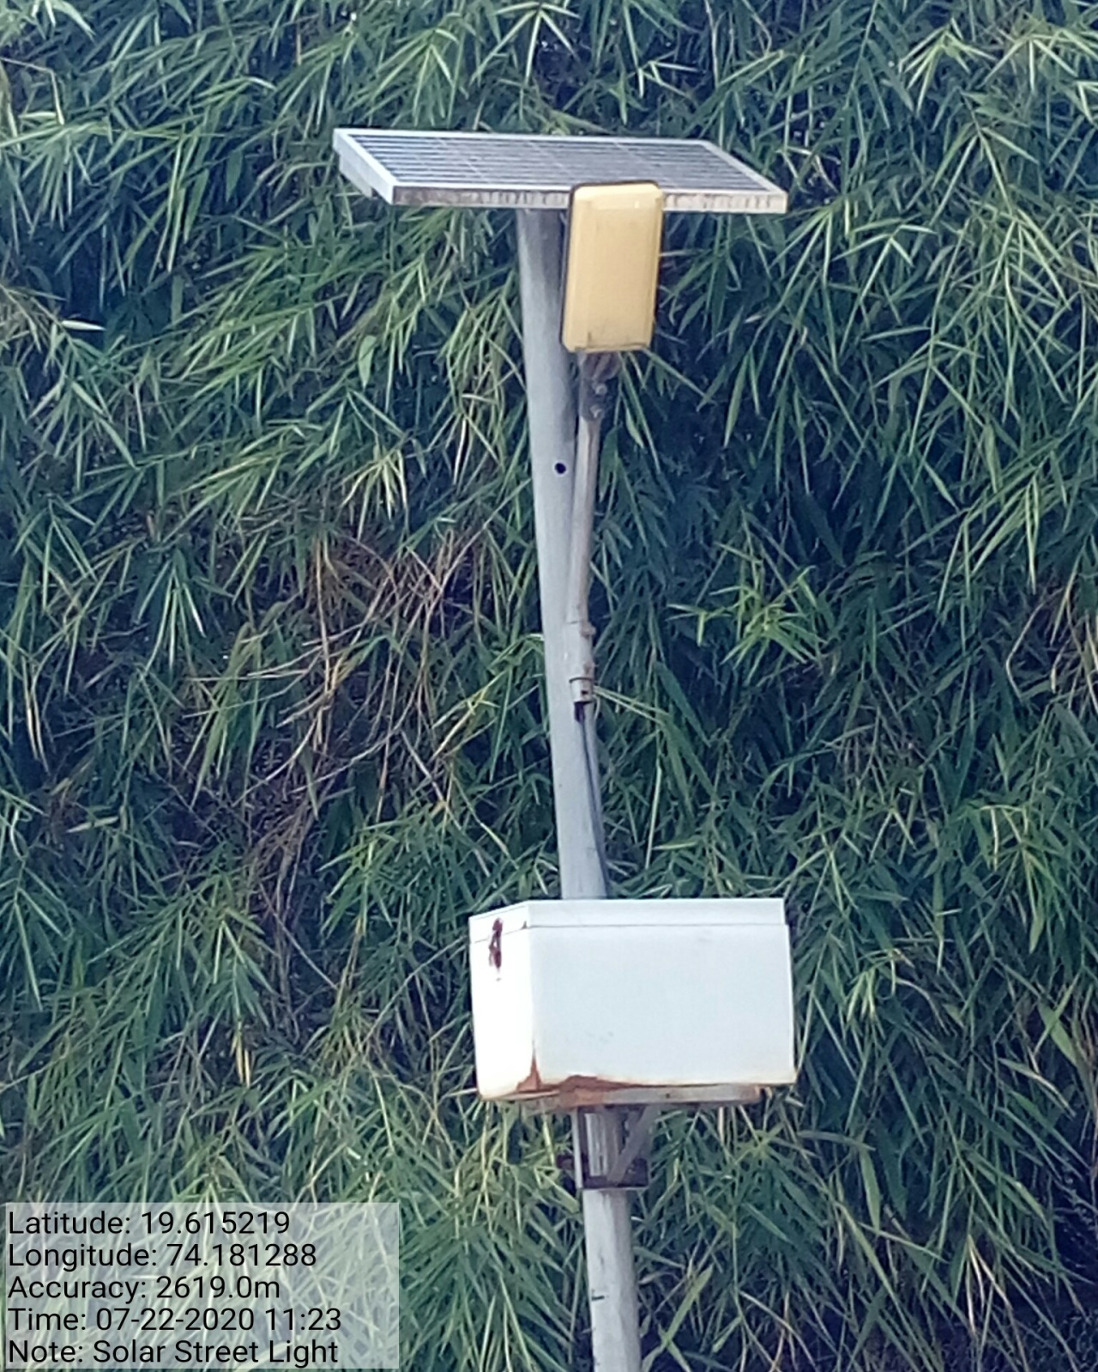
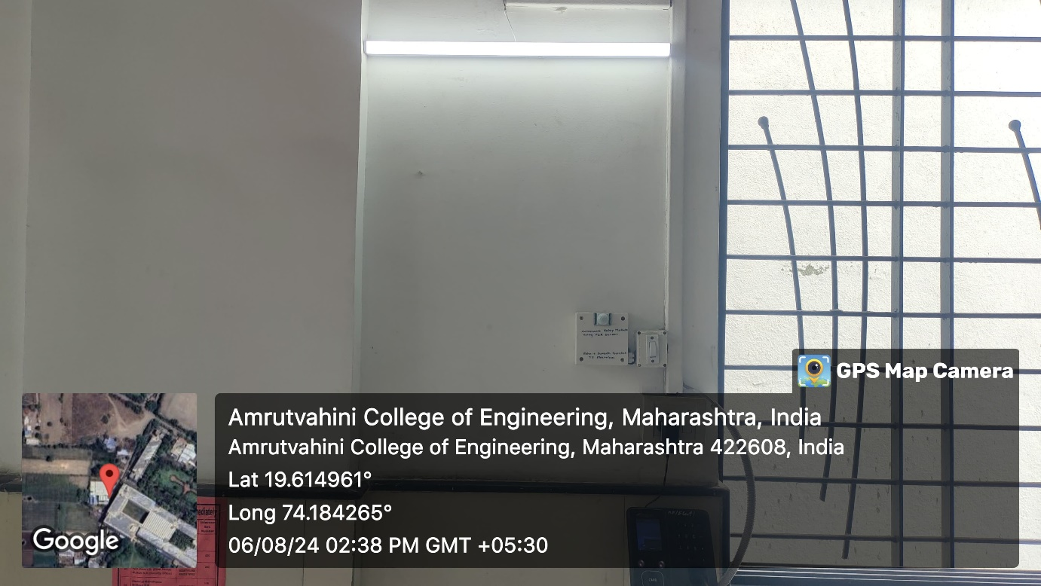

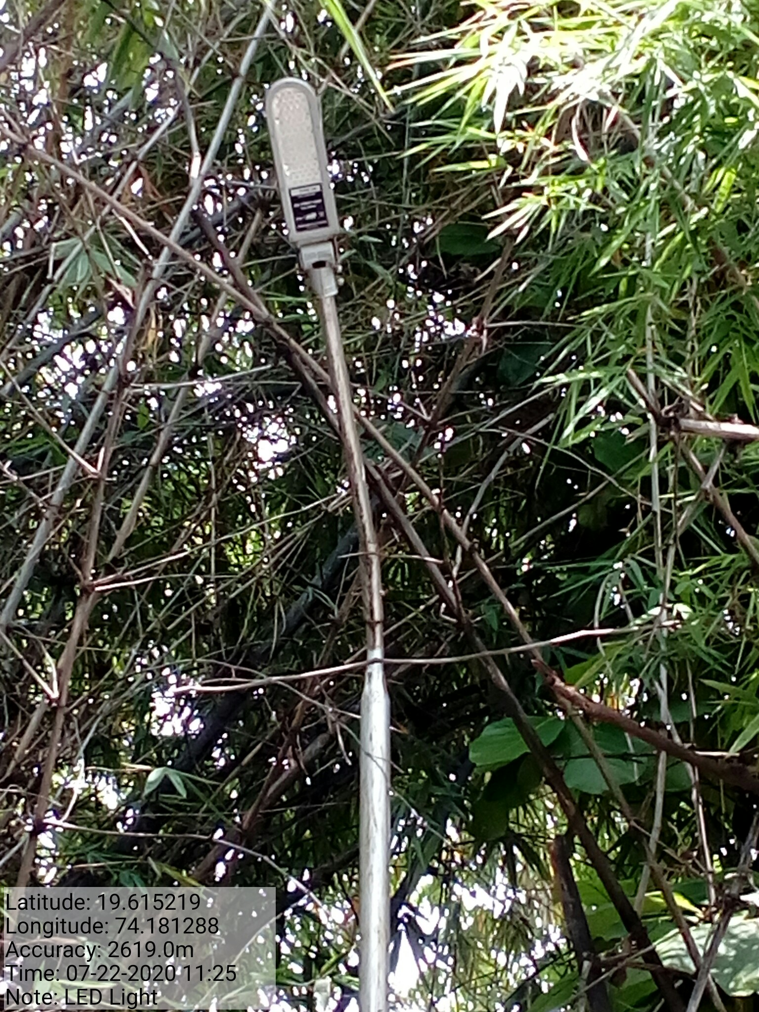

- LED Street Light: Purchase Order

- Power efficient equipment strategies: Microprocessor based APFC bank
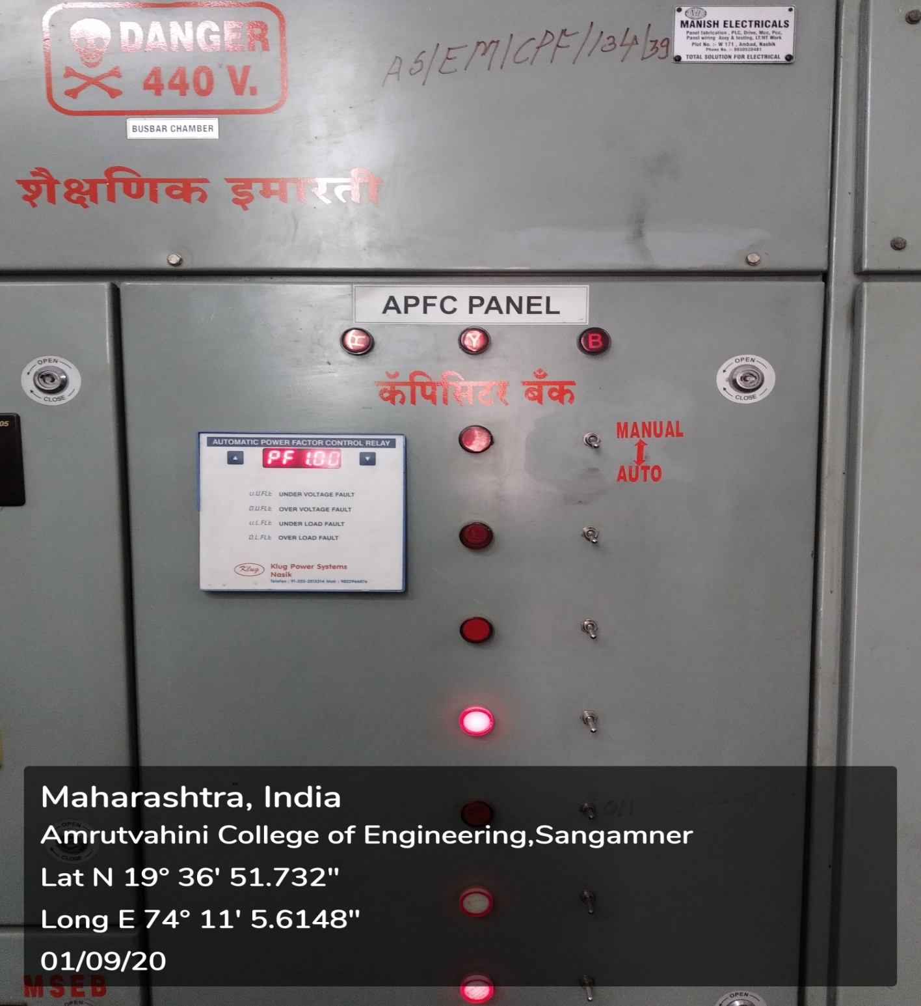

- Power efficient equipment strategies: 500KVA online tap changing transformer
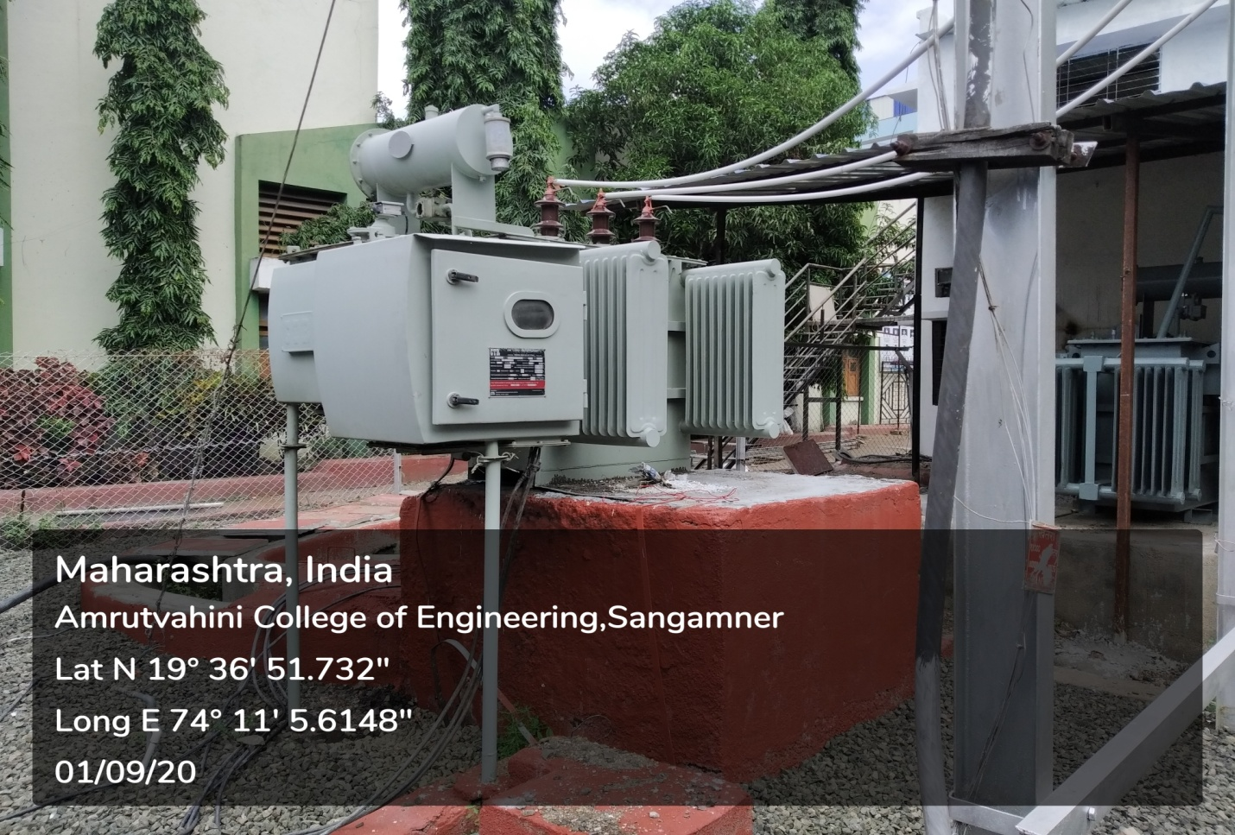
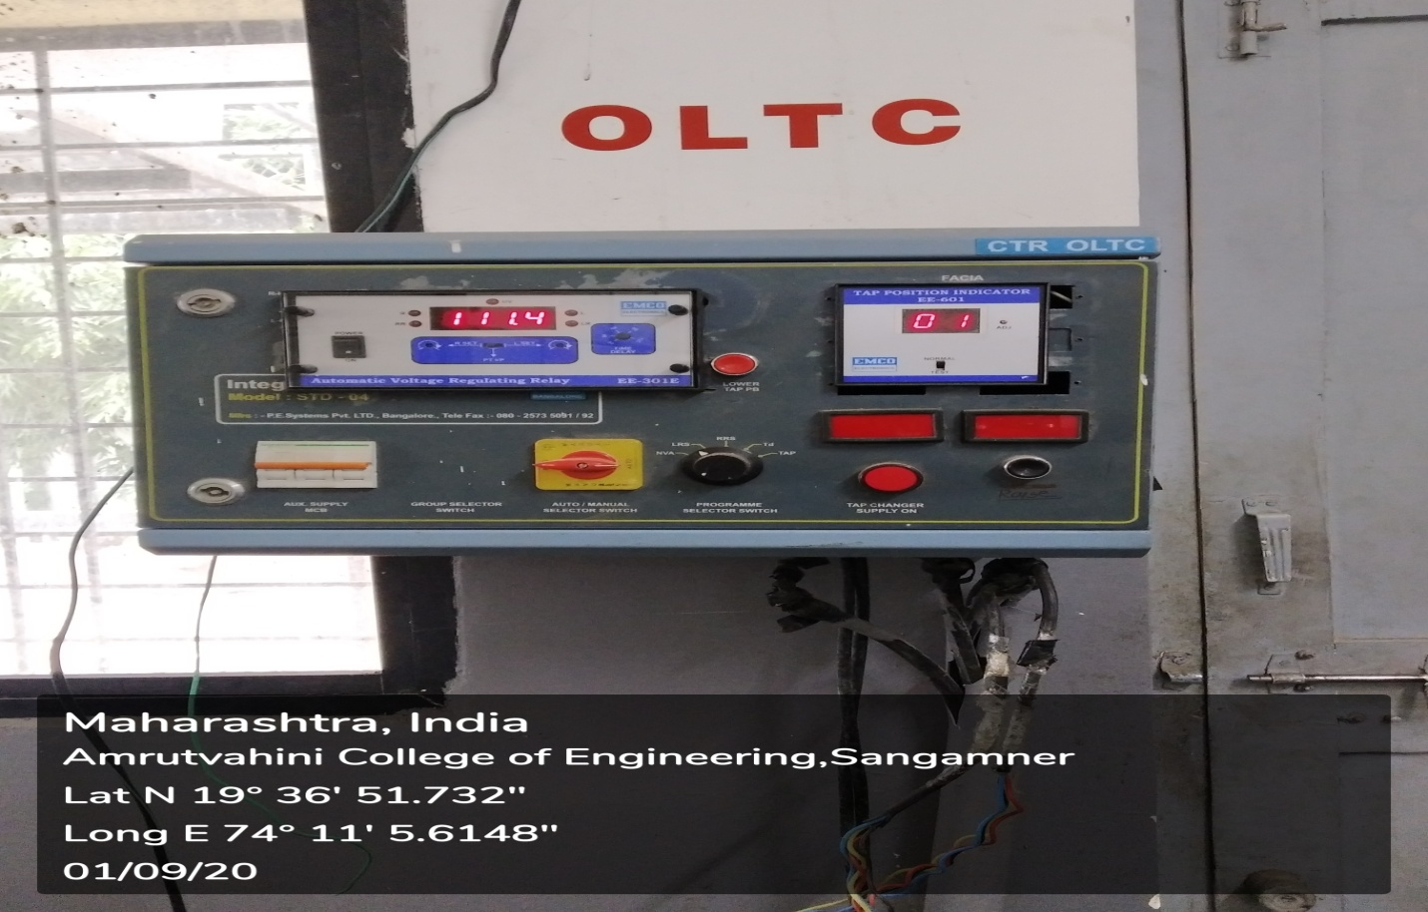

- Power efficient equipment strategies: Use of Star rating equipments
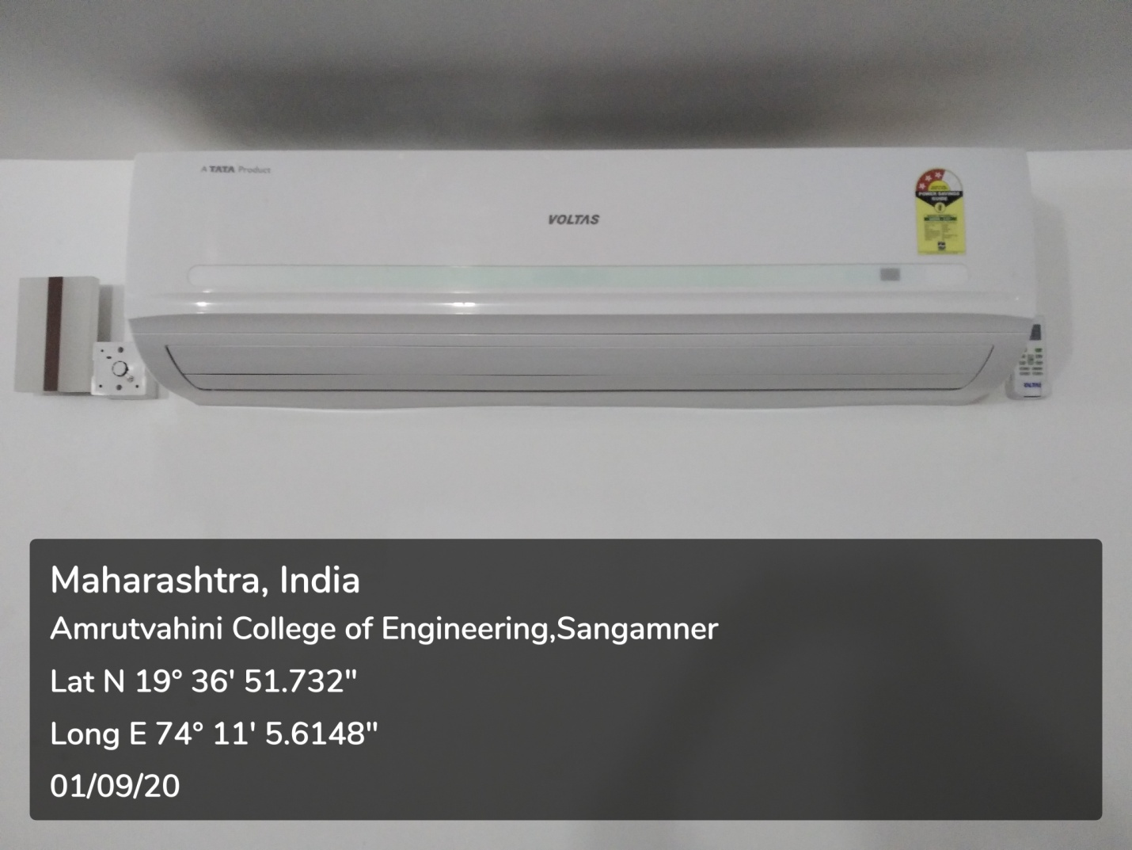

- Power efficient equipment strategies: Water supply through gravitational water flow
