7.1.2: The Institution has facilities for alternate sources of energy and energy conservation measures
Sensor Based Energy conservation
INDEX
Sr. No. | Description | Pg. No.
 | Solar Energy | 1
 | Maintenance Strategies | 2
 | Preventive maintenance | 2
 | Corrective maintenance | 2
 | Cleaning Strategies | 2
 | Reading Method | 2
 | Sensor based energy conservation | 3
The Institution has facilities for alternate sources of energy and energy conservation measures
- Solar Energy
Institute has installed 400 kW Solar roof top photovoltaic plant in the premises to fulfil the electricity requirement of the campus with the investment of 133.25 lakh& payback period of 1.78 years.
Installation cost (Rs. In lakhs) = 133.25
Generated electricity = 11, 71, 000 KWh
Reduction in CO₂ emission = 702600 Kg
Estimated saving(Rs. In lakhs) = 159.8415
CO2 Saving = 702600 Kg
The institute takes conscious efforts to create awareness about energy conservation and renewable energy usage among students.
The institute Secured the 2nd prize in 12th State Level Award Ceremony for Energy Conservation & Management by MEDA (Govt. of Maharashtra) in 2016-17
- Maintenance Strategies
IOT based Online Condition monitoring unit installed in the SRTPV plant that gives the regular monitoring of all the equipment’s connected like inverter, solar modules , protection devices etc
The website for monitoring the plant is www.injectsolar.com

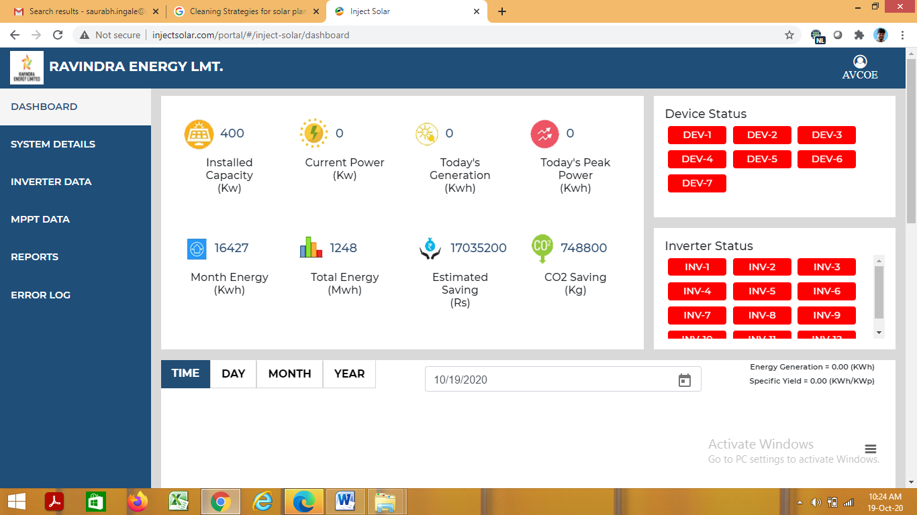
- Preventive maintenance
Preventive Maintenance activities comprise regular visual and physical inspections, as well as verification activities conducted with specific frequencies.
- Corrective maintenance
Corrective Maintenance covers the activities performed by the Maintenance team in order to restore a PV plant system, equipment or component to a status where it can perform the required function. Corrective Maintenance include:
✓ Fault Diagnosis: also called troubleshooting to identify fault cause and localization.
✓ Temporary Repair: to restore the required function of a faulty item for a limited time, until a Repair is carried out.
✓ Repair: to restore the required function permanently
- Cleaning Strategies
A house keeping team clean the solar modules on the regular basis with frequency of weekly using soft moping and water.
- Reading Method
A reading of all inverters will be taken using IOT based monitoring system which gives the individual reading of all inverters, solar generation meter. Maintenance team technicians also take the manual reading of inverters and solar generation meter.
- Sensor based energy conservation

