7.1.2: The Institution has facilities for alternate sources of energy and energy conservation measures
Wheeling to the Grid
INDEX
Sr. No. | Process | Page No.
 | Solar Energy Project- 400 KW Solar Roof Top PV Plant | 2
 | Net metering Photos | 3
 | Net metering Proof | 5
 | Bills of Solar Energy exported to MSDSL | 13

Wheeling to the Grid
- Solar Energy Project- 400 KW Solar Roof Top PV Plant
- Institute has installed 400 KW Solar Roof Top PV Plant as a clean energy project to make the campus eco-friendly. The project has been successfully installed and generating power which is more than energy requirement of the campus. The surplus power is export to MSEDCL (2.87 Lakh units)
- Effective utilization of natural sunlight in the campus.
- Using solar water heater at hostels. (capacity 41000 Litres per day)
- Use of Solar street lights in the campus.
Solar Roof Top PV Plant SRTPV Impact
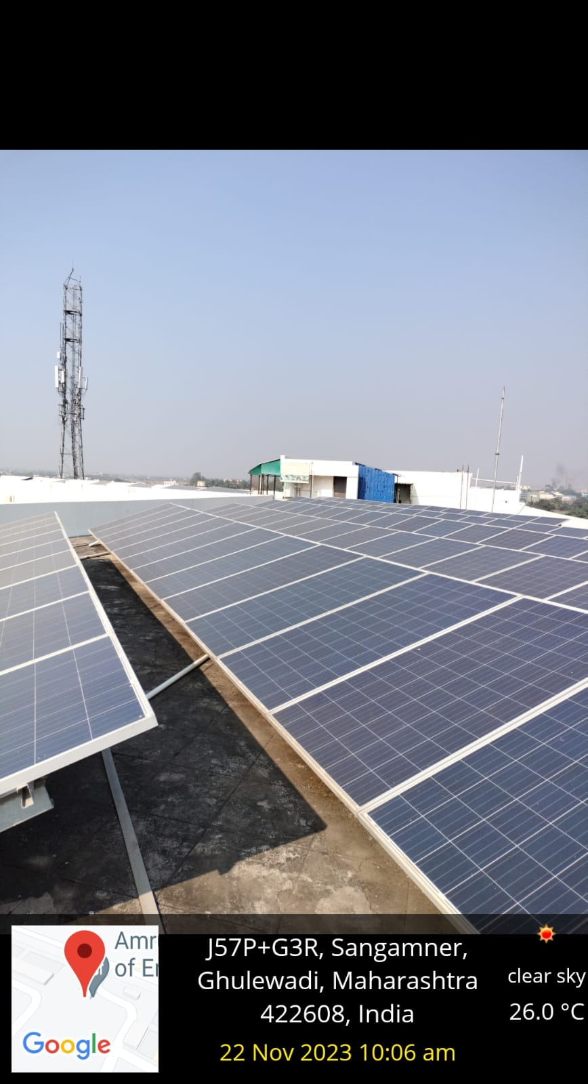
- Net metering Photos

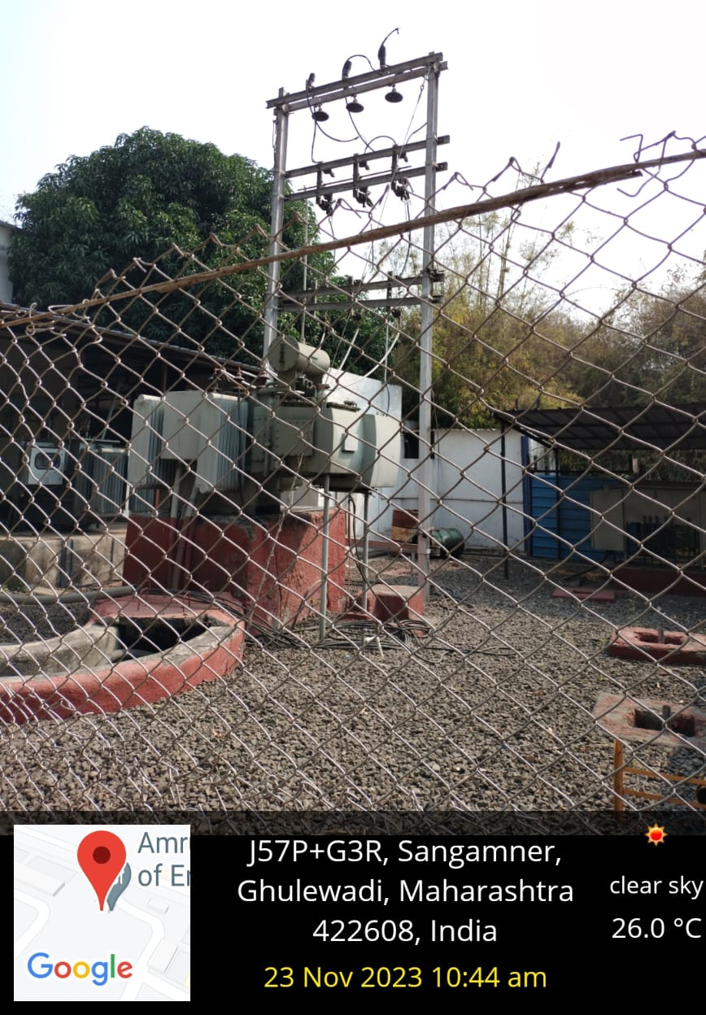

Net metering Photos:
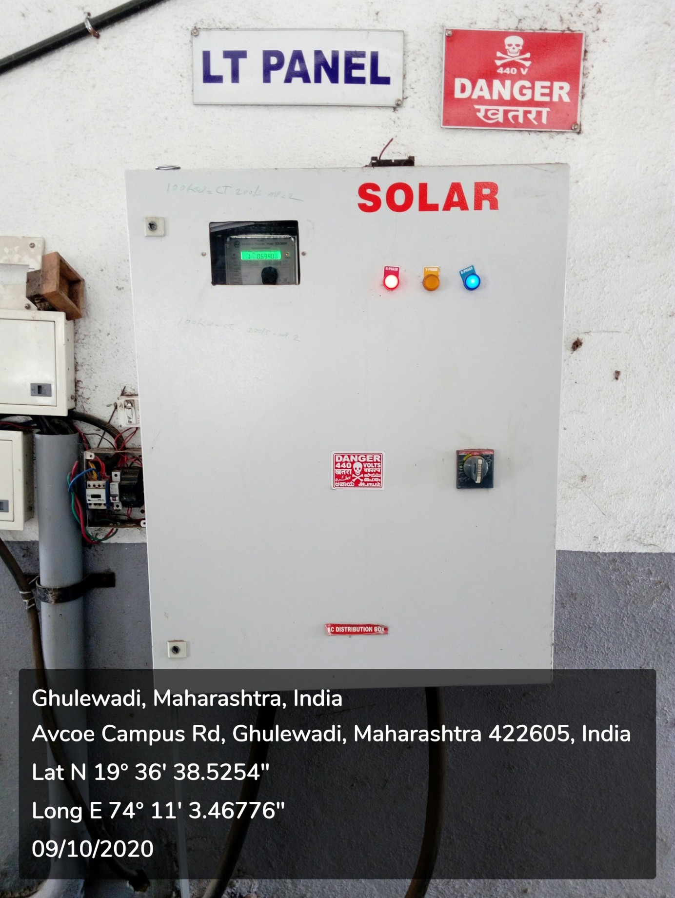

- Net Metering Proof

