7.1.2 The Institution has facilities for alternate sources of energy and energy conservation measures
Biogas Plant
INDEX
Sr. No. | Process | Page No.
 | Biogas Plant: Information | 2
 | Biogas Plant: Photos | 4
 | Biogas Plant: Purchase Order | 6

- Biogas Plant: Information
Generated compost using the canteen & mess waste food annually =3 tons of manure.

- Biogas Plant Photos:

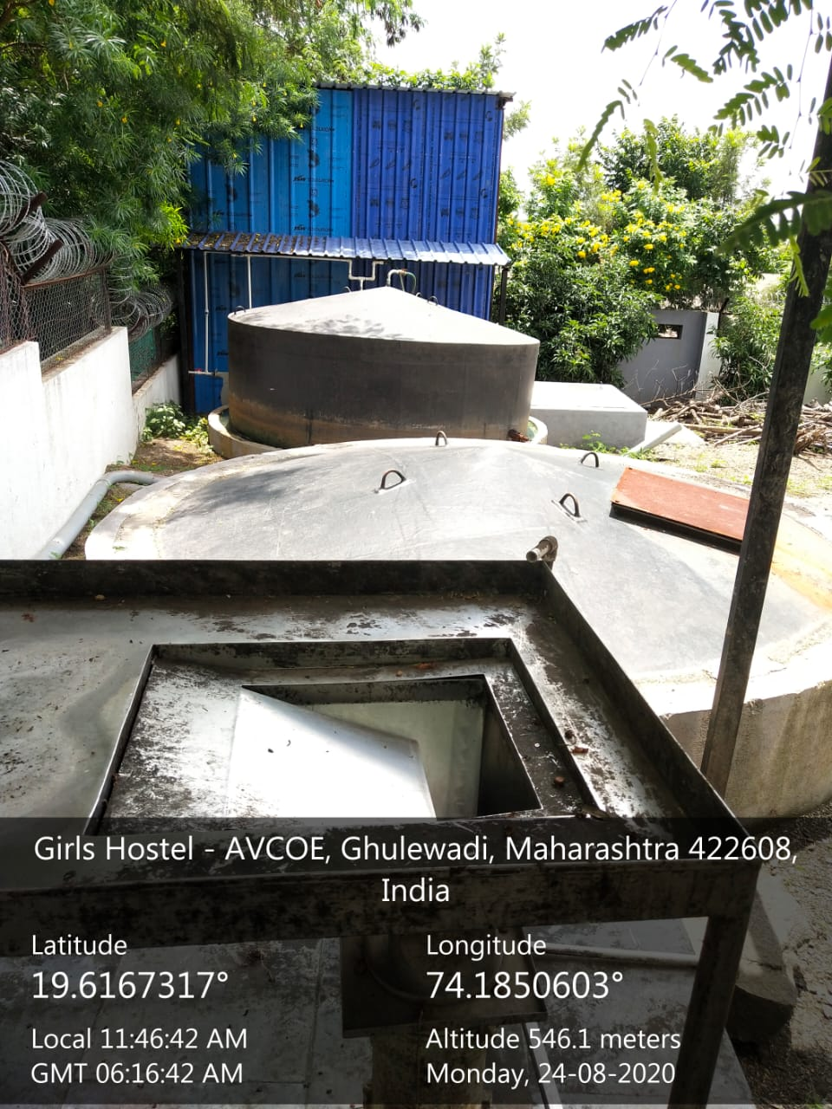

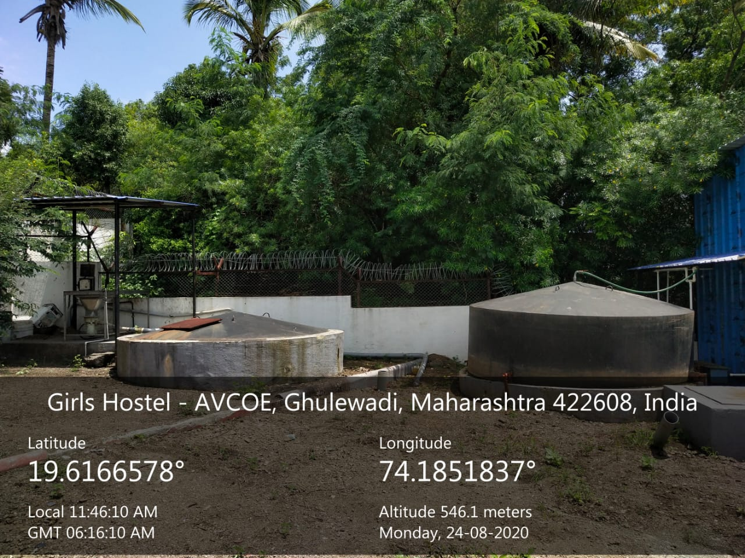

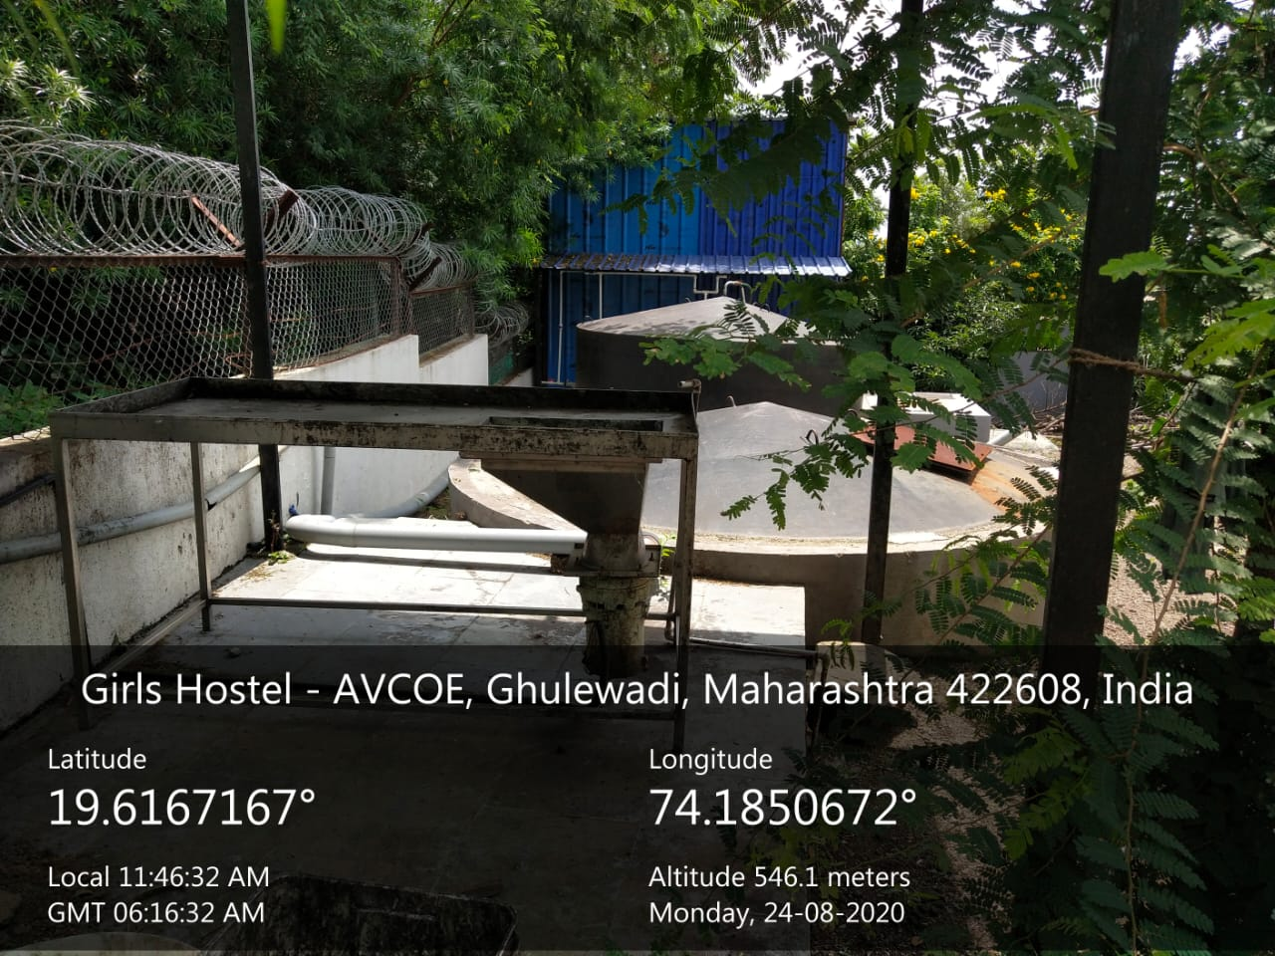

- Biogas: Purchase Order

