7.1.2 : The Institution has facilities for alternate sources of energy and energy conservation measures
Solar Energy
INDEX
Sr. No. | Process | Page No.
 | Solar Energy Project- 400 kW Solar Roof Top PV Plant | 2
 | Outcomes of Solar Energy initiative | 4
 | Solar-Wind Hybrid Plant: Photo | 5
 | Solar Water Heaters: Photos | 6
 | Purchase Orders of 100 kW Solar Photo Voltaic Plant | 7
 | Purchase Orders of 300 kW Solar Photo Voltaic Plant | 13
 | Purchase Orders of 5kW Solar-Wind Hybrid Plant | 20
 | Amrutvahini Sanstha Policy for Solar Energy | 22
 | Bills for Electricity mentioning Export of Electricity | 23-27

- Solar Energy Project- 400 KW Solar Roof Top PV Plant:
- Institute has installed 400 KW Solar Roof Top PV Plant as a clean energy project to make the campus eco-friendly. The project has been successfully installed and generating power which is more than energy requirement of the campus. The surplus power is export to MSEDCL (2.87 Lakh units)
- Effective utilization of natural sunlight in the campus.
- Using solar water heater at hostels. (capacity 41000 Litres per day)
- Use of Solar street lights in the campus.
Solar Roof Top PV Plant SRTPV Impact
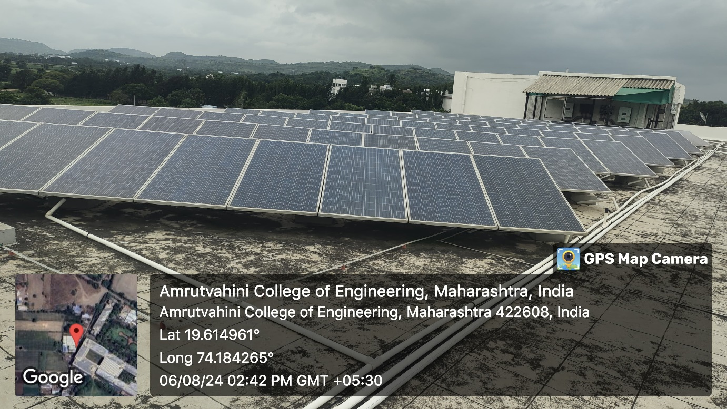
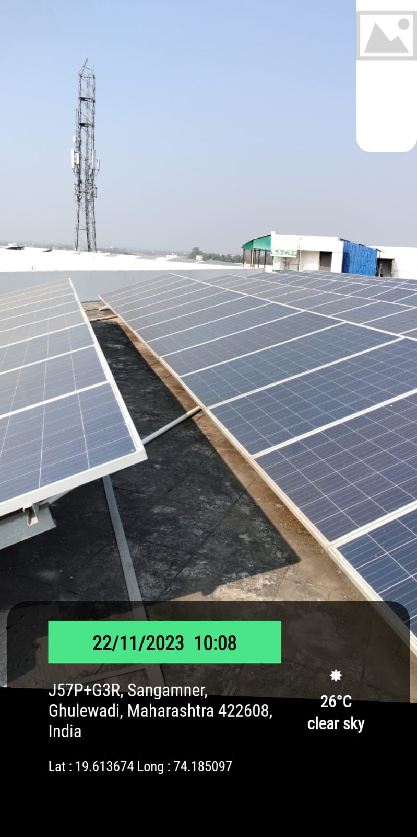

Installation cost (Rs. In lakhs) = 148.25
Generated electricity = 1303 Mwh
Estimated saving (Rs. In lakhs) = 177.86
CO2 Saving = 782600 Kg

Outcomes:
- Awarded as “Energy efficient Unit” in 21st National Energy Award for Excellence in Energy Management organized by Confederation of Indian Industry (CII).
- 12th State Level Energy Conservation Award of excellence in energy conservation and management by MEDA.
- Clean and Green Campus Award from AICTE, New Delhi.
- Reduction in Energy Consumption as Reflected in Electricity bill.

- Solar-Wind Hybrid Plant: Photo
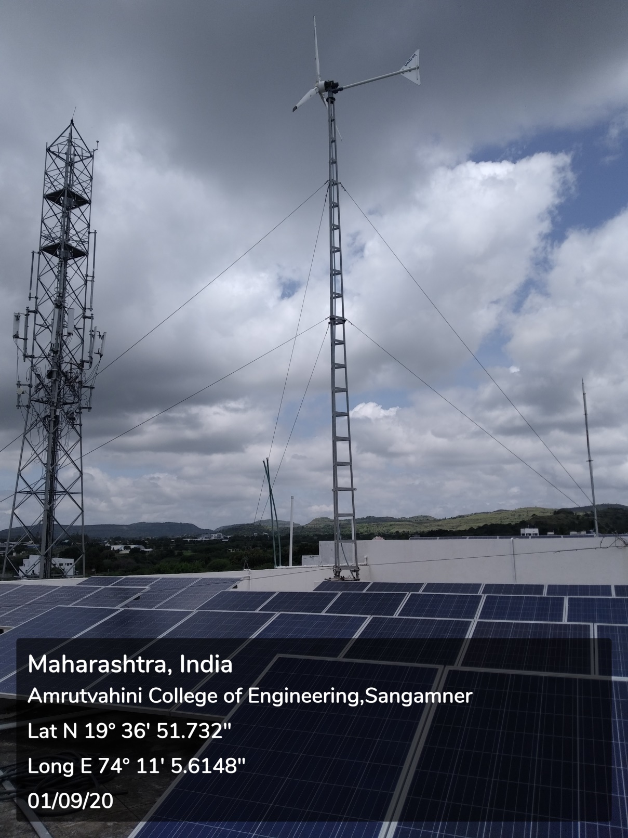

- Solar Water Heaters: Photos
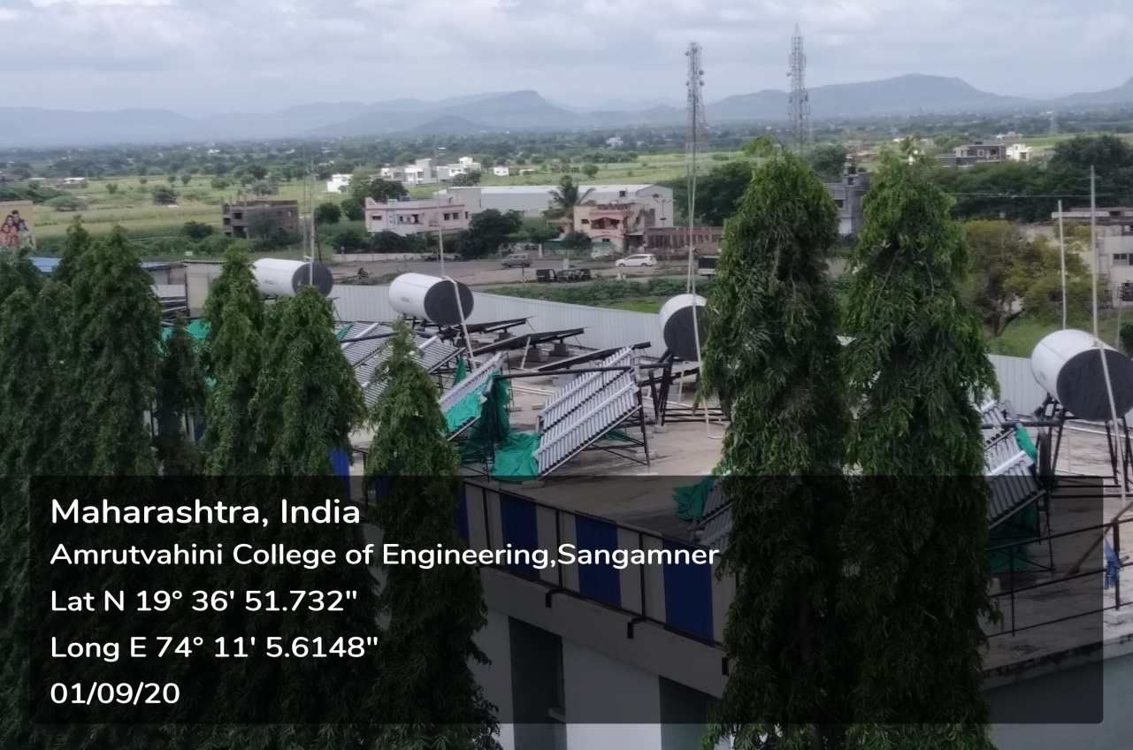
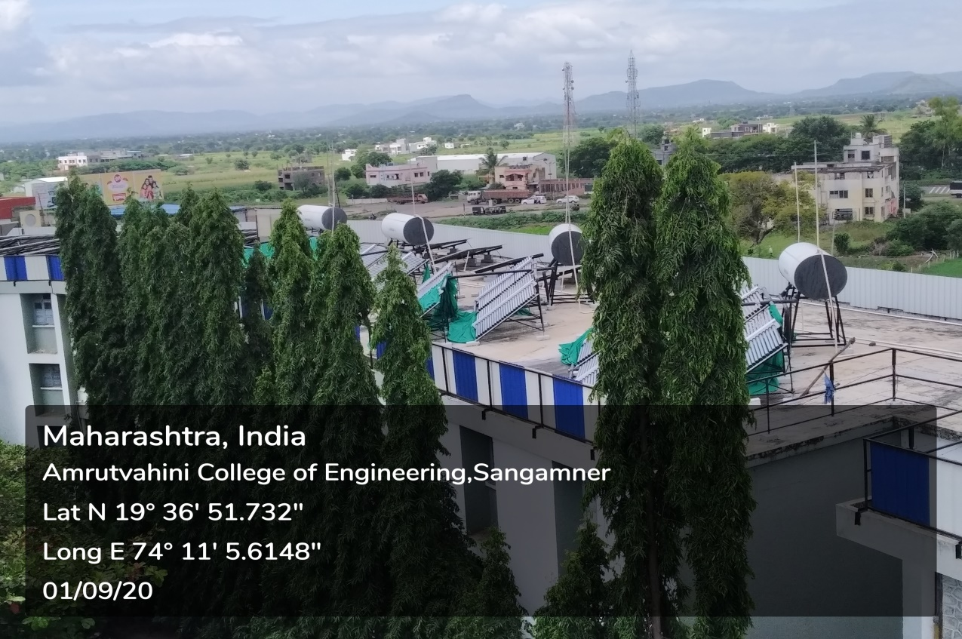

- Purchase Order of 100kWp Solar PhotoVoltaic Plant:

- Purchase Orders of 300 kWp Solar Photo Voltaic Plant

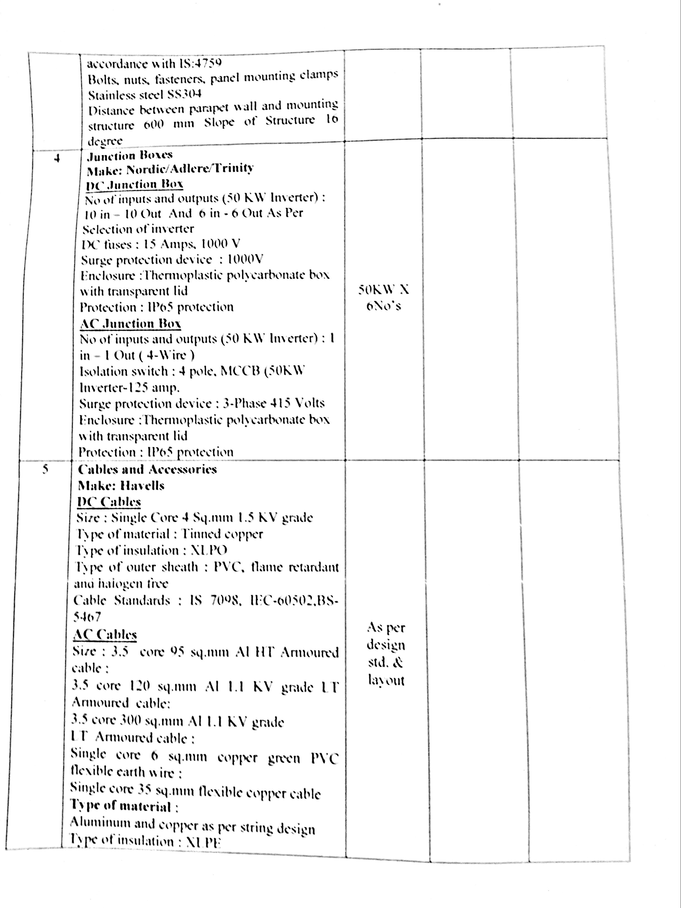

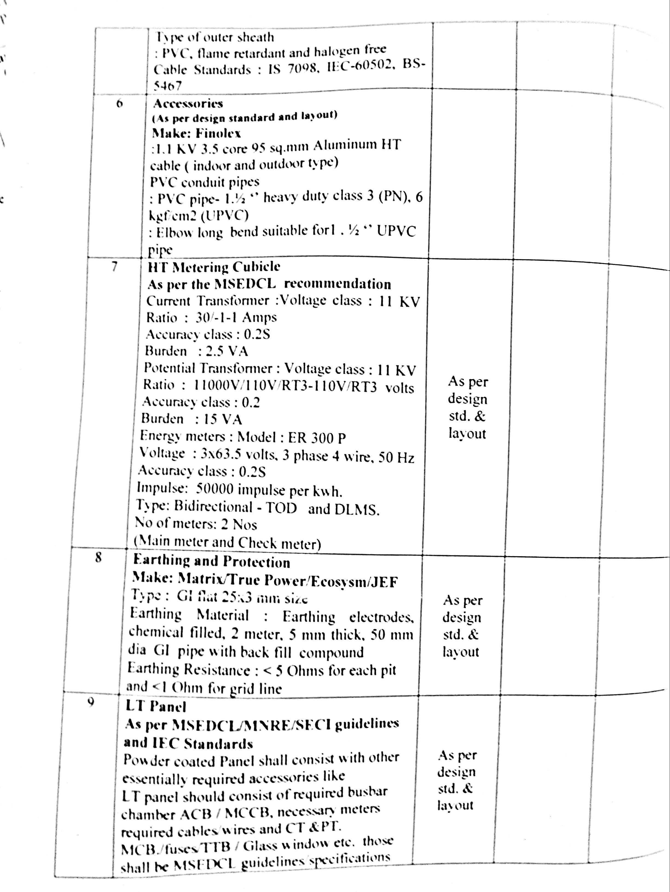

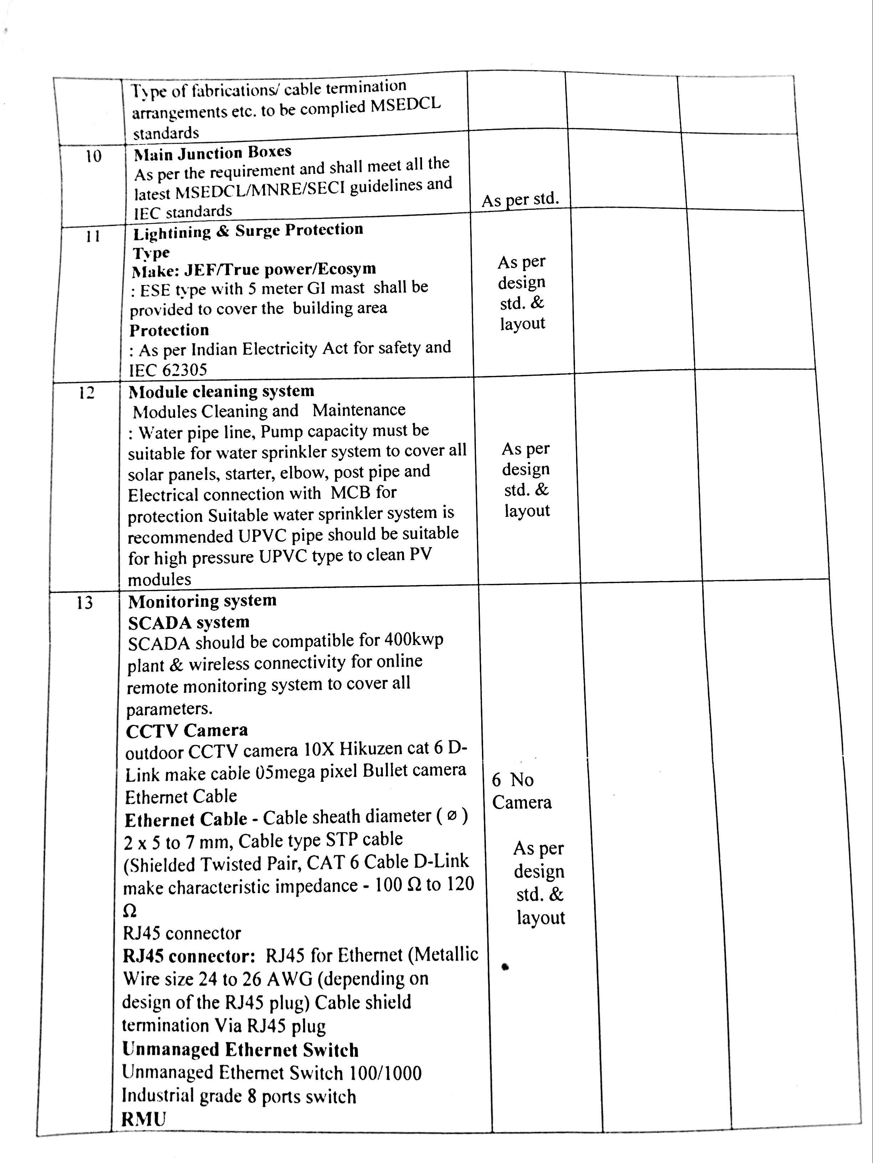

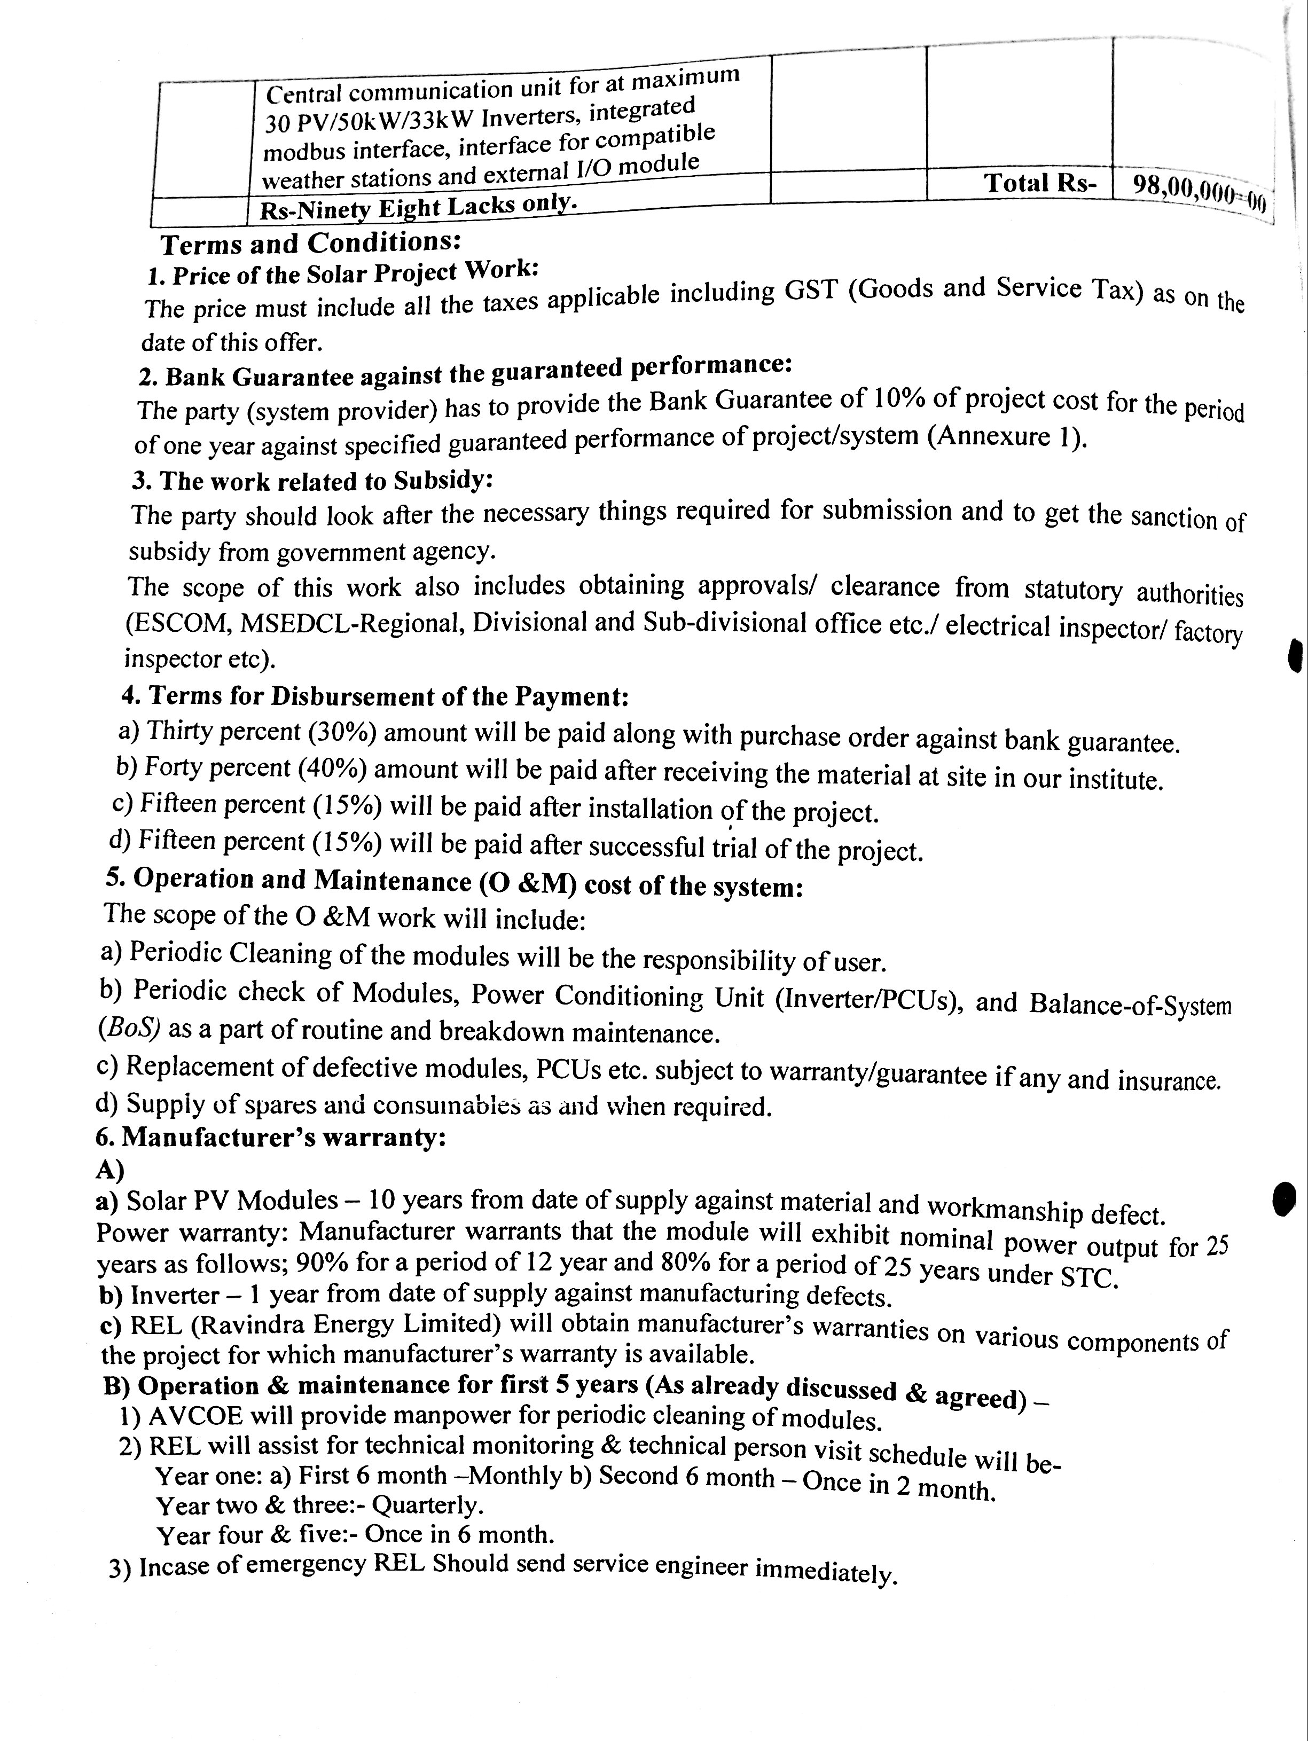

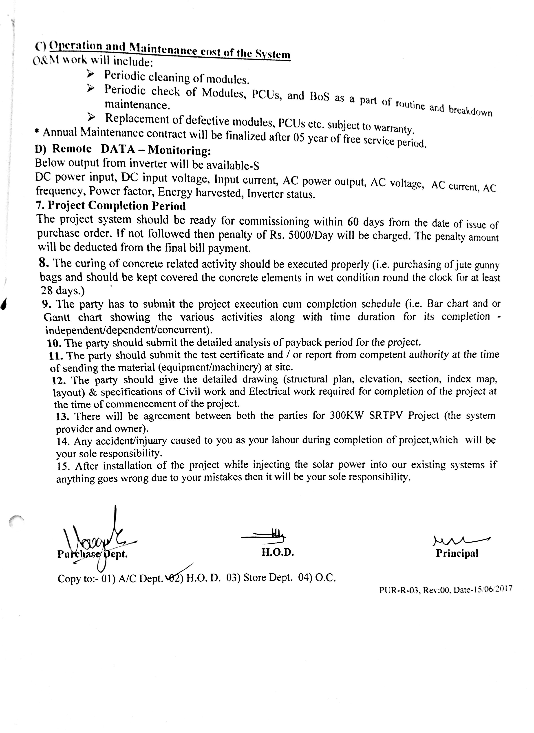

- Purchase Order of 5kW Solar-Wind Hybrid Plant:

- Amrutvahini Sanstha Policy Document for Solar Energy:
