7.1.11: Institution celebrates / organizes national and international commemorative days, events and festivals

INDEX

Sr.No. | Particulars | Page No.
 | Teacher’s Day celebration 05/09/2023 | 2-3
 | Mahatma Jyotiba Phule and Bharatratna Dr. Babasaheb Ambedkar Jayanti celebration 14/04/2024 | 4-5

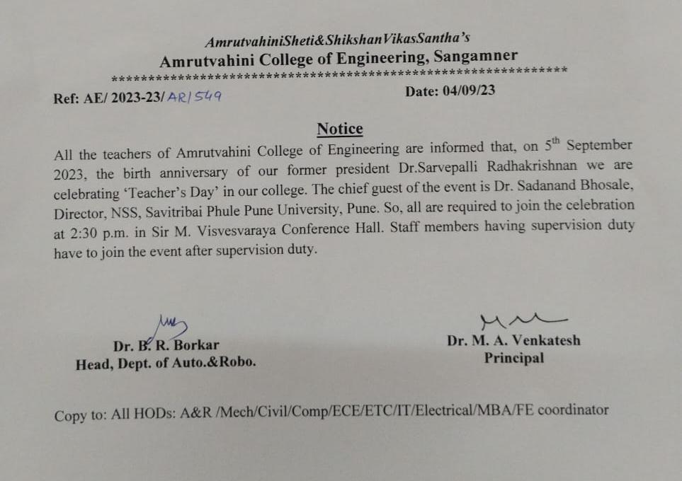
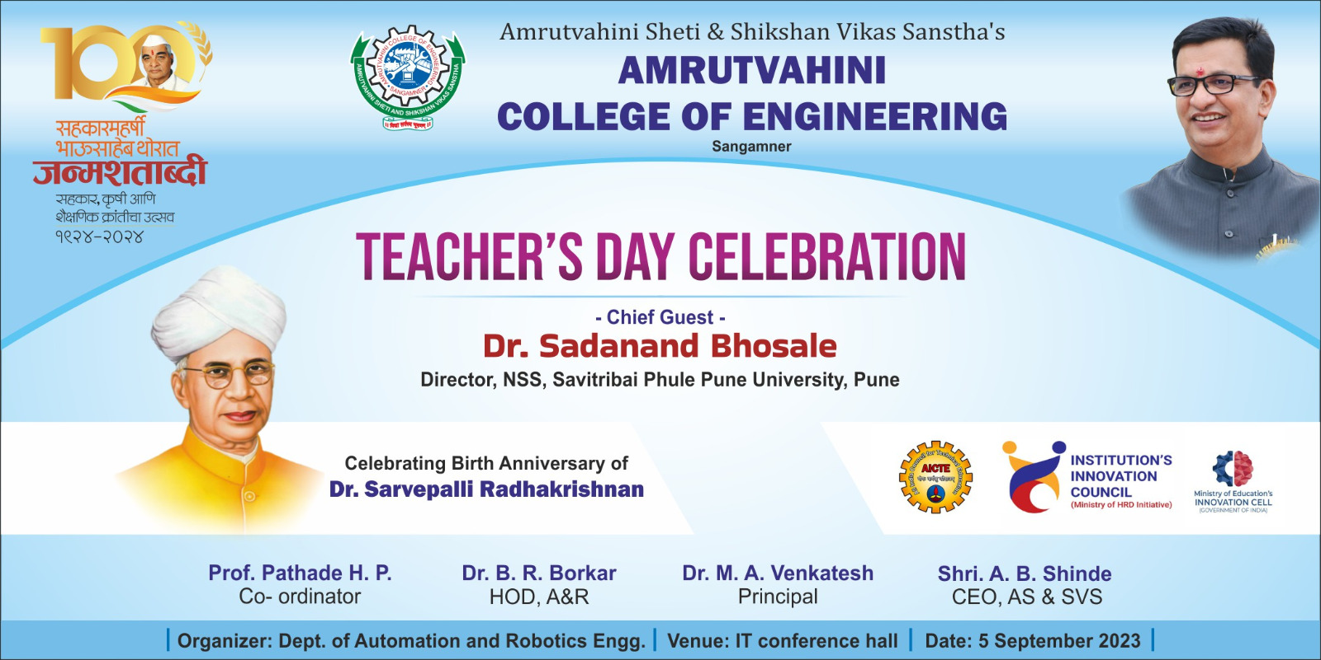
Teacher’s Day Celebration – 2023-24
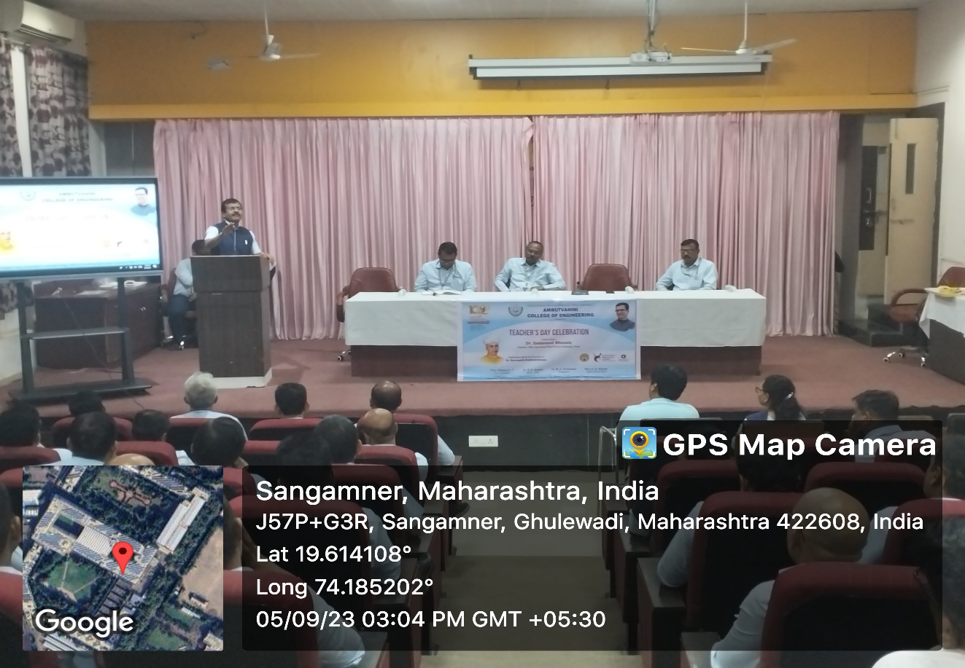

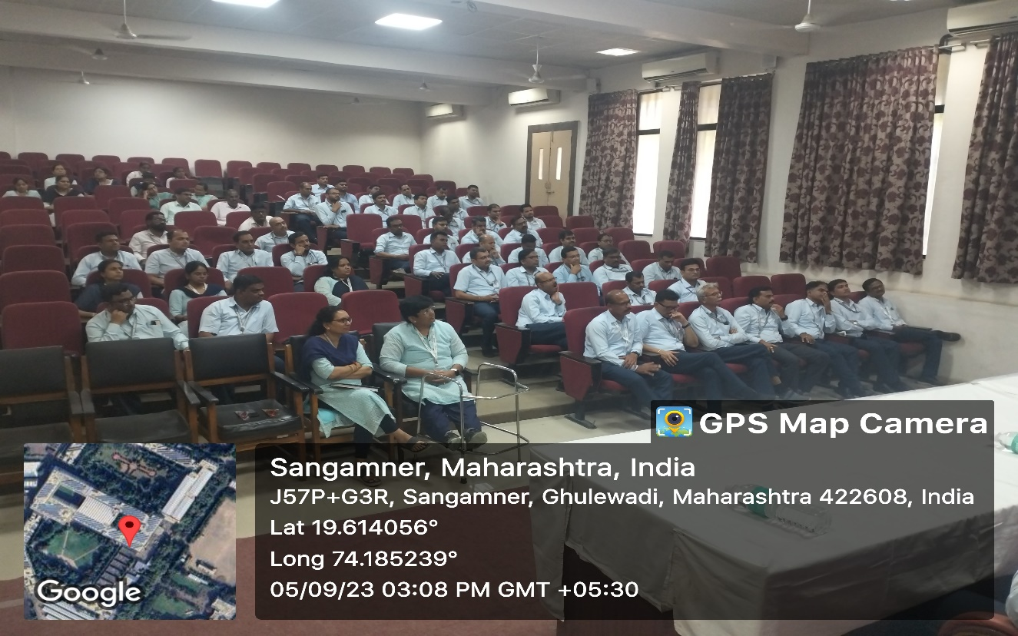
Teacher’s Day Celebration – 2023-24

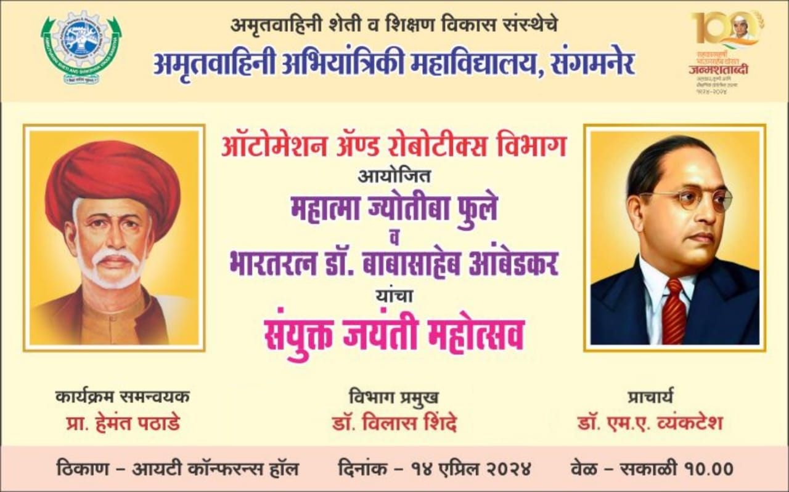
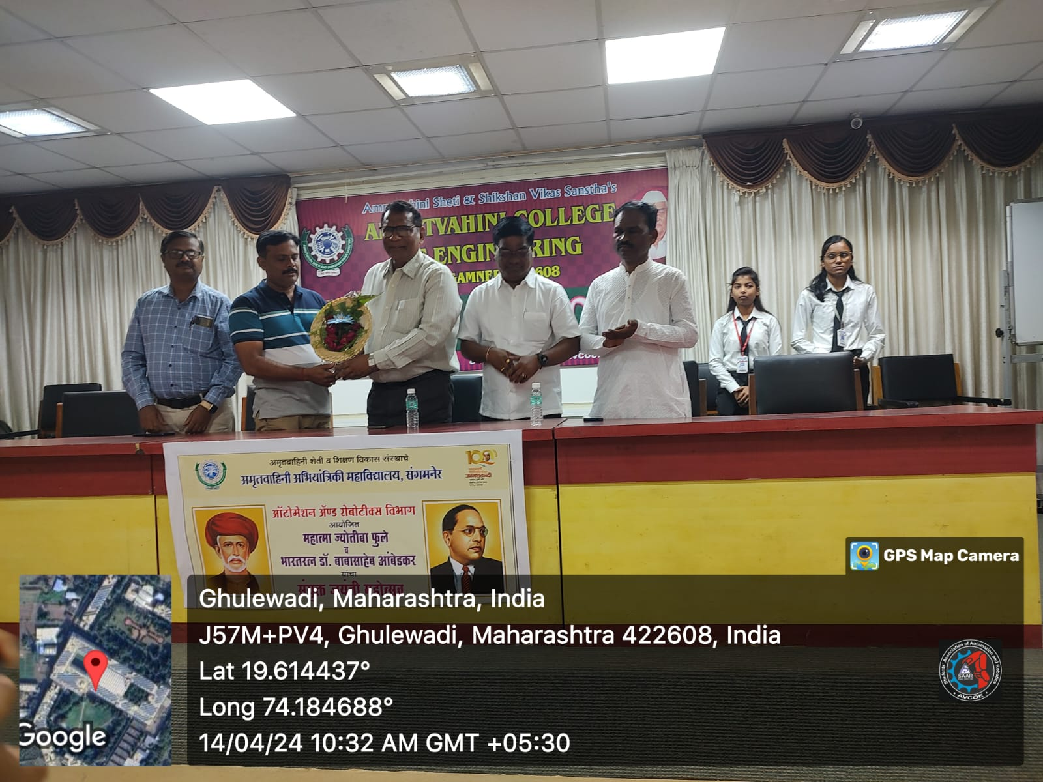

Mahatma Jyotiba Phule and Dr. Babasaheb Ambedkar Jayanti celebration

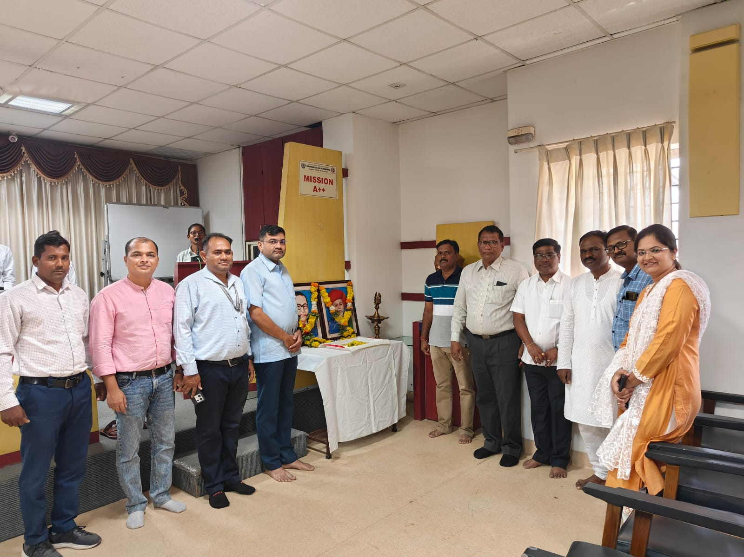

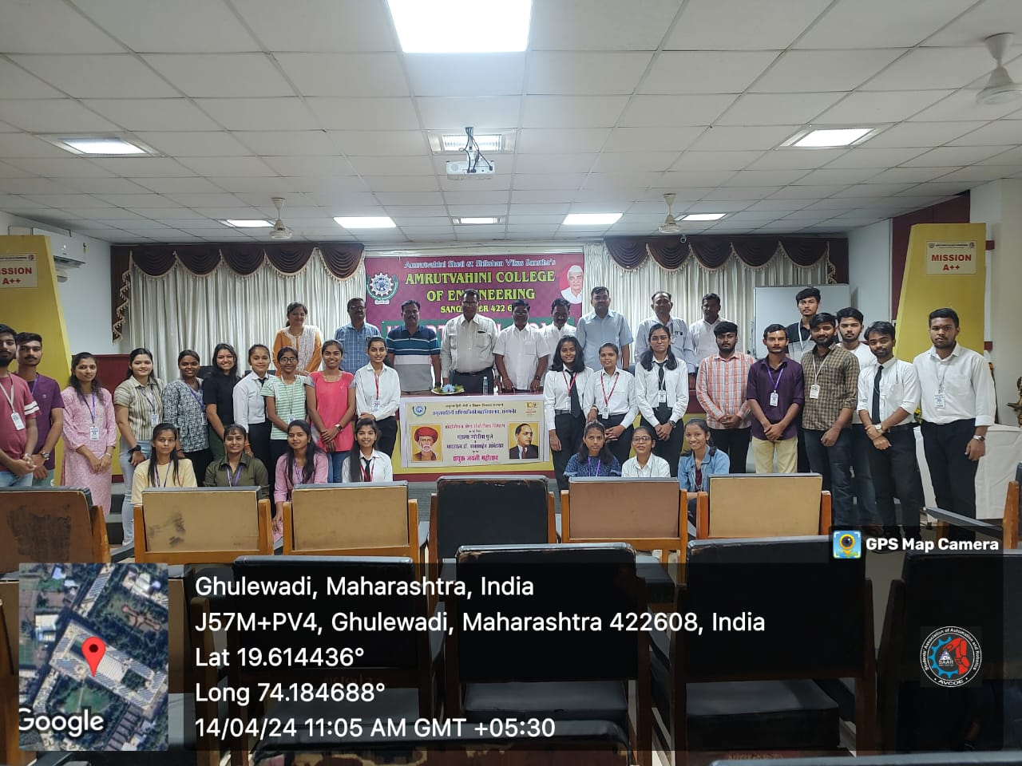

Mahatma Jyotiba Phule and Dr. Babasaheb Ambedkar Jayanti celebration

