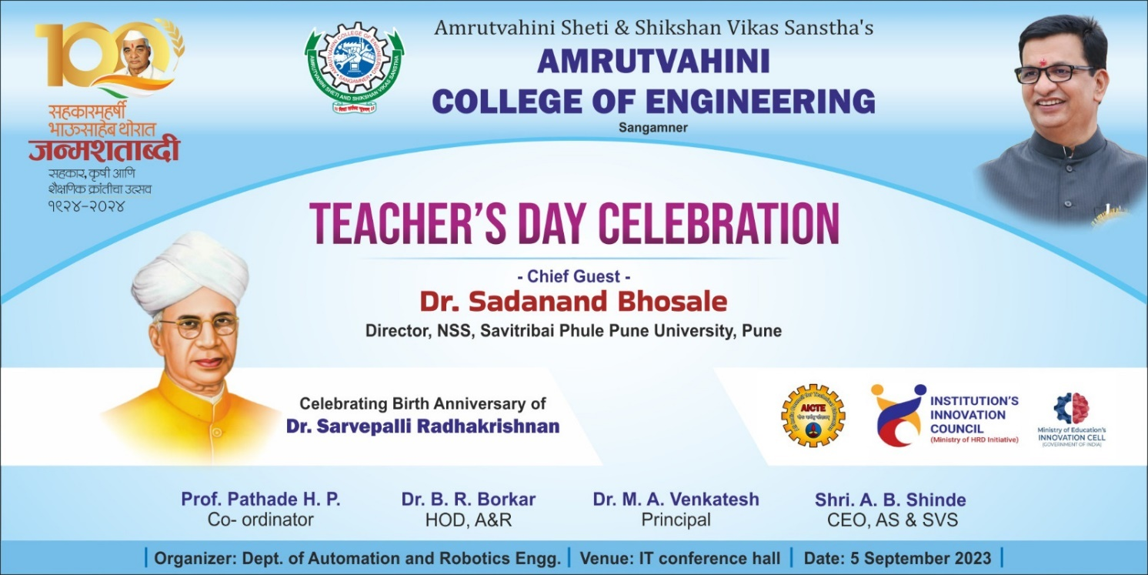
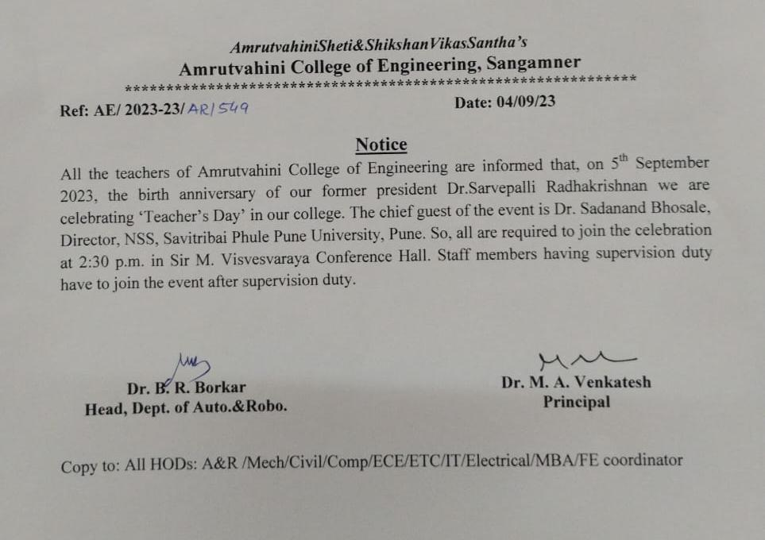

Ref/AE/R&D/2023-24 Date: 16/09/2023
To,
The Principal,
AVCOE, Sangamner.

Subject: Conduction Report of “Teachers Day Celebration” on 05/09/2023.

Respected Sir,
We the Department of Automation and Robotics as per your guidance organized teachers’ day celebration on 05/09/2023. We have invited as the chief guest for the celebration.
The details of the session are as follows:
Resource person | : | Dr. Sadanand Bhosale,  Director, NSS,  Savitribai Phule Pune University, Pune
Total no. of Faculties: | : | 65
Objectives | : | - To provide faculties with insights, information, and guidance for the importance of teaching and guiding process.  - Celebrate the role played by teachers in community upliftment.  - Recognize the central role teachers play in nurturing and guiding students through the lifelong learning process.
Outcomes | : | - Participants gain and understood the importance of teaching and guiding process.  - The session inspired and gave importance the role-played by teachers in community upliftment.  - Participants recognized the central role-played by teachers in nurturing and guiding students through the lifelong learning process.

Coordinator: Prof. H. P. Pathade, Assistant Professor, Dept. of Automation & Robotics.

This is for your kind information.
Thanking you,
With Regards,

Dr. B. S. Borkar
(President, IIC)

Glimpse of Teacher’s Day Celebration

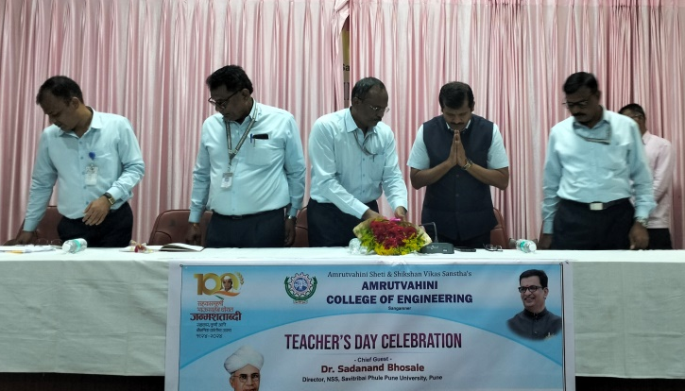 | 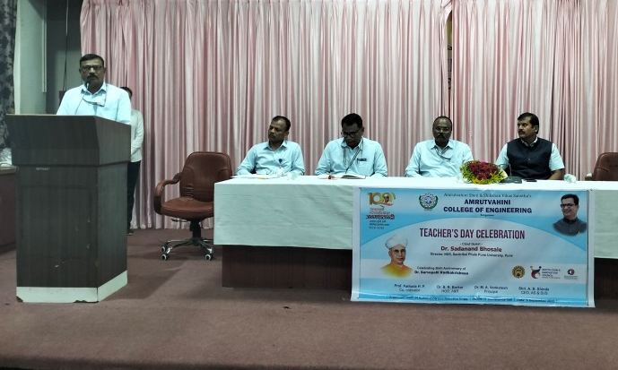
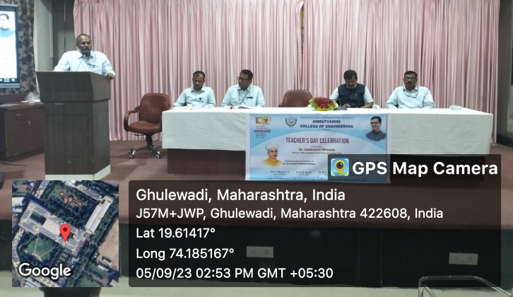 | 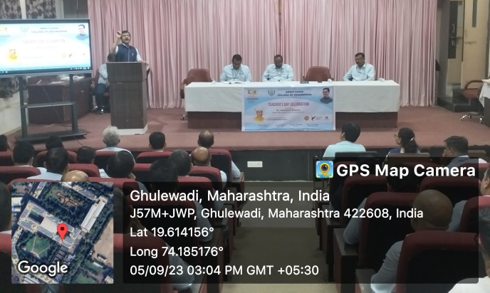
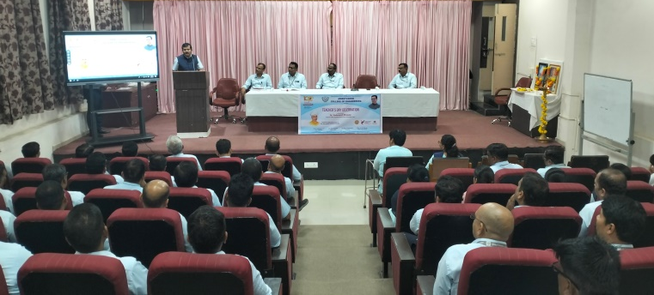 | 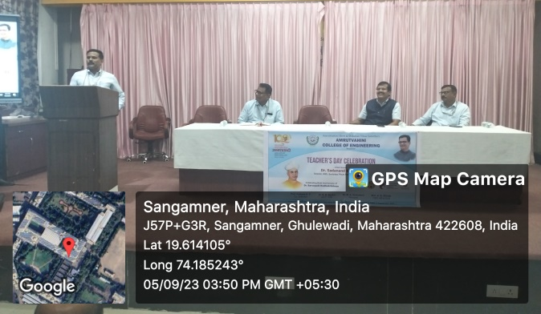

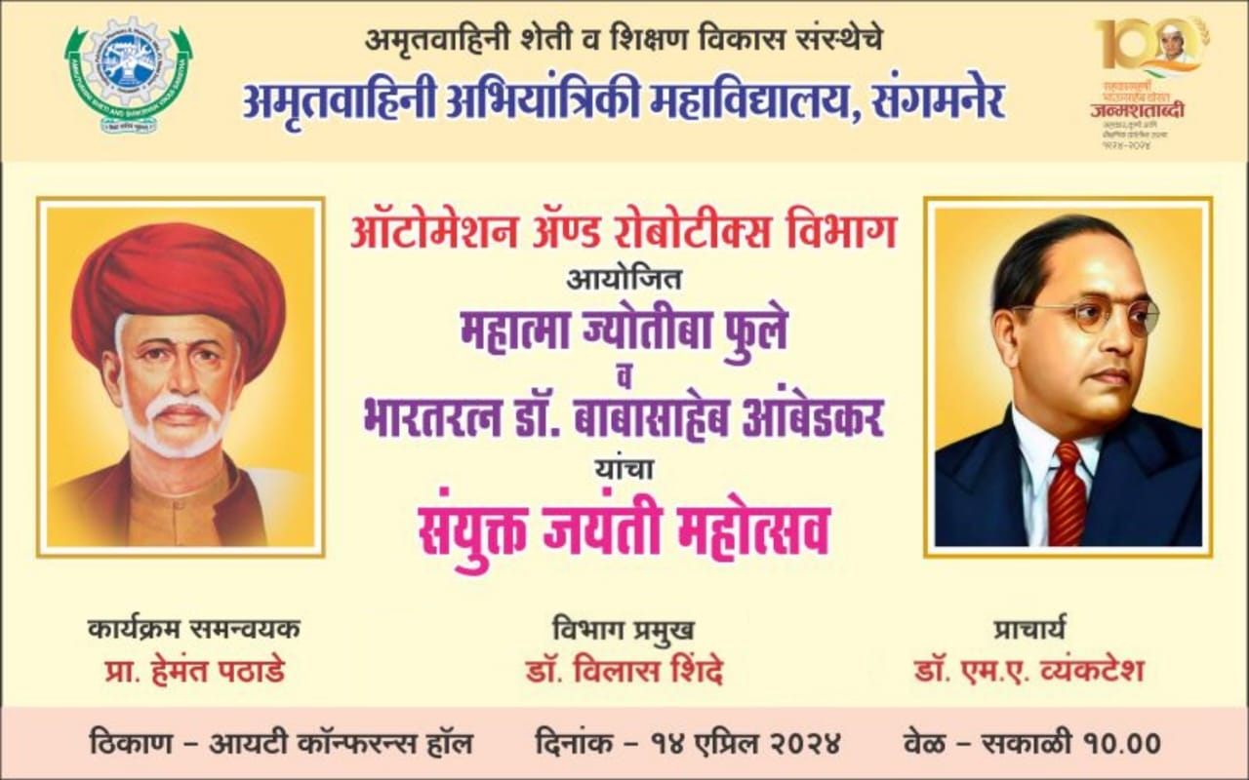

Ref/AE/R&D/2023-24 Date: 16/09/2023
To,
The Principal,
AVCOE, Sangamner.

Subject: Conduction Report of Mahatma Jyotiba Phule and Bharatratna Dr. Babasaheb Ambedkar Jayanti celebration on 14/04/2024.

Respected Sir,
We the Department of Automation and Robotics as per your guidance organized Mahatma Jyotiba Phule and Bharatratna Dr. Babasaheb Ambedkar Jayanti celebration on 14/04/2024 at 10:00 a. m. in IT conference Hall. Dr. M. R. Wakchaure, HOD, Civil Engineering Dept. was invited as the chief guest of the event. Students gave speech on contribution by Mahatma Phule and Dr. Babasaheb Ambedkar towards the society. Dr. B. N. Bansode sang two songs related to the celebration. Dr. M. R. Wakchaure and Dr. V. B. Shinde shared their view, experience and motivated the students. Vote of thanks was given by Parimal Pokharkar.
The details of the session are as follows:
Total no. of Faculties: | : | 10
Total no. of Students | : | 30
Objectives | : | - To provide insights, information, and guidance for the importance of great social reformers.  - Celebrate the birth anniversary of Mahatma Jyotiba Phule and Bharatratna Dr. Babasaheb Ambedkar.
Outcomes | : | - Participants gain and understood the importance of great social reformers.  - Celebrated the birth anniversary of Mahatma Jyotiba Phule and Bharatratna Dr. Babasaheb Ambedkar.

Coordinator: Prof. H. P. Pathade, Assistant Professor, Dept. of Automation & Robotics.

This is for your kind information.
Thanking you,
With Regards,

Dr. B. S. Borkar
(President, IIC)

