INDEX
Sr. No. Description Pg. No.
- Plan of the Institute 1
- Play Ground (Padmabhushan Vasantdada Patil Krida Sankul) 2
- Play Ground (Medha Ground) 3
- Amphitheatre 4
- Amrut Kalamanch 5
- Gymkhana Boys 6
- Gymkhana Girls 8
- Girls Hostel Volleyball and Basketball Ground 9
- Yoga facilities 10
- Plan of the Institute

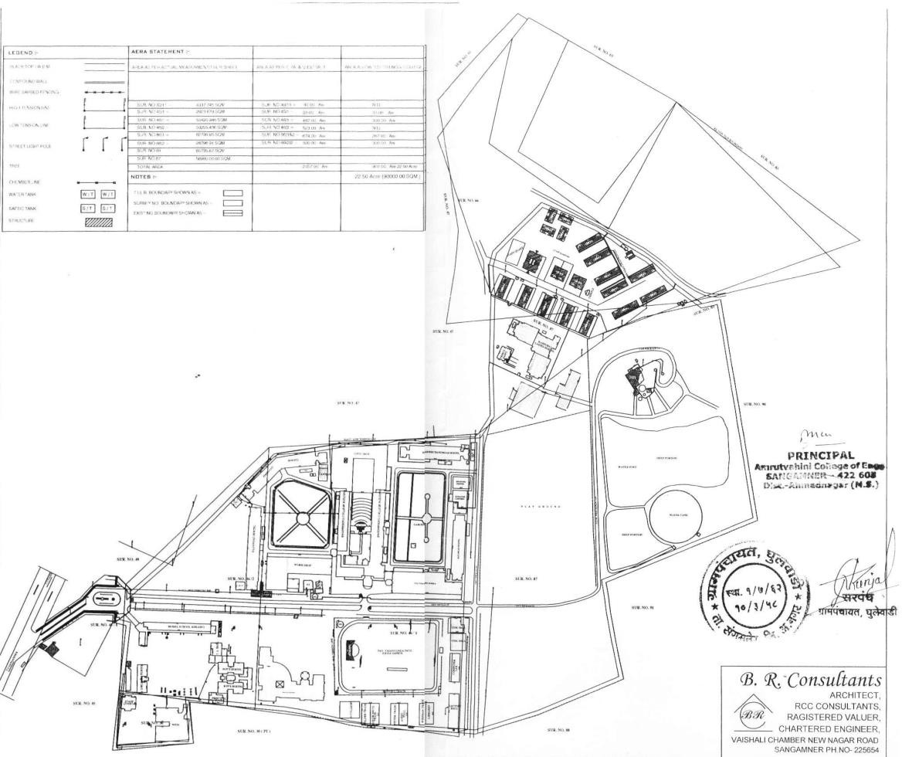
Fig. 1

- Play Ground (Padmabhushan Vasantdada Patil Krida Sankul)

Padmabhushan Vasantdada Patil Krida Sankul
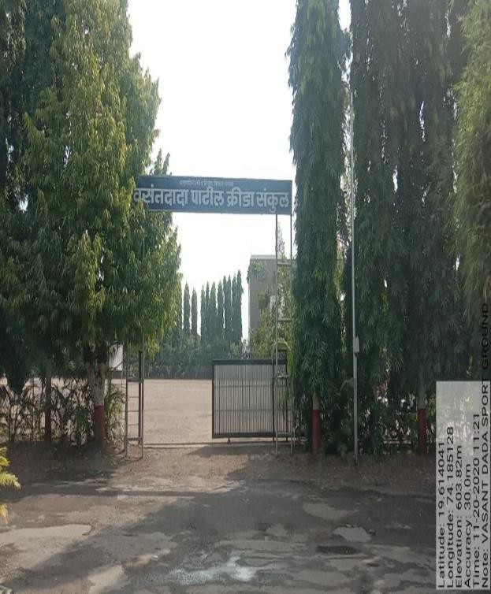

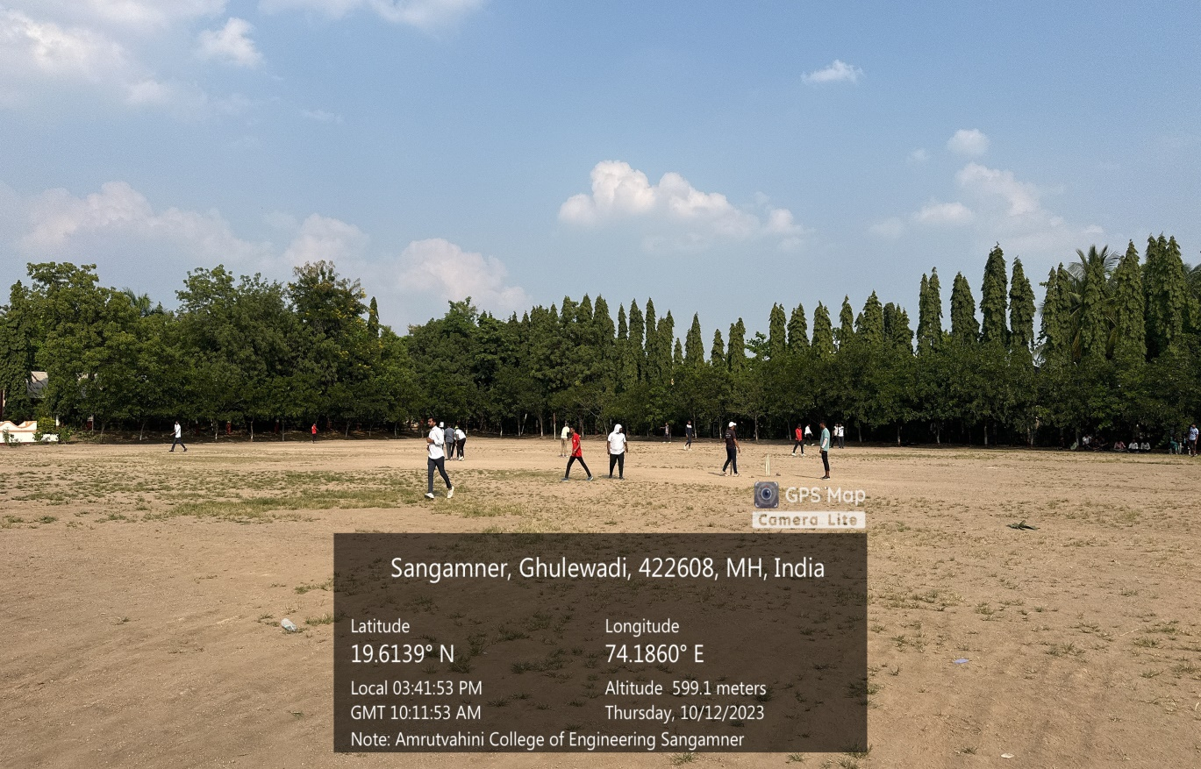

- Play Ground (Medha Ground)

Medha Ground
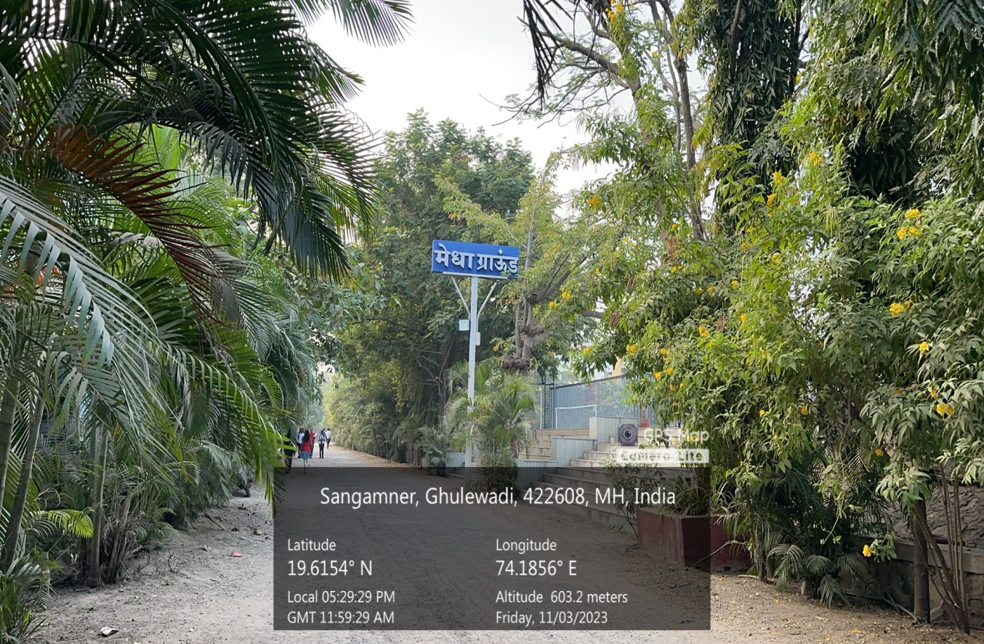
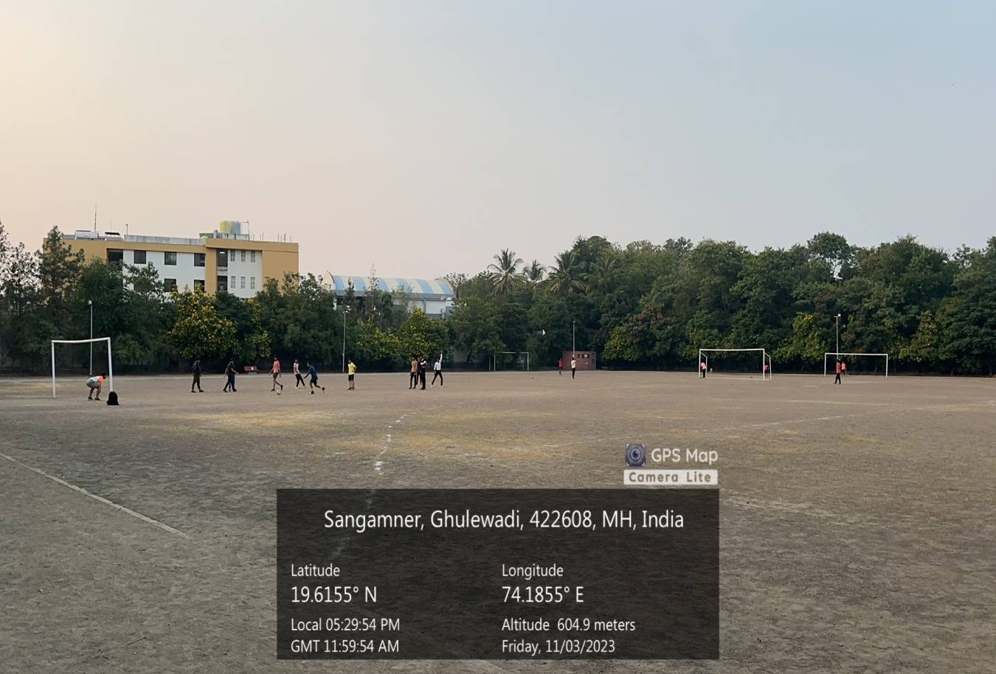

- Amphitheatre

Amphitheatre
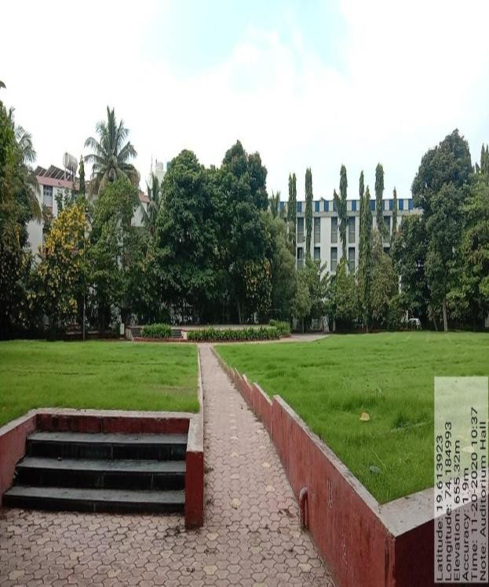
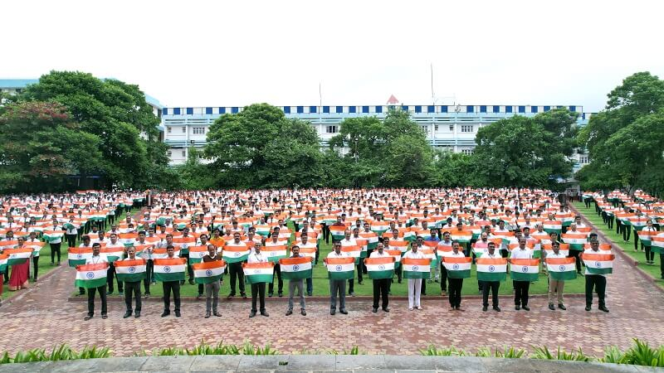

- Amrut Kalamanch

Amrut Kalamanch
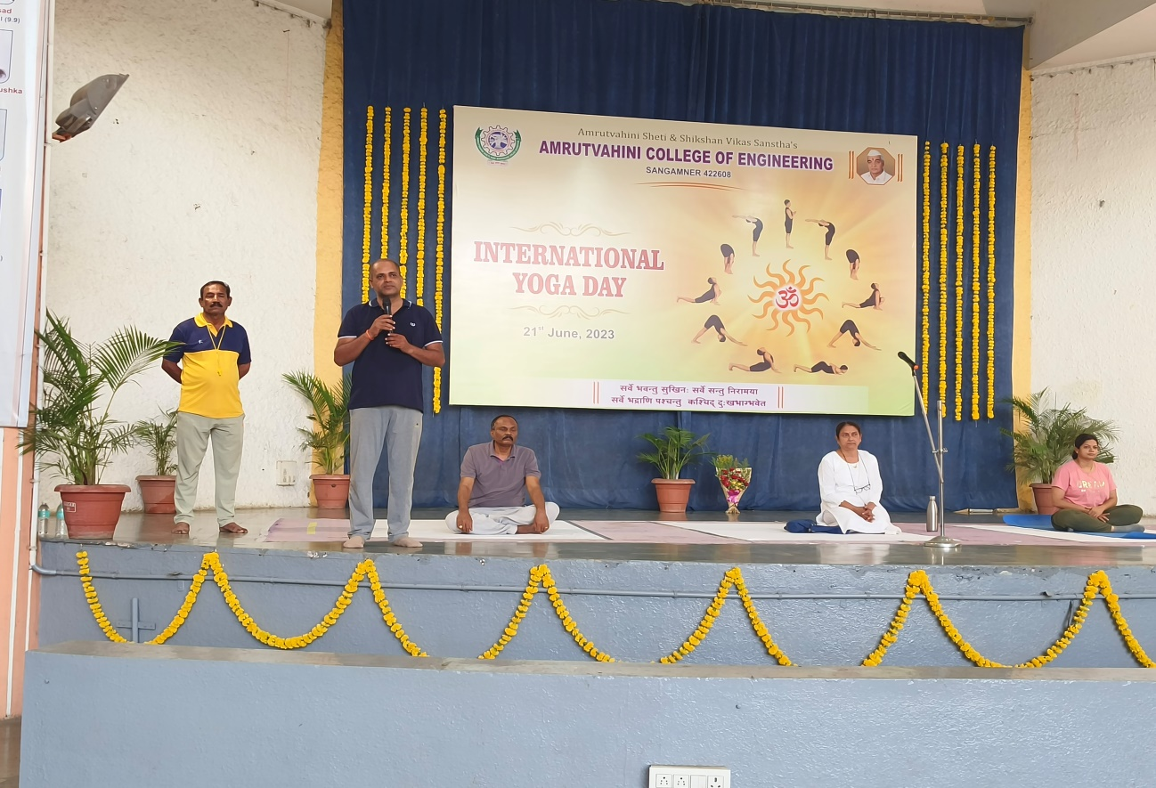
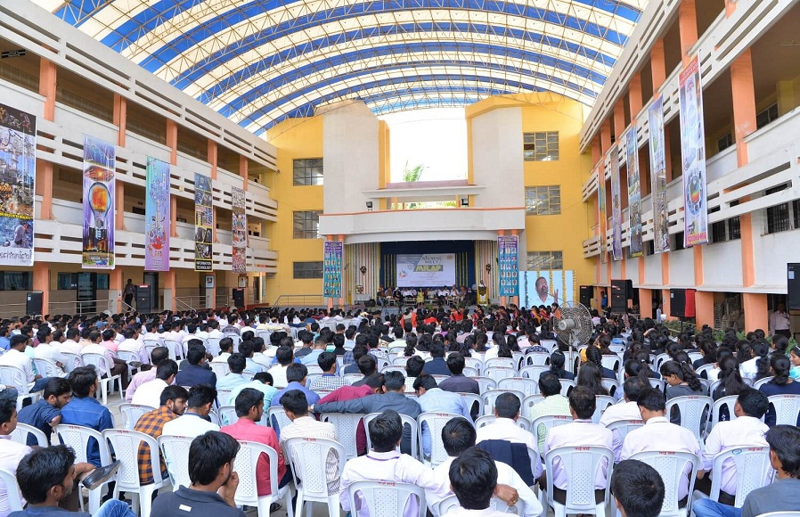

- Gymkhana Boys

Gymkhana Boys
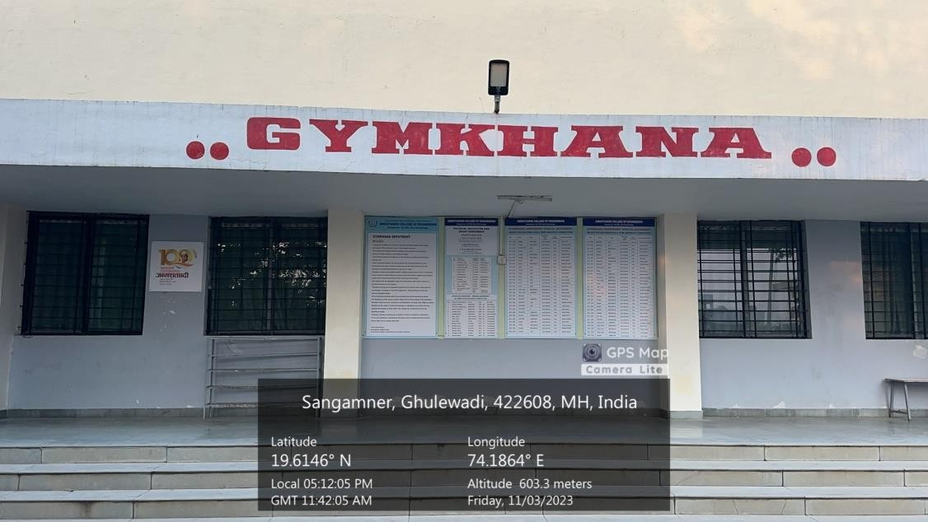

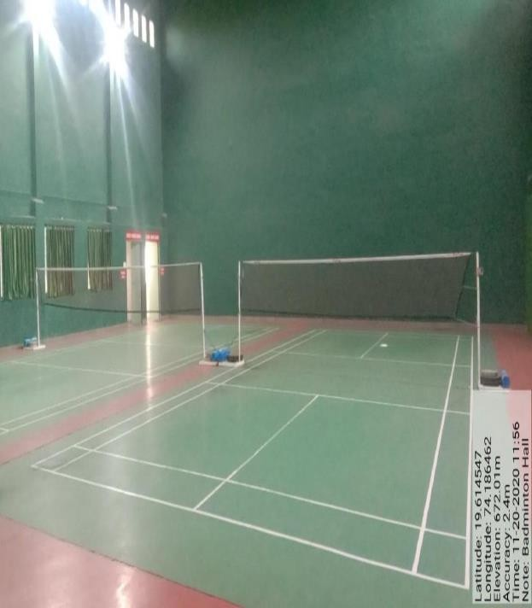

Gymkhana Boys
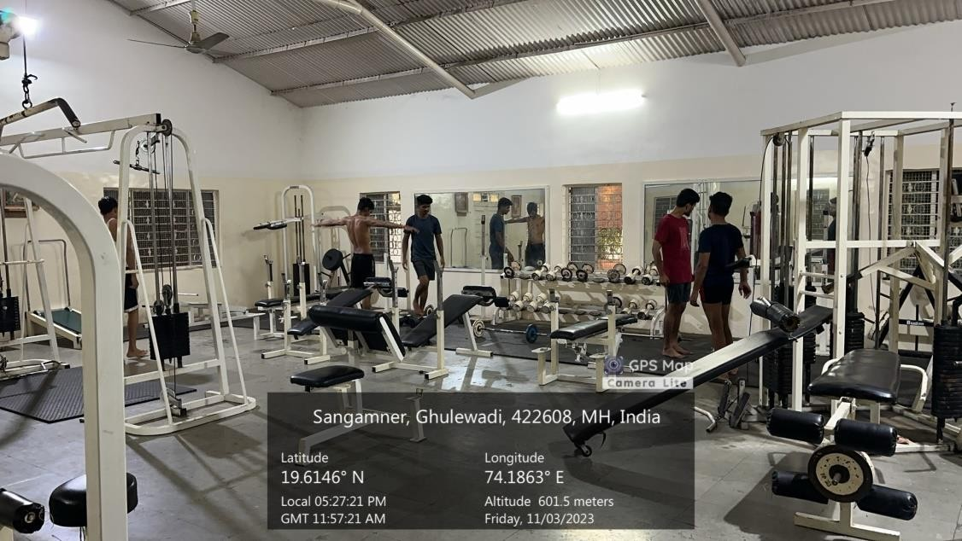
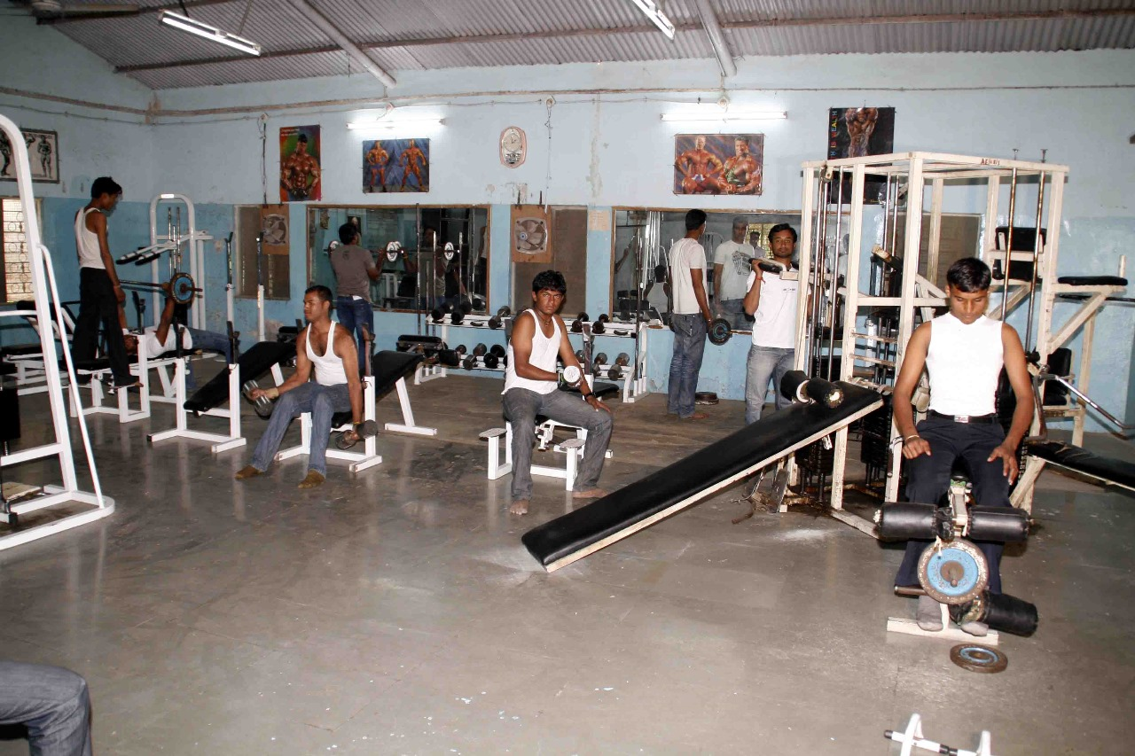

- Gymkhana Girls

Gymkhana Girls
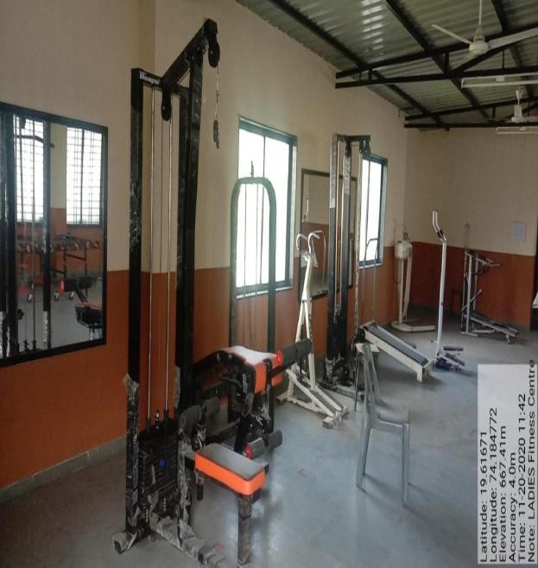
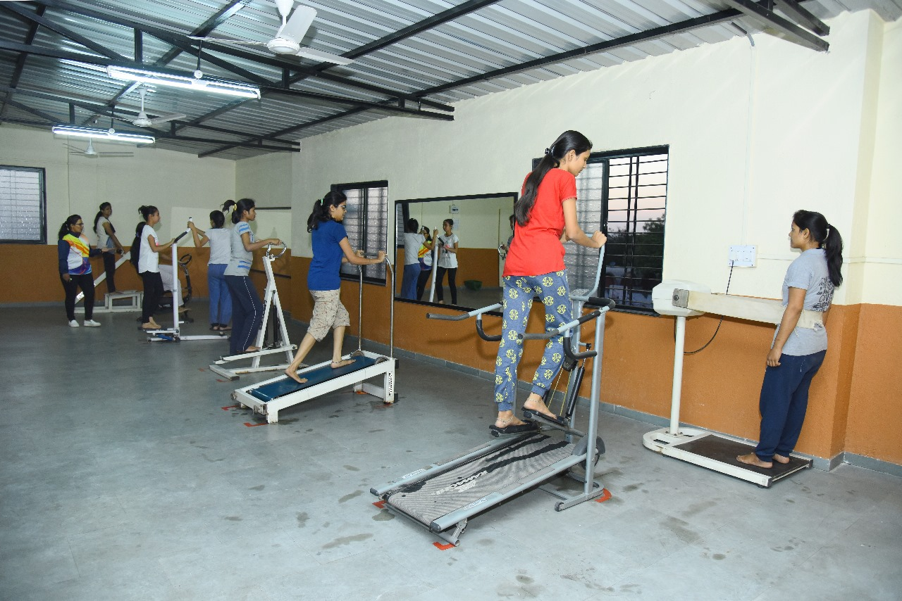

- Girls Hostel Volleyball and Basketball Ground

Girls Hostel Volleyball Ground
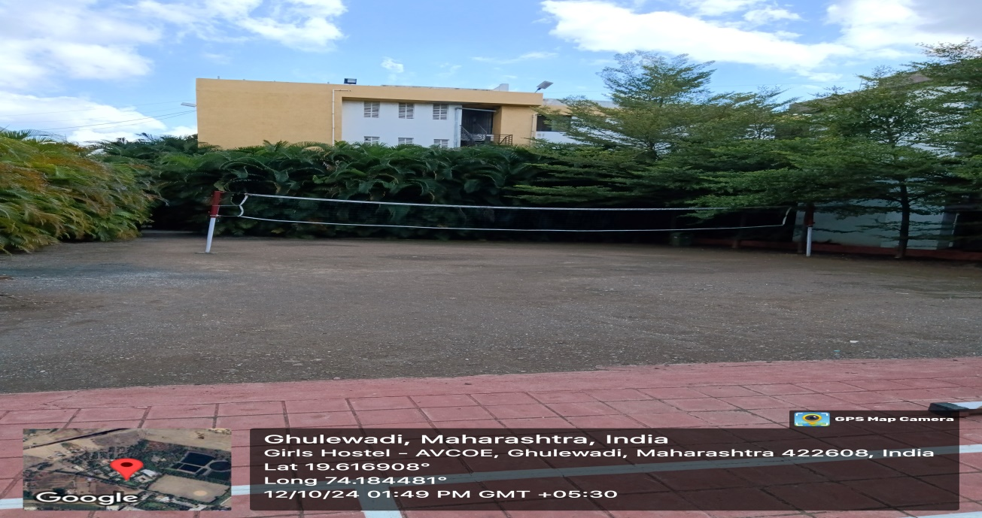
Girls Hostel Basketball Ground
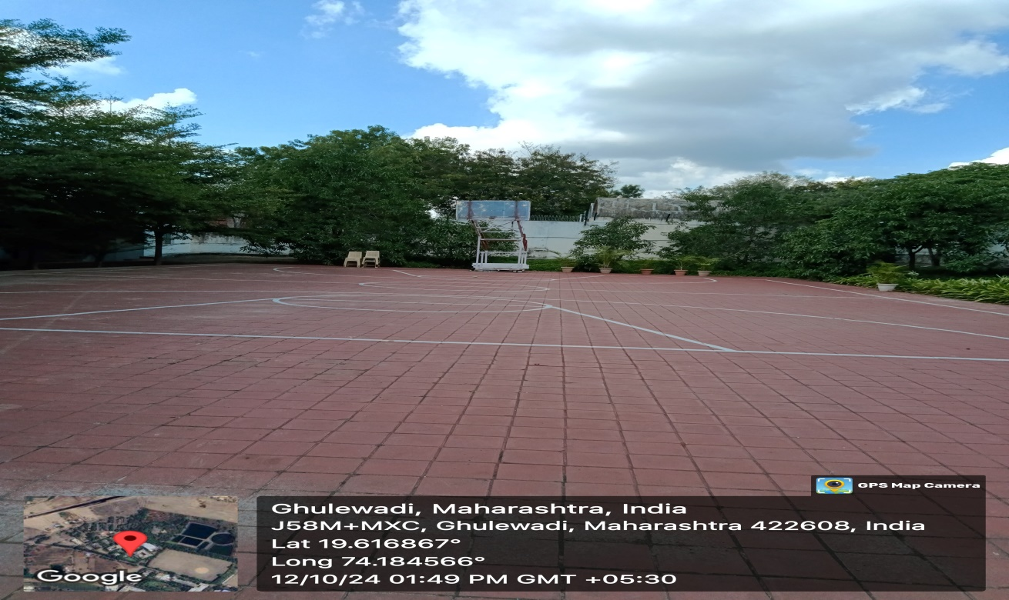

- Yoga facilities

Yoga facilities
