Gymkhana and Sports Facility

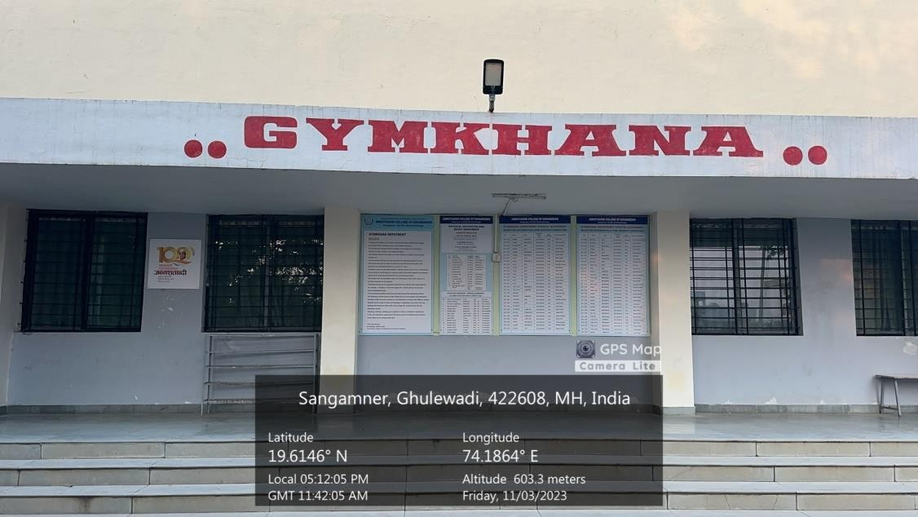
Photograph 1: Gymkhana Entrance
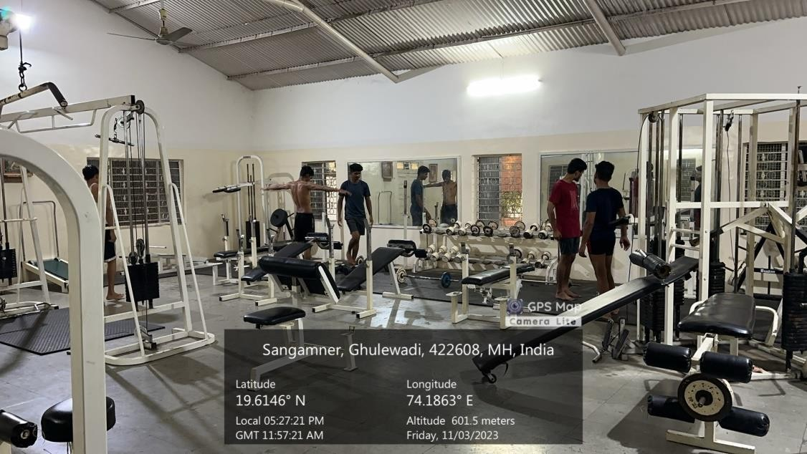
Photograph 2: Gymkhana Exercise Equipments
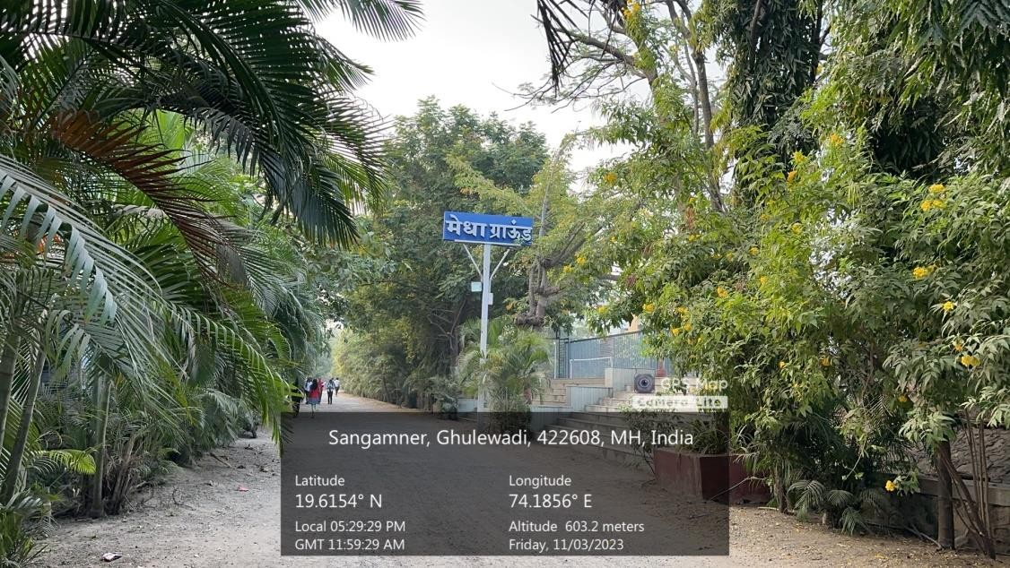
Photograph 3: Medha Sports Ground Entrance

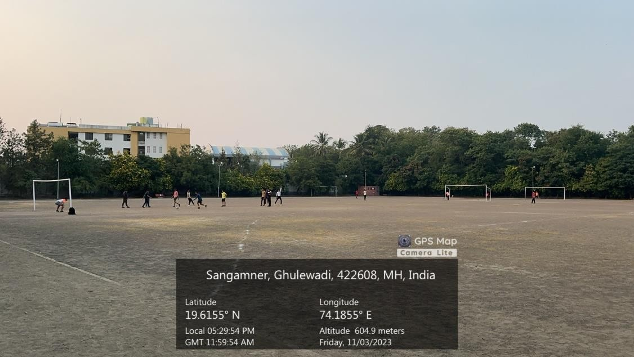
Photograph 4: Medha Sports Ground
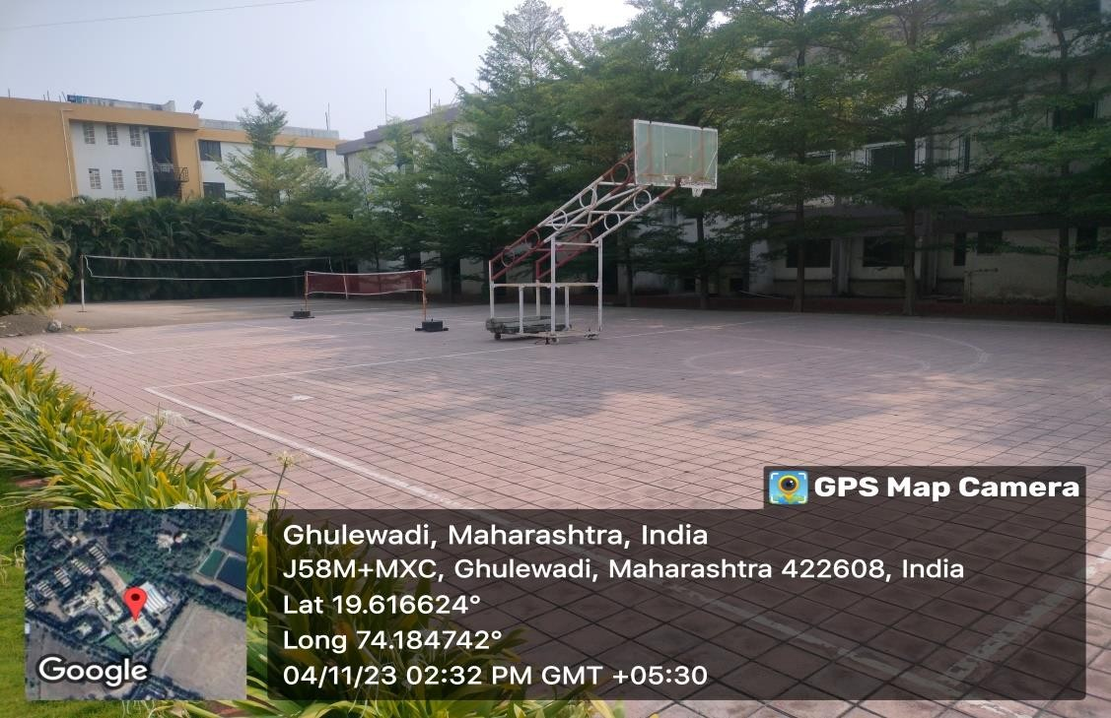
Photograph 5: Basketball Court
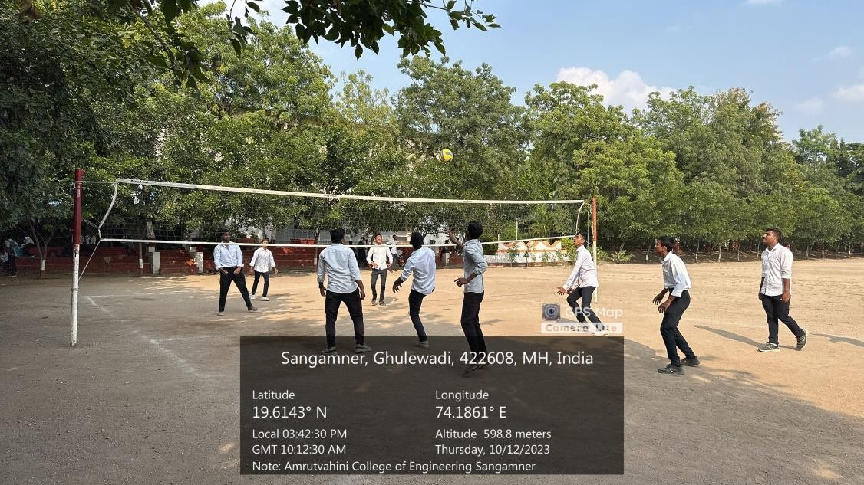
Photograph 6: Volleyball Court
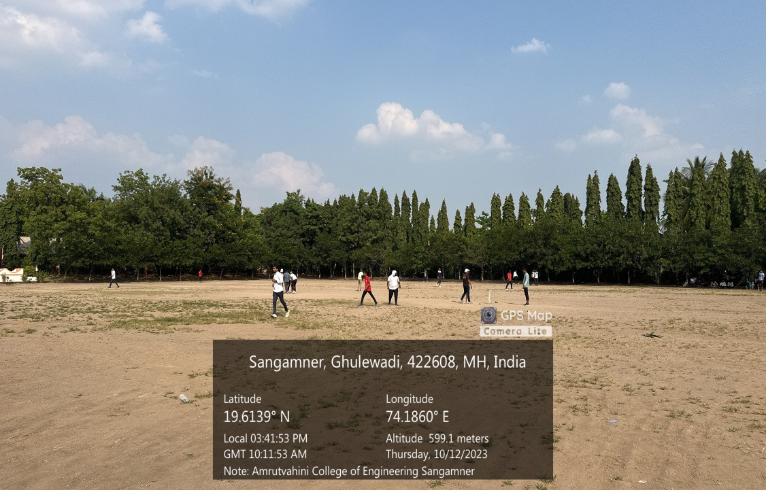
Photograph 7: Padmabhushan Vasantdada Patil Krida Sankul
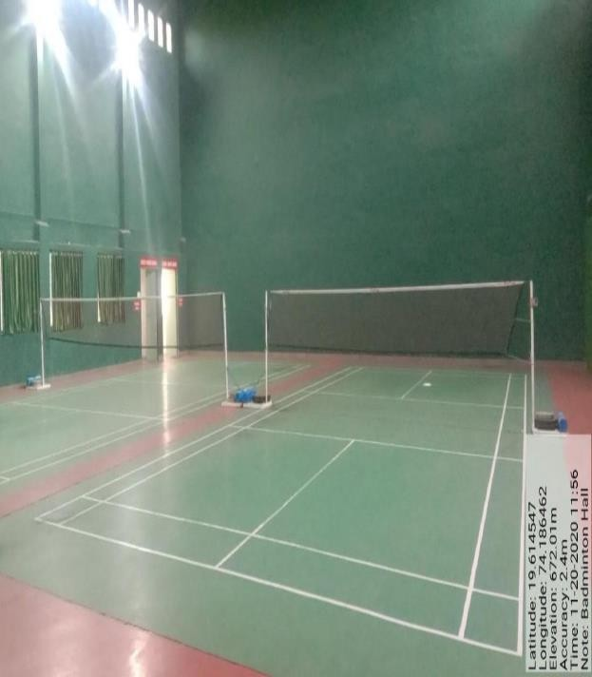
Photograph 8: Badminton Court
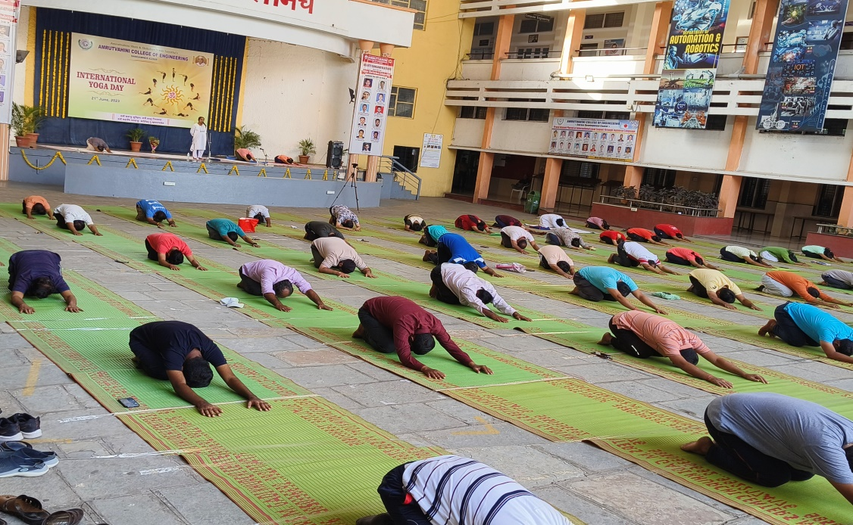
Photograph 9: Yoga Facility

