4.1.2: The Institution has adequate facilities for cultural activities, sports, games (indoor, outdoor), gymnasium, yoga etc.

INDEX

Sr. No. | Description | Pg. No.
1. | Institutional adequate facilities for cultural activities and sports | 1
2. | Link for Geo-tagged Photograph | 1
3. | Institution Plan (Bird’s Eye view) | 2
4. | Additional Information | 3

Institutional adequate facilities for cultural activities & sports
The Institute has two wide playgrounds having size 50,420m² (Padmabhushan Vasantdada Patil Krida- Sankul, Survey no. 46/1, shown in Fig. 1) and 58,980m² (Survey no.87) for sports for playing outdoor games such as cricket, volley ball, basketball, running track, horse riding and foot-ball. Similarly, the institute also has the facility for indoor games such as chess, table tennis and badminton. The Institute has cultural cell/Mudra Club which looks after cultural activities since 2015-16, every year Institute conducted a cultural event “Medha” to nurture the talent of the students.

Link for Geo-tagged Photograph
The Table below provides the information at a glance and the link for Geo-tagged photo /plan for the Institution having adequate facilities for cultural activities, sports, games (indoor, outdoor), gymnasium, yoga, etc.

Sr.  No. | Name of the facility | Area | Link to Open
1. | Padmabhushan Vasantdada Patil Krida Sankul | 50,420 m² | Click Here
2. | Medha Ground | 58,980 m² | Click Here
3. | Amphitheatre | 2,000 m² | Click Here
4. | Amrut Kalamanch | 550 m² | Click Here
5. | Gymkhana | 450 m² | Click Here
6. | Birds Eye view | -- | Click Here

Institution Plan (Bird’s Eye view)
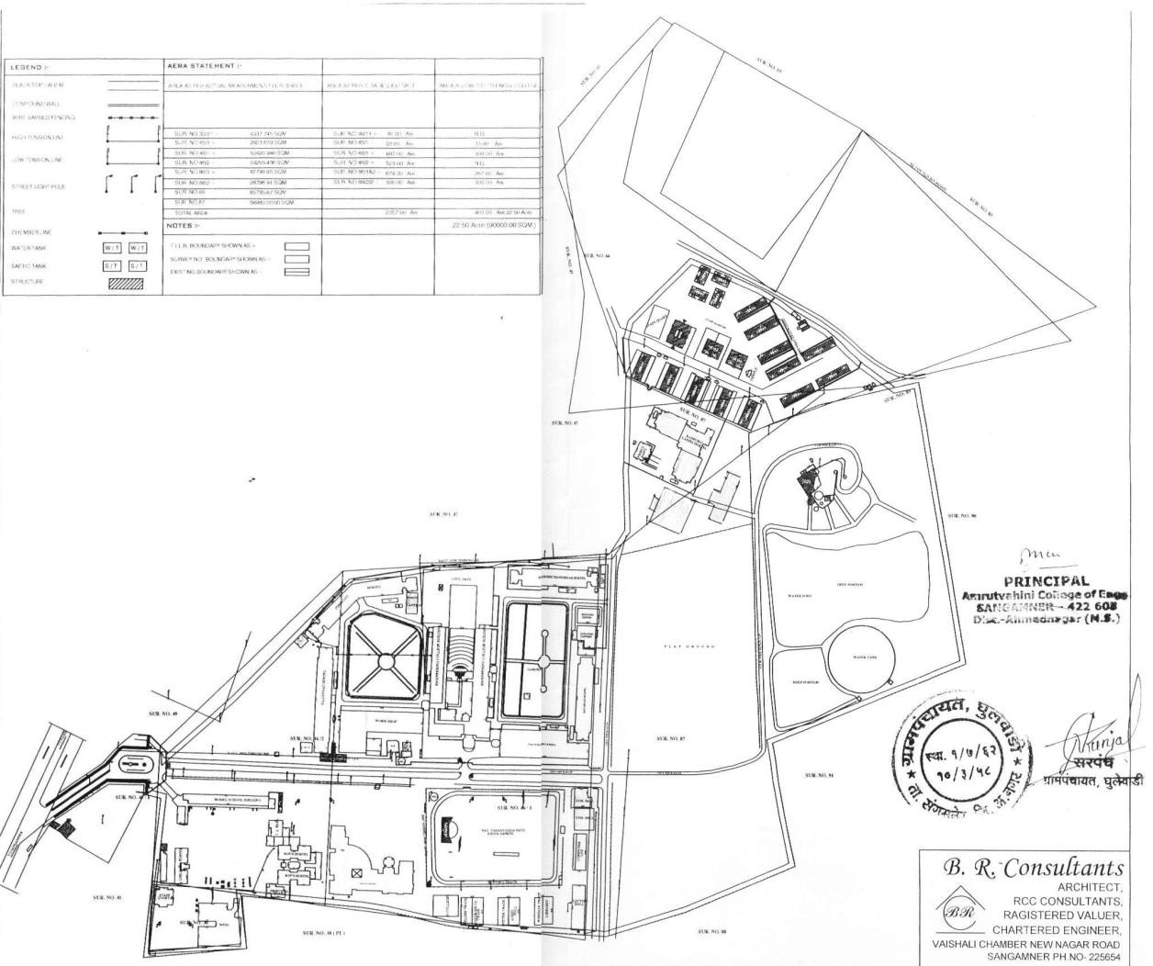

Fig. 1

Additional Information
For encouraging students towards cultural activities, the institute organizers many competitions like dance, song (group and solo), writing, debate, rangoli, flower decoration, poster making, painting etc every year at the time of “Medha” Youth Festival. Medha annual report of year 2023-24 is given in the following links.

Sr. No. | File Description | Link to open
1. | “Medha” 2023-24 | https://www.medhafest.com/

