

Amrutvahini College of Engineering, Sangamner

Department of Civil Engineering
4.1.1 Classrooms and seminar halls

Room ID | Description
G-14 | Class Room with Green-Board, DLP, Internet, OHP & DLP-Screen
G-15 | Class Room with Green-Board
G-30 | Tutorial Room with Green-Board, DLP, Internet, OHP & DLP-Screen
F-24 | Class Room with White-Board, DLP, Internet, OHP & DLP-Screen
F-25 | Class Room with White-Board, DLP, Internet, OHP & DLP-Screen
F-26 | Class Room with White-Board, DLP, Internet, OHP & DLP-Screen

- Geo-tagged photographs of Class Rooms/ Seminar Halls with Captions

ID No. | Photos
G14 | 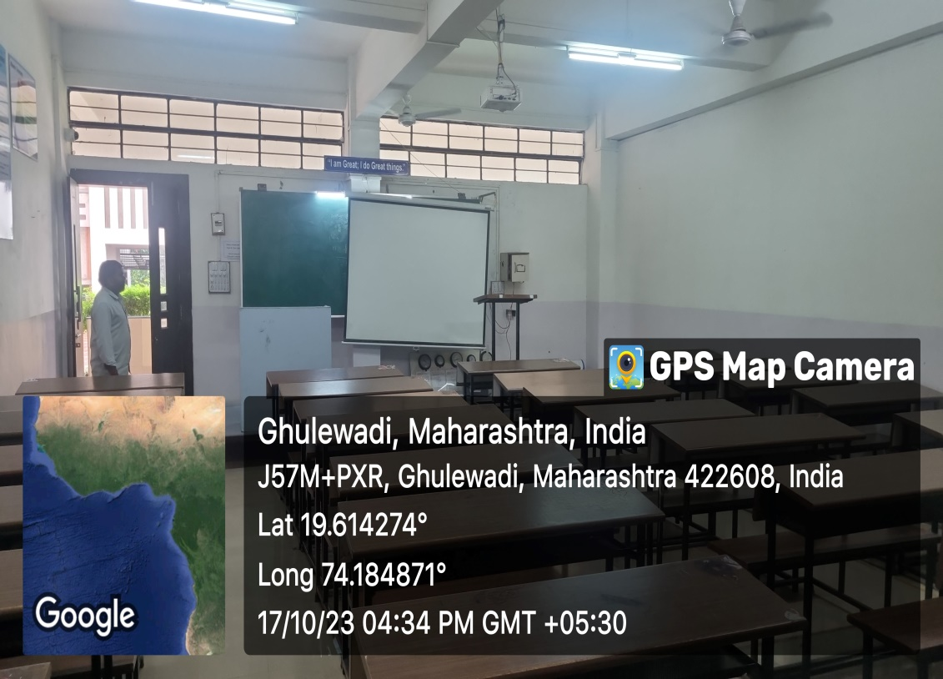
G15 | 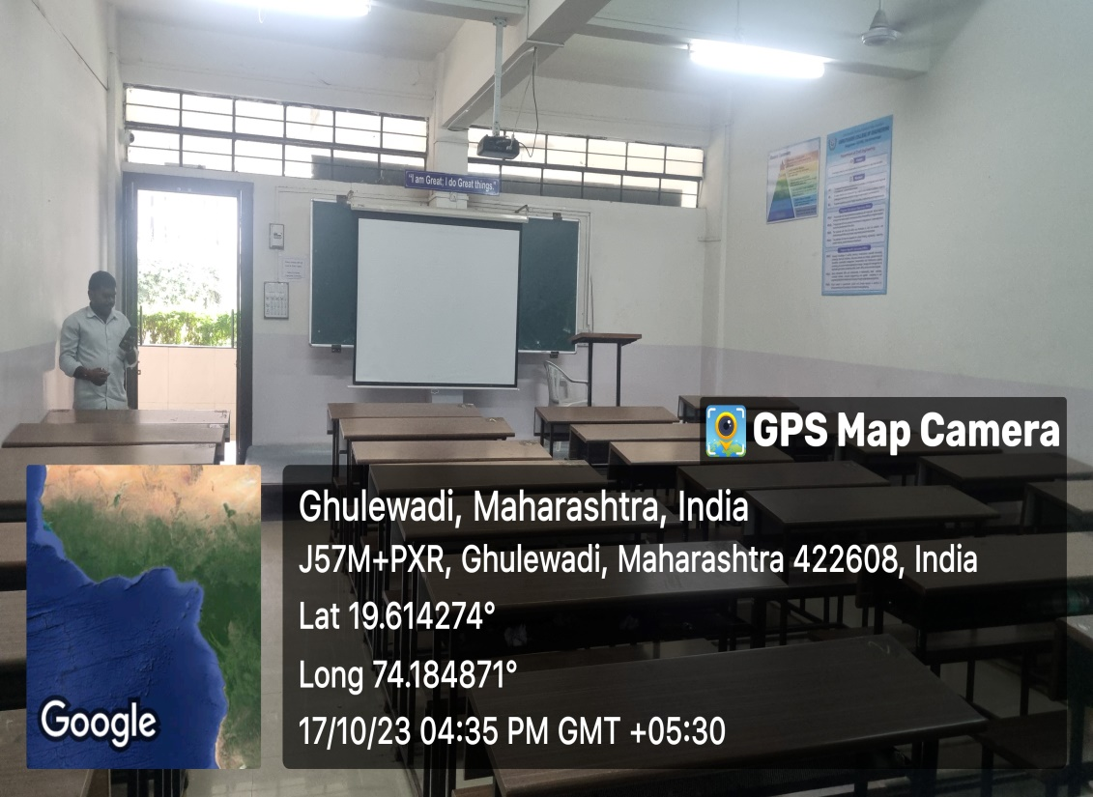
F24 | 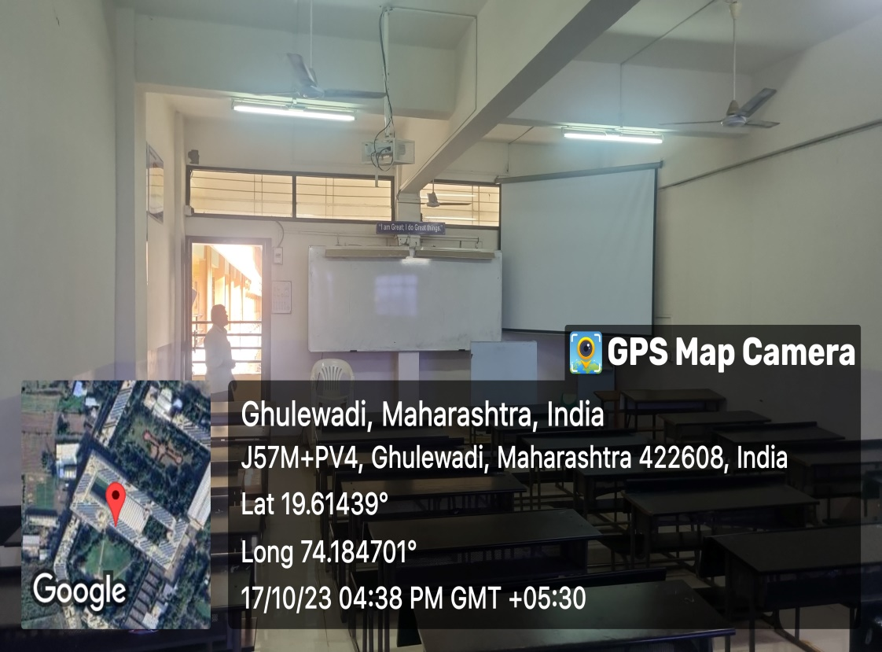
F25 | 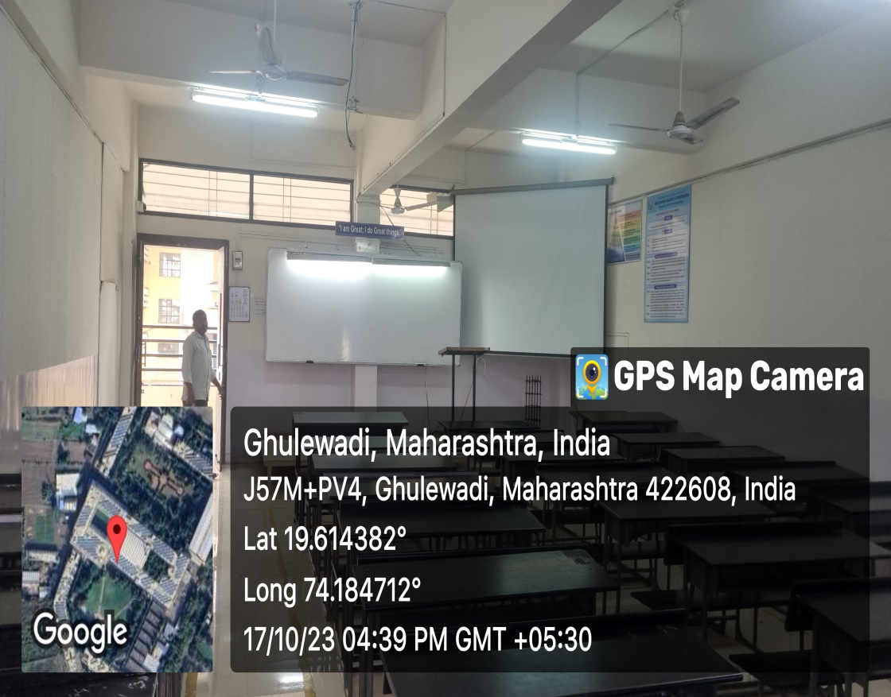
F26 | 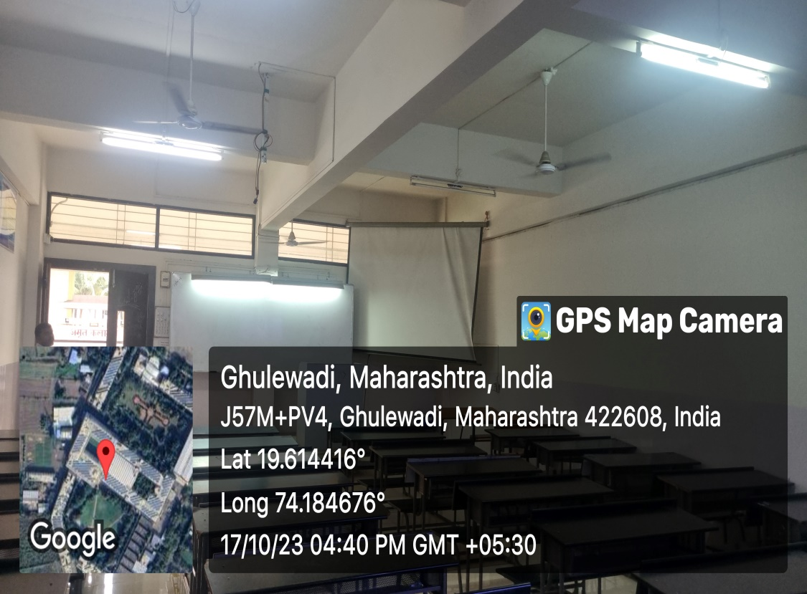
G30 | 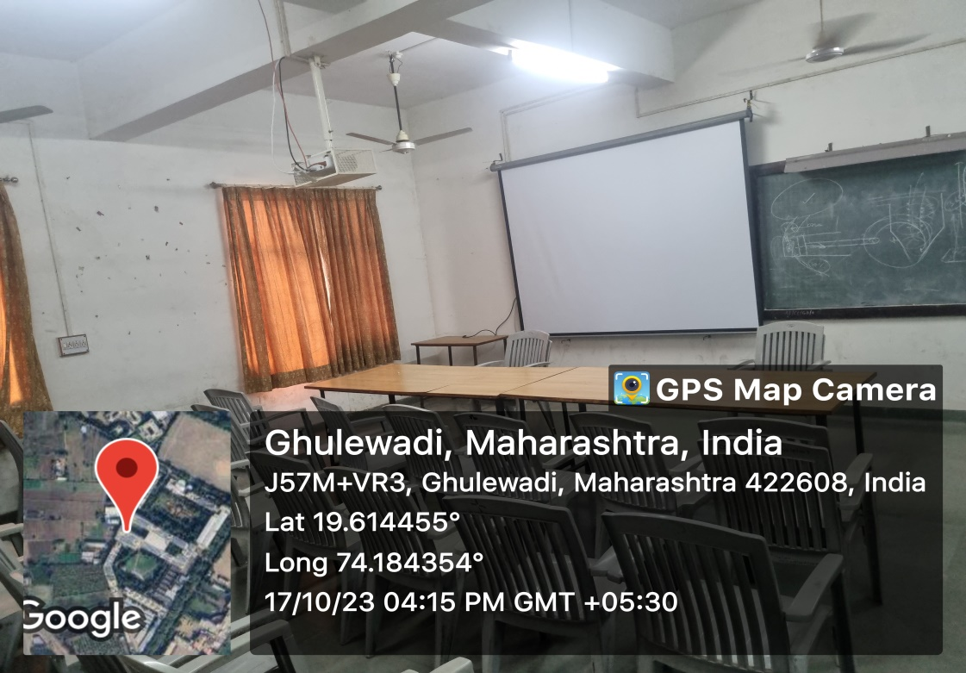

- List of Number of Laboratories and their Geo tagged photos :

Room ID | Description
G-16 | Fluid Mechanics Lab
G-17 | Fluid Machinery Lab
G-21 | Environmental Engineering Lab
G-22 | Transportation Lab
G-23 | PG CAD Lab
G-28 | Geotechnical Engineering Lab
G-27 | Geology lab
G-31 | Research Lab
G-34 | Mechanics Lab
G-33 | Surveying Lab
G-32 | Testing of Materials Lab
F-30 | UG CAD LAB
F-21 | Project Lab
G-35 | Innovation Centre

Room ID | Geo tagged Photo ID
G-16 | 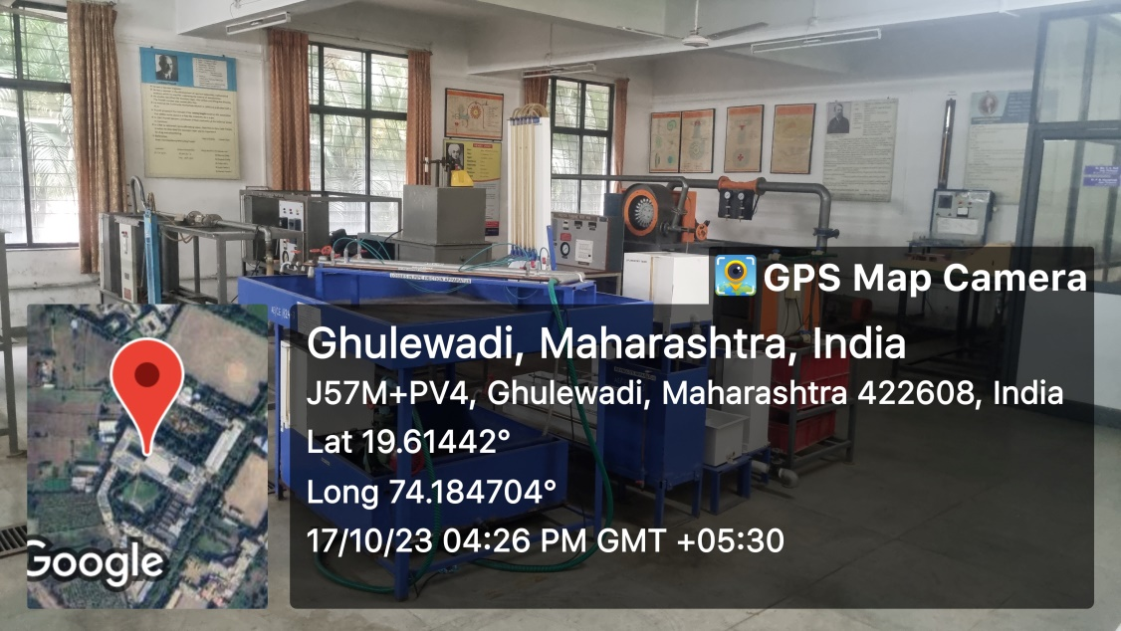
G-17 | 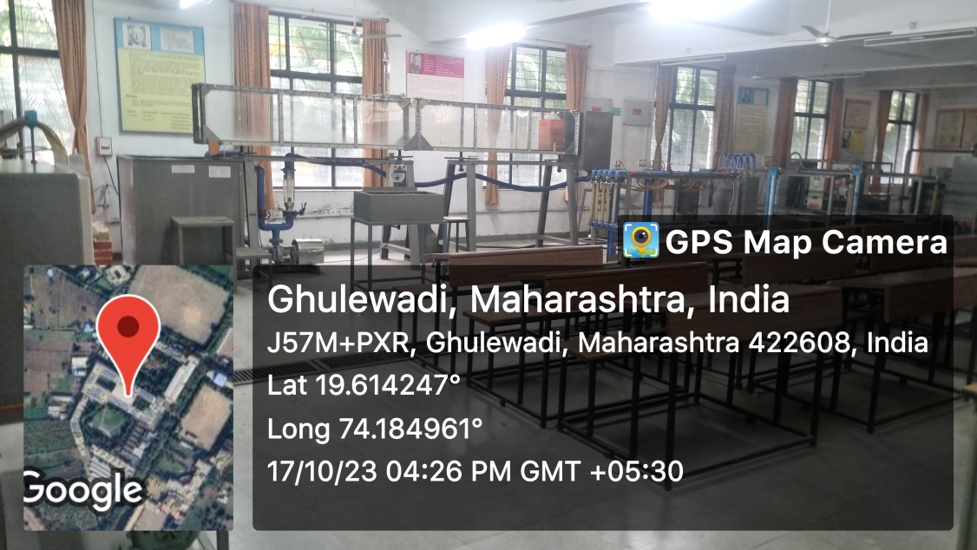
G-21 | 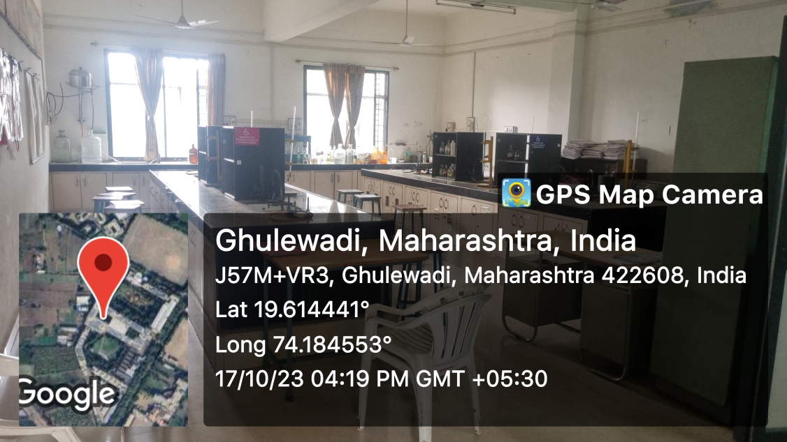
G-22 | 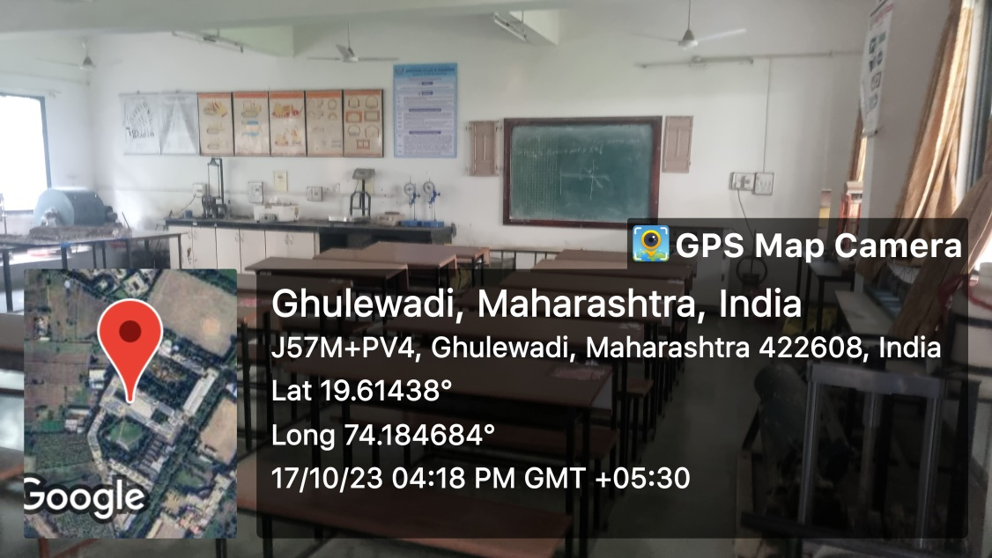
G-23 | 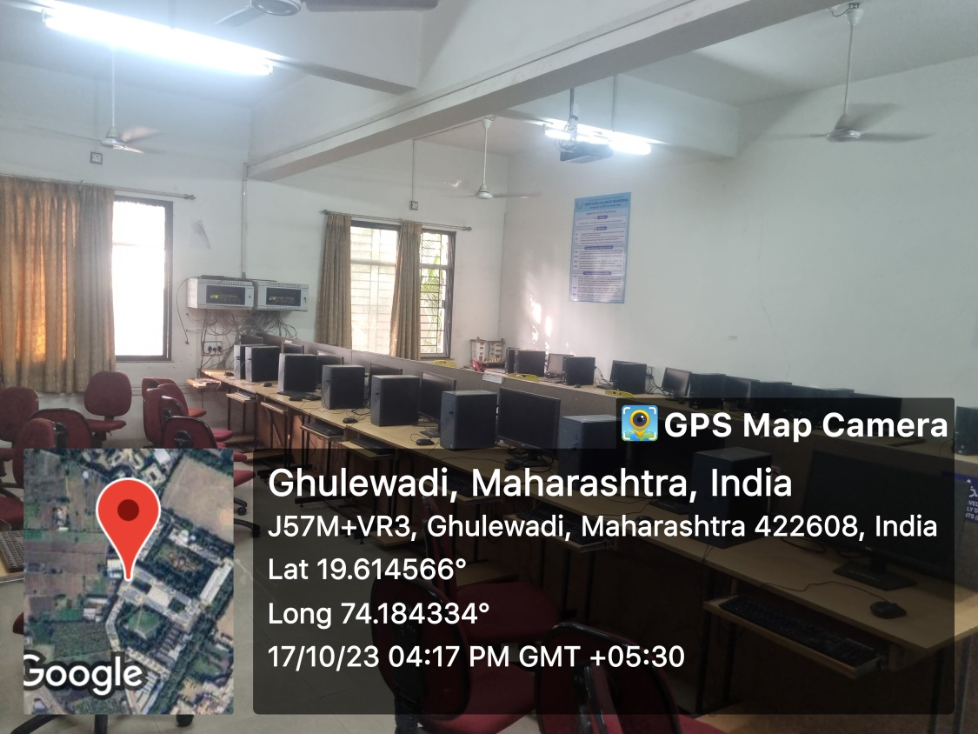
G-28 | 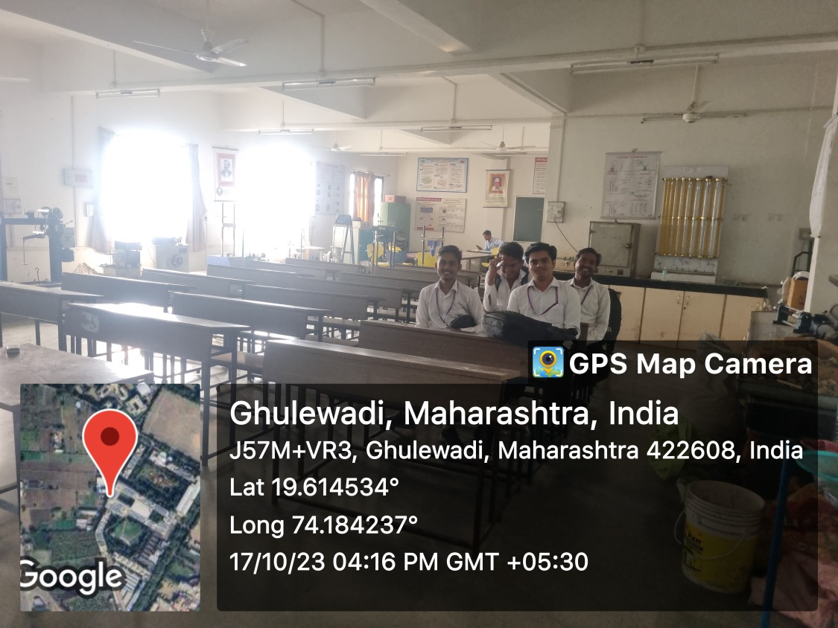
G-27 | 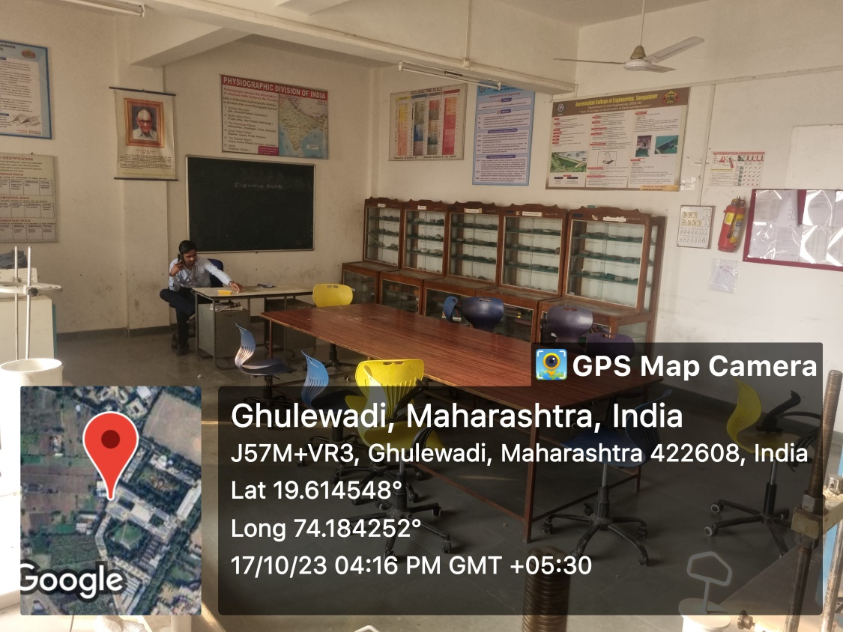
G-31 | 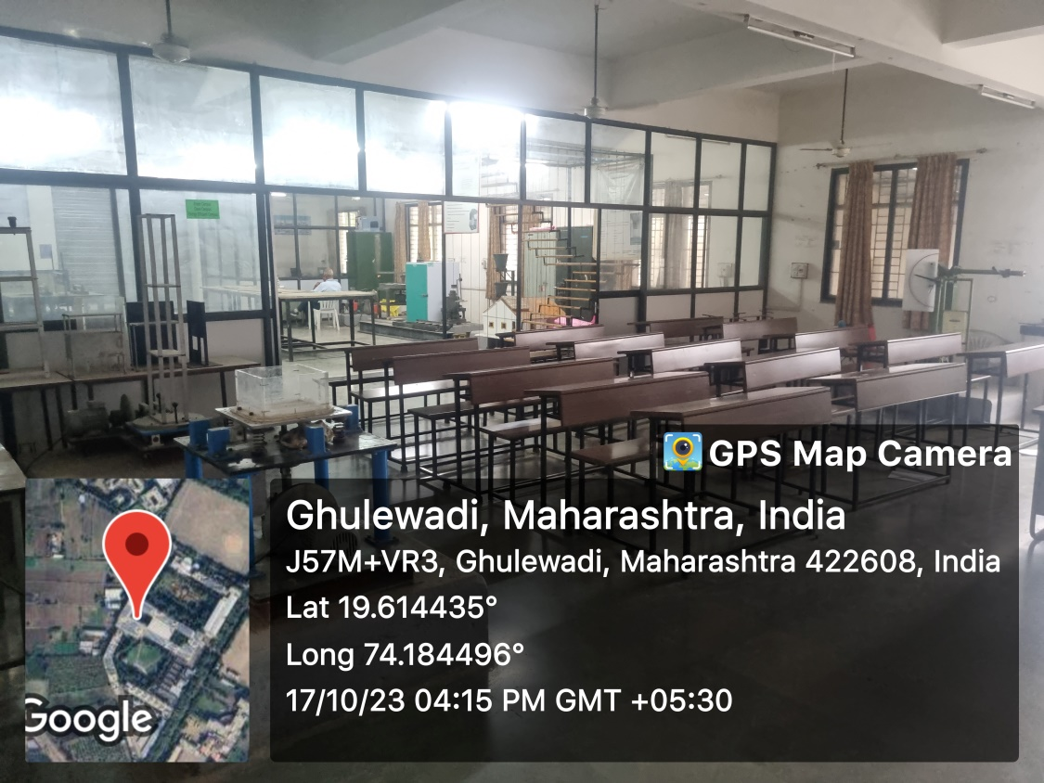
G-34 | 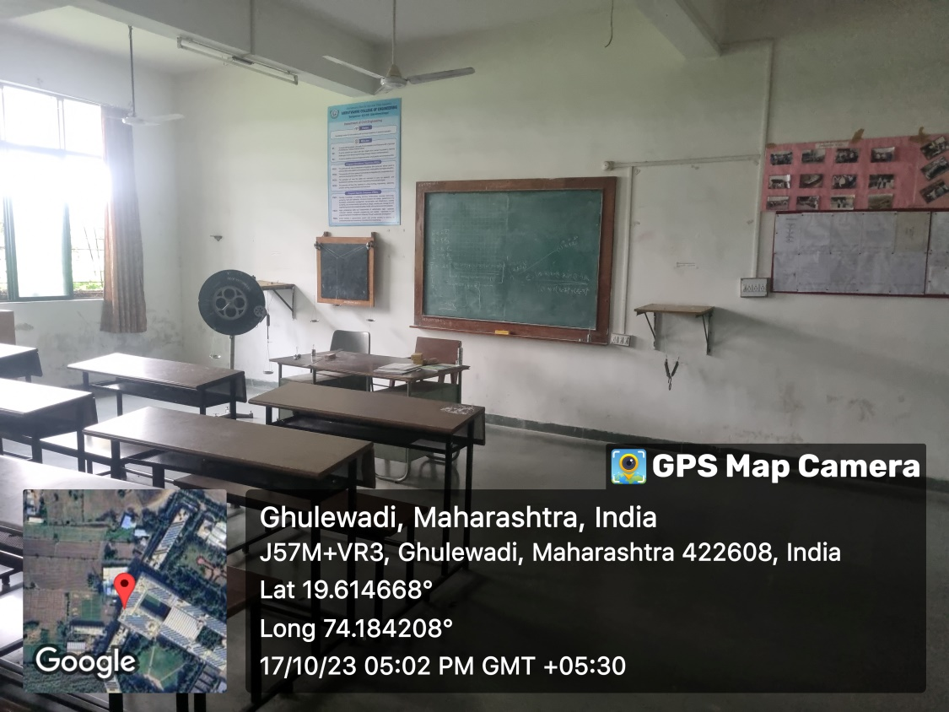
G-33 | 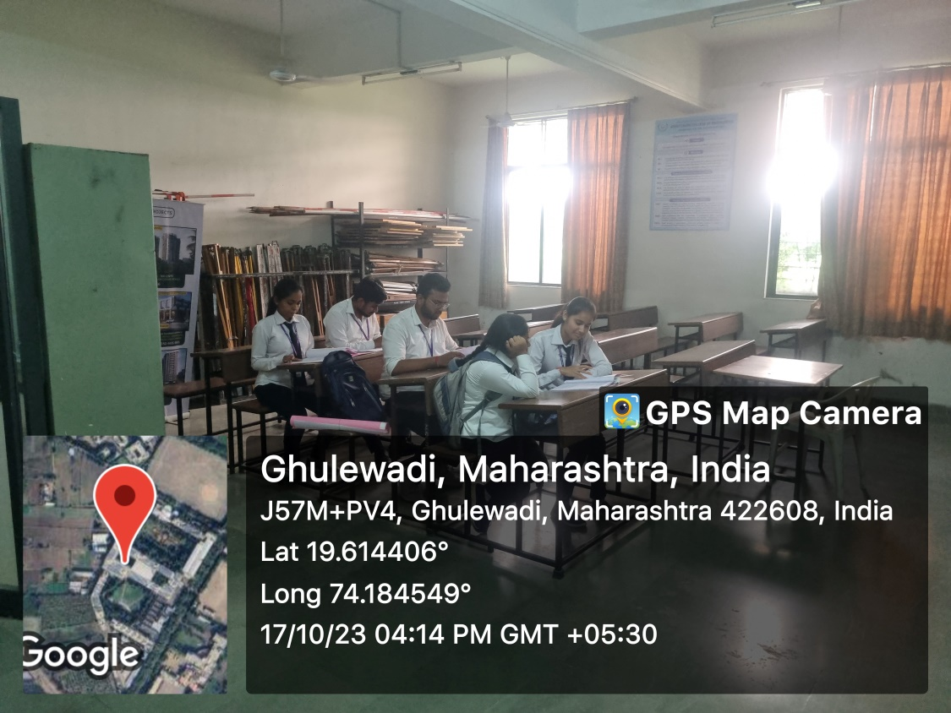
G-32 | 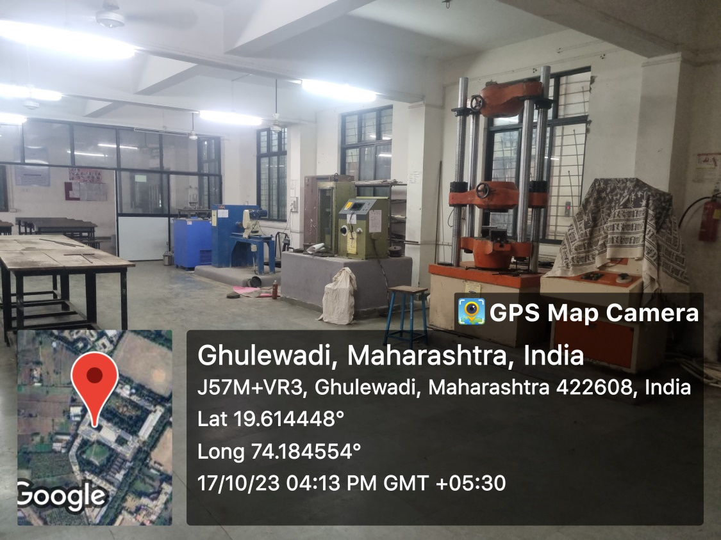
F-30 | 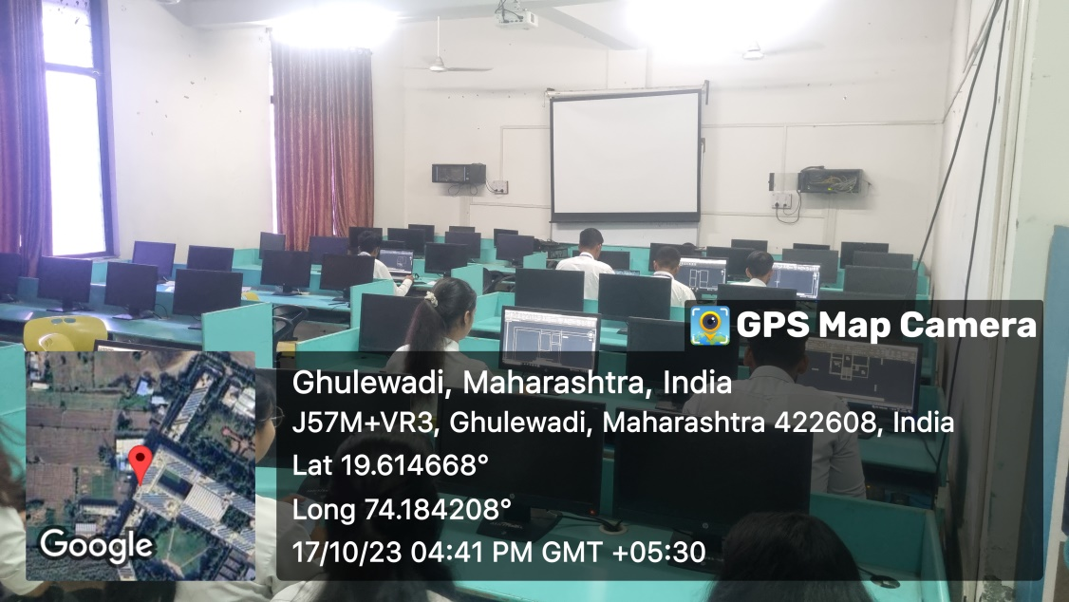
F-21 | 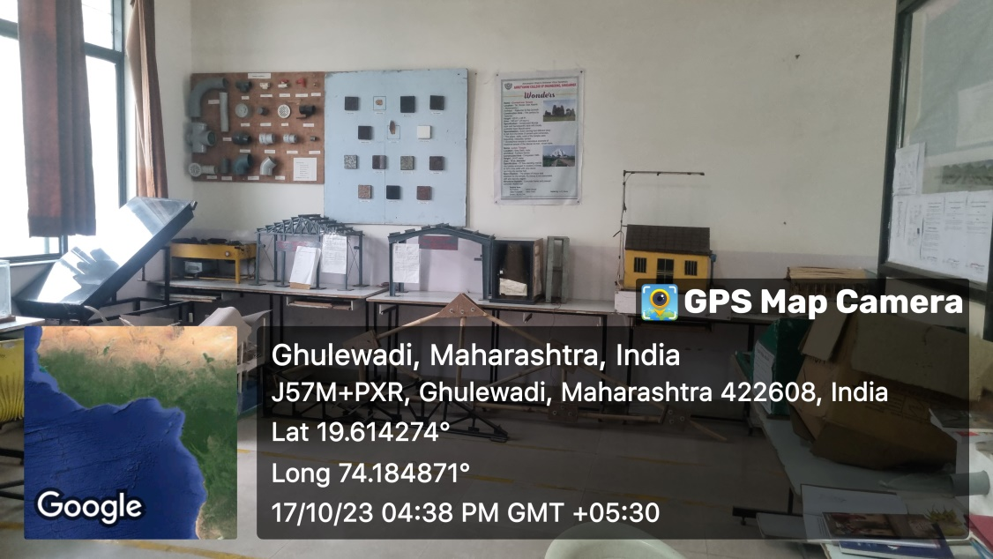
G-35 | 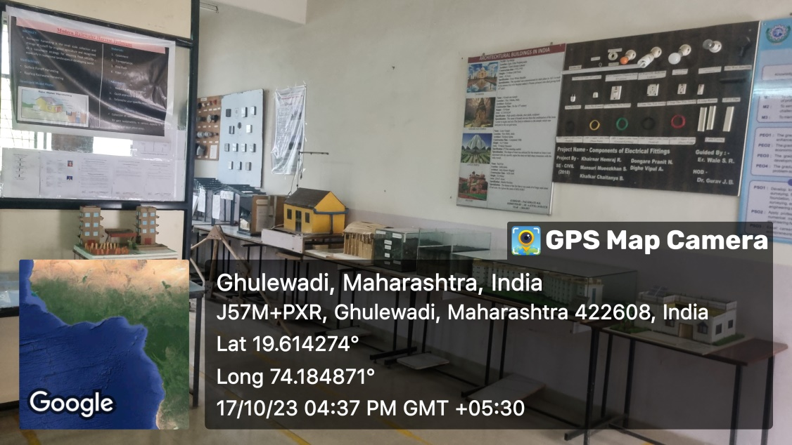

Plan of Department:
- Ground Floor:
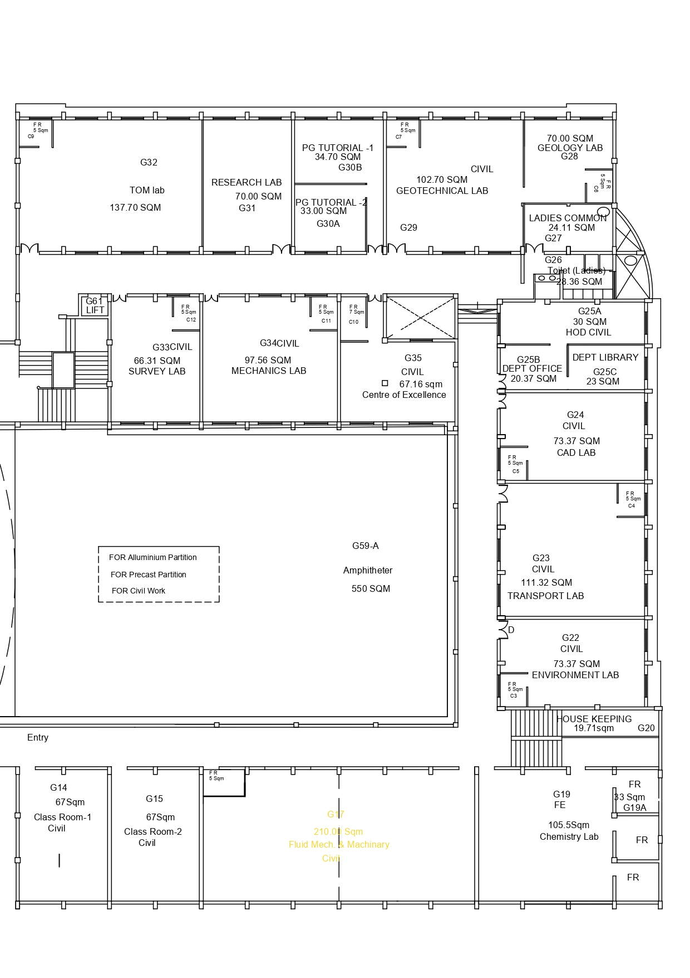

- First Floor
