2.3.3: Ratio of mentor to students for academic and other related issues (Data for the latest completed academic year)
2.3.3.1 Number of mentors
2.3.3.2 Number of students assigned to each Mentor
Index
Sr. No. | Description | Pg. No.
 | Ratio of mentor to students | 1
 | Links for List of Full Time Teachers as a Mentor/Tutor | 2
 | Number of Student during the Year | 3

Ratio of mentor to students
Ratio of mentor to students for the latest completed year (2023-24) is given below
Ratio of mentor to students for the latest completed academic year (2023-24)
Total No of Student | 3123
Total No of Mentors | 166
Ratio of Mentor to Students | 1:19
PG coordinator for the department is the mentor for the PG students.
Links for List of Full Time Teachers as a Mentor/Tutor
Please click the following Links for getting the certified list of full time teachers along with the departmental affiliation of the institute in the latest completed academic year (2023-24).
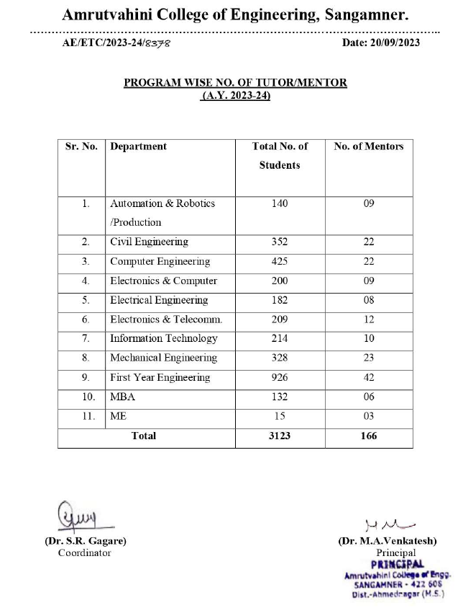
Sr. No. | File Description | Link to open
 | List of Full Time Teachers as a Mentor/Tutor for the year (2023-24)

Links for the Number of Students Click Here
Please click the following Links for getting the list of the number of students in each of the programs in the latest completed academic year of the institute (2023-24).
