Criterion 6- Governance, Leadership and Management (100)

Key Indicator- 6.1 Institutional Vision and Leadership (10)

Metric  No. |  | Weightage
6.1.1  Q_{l}M | The governance of the institution is reflective of and in tune with the vision and mission of the institution  Describe the vision and mission statement of the institution on the nature of governance, perspective plans and participation of the teachers in the decision making bodies of the institution within a maximum of 500 words  File Description  - Paste link for additional information  - Upload any additional information | 5
- Vision
To create opportunities for rural students to become able engineers and technocrats through continual excellence in Engineering Education.
- Mission
Our mission is to create self-disciplined, physically fit, mentally robust, and morally strong engineers and technocrats with high degree of integrity and sense of purpose who are capable to meet challenges of ever advancing technology for the benefit of mankind and nature.
We the management, the faculty, and staff therefore promise to strive hard and commit ourselves to achieve this objective through a continuous process of learning and appreciation of needs of time.
- Governance
- Top management directs Principal focusing on vision and mission of the institution.
- The Principal consistently follows top management policies to achieve the vision with the support of staff.
- Principal, Vice Principal, IQAC Director, Deans, Registrar and Head of Departments come together to form different committees to provide “decentralized administration” to achieve institution’s objectives and goals put forth.
- The institution is committed to follow quality framework defined by ISO 9001:2015 with the support of IQAC.
- Academic Planning: Semester wise academic calendar which includes all curricular, co-curricular, extracurricular activities by following University academic calendar.
- Financial Planning: Budget required in academic year as per perspective plan.

File Description | Template | Documents
Upload any additional information |  | Upload
Paste link for additional information

6.1.2  Q_{l}M | The effective leadership is visible in various institutional practices such as decentralization and participative management  Describe a case study showing decentralization and participative management in the institution in practice within a maximum of 500 words  File Description  - Paste link for additional information  - Upload any additional information | 5
Decentralization- ISO, etc.
Participative Management:-Involvement of stakeholders (GC, CDC, AAB (Academic advisory board), IQAC, DAB (Department Advisory board), DCC (Department Core Committee), Department association, student council etc.)
College promotes culture of participative management. Therefore, the committees are set up to execute predefined strategies that emphasize active stakeholder involvement.

- Students Council
- Students Association
- Cultural and sport and other activities

Top Management
Principal’s Administration
In-charges / Committee Coordinators
H.O.D
Faculty
Students Associations
Vice Principal, IQAC, Dean, Registrar

File Description | Template | Documents
Upload any additional information |  | Upload
Paste link for additional information

Key Indicator- 6.2 Strategy Development and Deployment (10)

Metric  No. |  | Weightage
6.2.1  Q_{l}M | The institutional Strategic/ perspective plan is effectively deployed  Describe one activity successfully implemented based on the strategic plan within a maximum of 500 words  File Description  - Strategic Plan and deployment documents on the website  - Paste link for additional information  - Upload any additional information | 2
Perspective Plan 2019 -2029
- External Environment
- UG Environment
- PG Education and Research.
(a) Goal: To start Automation and Robotics and Electronics and Computer Department
- Strategies and Tasks :
Strategy 5: Introduce core and emerging engineering courses:

Automation and robotics department instead of production engineering under Mechanical BoS and Electronics and Computer Engineering instead of Electronics Engineering under Electronics BoS is started from academic year 2021-22.

Mechatronics and AI & DS in Information Technology by 2022 -2023 and emerging disciplines in electronics and Telecommunication, Electrical and power within span of five years.

6.2.2  Q_{l}M | The functioning of the institutional bodies is effective and efficient as visible from policies, administrative setup, appointment and service rules, procedures, etc.  Describe the Organogram of the Institution within a maximum 500 words  File Description  - Paste link for additional information  - Link to Organogram of the Institution webpage  - Upload any additional information | 4
The organization has a well-structured administrative setup with Governing Council as the highest decision making body followed by CDC and AAB, 53 other functional bodies and committees.

Service rules, Procedures, Recruitment and Promotional Policies:

The Institute has a set of well-established rules, policies and regulations within the frame work of, AICTE, State Govt. and the affiliating university, which are approved by the Governing Council of, the Institute. The rules and regulations of the institute were first published in Nov 1997 and are, revised periodically. The following documents are published and are made available in the institute, library and in all departments to create awareness among the employees and students. The same is, also available in the college website – avcoe.org. The copies of the institute, Administrative Manual containing service rules, Procedures, Recruitment and Promotion Policies are circulated among all the staff (both Teaching and Non-teaching) for their information.
The following are the few manuals in which all the functional aspects of day to day activities are provided:
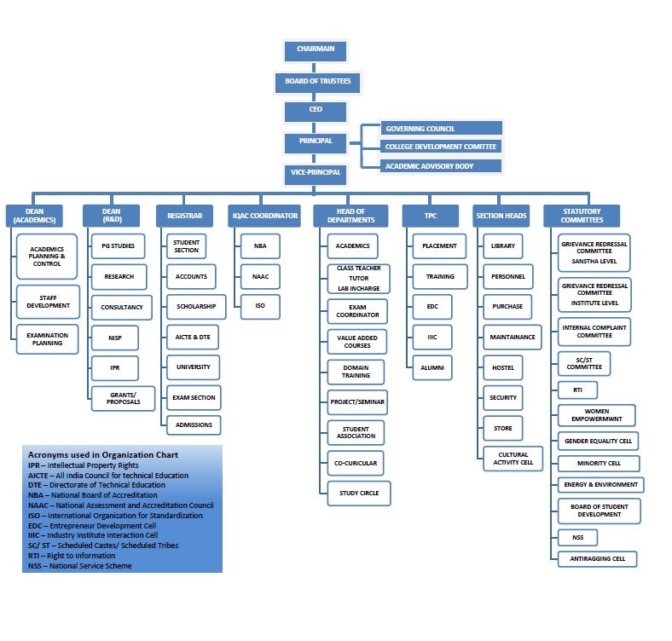
File Description | Template | Documents
Upload any additional information |  | Upload
Paste link for additional information
Link to Organogram of the Institution webpage

6.2.3.  Q_{n}M | Implementation of e-governance in areas of operation  - Administration  - Finance and Accounts  - Student Admission and Support  - Examination  Options:  - All of the above  - Any 3 of the above  - Any 2 of the above  - Any 1 of the above  - None of the above  Data Requirements: (As per Data Template)  - Areas of e-governance  Administration  Finance and Accounts  Student Admission and Support  Examination  - Name of the Vendor with contact details  - Year of implementation  File Description (Upload)  - ERP (Enterprise Resource Planning) Document  - Screen shots of user interfaces  - Any additional information  - Details of implementation of e-governance in areas of operation, Administration etc (Data Template) | 4
Options:
- All of the above
Have you collected
- ERP (Enterprise Resource Planning) Document
- Screen shots of user interfaces
- Any additional information
- Details of implementation of e-governance in areas of operation, Administration etc (Data Template)

File Description | Template | Documents
Screen shots of user interfaces |  | Upload
ERP (Enterprise Resource Planning) Document |  | Upload
Details of implementation of e-governance in areas of operation, Administration etc | Data Template | Upload
Any additional information |  | Upload

Key Indicator- 6.3 Faculty Empowerment Strategies (30)
Metric  No. |  | Weightage
6.3.1  Q_{l}M | The institution has effective welfare measures for teaching and non-teaching staff  Provide the list of existing welfare measures for teaching and non-teaching staff within a maximum of 500 words  File Description  - Paste link for additional information  - Upload any additional information | 05
All staff that is eligible as per the Staffs' Provident Fund legislation are enrolled as members to EPF Scheme. Institute provides gratuity scheme, Group Medical Insurance, for staff. All the benefits at superannuation are extended to all staff members. Summer and Winter Vacations of 70 days, 12 days Casual Leave per year. 10 days Medical Leave per year for approved faculty and 9 days of special leaves for ad-hoc faculty members. Six months maternity leave is available to the women employees. The institute allows faculties to go for higher studies and short term courses. On duty facility and training and travel grants for attending workshops /conferences/seminars. Fees reimbursement policy is in place for Swayam, NPTEL and NITTT courses. Institute provides residential facility for the staff members. Institute constituted Amrut Madatnidhi for staff in case of medical emergency with maximum help amount extended upto Rs.50,000/-. In case of any emergency, personal loan is also provided to the staff through staff credit society. Tuition fees collected in Equal Monthly Installments (EMI) for wards of the staff. Institute provides uniforms to non-teaching staff with all required accessories. Medical facility on campus, ambulance in case of emergency is also being provided for all staff.
File Description | Template | Documents
Upload any additional information |  | Upload
Paste link for additional information

6.3.2  Q_{n}M | Average percentage of teachers provided with financial support to attend conferences/workshops and towards membership fee of professional bodies during the last five years  6.3.2.1. Number of teachers provided with financial support to attend conferences/workshops and towards membership fee of professional bodies year wise during the last five years  Data Requirement for last five years: (As per Data Template)  - Name of the teacher  - Name of conference/ workshop attended for which financial support provided  - Name of the professional body for which membership fee is provided  Formula:  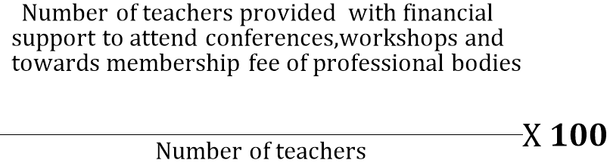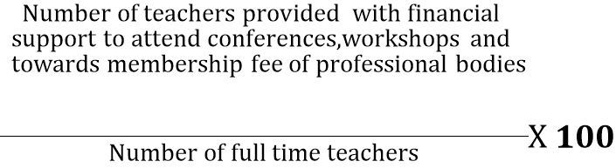 Percentage per year =  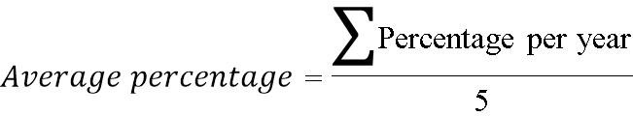  File Description:  - Upload any additional information  - Details of teachers provided with financial support to attend conference, workshops etc during the last five years (Data Template) | 10
  Year
  Number
Average percentage of teachers provided with financial support to attend conferences/workshops and towards membership fee of professional bodies during the last five years
Year | 15-16 | 16-17 | 17-18 | 18-19 | 19-20 | Av. % of last 5 years
Teachers provided with financial support | 25 | 22 | 45 | 33 | 47 | Av. % of last 5 years
No of Full time teachers | 207 | 216 | 202 | 205 | 198 | Av. % of last 5 years
% of teachers provided with financial support to attend conferences/workshops | 12.08 | 10.19 | 22.28 | 16.10 | 23.74 | 16.87

File Description | Template | Documents
Upload any additional information |  | Upload
Details of teachers provided with financial support to attend conference, workshops etc during the last five years | Data Template | Upload

6.3.3  Q_{n}M | Average number of professional development /administrative training programs organized by the institution for teaching and non-teaching staff during the last five years  6.3.3.1. Total number of professional development /administrative training Programmes organized by the institution for teaching and non teaching staff year wise during the last five years  Data Requirement for last five years: (As per Data Template)  - Title of the professional development Programme organised for teaching staff  - Title of the administrative raining Programme organised for non-teaching staff  - Dates (From- to)  Formula:  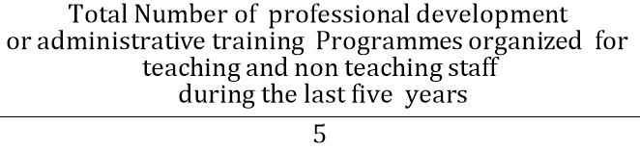  File Description (Upload):  - Reports of the Human Resource Development Centres (UGC ASC or other relevant centres).  - Reports of Academic Staff College or similar centers  - Upload any additional information  - Details of professional development / administrative training Programmes organized by the University for teaching and non teaching staff (Data Template) | 5
  Year
  Number
Average number of professional development /administrative training programs organized by the institution for teaching and non-teaching staff during the last five years
Year | 15-16 | 16-17 | 17-18 | 18-19 | 19-20 | % of last 5 years
number of professional development /administrative training programs for teaching and non-teaching staff during the last five years | 7 | 8 | 14 | 12 | 9 | 10

File Description | Template | Documents
Upload any additional information |  | Upload
Reports of the Human Resource Development Centres (UGC ASC or other relevant centres) |  | Upload
Reports of Academic Staff College or similar centers |  | Upload
Details of professional development / administrative training Programmes organized by the University for teaching and non-teaching staff | Data Template | Upload

6.3.4  Q_{n}M | Average percentage of teachers undergoing online/ face-to-face Faculty Development Programmes (FDP) during the last five years  (Professional Development Programmes, Orientation / Induction Programmes, Refresher Course, Short Term Course etc.)  6.3.4.1. Total number of teachers attending professional development Programmes viz., Orientation / Induction Programme, Refresher Course, Short Term Course year wise during the last five years  Data Requirement for last five years: (As per Data Template)  - Number of teachers  - Title of the Programme  - Duration (From –to)  Formula:  Percentage per year = 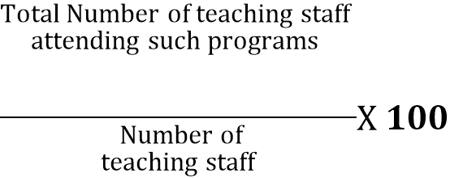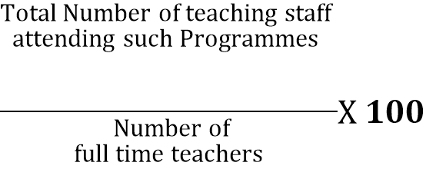  File Description  - IQAC report summary  - Reports of the Human Resource Development Centres (UGC ASC or other relevant centers).  - Upload any additional information  - Details of teachers attending professional development programmes during the last five years (Data Template) | 5
  Years
  Number
Average percentage of teachers undergoing online/ face-to-face Faculty Development Programmes (FDP) during the last five years
Year | 15-16 | 16-17 | 17-18 | 18-19 | 19-20 | Av. % of last 5 years
teachers undergoing online/ face-to-face FDP | 52 | 78 | 89 | 64 | 136 | Av. % of last 5 years
No of Full time teachers | 207 | 216 | 202 | 205 | 198 | Av. % of last 5 years
Average percentage of teachers undergoing online/ face-to-face Faculty Development Programmes (FDP) during the last five years | 25.12 | 36.11 | 44.06 | 31.22 | 68.69 | 41.04

File Description | Template | Documents
Upload any additional information |  | Upload
Reports of the Human Resource Development Centres (UGC ASC or other relevant centers) |  | Upload
IQAC report summary |  | Upload
Details of teachers attending professional development programmes during the last five years | Data Template | Upload

6.3.5  Q_{l}M | Institutions Performance Appraisal System for teaching and non-teaching staff  Describe the functioning status of the Performance Appraisal System for teaching and non-teaching staff within a maximum of 500 words  File Description  - Paste link for additional information  - Upload any additional information | 5
The Institute follows a systematic Performance Appraisal System for teaching and non-teaching staff. The management evaluates teachers based on teaching, R&D activities. The institution evaluates non-teaching staff based on performance in technical support and administration related activities, co-curricular, professional, development related activities, academic contributions, general conduct and qualities. A structured “Self-Appraisal Form” is used of by staff member for this purpose. The concerned HOD gives their remarks on the performance of the faculty member. Additionally Increment form based on API (Academic Performance Index) is introduced for awarding annual increments. The minimum requirement is 75% score. The management evaluates the faculty members and staff by merit rating based on their performance during the period of evaluation. They are recognized for academic performances, R&D, consultancy, IPR, results, project guidance’s, peer reviewed publications, funded research, patents developed, recognition by professional bodies and contribution towards achieving institutional goals. In case of non – teaching staff, increment is released based on their performance in the department, their urge to learn new technologies, interpersonal behavior and punctuality towards the work done in department and institute. The above methodology of merit rating has helped the institution to identify and reward meritorious employees and to positively motivate them.

File Description | Template | Documents
Upload any additional information |  | Upload
Paste link for additional information

Key Indicator- 6.4 Financial Management and Resource Mobilization (20)
Metric  No. |  | Weightage
6.4.1  Q_{l}M | Institution conducts internal and external financial audits regularly  Enumerate the various internal and external financial audits carried out during the last five years with the mechanism for settling audit objections within a maximum of 500 words  File Description  - Paste link for additional information  - Upload any additional information | 6
Institution conducts internal and external financial audits regularly.

At the beginning of every financial year, every department submits budget requirements to the institute. Head of the departments prepares budget reports, based on information provided by various lab in-charges and submit it to the institute. Budget is proposed by Principal in GC and CDC, and is approved by them. Looking at the syllabus revisions and requirements thereof additional procurement is suggested if any. At the end of every financial year, it is observed, whether the allocated budget is properly utilized or not. For above procedure, the institution is having qualified practicing CA as internal and external auditors who audit the accounts annually. After the audit, the report is sent to the management for review.
In addition to this, the institution is having consultants to give opinion on taxation and legal issues. The college is filing income tax return every year within the stipulated time.
Internal Audit- It is conducted quarterly in a year by the audit department of the parent institution, Hase and Firm, Nasik
External Audit- In the second stage, the audit is carried out by M/S. Rajendra Gundecha & Company C.A., Ahmednagar.
Internal/External Audit | Last Audit date | Details of Compliance
Auditors:  Rajendra M. Gundecha & Company, Sangamner | dd-mm-yyyy | There is no adverse remark on the accounts of the institution

File Description | Template | Documents
Upload any additional information |  | Upload
Paste link for additional information

6.4.2  Q_{n}M | Funds / Grants received from non-government bodies, individuals, philanthropist during the last five years (not covered in Criterion III)  6.4.2.1: Total Grants received from non-government bodies, individuals, Philanthropers year wise during the last five years (INR in Lakhs)  Data Requirement for last five years (As per Data Template)  - Name of the non-government bodies, individuals, Philanthropers  - Funds / Grants received  File Description  - Annual statements of accounts  - Any additional information  - Details of Funds / Grants received from of the non-government bodies, individuals, Philanthropies during the last five years (Data Template) | 8
  Year
  INR in Lakhs
Funds / Grants received from non-government bodies, individuals, philanthropist during the last five years
Year | 15-16 | 16-17 | 17-18 | 18-19 | 19-20
Funds / Grants received from non-government bodies | 0 | 0 | 2.28 | 3.17 | 0.33

File Description | Template | Documents
Details of Funds / Grants received from of the non-government bodies, individuals, Philanthropies during the last five years | Data Template | Upload
Any additional information |  | Upload
Annual statements of accounts |  | Upload

6.4.3  Q_{l}M | Institutional strategies for mobilization of funds and the optimal utilization of resources  Budget allocation -  - 10% of total income is taken out as corpus fund.  - 70% of total expected income is allocated for staff salary  - 20% of total expected income is budgeted in following proportion  - Library 5%  - Infrastructure built up -10%  - Laboratory equipment – 25%  - Laboratory Consumables – 5%  - Maintenance and Spares – 30%  - Research and Dev. – 3%  - Travel and Training – 2%  - Miscellaneous-10%  - Others – 10%  - Irrespective of the expenditure against each head for that financial year, the Institute allocates budgetary provisions as per the percentage decided. Unutilized funds may be used for other heads or can be forwarded to the next financial year.  - The funds are allocated for planned and unplanned activities, infrastructural and lab equipment to fulfill the requirements as per revised curriculum. Budgetary controls are exercised by Principal and accounts.  - Special considerations are made to accommodate unforeseen requirements. There has been no budget crunch that has affected the teaching learning process and effective functioning of the institute.  - Budget is prepared in March whereas the syllabus revision, Admissions and fees allocation is done in June/ July. So there may be some deviation in utilization and budgeted amount.  File Description  - Paste link for additional information  - Upload any additional information | 6
File Description | Template | Documents
Upload any additional information |  | Upload
Paste link for additional information

Key Indicator- 6.5 Internal Quality Assurance System (30)

Metric  No. |  | Weightage
6.5.1  Q_{l}M | Internal Quality Assurance Cell (IQAC) has contributed significantly for institutionalizing the quality assurance strategies and processes  Describe two practices institutionalized as a result of IQAC initiatives within a maximum of 500 words  File Description  - Paste link for additional information  - Upload any additional information | 10
- Energy Conservation Initiative & Green Initiatives s
Solar Roof Top (Photovoltaic Plant): Installed 400 Kw (Photovoltaic Plant) capacities with investment of Rs.148.38 (In Lakhs) to fulfill all campus electricity requirements.
Solar Thermal Water Heating: Installed with capacity of 41000 (LPD) at Hostels, with Investment of RS. 26.65 (In Lakh) to attain the daily requirement of hot water for students which have recorded saving of Rs. 86.1 (In Lakh/Year), Results in saving of Energy 615000(kWh).
Hybrid Solar & wind System (Capacity-5 Kw): Installed for departmental generation of energy having investment of Rs.12 (In Lakh) was the base for 400 Kw energy generations from solar mode.
Biogas Plant (Capacity -10 meter cube): Gas generation which is equivalent to 55401 kWh units applied for utilization in campus area for Mess.
Sewage Treatment Plant-3E Technology, Capacity-0.4 MLD: Plant developed and implemented which gives conversion of waste water into usable water supplied for Gardening and sports grounds.
Circulation of water through Gravity: with the use of gravity the water has circulated to various usages points which had energy saving of 20142 kWh units approx.
LED Tube lights/Bulbs/Energy Efficient Fans/ Street Lights: With change of type of luminaries, energy efficient fans, street light (LED) had shown saving of 58241 kWh approx.
Rain Water Harvesting: Installed at Hostel premises which gives efficient irrigation round hostel area, Shown 11kWh approx. saving in energy which may have used in lifting and circulating water.
Tree Plantation & Drip Irrigation: Initiative driven with 5000 Trees of Different Species having investment of Rs.0.98 (In Lakh). Drip Irrigation mode had implemented and which had resulted in 5371kWh saving of energy.

Instructions by IQAC for better conservation of energy:
Cleaning of all Lamps and Windows and broken glass should be replaced by plain glass. Windows should be kept open & outside bamboo & trees must trim regularly to clear day light. No tube light will be used in sunny days. Air conditioner leakage & filter should check regularly. PC system & Monitors shall be switched off regularly. Install dimmers in auditorium & meeting room. The institute is impaneled with Unnat Maharashtra Abhiyan since 2017 and is among only 12 private institutes included in the initiative. The institute is also impaneled with Unnat Bharat Abhiyan from 2019. Various activities related to social and holistic development like evaluation of rural water supply schemes, rejuvenation of rivers, analysis of electric feeder systems, viability analysis of MSMEs, analysis of soil through soil health card, understanding the developmental issues and helping the rural people have been undertaken as a part of UBA and UMA through participation of staff and students.
The institute is keen on its efforts on environment and using renewable energy sources. More than 5000 tress has been planted, 400 KW Roof top Solar power plant, solar water heaters 41000 LPD, sewage treatment plant has been installed. The efforts have been recognized by Maharashtra Energy Development Authority (MEDA) by awarding second prize for energy conservation and efficiency while AICTE has recognized the campus as "Green Campus".
File Description | Template | Documents
Upload any additional information |  | Upload
Paste link for additional information

6.5.2  Q_{l}M | The institution reviews its teaching learning process, structures & methodologies of operations and learning outcomes at periodic intervals through IQAC set up as per norms and recorded the incremental improvement in various activities  ( For first cycle - Incremental improvements made for the preceding five years with regard to quality  For second and subsequent cycles - Incremental improvements made for the preceding five years with regard to quality and post accreditation quality initiatives )  Describe any two examples of institutional reviews and implementation of teaching learning reforms facilitated by the IQAC within a maximum of 500 words each  File Description  - Paste link for additional information  - Upload any additional information | 10
File Description | Template | Documents
Upload any additional information |  | Upload
Paste link for additional information

6.5.3  Q_{n}M | Quality assurance initiatives of the institution include:  - Regular meeting of Internal Quality Assurance Cell (IQAC); Feedback collected, analysed and used for improvements  - Collaborative quality intitiatives with other institution(s)  - Participation in NIRF  - any other quality audit recognized by state, national or international agencies (ISO Certification, NBA)  Options:  - All of the above  - Any 3 of the above  - Any 2 of the above  - Any 1 of the above  - None of the above  Data Requirement for last five years: (As per Data Template  Quality initiatives  - AQARs prepared/ submitted  - Collaborative quality initiatives with other institution(s)  - Participation in NIRF  - Any other quality audit recognized by state, national or international agencies (ISO Certification, NBA)  File Description  - Paste web link of Annual reports of Institution  - Upload e-copies of the accreditations and certifications  - Upload any additional information  - Upload details of Quality assurance initiatives of the institution(Data Template) | 10
File Description | Template | Documents
Upload e-copies of the accreditations and certifications |  | Upload
Upload details of Quality assurance initiatives of the institution | Data Template | Upload
Upload any additional information |  | Upload
Paste web link of Annual reports of Institution

 | Details | Year
 | Details | 15-16 | 16-17 | 17-18 | 18-19 | 19-20
Infrastructure | Budget Utilization
Infrastructure | Internet
Library | Library budget
Library | Books
Library | Journals & Periodicals
Student | Intake
Student | Admissions
Student | Students benefited by scholarships & free ships by government schemes
Student | Certification Programs
Student | Students benefited by guidance for competitive examination & career counseling
Student | Placements
Student | Internship
Student | Higher Studies
Faculty | Faculty Number
Faculty | Faculty with Ph.D.
Faculty | Faculty with PG
Research and Development | Paper Publication, Book/ Conference
Result | Final Year Result
Extension Activities | Activities (Cultural +Sports)

