4.3.3: Bandwidth of internet connection in the Institution
Options:
A. ≥50 MBPS
B. 30 MBPS – 50 MBPS
C. 10 MBPS – 30 MBPS
D. 10 MBPS – 05 MBPS
E. < 05 MBPS
INDEX
Sr. No. | Description | Pg. No.
 | Internet Speed Test | 1
 | Purchase order of Internet Tata-sky | 2
 | BSNL-Internet Bills | 6
Bandwidth of internet connection in the Institution
Institution previously has 100MBPS internet bandwidth of BSNL which is now shifted to of Tatasky and detail of the proof is shown below.
- Internet Speed Test
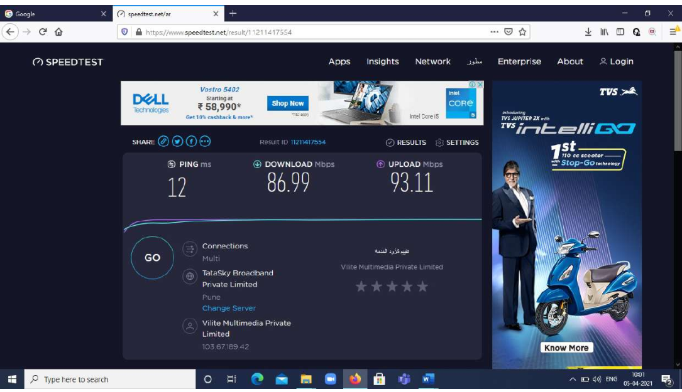

- Purchase order of Internet Tata-sky

- BSNL-Internet Bills

Sr.No. | Bill No. | Link
1 | Internet bill_Apr 2021_44-1
2 | Internet bill_June 2021_221
3 | Internet bill_Oct2021_882-1
4 | Internet bill_dec 2021_1243-1
5 | Internet bill_ Feb 2022_ 1668

