4.3.2: Student – Computer ratio (Data for the latest completed academic year).
INDEX
Sr. No. | Description | Pg. No.
 | Student – Computer ratio | 1
 | Link for Supporting Documents | 2
- Student – Computer ratio
Institution has adequate IT infrastructure and sufficient number of latest computers and laptops for the student use exclusively. Number of computers that Institute has for students use is 1125 for latest completed academic year (2020-21) as shown below in the attest copy.
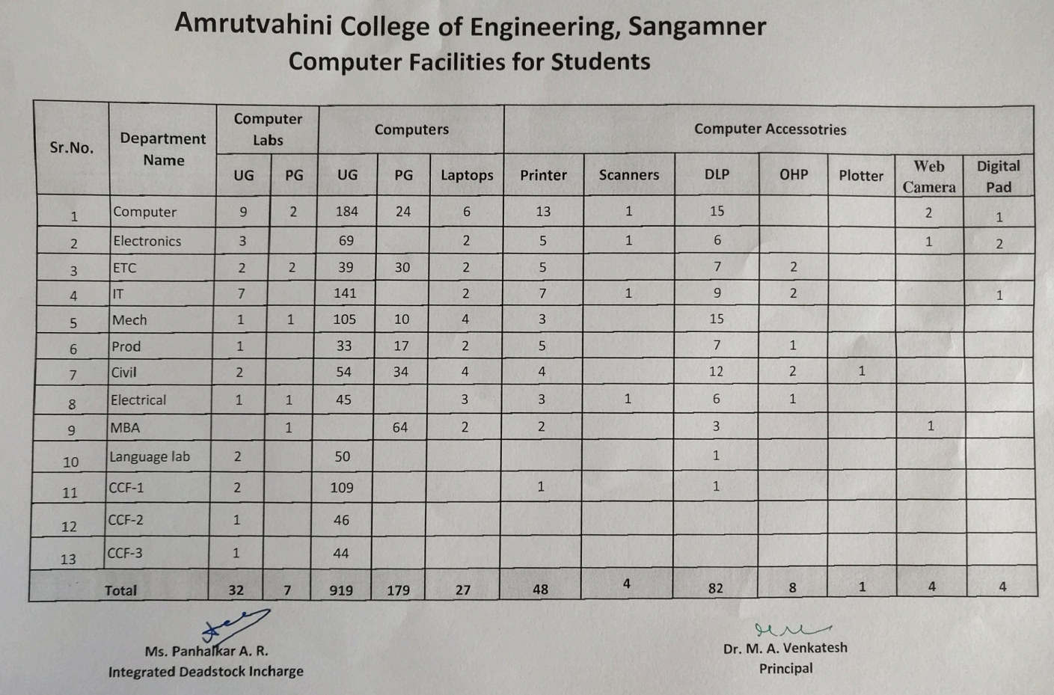

Student – Computer ratio
(Data for the latest completed academic year: 2020-21).
Total numbers of student enrolled | 3359
Number of computers for students | 1125
Student – Computer ratio | 2.98:1

Student – Computer ratio (Data for the latest completed academic year).
Number of computers that Institute has for students
The numbers of student enrolled for latest academic year (2020-21) are 3359. Therefore, student computer ration for the latest completed academic year is
$$Student – Computer ratio=\frac{3359}{(919+179+27)}=\frac{3359}{1125}=2.98$$

- Link for Supporting Documents
Link below provides department wise information about the computers exclusively used for students and their purchase order (PO) / dead stock entry.
Sr. No. | Programme | Link to Open
 | Civil Engineering
 | Computer Engineering
 | Electronics Engineering
 | Electronics & Telecommunication Engineering
 | Information Technology
 | Mechanical Engineering
 | Production Engineering
 | M.B.A

