AMRUTVAHINI COLLEGE OF ENGINEERING, SANGAMNER
Central Library-Institutional Repository

Access Institutional Repository by using http://103.76.10.193/ or you can access using avcoe.org →quick link→ Library Portal→ Institutional Repository.
You will get following screen as homepage.
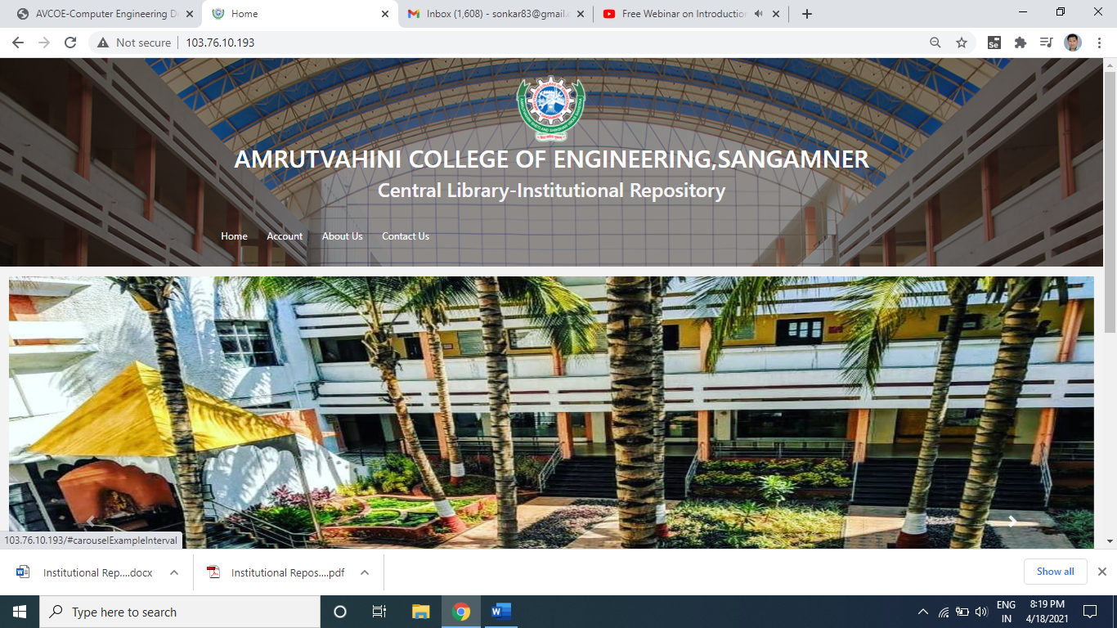
Staff Registration:

For staff registration select Account →staff registration menu
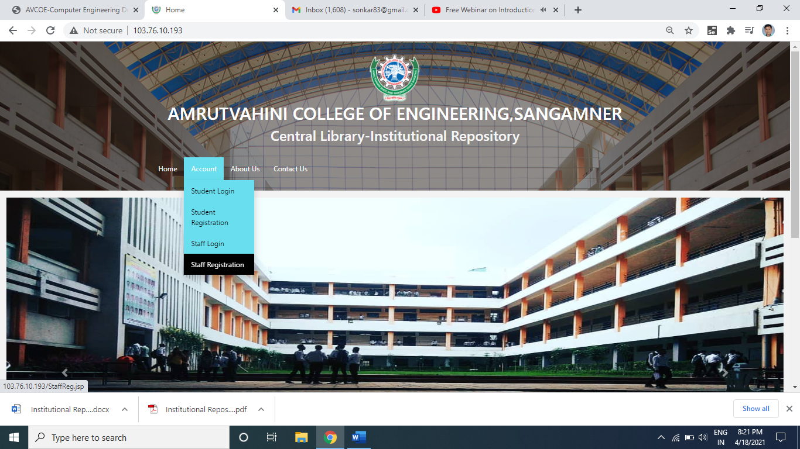

Then you can fill registration form in details and click on submit button
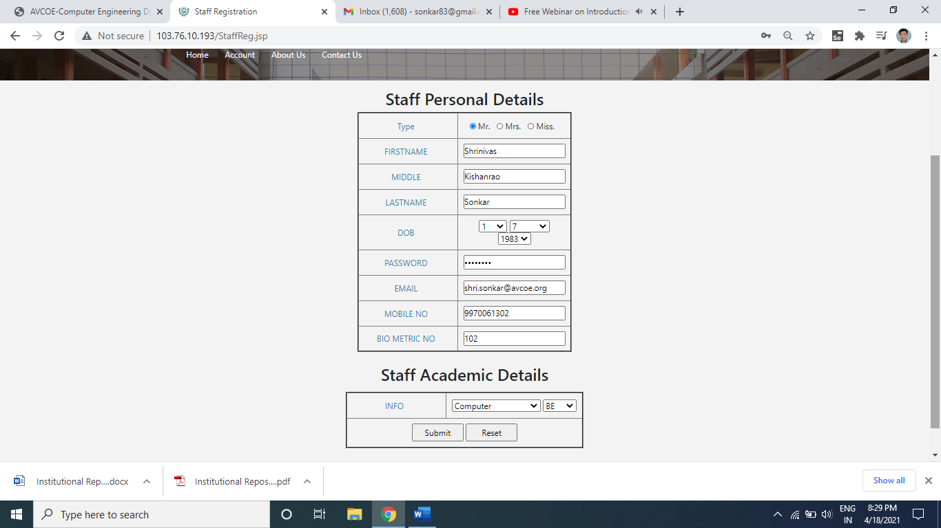
Once you click on submit button in staff registration form you will get following screen, which show user is added successfully.
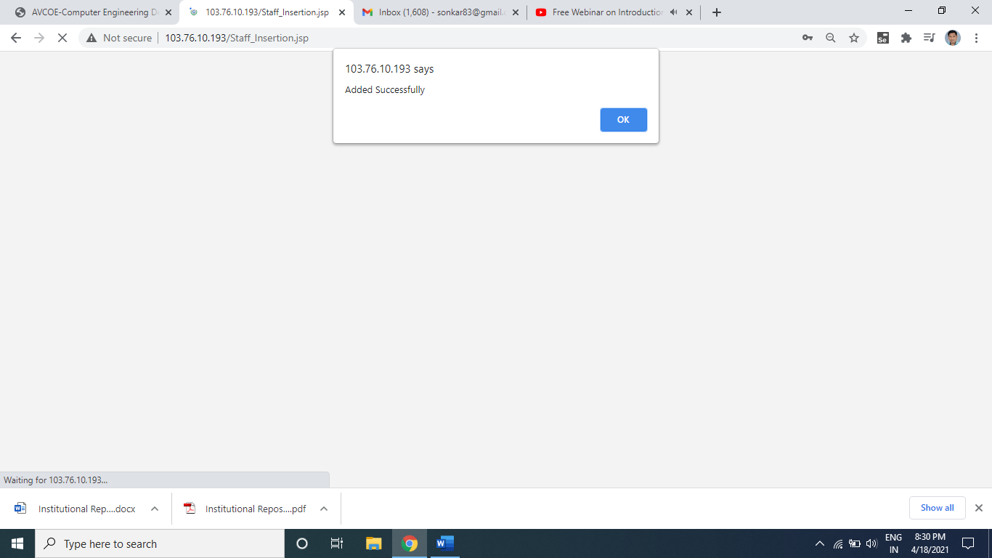

Staff Login: for login go to the Account→ Staff Login, once you have selected the same you will be prompted as following screen. Then fill the username as your email id that you have entered at the registration time and password. Then Type is the field whether you want to upload the data or you want to just view the data. As per your choice you can select the same. Finally click on submit button.
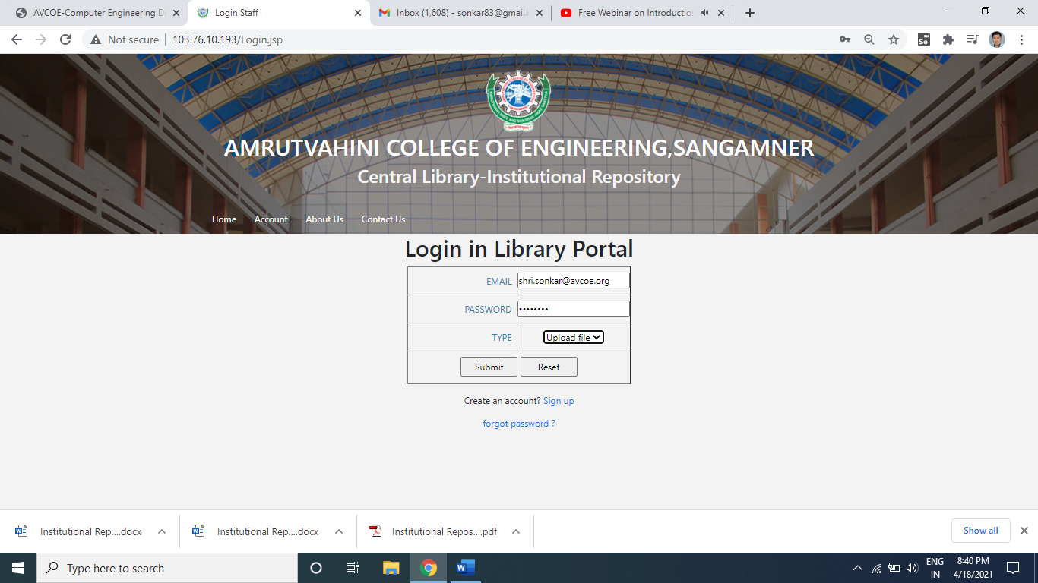

Once you have click the submit button in login page, you will get following screen, where you can upload your data by using upload file option.
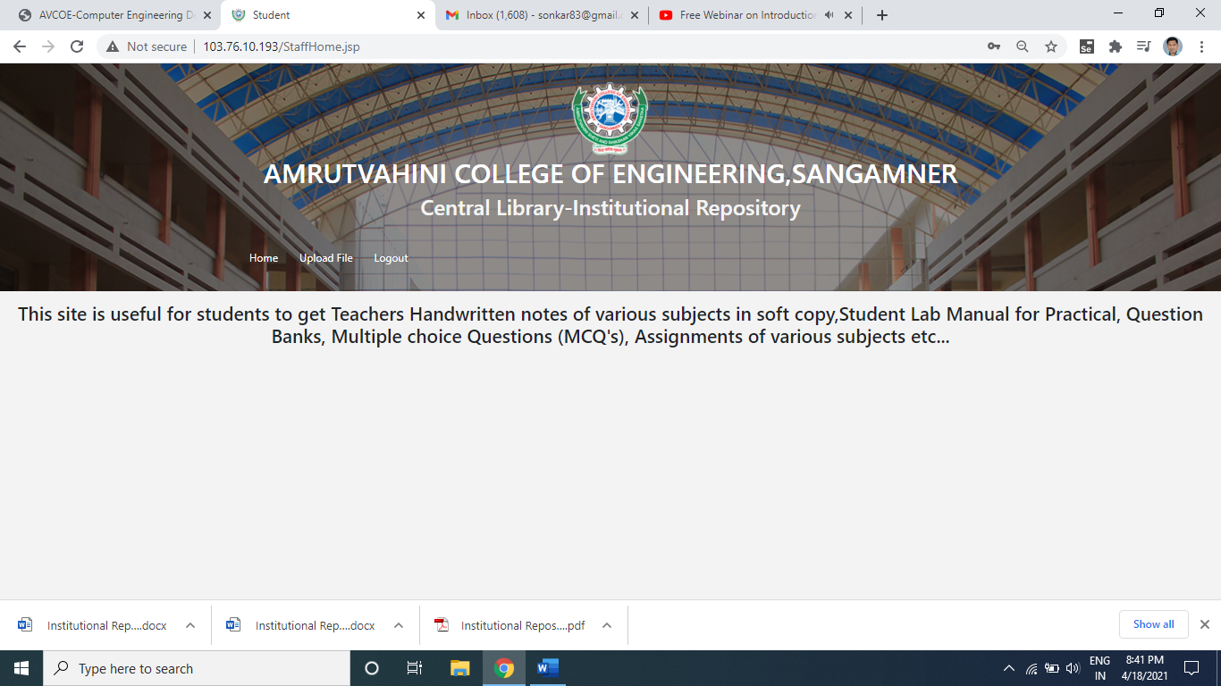

You can upload the file by selecting file from your computer then for which class you want to upload you can select the same. The same is shown in following figure.

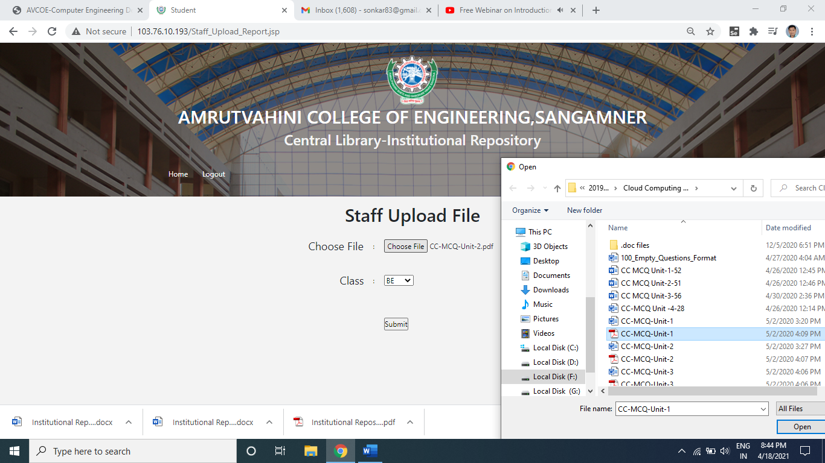
Once you have clicked the submit button for file uploading, you will get message as file uploaded successfully as shown in following screen.
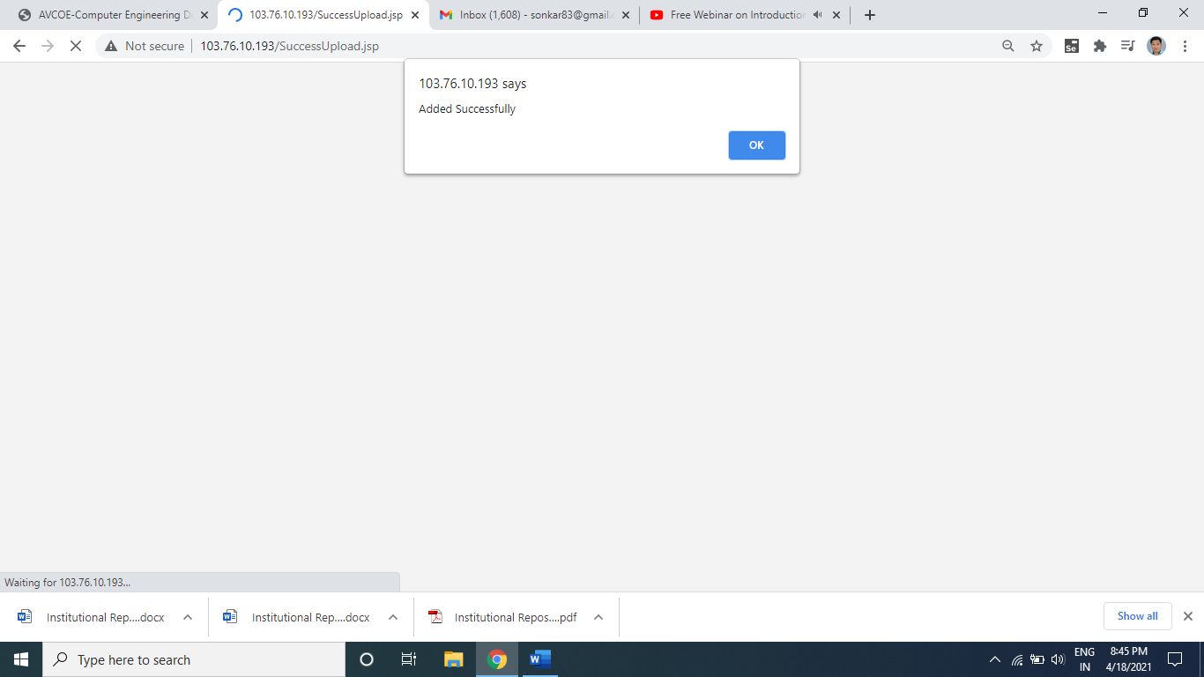

Logout: you can be logout by selecting logout menu option.
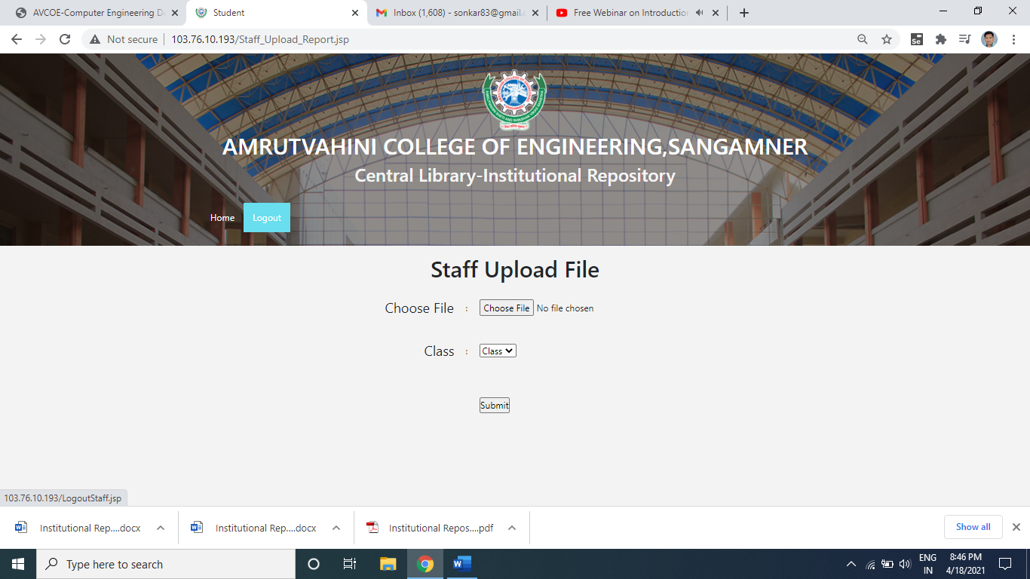
To Check View the Data: file that you have uploaded you can check by login your account, go through the account→ staff login and select type view data, as shown in following snap.

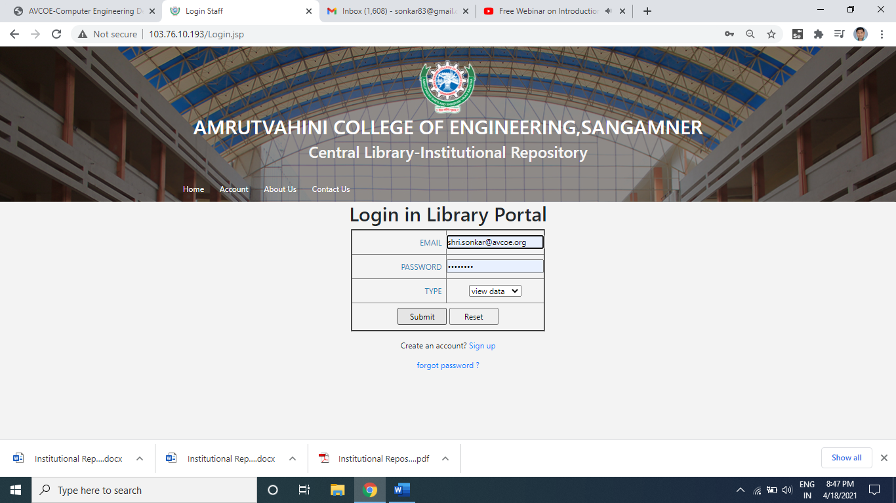

Then you go through respective branch →Class for which you have uploaded the file.
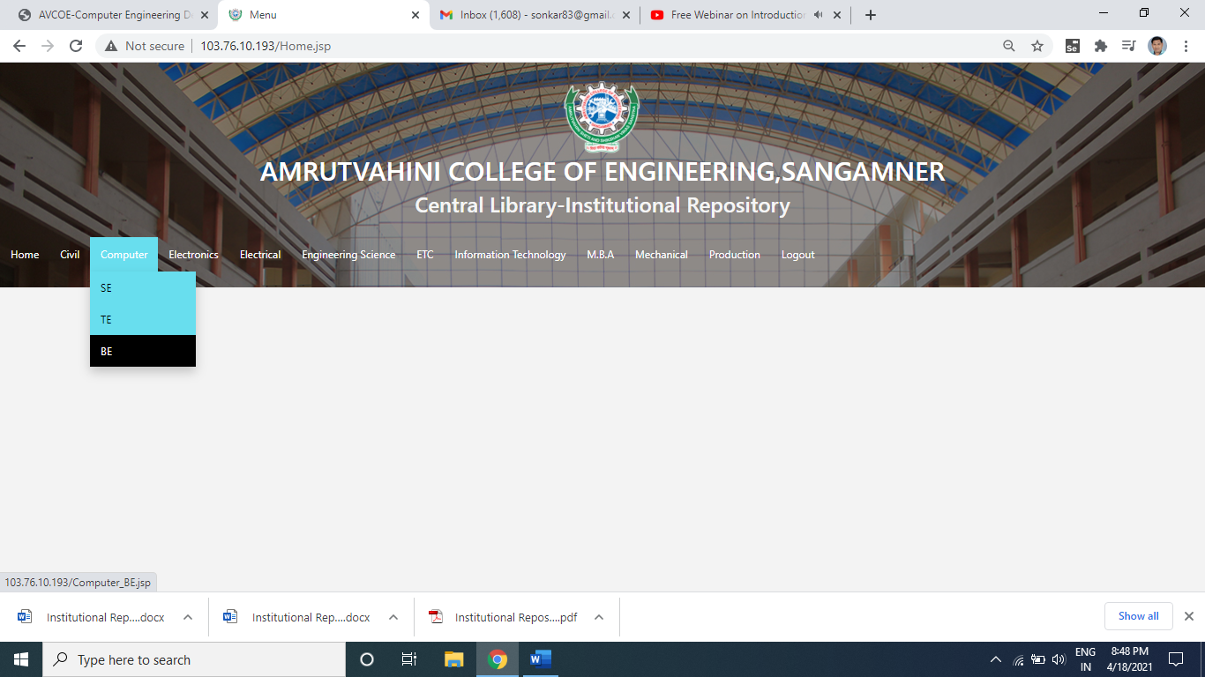
You can see that the file that you have uploaded in respective branch and class, as shown in following screen.
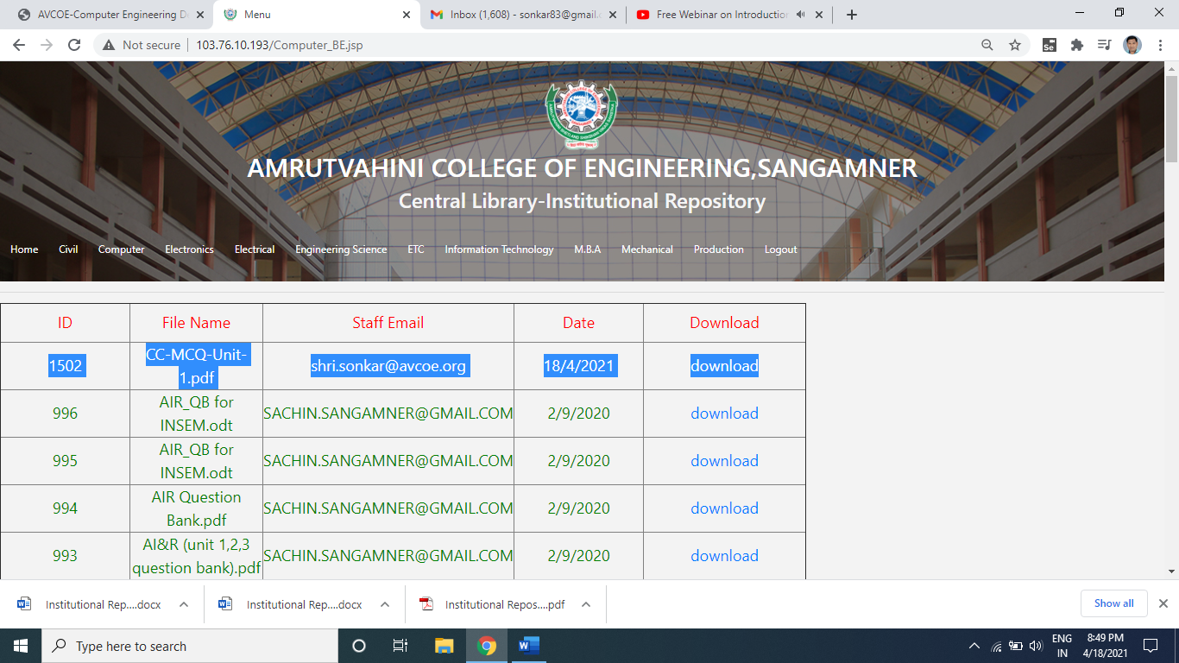

Student Module:

Access Institutional Repository by using http://103.76.10.193/ or you can access using avcoe.org →quick link→Library Portal→ Institutional Repository.
You will get following screen as homepage.

Student Registration: For student registration select Account →student registration menu
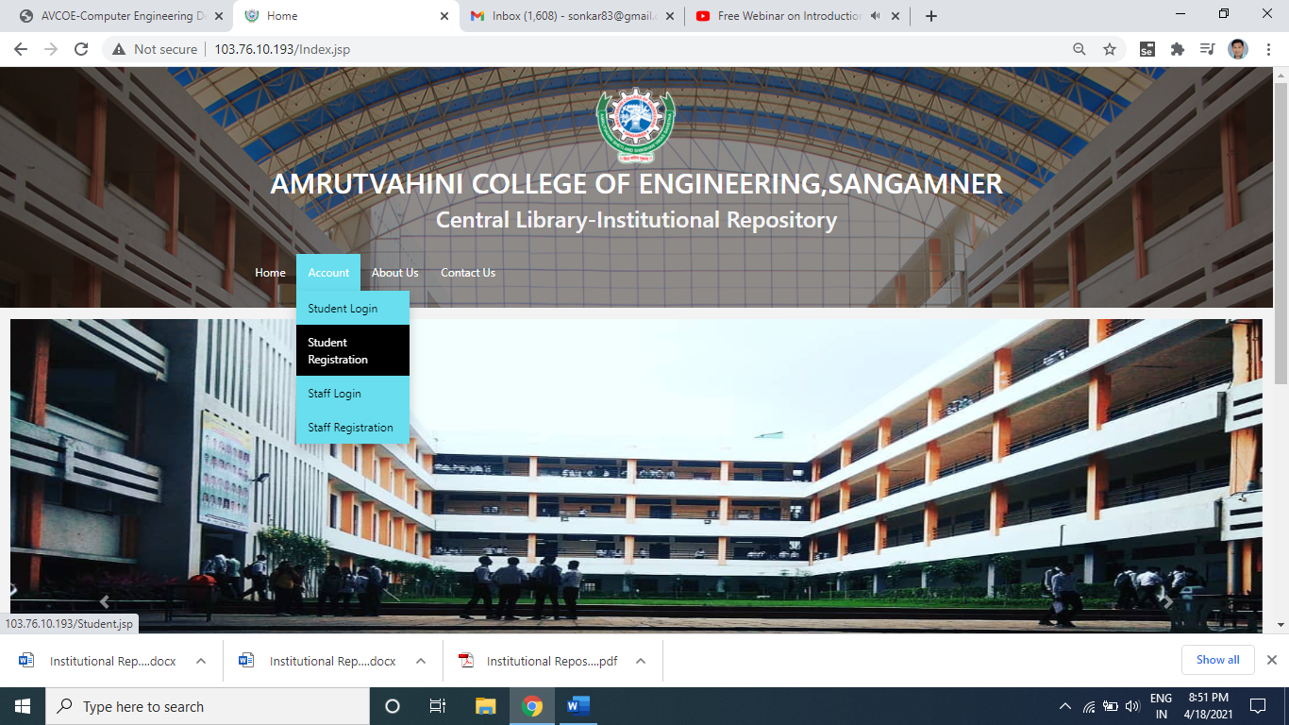

Then students need to fill the personal details and student academic details including your PRN number and roll number then click on submit button.
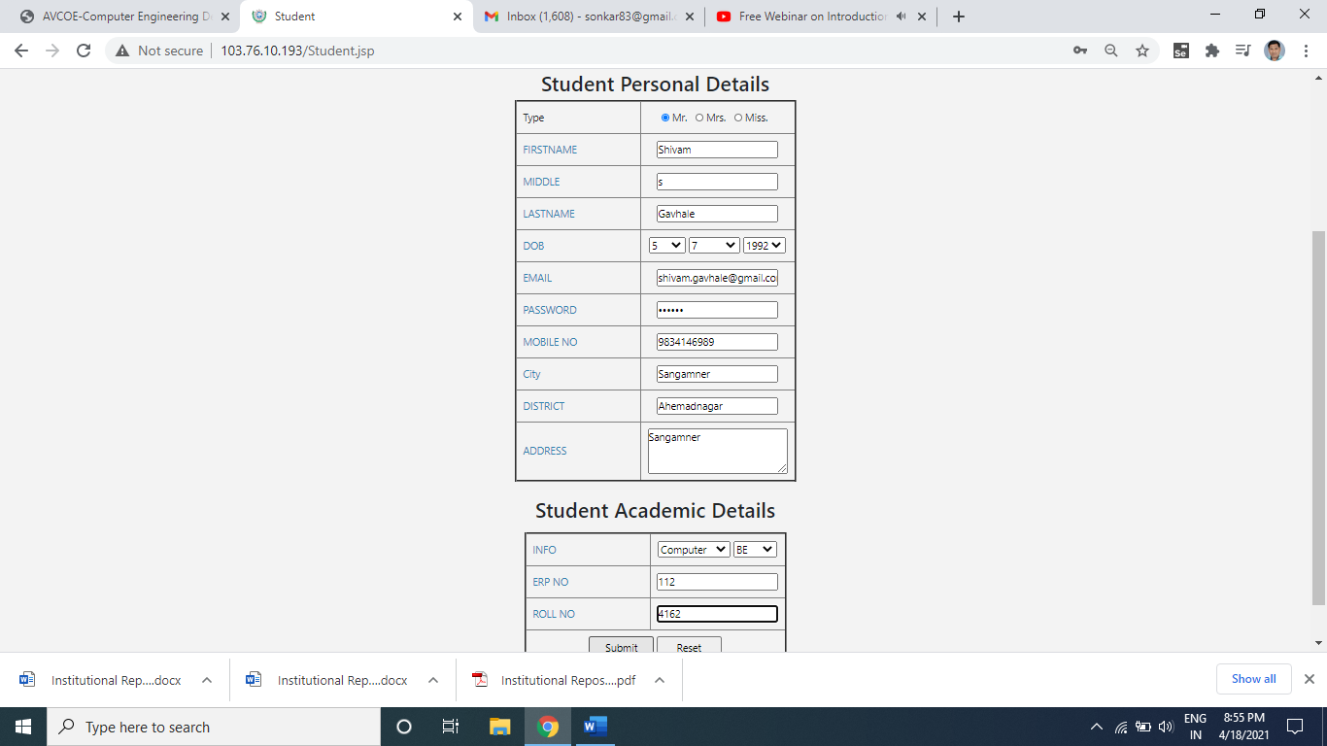
Once you have click on submit button on student registration from you will be get message as student added successfully.
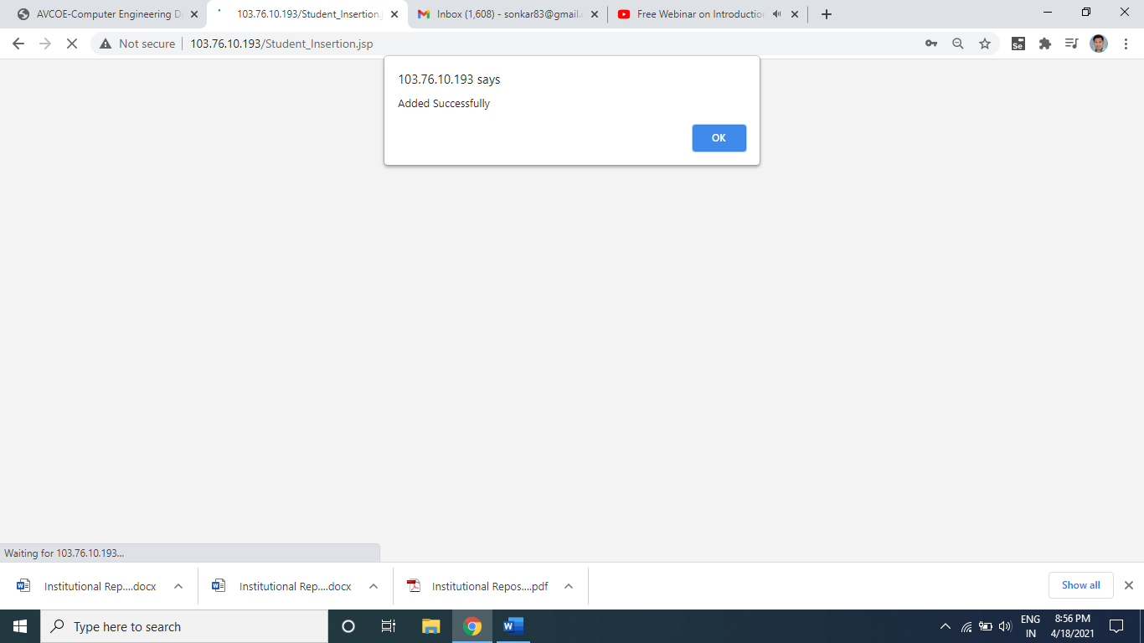

Student login: for student login you can go through the Account →Student login option, shown in following screen.
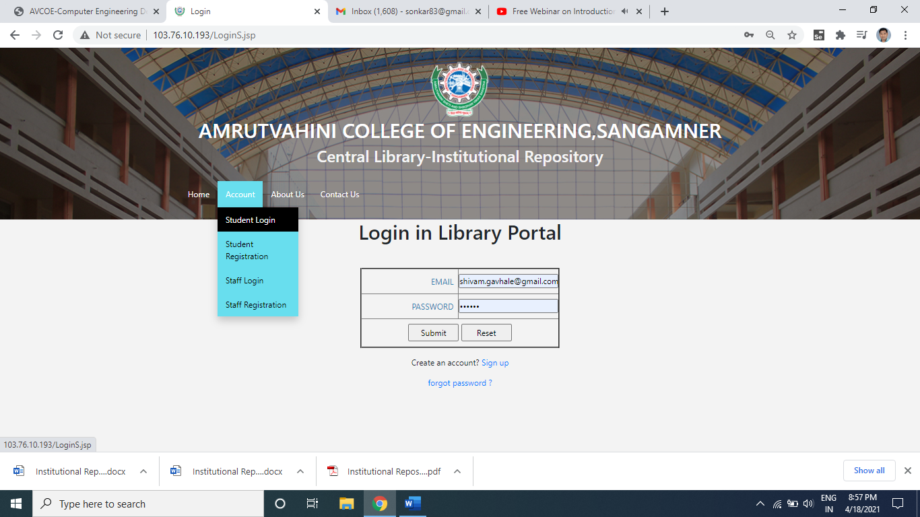

Then for which branch and class want to see the teaching material data then can navigate according them, as shown in following screen.
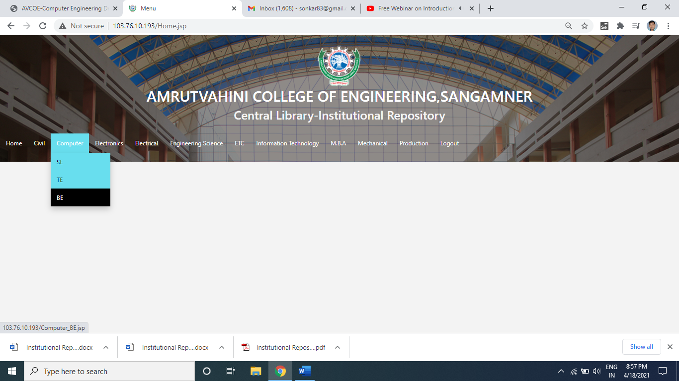

Student can download the file by clicking on download option.
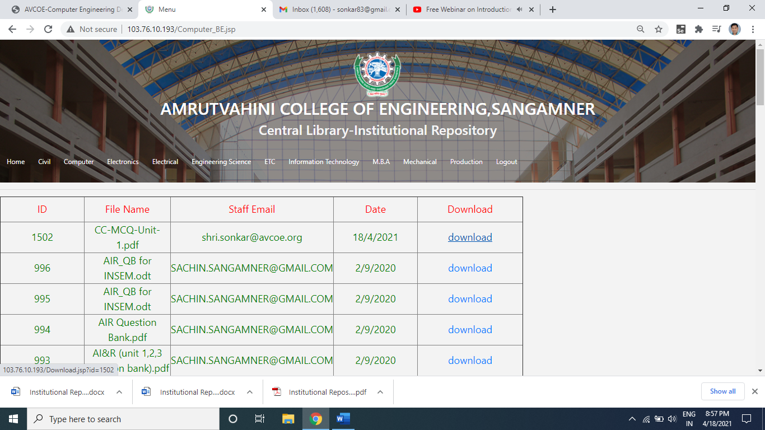
Following snap show the PDF file is downloaded at the bottom-leftmost corner.
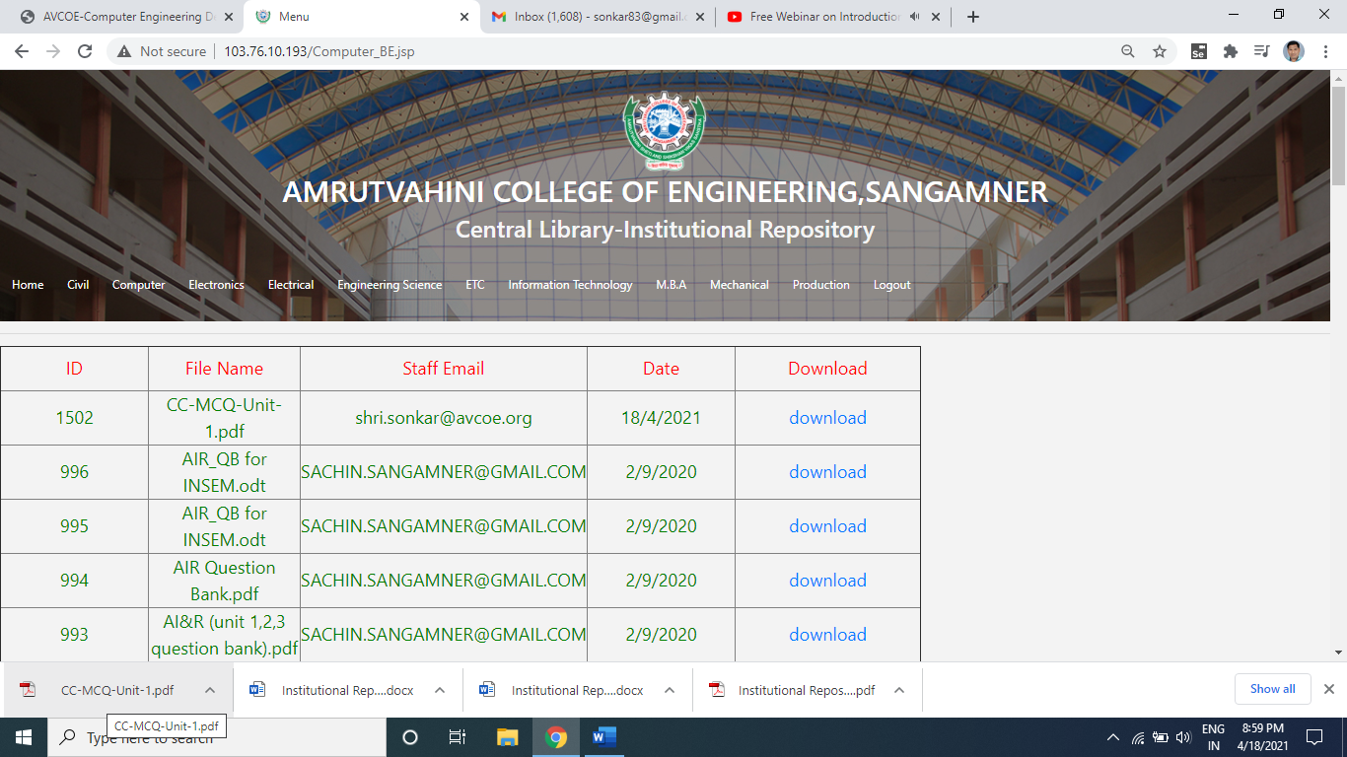

For any query contact: Prof.S.K.Sonkar(9970061302)
Asst.Prof.Computer Engg., Dept.

