4.2.1: Library is automated using Integrated Library Management System (ILMS).
INDEX
Sr. No. | Description | Pg. No.
 | Introduction | 1
 | Library Management Software - Sack Info2.5 (Educational ERP) | 2
 | Library Geo-tagged photo | 5

- Introduction
The library is automated using library management software ‘Ananosoft ERP (V.17.1.)’ Since 2012 to March 2018 and currently we are migrated to Sack Info ERP Software (V.2.5) since April 2018. The ILMS details are given below:
Sr. No | Name of the  ILMS Software | Nature of Automation | Version | Year of Automation
 | Sack Info | Fully | V.2.5. | 2021-2022
The library is fully automated with Sack Info 2.5 ERP library management system with barcode technology. The library has rich collection of text book, reference books, handbooks, manuals, rare books, e-books etc. The total number of books available in library is 66780 volumes and 14908 titles as on 31st May 2021 and also library has subscribed 119 Print Journals & 275 E-Journals.
- Library Management Software Screen shoot
Sack Info2.5 (Educational ERP)
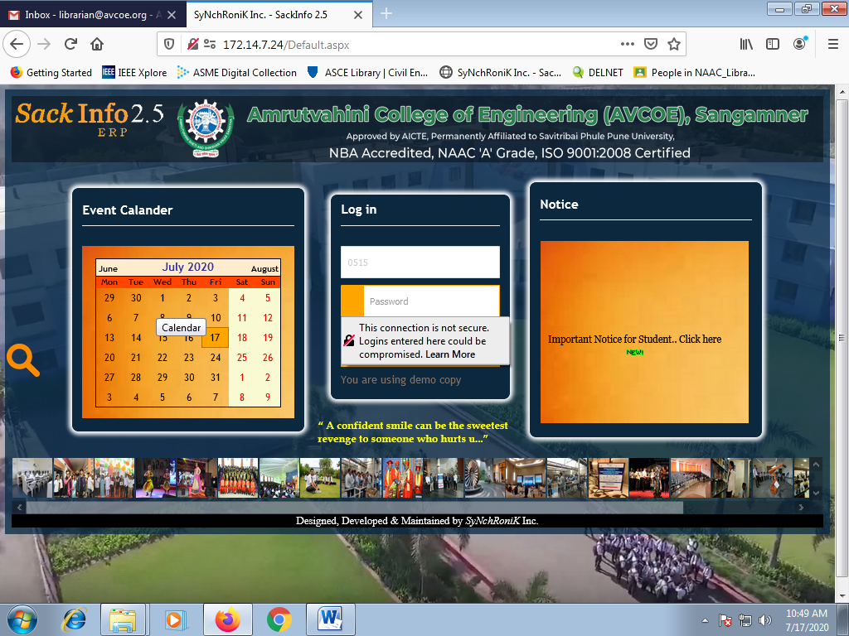

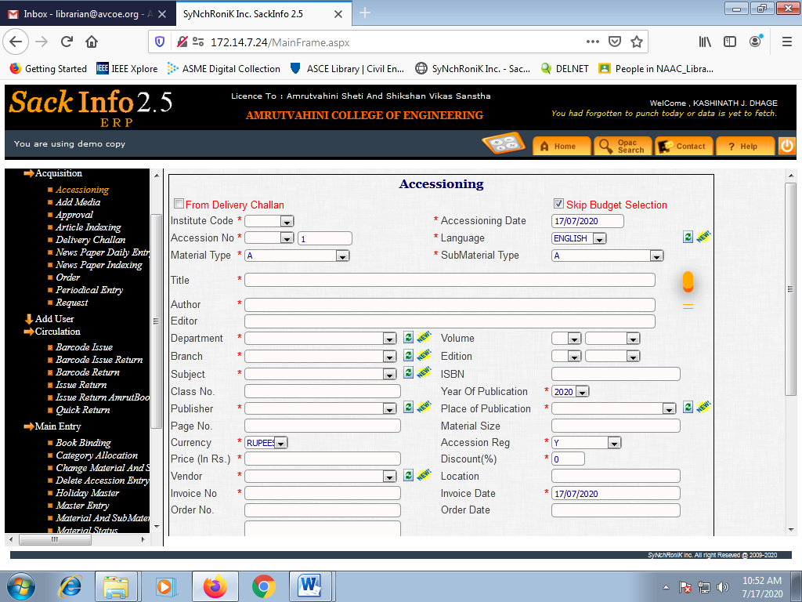
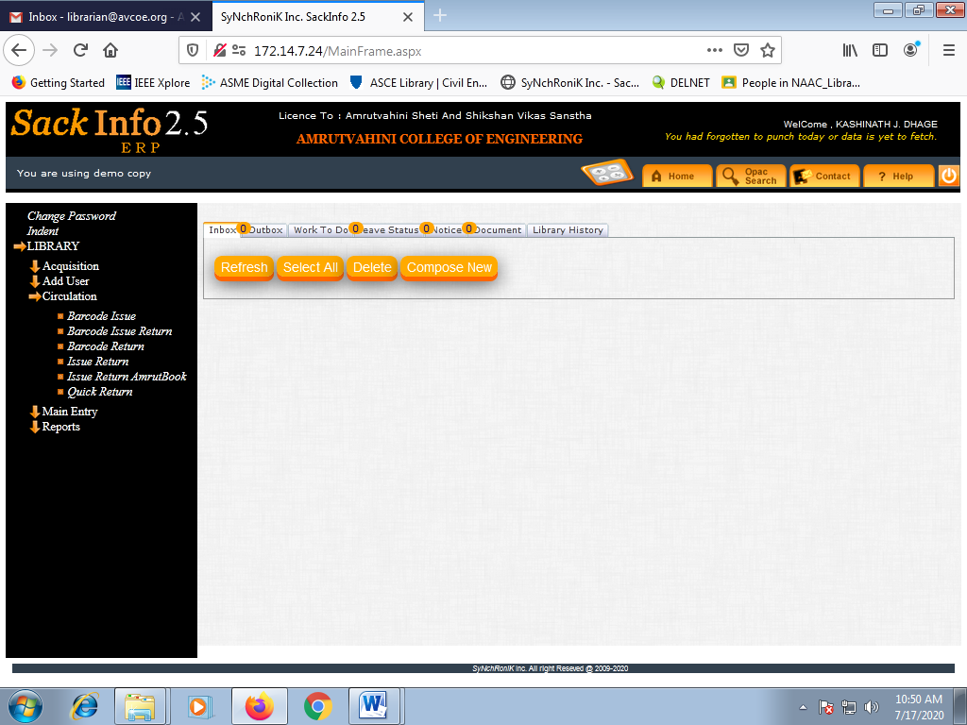
- Library Geo-tagged photo
Table below provides the link for library Geo-tagged photographs.
Sr. No. | Library Photographs | link
 | Library Geo-tagged photos

