4.1.2: The Institution has adequate facilities for cultural activities, sports, games (indoor, outdoor), gymnasium, yoga etc.
INDEX
Sr. No. | Description | Pg. No.
 | Institutional adequate facilities for cultural activities and sports | 1
 | Link for Geo-tagged Photograph | 1
 | Institution Plan (Bird’s Eye view) | 2
 | Additional Information | 3

- Institutional adequate facilities for cultural activities & sports
The Institute has two wide playgrounds having size 50,420m² (Padmabhushan Vasantdada Patil Krida- Sankul, Survey no. 46/1, shown in Fig. 1) and 58,980m² (Survey no.87) for sports for playing outdoor games such as cricket, volley ball, basketball, running track, horse riding and foot-ball. Similarly, the institute also has the facility for indoor games such as chess, table tennis and badminton. The Institute has cultural cell/Mudra Club which looks after cultural activities since 2015-16, every year Institute conducted a cultural event “Medha” to nurture the talent of the students.
- Link for Geo-tagged Photograph
The Table below provides the information at a glance and the link for Geo-tagged photo /plan for the Institution having adequate facilities for cultural activities, sports, games (indoor, outdoor), gymnasium, yoga, etc.
Sr. No. | Name of the facility | Area | Link to Open
 | Padmabhushan Vasantdada Patil Krida Sankul | 50,420 m²
 | Medha Ground | 58,980 m²
 | Amphitheatre | 2,000 m²
 | Amrut kalamanch | 550 m²
 | Gymkhana | 450 m²
 | Birds Eye veiw | --

- Institution Plan (Bird’s Eye view)
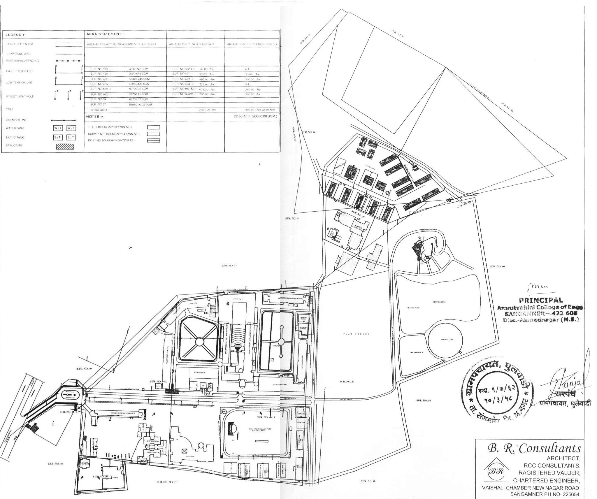
Fig. 1

