4.3.1 Institution frequently updates its IT facilities including Wi-Fi
Department has Computer, Electronic Software, MPMC labs and adequate IT infrastructure to meet curriculum requirements and changing technology. Through these laboratories, students perform practicals on various electronics application softwares such as XILINX, MATLAB, POWERSIM, ALTIUM DESIGNER, NI ACADEMIC LABVIEW, TURBO ASSMTOR 5, TURBO++ SUITE. All computers are interconnected by LAN with Internet facility. Students are promoted to use open-source software such as SCILAB and OCTAVE
JDK, VSCode and Apache NetBeans for the curriculum base or beyond curriculum practicals.

List of name of laboratories with computers:
Computer Specifications Details | No. of Computer | Dead Stock No | Lab | Purchase Date
COMPAQ Make P₄, 2.8GHZ,1GB RAM,40GB RAM | 2 | 484 | Electronic Software (ESW) | 24-09-2004
ZENITH Make DUAL CORE-1.8,2 GB RAM,160GB HDD | 9 | 515 | Electronic Software (ESW) | 04-04-2008
HP Make I-3 3.10 GHZ,4GB RAM,500 GB HDD,15.6''LED | 20 | 4 | Computer | 18-11-2011
HP Make I-3 3.30 GHZ,2GB RAM,500 GB HDD,15.6''LED | 30 | 563 | MPMC/  ESW | 23-07-2012
HP Make AMD 3.1 GHZ,8GB RAM,500GB HDD | 10 | 616 | MPMC | 05-11-2015
TOTAL COMPUTERS | 71

• Software purchase bill and its installation reports:
Sr. No | Dead Stock No. | Purchase  Date | Name of Software | No. of Copies / User | Lab | Total Cost
1 | 376 | 27/01/2000 | MATLAB 5x (Ref -11) + Control System TB + Fuzzy Logic TB | 1 | ESW | 107681
2 | 451 | 19/07/2002 | Turbo Assmtor 5 – Scholor, Product Code LSM1350 | 1  (20 User) | Computer | 86900
3 | 459 | 23/07/2002 | Window Server 2k English Intel AE CDS | 1  (5 User) | ESW | 24300
3 | 459 | 23/07/2002 | Additional License Copy Each User NET Pro. 2002 Win 32 | 29 | ESW | 89080
4 | 464 | 28/08/2002 | Turbo++ Suite Scholar License Copy | 5  (35 User) | Computer | 14700
5 | 465 | 28/08/2002 | Turbo++ Suite Scholar SKU License Copy | 15 | ESW | 44100
5 | 465 | 28/08/2002 | Windows -98 Licensed OEM Pack | 15 | ESW | 58350
6 | 467 | 19/07/2002 | MS Office XP Standard With 30 Papers License Copy | 1 | ESW | 77000
7 | 468 | 23/07/2002 | Access License For Windows N/T 2000 Server | 25 | Computer | 9375
8 | 469 | 28/08/2002 | SQL Server 2000 With License Pack | 20  (10 User) | Computer | 57000
9 | 474 | 12/02/2002 | Microsoft Windows 98 OEM License On Cd Software Copy | 15 | Computer | 58200
10 | 476 | 12/02/2003 | Office XP Professional 2000 Paper License Software Copy | 2 | Computer | 6820
11 | 497 | 09/10/2006 | Matrix (Multiple Application Tricks) CPLDmodule(Xilinx Xc-9572 Plc 84 | 4 | ESW | 18000
11 | 497 | 09/10/2006 | Microwind Package 05 Licdsc -H3 Microwindows Schematic Editor | 5 | ESW | 59500
12 | 502 | 27/03/2007 | MATLAB Software 7.0.1. | 10 | Computer | 295179.66
12 | 502 | 27/03/2007 | Signal Processing Tool Box | 10 | Computer | 122976
12 | 502 | 27/03/2007 | Communication Tool Box | 2 | Computer | 44579.28
12 | 502 | 27/03/2007 | Image Processing Tool Box | 2 | Computer | 44579.28
12 | 502 | 27/03/2007 | Simulink | 2 | Computer | 109209.01
12 | 502 | 27/03/2007 | Control System Tool Box | 1 | Computer | 26541.01
12 | 502 | 27/03/2007 | Signal Processing Block Set | 2 | Computer | 44579.07
12 | 502 | 27/03/2007 | Communication Block Set | 2 | Computer | 44579.07
13 | 537 | 31/05/2010 | Upgradation of MATLAB R-2010a | 10 | Computer | 100882.8
13 | 537 | 31/05/2010 | Simulink | 2 | Computer | 16192
13 | 537 | 31/05/2010 | Communication Back Set | 2 | Computer | 12988.7
13 | 537 | 31/05/2010 | Communication Tool Box | 2 | Computer | 12988.7
13 | 537 | 31/05/2010 | Control System Tool Box | 2 | Computer | 11515.4
13 | 537 | 31/05/2010 | Image Processing Tool Box | 2 | Computer | 12988.7
13 | 537 | 31/05/2010 | Signal Processing Block Set | 2 | Computer | 12988.7
13 | 537 | 31/05/2010 | Signal Process Tool Box | 10 | Computer | 40266
14 | 540 | 25/03/2011 | Ni Academic LABVIEW Software Part No-77979801 | 1  (50 user) | ESW | 322160
15 | 550 | 16/03/2012 | Power Sim Software PSIM Basic | 1 (05user) | ESW | 248343
15 | 550 | 16/03/2012 | Motor Drive Module | 1 | ESW | 97650
16 | 592 | 21/05/2014 | Academic Perpectual Concurrent License MATLAB Software 2014 A | 2 | ESW | 66412.5
16 | 592 | 21/05/2014 | Image Processing Tool Box | 1 | ESW | 13282.5
16 | 592 | 21/05/2014 | Wavelet Toolbox | 1 | ESW | 13282.5
17 | 1 | 09/09/2011 | Altium Designer Software Release 10custom Board | 1 | MPMC | 168787.5
17 | 1 | 09/09/2011 | Altium Designer Software | 10 user | MPMC | 151908
18 | 6 | 27/12/2013 | Xilinx Ise System Edition Software Ise 13.2 | 1  (25 User) | MPMC | 75600

- Xilinx Software
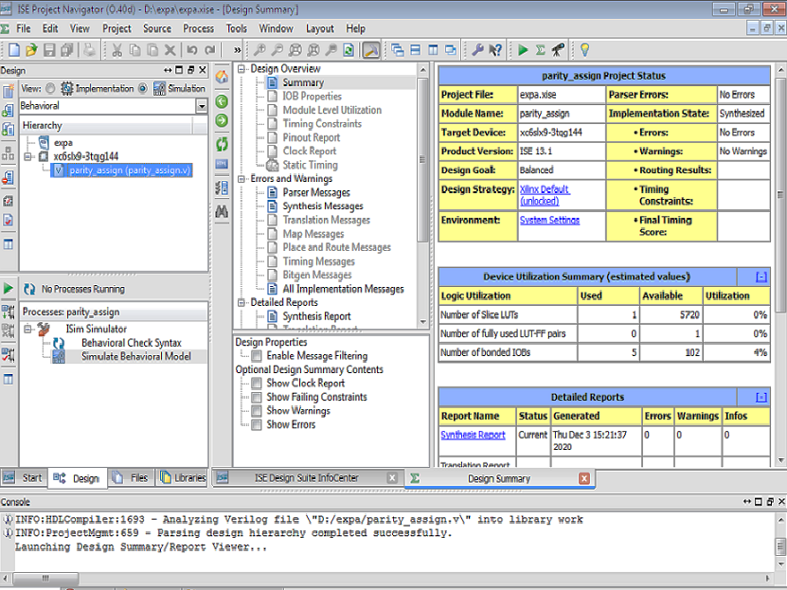

- Plan Ahead
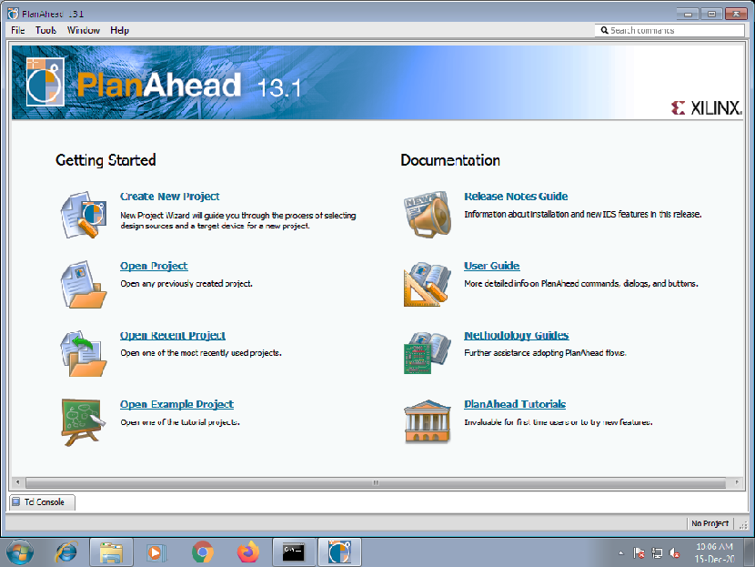
- Microwind Software
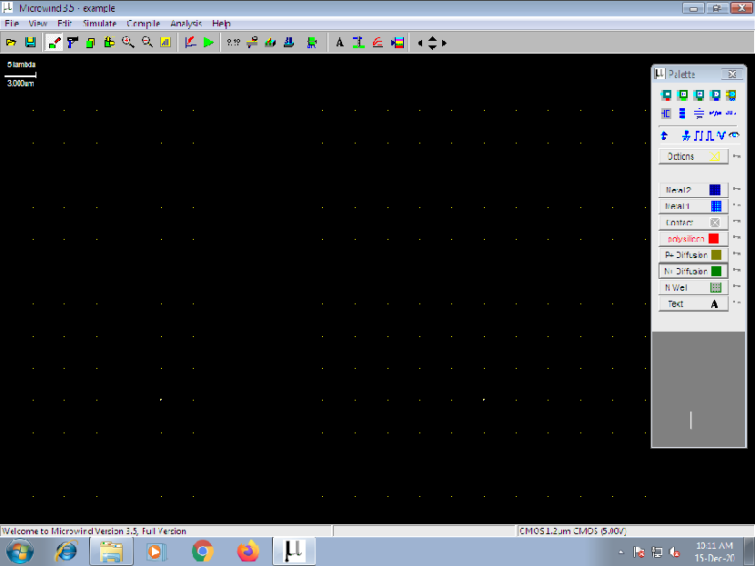
- MATLAB 2016a
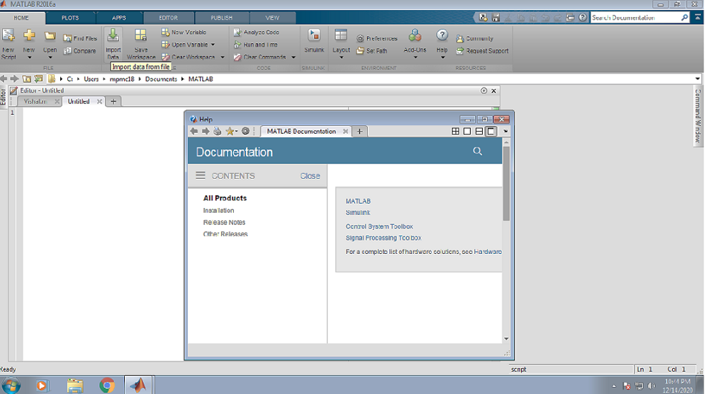
- MATLAB 2009b
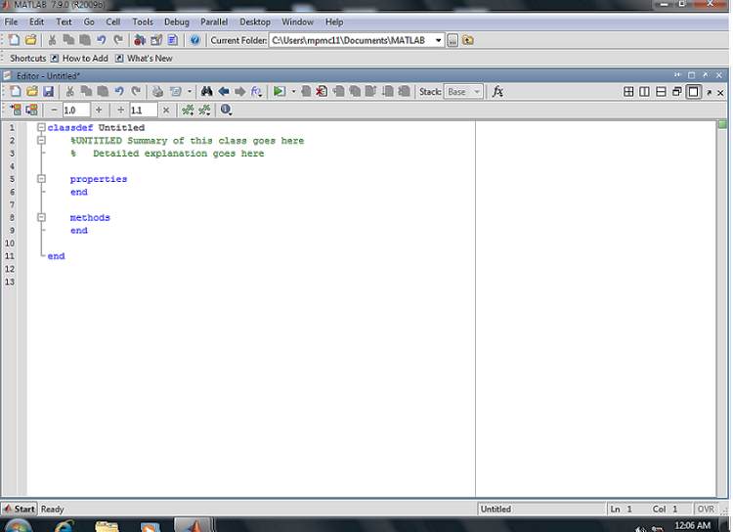

- Powersim
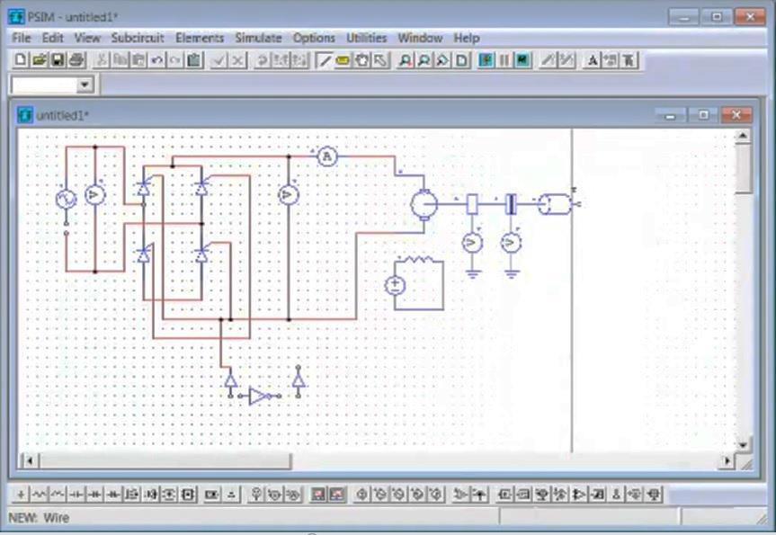

• List of LCD Projectors, Xerox Machines, Printers, Scanners, CCTV, Wi-Fi, Internet.
Sr. No | Dead Stock No. | Purchase  Date | Description | No. of Copies | Lab | Total Cost
LCD Projector
1 | 517 | 31/10/2001 | Epson LCD SVGA Projector Mn-EMP-50 Resolution 800 X 600 | 1 | Computer | 195000
2 | 521 | 03/12/2010 | DLP Optoma Cb-2800 Resolution 800 X 600 SVGA | 2 | Computer | 64800
2 | 521 | 03/12/2010 | Ceiling Kit With Video VGA | 2 | Computer | 11757
2 | 521 | 03/12/2010 | Screen Liberty 6'x4' Liberty | 2 | Computer | 6840
3 | 531 | 15/01/2011 | DLP Optoma Cb-2800 Resolution 800 X 600 SVGA | 1 | ESW | 28321.87
3 | 531 | 15/01/2011 | Ceiling Mount Kit With VGA Power Cable | 1 | ESW | 4809.37
3 | 531 | 15/01/2011 | Wall Mounting Screen 6'x4' | 1 | ESW | 4007.5
4 | 544 | 31/12/2010 | DLP Mitsubishi Model Es200v Resolution 800 X600 SVGA | 1 | Electronics Network | 27000
4 | 544 | 31/12/2010 | Screen Liberty 6'x4' Liberty | 1 | Electronics Network | 3037.5
4 | 544 | 31/12/2010 | Ceiling Mount Kit | 1 | Electronics Network | 5062.5
5 | 568 | 01/07/2012 | DLP Mitsubishi Model Es200v Resolution 800x600x5vga With Ceiling Mount Kit & Screen | 2 | MPMC | 68000
 |  |  |  |  | Electronics Communication | 68000
Printers
1 | 518 | 23/01/2009 | HP Laserjet Printer 1008 | 1 | Computer | 13000
2 | 526 | 15/10/2010 | Epson Dot Matrix Printer Lq-2090 | 1 | ESW | 33075
3 | 526 | 15/10/2010 | HP Laserjet Printer1008 | 1 | ESW | 13125
4 | 3 | 09/09/2011 | Printer Lx 300 Epson Make | 1 | MPMC | 9975
5 | 3 | 09/09/2011 | Printer Laserjet 1020 HP Make | 1 | MPMC | 9397.5
Scanners
1 | 423 | 17/07/2002 | HP Scanjet 7400c Scanner A4 Size Flatbed, Color Scanner, with USB SCSI | 1 | Computer | 26000

