Amrutvahini College Of Engineering, Sangamner

Experiential Learning, Participative Learning and Problem Solving

The institute encourages and practices experiential learning, participative learning and problem solving methodologies by employing student centric methods wherein faculty plays a role of facilitator.

Following are the glimpses of student’s involvement in experiential learning, participative learning and problem solving.

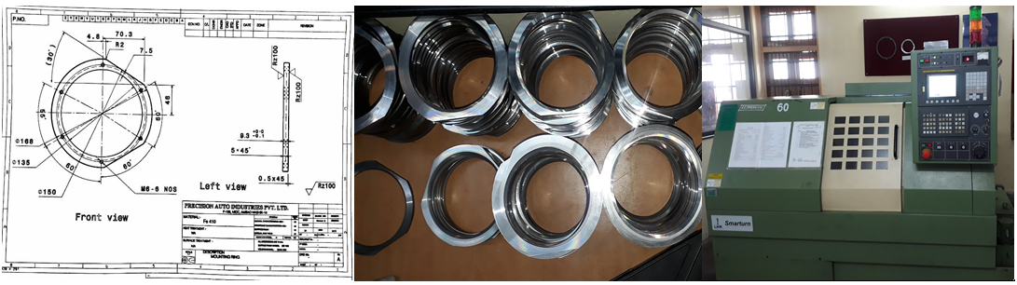

Manufactures components for Precision Auto Industries, Sinnar.

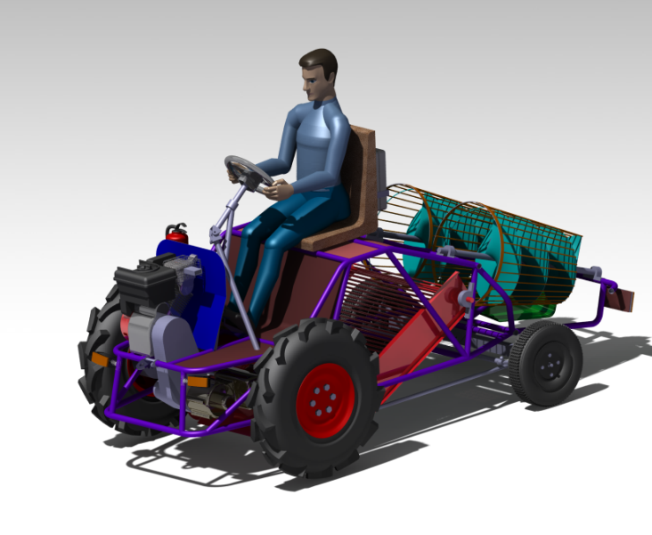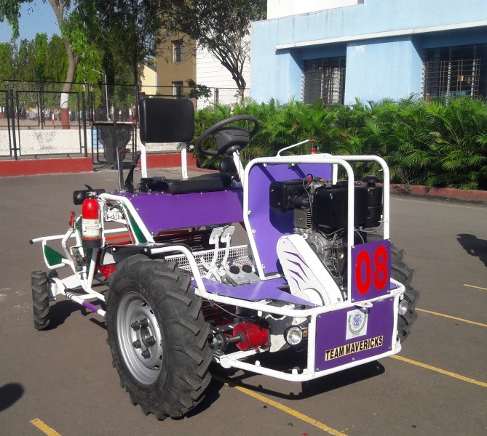

AVCOE ‘Team Mavericks’ manufacture ‘Onion Harvester’ in workshop which wins 1st Price in National Level event ‘Tifan 2018’ held and organized by MPKV, Rahuri.
Amrut Bench | Amrut Chulla (Simultaneously cook and heat the water)
Amrut Cot | 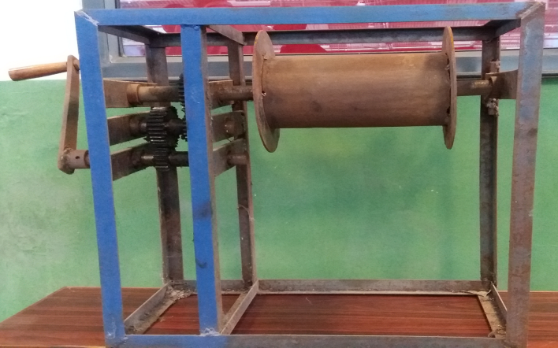  Amrut Crane
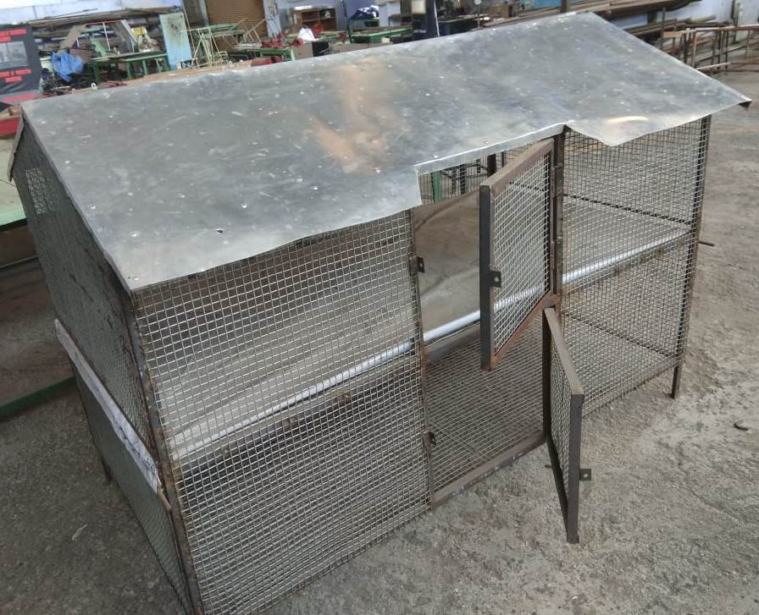  Amrut Chicken House | 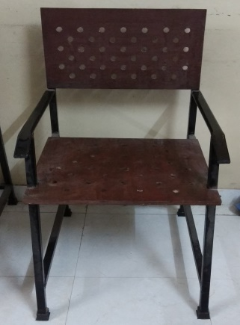  Amrut Chair

Amrut Bumb (Water Heater- Use farm waste as a fuel)

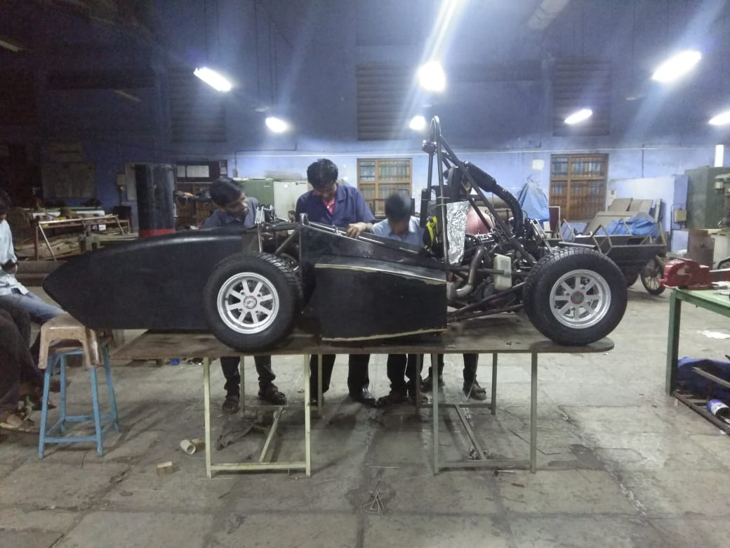

Students working on their vehicle for SAE competition

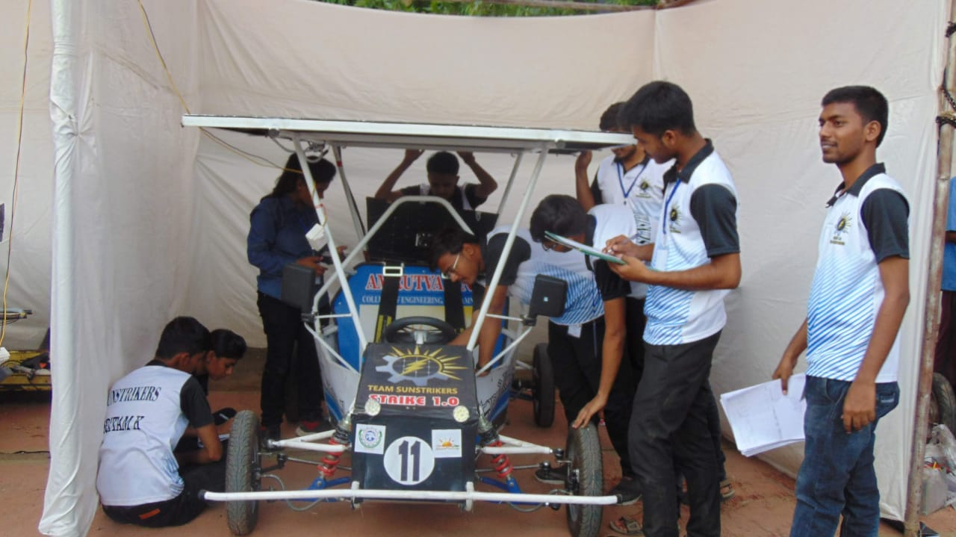

Team Sunstrikers getting their vehicle ready for the Solar Design Challenge competition

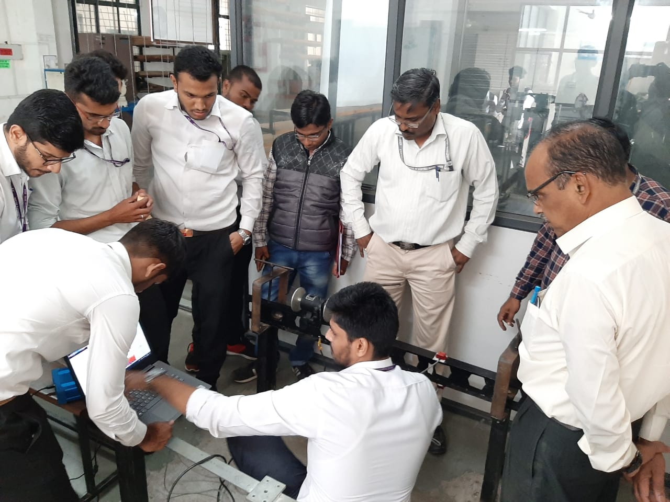

Civil Engineering students working on a shake table

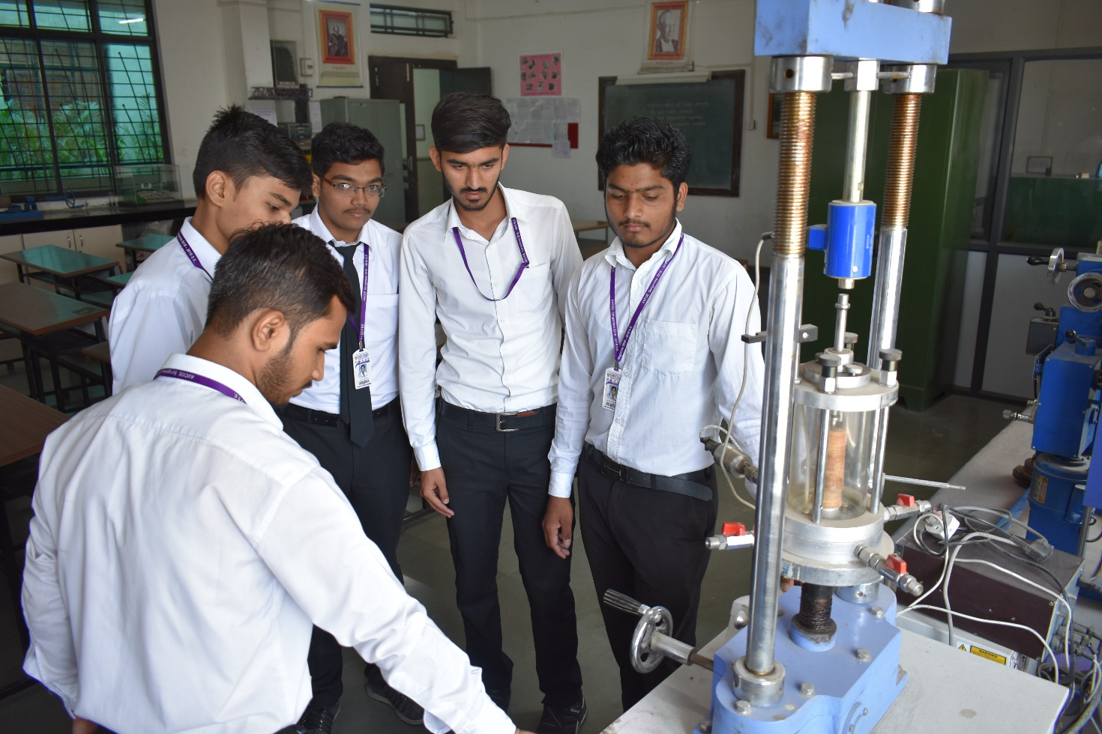

Civil Engineering studens doing soil testing

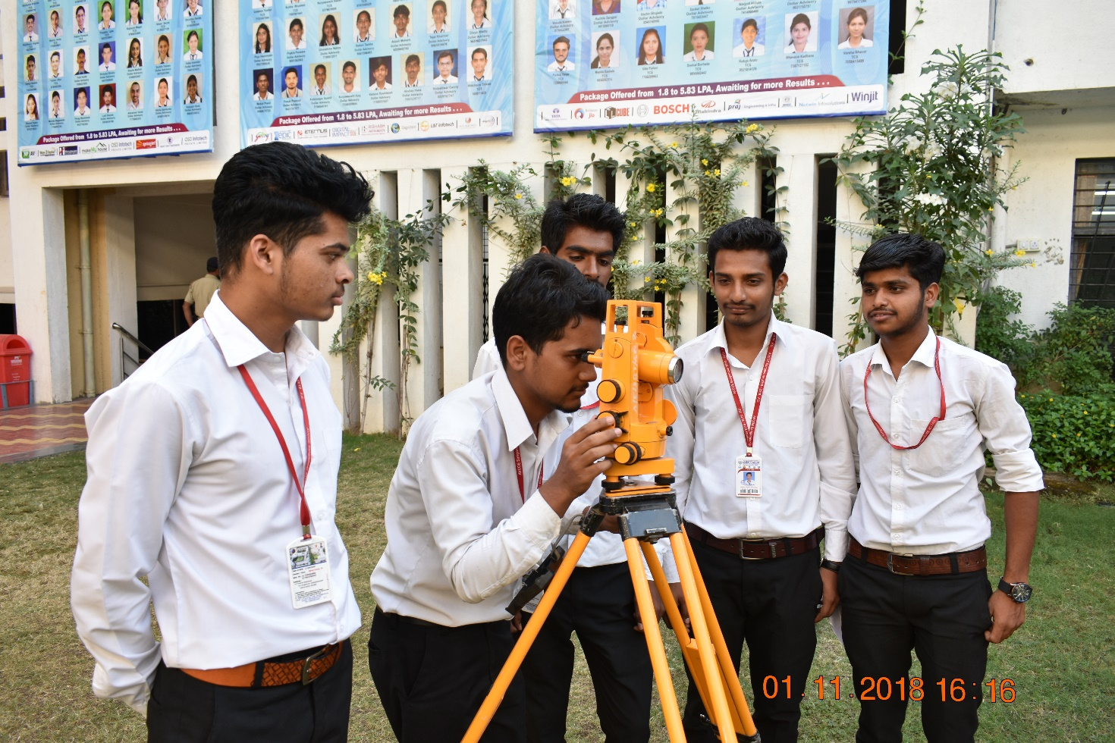

Students doing Survey work as a part of curriculum

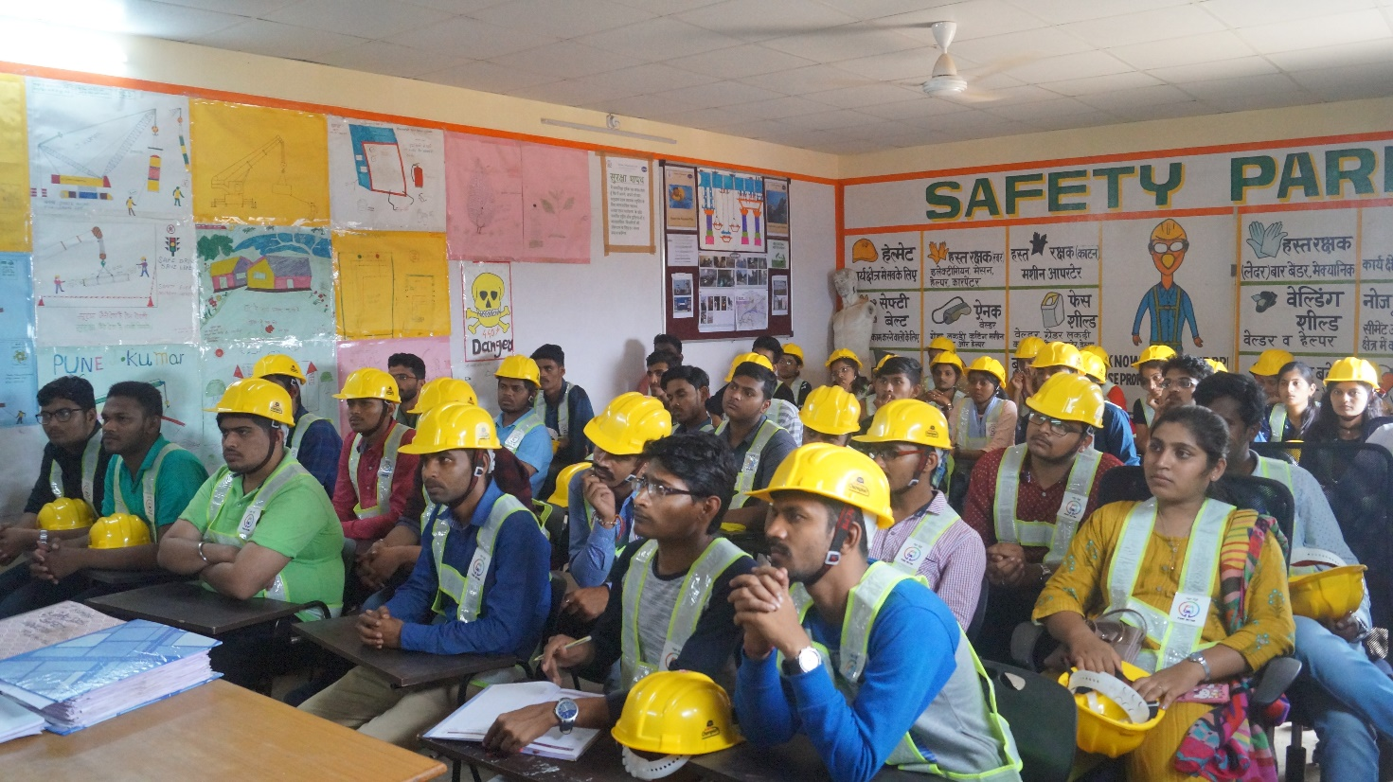

Experintial learninng at Maha Metro site Pune

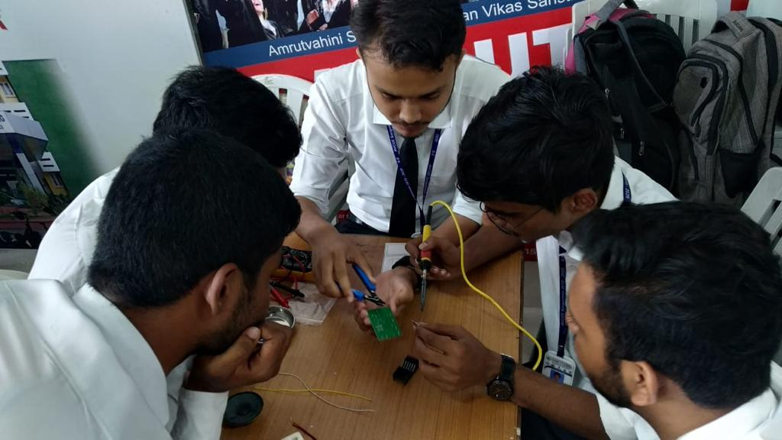

Students working on their mini/hobby project

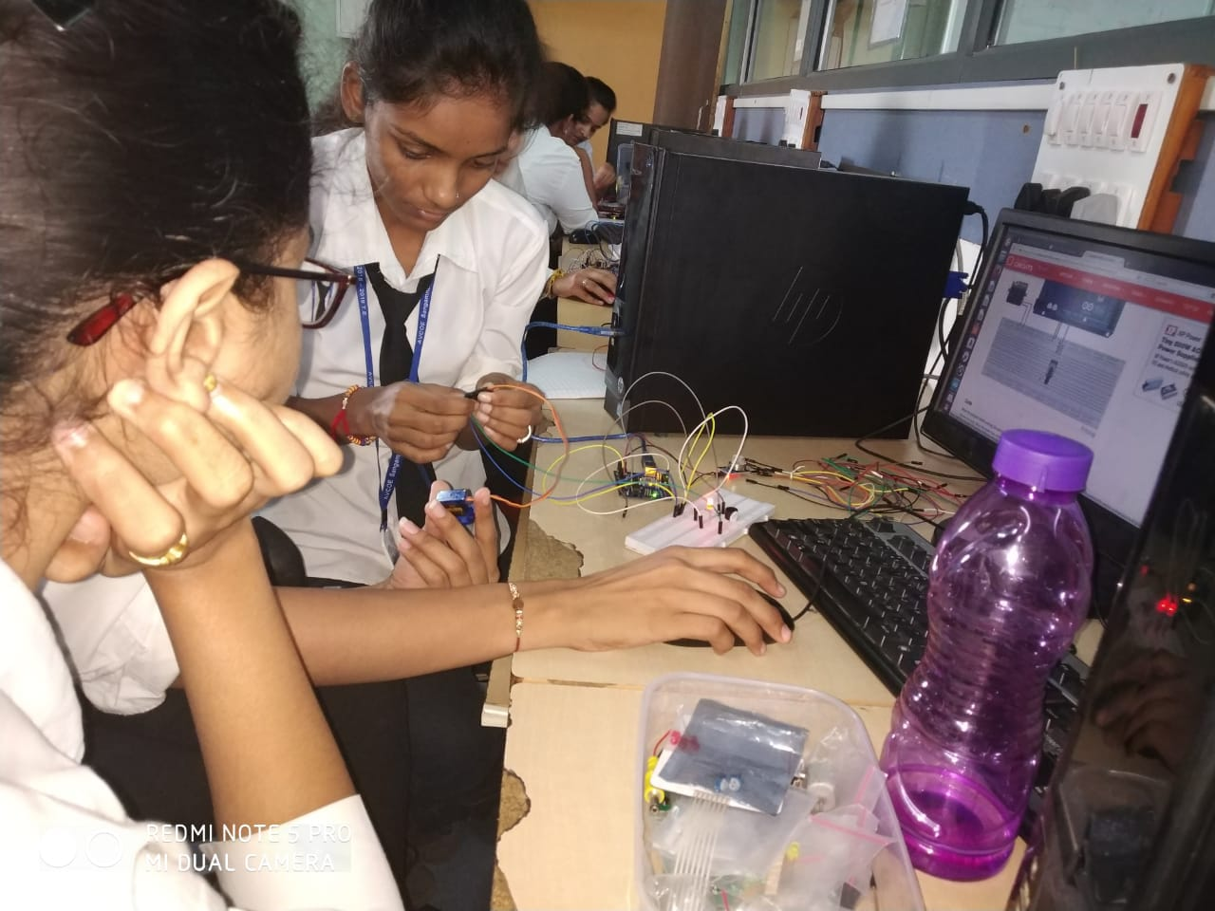

Electronics Engineering students building an IoT application

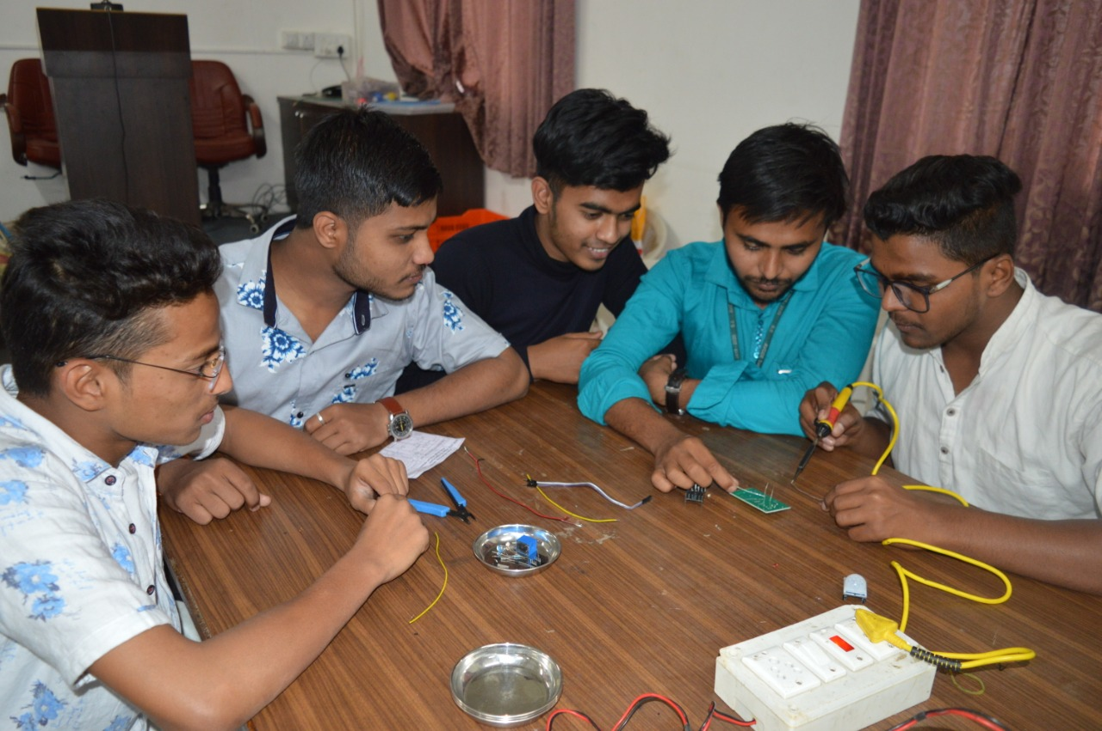

Electrical Engineering students doing soldering practice
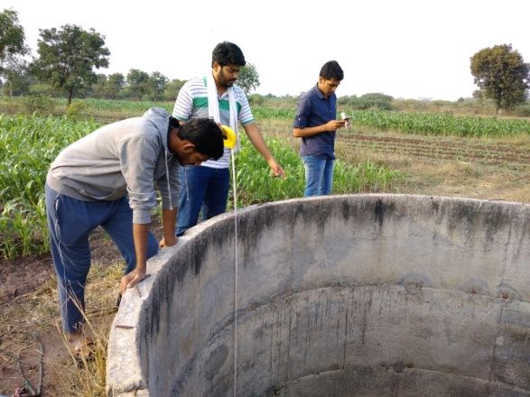 |  | 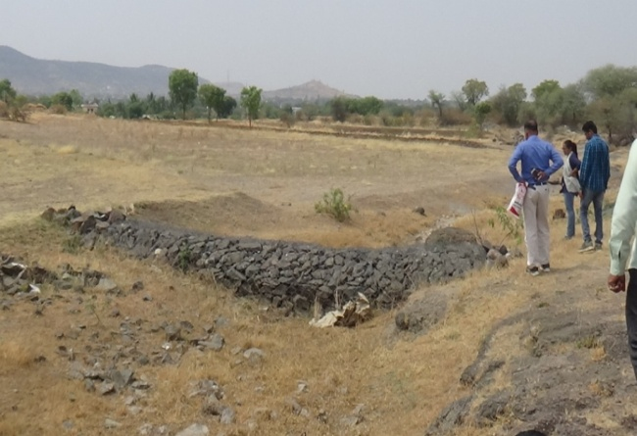

Students participation Unnat Maharastra Abhiyan and Jalyukta Shiwar Abhiyan

