As the part of experiential leaning 6 students from department of information technology have been selected as intern and working on different live model and project, list and detail of student is as follow
Sr No | Name of Student | Photo of the student | Mobile No. | Email ID | Company  Remark
1 | Vaishnav Mandlik | 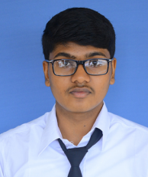 | 9975553860 | vaishnavmandlik@yahoo.com | Increaseimmunity
2 | Patil Vaidehi | 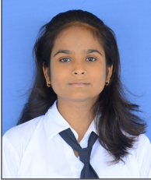 | 7057182178 | vaidehisp2000@gmail.com | TCS ION,Nashik
3 | Jape Udayshree | 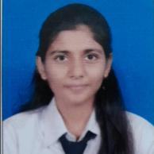 | 7038147576 | udayshree.jape14@gmail.com | Simply Local-Wabi Tech,Delhi
4 | Onkar Joshi | 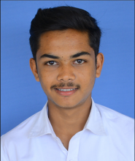 | 8830670719 | iamjoshionkar@gmail.com | Yash Sewa Samiti through Internshala.
5 | Chetan Deshmukh | 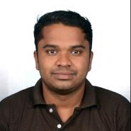 | 9545702577 | chetan.deshmukh04@gmail.com | Yash Sewa Samiti through Internshala.
6 | Akshay Deshmukh | 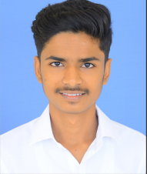 | 9767084322 | akshaydeshmukh134@gmail.com | Yash Sewa Samiti through Internshala.

