1.4 Feedback
Sr. no. | Documents | Page No
1 | Sample Filled Feedback Forms | 2-4
2 | Stakeholder feedback analysis report | 5
3 | Communication with the affiliating University Action taken | 6

Alumni Feedback
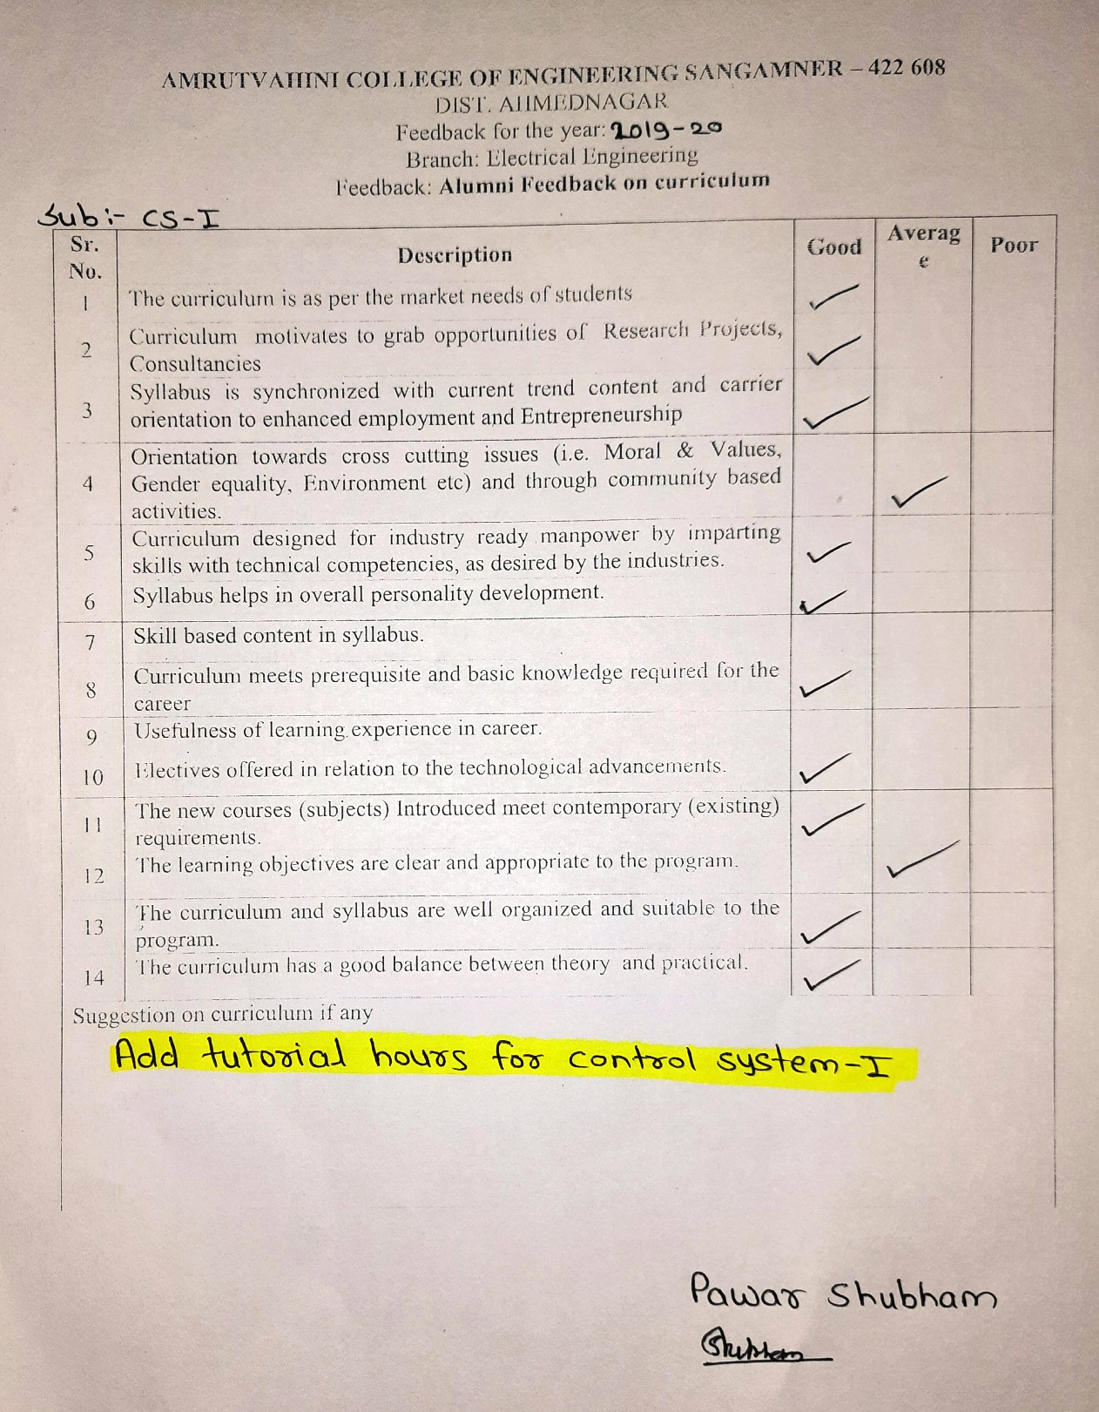

Employer Feedback
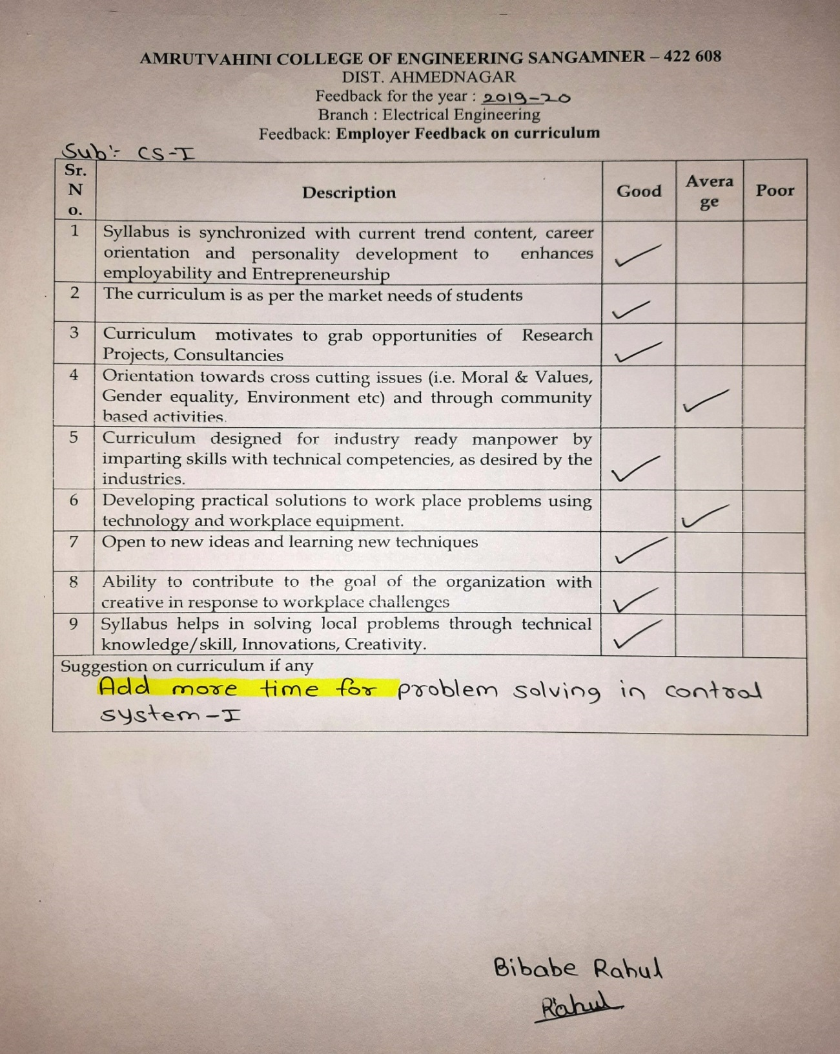

Teacher Feedback
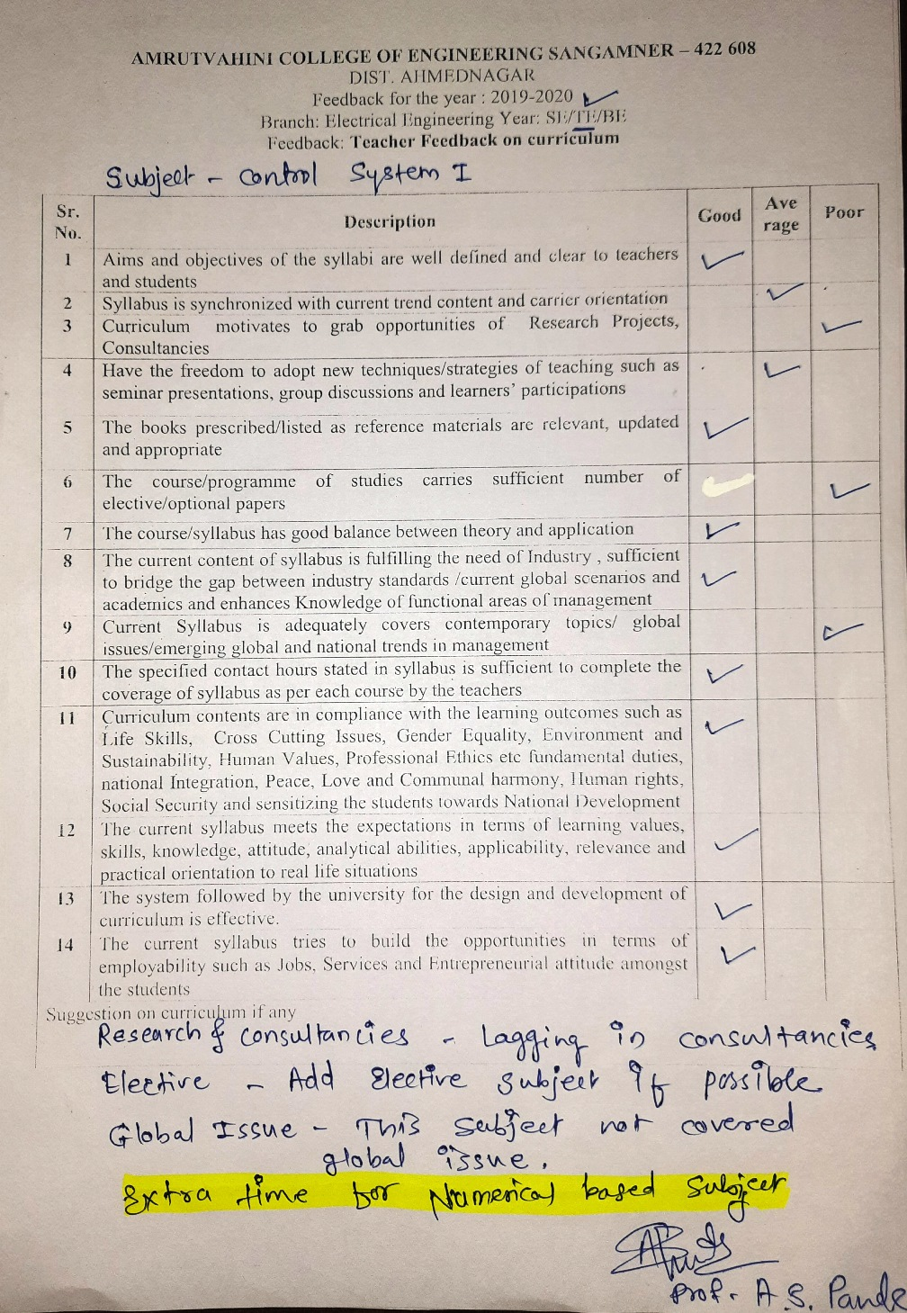

Feedback Report
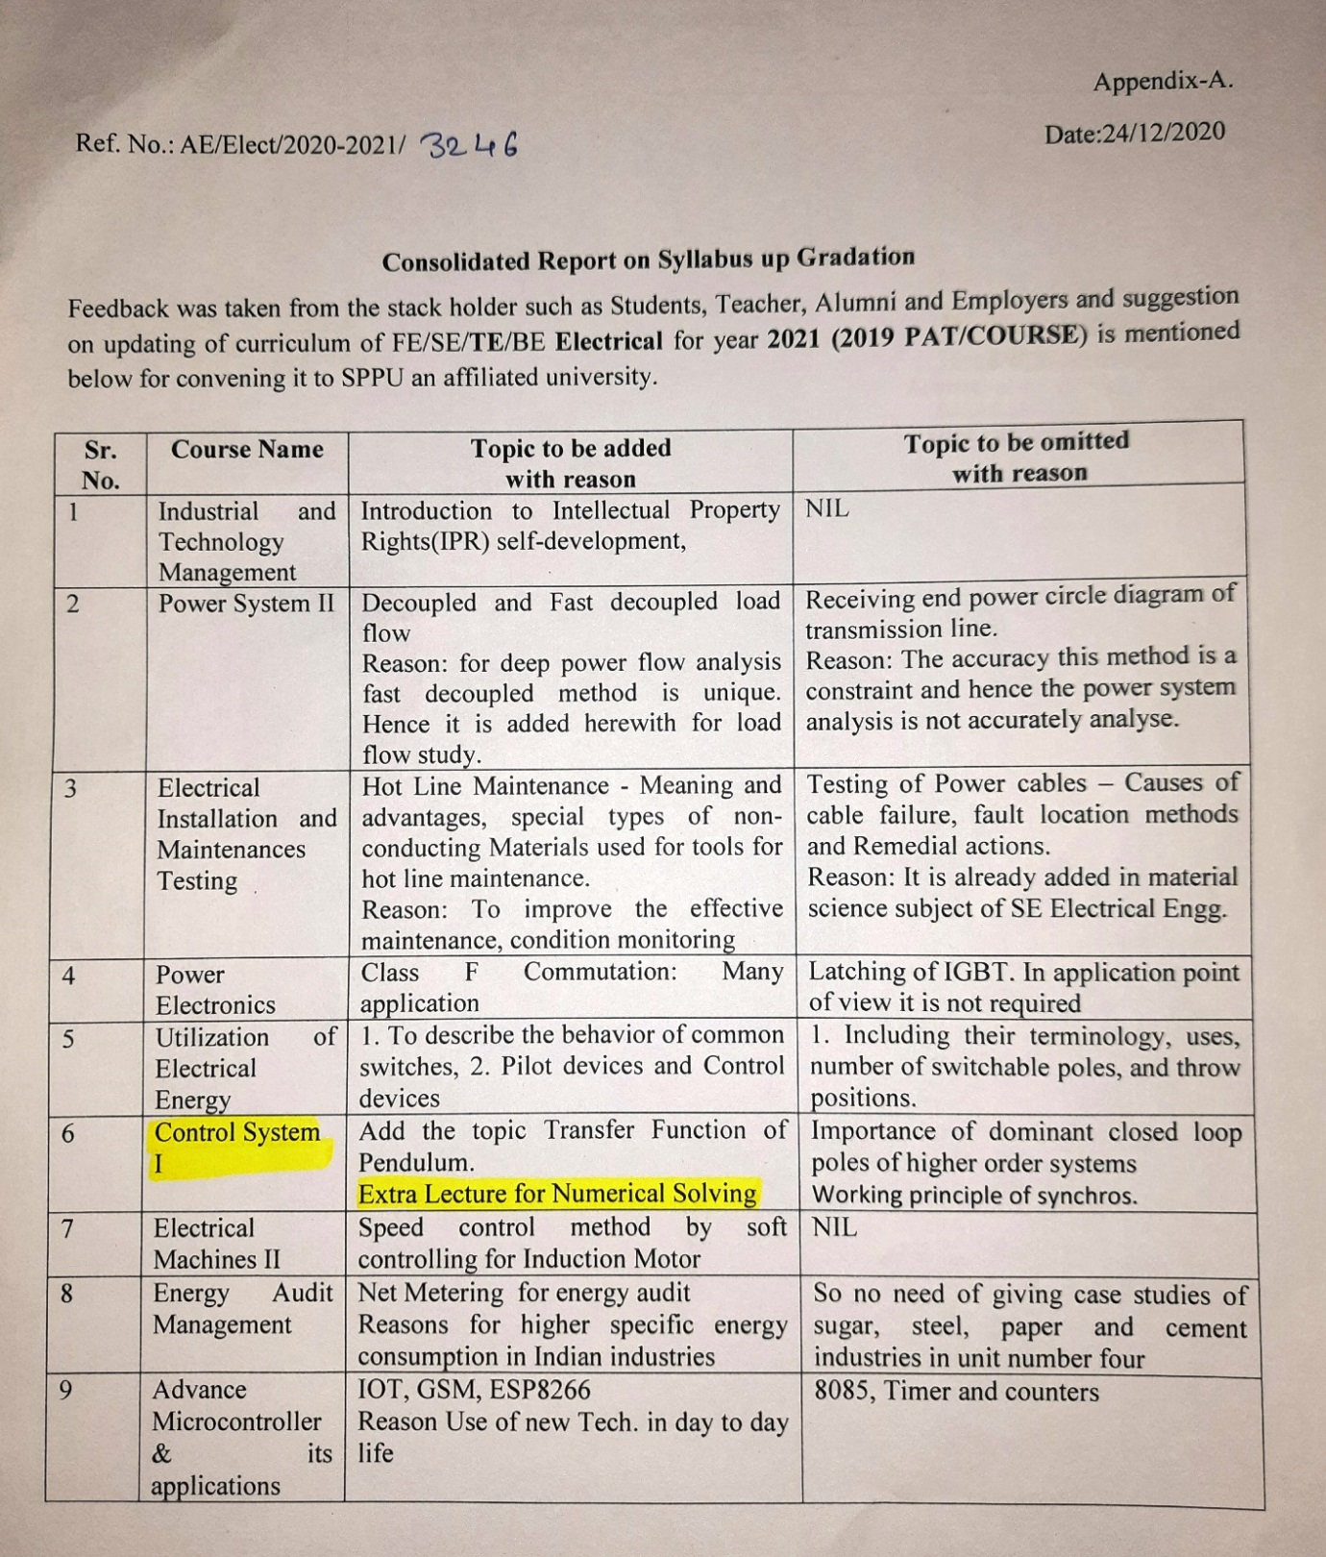

Action taken report
